A
PROJECT BASED LEARNING
ON
“Academic and Course Management — University ERP”
FOR PARTIAL FULFILLMENT
OF THE REQUIREMENTS FOR THE
DATABASE MANAGEMENT SYSTEM
OF T.Y. B. TECH
By
[[TO BE PROVIDED: student 1 name; use official roster]] | [[TO BE PROVIDED: roll no. 1; use official record]]
[[TO BE PROVIDED: student 2 name; use official roster]] | [[TO BE PROVIDED: roll no. 2; use official record]]
[[TO BE PROVIDED: student 3 name; use official roster]] | [[TO BE PROVIDED: roll no. 3; use official record]]
GUIDE
[[TO BE PROVIDED: guide name; confirm with department]]

DEPARTMENT OF
ELECTRONICS AND TELECOMMUNICATION ENGINEERING
PUNE INSTITUTE OF COMPUTER TECHNOLOGY
PUNE – 43
ACADEMIC YEAR: 2026-2027
Department of Electronics and Telecommunication Engineering
Pune Institute of Computer Technology, Pune – 43
CERTIFICATE
This is to certify that the Mini Project Report entitled
Academic and Course Management — University ERP
has been successfully completed by
[[TO BE PROVIDED: student 1 name; use official roster]] | [[TO BE PROVIDED: exam no. 1; use official record]]
[[TO BE PROVIDED: student 2 name; use official roster]] | [[TO BE PROVIDED: exam no. 2; use official record]]
[[TO BE PROVIDED: student 3 name; use official roster]] | [[TO BE PROVIDED: exam no. 3; use official record]]
Is Bonafide work carried out by them under the supervision of [[TO BE PROVIDED: Name of the Project Guide; confirm from guide allocation]] and it is approved for the partial fulfillment of the requirements for the Database Management Systems Course of TY BTech, E&TCE, PICT, Pune.
[[TO BE PROVIDED: Name of the Project Guide; department to confirm]]  Project Guide | Dr. S. V. Gaikwad  HOD, E&TC Dept. of E&TC
Place: Pune
Date : [[TO BE PROVIDED: actual approval date; signatories must supply after review]]
ACKNOWLEDGEMENT
This report acknowledges the supplied PICT templates for its institutional structure and the referenced source repository for the implementation artifacts examined. SQL definitions and design descriptions are attributed to the pinned source snapshot; original repository screenshots and historical logs are not presented as newly executed evidence.
[[TO BE PROVIDED: verified names and contributions of guide, faculty, staff and colleagues to acknowledge; report authors must obtain confirmation from those involved before submission]]
[[TO BE PROVIDED: student 1 name; use official roster and confirm team size]]
[[TO BE PROVIDED: student 2 name; use official roster and confirm team size]]
[[TO BE PROVIDED: student 3 name; use official roster and confirm team size]]
ABSTRACT
This report documents the Academic and Course Management module of a university ERP using the PICT DBMS report structure for academic year 2026-2027. The module is traced from its React interface and Express routes through services and repositories to the actual relational schema and SQL programmability. Its scope, actors, business rules, data flows, keys, constraints and functional dependencies are analyzed without asserting blanket third-normal-form compliance. Exact relevant SQL definitions and invocation templates are included. Static review distinguishes implemented behavior from gaps, policy assumptions and proposed enhancements. Repository-wide backend and frontend type checks and builds passed; the backend test command found no test files. Live database, API, browser and deployment execution were not verified. Positive, negative, boundary, transaction and authorization cases therefore retain explicit evidence placeholders. The resulting editable draft supports implementation review and viva preparation, while student identities, institutional approval and executed test evidence remain to be supplied by the team.
[[TO BE PROVIDED: student 1 name; confirm from official roster]]
[[TO BE PROVIDED: student 2 name; confirm from official roster]]
[[TO BE PROVIDED: student 3 name; confirm from official roster]]

List of figures:
Figure 2.1 Common stack used by this module 5
Figure 2.2 Academic and Course Management — Level 1 DFD 6
Figure 2.3 sp_bulk_enroll_students — transaction/workflow supplement 8
Figure 2.4 Module 2 — relational ER sheet 1/5 9
Figure 2.5 Module 2 — relational ER sheet 2/5 10
Figure 2.6 Module 2 — relational ER sheet 3/5 11
Figure 2.7 Module 2 — relational ER sheet 4/5 12
Figure 2.8 Module 2 — relational ER sheet 5/5 12

List of tables:
Table 1.1 Source-backed requirements and evidence boundaries 2
Table 2.1 Module processes and integration stores 7
Table 2.2 Shared / cross-module key contracts (not duplicated ownership) 14
Table 2.3 sections — full column dictionary 15
Table 2.4 program_subjects — full column dictionary 17
Table 2.5 course_offerings — full column dictionary 19
Table 2.6 enrollments — full column dictionary 22
Table 2.7 faculty_subjects — full column dictionary 24
Table 2.8 timetable — full column dictionary 26
Table 2.9 academic_calendar — full column dictionary 29
Table 2.10 class_sessions — full column dictionary 31
Table 2.11 departments — full column dictionary 33
Table 2.12 programs — full column dictionary 35
Table 2.13 batches — full column dictionary 37
Table 2.14 academic_years — full column dictionary 39
Table 2.15 semesters — full column dictionary 40
Table 2.16 subjects — full column dictionary 41
Table 2.17 Relation-level candidate keys and normalization assessment 44
Table 2.18 Academic and Course Management — exact API route/role register 64
Table 3.1 M2-01 — Single enrollment and duplicate 73
Table 3.2 M2-02 — Capacity and student status boundaries 74
Table 3.3 M2-03 — Bulk cohort idempotency / cleanup 74
Table 3.4 M2-04 — Drop/delete counter semantics 75
Table 3.5 M2-05 — Timetable overlap and endpoints 76
Table 3.6 M2-06 — Calendar and cross-faculty assignment 76
Table 3.7 M2-07 — Concurrent enrollment / direct UPDATE 77
Table 3.8 EXEC-01 — npm run typecheck in backend 78
Table 3.9 EXEC-02 — npm run build in backend 78
Table 3.10 EXEC-03 — npm run typecheck in frontend 79
Table 3.11 EXEC-04 — npm run build in frontend 79
Table 3.12 EXEC-05 — npm test in backend 80

Abbreviations (if any)
ERP — Enterprise Resource Planning
DBMS / RDBMS — Database Management System / Relational DBMS
ER / DFD — Entity–Relationship / Data Flow Diagram
PK / FK / UQ — Primary key / foreign key / UNIQUE constraint
FD / 1NF / 2NF / 3NF — Functional dependency / first, second and third normal forms
API / RBAC / JWT — Application Programming Interface / role-based access control / JSON Web Token
SPA / UDF / SQL — Single-page application / user-defined function / Structured Query Language
SGPA / CGPA — Semester / cumulative grade-point average
PF / LOP / YTD — Provident fund / loss of pay / year to date

Symbols / special words
X → Y — Functional dependency: equal X values imply equal Y values under the stated business assumptions.
1 / 0..1 / 0..N — Exactly one / optional one / zero or many; figure [P; C] gives parents per child and children per parent.
NULL — Missing/unknown or not applicable SQL value; it is not equal to zero or an empty string.
Σ and percentage — Sum across the stated grain; percentage numerator and denominator must be specified.
IN / OUT / @variable — Stored routine parameter modes and MySQL session variables; examples require selected synthetic fixture values.
Implemented / partial / planned / unverified — Defined in source / incomplete or inconsistent / proposed only / no execution evidence.
Evidence placeholder — The exact [[TO BE PROVIDED: ...]] markers are unresolved team inputs, not successful results.

Index
CHAPTER 1: MODULE OVERVIEW & REQUIREMENTS 1
1.1 Introduction & Motivation 1
1.2 Objectives 1
1.3 Scope, Actors & Boundaries 1
1.4 Functional & Non-Functional Requirements 2
1.5 Business Rules & Implementation Status 3
CHAPTER 2: MODULE DESIGN & IMPLEMENTATION 5
2.1 Module Architecture & Technology 5
2.2 Module Data Flow Diagram (Level 1 / Level 2 DFD) 6
2.2.1 Sub-System Processes, Data Stores & External Movement 7
2.3 Module ER Diagram, Sub-Schema & Data Dictionary 9
2.3.1 Shared academic masters used by this module 33
2.3.2 Normalization Analysis & Justified Exceptions 43
2.4 Advanced SQL Implementation 46
2.4.1 Stored Procedures (SQL Code & Execution Proofs) 46
2.4.2 Database Triggers (SQL Code & Execution Proofs) 50
2.4.3 User-Defined Functions (UDFs) (SQL Code & Execution Proofs) 57
2.4.4 Shared UDF consumer (not G2-owned) 57
2.5 Complex Analytical Queries & Views 59
2.6 Backend Routes, Services, Repository & Frontend Trace 64
2.7 Validation, Errors, Transactions & Limitations 70
CHAPTER 3: TESTING, CONCLUSION & REFERENCES 73
3.1 Module Test Plan & Preconditions 73
3.2 Positive, Negative, Edge, Authorization & Transaction Cases 73
3.2.1 Executed Repository-Wide Build Checks (not module correctness) 78
3.2.2 Required Evidence & Screenshot Checklist 80
3.3 Conclusion, Limitations & Future Enhancements 81
3.4 References 81

CHAPTER 1: MODULE OVERVIEW & REQUIREMENTS

1.1 Introduction & Motivation
Curriculum, a scheduled course offering and an individual enrollment are separate facts. Shared academic masters allow attendance, exams and payroll workload to refer to the same teaching context.
This self-contained module report concerns Academic and Course Management within the seven-module University ERP. It is based on commit b3b56e06cfa8df6ef3765380d0a14ba75b05dc22 and supplied PICT 2026-2027 templates, not on unverified menu labels or borrowed report identities. [T01, T02, T03, R00, R12]

1.2 Objectives
1. Connect student_id, subject_id, program_id, semester_id and faculty_id without duplicating business masters.
2. Block duplicate/capacity-conflicting inserts using keys, service checks and triggers.
3. Publish a reusable weekly timetable and dated class sessions to the attendance and examination modules.

1.3 Scope, Actors & Boundaries
Department/program/batch/year/semester lookups, subject CRUD, sections and class teachers, curriculum mappings in SQL, offerings, single and bulk enrollment, timetable CRUD and conflict inspection, academic calendar and faculty-subject assignment. Not every table has a complete standalone CRUD screen.
Actors: ADMIN; FACULTY; STUDENT and authenticated readers according to individual routes. Administrative writes are role-gated; learner self-enrollment and staff bulk enrollment are different paths.
Shared identity/academic masters, authentication, audit and notifications are summarized only where needed. The report does not duplicate the entire master; it provides the module's full schema, relevant programmable SQL, implementation trace and module-specific tests. Cross-cutting AI/mock/risk remains adjunct scope rather than a new core module.

1.4 Functional & Non-Functional Requirements
Table 1.1 Source-backed requirements and evidence boundaries
Requirement ID | Requirement / implementation | Evidence / status
M2-REQ-01 | Enrollment is UNIQUE by student_id/offering_id. The insert guard permits ACTIVE or SUSPENDED students and rejects only CANCELLED offerings; it is not an ACTIVE-only or OPEN-only gate. | Implemented, static
M2-REQ-02 | Insert/delete triggers maintain course_offerings.enrolled_count. All enrollment rows contribute; changing an enrollment to DROPPED does not execute the delete trigger. | Implemented, static
M2-REQ-03 | sp_bulk_enroll_students stages missing student/offering pairs for all ACTIVE students of the program; p_section_id filters offerings, not student batch/section membership. The temporary table avoids the mutating-table interaction. At-capacity prechecks may reject even a duplicate-only rerun. | Implemented, static
M2-REQ-04 | The timetable insert trigger checks overlapping faculty/section/room slots, rejects break intervals and checks applicable theory duration. An insert guard is not an equivalent update guard. | Implemented, static
M2-REQ-05 | class_sessions is located in the G2 schema block but is created/consumed by attendance routes. Shared academic masters remain enterprise tables, not additional module-specific copies. | Shared implementation
M2-REQ-06 | Capacity, conflict checks, day/time boundary behavior and concurrent insert races are unexecuted. UI visibility and a successful TypeScript build do not establish scheduling correctness. | Unverified / partial
M2-NFR-01 | Authenticated/role-scoped server access, parameter binding and validation at the actual implementation points. | Source-defined, not a comprehensive security pass.
M2-NFR-02 | Atomic business changes where procedures define transaction handling; audit/notification service writes may be separate. | Source-defined; rollback/concurrency not executed.
M2-NFR-03 | [[TO BE PROVIDED: approved performance, availability, backup and browser targets for this module; team/test lead must provide requirements and measured evidence]] | No invented response-time, user-capacity or recovery claim.

1.5 Business Rules & Implementation Status
Implemented, static — Enrollment is UNIQUE by student_id/offering_id. The insert guard permits ACTIVE or SUSPENDED students and rejects only CANCELLED offerings; it is not an ACTIVE-only or OPEN-only gate.
Implemented, static — Insert/delete triggers maintain course_offerings.enrolled_count. All enrollment rows contribute; changing an enrollment to DROPPED does not execute the delete trigger.
Implemented, static — sp_bulk_enroll_students stages missing student/offering pairs for all ACTIVE students of the program; p_section_id filters offerings, not student batch/section membership. The temporary table avoids the mutating-table interaction. At-capacity prechecks may reject even a duplicate-only rerun.
Implemented, static — The timetable insert trigger checks overlapping faculty/section/room slots, rejects break intervals and checks applicable theory duration. An insert guard is not an equivalent update guard.
Shared implementation — class_sessions is located in the G2 schema block but is created/consumed by attendance routes. Shared academic masters remain enterprise tables, not additional module-specific copies.
Unverified / partial — Capacity, conflict checks, day/time boundary behavior and concurrent insert races are unexecuted. UI visibility and a successful TypeScript build do not establish scheduling correctness.
Implemented means a definition or code path was found. Partial means a source-defined limitation/inconsistency exists. Planned enhancements are proposals only. Unverified means no live result was obtained. Four repository-wide compiler/build checks passed, but no module-specific SQL/API/E2E suite is claimed to have passed.

CHAPTER 2: MODULE DESIGN & IMPLEMENTATION

2.1 Module Architecture & Technology
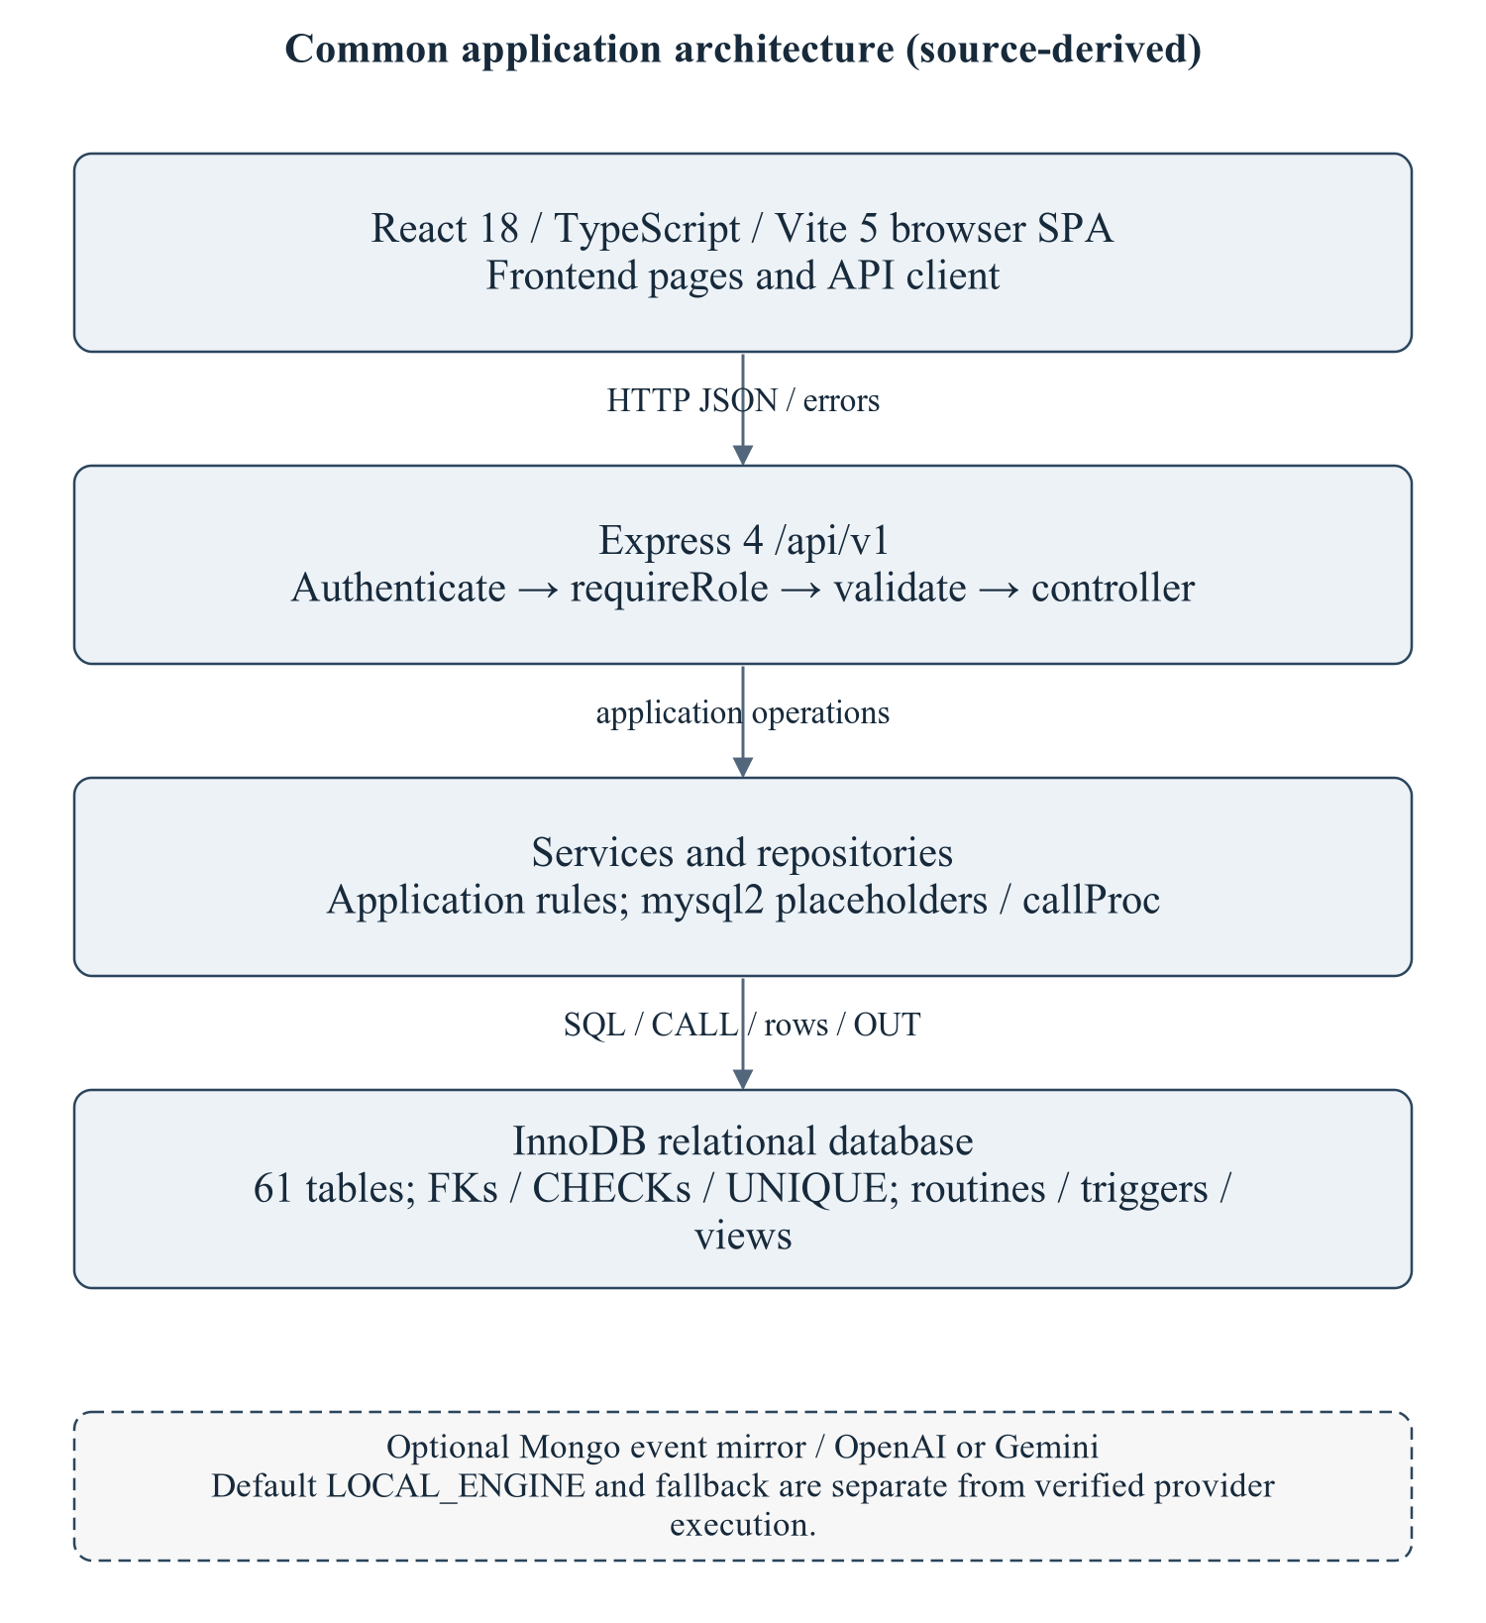
Figure 2.1 Common stack used by this module
The architecture is summarized to locate the module's routes/services/repository and SQL; it is not a copy of the master's enterprise narrative. Optional provider execution is not established.
Editable drawing source: diagrams/01_common_architecture.svg, .dot and .mmd. Edit SVG text/shapes in a vector editor, or regenerate from DOT/Mermaid; retain FK IDs and source names. These figures were created from static source, not captured from a running ERP.
React18/TypeScript/Vite5 client → Express4 /api/v1/academics → module controller/service/repository → mysql2/InnoDB. Node>=18 is specified by backend package metadata; audit checks used Node20.20.2. MySQL8-style SQL and Compose MariaDB11.8 are separate unverified runtime targets. Hardware/IDE/browser performance requirements await MI15/MI16. [R09, R23]

2.2 Module Data Flow Diagram (Level 1 / Level 2 DFD)
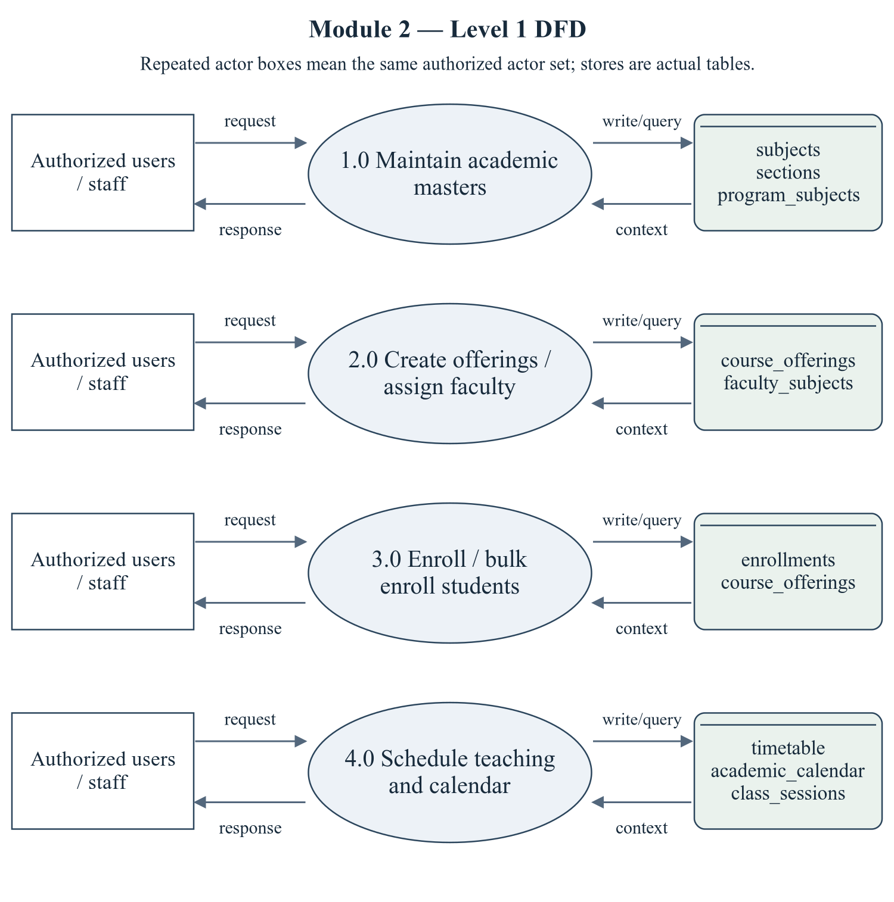
Figure 2.2 Academic and Course Management — Level 1 DFD
Repeated actor boxes mean the same external entity set. Each D label names real stores, not a fabricated table; role and row scope remain as specified in the route/ownership discussion.
Editable drawing source: diagrams/05_module_02_dfd_level1.svg, .dot and .mmd. Edit SVG text/shapes in a vector editor, or regenerate from DOT/Mermaid; retain FK IDs and source names. These figures were created from static source, not captured from a running ERP.

2.2.1 Sub-System Processes, Data Stores & External Movement
Table 2.1 Module processes and integration stores
Process | Actual persisted stores | Data movement
1.0 Maintain academic masters | subjects, sections, program_subjects | Actor request/decision → module process; data query/write ↔ actual stores; response/report → actor.
2.0 Create offerings / assign faculty | course_offerings, faculty_subjects | Actor request/decision → module process; data query/write ↔ actual stores; response/report → actor.
3.0 Enroll / bulk enroll students | enrollments, course_offerings | Actor request/decision → module process; data query/write ↔ actual stores; response/report → actor.
4.0 Schedule teaching and calendar | timetable, academic_calendar, class_sessions | Actor request/decision → module process; data query/write ↔ actual stores; response/report → actor.

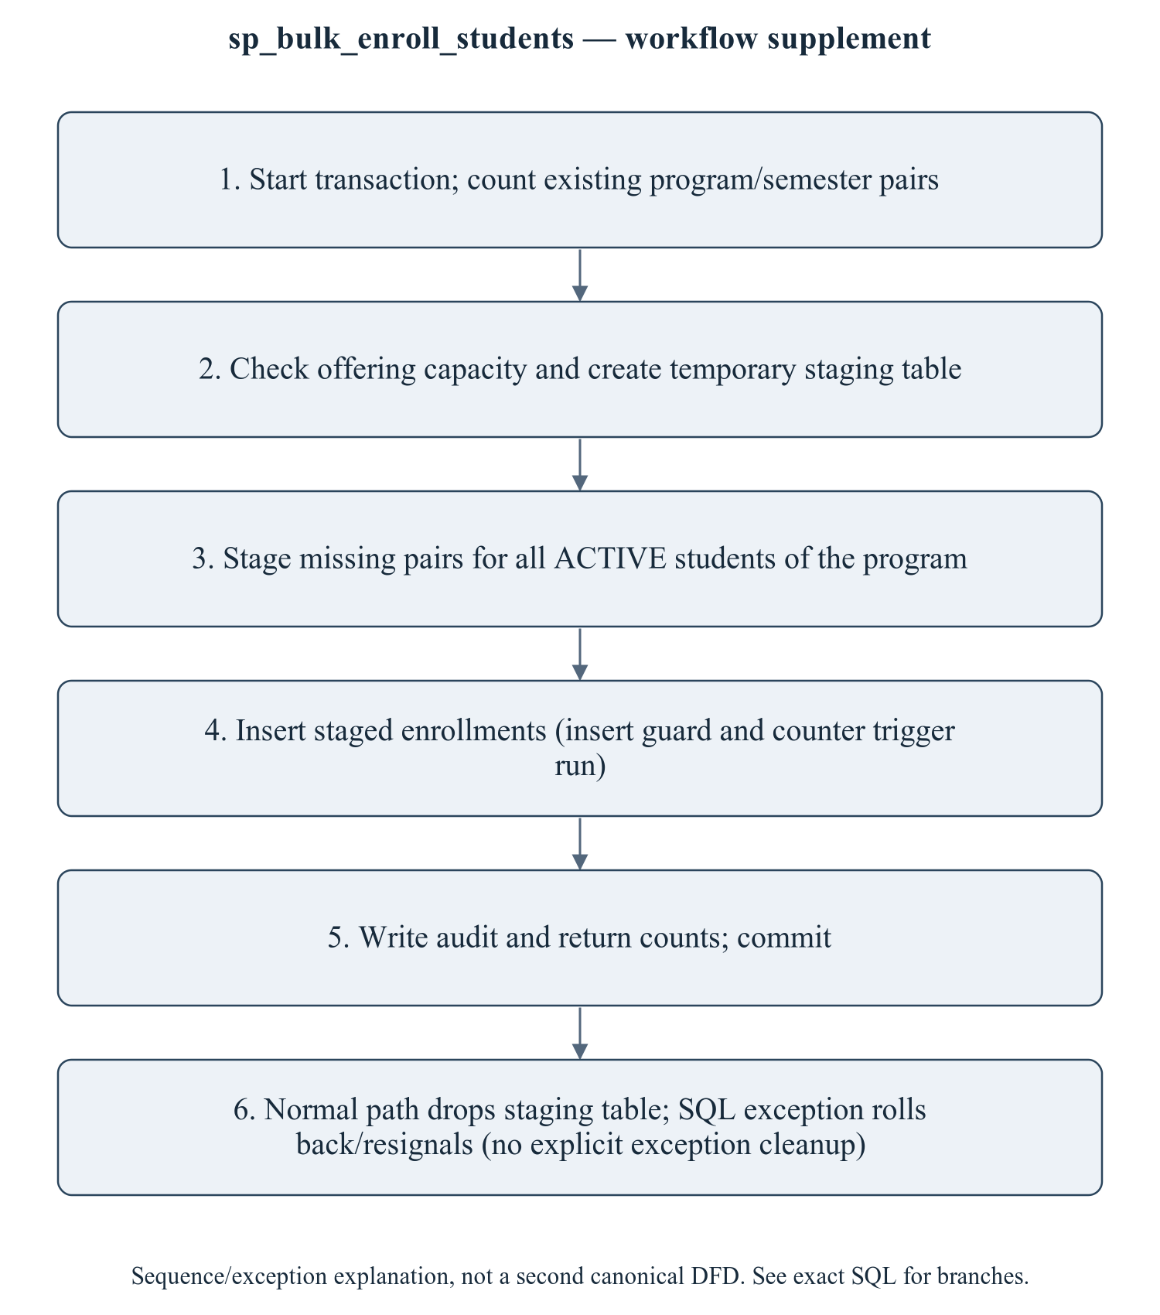
Figure 2.3 sp_bulk_enroll_students — transaction/workflow supplement
This is a procedure sequence/exception explanation, not a second canonical DFD. Enrollment status semantics and the counter meaning must be agreed before changing rows in place. The trigger guards insertion, while direct SQL UPDATE paths require separate tests. Timetable capacities and policy statements must follow actual code, not old documentation.
Editable drawing source: diagrams/06_module_02_procedure_workflow.svg, .dot and .mmd. Edit SVG text/shapes in a vector editor, or regenerate from DOT/Mermaid; retain FK IDs and source names. These figures were created from static source, not captured from a running ERP.

2.3 Module ER Diagram, Sub-Schema & Data Dictionary
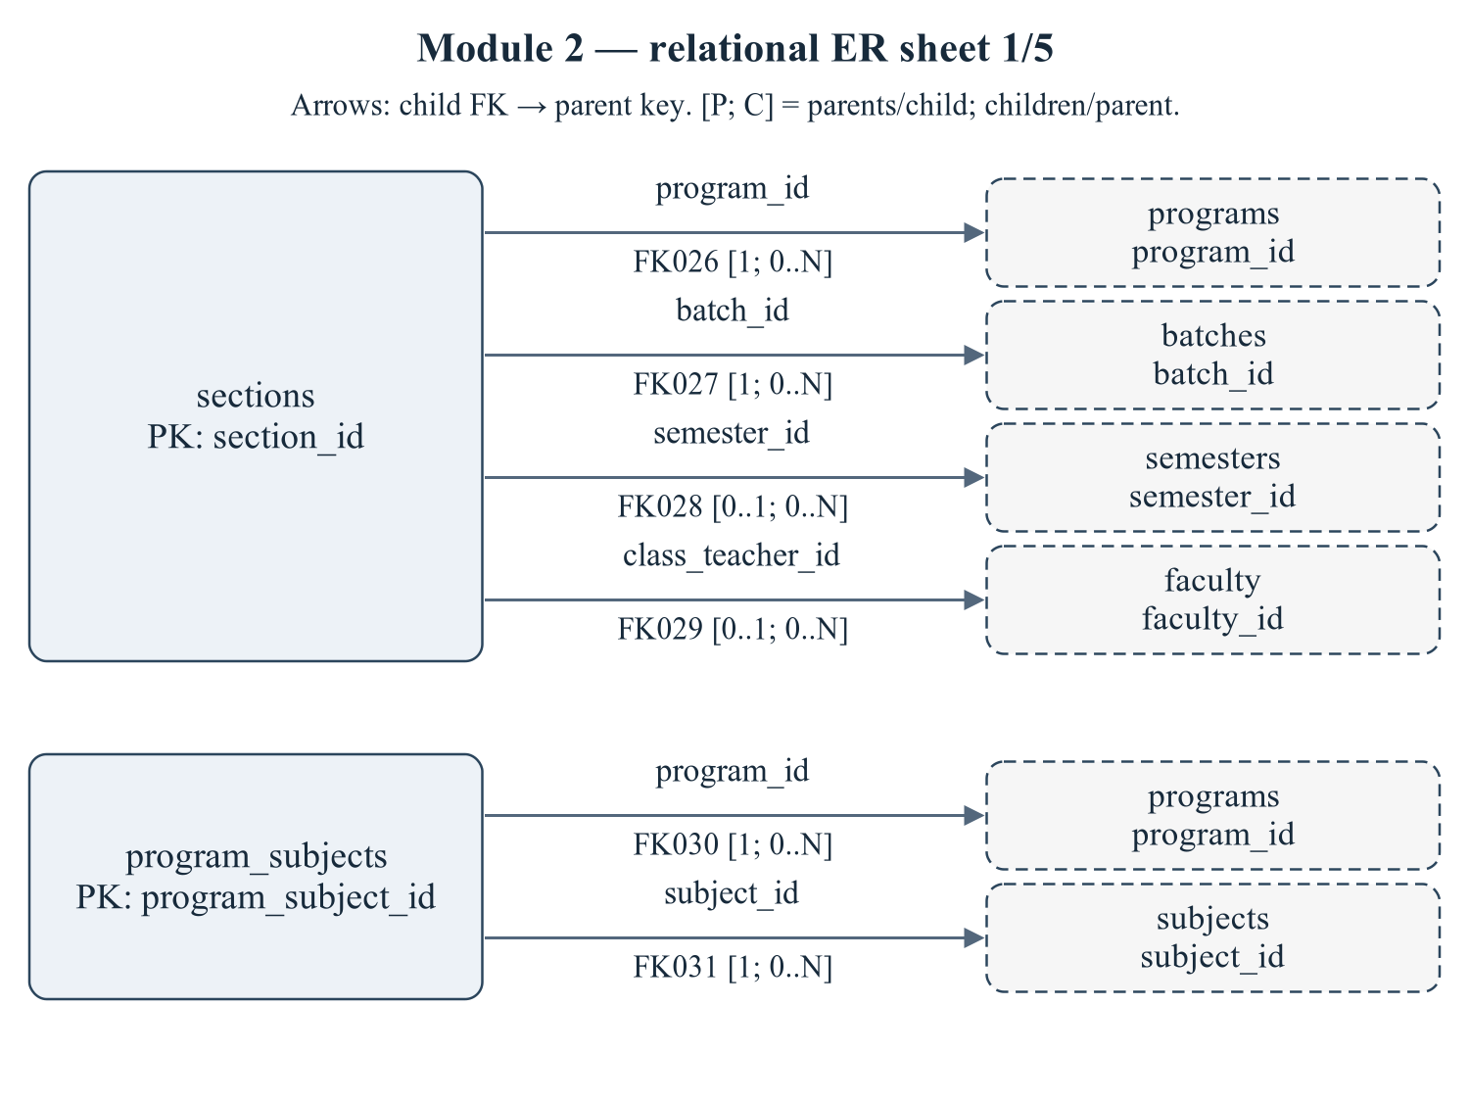
Figure 2.4 Module 2 — relational ER sheet 1/5
The child relations sections, program_subjects refer to actual target keys. Arrows are FK→parent; [P; C] gives parents per child and children per parent. IDs reconcile with the full dictionary and workbook. Dashed parent repetition does not transfer ownership.
Editable drawing source: diagrams/03_er_panel_02_part_01.svg, .dot and .mmd. Edit SVG text/shapes in a vector editor, or regenerate from DOT/Mermaid; retain FK IDs and source names. These figures were created from static source, not captured from a running ERP.
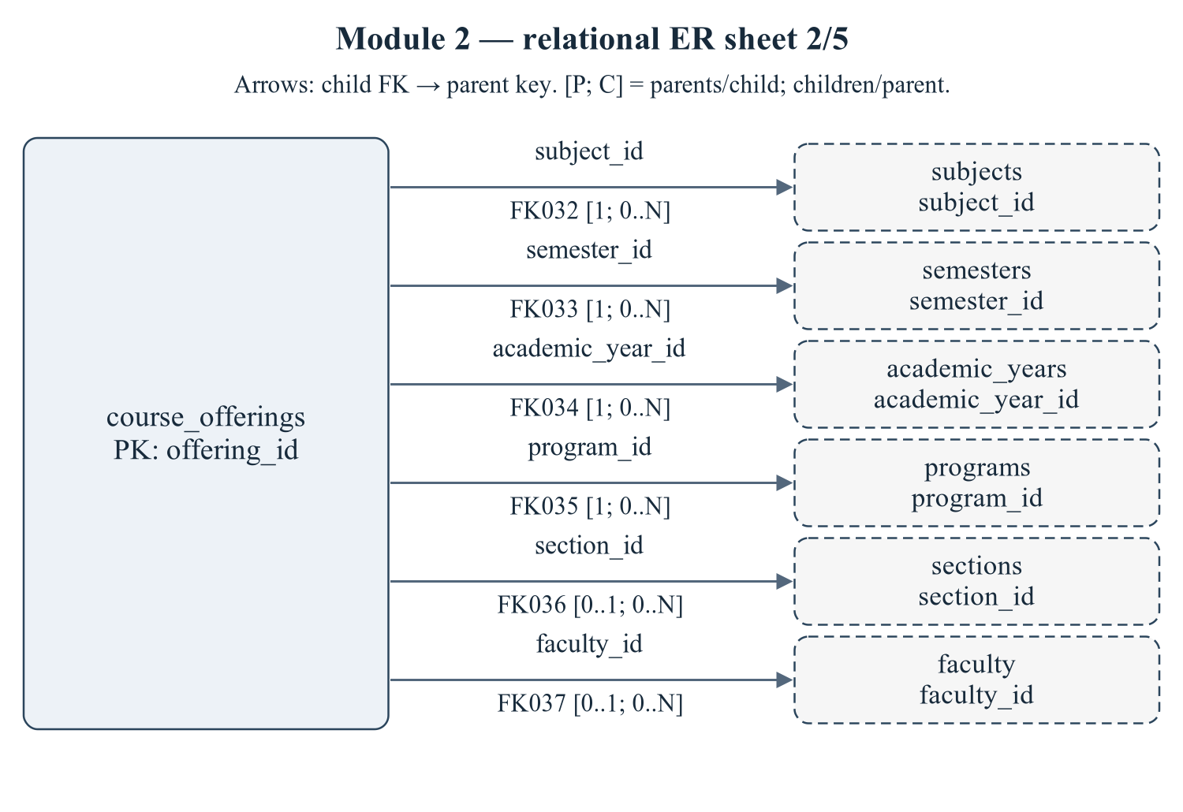
Figure 2.5 Module 2 — relational ER sheet 2/5
The child relations course_offerings refer to actual target keys. Arrows are FK→parent; [P; C] gives parents per child and children per parent. IDs reconcile with the full dictionary and workbook. Dashed parent repetition does not transfer ownership.
Editable drawing source: diagrams/03_er_panel_02_part_02.svg, .dot and .mmd. Edit SVG text/shapes in a vector editor, or regenerate from DOT/Mermaid; retain FK IDs and source names. These figures were created from static source, not captured from a running ERP.
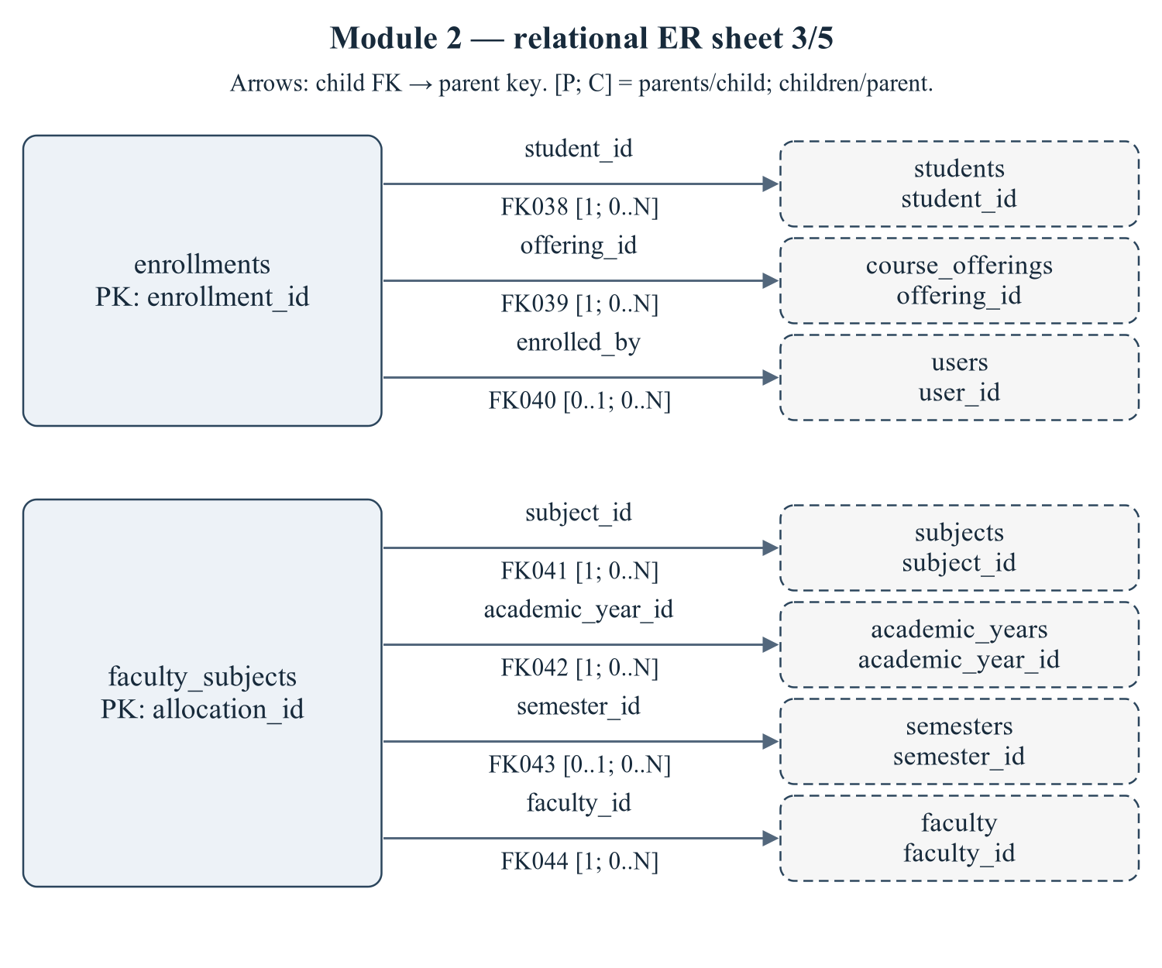
Figure 2.6 Module 2 — relational ER sheet 3/5
The child relations enrollments, faculty_subjects refer to actual target keys. Arrows are FK→parent; [P; C] gives parents per child and children per parent. IDs reconcile with the full dictionary and workbook. Dashed parent repetition does not transfer ownership.
Editable drawing source: diagrams/03_er_panel_02_part_03.svg, .dot and .mmd. Edit SVG text/shapes in a vector editor, or regenerate from DOT/Mermaid; retain FK IDs and source names. These figures were created from static source, not captured from a running ERP.
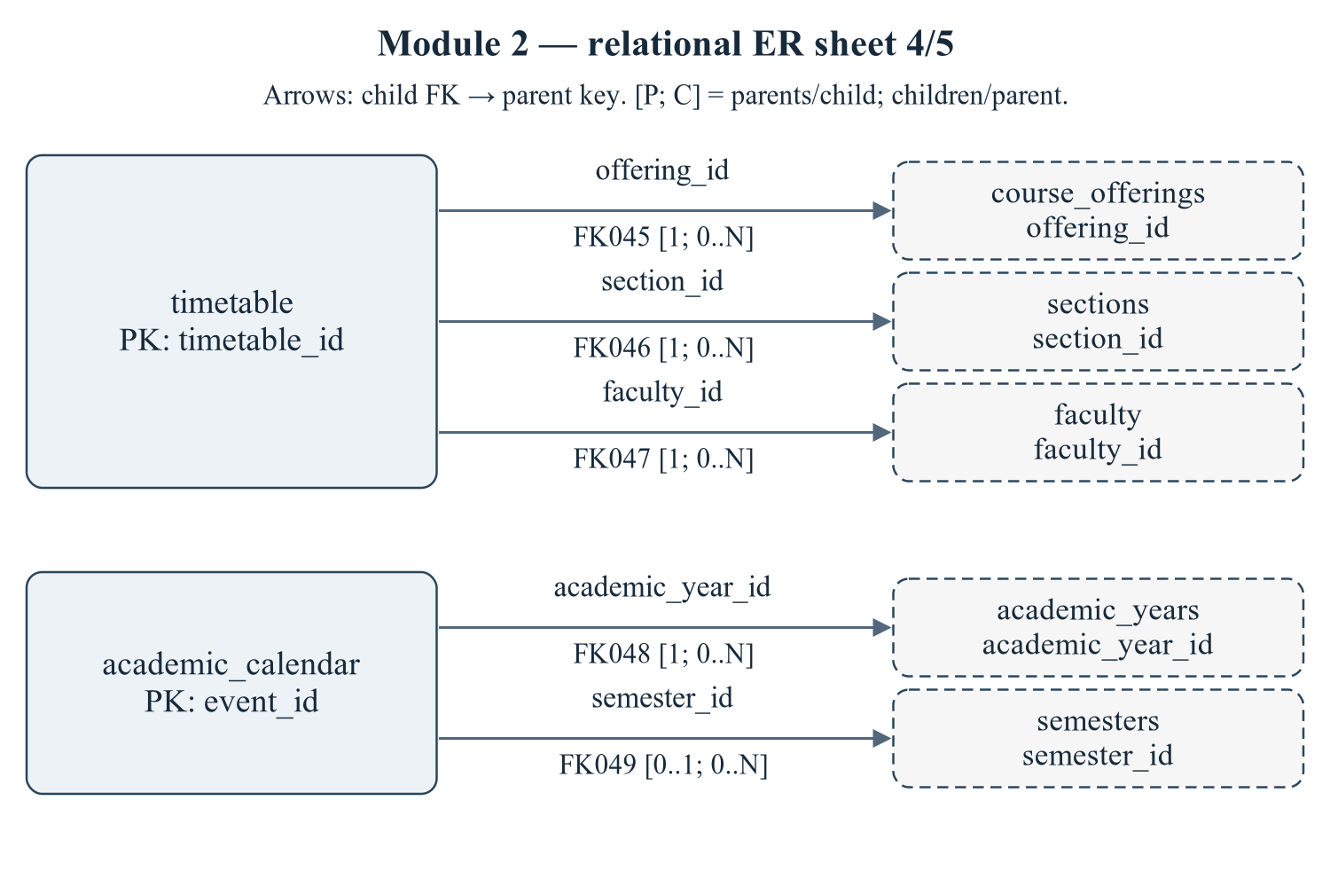
Figure 2.7 Module 2 — relational ER sheet 4/5
The child relations timetable, academic_calendar refer to actual target keys. Arrows are FK→parent; [P; C] gives parents per child and children per parent. IDs reconcile with the full dictionary and workbook. Dashed parent repetition does not transfer ownership.
Editable drawing source: diagrams/03_er_panel_02_part_04.svg, .dot and .mmd. Edit SVG text/shapes in a vector editor, or regenerate from DOT/Mermaid; retain FK IDs and source names. These figures were created from static source, not captured from a running ERP.
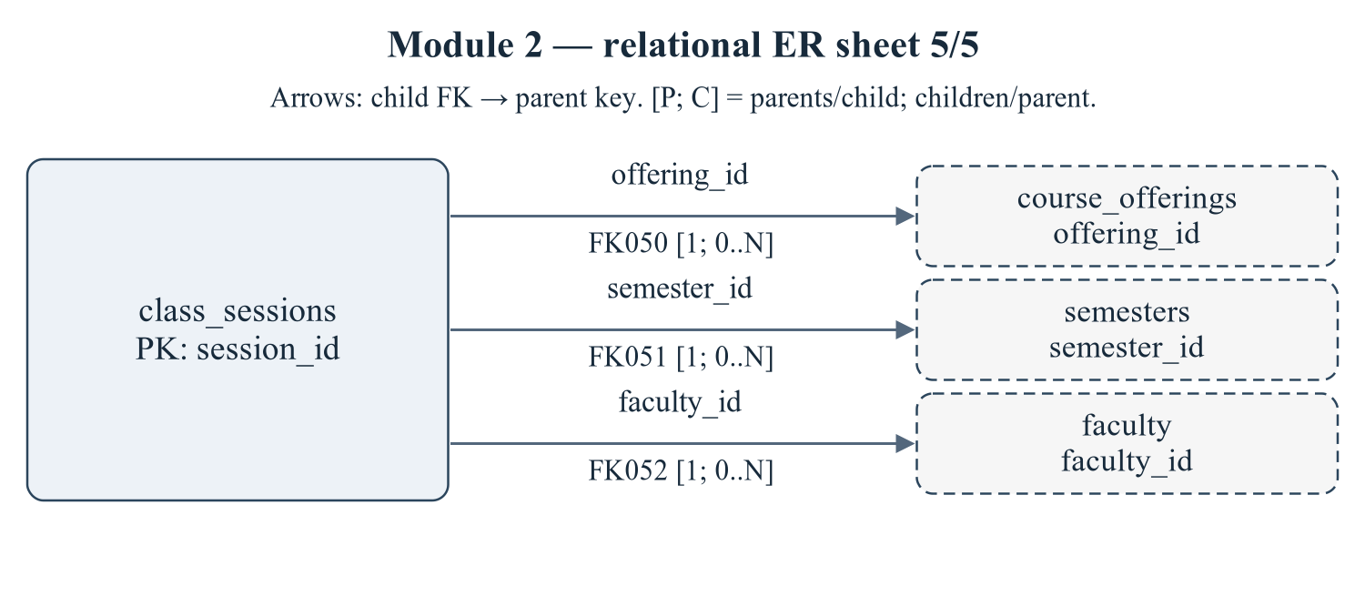
Figure 2.8 Module 2 — relational ER sheet 5/5
The child relations class_sessions refer to actual target keys. Arrows are FK→parent; [P; C] gives parents per child and children per parent. IDs reconcile with the full dictionary and workbook. Dashed parent repetition does not transfer ownership.
Editable drawing source: diagrams/03_er_panel_02_part_05.svg, .dot and .mmd. Edit SVG text/shapes in a vector editor, or regenerate from DOT/Mermaid; retain FK IDs and source names. These figures were created from static source, not captured from a running ERP.
Relational notation below lists actual attributes. The full dictionary supplies types/nullability/defaults/constraints; PK/FK notation does not invent undeclared relationships.
sections( section_id, section_code, program_id, batch_id, semester_id, capacity, room_number, class_teacher_id, status). PK={section_id}; FK IDs={FK026,FK027,FK028,FK029}.
program_subjects( program_subject_id, program_id, subject_id, semester_no, is_elective). PK={program_subject_id}; FK IDs={FK030,FK031}.
course_offerings( offering_id, subject_id, semester_id, academic_year_id, program_id, section_id, faculty_id, capacity, enrolled_count, offering_type, status, created_at). PK={offering_id}; FK IDs={FK032,FK033,FK034,FK035,FK036,FK037}.
enrollments( enrollment_id, student_id, offering_id, enrolled_on, enrolled_by, grade, grade_points, status, created_at, updated_at). PK={enrollment_id}; FK IDs={FK038,FK039,FK040}.
faculty_subjects( allocation_id, faculty_id, subject_id, academic_year_id, semester_id, is_primary, assigned_on). PK={allocation_id}; FK IDs={FK041,FK042,FK043,FK044}.
timetable( timetable_id, offering_id, section_id, faculty_id, day_of_week, start_time, end_time, room_number, slot_label, is_active). PK={timetable_id}; FK IDs={FK045,FK046,FK047}.
academic_calendar( event_id, academic_year_id, semester_id, title, description, event_type, event_date, end_date, is_holiday, created_at). PK={event_id}; FK IDs={FK048,FK049}.
class_sessions( session_id, offering_id, faculty_id, semester_id, session_date, session_no, topic, room_number, start_time, end_time, status, created_at). PK={session_id}; FK IDs={FK050,FK051,FK052}.
Table 2.2 Shared / cross-module key contracts (not duplicated ownership)
Parent table / key | Module relationship | Declared action / FK ID
academic_years, PK academic_year_id | course_offerings.academic_year_id → academic_year_id; faculty_subjects.academic_year_id → academic_year_id; academic_calendar.academic_year_id → academic_year_id | FK034: ON DELETE CASCADE; FK042: ON DELETE CASCADE; FK048: ON DELETE CASCADE
batches, PK batch_id | sections.batch_id → batch_id | FK027: ON DELETE CASCADE
faculty, PK faculty_id | sections.class_teacher_id → faculty_id; course_offerings.faculty_id → faculty_id; faculty_subjects.faculty_id → faculty_id; timetable.faculty_id → faculty_id; class_sessions.faculty_id → faculty_id | FK029: ON DELETE SET NULL; FK037: ON DELETE SET NULL; FK044: ON DELETE CASCADE; FK047: ON DELETE CASCADE; FK052: ON DELETE CASCADE
programs, PK program_id | sections.program_id → program_id; program_subjects.program_id → program_id; course_offerings.program_id → program_id | FK026: ON DELETE CASCADE; FK030: ON DELETE CASCADE; FK035: ON DELETE CASCADE
semesters, PK semester_id | sections.semester_id → semester_id; course_offerings.semester_id → semester_id; faculty_subjects.semester_id → semester_id; academic_calendar.semester_id → semester_id; class_sessions.semester_id → semester_id | FK028: ON DELETE SET NULL; FK033: ON DELETE CASCADE; FK043: ON DELETE SET NULL; FK049: ON DELETE SET NULL; FK051: ON DELETE CASCADE
students, PK student_id | enrollments.student_id → student_id | FK038: ON DELETE CASCADE
subjects, PK subject_id | program_subjects.subject_id → subject_id; course_offerings.subject_id → subject_id; faculty_subjects.subject_id → subject_id | FK031: ON DELETE CASCADE; FK032: ON DELETE CASCADE; FK041: ON DELETE CASCADE
users, PK user_id | enrollments.enrolled_by → user_id | FK040: ON DELETE SET NULL

The table dictionaries in this module cover its persisted schema in full. External parents above retain their original ownership; their complete 677-column enterprise dictionary is supplied in the master report and inventory workbook. Shared contracts are repeated here so this module can be read independently without pretending to own another module's tables.
sections — G2: class sections inside a batch.
Definition: database/02_tables.sql:236–256. Owner: Academic and Course Management.
Table 2.3 sections — full column dictionary
Column and exact SQL type | Null / default / generation | Keys and purpose
section_id  SMALLINT UNSIGNED | NOT NULL  DEFAULT: No explicit DEFAULT  AUTO_INCREMENT | PK  Primary row identifier.
section_code  VARCHAR(10) | NOT NULL  DEFAULT: No explicit DEFAULT | UQ uq_sections_batch_code (batch_id,section_code)  A, B, C
program_id  SMALLINT UNSIGNED | NOT NULL  DEFAULT: No explicit DEFAULT | FK026 → programs.program_id  References programs.program_id.
batch_id  SMALLINT UNSIGNED | NOT NULL  DEFAULT: No explicit DEFAULT | UQ uq_sections_batch_code (batch_id,section_code); FK027 → batches.batch_id  References batches.batch_id.
semester_id  SMALLINT UNSIGNED | NULL permitted  DEFAULT: No explicit DEFAULT | FK028 → semesters.semester_id  References semesters.semester_id.
capacity  SMALLINT UNSIGNED | NOT NULL  DEFAULT: 60 | Capacity value.
room_number  VARCHAR(20) | NULL permitted  DEFAULT: No explicit DEFAULT | Room number value.
class_teacher_id  INT UNSIGNED | NULL permitted  DEFAULT: No explicit DEFAULT | FK029 → faculty.faculty_id  FK -> faculty(faculty_id), added in 03
status  ENUM('ACTIVE','INACTIVE') | NOT NULL  DEFAULT: 'ACTIVE' | Lifecycle state; exact permitted values are in the declared ENUM.

PRIMARY KEY: section_id
UNIQUE constraints: UNIQUE KEY `uq_sections_batch_code` (`batch_id`, `section_code`)
CHECK constraints: CONSTRAINT `chk_sections_capacity` CHECK (`capacity` BETWEEN 1 AND 300)
Secondary indexes: KEY `idx_sections_program` (`program_id`)
FK026 fk_sections_program: CONSTRAINT `fk_sections_program` FOREIGN KEY (`program_id`)
REFERENCES `programs` (`program_id`) ON DELETE CASCADE. Parent/child multiplicities 1 / 0..N. Omitted referential actions use restrictive defaults, not an invented cascade.
FK027 fk_sections_batch: CONSTRAINT `fk_sections_batch` FOREIGN KEY (`batch_id`)
REFERENCES `batches` (`batch_id`) ON DELETE CASCADE. Parent/child multiplicities 1 / 0..N. Omitted referential actions use restrictive defaults, not an invented cascade.
FK028 fk_sections_semester: CONSTRAINT `fk_sections_semester` FOREIGN KEY (`semester_id`)
REFERENCES `semesters` (`semester_id`) ON DELETE SET NULL. Parent/child multiplicities 0..1 / 0..N. Omitted referential actions use restrictive defaults, not an invented cascade.
FK029 fk_sections_class_teacher: CONSTRAINT `fk_sections_class_teacher`
FOREIGN KEY (`class_teacher_id`) REFERENCES `faculty` (`faculty_id`) ON DELETE SET NULL. Parent/child multiplicities 0..1 / 0..N. Omitted referential actions use restrictive defaults, not an invented cascade.
Normalization / dependency note: batch_id -> program_id repeats domain hierarchy inside sections; retain only if an explicitly maintained snapshot/validation contract is approved.
program_subjects — G2: curriculum mapping program -> subject per semester.
Definition: database/02_tables.sql:261–275. Owner: Academic and Course Management.
Table 2.4 program_subjects — full column dictionary
Column and exact SQL type | Null / default / generation | Keys and purpose
program_subject_id  SMALLINT UNSIGNED | NOT NULL  DEFAULT: No explicit DEFAULT  AUTO_INCREMENT | PK  Primary row identifier.
program_id  SMALLINT UNSIGNED | NOT NULL  DEFAULT: No explicit DEFAULT | UQ uq_program_subjects (program_id,subject_id,semester_no); FK030 → programs.program_id  References programs.program_id.
subject_id  SMALLINT UNSIGNED | NOT NULL  DEFAULT: No explicit DEFAULT | UQ uq_program_subjects (program_id,subject_id,semester_no); FK031 → subjects.subject_id  References subjects.subject_id.
semester_no  TINYINT UNSIGNED | NOT NULL  DEFAULT: No explicit DEFAULT | UQ uq_program_subjects (program_id,subject_id,semester_no)  Semester no value.
is_elective  TINYINT(1) | NOT NULL  DEFAULT: 0 | Elective flag.

PRIMARY KEY: program_subject_id
UNIQUE constraints: UNIQUE KEY `uq_program_subjects` (`program_id`, `subject_id`, `semester_no`)
CHECK constraints: CONSTRAINT `chk_ps_semester` CHECK (`semester_no` BETWEEN 1 AND 12)
Secondary indexes: KEY `idx_program_subjects_sem` (`program_id`, `semester_no`)
FK030 fk_ps_program: CONSTRAINT `fk_ps_program` FOREIGN KEY (`program_id`)
REFERENCES `programs` (`program_id`) ON DELETE CASCADE. Parent/child multiplicities 1 / 0..N. Omitted referential actions use restrictive defaults, not an invented cascade.
FK031 fk_ps_subject: CONSTRAINT `fk_ps_subject` FOREIGN KEY (`subject_id`)
REFERENCES `subjects` (`subject_id`) ON DELETE CASCADE. Parent/child multiplicities 1 / 0..N. Omitted referential actions use restrictive defaults, not an invented cascade.
Normalization / dependency note: PK determines the remaining stored attributes. Non-null declared UNIQUE tuples are additional candidate-key evidence. No further non-key determinant was established from DDL alone; 3NF is conditional on the stated business FDs being complete, not certified solely by having a surrogate key.
course_offerings — A subject made available for a semester/program/optional section with assigned faculty and seat counter.
Definition: database/02_tables.sql:280–310. Owner: Academic and Course Management.
Table 2.5 course_offerings — full column dictionary
Column and exact SQL type | Null / default / generation | Keys and purpose
offering_id  INT UNSIGNED | NOT NULL  DEFAULT: No explicit DEFAULT  AUTO_INCREMENT | PK  Primary row identifier.
subject_id  SMALLINT UNSIGNED | NOT NULL  DEFAULT: No explicit DEFAULT | UQ uq_offerings (subject_id,semester_id,program_id,section_id); FK032 → subjects.subject_id  References subjects.subject_id.
semester_id  SMALLINT UNSIGNED | NOT NULL  DEFAULT: No explicit DEFAULT | UQ uq_offerings (subject_id,semester_id,program_id,section_id); FK033 → semesters.semester_id  References semesters.semester_id.
academic_year_id  SMALLINT UNSIGNED | NOT NULL  DEFAULT: No explicit DEFAULT | FK034 → academic_years.academic_year_id  References academic_years.academic_year_id.
program_id  SMALLINT UNSIGNED | NOT NULL  DEFAULT: No explicit DEFAULT | UQ uq_offerings (subject_id,semester_id,program_id,section_id); FK035 → programs.program_id  References programs.program_id.
section_id  SMALLINT UNSIGNED | NULL permitted  DEFAULT: No explicit DEFAULT | UQ uq_offerings (subject_id,semester_id,program_id,section_id); FK036 → sections.section_id  References sections.section_id.
faculty_id  INT UNSIGNED | NULL permitted  DEFAULT: No explicit DEFAULT | FK037 → faculty.faculty_id  FK -> faculty.faculty_id (added in 03)
capacity  SMALLINT UNSIGNED | NOT NULL  DEFAULT: 60 | Capacity value.
enrolled_count  SMALLINT UNSIGNED | NOT NULL  DEFAULT: 0 | Enrolled count value.
offering_type  ENUM('REGULAR','ELECTIVE','BACKLOG','AUDIT') | NOT NULL  DEFAULT: 'REGULAR' | Offering type value.
status  ENUM('OPEN','CLOSED','CANCELLED','COMPLETED') | NOT NULL  DEFAULT: 'OPEN' | Lifecycle state; exact permitted values are in the declared ENUM.
created_at  TIMESTAMP | NOT NULL  DEFAULT: CURRENT_TIMESTAMP | Row creation timestamp.

PRIMARY KEY: offering_id
UNIQUE constraints: UNIQUE KEY `uq_offerings` (`subject_id`, `semester_id`, `program_id`, `section_id`)
CHECK constraints: CONSTRAINT `chk_offerings_capacity` CHECK (`capacity` >= 1); CONSTRAINT `chk_offerings_enrolled` CHECK (`enrolled_count` >= 0)
Secondary indexes: KEY `idx_offerings_faculty` (`faculty_id`); KEY `idx_offerings_semester` (`semester_id`); KEY `idx_offerings_program` (`program_id`); KEY `idx_offerings_year_status` (`academic_year_id`, `status`)
FK032 fk_offerings_subject: CONSTRAINT `fk_offerings_subject` FOREIGN KEY (`subject_id`)
REFERENCES `subjects` (`subject_id`) ON DELETE CASCADE. Parent/child multiplicities 1 / 0..N. Omitted referential actions use restrictive defaults, not an invented cascade.
FK033 fk_offerings_semester: CONSTRAINT `fk_offerings_semester` FOREIGN KEY (`semester_id`)
REFERENCES `semesters` (`semester_id`) ON DELETE CASCADE. Parent/child multiplicities 1 / 0..N. Omitted referential actions use restrictive defaults, not an invented cascade.
FK034 fk_offerings_year: CONSTRAINT `fk_offerings_year` FOREIGN KEY (`academic_year_id`)
REFERENCES `academic_years` (`academic_year_id`) ON DELETE CASCADE. Parent/child multiplicities 1 / 0..N. Omitted referential actions use restrictive defaults, not an invented cascade.
FK035 fk_offerings_program: CONSTRAINT `fk_offerings_program` FOREIGN KEY (`program_id`)
REFERENCES `programs` (`program_id`) ON DELETE CASCADE. Parent/child multiplicities 1 / 0..N. Omitted referential actions use restrictive defaults, not an invented cascade.
FK036 fk_offerings_section: CONSTRAINT `fk_offerings_section` FOREIGN KEY (`section_id`)
REFERENCES `sections` (`section_id`) ON DELETE SET NULL. Parent/child multiplicities 0..1 / 0..N. Omitted referential actions use restrictive defaults, not an invented cascade.
FK037 fk_offerings_faculty: CONSTRAINT `fk_offerings_faculty`
FOREIGN KEY (`faculty_id`) REFERENCES `faculty` (`faculty_id`) ON DELETE SET NULL. Parent/child multiplicities 0..1 / 0..N. Omitted referential actions use restrictive defaults, not an invented cascade.
Normalization / dependency note: semester_id -> academic_year_id means the duplicated year can create an intended transitive dependency among stored columns. enrolled_count is a maintained aggregate over enrollments and must be reconciled, not called an atomic enrollment fact.
enrollments — G2: student enrolled into a course offering (no duplicate enrollment).
Definition: database/02_tables.sql:315–337. Owner: Academic and Course Management.
Table 2.6 enrollments — full column dictionary
Column and exact SQL type | Null / default / generation | Keys and purpose
enrollment_id  INT UNSIGNED | NOT NULL  DEFAULT: No explicit DEFAULT  AUTO_INCREMENT | PK  Primary row identifier.
student_id  INT UNSIGNED | NOT NULL  DEFAULT: No explicit DEFAULT | UQ uq_enrollments_student_offering (student_id,offering_id); FK038 → students.student_id  References students.student_id.
offering_id  INT UNSIGNED | NOT NULL  DEFAULT: No explicit DEFAULT | UQ uq_enrollments_student_offering (student_id,offering_id); FK039 → course_offerings.offering_id  References course_offerings.offering_id.
enrolled_on  DATE | NOT NULL  DEFAULT: (CURRENT_DATE) | Enrolled on date/time, as typed.
enrolled_by  INT UNSIGNED | NULL permitted  DEFAULT: No explicit DEFAULT | FK040 → users.user_id  References users.user_id.
grade  VARCHAR(4) | NULL permitted  DEFAULT: No explicit DEFAULT | Final grade letter for this offering
grade_points  DECIMAL(4,2) | NULL permitted  DEFAULT: No explicit DEFAULT | Stored grade points; derivation depends on the relevant grade/result logic.
status  ENUM('ENROLLED','COMPLETED','DROPPED','FAILED','PASSED') | NOT NULL  DEFAULT: 'ENROLLED' | Lifecycle state; exact permitted values are in the declared ENUM.
created_at  TIMESTAMP | NOT NULL  DEFAULT: CURRENT_TIMESTAMP | Row creation timestamp.
updated_at  TIMESTAMP; ON UPDATE CURRENT_TIMESTAMP | NOT NULL  DEFAULT: CURRENT_TIMESTAMP | Last row-update timestamp.

PRIMARY KEY: enrollment_id
UNIQUE constraints: UNIQUE KEY `uq_enrollments_student_offering` (`student_id`, `offering_id`)
CHECK constraints: CONSTRAINT `chk_enrollments_points` CHECK (`grade_points` IS NULL OR (`grade_points` BETWEEN 0 AND 10))
Secondary indexes: KEY `idx_enrollments_offering` (`offering_id`); KEY `idx_enrollments_status` (`status`); KEY `idx_enrollments_student_status` (`student_id`, `status`)
FK038 fk_enrollments_student: CONSTRAINT `fk_enrollments_student` FOREIGN KEY (`student_id`)
REFERENCES `students` (`student_id`) ON DELETE CASCADE. Parent/child multiplicities 1 / 0..N. Omitted referential actions use restrictive defaults, not an invented cascade.
FK039 fk_enrollments_offering: CONSTRAINT `fk_enrollments_offering` FOREIGN KEY (`offering_id`)
REFERENCES `course_offerings` (`offering_id`) ON DELETE CASCADE. Parent/child multiplicities 1 / 0..N. Omitted referential actions use restrictive defaults, not an invented cascade.
FK040 fk_enrollments_user: CONSTRAINT `fk_enrollments_user` FOREIGN KEY (`enrolled_by`)
REFERENCES `users` (`user_id`) ON DELETE SET NULL. Parent/child multiplicities 0..1 / 0..N. Omitted referential actions use restrictive defaults, not an invented cascade.
Normalization / dependency note: PK determines the remaining stored attributes. Non-null declared UNIQUE tuples are additional candidate-key evidence. No further non-key determinant was established from DDL alone; 3NF is conditional on the stated business FDs being complete, not certified solely by having a surrogate key.
faculty_subjects — G2: which faculty teaches which subject in which year.
Definition: database/02_tables.sql:342–359. Owner: Academic and Course Management.
Table 2.7 faculty_subjects — full column dictionary
Column and exact SQL type | Null / default / generation | Keys and purpose
allocation_id  INT UNSIGNED | NOT NULL  DEFAULT: No explicit DEFAULT  AUTO_INCREMENT | PK  Primary row identifier.
faculty_id  INT UNSIGNED | NOT NULL  DEFAULT: No explicit DEFAULT | UQ uq_faculty_subjects (faculty_id,subject_id,academic_year_id,semester_id); FK044 → faculty.faculty_id  FK -> faculty.faculty_id (added in 03)
subject_id  SMALLINT UNSIGNED | NOT NULL  DEFAULT: No explicit DEFAULT | UQ uq_faculty_subjects (faculty_id,subject_id,academic_year_id,semester_id); FK041 → subjects.subject_id  References subjects.subject_id.
academic_year_id  SMALLINT UNSIGNED | NOT NULL  DEFAULT: No explicit DEFAULT | UQ uq_faculty_subjects (faculty_id,subject_id,academic_year_id,semester_id); FK042 → academic_years.academic_year_id  References academic_years.academic_year_id.
semester_id  SMALLINT UNSIGNED | NULL permitted  DEFAULT: No explicit DEFAULT | UQ uq_faculty_subjects (faculty_id,subject_id,academic_year_id,semester_id); FK043 → semesters.semester_id  References semesters.semester_id.
is_primary  TINYINT(1) | NOT NULL  DEFAULT: 1 | Primary-record/assignment flag.
assigned_on  DATE | NOT NULL  DEFAULT: (CURRENT_DATE) | Assigned on date/time, as typed.

PRIMARY KEY: allocation_id
UNIQUE constraints: UNIQUE KEY `uq_faculty_subjects` (`faculty_id`, `subject_id`, `academic_year_id`, `semester_id`)
CHECK constraints: None declared.
Secondary indexes: KEY `idx_fs_subject` (`subject_id`)
FK041 fk_fs_subject: CONSTRAINT `fk_fs_subject` FOREIGN KEY (`subject_id`)
REFERENCES `subjects` (`subject_id`) ON DELETE CASCADE. Parent/child multiplicities 1 / 0..N. Omitted referential actions use restrictive defaults, not an invented cascade.
FK042 fk_fs_year: CONSTRAINT `fk_fs_year` FOREIGN KEY (`academic_year_id`)
REFERENCES `academic_years` (`academic_year_id`) ON DELETE CASCADE. Parent/child multiplicities 1 / 0..N. Omitted referential actions use restrictive defaults, not an invented cascade.
FK043 fk_fs_semester: CONSTRAINT `fk_fs_semester` FOREIGN KEY (`semester_id`)
REFERENCES `semesters` (`semester_id`) ON DELETE SET NULL. Parent/child multiplicities 0..1 / 0..N. Omitted referential actions use restrictive defaults, not an invented cascade.
FK044 fk_fs_faculty: CONSTRAINT `fk_fs_faculty`
FOREIGN KEY (`faculty_id`) REFERENCES `faculty` (`faculty_id`) ON DELETE CASCADE. Parent/child multiplicities 1 / 0..N. Omitted referential actions use restrictive defaults, not an invented cascade.
Normalization / dependency note: PK determines the remaining stored attributes. Non-null declared UNIQUE tuples are additional candidate-key evidence. No further non-key determinant was established from DDL alone; 3NF is conditional on the stated business FDs being complete, not certified solely by having a surrogate key.
timetable — G2: weekly timetable. Conflicts blocked by UNIQUE keys + trigger.
Definition: database/02_tables.sql:364–385. Owner: Academic and Course Management.
Table 2.8 timetable — full column dictionary
Column and exact SQL type | Null / default / generation | Keys and purpose
timetable_id  SMALLINT UNSIGNED | NOT NULL  DEFAULT: No explicit DEFAULT  AUTO_INCREMENT | PK  Primary row identifier.
offering_id  INT UNSIGNED | NOT NULL  DEFAULT: No explicit DEFAULT | FK045 → course_offerings.offering_id  References course_offerings.offering_id.
section_id  SMALLINT UNSIGNED | NOT NULL  DEFAULT: No explicit DEFAULT | UQ uq_timetable_section_slot (section_id,day_of_week,start_time); FK046 → sections.section_id  References sections.section_id.
faculty_id  INT UNSIGNED | NOT NULL  DEFAULT: No explicit DEFAULT | UQ uq_timetable_faculty_slot (faculty_id,day_of_week,start_time); FK047 → faculty.faculty_id  FK -> faculty.faculty_id (added in 03)
day_of_week  ENUM('MONDAY','TUESDAY','WEDNESDAY','THURSDAY','FRIDAY','SATURDAY','SUNDAY') | NOT NULL  DEFAULT: No explicit DEFAULT | UQ uq_timetable_section_slot (section_id,day_of_week,start_time); UQ uq_timetable_faculty_slot (faculty_id,day_of_week,start_time); UQ uq_timetable_room_slot (room_number,day_of_week,start_time)  Day of week value.
start_time  TIME | NOT NULL  DEFAULT: No explicit DEFAULT | UQ uq_timetable_section_slot (section_id,day_of_week,start_time); UQ uq_timetable_faculty_slot (faculty_id,day_of_week,start_time); UQ uq_timetable_room_slot (room_number,day_of_week,start_time)  Start time value.
end_time  TIME | NOT NULL  DEFAULT: No explicit DEFAULT | End time value.
room_number  VARCHAR(20) | NOT NULL  DEFAULT: No explicit DEFAULT | UQ uq_timetable_room_slot (room_number,day_of_week,start_time)  Room number value.
slot_label  VARCHAR(20) | NULL permitted  DEFAULT: No explicit DEFAULT | e.g. 09:00-10:00
is_active  TINYINT(1) | NOT NULL  DEFAULT: 1 | Enabled/active flag.

PRIMARY KEY: timetable_id
UNIQUE constraints: UNIQUE KEY `uq_timetable_section_slot` (`section_id`, `day_of_week`, `start_time`); UNIQUE KEY `uq_timetable_faculty_slot` (`faculty_id`, `day_of_week`, `start_time`); UNIQUE KEY `uq_timetable_room_slot` (`room_number`, `day_of_week`, `start_time`)
CHECK constraints: CONSTRAINT `chk_timetable_time` CHECK (`end_time` > `start_time`)
Secondary indexes: KEY `idx_timetable_offering` (`offering_id`)
FK045 fk_timetable_offering: CONSTRAINT `fk_timetable_offering` FOREIGN KEY (`offering_id`)
REFERENCES `course_offerings` (`offering_id`) ON DELETE CASCADE. Parent/child multiplicities 1 / 0..N. Omitted referential actions use restrictive defaults, not an invented cascade.
FK046 fk_timetable_section: CONSTRAINT `fk_timetable_section` FOREIGN KEY (`section_id`)
REFERENCES `sections` (`section_id`) ON DELETE CASCADE. Parent/child multiplicities 1 / 0..N. Omitted referential actions use restrictive defaults, not an invented cascade.
FK047 fk_timetable_faculty: CONSTRAINT `fk_timetable_faculty`
FOREIGN KEY (`faculty_id`) REFERENCES `faculty` (`faculty_id`) ON DELETE CASCADE. Parent/child multiplicities 1 / 0..N. Omitted referential actions use restrictive defaults, not an invented cascade.
Normalization / dependency note: PK determines the remaining stored attributes. Non-null declared UNIQUE tuples are additional candidate-key evidence. No further non-key determinant was established from DDL alone; 3NF is conditional on the stated business FDs being complete, not certified solely by having a surrogate key.
academic_calendar — G2: academic calendar shared with exams, finance and students.
Definition: database/02_tables.sql:390–409. Owner: Academic and Course Management.
Table 2.9 academic_calendar — full column dictionary
Column and exact SQL type | Null / default / generation | Keys and purpose
event_id  INT UNSIGNED | NOT NULL  DEFAULT: No explicit DEFAULT  AUTO_INCREMENT | PK  Primary row identifier.
academic_year_id  SMALLINT UNSIGNED | NOT NULL  DEFAULT: No explicit DEFAULT | FK048 → academic_years.academic_year_id  References academic_years.academic_year_id.
semester_id  SMALLINT UNSIGNED | NULL permitted  DEFAULT: No explicit DEFAULT | FK049 → semesters.semester_id  References semesters.semester_id.
title  VARCHAR(150) | NOT NULL  DEFAULT: No explicit DEFAULT | Title value.
description  VARCHAR(500) | NULL permitted  DEFAULT: No explicit DEFAULT | Descriptive text.
event_type  ENUM('EXAM','HOLIDAY','FEST','WORKSHOP','SEMINAR','RESULT','FEE_DUE','OTHER') | NOT NULL  DEFAULT: 'OTHER' | Event type value.
event_date  DATE | NOT NULL  DEFAULT: No explicit DEFAULT | Event date date/time, as typed.
end_date  DATE | NULL permitted  DEFAULT: No explicit DEFAULT | End date date/time, as typed.
is_holiday  TINYINT(1) | NOT NULL  DEFAULT: 0 | Holiday flag.
created_at  TIMESTAMP | NOT NULL  DEFAULT: CURRENT_TIMESTAMP | Row creation timestamp.

PRIMARY KEY: event_id
UNIQUE constraints: None declared.
CHECK constraints: CONSTRAINT `chk_calendar_dates` CHECK (`end_date` IS NULL OR `end_date` >= `event_date`)
Secondary indexes: KEY `idx_calendar_year` (`academic_year_id`); KEY `idx_calendar_date` (`event_date`)
FK048 fk_calendar_year: CONSTRAINT `fk_calendar_year` FOREIGN KEY (`academic_year_id`)
REFERENCES `academic_years` (`academic_year_id`) ON DELETE CASCADE. Parent/child multiplicities 1 / 0..N. Omitted referential actions use restrictive defaults, not an invented cascade.
FK049 fk_calendar_semester: CONSTRAINT `fk_calendar_semester` FOREIGN KEY (`semester_id`)
REFERENCES `semesters` (`semester_id`) ON DELETE SET NULL. Parent/child multiplicities 0..1 / 0..N. Omitted referential actions use restrictive defaults, not an invented cascade.
Normalization / dependency note: PK determines the remaining stored attributes. Non-null declared UNIQUE tuples are additional candidate-key evidence. No further non-key determinant was established from DDL alone; 3NF is conditional on the stated business FDs being complete, not certified solely by having a surrogate key.
class_sessions — G2/G3: a single lecture. Attendance rows hang off this.
Definition: database/02_tables.sql:414–435. Owner: Academic and Course Management.
Table 2.10 class_sessions — full column dictionary
Column and exact SQL type | Null / default / generation | Keys and purpose
session_id  INT UNSIGNED | NOT NULL  DEFAULT: No explicit DEFAULT  AUTO_INCREMENT | PK  Primary row identifier.
offering_id  INT UNSIGNED | NOT NULL  DEFAULT: No explicit DEFAULT | UQ uq_sessions_offering_date_no (offering_id,session_date,session_no); FK050 → course_offerings.offering_id  References course_offerings.offering_id.
faculty_id  INT UNSIGNED | NOT NULL  DEFAULT: No explicit DEFAULT | FK052 → faculty.faculty_id  FK -> faculty.faculty_id (added in 03)
semester_id  SMALLINT UNSIGNED | NOT NULL  DEFAULT: No explicit DEFAULT | FK051 → semesters.semester_id  References semesters.semester_id.
session_date  DATE | NOT NULL  DEFAULT: No explicit DEFAULT | UQ uq_sessions_offering_date_no (offering_id,session_date,session_no)  Session date date/time, as typed.
session_no  TINYINT UNSIGNED | NOT NULL  DEFAULT: 1 | UQ uq_sessions_offering_date_no (offering_id,session_date,session_no)  Session no value.
topic  VARCHAR(255) | NULL permitted  DEFAULT: No explicit DEFAULT | Topic value.
room_number  VARCHAR(20) | NULL permitted  DEFAULT: No explicit DEFAULT | Room number value.
start_time  TIME | NULL permitted  DEFAULT: No explicit DEFAULT | Start time value.
end_time  TIME | NULL permitted  DEFAULT: No explicit DEFAULT | End time value.
status  ENUM('SCHEDULED','COMPLETED','CANCELLED') | NOT NULL  DEFAULT: 'COMPLETED' | Lifecycle state; exact permitted values are in the declared ENUM.
created_at  TIMESTAMP | NOT NULL  DEFAULT: CURRENT_TIMESTAMP | Row creation timestamp.

PRIMARY KEY: session_id
UNIQUE constraints: UNIQUE KEY `uq_sessions_offering_date_no` (`offering_id`, `session_date`, `session_no`)
CHECK constraints: None declared.
Secondary indexes: KEY `idx_sessions_faculty` (`faculty_id`, `session_date`); KEY `idx_sessions_date` (`session_date`)
FK050 fk_sessions_offering: CONSTRAINT `fk_sessions_offering` FOREIGN KEY (`offering_id`)
REFERENCES `course_offerings` (`offering_id`) ON DELETE CASCADE. Parent/child multiplicities 1 / 0..N. Omitted referential actions use restrictive defaults, not an invented cascade.
FK051 fk_sessions_semester: CONSTRAINT `fk_sessions_semester` FOREIGN KEY (`semester_id`)
REFERENCES `semesters` (`semester_id`) ON DELETE CASCADE. Parent/child multiplicities 1 / 0..N. Omitted referential actions use restrictive defaults, not an invented cascade.
FK052 fk_sessions_faculty: CONSTRAINT `fk_sessions_faculty`
FOREIGN KEY (`faculty_id`) REFERENCES `faculty` (`faculty_id`) ON DELETE CASCADE. Parent/child multiplicities 1 / 0..N. Omitted referential actions use restrictive defaults, not an invented cascade.
Normalization / dependency note: offering_id -> semester_id in the academic domain means the copied semester_id is derived context. Session identity/timing and attendance-grain keys should be separated from duplicated teaching context.

2.3.1 Shared academic masters used by this module
departments — Academic departments. One row per department - shared everywhere.
Definition: database/01_schema.sql:87–102. Owner: Shared enterprise.
Table 2.11 departments — full column dictionary
Column and exact SQL type | Null / default / generation | Keys and purpose
department_id  INT UNSIGNED | NOT NULL  DEFAULT: No explicit DEFAULT  AUTO_INCREMENT | PK  Primary row identifier.
department_code  VARCHAR(20) | NOT NULL  DEFAULT: No explicit DEFAULT | UQ uq_departments_code (department_code)  e.g. CE, ETC, IT
name  VARCHAR(120) | NOT NULL  DEFAULT: No explicit DEFAULT | UQ uq_departments_name (name)  Stored display/name attribute.
short_name  VARCHAR(40) | NULL permitted  DEFAULT: No explicit DEFAULT | Short name value.
hod_faculty_id  INT UNSIGNED | NULL permitted  DEFAULT: No explicit DEFAULT | FK002 → faculty.faculty_id  FK -> faculty(faculty_id), added in 03_constraints.sql
email  VARCHAR(150) | NULL permitted  DEFAULT: No explicit DEFAULT | Stored email address; privacy-sensitive data.
phone  VARCHAR(20) | NULL permitted  DEFAULT: No explicit DEFAULT | Stored contact phone.
established_year  SMALLINT UNSIGNED | NULL permitted  DEFAULT: No explicit DEFAULT | Established year value.
status  ENUM('ACTIVE','INACTIVE') | NOT NULL  DEFAULT: 'ACTIVE' | Lifecycle state; exact permitted values are in the declared ENUM.
created_at  TIMESTAMP | NOT NULL  DEFAULT: CURRENT_TIMESTAMP | Row creation timestamp.
updated_at  TIMESTAMP; ON UPDATE CURRENT_TIMESTAMP | NOT NULL  DEFAULT: CURRENT_TIMESTAMP | Last row-update timestamp.

PRIMARY KEY: department_id
UNIQUE constraints: UNIQUE KEY `uq_departments_code` (`department_code`); UNIQUE KEY `uq_departments_name` (`name`)
CHECK constraints: None declared.
Secondary indexes: None explicitly declared beyond PK/UNIQUE/FK support.
FK002 fk_departments_hod: CONSTRAINT `fk_departments_hod`
FOREIGN KEY (`hod_faculty_id`) REFERENCES `faculty` (`faculty_id`) ON DELETE SET NULL. Parent/child multiplicities 0..1 / 0..N. Omitted referential actions use restrictive defaults, not an invented cascade.
Normalization / dependency note: PK determines the remaining stored attributes. Non-null declared UNIQUE tuples are additional candidate-key evidence. No further non-key determinant was established from DDL alone; 3NF is conditional on the stated business FDs being complete, not certified solely by having a surrogate key.
programs — Degree / diploma programs offered by the university.
Definition: database/01_schema.sql:155–175. Owner: Shared enterprise.
Table 2.12 programs — full column dictionary
Column and exact SQL type | Null / default / generation | Keys and purpose
program_id  SMALLINT UNSIGNED | NOT NULL  DEFAULT: No explicit DEFAULT  AUTO_INCREMENT | PK  Primary row identifier.
program_code  VARCHAR(20) | NOT NULL  DEFAULT: No explicit DEFAULT | UQ uq_programs_code (program_code)  e.g. BTECH-ETC
name  VARCHAR(150) | NOT NULL  DEFAULT: No explicit DEFAULT | Stored display/name attribute.
short_name  VARCHAR(40) | NULL permitted  DEFAULT: No explicit DEFAULT | Short name value.
level  ENUM('DIPLOMA','UG','PG','PHD') | NOT NULL  DEFAULT: 'UG' | Level value.
department_id  INT UNSIGNED | NOT NULL  DEFAULT: No explicit DEFAULT | FK004 → departments.department_id  References departments.department_id.
duration_years  TINYINT UNSIGNED | NOT NULL  DEFAULT: 4 | Duration years value.
total_semesters  TINYINT UNSIGNED | NOT NULL  DEFAULT: 8 | Total semesters value.
total_credits  SMALLINT UNSIGNED | NOT NULL  DEFAULT: 160 | Total credits value.
intake  SMALLINT UNSIGNED | NOT NULL  DEFAULT: 60 | Intake value.
status  ENUM('ACTIVE','INACTIVE','CLOSED') | NOT NULL  DEFAULT: 'ACTIVE' | Lifecycle state; exact permitted values are in the declared ENUM.
created_at  TIMESTAMP | NOT NULL  DEFAULT: CURRENT_TIMESTAMP | Row creation timestamp.
updated_at  TIMESTAMP; ON UPDATE CURRENT_TIMESTAMP | NOT NULL  DEFAULT: CURRENT_TIMESTAMP | Last row-update timestamp.

PRIMARY KEY: program_id
UNIQUE constraints: UNIQUE KEY `uq_programs_code` (`program_code`)
CHECK constraints: CONSTRAINT `chk_programs_duration` CHECK (`duration_years` BETWEEN 1 AND 8)
Secondary indexes: KEY `idx_programs_department` (`department_id`)
FK004 fk_programs_department: CONSTRAINT `fk_programs_department` FOREIGN KEY (`department_id`)
REFERENCES `departments` (`department_id`) ON DELETE RESTRICT. Parent/child multiplicities 1 / 0..N. Omitted referential actions use restrictive defaults, not an invented cascade.
Normalization / dependency note: PK determines the remaining stored attributes. Non-null declared UNIQUE tuples are additional candidate-key evidence. No further non-key determinant was established from DDL alone; 3NF is conditional on the stated business FDs being complete, not certified solely by having a surrogate key.
batches — Student cohort / batch inside a program.
Definition: database/01_schema.sql:180–198. Owner: Shared enterprise.
Table 2.13 batches — full column dictionary
Column and exact SQL type | Null / default / generation | Keys and purpose
batch_id  SMALLINT UNSIGNED | NOT NULL  DEFAULT: No explicit DEFAULT  AUTO_INCREMENT | PK  Primary row identifier.
batch_code  VARCHAR(20) | NOT NULL  DEFAULT: No explicit DEFAULT | UQ uq_batches_code (batch_code)  e.g. ETC-2024-A
program_id  SMALLINT UNSIGNED | NOT NULL  DEFAULT: No explicit DEFAULT | FK005 → programs.program_id  References programs.program_id.
academic_year_id  SMALLINT UNSIGNED | NOT NULL  DEFAULT: No explicit DEFAULT | FK006 → academic_years.academic_year_id  Year of admission
start_year  SMALLINT UNSIGNED | NOT NULL  DEFAULT: No explicit DEFAULT | Start year value.
end_year  SMALLINT UNSIGNED | NOT NULL  DEFAULT: No explicit DEFAULT | End year value.
current_semester_no  TINYINT UNSIGNED | NOT NULL  DEFAULT: 1 | Current semester no value.
strength  SMALLINT UNSIGNED | NOT NULL  DEFAULT: 0 | Strength value.
status  ENUM('ACTIVE','GRADUATED','INACTIVE') | NOT NULL  DEFAULT: 'ACTIVE' | Lifecycle state; exact permitted values are in the declared ENUM.

PRIMARY KEY: batch_id
UNIQUE constraints: UNIQUE KEY `uq_batches_code` (`batch_code`)
CHECK constraints: CONSTRAINT `chk_batches_years` CHECK (`end_year` > `start_year`)
Secondary indexes: KEY `idx_batches_program` (`program_id`)
FK005 fk_batches_program: CONSTRAINT `fk_batches_program` FOREIGN KEY (`program_id`)
REFERENCES `programs` (`program_id`) ON DELETE CASCADE. Parent/child multiplicities 1 / 0..N. Omitted referential actions use restrictive defaults, not an invented cascade.
FK006 fk_batches_year: CONSTRAINT `fk_batches_year` FOREIGN KEY (`academic_year_id`)
REFERENCES `academic_years` (`academic_year_id`) ON DELETE RESTRICT. Parent/child multiplicities 1 / 0..N. Omitted referential actions use restrictive defaults, not an invented cascade.
Normalization / dependency note: PK determines the remaining stored attributes. Non-null declared UNIQUE tuples are additional candidate-key evidence. No further non-key determinant was established from DDL alone; 3NF is conditional on the stated business FDs being complete, not certified solely by having a surrogate key.
academic_years — Academic year master. Single source of truth for all modules.
Definition: database/01_schema.sql:119–129. Owner: Shared enterprise.
Table 2.14 academic_years — full column dictionary
Column and exact SQL type | Null / default / generation | Keys and purpose
academic_year_id  SMALLINT UNSIGNED | NOT NULL  DEFAULT: No explicit DEFAULT  AUTO_INCREMENT | PK  Primary row identifier.
year_label  VARCHAR(20) | NOT NULL  DEFAULT: No explicit DEFAULT | UQ uq_academic_years_label (year_label)  e.g. 2025-26
start_date  DATE | NOT NULL  DEFAULT: No explicit DEFAULT | Start date date/time, as typed.
end_date  DATE | NOT NULL  DEFAULT: No explicit DEFAULT | End date date/time, as typed.
is_current  TINYINT(1) | NOT NULL  DEFAULT: 0 | Current academic-period flag.
status  ENUM('ACTIVE','CLOSED','UPCOMING') | NOT NULL  DEFAULT: 'ACTIVE' | Lifecycle state; exact permitted values are in the declared ENUM.

PRIMARY KEY: academic_year_id
UNIQUE constraints: UNIQUE KEY `uq_academic_years_label` (`year_label`)
CHECK constraints: CONSTRAINT `chk_academic_years_dates` CHECK (`end_date` > `start_date`)
Secondary indexes: None explicitly declared beyond PK/UNIQUE/FK support.
Normalization / dependency note: PK determines the remaining stored attributes. Non-null declared UNIQUE tuples are additional candidate-key evidence. No further non-key determinant was established from DDL alone; 3NF is conditional on the stated business FDs being complete, not certified solely by having a surrogate key.
semesters — Semester master, one row per (academic year, semester number).
Definition: database/01_schema.sql:134–150. Owner: Shared enterprise.
Table 2.15 semesters — full column dictionary
Column and exact SQL type | Null / default / generation | Keys and purpose
semester_id  SMALLINT UNSIGNED | NOT NULL  DEFAULT: No explicit DEFAULT  AUTO_INCREMENT | PK  Primary row identifier.
academic_year_id  SMALLINT UNSIGNED | NOT NULL  DEFAULT: No explicit DEFAULT | UQ uq_semesters_year_no (academic_year_id,semester_no); FK003 → academic_years.academic_year_id  References academic_years.academic_year_id.
semester_no  TINYINT UNSIGNED | NOT NULL  DEFAULT: No explicit DEFAULT | UQ uq_semesters_year_no (academic_year_id,semester_no)  1..8
name  VARCHAR(40) | NOT NULL  DEFAULT: No explicit DEFAULT | e.g. Semester 3
start_date  DATE | NOT NULL  DEFAULT: No explicit DEFAULT | Start date date/time, as typed.
end_date  DATE | NOT NULL  DEFAULT: No explicit DEFAULT | End date date/time, as typed.
is_current  TINYINT(1) | NOT NULL  DEFAULT: 0 | Current academic-period flag.
result_published  TINYINT(1) | NOT NULL  DEFAULT: 0 | Result published value.

PRIMARY KEY: semester_id
UNIQUE constraints: UNIQUE KEY `uq_semesters_year_no` (`academic_year_id`, `semester_no`)
CHECK constraints: CONSTRAINT `chk_semesters_no` CHECK (`semester_no` BETWEEN 1 AND 12); CONSTRAINT `chk_semesters_dates` CHECK (`end_date` > `start_date`)
Secondary indexes: KEY `idx_semesters_current` (`is_current`)
FK003 fk_semesters_year: CONSTRAINT `fk_semesters_year` FOREIGN KEY (`academic_year_id`)
REFERENCES `academic_years` (`academic_year_id`) ON DELETE CASCADE. Parent/child multiplicities 1 / 0..N. Omitted referential actions use restrictive defaults, not an invented cascade.
Normalization / dependency note: PK determines the remaining stored attributes. Non-null declared UNIQUE tuples are additional candidate-key evidence. No further non-key determinant was established from DDL alone; 3NF is conditional on the stated business FDs being complete, not certified solely by having a surrogate key.
subjects — Subject master. Shared by academic, attendance and exam modules.
Definition: database/01_schema.sql:203–224. Owner: Shared enterprise.
Table 2.16 subjects — full column dictionary
Column and exact SQL type | Null / default / generation | Keys and purpose
subject_id  SMALLINT UNSIGNED | NOT NULL  DEFAULT: No explicit DEFAULT  AUTO_INCREMENT | PK  Primary row identifier.
subject_code  VARCHAR(20) | NOT NULL  DEFAULT: No explicit DEFAULT | UQ uq_subjects_code (subject_code)  e.g. ETC301
name  VARCHAR(150) | NOT NULL  DEFAULT: No explicit DEFAULT | Stored display/name attribute.
short_name  VARCHAR(40) | NULL permitted  DEFAULT: No explicit DEFAULT | Short name value.
credits  TINYINT UNSIGNED | NOT NULL  DEFAULT: 3 | Credits value.
subject_type  ENUM('THEORY','PRACTICAL','ELECTIVE','PROJECT','SEMINAR') | NOT NULL  DEFAULT: 'THEORY' | Subject type value.
department_id  INT UNSIGNED | NOT NULL  DEFAULT: No explicit DEFAULT | FK007 → departments.department_id  References departments.department_id.
lecture_hours  TINYINT UNSIGNED | NOT NULL  DEFAULT: 3 | Lecture hours value.
tutorial_hours  TINYINT UNSIGNED | NOT NULL  DEFAULT: 0 | Tutorial hours value.
practical_hours  TINYINT UNSIGNED | NOT NULL  DEFAULT: 0 | Practical hours value.
is_elective  TINYINT(1) | NOT NULL  DEFAULT: 0 | Elective flag.
status  ENUM('ACTIVE','INACTIVE') | NOT NULL  DEFAULT: 'ACTIVE' | Lifecycle state; exact permitted values are in the declared ENUM.
created_at  TIMESTAMP | NOT NULL  DEFAULT: CURRENT_TIMESTAMP | Row creation timestamp.

PRIMARY KEY: subject_id
UNIQUE constraints: UNIQUE KEY `uq_subjects_code` (`subject_code`)
CHECK constraints: CONSTRAINT `chk_subjects_credits` CHECK (`credits` BETWEEN 1 AND 12)
Secondary indexes: KEY `idx_subjects_department` (`department_id`); KEY `idx_subjects_type` (`subject_type`)
FK007 fk_subjects_department: CONSTRAINT `fk_subjects_department` FOREIGN KEY (`department_id`)
REFERENCES `departments` (`department_id`) ON DELETE RESTRICT. Parent/child multiplicities 1 / 0..N. Omitted referential actions use restrictive defaults, not an invented cascade.
Normalization / dependency note: PK determines the remaining stored attributes. Non-null declared UNIQUE tuples are additional candidate-key evidence. No further non-key determinant was established from DDL alone; 3NF is conditional on the stated business FDs being complete, not certified solely by having a surrogate key.
These enterprise master dictionaries are relevant shared dependencies, not additional owned G2 tables.

2.3.2 Normalization Analysis & Justified Exceptions
3NF is a property of a relation under a complete functional-dependency set, not a consequence of naming an integer primary key. The DDL supplies PKs, non-null UNIQUE candidates, types and referential constraints; domain FDs and historical snapshot intent require the business owner. Nullable UNIQUE tuples are not automatically candidate keys: multiple NULL-bearing values may be permitted. CHECK accepts TRUE/UNKNOWN and enforced support depends on the actual server version (MySQL 8.0.16+ for enforced CHECK). [D01, D03, R01, R02, R03]
1NF is provisionally interpreted at the declared SQL-type level: one row value per attribute. JSON/text document fields are treated as opaque values, not silently decomposed into invented child tables. 2NF requires dependence on the whole of every candidate key. 3NF additionally rejects non-key determinants unless the dependent attribute is prime or the determinant is a superkey. Cross-table contact duplication and maintained cross-row counters are discussed separately from formal within-row FD violations.
Table 2.17 Relation-level candidate keys and normalization assessment
Relation | Proven key candidates | FD / exception / evidence assessment
sections | (section_id); (batch_id,section_code) | batch_id -> program_id repeats domain hierarchy inside sections; retain only if an explicitly maintained snapshot/validation contract is approved.
program_subjects | (program_subject_id); (program_id,subject_id,semester_no) | PK determines the remaining stored attributes. Non-null declared UNIQUE tuples are additional candidate-key evidence. No further non-key determinant was established from DDL alone; 3NF is conditional on the stated business FDs being complete, not certified solely by having a surrogate key.
course_offerings | (offering_id) | semester_id -> academic_year_id means the duplicated year can create an intended transitive dependency among stored columns. enrolled_count is a maintained aggregate over enrollments and must be reconciled, not called an atomic enrollment fact.
enrollments | (enrollment_id); (student_id,offering_id) | PK determines the remaining stored attributes. Non-null declared UNIQUE tuples are additional candidate-key evidence. No further non-key determinant was established from DDL alone; 3NF is conditional on the stated business FDs being complete, not certified solely by having a surrogate key.
faculty_subjects | (allocation_id) | PK determines the remaining stored attributes. Non-null declared UNIQUE tuples are additional candidate-key evidence. No further non-key determinant was established from DDL alone; 3NF is conditional on the stated business FDs being complete, not certified solely by having a surrogate key.
timetable | (timetable_id); (section_id,day_of_week,start_time); (faculty_id,day_of_week,start_time); (room_number,day_of_week,start_time) | PK determines the remaining stored attributes. Non-null declared UNIQUE tuples are additional candidate-key evidence. No further non-key determinant was established from DDL alone; 3NF is conditional on the stated business FDs being complete, not certified solely by having a surrogate key.
academic_calendar | (event_id) | PK determines the remaining stored attributes. Non-null declared UNIQUE tuples are additional candidate-key evidence. No further non-key determinant was established from DDL alone; 3NF is conditional on the stated business FDs being complete, not certified solely by having a surrogate key.
class_sessions | (session_id); (offering_id,session_date,session_no) | offering_id -> semester_id in the academic domain means the copied semester_id is derived context. Session identity/timing and attendance-grain keys should be separated from duplicated teaching context.

Module-specific decomposition proposal — not implemented DDL: semesters.semester_id determines academic_year_id. Under the intended rule that an offering uses the year of its semester, course_offerings repeats that year beside semester_id. Deriving the year by the semester lookup removes a non-key determinant from the offering relation. The semester PK preserves lookup uniqueness, but equality with the currently stored offering year must be tested before claiming a lossless reconstruction. The same current-versus-historical-context question applies to section/batch/program identifiers; no coordinated migration has been performed.
This module-specific analysis is a design assessment, not implemented replacement DDL or an executed migration. Confirm domain dependencies and historical semantics, then verify key preservation, join equivalence and affected API/trigger behavior before changing the schema. Current definitions and actual evidence gaps remain authoritative.

2.4 Advanced SQL Implementation

2.4.1 Stored Procedures (SQL Code & Execution Proofs)

sp_bulk_enroll_students
Purpose / expected behavior: Stage missing enrollment pairs for ACTIVE program students and selected semester/optional offering section, insert and recalculate counters, and return enrolled/skipped counts. There is no student batch/section predicate; at-capacity prechecks can reject a rerun before skipping duplicates.
Source: database/05_procedures.sql:71–163. Definition found in the pinned snapshot; live existence and execution are unverified. Exact source comments may be stale; only inventoried definitions establish object names.
IN p_program_id: SMALLINT UNSIGNED
IN p_semester_id: SMALLINT UNSIGNED
IN p_section_id: SMALLINT UNSIGNED
IN p_enrolled_by: INT UNSIGNED
OUT p_enrolled: INT
OUT p_skipped: INT
OUT p_message: VARCHAR(255)
Outputs: p_enrolled INT, p_skipped INT, p_message VARCHAR(255)
Read/write dependencies: audit_logs, course_offerings, enrollments, students, v_capacity_violation
Routine calls: No other stored routine call extracted.
Transaction boundary: Explicit START TRANSACTION / COMMIT and SQLEXCEPTION handling in the definition.
Invocation template (not executed): bind every @ input to a mutually consistent synthetic fixture selected from the declared tables and run only on an authorized disposable schema. Numeric literals below are planned test inputs, not observed results. Internal COMMIT means wrapping a CALL in an outer ROLLBACK is not a safe fixture-cleanup strategy.
CALL sp_bulk_enroll_students(@p_program_id, @p_semester_id, @p_section_id, @p_enrolled_by, @p_enrolled, @p_skipped, @p_message);
SELECT @p_enrolled AS p_enrolled, @p_skipped AS p_skipped, @p_message AS p_message;

Actual result: [[TO BE PROVIDED: run this test and record the actual result]]
Status: [[TO BE PROVIDED: run this test and record the actual result]]
Required evidence: [[TO BE PROVIDED: execute sp_bulk_enroll_students or its triggering DML using the corresponding module test case; owner must attach sanitized inputs, OUT/SELECT/error output, before/after effects and timestamp]]
Exact SQL definition (unchanged from source):
CREATE PROCEDURE `sp_bulk_enroll_students`(
IN p_program_id SMALLINT UNSIGNED,
IN p_semester_id SMALLINT UNSIGNED,
IN p_section_id SMALLINT UNSIGNED,
IN p_enrolled_by INT UNSIGNED,
OUT p_enrolled INT,
OUT p_skipped INT,
OUT p_message VARCHAR(255)
)
BEGIN
DECLARE v_capacity_violation INT DEFAULT 0;
DECLARE EXIT HANDLER FOR SQLEXCEPTION
BEGIN
ROLLBACK;
RESIGNAL; -- keep the original error visible to the caller
END;

START TRANSACTION;

-- How many (student, offering) pairs are still missing?
SELECT COUNT(*) INTO p_skipped
FROM `students` s
JOIN `course_offerings` o
ON o.`program_id` = p_program_id
AND o.`semester_id` = p_semester_id
AND (p_section_id IS NULL OR o.`section_id` = p_section_id)
WHERE s.`program_id` = p_program_id
AND s.`status` = 'ACTIVE'
AND EXISTS (SELECT 1 FROM `enrollments` e
WHERE e.`student_id` = s.`student_id` AND e.`offering_id` = o.`offering_id`);

-- Guard: refuse to over-fill an offering.
SELECT COUNT(*) INTO v_capacity_violation
FROM (
SELECT o.`offering_id`, o.`capacity`,
COUNT(e.`enrollment_id`) AS `already`
FROM `course_offerings` o
LEFT JOIN `enrollments` e ON e.`offering_id` = o.`offering_id`
WHERE o.`program_id` = p_program_id
AND o.`semester_id` = p_semester_id
AND (p_section_id IS NULL OR o.`section_id` = p_section_id)
GROUP BY o.`offering_id`, o.`capacity`
HAVING `already` >= o.`capacity`
) x;

IF v_capacity_violation > 0 THEN
SIGNAL SQLSTATE '45000'
SET MESSAGE_TEXT = 'One or more course offerings have reached their capacity.';
END IF;

-- The pairs are staged in a temporary table first. MySQL error 1442 forbids a
-- trigger from writing to `course_offerings` while the statement that fired it is
-- still reading that table, so the INSERT below must not JOIN course_offerings.
DROP TEMPORARY TABLE IF EXISTS `tmp_enroll_batch`;
CREATE TEMPORARY TABLE `tmp_enroll_batch` (
`student_id` INT UNSIGNED NOT NULL,
`offering_id` INT UNSIGNED NOT NULL,
PRIMARY KEY (`student_id`, `offering_id`)
) ENGINE = Memory;

INSERT INTO `tmp_enroll_batch` (`student_id`, `offering_id`)
SELECT s.`student_id`, o.`offering_id`
FROM `students` s
JOIN `course_offerings` o
ON o.`program_id` = p_program_id
AND o.`semester_id` = p_semester_id
AND (p_section_id IS NULL OR o.`section_id` = p_section_id)
WHERE s.`program_id` = p_program_id
AND s.`status` = 'ACTIVE'
AND NOT EXISTS (SELECT 1 FROM `enrollments` e
WHERE e.`student_id` = s.`student_id` AND e.`offering_id` = o.`offering_id`);

INSERT INTO `enrollments` (`student_id`, `offering_id`, `enrolled_on`, `enrolled_by`, `status`)
SELECT `student_id`, `offering_id`, CURDATE(), p_enrolled_by, 'ENROLLED'
FROM `tmp_enroll_batch`;

SET p_enrolled = ROW_COUNT();
DROP TEMPORARY TABLE IF EXISTS `tmp_enroll_batch`;

-- Keep the denormalised seat counter in sync.
UPDATE `course_offerings` o
SET o.`enrolled_count` = (SELECT COUNT(*) FROM `enrollments` e WHERE e.`offering_id` = o.`offering_id`)
WHERE o.`program_id` = p_program_id
AND o.`semester_id` = p_semester_id
AND (p_section_id IS NULL OR o.`section_id` = p_section_id);

INSERT INTO `audit_logs` (`user_id`, `action`, `entity`, `entity_id`, `description`)
VALUES (p_enrolled_by, 'CREATE', 'enrollments', NULL,
CONCAT('Bulk enrollment: ', p_enrolled, ' new enrollments, ', p_skipped, ' already present'));

SET p_message = CONCAT('Enrolled ', p_enrolled, ' student-subject combinations.');
COMMIT;
END$$

2.4.2 Database Triggers (SQL Code & Execution Proofs)

trg_enrollments_bi_guard
Purpose / expected behavior: Check student state, offering existence/state and capacity before enrollment insertion. ACTIVE/SUSPENDED are permitted student states; only CANCELLED offerings are rejected by the state condition.
Source: database/06_triggers.sql:93–128. Definition found in the pinned snapshot; live existence and execution are unverified. Exact source comments may be stale; only inventoried definitions establish object names.
Event / inputs / output: BEFORE INSERT ON `enrollments` FOR EACH ROW; OLD/NEW are event-appropriate row images; no explicit arguments or scalar return. Side effects are described above.
Read/write dependencies: course_offerings, enrollments, students, v_capacity, v_prog, v_seats, v_st_state, v_status
Routine calls: No other stored routine call extracted.
Invocation template (not executed): bind every @ input to a mutually consistent synthetic fixture selected from the declared tables and run only on an authorized disposable schema. Numeric literals below are planned test inputs, not observed results. Internal COMMIT means wrapping a CALL in an outer ROLLBACK is not a safe fixture-cleanup strategy.
INSERT INTO enrollments (student_id, offering_id, enrolled_by) VALUES (@fixture_student_id, @fixture_offering_id, @actor_user_id);

Actual result: [[TO BE PROVIDED: run this test and record the actual result]]
Status: [[TO BE PROVIDED: run this test and record the actual result]]
Required evidence: [[TO BE PROVIDED: execute trg_enrollments_bi_guard or its triggering DML using the corresponding module test case; owner must attach sanitized inputs, OUT/SELECT/error output, before/after effects and timestamp]]
Exact SQL definition (unchanged from source):
CREATE TRIGGER `trg_enrollments_bi_guard`
BEFORE INSERT ON `enrollments` FOR EACH ROW
BEGIN
DECLARE v_status VARCHAR(20);
DECLARE v_capacity SMALLINT UNSIGNED;
DECLARE v_seats INT;
DECLARE v_st_state VARCHAR(20);
DECLARE v_prog SMALLINT UNSIGNED;

SELECT o.`status`, o.`capacity`, o.`program_id`
INTO v_status, v_capacity, v_prog
FROM `course_offerings` o WHERE o.`offering_id` = NEW.`offering_id`;

IF v_status IS NULL THEN
SIGNAL SQLSTATE '45000' SET MESSAGE_TEXT = 'Course offering does not exist.';
END IF;
IF v_status = 'CANCELLED' THEN
SIGNAL SQLSTATE '45000' SET MESSAGE_TEXT = 'This course offering has been cancelled.';
END IF;

SELECT s.`status`, s.`program_id` INTO v_st_state, v_prog
FROM `students` s WHERE s.`student_id` = NEW.`student_id`;

IF v_st_state NOT IN ('ACTIVE', 'SUSPENDED') THEN
SIGNAL SQLSTATE '45000'
SET MESSAGE_TEXT = 'Only ACTIVE students can be enrolled.';
END IF;

SELECT COUNT(*) INTO v_seats
FROM `enrollments` e WHERE e.`offering_id` = NEW.`offering_id`;

IF v_seats >= v_capacity THEN
SIGNAL SQLSTATE '45000'
SET MESSAGE_TEXT = 'This course offering is already full.';
END IF;
END$$

trg_enrollments_ai_count
Purpose / expected behavior: Increment offering.enrolled_count after every inserted enrollment, without filtering enrollment status.
Source: database/06_triggers.sql:131–137. Definition found in the pinned snapshot; live existence and execution are unverified. Exact source comments may be stale; only inventoried definitions establish object names.
Event / inputs / output: AFTER INSERT ON `enrollments` FOR EACH ROW; OLD/NEW are event-appropriate row images; no explicit arguments or scalar return. Side effects are described above.
Read/write dependencies: course_offerings, enrollments
Routine calls: No other stored routine call extracted.
Invocation template (not executed): bind every @ input to a mutually consistent synthetic fixture selected from the declared tables and run only on an authorized disposable schema. Numeric literals below are planned test inputs, not observed results. Internal COMMIT means wrapping a CALL in an outer ROLLBACK is not a safe fixture-cleanup strategy.
INSERT INTO enrollments (student_id, offering_id, enrolled_by) VALUES (@fixture_student_id, @fixture_offering_id, @actor_user_id);

Actual result: [[TO BE PROVIDED: run this test and record the actual result]]
Status: [[TO BE PROVIDED: run this test and record the actual result]]
Required evidence: [[TO BE PROVIDED: execute trg_enrollments_ai_count or its triggering DML using the corresponding module test case; owner must attach sanitized inputs, OUT/SELECT/error output, before/after effects and timestamp]]
Exact SQL definition (unchanged from source):
CREATE TRIGGER `trg_enrollments_ai_count`
AFTER INSERT ON `enrollments` FOR EACH ROW
BEGIN
UPDATE `course_offerings`
SET `enrolled_count` = (SELECT COUNT(*) FROM `enrollments` e WHERE e.`offering_id` = NEW.`offering_id`)
WHERE `offering_id` = NEW.`offering_id`;
END$$

trg_enrollments_ad_count
Purpose / expected behavior: Decrement offering.enrolled_count after an enrollment DELETE, bounded as implemented. A status UPDATE does not invoke this trigger.
Source: database/06_triggers.sql:140–146. Definition found in the pinned snapshot; live existence and execution are unverified. Exact source comments may be stale; only inventoried definitions establish object names.
Event / inputs / output: AFTER DELETE ON `enrollments` FOR EACH ROW; OLD/NEW are event-appropriate row images; no explicit arguments or scalar return. Side effects are described above.
Read/write dependencies: course_offerings, enrollments
Routine calls: No other stored routine call extracted.
Invocation template (not executed): bind every @ input to a mutually consistent synthetic fixture selected from the declared tables and run only on an authorized disposable schema. Numeric literals below are planned test inputs, not observed results. Internal COMMIT means wrapping a CALL in an outer ROLLBACK is not a safe fixture-cleanup strategy.
DELETE FROM enrollments WHERE enrollment_id = @fixture_enrollment_id;

Actual result: [[TO BE PROVIDED: run this test and record the actual result]]
Status: [[TO BE PROVIDED: run this test and record the actual result]]
Required evidence: [[TO BE PROVIDED: execute trg_enrollments_ad_count or its triggering DML using the corresponding module test case; owner must attach sanitized inputs, OUT/SELECT/error output, before/after effects and timestamp]]
Exact SQL definition (unchanged from source):
CREATE TRIGGER `trg_enrollments_ad_count`
AFTER DELETE ON `enrollments` FOR EACH ROW
BEGIN
UPDATE `course_offerings`
SET `enrolled_count` = (SELECT COUNT(*) FROM `enrollments` e WHERE e.`offering_id` = OLD.`offering_id`)
WHERE `offering_id` = OLD.`offering_id`;
END$$

trg_timetable_bi_conflict
Purpose / expected behavior: Reject overlapping faculty/section/room times and implemented break/duration conflicts before timetable INSERT. No corresponding timetable UPDATE trigger is defined.
Source: database/06_triggers.sql:152–197. Definition found in the pinned snapshot; live existence and execution are unverified. Exact source comments may be stale; only inventoried definitions establish object names.
Event / inputs / output: BEFORE INSERT ON `timetable` FOR EACH ROW; OLD/NEW are event-appropriate row images; no explicit arguments or scalar return. Side effects are described above.
Read/write dependencies: course_offerings, subjects, timetable, v_clash, v_subj
Routine calls: No other stored routine call extracted.
Invocation template (not executed): bind every @ input to a mutually consistent synthetic fixture selected from the declared tables and run only on an authorized disposable schema. Numeric literals below are planned test inputs, not observed results. Internal COMMIT means wrapping a CALL in an outer ROLLBACK is not a safe fixture-cleanup strategy.
INSERT INTO timetable (offering_id, section_id, faculty_id, day_of_week, start_time, end_time, room_number) VALUES (@fixture_offering_id, @fixture_section_id, @fixture_faculty_id, 'MONDAY', '09:00:00', '10:00:00', @fixture_room_label);

Actual result: [[TO BE PROVIDED: run this test and record the actual result]]
Status: [[TO BE PROVIDED: run this test and record the actual result]]
Required evidence: [[TO BE PROVIDED: execute trg_timetable_bi_conflict or its triggering DML using the corresponding module test case; owner must attach sanitized inputs, OUT/SELECT/error output, before/after effects and timestamp]]
Exact SQL definition (unchanged from source):
CREATE TRIGGER `trg_timetable_bi_conflict`
BEFORE INSERT ON `timetable` FOR EACH ROW
BEGIN
DECLARE v_clash INT DEFAULT 0;
DECLARE v_subj VARCHAR(150);

IF NEW.`end_time` <= NEW.`start_time` THEN
SIGNAL SQLSTATE '45000' SET MESSAGE_TEXT = 'Slot end time must be after the start time.';
END IF;

SELECT COUNT(*) INTO v_clash
FROM `timetable` t
WHERE t.`faculty_id` = NEW.`faculty_id`
AND t.`day_of_week` = NEW.`day_of_week`
AND t.`start_time` = NEW.`start_time`;
IF v_clash > 0 THEN
SELECT s.`name` INTO v_subj FROM `subjects` s
JOIN `course_offerings` o ON o.`subject_id` = s.`subject_id`
WHERE o.`offering_id` = (SELECT `offering_id` FROM `timetable`
WHERE `faculty_id` = NEW.`faculty_id`
AND `day_of_week` = NEW.`day_of_week`
AND `start_time` = NEW.`start_time` LIMIT 1);
SIGNAL SQLSTATE '45000'
SET MESSAGE_TEXT = 'Timetable conflict: this faculty member already teaches another class in that slot.';
END IF;

SELECT COUNT(*) INTO v_clash
FROM `timetable` t
WHERE t.`room_number` = NEW.`room_number`
AND t.`day_of_week` = NEW.`day_of_week`
AND t.`start_time` = NEW.`start_time`;
IF v_clash > 0 THEN
SIGNAL SQLSTATE '45000'
SET MESSAGE_TEXT = 'Timetable conflict: this room is already booked in that slot.';
END IF;

SELECT COUNT(*) INTO v_clash
FROM `timetable` t
WHERE t.`section_id` = NEW.`section_id`
AND t.`day_of_week` = NEW.`day_of_week`
AND t.`start_time` = NEW.`start_time`;
IF v_clash > 0 THEN
SIGNAL SQLSTATE '45000'
SET MESSAGE_TEXT = 'Timetable conflict: this section already has a class in that slot.';
END IF;
END$$

2.4.3 User-Defined Functions (UDFs) (SQL Code & Execution Proofs)
No implementation was found in the inspected repository. Confirm whether this feature is required and implement it if necessary.
No module-owned UDF is defined; shared/referenced attendance, finance or result UDFs are identified at their consumers. This statement does not mean the whole ERP lacks functions.

2.4.4 Shared UDF consumer (not G2-owned)

fn_calculate_attendance_percentage
Purpose / expected behavior: Return PRESENT/LATE divided by counted non-EXCUSED attendance rows for a student/offering, rounded to two decimals; return 100 when the denominator is zero.
Source: database/07_functions.sql:42–63. Definition found in the pinned snapshot; live existence and execution are unverified. Exact source comments may be stale; only inventoried definitions establish object names.
IN p_student_id: INT UNSIGNED
IN p_offering_id: INT UNSIGNED
Output: decimal(5,2) scalar return value.
Read/write dependencies: attendance, v_present, v_total
Routine calls: No other stored routine call extracted.
Invocation template (not executed): bind every @ input to a mutually consistent synthetic fixture selected from the declared tables and run only on an authorized disposable schema. Numeric literals below are planned test inputs, not observed results. Internal COMMIT means wrapping a CALL in an outer ROLLBACK is not a safe fixture-cleanup strategy.
SELECT fn_calculate_attendance_percentage(@p_student_id, @p_offering_id) AS computed_value;

Actual result: [[TO BE PROVIDED: run this test and record the actual result]]
Status: [[TO BE PROVIDED: run this test and record the actual result]]
Required evidence: [[TO BE PROVIDED: execute fn_calculate_attendance_percentage or its triggering DML using the corresponding module test case; owner must attach sanitized inputs, OUT/SELECT/error output, before/after effects and timestamp]]
Exact SQL definition (unchanged from source):
CREATE FUNCTION `fn_calculate_attendance_percentage`(
p_student_id INT UNSIGNED,
p_offering_id INT UNSIGNED
) RETURNS decimal(5,2)
READS SQL DATA
BEGIN
DECLARE v_total INT DEFAULT 0;
DECLARE v_present INT DEFAULT 0;

SELECT COUNT(*),
SUM(CASE WHEN a.`status` IN ('PRESENT','LATE') THEN 1 ELSE 0 END)
INTO v_total, v_present
FROM `attendance` a
WHERE a.`student_id` = p_student_id
AND a.`offering_id` = p_offering_id
AND a.`status` <> 'EXCUSED';

IF v_total = 0 THEN
RETURN 100.00;
END IF;
RETURN ROUND((v_present / v_total) * 100, 2);
END$$

2.5 Complex Analytical Queries & Views
No implementation was found in the inspected repository. Confirm whether this feature is required and implement it if necessary.
No dedicated module-owned CREATE VIEW definition was found. Application analytics use repository SELECT statements and the shared v_faculty_workload view; ownership remains with Faculty/HR.
Q24 recursively generates the semester ladder for a program; Q40 detects timetable clashes with interval self-joins. Both are analytical examples from 09_queries.sql, not stored routines or measured output. [R08]

Q24 — Recursive CTE — semester ladder for a program (1 → total_semesters)
Source: database/09_queries.sql:591. Purpose is the query projection/aggregation below; no output rows have been generated. Expected column structure follows aliases in the exact statement.
WITH RECURSIVE ladder AS (
SELECT 1 AS semester_no, p.total_semesters, p.program_id, p.program_code
FROM programs p
WHERE p.total_semesters > 0
UNION ALL
SELECT l.semester_no + 1, l.total_semesters, l.program_id, l.program_code
FROM ladder l
WHERE l.semester_no < l.total_semesters)
SELECT l.program_code,
l.semester_no,
COUNT(DISTINCT ps.subject_id) AS subjects_in_curriculum,
(SELECT COUNT(*) FROM students s
WHERE s.program_id = l.program_id
AND s.current_semester_no = l.semester_no
AND s.status = 'ACTIVE') AS students_here
FROM ladder l
LEFT JOIN program_subjects ps
ON ps.program_id = l.program_id
AND ps.semester_no = l.semester_no
GROUP BY l.program_id, l.program_code, l.semester_no
ORDER BY l.program_code, l.semester_no;

Actual result: [[TO BE PROVIDED: run this test and record the actual result]]
Status: [[TO BE PROVIDED: run this test and record the actual result]]

Q40 — Timetable clash detection — the query behind the conflict API
Source: database/09_queries.sql:1013. Purpose is the query projection/aggregation below; no output rows have been generated. Expected column structure follows aliases in the exact statement.
SELECT 'FACULTY' AS clash_type,
f.employee_code,
CONCAT(f.first_name, ' ', f.last_name) AS faculty_name,
t1.day_of_week,
t1.start_time,
t1.end_time,
t1.room_number AS room_a,
t2.room_number AS room_b,
s1.subject_code AS subject_a,
s2.subject_code AS subject_b
FROM timetable t1
JOIN timetable t2
ON t1.faculty_id = t2.faculty_id
AND t1.timetable_id < t2.timetable_id
AND t1.day_of_week = t2.day_of_week
AND t1.start_time < t2.end_time
AND t2.start_time < t1.end_time
AND t1.is_active = 1
AND t2.is_active = 1
JOIN faculty f ON f.faculty_id = t1.faculty_id
JOIN course_offerings o1 ON o1.offering_id = t1.offering_id
JOIN subjects s1 ON s1.subject_id = o1.subject_id
JOIN course_offerings o2 ON o2.offering_id = t2.offering_id
JOIN subjects s2 ON s2.subject_id = o2.subject_id

UNION ALL

SELECT 'ROOM',
f.employee_code,
CONCAT(f.first_name, ' ', f.last_name),
t1.day_of_week,
t1.start_time,
t1.end_time,
t1.room_number,
t2.room_number,
s1.subject_code,
s2.subject_code
FROM timetable t1
JOIN timetable t2
ON t1.room_number = t2.room_number
AND t1.timetable_id < t2.timetable_id
AND t1.day_of_week = t2.day_of_week
AND t1.start_time < t2.end_time
AND t2.start_time < t1.end_time
AND t1.is_active = 1
AND t2.is_active = 1
JOIN faculty f ON f.faculty_id = t1.faculty_id
JOIN course_offerings o1 ON o1.offering_id = t1.offering_id
JOIN subjects s1 ON s1.subject_id = o1.subject_id
JOIN course_offerings o2 ON o2.offering_id = t2.offering_id
JOIN subjects s2 ON s2.subject_id = o2.subject_id
ORDER BY clash_type, day_of_week, start_time;

Actual result: [[TO BE PROVIDED: run this test and record the actual result]]
Status: [[TO BE PROVIDED: run this test and record the actual result]]

v_faculty_workload
Purpose / expected behavior: Combine faculty designation/department, offerings, enrollment, timetable, class-session and leave workload aggregates. It is consumed by the academic module as a shared view.
Source: database/08_views.sql:177–209. Definition found in the pinned snapshot; live existence and execution are unverified. Exact source comments may be stale; only inventoried definitions establish object names.
Inputs / output: No parameters; SELECT returns columns: faculty_id, employee_code, full_name, email, department_id, department_code, department_name, designation, teaching_hours_per_week, status, offerings_count, students_taught, sessions_taken, timetable_slots, pending_leaves. WHERE/JOIN predicates are query inputs, not stored view parameters.
Read/write dependencies: class_sessions, course_offerings, departments, designations, enrollments, faculty, faculty_leaves, timetable
Routine calls: No other stored routine call extracted.
Invocation template (not executed): bind every @ input to a mutually consistent synthetic fixture selected from the declared tables and run only on an authorized disposable schema. Numeric literals below are planned test inputs, not observed results. Internal COMMIT means wrapping a CALL in an outer ROLLBACK is not a safe fixture-cleanup strategy.
SELECT * FROM v_faculty_workload LIMIT 10;

Actual result: [[TO BE PROVIDED: run this test and record the actual result]]
Status: [[TO BE PROVIDED: run this test and record the actual result]]
Required evidence: [[TO BE PROVIDED: execute v_faculty_workload or its triggering DML using the corresponding module test case; owner must attach sanitized inputs, OUT/SELECT/error output, before/after effects and timestamp]]
Exact SQL definition (unchanged from source):
CREATE OR REPLACE VIEW `v_faculty_workload` AS
SELECT f.`faculty_id`, f.`employee_code`,
CONCAT(f.`first_name`, ' ', f.`last_name`) AS `full_name`,
f.`email`, f.`department_id`, d.`department_code`, d.`name` AS `department_name`,
des.`title` AS `designation`, des.`teaching_hours_per_week`, f.`status`,
IFNULL(oc.`offerings_count`, 0) AS `offerings_count`,
IFNULL(ec.`students_taught`, 0) AS `students_taught`,
IFNULL(sc.`sessions_taken`, 0) AS `sessions_taken`,
IFNULL(tc.`timetable_slots`, 0) AS `timetable_slots`,
IFNULL(lc.`pending_leaves`, 0) AS `pending_leaves`
FROM `faculty` f
JOIN `departments` d ON d.`department_id` = f.`department_id`
JOIN `designations` des ON des.`designation_id` = f.`designation_id`
LEFT JOIN (SELECT `faculty_id`, COUNT(*) AS `offerings_count`
FROM `course_offerings` GROUP BY `faculty_id`) oc
ON oc.`faculty_id` = f.`faculty_id`
LEFT JOIN (SELECT co.`faculty_id`, COUNT(e.`enrollment_id`) AS `students_taught`
FROM `course_offerings` co
LEFT JOIN `enrollments` e ON e.`offering_id` = co.`offering_id`
GROUP BY co.`faculty_id`) ec
ON ec.`faculty_id` = f.`faculty_id`
LEFT JOIN (SELECT co.`faculty_id`, COUNT(cs.`session_id`) AS `sessions_taken`
FROM `course_offerings` co
LEFT JOIN `class_sessions` cs ON cs.`offering_id` = co.`offering_id`
GROUP BY co.`faculty_id`) sc
ON sc.`faculty_id` = f.`faculty_id`
LEFT JOIN (SELECT `faculty_id`, COUNT(*) AS `timetable_slots`
FROM `timetable` WHERE `is_active` = 1 GROUP BY `faculty_id`) tc
ON tc.`faculty_id` = f.`faculty_id`
LEFT JOIN (SELECT `faculty_id`, COUNT(*) AS `pending_leaves`
FROM `faculty_leaves` WHERE `status` = 'PENDING'
GROUP BY `faculty_id`) lc
ON lc.`faculty_id` = f.`faculty_id`;

2.6 Backend Routes, Services, Repository & Frontend Trace
Table 2.18 Academic and Course Management — exact API route/role register
Method and route | Role gate / handler | Validation and source
GET /api/v1/academics/departments | Authenticated; row scope must be inspected  Handler: departments | No route-local Zod validation; service/DB checks may apply  backend/src/routes/academic.routes.ts:13
GET /api/v1/academics/departments/:id | Authenticated; row scope must be inspected  Handler: department | No route-local Zod validation; service/DB checks may apply  backend/src/routes/academic.routes.ts:14
GET /api/v1/academics/programs | Authenticated; row scope must be inspected  Handler: programs | No route-local Zod validation; service/DB checks may apply  backend/src/routes/academic.routes.ts:15
GET /api/v1/academics/programs/all | Authenticated; row scope must be inspected  Handler: allPrograms | No route-local Zod validation; service/DB checks may apply  backend/src/routes/academic.routes.ts:16
GET /api/v1/academics/categories | Authenticated; row scope must be inspected  Handler: categories | No route-local Zod validation; service/DB checks may apply  backend/src/routes/academic.routes.ts:17
GET /api/v1/academics/batches | Authenticated; row scope must be inspected  Handler: batches | No route-local Zod validation; service/DB checks may apply  backend/src/routes/academic.routes.ts:18
GET /api/v1/academics/years | Authenticated; row scope must be inspected  Handler: academicYears | No route-local Zod validation; service/DB checks may apply  backend/src/routes/academic.routes.ts:19
GET /api/v1/academics/semesters | Authenticated; row scope must be inspected  Handler: semesters | No route-local Zod validation; service/DB checks may apply  backend/src/routes/academic.routes.ts:20
GET /api/v1/academics/semesters/current | Authenticated; row scope must be inspected  Handler: currentSemester | No route-local Zod validation; service/DB checks may apply  backend/src/routes/academic.routes.ts:21
GET /api/v1/academics/sections | Authenticated; row scope must be inspected  Handler: sections | No route-local Zod validation; service/DB checks may apply  backend/src/routes/academic.routes.ts:22
GET /api/v1/academics/subjects | Authenticated; row scope must be inspected  Handler: subjects | No route-local Zod validation; service/DB checks may apply  backend/src/routes/academic.routes.ts:23
GET /api/v1/academics/subjects/:id | Authenticated; row scope must be inspected  Handler: subject | No route-local Zod validation; service/DB checks may apply  backend/src/routes/academic.routes.ts:24
GET /api/v1/academics/offerings | Authenticated; row scope must be inspected  Handler: offerings | No route-local Zod validation; service/DB checks may apply  backend/src/routes/academic.routes.ts:25
GET /api/v1/academics/offerings/:id | Authenticated; row scope must be inspected  Handler: offering | No route-local Zod validation; service/DB checks may apply  backend/src/routes/academic.routes.ts:26
GET /api/v1/academics/enrollments | ADMIN, FACULTY, EXAM_CELL, ACCOUNTANT, HOSTEL_ADMIN, HR  Handler: enrollments | No route-local Zod validation; service/DB checks may apply  backend/src/routes/academic.routes.ts:27
GET /api/v1/academics/faculty-subjects | ADMIN, FACULTY  Handler: facultySubjects | No route-local Zod validation; service/DB checks may apply  backend/src/routes/academic.routes.ts:28
GET /api/v1/academics/timetable/section/:id | Authenticated; row scope must be inspected  Handler: timetableSection | No route-local Zod validation; service/DB checks may apply  backend/src/routes/academic.routes.ts:30
GET /api/v1/academics/timetable/faculty/:id | Authenticated; row scope must be inspected  Handler: timetableFaculty | No route-local Zod validation; service/DB checks may apply  backend/src/routes/academic.routes.ts:31
GET /api/v1/academics/timetable/student/:id | ADMIN, FACULTY, STUDENT  Handler: timetableStudent | No route-local Zod validation; service/DB checks may apply  backend/src/routes/academic.routes.ts:32
GET /api/v1/academics/timetable/conflicts | ADMIN  Handler: timetableConflicts | No route-local Zod validation; service/DB checks may apply  backend/src/routes/academic.routes.ts:33
GET /api/v1/academics/calendar | Authenticated; row scope must be inspected  Handler: calendar | No route-local Zod validation; service/DB checks may apply  backend/src/routes/academic.routes.ts:35
POST /api/v1/academics/subjects | ADMIN  Handler: createSubject | No route-local Zod validation; service/DB checks may apply  backend/src/routes/academic.routes.ts:38
PUT /api/v1/academics/subjects/:id | ADMIN  Handler: updateSubject | No route-local Zod validation; service/DB checks may apply  backend/src/routes/academic.routes.ts:39
POST /api/v1/academics/sections | ADMIN  Handler: createSection | No route-local Zod validation; service/DB checks may apply  backend/src/routes/academic.routes.ts:40
PUT /api/v1/academics/sections/:id/class-teacher | ADMIN  Handler: setClassTeacher | No route-local Zod validation; service/DB checks may apply  backend/src/routes/academic.routes.ts:41
POST /api/v1/academics/offerings | ADMIN  Handler: createOffering | No route-local Zod validation; service/DB checks may apply  backend/src/routes/academic.routes.ts:42
PUT /api/v1/academics/offerings/:id | ADMIN  Handler: updateOffering | No route-local Zod validation; service/DB checks may apply  backend/src/routes/academic.routes.ts:43
POST /api/v1/academics/enrollments | ADMIN  Handler: enroll | No route-local Zod validation; service/DB checks may apply  backend/src/routes/academic.routes.ts:44
POST /api/v1/academics/enrollments/bulk | ADMIN  Handler: bulkEnroll | No route-local Zod validation; service/DB checks may apply  backend/src/routes/academic.routes.ts:45
DELETE /api/v1/academics/enrollments/:id | ADMIN  Handler: dropEnrollment | No route-local Zod validation; service/DB checks may apply  backend/src/routes/academic.routes.ts:46
POST /api/v1/academics/timetable | ADMIN  Handler: createTimetable | No route-local Zod validation; service/DB checks may apply  backend/src/routes/academic.routes.ts:47
DELETE /api/v1/academics/timetable/:id | ADMIN  Handler: deleteTimetable | No route-local Zod validation; service/DB checks may apply  backend/src/routes/academic.routes.ts:48
POST /api/v1/academics/calendar | ADMIN  Handler: createEvent | No route-local Zod validation; service/DB checks may apply  backend/src/routes/academic.routes.ts:49
DELETE /api/v1/academics/calendar/:id | ADMIN  Handler: deleteEvent | No route-local Zod validation; service/DB checks may apply  backend/src/routes/academic.routes.ts:50
POST /api/v1/academics/faculty-subjects | ADMIN  Handler: assignFacultySubject | No route-local Zod validation; service/DB checks may apply  backend/src/routes/academic.routes.ts:51
DELETE /api/v1/academics/faculty-subjects/:id | ADMIN  Handler: removeFacultySubject | No route-local Zod validation; service/DB checks may apply  backend/src/routes/academic.routes.ts:52

backend/src/controllers/academic.controller.ts: Exports: departments, department, programs, allPrograms, categories, subjects, subject, createSubject, updateSubject, batches, academicYears, semesters, currentSemester, sections, createSection, setClassTeacher, offerings, offering, createOffering, updateOffering, enrollments, enroll, dropEnrollment, bulkEnroll, timetableSection, timetableFaculty, timetableStudent, timetableConflicts, createTimetable, deleteTimetable, calendar, createEvent, deleteEvent, facultySubjects, assignFacultySubject, removeFacultySubject. SQL references: .
backend/src/repositories/academic.repository.ts: Exports: departmentsRepo, categoriesRepo, designationsRepo, programsRepo, subjectsRepo, batchesRepo, yearsRepo, sectionsRepo, offeringsRepo, enrollmentsRepo, timetableRepo, calendarRepo, facultySubjectsRepo, curriculumRepo. SQL references: academic_calendar, academic_years, batches, course_offerings, departments, enrollments, faculty, faculty_subjects, program_subjects, programs, sections, semesters, students, subjects, timetable, fn_calculate_attendance_percentage.
backend/src/services/academic.service.ts: Exports: departments, programs, subjects, batches, years, sections, categories, offerings, enrollments, timetable, calendar, curriculum, facultySubjects. SQL references: sp_bulk_enroll_students.
Frontend source pages: frontend/src/pages/academics/AcademicsMastersPage.tsx; frontend/src/pages/academics/CalendarPage.tsx; frontend/src/pages/academics/OfferingsPage.tsx; frontend/src/pages/academics/SubjectsPage.tsx; frontend/src/pages/academics/TimetablePage.tsx.
The enrollment page lives under frontend/src/pages/students/EnrollmentsPage.tsx but consumes academic enrollment routes; menu location does not change module ownership. class_sessions is a shared G2/G3 schema object.
Controller → service → repository separation is present in source. mysql2 query/execute helpers bind values; callProc reads OUT parameters on one acquired connection. Some services write audit/notifications after the database operation on a separate pooled request, so a procedure transaction does not make every service side effect atomic. [R12, R09, R19]
Validation/error contract: route-local Zod schemas operate on request bodies where listed; the report does not infer validation for routes without validate(...). Services raise AppError for selected missing records/invalid inputs; DB FK/UNIQUE/CHECK/SIGNAL errors pass through the shared handler. HTTP statuses and payloads need API execution evidence, not invented response screenshots. [R10]

2.7 Validation, Errors, Transactions & Limitations
Enrollment status semantics and the counter meaning must be agreed before changing rows in place. The trigger guards insertion, while direct SQL UPDATE paths require separate tests. Timetable capacities and policy statements must follow actual code, not old documentation.
F09 [High] First-login server enforcement gap: Frontend password-change redirect exists, but authentication middleware does not deny other protected API calls for first-login users. Source: backend/src/middleware/auth.ts; frontend/src/App.tsx. Action/proposal: Add a server-side first-login allowlist for me/change-password/logout and test direct API access.
F15 [Medium] Enrollment status/counter contract: Counters count all inserts/deletes, including non-active rows; status updates do not fire those counter triggers. Guard allows SUSPENDED students. Source: database/06_triggers.sql. Action/proposal: Define physical-row versus active-enrollment counters and test drop/re-enroll updates.
F16 [High] Database test drift / verdict capture: SQL admission approval fixture uses an old signature. runFile discards SELECT result sets; SQL assertion failures are not reliably converted to failing process status. Source: tests/db/test_rules.sql; backend/src/scripts/runDbTests.ts; backend/src/scripts/sqlRunner.ts. Action/proposal: Fix current signature, capture assertion rows and fail the runner when any assertion fails.
F17 [Medium] API smoke authorization expectation drift: The student /students expectation must be reconciled with current route authorization before claiming a passing suite. Source: tests/api/smoke.sh; backend/src/routes/student.routes.ts. Action/proposal: Review expected policy, update the test where approved and retain raw HTTP evidence.
F20 [Medium] Container initialization is a different path: Compose mounts numeric SQL files in filename order; the supported TS runner loads functions/views before seeds/procedures/triggers. Compatibility/order cannot be assumed equivalent. Source: docker-compose.yml; backend/src/scripts/sqlRunner.ts. Action/proposal: Verify a clean disposable container boot or replace with an explicit dependency-aware initializer.
F21 [High] Runtime institution/year defaults do not match report context: 03_constraints.sql includes a different long institute name and CURRENT_ACADEMIC_YEAR=2025-26. Report identity/year comes from supplied PICT templates (2026-2027), not this seed setting. Source: database/03_constraints.sql. Action/proposal: Have the team approve/reset institutional settings and active year flags; do not silently rewrite repository evidence.
F22 [Medium] Documentation TLS drift: README says pool TLS/CA settings are absent, but the application pool now reads DB_SSL_CA with certificate validation. The SQL runner does not mirror that option. Source: README.md; backend/src/config/env.ts; backend/src/config/database.ts; backend/src/scripts/sqlRunner.ts. Action/proposal: Treat current code as primary; align documentation and test both connection paths without disclosing CA/credentials.
F26 [Medium] Analytics source-quality exceptions: Q02 compares offering state to ACTIVE, Q44 compares enrollment state to ACTIVE: validate against actual ENUMs. Q14 capacity can fan out; Q23 compares dates directly to timestamps; Q35 claims dues blocking; Q37 includes future dues in 0-30. Q43 comment overclaims CUBE/GROUPING SETS. Source: database/09_queries.sql. Action/proposal: Treat all 45 examples as source artifacts requiring semantic/runtime review; do not report invented outputs or capabilities.
F27 [Medium] Broadcast read-state is shared: A NULL-user notification is a single broadcast row; mark-read updates that shared row, rather than a per-recipient receipt table. Source: backend/src/repositories/notification.repository.ts; database/01_schema.sql. Action/proposal: Define broadcast read semantics; add per-recipient receipt state only as a proposed future design.
F31 [Medium] Bulk enrollment cohort and cleanup scope: Students are filtered by program/ACTIVE, not batch or section membership; section filters offerings. Capacity precheck may reject duplicate-only reruns; exception handler does not explicitly drop the Memory temporary table. Source: database/05_procedures.sql. Action/proposal: Define intended cohort filters and staging cleanup; test full capacity and pooled-connection reuse.
F28 [Medium] Build is not functional validation: Four typecheck/build commands pass. Vitest exits 1 because no test files are found; no live DB/API/E2E or deployment execution was performed. Source: audit/evidence/backend_typecheck.log; audit/evidence/backend_build.log; audit/evidence/frontend_typecheck.log; audit/evidence/frontend_build.log; audit/evidence/backend_vitest.log. Action/proposal: Supply independent, sanitized SQL/API evidence before calling the ERP tested or deployed successfully.
These are static source findings and acceptance risks, not assertions that a live exploit, SQL error or failing business test was observed.

CHAPTER 3: TESTING, CONCLUSION & REFERENCES

3.1 Module Test Plan & Preconditions
Only EXEC-01..EXEC-05 below were executed in this audit. All other cases have the exact requested unresolved Actual result and Status marker. Synthetic counts, percentages and marks in Expected/Input cells are planned oracle fixtures, not captured ERP records.
Run mutating tests only on a disposable authorized database/API. Select mutually compatible fixture IDs through joins (student → enrollment → offering → session/exam/bill/allocation), never assume seed IDs equal 1 or reuse real student records. Capture server/version/sql_mode/timezone, SQL/request, actor role, before/after rows, OUT values, error/status and cleanup. Do not publish passwords, hashes, bearer/refresh tokens, connection strings, real email/phone/bank records or environment values.
Procedures with internal COMMIT/ROLLBACK cannot safely be isolated merely by an outer transaction; use dedicated fixtures/schema rebuild/restore. For concurrency use two independent connections and retain ordering. For every negative case verify unchanged related rows as well as the error. Fix the stale admission signature and make the SQL harness expose/assert FAIL rows before treating db:test exit status as evidence. [R20, R21, R22, D04]
Module integration prerequisites: load the dependency-aware 01→02→03→07→08→04→05→06 source order on a disposable DB, verify declared cross-module FK parents, choose compatible synthetic actor/student/faculty/semester records and retain before-state data. Do not copy seed personal records or demo credentials into screenshots.

3.2 Positive, Negative, Edge, Authorization & Transaction Cases
Table 3.1 M2-01 — Single enrollment and duplicate
Test field | Required record
Test ID / module | M2-01 / Academic and Course Management
Objective | Single enrollment and duplicate
Preconditions | Eligible ACTIVE student, non-CANCELLED offering with capacity, no existing enrollment.
Input / action | Insert one enrollment, repeat identical student/offering insertion; inspect counter after each.
Expected result | First accepted; second rejected by UNIQUE/guard; counter changes once.
Actual result | [[TO BE PROVIDED: run this test and record the actual result]]
Status | [[TO BE PROVIDED: run this test and record the actual result]]
Evidence | [[TO BE PROVIDED: attach sanitized SQL/API transcript or screenshot for M2-01; module/test owner should capture fixture identifiers, command/request, before/after/error and execution timestamp from an authorized disposable environment]]

Table 3.2 M2-02 — Capacity and student status boundaries
Test field | Required record
Test ID / module | M2-02 / Academic and Course Management
Objective | Capacity and student status boundaries
Preconditions | Offerings at capacity and one slot below; fixtures ACTIVE, SUSPENDED and an ineligible state.
Input / action | Try each state/capacity combination, including an offering not OPEN but not CANCELLED.
Expected result | Record actual guard behavior: ACTIVE/SUSPENDED allowed subject to other checks; CANCELLED/capacity/ineligible state rejected.
Actual result | [[TO BE PROVIDED: run this test and record the actual result]]
Status | [[TO BE PROVIDED: run this test and record the actual result]]
Evidence | [[TO BE PROVIDED: attach sanitized SQL/API transcript or screenshot for M2-02; module/test owner should capture fixture identifiers, command/request, before/after/error and execution timestamp from an authorized disposable environment]]

Table 3.3 M2-03 — Bulk cohort idempotency / cleanup
Test field | Required record
Test ID / module | M2-03 / Academic and Course Management
Objective | Bulk cohort idempotency / cleanup
Preconditions | Cohort students, mixed existing enrollment and free slots; current procedure loaded.
Input / action | Call sp_bulk_enroll_students twice; inject one failing candidate on a fresh fixture.
Expected result | Record OUT counts; second call creates no duplicate rows or reports a capacity rejection; failure rolls back transactional data. Record whether a temporary table remains on a reused connection because no explicit exception-path DROP is present.
Actual result | [[TO BE PROVIDED: run this test and record the actual result]]
Status | [[TO BE PROVIDED: run this test and record the actual result]]
Evidence | [[TO BE PROVIDED: attach sanitized SQL/API transcript or screenshot for M2-03; module/test owner should capture fixture identifiers, command/request, before/after/error and execution timestamp from an authorized disposable environment]]

Table 3.4 M2-04 — Drop/delete counter semantics
Test field | Required record
Test ID / module | M2-04 / Academic and Course Management
Objective | Drop/delete counter semantics
Preconditions | Two enrollments with known enrolled_count.
Input / action | Change one status to DROPPED; explicitly DELETE another; compare row count, active count and stored counter.
Expected result | Observe current all-row counter contract; UPDATE and DELETE effects differ; reconcile with approved policy.
Actual result | [[TO BE PROVIDED: run this test and record the actual result]]
Status | [[TO BE PROVIDED: run this test and record the actual result]]
Evidence | [[TO BE PROVIDED: attach sanitized SQL/API transcript or screenshot for M2-04; module/test owner should capture fixture identifiers, command/request, before/after/error and execution timestamp from an authorized disposable environment]]

Table 3.5 M2-05 — Timetable overlap and endpoints
Test field | Required record
Test ID / module | M2-05 / Academic and Course Management
Objective | Timetable overlap and endpoints
Preconditions | Valid offering/faculty/section/room; one timetable row and disposable transactions.
Input / action | Insert overlapping faculty, section and room times, then adjacent end/start times and a break-crossing slot.
Expected result | Conflicting/break cases reject under trigger; adjacent times follow exact < and > interval conditions; record all boundaries.
Actual result | [[TO BE PROVIDED: run this test and record the actual result]]
Status | [[TO BE PROVIDED: run this test and record the actual result]]
Evidence | [[TO BE PROVIDED: attach sanitized SQL/API transcript or screenshot for M2-05; module/test owner should capture fixture identifiers, command/request, before/after/error and execution timestamp from an authorized disposable environment]]

Table 3.6 M2-06 — Calendar and cross-faculty assignment
Test field | Required record
Test ID / module | M2-06 / Academic and Course Management
Objective | Calendar and cross-faculty assignment
Preconditions | Authorized staff and unauthorized student/faculty fixtures.
Input / action | Create/delete a calendar event and assign faculty-subject mapping; call same endpoints with disallowed role.
Expected result | Permitted writes succeed; disallowed role returns authorization error without row changes.
Actual result | [[TO BE PROVIDED: run this test and record the actual result]]
Status | [[TO BE PROVIDED: run this test and record the actual result]]
Evidence | [[TO BE PROVIDED: attach sanitized SQL/API transcript or screenshot for M2-06; module/test owner should capture fixture identifiers, command/request, before/after/error and execution timestamp from an authorized disposable environment]]

Table 3.7 M2-07 — Concurrent enrollment / direct UPDATE
Test field | Required record
Test ID / module | M2-07 / Academic and Course Management
Objective | Concurrent enrollment / direct UPDATE
Preconditions | One remaining slot and two eligible students in two connections.
Input / action | Race inserts; also move an existing enrollment/timetable row via direct UPDATE.
Expected result | Acceptance target: no oversubscription and consistent counts; any precheck/update guard gap is recorded as an actual finding.
Actual result | [[TO BE PROVIDED: run this test and record the actual result]]
Status | [[TO BE PROVIDED: run this test and record the actual result]]
Evidence | [[TO BE PROVIDED: attach sanitized SQL/API transcript or screenshot for M2-07; module/test owner should capture fixture identifiers, command/request, before/after/error and execution timestamp from an authorized disposable environment]]

3.2.1 Executed Repository-Wide Build Checks (not module correctness)
Table 3.8 EXEC-01 — npm run typecheck in backend
Test field | Required record
Test ID / module | EXEC-01 / Enterprise
Objective | npm run typecheck in backend
Preconditions | Pinned clean repository; npm ci --ignore-scripts --no-audit --no-fund completed; Node 20.20.2, npm 10.8.2, TypeScript 5.9.3. No DB/API required.
Input / action | cwd=backend; npm run typecheck
Expected result | TypeScript compiler exits 0.
Actual result | Exit 0; tsc --noEmit completed.
Execution date / exit | 2026-10-19 / 0
Status | PASS (compiler only)
Evidence | evidence/backend_typecheck.log

Table 3.9 EXEC-02 — npm run build in backend
Test field | Required record
Test ID / module | EXEC-02 / Enterprise
Objective | npm run build in backend
Preconditions | Pinned clean repository; npm ci --ignore-scripts --no-audit --no-fund completed; Node 20.20.2, npm 10.8.2, TypeScript 5.9.3. No DB/API required.
Input / action | cwd=backend; npm run build
Expected result | Production TypeScript compilation exits 0.
Actual result | Exit 0; tsc -p tsconfig.json completed.
Execution date / exit | 2026-10-19 / 0
Status | PASS (build only)
Evidence | evidence/backend_build.log

Table 3.10 EXEC-03 — npm run typecheck in frontend
Test field | Required record
Test ID / module | EXEC-03 / Enterprise
Objective | npm run typecheck in frontend
Preconditions | Pinned clean repository; npm ci --ignore-scripts --no-audit --no-fund completed; Node 20.20.2, npm 10.8.2, TypeScript 5.9.3. No DB/API required.
Input / action | cwd=frontend; npm run typecheck
Expected result | TypeScript compiler exits 0.
Actual result | Exit 0; tsc --noEmit completed.
Execution date / exit | 2026-10-19 / 0
Status | PASS (compiler only)
Evidence | evidence/frontend_typecheck.log

Table 3.11 EXEC-04 — npm run build in frontend
Test field | Required record
Test ID / module | EXEC-04 / Enterprise
Objective | npm run build in frontend
Preconditions | Pinned clean repository; npm ci --ignore-scripts --no-audit --no-fund completed; Node 20.20.2, npm 10.8.2, TypeScript 5.9.3. No DB/API required.
Input / action | cwd=frontend; npm run build
Expected result | Vite production bundling exits 0.
Actual result | Exit 0; production assets generated. Not a browser/E2E test.
Execution date / exit | 2026-10-19 / 0
Status | PASS (build only)
Evidence | evidence/frontend_build.log

Table 3.12 EXEC-05 — npm test in backend
Test field | Required record
Test ID / module | EXEC-05 / Enterprise
Objective | npm test in backend
Preconditions | Pinned clean repository; npm ci --ignore-scripts --no-audit --no-fund completed; Node 20.20.2, npm 10.8.2, TypeScript 5.9.3. No DB/API required.
Input / action | cwd=backend; npm test
Expected result | Discover and execute repository unit tests.
Actual result | Exit 1; No test files found. No business-rule assertions ran.
Execution date / exit | 2026-10-19 / 1
Status | NOT PASSED — NO TEST FILES
Evidence | evidence/backend_vitest.log

3.2.2 Required Evidence & Screenshot Checklist
SS-M2-A: Academic and Course Management: Main workflow success with linked DB evidence [[TO BE PROVIDED: capture this live test screenshot; module owner must attach timestamp, route, synthetic fixture/test ID and matching sanitized SQL/API evidence]]
SS-M2-B: Academic and Course Management: Validation/authorization rejection [[TO BE PROVIDED: capture this live test screenshot; module owner must attach timestamp, route, synthetic fixture/test ID and matching sanitized SQL/API evidence]]
SS-M2-C: Academic and Course Management: SQL routine/trigger effect and rollback evidence [[TO BE PROVIDED: capture this live test screenshot; module owner must attach timestamp, route, synthetic fixture/test ID and matching sanitized SQL/API evidence]]
Existing Group2 repository screenshots are fixture-backed React illustrations produced using intercepted synthetic API responses; they are not new captures or live DB/API proof and are not used as passing evidence. Attach output for each routine invocation and triggering DML, including rejects and rollback, before replacing any placeholder. [R26]

3.3 Conclusion, Limitations & Future Enhancements
The module has identifiable schema, API/service/repository and frontend implementation, with actual SQL objects documented above. Its static dependencies and local compiler/build checks are established; live database behavior, API authorization, atomicity, runtime analytics and institutional policy compliance remain unverified. Enrollment status semantics and the counter meaning must be agreed before changing rows in place. The trigger guards insertion, while direct SQL UPDATE paths require separate tests. Timetable capacities and policy statements must follow actual code, not old documentation.
Proposed improvements — not implemented claims: Centralize enrollment status/capacity semantics; add update-time scheduling guards and faculty ownership rules; test staging cleanup and parallel enrollment; reconcile timetable policy with curriculum hours.
Submission blockers: confirm authors/guide/signatories and title, fix or explicitly accept source gaps, execute every module case plus relevant INT tests, attach sanitized output and refresh the final TNR/TOC print layout. This certificate remains an unsigned template, not institutional approval.

3.4 References
Primary references are commit-pinned repository files; supplied templates govern format. Official documentation explains DBMS/framework semantics, not evidence that this ERP executed successfully. External documentation consulted 2026-10-19.
[T01] Supplied PICT cover, certificate and acknowledgement template.
templates/1_1firstthreepages_report_2026-27.pdf
[T02] Supplied PICT Roman-indexed front-matter template.
templates/1_2romanindexedpages_2026-27.pdf
[T03] Supplied PICT DBMS report structure and formatting instructions.
templates/Dbms Project Template 2026-27.pdf
[R00] Repository snapshot, commit b3b56e06cfa8df6ef3765380d0a14ba75b05dc22.
https://github.com/harshtakalkar037-boop/DBMS-PROJECT/tree/b3b56e06cfa8df6ef3765380d0a14ba75b05dc22
[R01] Shared-master schema.
https://github.com/harshtakalkar037-boop/DBMS-PROJECT/blob/b3b56e06cfa8df6ef3765380d0a14ba75b05dc22/database/01_schema.sql
[R02] Module and adjunct table definitions.
https://github.com/harshtakalkar037-boop/DBMS-PROJECT/blob/b3b56e06cfa8df6ef3765380d0a14ba75b05dc22/database/02_tables.sql
[R03] Deferred constraints, indexes, default settings and grade policy.
https://github.com/harshtakalkar037-boop/DBMS-PROJECT/blob/b3b56e06cfa8df6ef3765380d0a14ba75b05dc22/database/03_constraints.sql
[R04] All 17 stored procedure definitions.
https://github.com/harshtakalkar037-boop/DBMS-PROJECT/blob/b3b56e06cfa8df6ef3765380d0a14ba75b05dc22/database/05_procedures.sql
[R05] All 28 trigger definitions and final occupancy reconciliation.
https://github.com/harshtakalkar037-boop/DBMS-PROJECT/blob/b3b56e06cfa8df6ef3765380d0a14ba75b05dc22/database/06_triggers.sql
[R06] All 13 user-defined function definitions.
https://github.com/harshtakalkar037-boop/DBMS-PROJECT/blob/b3b56e06cfa8df6ef3765380d0a14ba75b05dc22/database/07_functions.sql
[R07] All 20 view definitions.
https://github.com/harshtakalkar037-boop/DBMS-PROJECT/blob/b3b56e06cfa8df6ef3765380d0a14ba75b05dc22/database/08_views.sql
[R08] 45 analytical query examples (not application endpoint SQL).
https://github.com/harshtakalkar037-boop/DBMS-PROJECT/blob/b3b56e06cfa8df6ef3765380d0a14ba75b05dc22/database/09_queries.sql
[R09] API initialization, environment keys and shared DB helpers.
https://github.com/harshtakalkar037-boop/DBMS-PROJECT/blob/b3b56e06cfa8df6ef3765380d0a14ba75b05dc22/backend/src/app.ts
https://github.com/harshtakalkar037-boop/DBMS-PROJECT/blob/b3b56e06cfa8df6ef3765380d0a14ba75b05dc22/backend/src/config/env.ts
https://github.com/harshtakalkar037-boop/DBMS-PROJECT/blob/b3b56e06cfa8df6ef3765380d0a14ba75b05dc22/backend/src/config/database.ts
https://github.com/harshtakalkar037-boop/DBMS-PROJECT/blob/b3b56e06cfa8df6ef3765380d0a14ba75b05dc22/backend/src/config/mongo.ts
[R10] Authentication, RBAC, validation and error handling.
https://github.com/harshtakalkar037-boop/DBMS-PROJECT/blob/b3b56e06cfa8df6ef3765380d0a14ba75b05dc22/backend/src/middleware/auth.ts
https://github.com/harshtakalkar037-boop/DBMS-PROJECT/blob/b3b56e06cfa8df6ef3765380d0a14ba75b05dc22/backend/src/middleware/validate.ts
https://github.com/harshtakalkar037-boop/DBMS-PROJECT/blob/b3b56e06cfa8df6ef3765380d0a14ba75b05dc22/backend/src/middleware/errorHandler.ts
https://github.com/harshtakalkar037-boop/DBMS-PROJECT/blob/b3b56e06cfa8df6ef3765380d0a14ba75b05dc22/backend/src/services/auth.service.ts
https://github.com/harshtakalkar037-boop/DBMS-PROJECT/blob/b3b56e06cfa8df6ef3765380d0a14ba75b05dc22/backend/src/repositories/auth.repository.ts
https://github.com/harshtakalkar037-boop/DBMS-PROJECT/blob/b3b56e06cfa8df6ef3765380d0a14ba75b05dc22/backend/src/routes/auth.routes.ts
[R12] Academic and Course Management implementation chain.
https://github.com/harshtakalkar037-boop/DBMS-PROJECT/blob/b3b56e06cfa8df6ef3765380d0a14ba75b05dc22/backend/src/routes/academic.routes.ts
https://github.com/harshtakalkar037-boop/DBMS-PROJECT/blob/b3b56e06cfa8df6ef3765380d0a14ba75b05dc22/backend/src/controllers/academic.controller.ts
https://github.com/harshtakalkar037-boop/DBMS-PROJECT/blob/b3b56e06cfa8df6ef3765380d0a14ba75b05dc22/backend/src/services/academic.service.ts
https://github.com/harshtakalkar037-boop/DBMS-PROJECT/blob/b3b56e06cfa8df6ef3765380d0a14ba75b05dc22/backend/src/repositories/academic.repository.ts
[R18] Cross-cutting AI, risk, mock, dashboard, reports, search, audit, settings and notifications.
https://github.com/harshtakalkar037-boop/DBMS-PROJECT/blob/b3b56e06cfa8df6ef3765380d0a14ba75b05dc22/backend/src/services/ai.service.ts
https://github.com/harshtakalkar037-boop/DBMS-PROJECT/blob/b3b56e06cfa8df6ef3765380d0a14ba75b05dc22/backend/src/services/mockexam.service.ts
https://github.com/harshtakalkar037-boop/DBMS-PROJECT/blob/b3b56e06cfa8df6ef3765380d0a14ba75b05dc22/backend/src/repositories/ai.repository.ts
https://github.com/harshtakalkar037-boop/DBMS-PROJECT/blob/b3b56e06cfa8df6ef3765380d0a14ba75b05dc22/backend/src/repositories/mockexam.repository.ts
https://github.com/harshtakalkar037-boop/DBMS-PROJECT/blob/b3b56e06cfa8df6ef3765380d0a14ba75b05dc22/backend/src/repositories/reports.repository.ts
https://github.com/harshtakalkar037-boop/DBMS-PROJECT/blob/b3b56e06cfa8df6ef3765380d0a14ba75b05dc22/backend/src/repositories/dashboard.repository.ts
https://github.com/harshtakalkar037-boop/DBMS-PROJECT/blob/b3b56e06cfa8df6ef3765380d0a14ba75b05dc22/backend/src/repositories/search.repository.ts
https://github.com/harshtakalkar037-boop/DBMS-PROJECT/blob/b3b56e06cfa8df6ef3765380d0a14ba75b05dc22/backend/src/repositories/notification.repository.ts
https://github.com/harshtakalkar037-boop/DBMS-PROJECT/blob/b3b56e06cfa8df6ef3765380d0a14ba75b05dc22/backend/src/repositories/settings.repository.ts
https://github.com/harshtakalkar037-boop/DBMS-PROJECT/blob/b3b56e06cfa8df6ef3765380d0a14ba75b05dc22/backend/src/repositories/audit.repository.ts
https://github.com/harshtakalkar037-boop/DBMS-PROJECT/blob/b3b56e06cfa8df6ef3765380d0a14ba75b05dc22/backend/src/routes/ai.routes.ts
https://github.com/harshtakalkar037-boop/DBMS-PROJECT/blob/b3b56e06cfa8df6ef3765380d0a14ba75b05dc22/backend/src/routes/mock.routes.ts
https://github.com/harshtakalkar037-boop/DBMS-PROJECT/blob/b3b56e06cfa8df6ef3765380d0a14ba75b05dc22/backend/src/routes/report.routes.ts
https://github.com/harshtakalkar037-boop/DBMS-PROJECT/blob/b3b56e06cfa8df6ef3765380d0a14ba75b05dc22/backend/src/routes/misc.routes.ts
[R19] Frontend routing, HTTP/session client and source pages.
https://github.com/harshtakalkar037-boop/DBMS-PROJECT/blob/b3b56e06cfa8df6ef3765380d0a14ba75b05dc22/frontend/src/App.tsx
https://github.com/harshtakalkar037-boop/DBMS-PROJECT/blob/b3b56e06cfa8df6ef3765380d0a14ba75b05dc22/frontend/src/lib/api.ts
https://github.com/harshtakalkar037-boop/DBMS-PROJECT/blob/b3b56e06cfa8df6ef3765380d0a14ba75b05dc22/frontend/src/lib/auth.tsx
[R20] Dependency-aware DB initialization and verification scripts.
https://github.com/harshtakalkar037-boop/DBMS-PROJECT/blob/b3b56e06cfa8df6ef3765380d0a14ba75b05dc22/backend/src/scripts/sqlRunner.ts
https://github.com/harshtakalkar037-boop/DBMS-PROJECT/blob/b3b56e06cfa8df6ef3765380d0a14ba75b05dc22/backend/src/scripts/resetDb.ts
https://github.com/harshtakalkar037-boop/DBMS-PROJECT/blob/b3b56e06cfa8df6ef3765380d0a14ba75b05dc22/backend/src/scripts/seed.ts
https://github.com/harshtakalkar037-boop/DBMS-PROJECT/blob/b3b56e06cfa8df6ef3765380d0a14ba75b05dc22/backend/src/scripts/verifyDb.ts
https://github.com/harshtakalkar037-boop/DBMS-PROJECT/blob/b3b56e06cfa8df6ef3765380d0a14ba75b05dc22/backend/src/scripts/runDbTests.ts
https://github.com/harshtakalkar037-boop/DBMS-PROJECT/blob/b3b56e06cfa8df6ef3765380d0a14ba75b05dc22/backend/src/scripts/doctor.ts
[R21] SQL business-rule test source (not executed here).
https://github.com/harshtakalkar037-boop/DBMS-PROJECT/blob/b3b56e06cfa8df6ef3765380d0a14ba75b05dc22/tests/db/test_rules.sql
[R22] API smoke/workflow test sources (not executed here).
https://github.com/harshtakalkar037-boop/DBMS-PROJECT/blob/b3b56e06cfa8df6ef3765380d0a14ba75b05dc22/tests/api/smoke.sh
https://github.com/harshtakalkar037-boop/DBMS-PROJECT/blob/b3b56e06cfa8df6ef3765380d0a14ba75b05dc22/tests/api/workflow.py
[R23] Dependency and deployment configuration.
https://github.com/harshtakalkar037-boop/DBMS-PROJECT/blob/b3b56e06cfa8df6ef3765380d0a14ba75b05dc22/backend/package.json
https://github.com/harshtakalkar037-boop/DBMS-PROJECT/blob/b3b56e06cfa8df6ef3765380d0a14ba75b05dc22/frontend/package.json
https://github.com/harshtakalkar037-boop/DBMS-PROJECT/blob/b3b56e06cfa8df6ef3765380d0a14ba75b05dc22/backend/Dockerfile
https://github.com/harshtakalkar037-boop/DBMS-PROJECT/blob/b3b56e06cfa8df6ef3765380d0a14ba75b05dc22/frontend/Dockerfile
https://github.com/harshtakalkar037-boop/DBMS-PROJECT/blob/b3b56e06cfa8df6ef3765380d0a14ba75b05dc22/docker-compose.yml
https://github.com/harshtakalkar037-boop/DBMS-PROJECT/blob/b3b56e06cfa8df6ef3765380d0a14ba75b05dc22/frontend/vite.config.ts
https://github.com/harshtakalkar037-boop/DBMS-PROJECT/blob/b3b56e06cfa8df6ef3765380d0a14ba75b05dc22/frontend/vercel.json
[R24] Seed/load artifacts and upgrades, inspected without republishing row data.
https://github.com/harshtakalkar037-boop/DBMS-PROJECT/blob/b3b56e06cfa8df6ef3765380d0a14ba75b05dc22/database/04_seed.sql
https://github.com/harshtakalkar037-boop/DBMS-PROJECT/blob/b3b56e06cfa8df6ef3765380d0a14ba75b05dc22/database/migrations/2026-10-10_unique_admission_email.sql
https://github.com/harshtakalkar037-boop/DBMS-PROJECT/blob/b3b56e06cfa8df6ef3765380d0a14ba75b05dc22/database/migrations/2026-10-10_approve_admission_credentials.sql
[R26] Provenance of six existing fixture-backed screenshots.
https://github.com/harshtakalkar037-boop/DBMS-PROJECT/blob/b3b56e06cfa8df6ef3765380d0a14ba75b05dc22/docs/reports/group2/capture_screenshots.cjs
[R27] Checks actually executed for this package on 2026-10-19.
evidence/backend_typecheck.log
evidence/backend_build.log
evidence/frontend_typecheck.log
evidence/frontend_build.log
evidence/backend_vitest.log
[D01] MySQL 8.0 Reference Manual: CHECK constraints.
https://dev.mysql.com/doc/refman/8.0/en/create-table-check-constraints.html
[D02] MySQL 8.0 Reference Manual: trigger syntax and OLD/NEW semantics.
https://dev.mysql.com/doc/refman/8.0/en/trigger-syntax.html
[D03] MySQL 8.0 Reference Manual: CREATE INDEX / UNIQUE behavior.
https://dev.mysql.com/doc/refman/8.0/en/create-index.html
[D04] MySQL 8.0 Reference Manual: START TRANSACTION / COMMIT / ROLLBACK.
https://dev.mysql.com/doc/refman/8.0/en/commit.html
[D05] mysql2 documentation: prepared statements and parameter serialization.
https://sidorares.github.io/node-mysql2/docs/documentation/prepared-statements
[D06] React official documentation: components and state.
https://react.dev/learn
[D07] Express official version 4 API documentation.
https://expressjs.com/en/4x/api/
[D08] TypeScript official compiler CLI documentation.
https://www.typescriptlang.org/docs/handbook/compiler-options.html
[D09] Vite version 5 documentation: production build.
https://v5.vite.dev/guide/build.html

