A
PROJECT BASED LEARNING
ON
“Fees and Payments — University ERP”
FOR PARTIAL FULFILLMENT
OF THE REQUIREMENTS FOR THE
DATABASE MANAGEMENT SYSTEM
OF T.Y. B. TECH
By
[[TO BE PROVIDED: student 1 name; use official roster]] | [[TO BE PROVIDED: roll no. 1; use official record]]
[[TO BE PROVIDED: student 2 name; use official roster]] | [[TO BE PROVIDED: roll no. 2; use official record]]
[[TO BE PROVIDED: student 3 name; use official roster]] | [[TO BE PROVIDED: roll no. 3; use official record]]
GUIDE
[[TO BE PROVIDED: guide name; confirm with department]]

DEPARTMENT OF
ELECTRONICS AND TELECOMMUNICATION ENGINEERING
PUNE INSTITUTE OF COMPUTER TECHNOLOGY
PUNE – 43
ACADEMIC YEAR: 2026-2027
Department of Electronics and Telecommunication Engineering
Pune Institute of Computer Technology, Pune – 43
CERTIFICATE
This is to certify that the Mini Project Report entitled
Fees and Payments — University ERP
has been successfully completed by
[[TO BE PROVIDED: student 1 name; use official roster]] | [[TO BE PROVIDED: exam no. 1; use official record]]
[[TO BE PROVIDED: student 2 name; use official roster]] | [[TO BE PROVIDED: exam no. 2; use official record]]
[[TO BE PROVIDED: student 3 name; use official roster]] | [[TO BE PROVIDED: exam no. 3; use official record]]
Is Bonafide work carried out by them under the supervision of [[TO BE PROVIDED: Name of the Project Guide; confirm from guide allocation]] and it is approved for the partial fulfillment of the requirements for the Database Management Systems Course of TY BTech, E&TCE, PICT, Pune.
[[TO BE PROVIDED: Name of the Project Guide; department to confirm]]  Project Guide | Dr. S. V. Gaikwad  HOD, E&TC Dept. of E&TC
Place: Pune
Date : [[TO BE PROVIDED: actual approval date; signatories must supply after review]]
ACKNOWLEDGEMENT
This report acknowledges the supplied PICT templates for its institutional structure and the referenced source repository for the implementation artifacts examined. SQL definitions and design descriptions are attributed to the pinned source snapshot; original repository screenshots and historical logs are not presented as newly executed evidence.
[[TO BE PROVIDED: verified names and contributions of guide, faculty, staff and colleagues to acknowledge; report authors must obtain confirmation from those involved before submission]]
[[TO BE PROVIDED: student 1 name; use official roster and confirm team size]]
[[TO BE PROVIDED: student 2 name; use official roster and confirm team size]]
[[TO BE PROVIDED: student 3 name; use official roster and confirm team size]]
ABSTRACT
This report documents the Fees and Payments module of a university ERP using the PICT DBMS report structure for academic year 2026-2027. The module is traced from its React interface and Express routes through services and repositories to the actual relational schema and SQL programmability. Its scope, actors, business rules, data flows, keys, constraints and functional dependencies are analyzed without asserting blanket third-normal-form compliance. Exact relevant SQL definitions and invocation templates are included. Static review distinguishes implemented behavior from gaps, policy assumptions and proposed enhancements. Repository-wide backend and frontend type checks and builds passed; the backend test command found no test files. Live database, API, browser and deployment execution were not verified. Positive, negative, boundary, transaction and authorization cases therefore retain explicit evidence placeholders. The resulting editable draft supports implementation review and viva preparation, while student identities, institutional approval and executed test evidence remain to be supplied by the team.
[[TO BE PROVIDED: student 1 name; confirm from official roster]]
[[TO BE PROVIDED: student 2 name; confirm from official roster]]
[[TO BE PROVIDED: student 3 name; confirm from official roster]]

List of figures:
Figure 2.1 Common stack used by this module 5
Figure 2.2 Fees and Payments — Level 1 DFD 6
Figure 2.3 sp_process_fee_payment — transaction/workflow supplement 8
Figure 2.4 Module 5 — relational ER sheet 1/4 9
Figure 2.5 Module 5 — relational ER sheet 2/4 10
Figure 2.6 Module 5 — relational ER sheet 3/4 11
Figure 2.7 Module 5 — relational ER sheet 4/4 12

List of tables:
Table 1.1 Source-backed requirements and evidence boundaries 2
Table 2.1 Module processes and integration stores 7
Table 2.2 Shared / cross-module key contracts (not duplicated ownership) 13
Table 2.3 fee_structures — full column dictionary 14
Table 2.4 student_fees — full column dictionary 17
Table 2.5 payments — full column dictionary 21
Table 2.6 scholarships — full column dictionary 23
Table 2.7 student_scholarships — full column dictionary 25
Table 2.8 fines — full column dictionary 27
Table 2.9 refunds — full column dictionary 29
Table 2.10 transactions — full column dictionary 31
Table 2.11 Relation-level candidate keys and normalization assessment 33
Table 2.12 Fees and Payments — exact API route/role register 60
Table 3.1 M5-01 — Generate bills and repeat 69
Table 3.2 M5-02 — Partial/full payment and ledger 70
Table 3.3 M5-03 — Nonpositive and excess payment 71
Table 3.4 M5-04 — Concurrent payments / repeated request 71
Table 3.5 M5-05 — Refund full/partial/repeated 72
Table 3.6 M5-06 — Late fee grace/rate and rerun 72
Table 3.7 M5-07 — Student scope / scholarship / fine accounting 73
Table 3.8 EXEC-01 — npm run typecheck in backend 74
Table 3.9 EXEC-02 — npm run build in backend 74
Table 3.10 EXEC-03 — npm run typecheck in frontend 75
Table 3.11 EXEC-04 — npm run build in frontend 75
Table 3.12 EXEC-05 — npm test in backend 76

Abbreviations (if any)
ERP — Enterprise Resource Planning
DBMS / RDBMS — Database Management System / Relational DBMS
ER / DFD — Entity–Relationship / Data Flow Diagram
PK / FK / UQ — Primary key / foreign key / UNIQUE constraint
FD / 1NF / 2NF / 3NF — Functional dependency / first, second and third normal forms
API / RBAC / JWT — Application Programming Interface / role-based access control / JSON Web Token
SPA / UDF / SQL — Single-page application / user-defined function / Structured Query Language
SGPA / CGPA — Semester / cumulative grade-point average
PF / LOP / YTD — Provident fund / loss of pay / year to date

Symbols / special words
X → Y — Functional dependency: equal X values imply equal Y values under the stated business assumptions.
1 / 0..1 / 0..N — Exactly one / optional one / zero or many; figure [P; C] gives parents per child and children per parent.
NULL — Missing/unknown or not applicable SQL value; it is not equal to zero or an empty string.
Σ and percentage — Sum across the stated grain; percentage numerator and denominator must be specified.
IN / OUT / @variable — Stored routine parameter modes and MySQL session variables; examples require selected synthetic fixture values.
Implemented / partial / planned / unverified — Defined in source / incomplete or inconsistent / proposed only / no execution evidence.
Evidence placeholder — The exact [[TO BE PROVIDED: ...]] markers are unresolved team inputs, not successful results.

Index
CHAPTER 1: MODULE OVERVIEW & REQUIREMENTS 1
1.1 Introduction & Motivation 1
1.2 Objectives 1
1.3 Scope, Actors & Boundaries 1
1.4 Functional & Non-Functional Requirements 2
1.5 Business Rules & Implementation Status 3
CHAPTER 2: MODULE DESIGN & IMPLEMENTATION 5
2.1 Module Architecture & Technology 5
2.2 Module Data Flow Diagram (Level 1 / Level 2 DFD) 6
2.2.1 Sub-System Processes, Data Stores & External Movement 7
2.3 Module ER Diagram, Sub-Schema & Data Dictionary 9
2.3.1 Normalization Analysis & Justified Exceptions 32
2.4 Advanced SQL Implementation 35
2.4.1 Stored Procedures (SQL Code & Execution Proofs) 35
2.4.2 Database Triggers (SQL Code & Execution Proofs) 45
2.4.3 User-Defined Functions (UDFs) (SQL Code & Execution Proofs) 51
2.5 Complex Analytical Queries & Views 54
2.6 Backend Routes, Services, Repository & Frontend Trace 60
2.7 Validation, Errors, Transactions & Limitations 66
CHAPTER 3: TESTING, CONCLUSION & REFERENCES 69
3.1 Module Test Plan & Preconditions 69
3.2 Positive, Negative, Edge, Authorization & Transaction Cases 69
3.2.1 Executed Repository-Wide Build Checks (not module correctness) 74
3.2.2 Required Evidence & Screenshot Checklist 76
3.3 Conclusion, Limitations & Future Enhancements 77
3.4 References 77

CHAPTER 1: MODULE OVERVIEW & REQUIREMENTS

1.1 Introduction & Motivation
A fee template, an assessed student bill, a payment receipt and a financial ledger entry represent different accounting events. Shared student identities and trigger-backed postings reduce manual reconciliation, while refund semantics require particularly careful evidence.
This self-contained module report concerns Fees and Payments within the seven-module University ERP. It is based on commit b3b56e06cfa8df6ef3765380d0a14ba75b05dc22 and supplied PICT 2026-2027 templates, not on unverified menu labels or borrowed report identities. [T01, T02, T03, R00, R15]

1.2 Objectives
1. Generate student bills from program/semester/year templates while explicitly documenting that the current generator chooses only category_id IS NULL structures.
2. Keep due_amount and ledger postings explainable through implemented formulas and trigger effects.
3. Test overpayment, repeated requests and refund consistency instead of presenting stored money values as verified accounting output.

1.3 Scope, Actors & Boundaries
Fee structure maintenance; semester bill generation; scholarship awards; fines; manual payment recording and receipt lookup; full-payment status reversal through the existing refund path; collection/defaulter/ledger analytics. No external payment gateway settlement or bank reconciliation service was found.
Actors: ACCOUNTANT and ADMIN for financial writes; STUDENT for own fees/payments where the controller scopes the request; other staff only through explicitly permitted report routes.
Shared identity/academic masters, authentication, audit and notifications are summarized only where needed. The report does not duplicate the entire master; it provides the module's full schema, relevant programmable SQL, implementation trace and module-specific tests. Cross-cutting AI/mock/risk remains adjunct scope rather than a new core module.

1.4 Functional & Non-Functional Requirements
Table 1.1 Source-backed requirements and evidence boundaries
Requirement ID | Requirement / implementation | Evidence / status
M5-REQ-01 | student_fees.due_amount is an ordinary stored DECIMAL, not a generated column. Its BEFORE UPDATE trigger recomputes GREATEST(0,total_amount-scholarship_amount-discount_amount-paid_amount+fine_amount); insert values are supplied by the writer. Component checks and the billing UNIQUE tuple also apply. | Implemented, static
M5-REQ-02 | sp_generate_semester_fees selects a category_id IS NULL program/semester/year template, bills ACTIVE program students not already billed in that semester, then joins year-matched scholarship rows without a sanction-status filter. Multiple scholarship awards and category-specific structures require policy/selection repair. Late fees use the actual UDF. | Implemented, static
M5-REQ-03 | sp_process_fee_payment checks the bill and amount, inserts a successful payment and replaces the initial receipt sequence with the actual payment ID. trg_payment_ai increments the bill and posts a CREDIT ledger row. | Implemented, static
M5-REQ-04 | Payment due validation precedes START TRANSACTION and permits up to 0.01 above the recorded due; no observed bill row lock serializes competing payments. The initial in-transaction MAX(payment_id)+1 receipt construction also needs a concurrency test. | Partial / transaction risk
M5-REQ-05 | The service inserts a refunds row and separately changes the original payment to REFUNDED. The update trigger reverses the entire original payment, even if the requested refund amount is smaller. Cumulative/refund-status validation and atomicity are not established. | Partial / refund risk
M5-REQ-06 | No payment, refund, late fee, scholarship, ledger balance or concurrency outcome is verified live. The notification code reads fee_code although the repository alias is feeCode. | Unverified
M5-NFR-01 | Authenticated/role-scoped server access, parameter binding and validation at the actual implementation points. | Source-defined, not a comprehensive security pass.
M5-NFR-02 | Atomic business changes where procedures define transaction handling; audit/notification service writes may be separate. | Source-defined; rollback/concurrency not executed.
M5-NFR-03 | [[TO BE PROVIDED: approved performance, availability, backup and browser targets for this module; team/test lead must provide requirements and measured evidence]] | No invented response-time, user-capacity or recovery claim.

1.5 Business Rules & Implementation Status
Implemented, static — student_fees.due_amount is an ordinary stored DECIMAL, not a generated column. Its BEFORE UPDATE trigger recomputes GREATEST(0,total_amount-scholarship_amount-discount_amount-paid_amount+fine_amount); insert values are supplied by the writer. Component checks and the billing UNIQUE tuple also apply.
Implemented, static — sp_generate_semester_fees selects a category_id IS NULL program/semester/year template, bills ACTIVE program students not already billed in that semester, then joins year-matched scholarship rows without a sanction-status filter. Multiple scholarship awards and category-specific structures require policy/selection repair. Late fees use the actual UDF.
Implemented, static — sp_process_fee_payment checks the bill and amount, inserts a successful payment and replaces the initial receipt sequence with the actual payment ID. trg_payment_ai increments the bill and posts a CREDIT ledger row.
Partial / transaction risk — Payment due validation precedes START TRANSACTION and permits up to 0.01 above the recorded due; no observed bill row lock serializes competing payments. The initial in-transaction MAX(payment_id)+1 receipt construction also needs a concurrency test.
Partial / refund risk — The service inserts a refunds row and separately changes the original payment to REFUNDED. The update trigger reverses the entire original payment, even if the requested refund amount is smaller. Cumulative/refund-status validation and atomicity are not established.
Unverified — No payment, refund, late fee, scholarship, ledger balance or concurrency outcome is verified live. The notification code reads fee_code although the repository alias is feeCode.
Implemented means a definition or code path was found. Partial means a source-defined limitation/inconsistency exists. Planned enhancements are proposals only. Unverified means no live result was obtained. Four repository-wide compiler/build checks passed, but no module-specific SQL/API/E2E suite is claimed to have passed.

CHAPTER 2: MODULE DESIGN & IMPLEMENTATION

2.1 Module Architecture & Technology
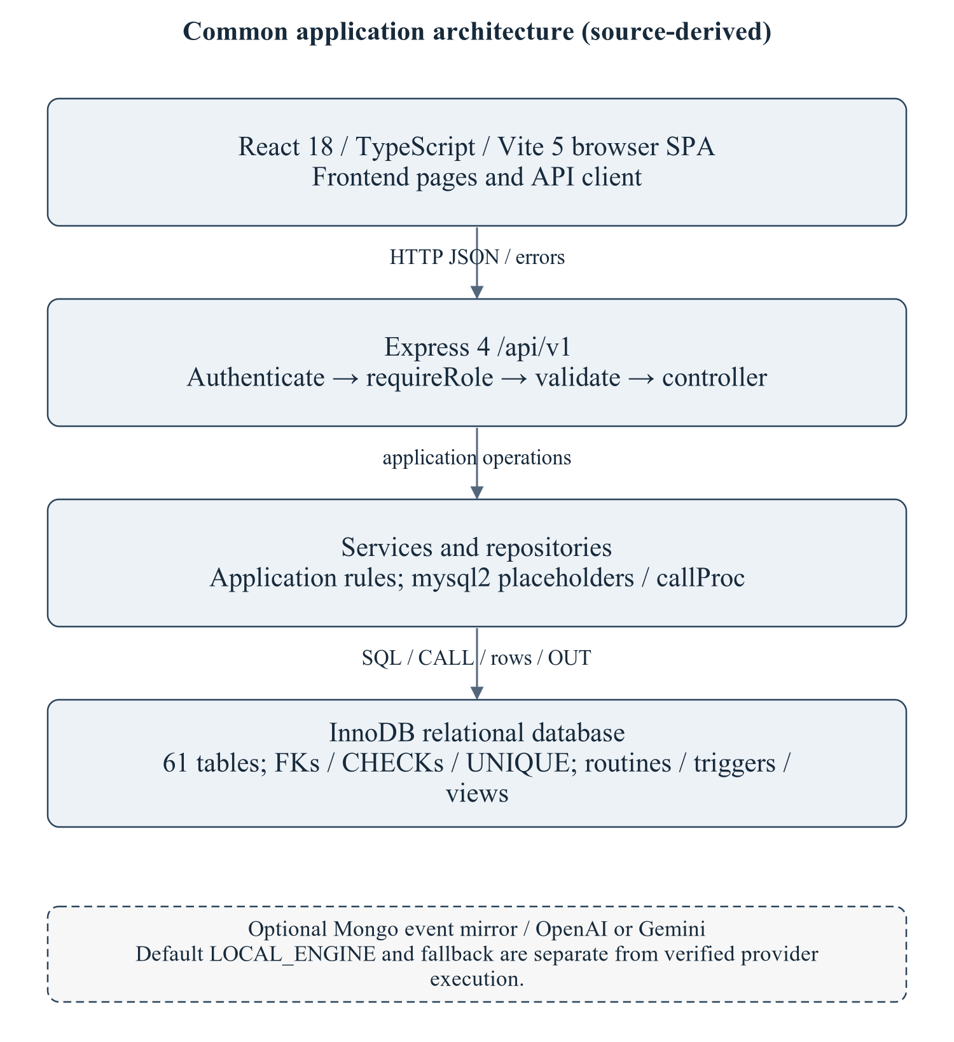
Figure 2.1 Common stack used by this module
The architecture is summarized to locate the module's routes/services/repository and SQL; it is not a copy of the master's enterprise narrative. Optional provider execution is not established.
Editable drawing source: diagrams/01_common_architecture.svg, .dot and .mmd. Edit SVG text/shapes in a vector editor, or regenerate from DOT/Mermaid; retain FK IDs and source names. These figures were created from static source, not captured from a running ERP.
React18/TypeScript/Vite5 client → Express4 /api/v1/fees → module controller/service/repository → mysql2/InnoDB. Node>=18 is specified by backend package metadata; audit checks used Node20.20.2. MySQL8-style SQL and Compose MariaDB11.8 are separate unverified runtime targets. Hardware/IDE/browser performance requirements await MI15/MI16. [R09, R23]

2.2 Module Data Flow Diagram (Level 1 / Level 2 DFD)
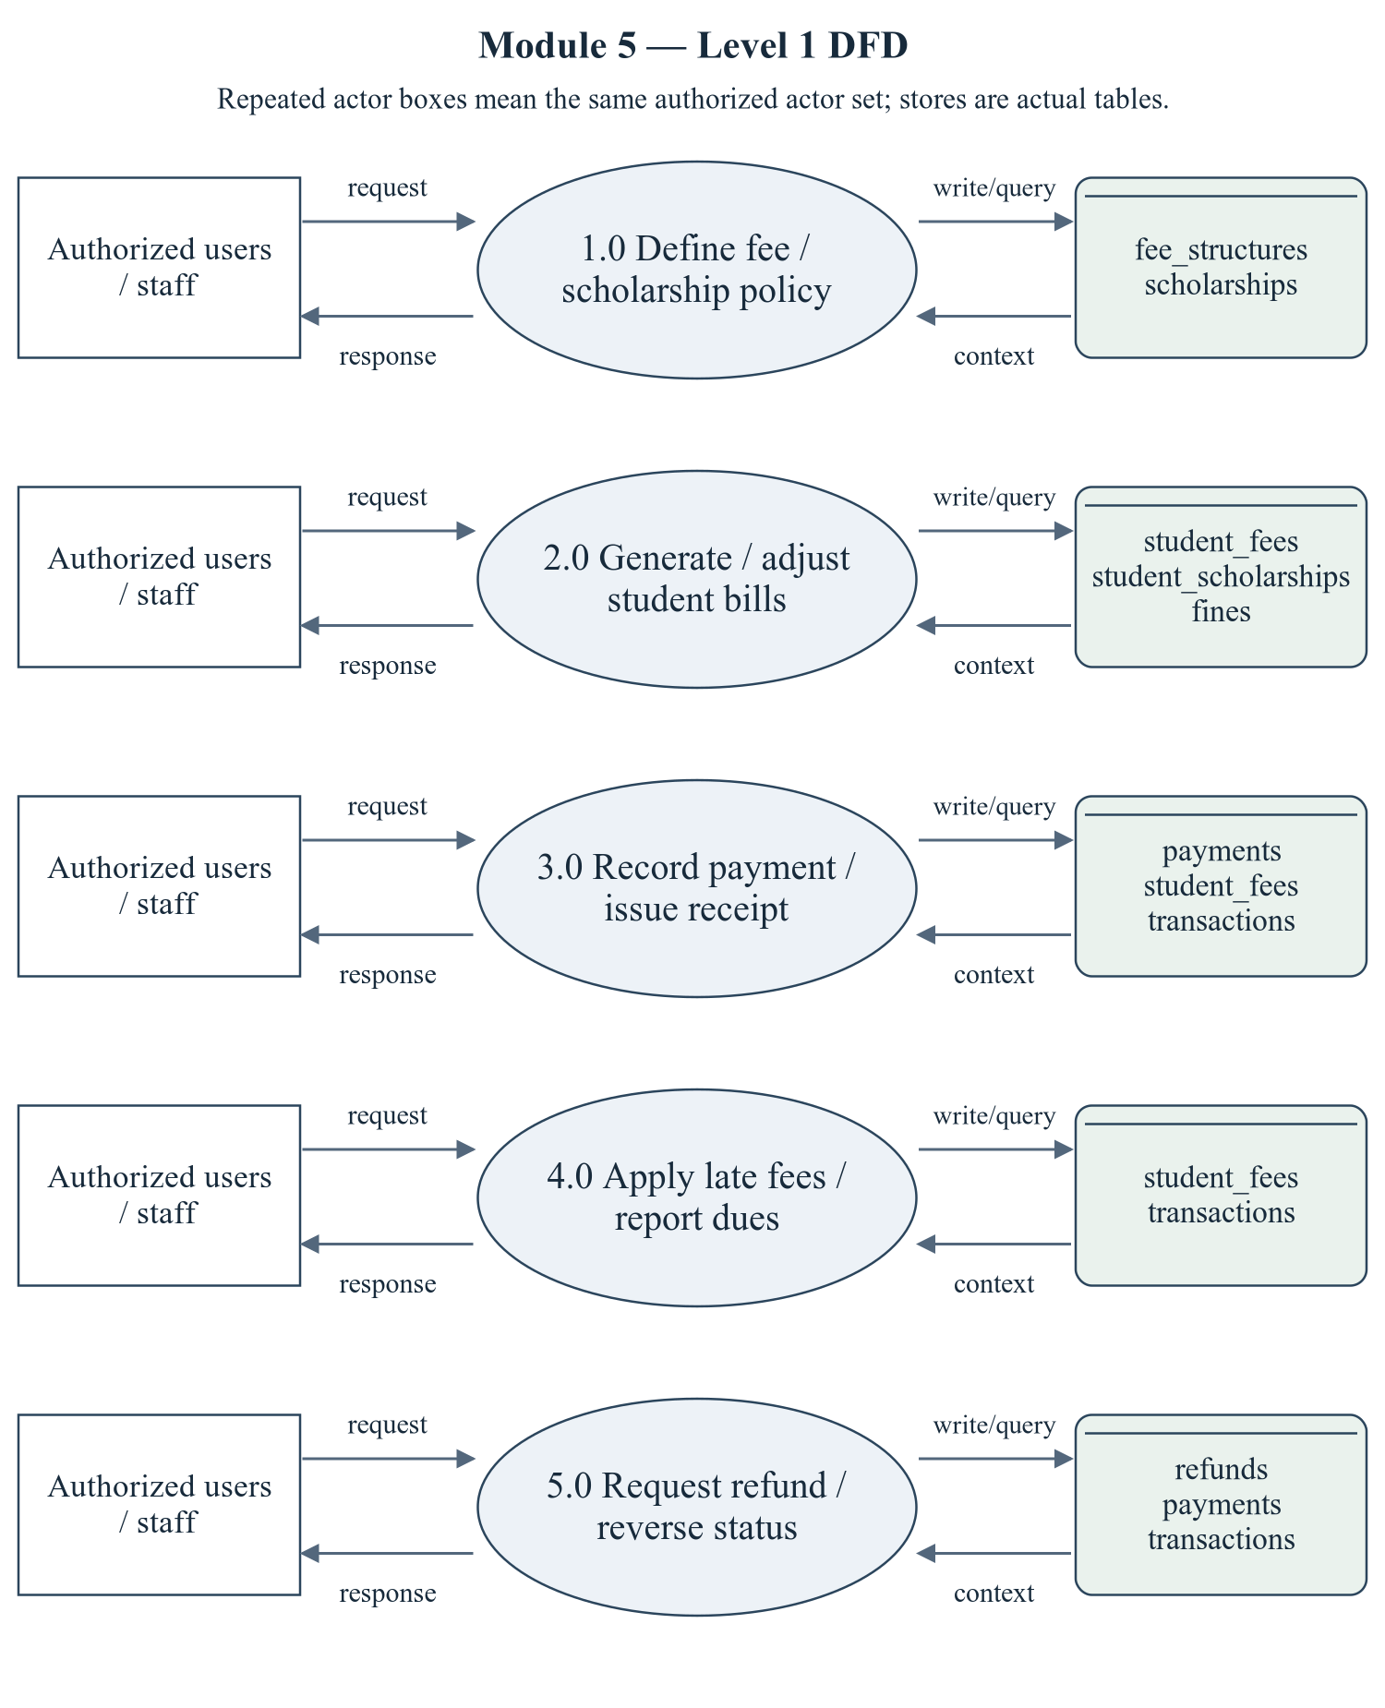
Figure 2.2 Fees and Payments — Level 1 DFD
Repeated actor boxes mean the same external entity set. Each D label names real stores, not a fabricated table; role and row scope remain as specified in the route/ownership discussion.
Editable drawing source: diagrams/05_module_05_dfd_level1.svg, .dot and .mmd. Edit SVG text/shapes in a vector editor, or regenerate from DOT/Mermaid; retain FK IDs and source names. These figures were created from static source, not captured from a running ERP.

2.2.1 Sub-System Processes, Data Stores & External Movement
Table 2.1 Module processes and integration stores
Process | Actual persisted stores | Data movement
1.0 Define fee / scholarship policy | fee_structures, scholarships | Actor request/decision → module process; data query/write ↔ actual stores; response/report → actor.
2.0 Generate / adjust student bills | student_fees, student_scholarships, fines | Actor request/decision → module process; data query/write ↔ actual stores; response/report → actor.
3.0 Record payment / issue receipt | payments, student_fees, transactions | Actor request/decision → module process; data query/write ↔ actual stores; response/report → actor.
4.0 Apply late fees / report dues | student_fees, transactions | Actor request/decision → module process; data query/write ↔ actual stores; response/report → actor.
5.0 Request refund / reverse status | refunds, payments, transactions | Actor request/decision → module process; data query/write ↔ actual stores; response/report → actor.

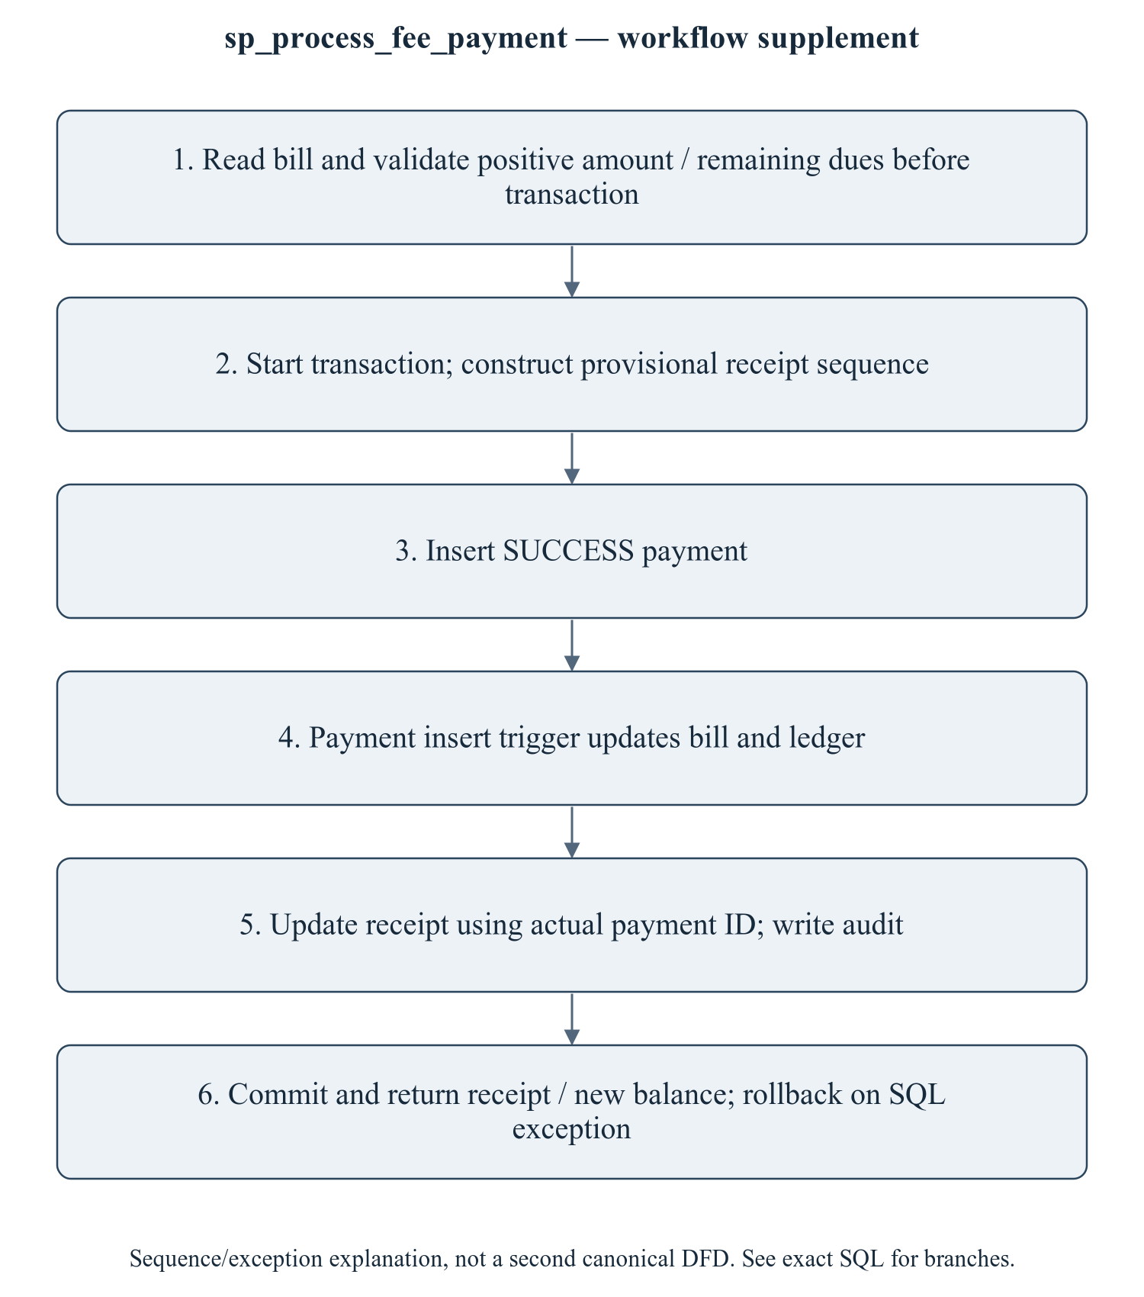
Figure 2.3 sp_process_fee_payment — transaction/workflow supplement
This is a procedure sequence/exception explanation, not a second canonical DFD. The BEFORE UPDATE trigger floors calculated dues at zero; the CHECK only guards nonnegative stored amounts. Neither proves overpayment or inconsistent direct INSERT is impossible. Manual finance recording is not a payment gateway. Partial refunds must not be described as correct until the full-reversal mismatch is repaired and executed.
Editable drawing source: diagrams/06_module_05_procedure_workflow.svg, .dot and .mmd. Edit SVG text/shapes in a vector editor, or regenerate from DOT/Mermaid; retain FK IDs and source names. These figures were created from static source, not captured from a running ERP.

2.3 Module ER Diagram, Sub-Schema & Data Dictionary
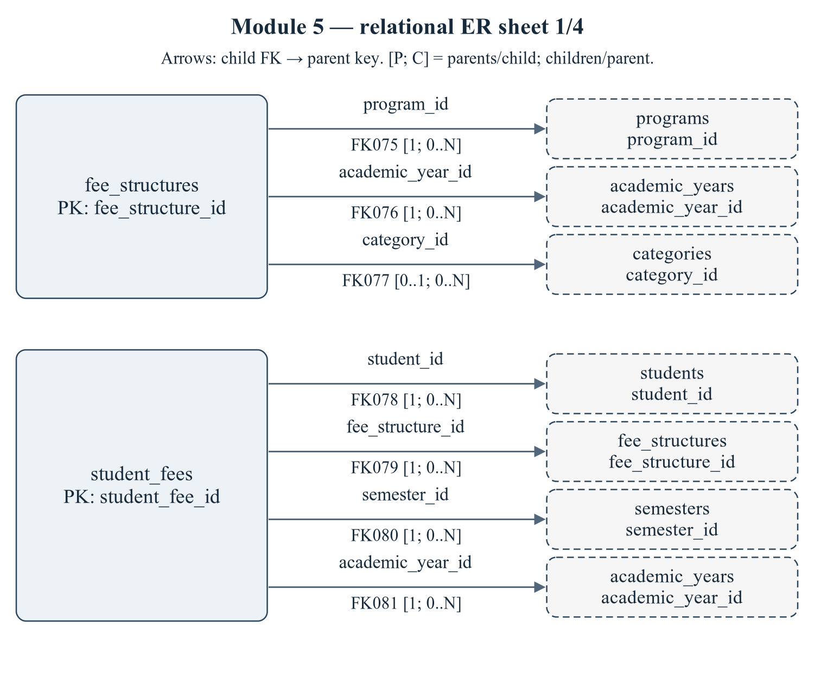
Figure 2.4 Module 5 — relational ER sheet 1/4
The child relations fee_structures, student_fees refer to actual target keys. Arrows are FK→parent; [P; C] gives parents per child and children per parent. IDs reconcile with the full dictionary and workbook. Dashed parent repetition does not transfer ownership.
Editable drawing source: diagrams/03_er_panel_05_part_01.svg, .dot and .mmd. Edit SVG text/shapes in a vector editor, or regenerate from DOT/Mermaid; retain FK IDs and source names. These figures were created from static source, not captured from a running ERP.
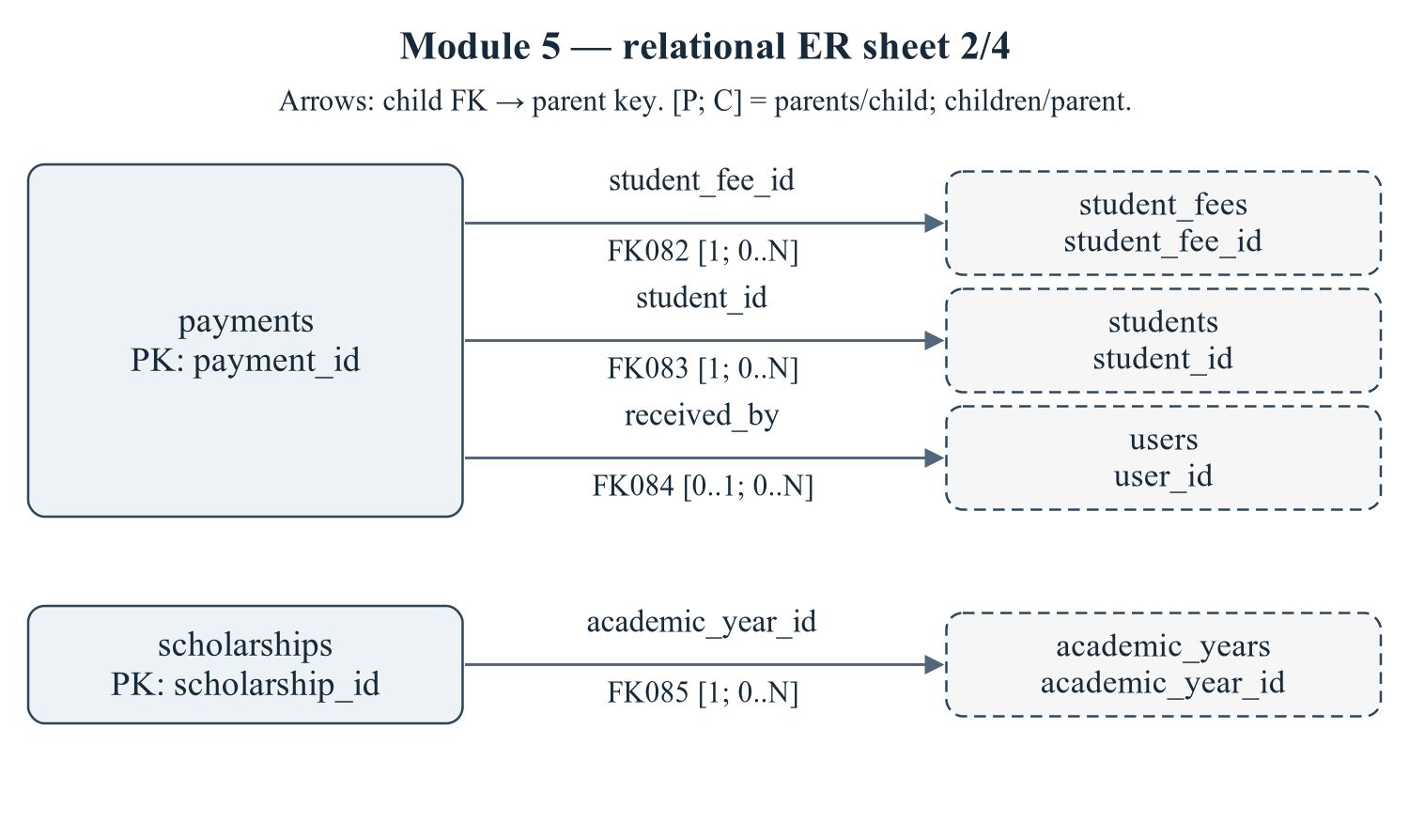
Figure 2.5 Module 5 — relational ER sheet 2/4
The child relations payments, scholarships refer to actual target keys. Arrows are FK→parent; [P; C] gives parents per child and children per parent. IDs reconcile with the full dictionary and workbook. Dashed parent repetition does not transfer ownership.
Editable drawing source: diagrams/03_er_panel_05_part_02.svg, .dot and .mmd. Edit SVG text/shapes in a vector editor, or regenerate from DOT/Mermaid; retain FK IDs and source names. These figures were created from static source, not captured from a running ERP.
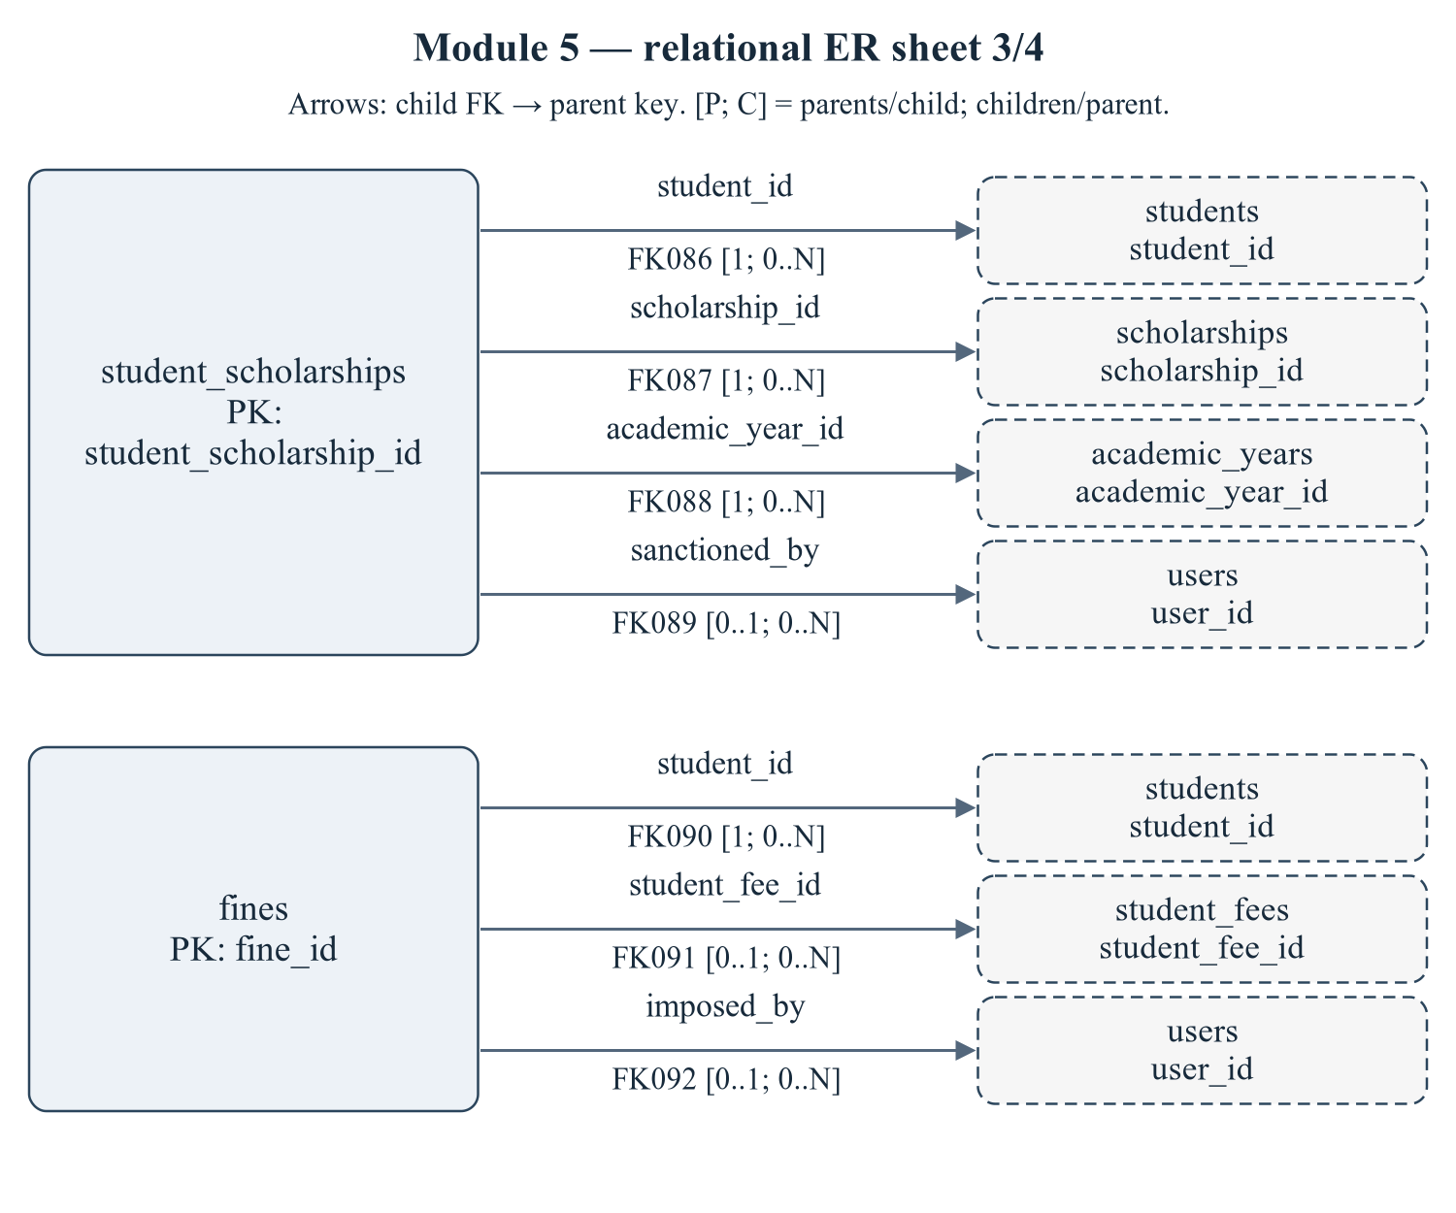
Figure 2.6 Module 5 — relational ER sheet 3/4
The child relations student_scholarships, fines refer to actual target keys. Arrows are FK→parent; [P; C] gives parents per child and children per parent. IDs reconcile with the full dictionary and workbook. Dashed parent repetition does not transfer ownership.
Editable drawing source: diagrams/03_er_panel_05_part_03.svg, .dot and .mmd. Edit SVG text/shapes in a vector editor, or regenerate from DOT/Mermaid; retain FK IDs and source names. These figures were created from static source, not captured from a running ERP.
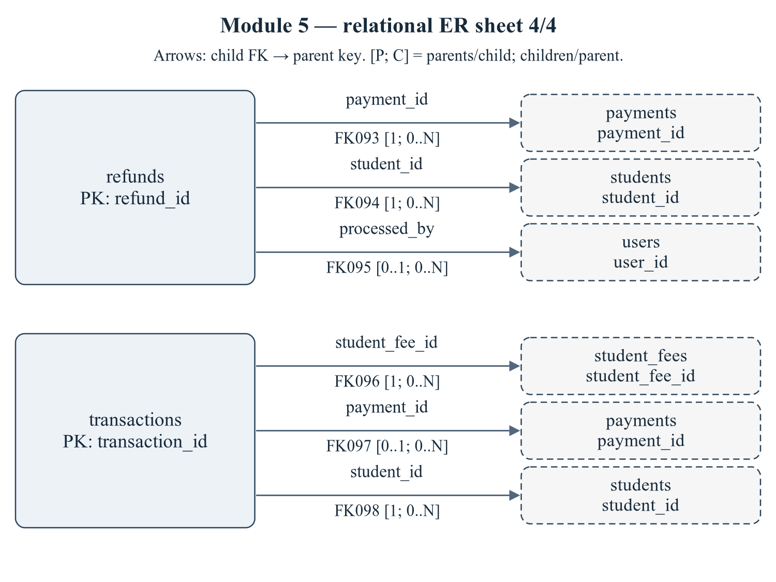
Figure 2.7 Module 5 — relational ER sheet 4/4
The child relations refunds, transactions refer to actual target keys. Arrows are FK→parent; [P; C] gives parents per child and children per parent. IDs reconcile with the full dictionary and workbook. Dashed parent repetition does not transfer ownership.
Editable drawing source: diagrams/03_er_panel_05_part_04.svg, .dot and .mmd. Edit SVG text/shapes in a vector editor, or regenerate from DOT/Mermaid; retain FK IDs and source names. These figures were created from static source, not captured from a running ERP.
Relational notation below lists actual attributes. The full dictionary supplies types/nullability/defaults/constraints; PK/FK notation does not invent undeclared relationships.
fee_structures( fee_structure_id, fee_code, program_id, semester_no, academic_year_id, category_id, tuition_fee, hostel_fee, exam_fee, library_fee, lab_fee, development_fee, other_fee, late_fee_per_day, grace_days, due_date, status, created_at). PK={fee_structure_id}; FK IDs={FK075,FK076,FK077}.
student_fees( student_fee_id, student_id, fee_structure_id, semester_id, academic_year_id, total_amount, scholarship_amount, discount_amount, fine_amount, paid_amount, due_amount, status, due_date, paid_on, remarks, created_at, updated_at). PK={student_fee_id}; FK IDs={FK078,FK079,FK080,FK081}.
payments( payment_id, receipt_no, transaction_id, student_fee_id, student_id, amount, payment_mode, payment_date, status, reference_no, received_by, remarks, created_at). PK={payment_id}; FK IDs={FK082,FK083,FK084}.
scholarships( scholarship_id, scholarship_code, name, provider, scholarship_type, amount, is_percentage, criteria, max_beneficiaries, academic_year_id, status). PK={scholarship_id}; FK IDs={FK085}.
student_scholarships( student_scholarship_id, student_id, scholarship_id, academic_year_id, amount, sanctioned_on, sanctioned_by, status, remarks). PK={student_scholarship_id}; FK IDs={FK086,FK087,FK088,FK089}.
fines( fine_id, student_id, student_fee_id, reason, fine_type, amount, imposed_on, imposed_by, status, remarks). PK={fine_id}; FK IDs={FK090,FK091,FK092}.
refunds( refund_id, payment_id, student_id, amount, reason, refund_mode, refund_date, status, processed_by, remarks). PK={refund_id}; FK IDs={FK093,FK094,FK095}.
transactions( transaction_id, student_fee_id, payment_id, student_id, txn_type, amount, balance_after, description, created_at). PK={transaction_id}; FK IDs={FK096,FK097,FK098}.
Table 2.2 Shared / cross-module key contracts (not duplicated ownership)
Parent table / key | Module relationship | Declared action / FK ID
academic_years, PK academic_year_id | fee_structures.academic_year_id → academic_year_id; student_fees.academic_year_id → academic_year_id; scholarships.academic_year_id → academic_year_id; student_scholarships.academic_year_id → academic_year_id | FK076: ON DELETE CASCADE; FK081: ON DELETE CASCADE; FK085: ON DELETE CASCADE; FK088: ON DELETE CASCADE
categories, PK category_id | fee_structures.category_id → category_id | FK077: ON DELETE SET NULL
programs, PK program_id | fee_structures.program_id → program_id | FK075: ON DELETE CASCADE
semesters, PK semester_id | student_fees.semester_id → semester_id | FK080: ON DELETE CASCADE
students, PK student_id | student_fees.student_id → student_id; payments.student_id → student_id; student_scholarships.student_id → student_id; fines.student_id → student_id; refunds.student_id → student_id; transactions.student_id → student_id | FK078: ON DELETE CASCADE; FK083: ON DELETE CASCADE; FK086: ON DELETE CASCADE; FK090: ON DELETE CASCADE; FK094: ON DELETE CASCADE; FK098: ON DELETE CASCADE
users, PK user_id | payments.received_by → user_id; student_scholarships.sanctioned_by → user_id; fines.imposed_by → user_id; refunds.processed_by → user_id | FK084: ON DELETE SET NULL; FK089: ON DELETE SET NULL; FK092: ON DELETE SET NULL; FK095: ON DELETE SET NULL

The table dictionaries in this module cover its persisted schema in full. External parents above retain their original ownership; their complete 677-column enterprise dictionary is supplied in the master report and inventory workbook. Shared contracts are repeated here so this module can be read independently without pretending to own another module's tables.
fee_structures — G5: fee template per program/semester/category.
Definition: database/02_tables.sql:663–695. Owner: Fees and Payments.
Table 2.3 fee_structures — full column dictionary
Column and exact SQL type | Null / default / generation | Keys and purpose
fee_structure_id  SMALLINT UNSIGNED | NOT NULL  DEFAULT: No explicit DEFAULT  AUTO_INCREMENT | PK  Primary row identifier.
fee_code  VARCHAR(30) | NOT NULL  DEFAULT: No explicit DEFAULT | UQ uq_fee_structures_code (fee_code)  FS-BTECH-ETC-S3-GEN
program_id  SMALLINT UNSIGNED | NOT NULL  DEFAULT: No explicit DEFAULT | UQ uq_fee_structures_key (program_id,semester_no,academic_year_id,category_id); FK075 → programs.program_id  References programs.program_id.
semester_no  TINYINT UNSIGNED | NOT NULL  DEFAULT: No explicit DEFAULT | UQ uq_fee_structures_key (program_id,semester_no,academic_year_id,category_id)  Semester no value.
academic_year_id  SMALLINT UNSIGNED | NOT NULL  DEFAULT: No explicit DEFAULT | UQ uq_fee_structures_key (program_id,semester_no,academic_year_id,category_id); FK076 → academic_years.academic_year_id  References academic_years.academic_year_id.
category_id  TINYINT UNSIGNED | NULL permitted  DEFAULT: No explicit DEFAULT | UQ uq_fee_structures_key (program_id,semester_no,academic_year_id,category_id); FK077 → categories.category_id  NULL => applies to all categories
tuition_fee  DECIMAL(10,2) | NOT NULL  DEFAULT: 0.00 | Tuition fee value.
hostel_fee  DECIMAL(10,2) | NOT NULL  DEFAULT: 0.00 | Hostel fee value.
exam_fee  DECIMAL(10,2) | NOT NULL  DEFAULT: 0.00 | Exam fee value.
library_fee  DECIMAL(10,2) | NOT NULL  DEFAULT: 0.00 | Library fee value.
lab_fee  DECIMAL(10,2) | NOT NULL  DEFAULT: 0.00 | Lab fee value.
development_fee  DECIMAL(10,2) | NOT NULL  DEFAULT: 0.00 | Development fee value.
other_fee  DECIMAL(10,2) | NOT NULL  DEFAULT: 0.00 | Other fee value.
late_fee_per_day  DECIMAL(8,2) | NOT NULL  DEFAULT: 50.00 | Late fee per day value.
grace_days  SMALLINT UNSIGNED | NOT NULL  DEFAULT: 10 | Grace days value.
due_date  DATE | NOT NULL  DEFAULT: No explicit DEFAULT | Due date date/time, as typed.
status  ENUM('ACTIVE','INACTIVE') | NOT NULL  DEFAULT: 'ACTIVE' | Lifecycle state; exact permitted values are in the declared ENUM.
created_at  TIMESTAMP | NOT NULL  DEFAULT: CURRENT_TIMESTAMP | Row creation timestamp.

PRIMARY KEY: fee_structure_id
UNIQUE constraints: UNIQUE KEY `uq_fee_structures_code` (`fee_code`); UNIQUE KEY `uq_fee_structures_key` (`program_id`, `semester_no`, `academic_year_id`, `category_id`)
CHECK constraints: CONSTRAINT `chk_fee_structures_nonneg` CHECK (`tuition_fee` >= 0 AND `hostel_fee` >= 0
AND `exam_fee` >= 0 AND `library_fee` >= 0 AND `lab_fee` >= 0
AND `development_fee` >= 0 AND `other_fee` >= 0)
Secondary indexes: KEY `idx_fee_structures_program` (`program_id`)
FK075 fk_fee_structures_program: CONSTRAINT `fk_fee_structures_program` FOREIGN KEY (`program_id`)
REFERENCES `programs` (`program_id`) ON DELETE CASCADE. Parent/child multiplicities 1 / 0..N. Omitted referential actions use restrictive defaults, not an invented cascade.
FK076 fk_fee_structures_year: CONSTRAINT `fk_fee_structures_year` FOREIGN KEY (`academic_year_id`)
REFERENCES `academic_years` (`academic_year_id`) ON DELETE CASCADE. Parent/child multiplicities 1 / 0..N. Omitted referential actions use restrictive defaults, not an invented cascade.
FK077 fk_fee_structures_category: CONSTRAINT `fk_fee_structures_category` FOREIGN KEY (`category_id`)
REFERENCES `categories` (`category_id`) ON DELETE SET NULL. Parent/child multiplicities 0..1 / 0..N. Omitted referential actions use restrictive defaults, not an invented cascade.
Normalization / dependency note: The business tuple (program_id,semester_no,academic_year_id,category_id) is UNIQUE but category_id is nullable, so it is not automatically a candidate key. The fee components are stored individually; no total_amount column exists in this table. The generation procedure sums them into student_fees.
student_fees — G5: fee ledger head per student per semester.
Definition: database/02_tables.sql:700–735. Owner: Fees and Payments.
Table 2.4 student_fees — full column dictionary
Column and exact SQL type | Null / default / generation | Keys and purpose
student_fee_id  INT UNSIGNED | NOT NULL  DEFAULT: No explicit DEFAULT  AUTO_INCREMENT | PK  Primary row identifier.
student_id  INT UNSIGNED | NOT NULL  DEFAULT: No explicit DEFAULT | UQ uq_student_fees (student_id,fee_structure_id,semester_id); FK078 → students.student_id  References students.student_id.
fee_structure_id  SMALLINT UNSIGNED | NOT NULL  DEFAULT: No explicit DEFAULT | UQ uq_student_fees (student_id,fee_structure_id,semester_id); FK079 → fee_structures.fee_structure_id  References fee_structures.fee_structure_id.
semester_id  SMALLINT UNSIGNED | NOT NULL  DEFAULT: No explicit DEFAULT | UQ uq_student_fees (student_id,fee_structure_id,semester_id); FK080 → semesters.semester_id  References semesters.semester_id.
academic_year_id  SMALLINT UNSIGNED | NOT NULL  DEFAULT: No explicit DEFAULT | FK081 → academic_years.academic_year_id  References academic_years.academic_year_id.
total_amount  DECIMAL(10,2) | NOT NULL  DEFAULT: 0.00 | Assessed total amount stored on the bill.
scholarship_amount  DECIMAL(10,2) | NOT NULL  DEFAULT: 0.00 | Scholarship amount value.
discount_amount  DECIMAL(10,2) | NOT NULL  DEFAULT: 0.00 | Discount amount value.
fine_amount  DECIMAL(10,2) | NOT NULL  DEFAULT: 0.00 | Fine amount value.
paid_amount  DECIMAL(10,2) | NOT NULL  DEFAULT: 0.00 | Stored total paid amount; reconcile with successful receipts.
due_amount  DECIMAL(10,2) | NOT NULL  DEFAULT: 0.00 | Stored outstanding bill amount; recomputed by the fee BEFORE UPDATE trigger, not a generated column.
status  ENUM('PENDING','PARTIAL','PAID','OVERDUE','REFUNDED') | NOT NULL  DEFAULT: 'PENDING' | Lifecycle state; exact permitted values are in the declared ENUM.
due_date  DATE | NOT NULL  DEFAULT: No explicit DEFAULT | Due date date/time, as typed.
paid_on  DATETIME | NULL permitted  DEFAULT: No explicit DEFAULT | Paid on date/time, as typed.
remarks  VARCHAR(255) | NULL permitted  DEFAULT: No explicit DEFAULT | Operation or record remarks.
created_at  TIMESTAMP | NOT NULL  DEFAULT: CURRENT_TIMESTAMP | Row creation timestamp.
updated_at  TIMESTAMP; ON UPDATE CURRENT_TIMESTAMP | NOT NULL  DEFAULT: CURRENT_TIMESTAMP | Last row-update timestamp.

PRIMARY KEY: student_fee_id
UNIQUE constraints: UNIQUE KEY `uq_student_fees` (`student_id`, `fee_structure_id`, `semester_id`)
CHECK constraints: CONSTRAINT `chk_student_fees_amounts` CHECK (`total_amount` >= 0 AND `paid_amount` >= 0
AND `due_amount` >= 0 AND `fine_amount` >= 0 AND `scholarship_amount` >= 0
AND `discount_amount` >= 0); CONSTRAINT `chk_student_fees_paid_limit` CHECK (`paid_amount` <= `total_amount`)
Secondary indexes: KEY `idx_student_fees_status` (`status`); KEY `idx_student_fees_due` (`due_date`); KEY `idx_student_fees_semester`(`semester_id`); KEY `idx_student_fees_status_sem` (`semester_id`, `status`)
FK078 fk_student_fees_student: CONSTRAINT `fk_student_fees_student` FOREIGN KEY (`student_id`)
REFERENCES `students` (`student_id`) ON DELETE CASCADE. Parent/child multiplicities 1 / 0..N. Omitted referential actions use restrictive defaults, not an invented cascade.
FK079 fk_student_fees_structure: CONSTRAINT `fk_student_fees_structure` FOREIGN KEY (`fee_structure_id`)
REFERENCES `fee_structures` (`fee_structure_id`) ON DELETE RESTRICT. Parent/child multiplicities 1 / 0..N. Omitted referential actions use restrictive defaults, not an invented cascade.
FK080 fk_student_fees_semester: CONSTRAINT `fk_student_fees_semester` FOREIGN KEY (`semester_id`)
REFERENCES `semesters` (`semester_id`) ON DELETE CASCADE. Parent/child multiplicities 1 / 0..N. Omitted referential actions use restrictive defaults, not an invented cascade.
FK081 fk_student_fees_year: CONSTRAINT `fk_student_fees_year` FOREIGN KEY (`academic_year_id`)
REFERENCES `academic_years` (`academic_year_id`) ON DELETE CASCADE. Parent/child multiplicities 1 / 0..N. Omitted referential actions use restrictive defaults, not an invented cascade.
Normalization / dependency note: student_fee_id is the surrogate key and the billing tuple is a non-null UNIQUE. academic_year_id follows semester_id; due_amount is stored and recomputed by a BEFORE UPDATE trigger from bill components/discount/scholarship/paid/fine, not defined as a generated column. Snapshotted charges plus maintained payment totals require reconciliation and a policy for historical fee-template changes.
payments — G5: payment receipt. Trigger updates student_fees status.
Definition: database/02_tables.sql:740–767. Owner: Fees and Payments.
Table 2.5 payments — full column dictionary
Column and exact SQL type | Null / default / generation | Keys and purpose
payment_id  INT UNSIGNED | NOT NULL  DEFAULT: No explicit DEFAULT  AUTO_INCREMENT | PK  Primary row identifier.
receipt_no  VARCHAR(30) | NOT NULL  DEFAULT: No explicit DEFAULT | UQ uq_payments_receipt (receipt_no)  RCP-2026-000001
transaction_id  VARCHAR(60) | NOT NULL  DEFAULT: No explicit DEFAULT | UQ uq_payments_txn (transaction_id)  Gateway / bank reference, UNIQUE
student_fee_id  INT UNSIGNED | NOT NULL  DEFAULT: No explicit DEFAULT | FK082 → student_fees.student_fee_id  References student_fees.student_fee_id.
student_id  INT UNSIGNED | NOT NULL  DEFAULT: No explicit DEFAULT | FK083 → students.student_id  References students.student_id.
amount  DECIMAL(10,2) | NOT NULL  DEFAULT: No explicit DEFAULT | Amount value.
payment_mode  ENUM('CASH','CARD','UPI','NETBANKING','CHEQUE','DD','ONLINE','SCHOLARSHIP') | NOT NULL  DEFAULT: 'ONLINE' | Payment mode value.
payment_date  DATETIME | NOT NULL  DEFAULT: CURRENT_TIMESTAMP | Payment date date/time, as typed.
status  ENUM('SUCCESS','PENDING','FAILED','REFUNDED') | NOT NULL  DEFAULT: 'SUCCESS' | Lifecycle state; exact permitted values are in the declared ENUM.
reference_no  VARCHAR(60) | NULL permitted  DEFAULT: No explicit DEFAULT | Reference no value.
received_by  INT UNSIGNED | NULL permitted  DEFAULT: No explicit DEFAULT | FK084 → users.user_id  References users.user_id.
remarks  VARCHAR(255) | NULL permitted  DEFAULT: No explicit DEFAULT | Operation or record remarks.
created_at  TIMESTAMP | NOT NULL  DEFAULT: CURRENT_TIMESTAMP | Row creation timestamp.

PRIMARY KEY: payment_id
UNIQUE constraints: UNIQUE KEY `uq_payments_receipt` (`receipt_no`); UNIQUE KEY `uq_payments_txn` (`transaction_id`)
CHECK constraints: CONSTRAINT `chk_payments_amount` CHECK (`amount` > 0)
Secondary indexes: KEY `idx_payments_student` (`student_id`); KEY `idx_payments_fee` (`student_fee_id`); KEY `idx_payments_date` (`payment_date`)
FK082 fk_payments_fee: CONSTRAINT `fk_payments_fee` FOREIGN KEY (`student_fee_id`)
REFERENCES `student_fees` (`student_fee_id`) ON DELETE CASCADE. Parent/child multiplicities 1 / 0..N. Omitted referential actions use restrictive defaults, not an invented cascade.
FK083 fk_payments_student: CONSTRAINT `fk_payments_student` FOREIGN KEY (`student_id`)
REFERENCES `students` (`student_id`) ON DELETE CASCADE. Parent/child multiplicities 1 / 0..N. Omitted referential actions use restrictive defaults, not an invented cascade.
FK084 fk_payments_receiver: CONSTRAINT `fk_payments_receiver` FOREIGN KEY (`received_by`)
REFERENCES `users` (`user_id`) ON DELETE SET NULL. Parent/child multiplicities 0..1 / 0..N. Omitted referential actions use restrictive defaults, not an invented cascade.
Normalization / dependency note: The NOT NULL student_fee_id identifies a bill which determines student_id, while both are stored. This is an intended domain transitive dependency unless explicitly preserved as an event snapshot; payment amount/date/mode/receipt remain payment facts.
scholarships — G5: scholarship master.
Definition: database/02_tables.sql:772–789. Owner: Fees and Payments.
Table 2.6 scholarships — full column dictionary
Column and exact SQL type | Null / default / generation | Keys and purpose
scholarship_id  SMALLINT UNSIGNED | NOT NULL  DEFAULT: No explicit DEFAULT  AUTO_INCREMENT | PK  Primary row identifier.
scholarship_code  VARCHAR(20) | NOT NULL  DEFAULT: No explicit DEFAULT | UQ uq_scholarships_code (scholarship_code)  Scholarship code identifier/label.
name  VARCHAR(150) | NOT NULL  DEFAULT: No explicit DEFAULT | Stored display/name attribute.
provider  VARCHAR(120) | NOT NULL  DEFAULT: No explicit DEFAULT | Provider value.
scholarship_type  ENUM('MERIT','NEED','SPORTS','GOVERNMENT','MINORITY','OTHER') | NOT NULL  DEFAULT: 'MERIT' | Scholarship type value.
amount  DECIMAL(10,2) | NOT NULL  DEFAULT: 0.00 | Amount value.
is_percentage  TINYINT(1) | NOT NULL  DEFAULT: 0 | 1 => amount is a % of tuition
criteria  VARCHAR(500) | NULL permitted  DEFAULT: No explicit DEFAULT | Criteria value.
max_beneficiaries  SMALLINT UNSIGNED | NULL permitted  DEFAULT: No explicit DEFAULT | Max beneficiaries value.
academic_year_id  SMALLINT UNSIGNED | NOT NULL  DEFAULT: No explicit DEFAULT | FK085 → academic_years.academic_year_id  References academic_years.academic_year_id.
status  ENUM('ACTIVE','INACTIVE') | NOT NULL  DEFAULT: 'ACTIVE' | Lifecycle state; exact permitted values are in the declared ENUM.

PRIMARY KEY: scholarship_id
UNIQUE constraints: UNIQUE KEY `uq_scholarships_code` (`scholarship_code`)
CHECK constraints: CONSTRAINT `chk_scholarships_amount` CHECK (`amount` >= 0)
Secondary indexes: None explicitly declared beyond PK/UNIQUE/FK support.
FK085 fk_scholarships_year: CONSTRAINT `fk_scholarships_year` FOREIGN KEY (`academic_year_id`)
REFERENCES `academic_years` (`academic_year_id`) ON DELETE CASCADE. Parent/child multiplicities 1 / 0..N. Omitted referential actions use restrictive defaults, not an invented cascade.
Normalization / dependency note: PK determines the remaining stored attributes. Non-null declared UNIQUE tuples are additional candidate-key evidence. No further non-key determinant was established from DDL alone; 3NF is conditional on the stated business FDs being complete, not certified solely by having a surrogate key.
student_scholarships — G5: scholarship awarded to a student for a year.
Definition: database/02_tables.sql:791–813. Owner: Fees and Payments.
Table 2.7 student_scholarships — full column dictionary
Column and exact SQL type | Null / default / generation | Keys and purpose
student_scholarship_id  INT UNSIGNED | NOT NULL  DEFAULT: No explicit DEFAULT  AUTO_INCREMENT | PK  Primary row identifier.
student_id  INT UNSIGNED | NOT NULL  DEFAULT: No explicit DEFAULT | UQ uq_student_scholarships (student_id,scholarship_id,academic_year_id); FK086 → students.student_id  References students.student_id.
scholarship_id  SMALLINT UNSIGNED | NOT NULL  DEFAULT: No explicit DEFAULT | UQ uq_student_scholarships (student_id,scholarship_id,academic_year_id); FK087 → scholarships.scholarship_id  References scholarships.scholarship_id.
academic_year_id  SMALLINT UNSIGNED | NOT NULL  DEFAULT: No explicit DEFAULT | UQ uq_student_scholarships (student_id,scholarship_id,academic_year_id); FK088 → academic_years.academic_year_id  References academic_years.academic_year_id.
amount  DECIMAL(10,2) | NOT NULL  DEFAULT: 0.00 | Amount value.
sanctioned_on  DATE | NOT NULL  DEFAULT: (CURRENT_DATE) | Sanctioned on date/time, as typed.
sanctioned_by  INT UNSIGNED | NULL permitted  DEFAULT: No explicit DEFAULT | FK089 → users.user_id  References users.user_id.
status  ENUM('APPLIED','APPROVED','REJECTED','CREDITED') | NOT NULL  DEFAULT: 'APPROVED' | Lifecycle state; exact permitted values are in the declared ENUM.
remarks  VARCHAR(255) | NULL permitted  DEFAULT: No explicit DEFAULT | Operation or record remarks.

PRIMARY KEY: student_scholarship_id
UNIQUE constraints: UNIQUE KEY `uq_student_scholarships` (`student_id`, `scholarship_id`, `academic_year_id`)
CHECK constraints: CONSTRAINT `chk_ss_amount` CHECK (`amount` >= 0)
Secondary indexes: KEY `idx_ss_student` (`student_id`)
FK086 fk_ss_student: CONSTRAINT `fk_ss_student` FOREIGN KEY (`student_id`)
REFERENCES `students` (`student_id`) ON DELETE CASCADE. Parent/child multiplicities 1 / 0..N. Omitted referential actions use restrictive defaults, not an invented cascade.
FK087 fk_ss_scholarship: CONSTRAINT `fk_ss_scholarship` FOREIGN KEY (`scholarship_id`)
REFERENCES `scholarships` (`scholarship_id`) ON DELETE CASCADE. Parent/child multiplicities 1 / 0..N. Omitted referential actions use restrictive defaults, not an invented cascade.
FK088 fk_ss_year: CONSTRAINT `fk_ss_year` FOREIGN KEY (`academic_year_id`)
REFERENCES `academic_years` (`academic_year_id`) ON DELETE CASCADE. Parent/child multiplicities 1 / 0..N. Omitted referential actions use restrictive defaults, not an invented cascade.
FK089 fk_ss_user: CONSTRAINT `fk_ss_user` FOREIGN KEY (`sanctioned_by`)
REFERENCES `users` (`user_id`) ON DELETE SET NULL. Parent/child multiplicities 0..1 / 0..N. Omitted referential actions use restrictive defaults, not an invented cascade.
Normalization / dependency note: PK determines the remaining stored attributes. Non-null declared UNIQUE tuples are additional candidate-key evidence. No further non-key determinant was established from DDL alone; 3NF is conditional on the stated business FDs being complete, not certified solely by having a surrogate key.
fines — G5: fines raised against students.
Definition: database/02_tables.sql:818–838. Owner: Fees and Payments.
Table 2.8 fines — full column dictionary
Column and exact SQL type | Null / default / generation | Keys and purpose
fine_id  INT UNSIGNED | NOT NULL  DEFAULT: No explicit DEFAULT  AUTO_INCREMENT | PK  Primary row identifier.
student_id  INT UNSIGNED | NOT NULL  DEFAULT: No explicit DEFAULT | FK090 → students.student_id  References students.student_id.
student_fee_id  INT UNSIGNED | NULL permitted  DEFAULT: No explicit DEFAULT | FK091 → student_fees.student_fee_id  References student_fees.student_fee_id.
reason  VARCHAR(255) | NOT NULL  DEFAULT: No explicit DEFAULT | Reason value.
fine_type  ENUM('LATE_FEE','LIBRARY','HOSTEL_DAMAGE','DISCIPLINE','EXAM_MALPRACTICE','OTHER') | NOT NULL  DEFAULT: 'OTHER' | Fine type value.
amount  DECIMAL(10,2) | NOT NULL  DEFAULT: No explicit DEFAULT | Amount value.
imposed_on  DATE | NOT NULL  DEFAULT: (CURRENT_DATE) | Imposed on date/time, as typed.
imposed_by  INT UNSIGNED | NULL permitted  DEFAULT: No explicit DEFAULT | FK092 → users.user_id  References users.user_id.
status  ENUM('PENDING','PAID','WAIVED') | NOT NULL  DEFAULT: 'PENDING' | Lifecycle state; exact permitted values are in the declared ENUM.
remarks  VARCHAR(255) | NULL permitted  DEFAULT: No explicit DEFAULT | Operation or record remarks.

PRIMARY KEY: fine_id
UNIQUE constraints: None declared.
CHECK constraints: CONSTRAINT `chk_fines_amount` CHECK (`amount` > 0)
Secondary indexes: KEY `idx_fines_student` (`student_id`)
FK090 fk_fines_student: CONSTRAINT `fk_fines_student` FOREIGN KEY (`student_id`)
REFERENCES `students` (`student_id`) ON DELETE CASCADE. Parent/child multiplicities 1 / 0..N. Omitted referential actions use restrictive defaults, not an invented cascade.
FK091 fk_fines_fee: CONSTRAINT `fk_fines_fee` FOREIGN KEY (`student_fee_id`)
REFERENCES `student_fees` (`student_fee_id`) ON DELETE SET NULL. Parent/child multiplicities 0..1 / 0..N. Omitted referential actions use restrictive defaults, not an invented cascade.
FK092 fk_fines_user: CONSTRAINT `fk_fines_user` FOREIGN KEY (`imposed_by`)
REFERENCES `users` (`user_id`) ON DELETE SET NULL. Parent/child multiplicities 0..1 / 0..N. Omitted referential actions use restrictive defaults, not an invented cascade.
Normalization / dependency note: PK determines the remaining stored attributes. Non-null declared UNIQUE tuples are additional candidate-key evidence. No further non-key determinant was established from DDL alone; 3NF is conditional on the stated business FDs being complete, not certified solely by having a surrogate key.
refunds — G5: refund processing.
Definition: database/02_tables.sql:843–863. Owner: Fees and Payments.
Table 2.9 refunds — full column dictionary
Column and exact SQL type | Null / default / generation | Keys and purpose
refund_id  INT UNSIGNED | NOT NULL  DEFAULT: No explicit DEFAULT  AUTO_INCREMENT | PK  Primary row identifier.
payment_id  INT UNSIGNED | NOT NULL  DEFAULT: No explicit DEFAULT | FK093 → payments.payment_id  References payments.payment_id.
student_id  INT UNSIGNED | NOT NULL  DEFAULT: No explicit DEFAULT | FK094 → students.student_id  References students.student_id.
amount  DECIMAL(10,2) | NOT NULL  DEFAULT: No explicit DEFAULT | Amount value.
reason  VARCHAR(255) | NOT NULL  DEFAULT: No explicit DEFAULT | Reason value.
refund_mode  ENUM('CASH','UPI','NETBANKING','CHEQUE') | NOT NULL  DEFAULT: 'NETBANKING' | Refund mode value.
refund_date  DATETIME | NOT NULL  DEFAULT: CURRENT_TIMESTAMP | Refund date date/time, as typed.
status  ENUM('INITIATED','PROCESSED','REJECTED') | NOT NULL  DEFAULT: 'INITIATED' | Lifecycle state; exact permitted values are in the declared ENUM.
processed_by  INT UNSIGNED | NULL permitted  DEFAULT: No explicit DEFAULT | FK095 → users.user_id  References users.user_id.
remarks  VARCHAR(255) | NULL permitted  DEFAULT: No explicit DEFAULT | Operation or record remarks.

PRIMARY KEY: refund_id
UNIQUE constraints: None declared.
CHECK constraints: CONSTRAINT `chk_refunds_amount` CHECK (`amount` > 0)
Secondary indexes: KEY `idx_refunds_student` (`student_id`)
FK093 fk_refunds_payment: CONSTRAINT `fk_refunds_payment` FOREIGN KEY (`payment_id`)
REFERENCES `payments` (`payment_id`) ON DELETE CASCADE. Parent/child multiplicities 1 / 0..N. Omitted referential actions use restrictive defaults, not an invented cascade.
FK094 fk_refunds_student: CONSTRAINT `fk_refunds_student` FOREIGN KEY (`student_id`)
REFERENCES `students` (`student_id`) ON DELETE CASCADE. Parent/child multiplicities 1 / 0..N. Omitted referential actions use restrictive defaults, not an invented cascade.
FK095 fk_refunds_user: CONSTRAINT `fk_refunds_user` FOREIGN KEY (`processed_by`)
REFERENCES `users` (`user_id`) ON DELETE SET NULL. Parent/child multiplicities 0..1 / 0..N. Omitted referential actions use restrictive defaults, not an invented cascade.
Normalization / dependency note: PK determines the remaining stored attributes. Non-null declared UNIQUE tuples are additional candidate-key evidence. No further non-key determinant was established from DDL alone; 3NF is conditional on the stated business FDs being complete, not certified solely by having a surrogate key.
transactions — Financial posting rows; current payment/refund paths do not establish complete accounting coverage.
Definition: database/02_tables.sql:868–888. Owner: Fees and Payments.
Table 2.10 transactions — full column dictionary
Column and exact SQL type | Null / default / generation | Keys and purpose
transaction_id  BIGINT UNSIGNED | NOT NULL  DEFAULT: No explicit DEFAULT  AUTO_INCREMENT | PK  Primary row identifier.
student_fee_id  INT UNSIGNED | NOT NULL  DEFAULT: No explicit DEFAULT | FK096 → student_fees.student_fee_id  References student_fees.student_fee_id.
payment_id  INT UNSIGNED | NULL permitted  DEFAULT: No explicit DEFAULT | FK097 → payments.payment_id  References payments.payment_id.
student_id  INT UNSIGNED | NOT NULL  DEFAULT: No explicit DEFAULT | FK098 → students.student_id  References students.student_id.
txn_type  ENUM('DEBIT','CREDIT') | NOT NULL  DEFAULT: No explicit DEFAULT | Txn type value.
amount  DECIMAL(10,2) | NOT NULL  DEFAULT: No explicit DEFAULT | Amount value.
balance_after  DECIMAL(10,2) | NOT NULL  DEFAULT: 0.00 | Stored balance snapshot after a ledger event.
description  VARCHAR(255) | NULL permitted  DEFAULT: No explicit DEFAULT | Descriptive text.
created_at  TIMESTAMP | NOT NULL  DEFAULT: CURRENT_TIMESTAMP | Row creation timestamp.

PRIMARY KEY: transaction_id
UNIQUE constraints: None declared.
CHECK constraints: CONSTRAINT `chk_txn_amount` CHECK (`amount` >= 0)
Secondary indexes: KEY `idx_txn_student` (`student_id`); KEY `idx_txn_fee` (`student_fee_id`)
FK096 fk_txn_fee: CONSTRAINT `fk_txn_fee` FOREIGN KEY (`student_fee_id`)
REFERENCES `student_fees` (`student_fee_id`) ON DELETE CASCADE. Parent/child multiplicities 1 / 0..N. Omitted referential actions use restrictive defaults, not an invented cascade.
FK097 fk_txn_payment: CONSTRAINT `fk_txn_payment` FOREIGN KEY (`payment_id`)
REFERENCES `payments` (`payment_id`) ON DELETE SET NULL. Parent/child multiplicities 0..1 / 0..N. Omitted referential actions use restrictive defaults, not an invented cascade.
FK098 fk_txn_student: CONSTRAINT `fk_txn_student` FOREIGN KEY (`student_id`)
REFERENCES `students` (`student_id`) ON DELETE CASCADE. Parent/child multiplicities 1 / 0..N. Omitted referential actions use restrictive defaults, not an invented cascade.
Normalization / dependency note: Payment/bill/student identifiers and balance_after reproduce linked financial context. A ledger snapshot is justified only with immutability, ordering and reconciliation semantics; 3NF alone does not prove accounting correctness.

2.3.1 Normalization Analysis & Justified Exceptions
3NF is a property of a relation under a complete functional-dependency set, not a consequence of naming an integer primary key. The DDL supplies PKs, non-null UNIQUE candidates, types and referential constraints; domain FDs and historical snapshot intent require the business owner. Nullable UNIQUE tuples are not automatically candidate keys: multiple NULL-bearing values may be permitted. CHECK accepts TRUE/UNKNOWN and enforced support depends on the actual server version (MySQL 8.0.16+ for enforced CHECK). [D01, D03, R01, R02, R03]
1NF is provisionally interpreted at the declared SQL-type level: one row value per attribute. JSON/text document fields are treated as opaque values, not silently decomposed into invented child tables. 2NF requires dependence on the whole of every candidate key. 3NF additionally rejects non-key determinants unless the dependent attribute is prime or the determinant is a superkey. Cross-table contact duplication and maintained cross-row counters are discussed separately from formal within-row FD violations.
Table 2.11 Relation-level candidate keys and normalization assessment
Relation | Proven key candidates | FD / exception / evidence assessment
fee_structures | (fee_structure_id); (fee_code) | The business tuple (program_id,semester_no,academic_year_id,category_id) is UNIQUE but category_id is nullable, so it is not automatically a candidate key. The fee components are stored individually; no total_amount column exists in this table. The generation procedure sums them into student_fees.
student_fees | (student_fee_id); (student_id,fee_structure_id,semester_id) | student_fee_id is the surrogate key and the billing tuple is a non-null UNIQUE. academic_year_id follows semester_id; due_amount is stored and recomputed by a BEFORE UPDATE trigger from bill components/discount/scholarship/paid/fine, not defined as a generated column. Snapshotted charges plus maintained payment totals require reconciliation and a policy for historical fee-template changes.
payments | (payment_id); (receipt_no); (transaction_id) | The NOT NULL student_fee_id identifies a bill which determines student_id, while both are stored. This is an intended domain transitive dependency unless explicitly preserved as an event snapshot; payment amount/date/mode/receipt remain payment facts.
scholarships | (scholarship_id); (scholarship_code) | PK determines the remaining stored attributes. Non-null declared UNIQUE tuples are additional candidate-key evidence. No further non-key determinant was established from DDL alone; 3NF is conditional on the stated business FDs being complete, not certified solely by having a surrogate key.
student_scholarships | (student_scholarship_id); (student_id,scholarship_id,academic_year_id) | PK determines the remaining stored attributes. Non-null declared UNIQUE tuples are additional candidate-key evidence. No further non-key determinant was established from DDL alone; 3NF is conditional on the stated business FDs being complete, not certified solely by having a surrogate key.
fines | (fine_id) | PK determines the remaining stored attributes. Non-null declared UNIQUE tuples are additional candidate-key evidence. No further non-key determinant was established from DDL alone; 3NF is conditional on the stated business FDs being complete, not certified solely by having a surrogate key.
refunds | (refund_id) | PK determines the remaining stored attributes. Non-null declared UNIQUE tuples are additional candidate-key evidence. No further non-key determinant was established from DDL alone; 3NF is conditional on the stated business FDs being complete, not certified solely by having a surrogate key.
transactions | (transaction_id) | Payment/bill/student identifiers and balance_after reproduce linked financial context. A ledger snapshot is justified only with immutability, ordering and reconciliation semantics; 3NF alone does not prove accounting correctness.

Module-specific decomposition proposal — not implemented DDL: student_fees.student_fee_id determines its student_id, while payments stores both a NOT NULL student_fee_id and a student_id. Under the intended bill-owner rule this is a transitive dependence from the payment key through the bill. Deriving payment ownership through student_fees would remove the duplicate owner field. The bill PK preserves lookup uniqueness, but all existing payment/bill owner pairs must first be checked for agreement. student_fees.due_amount is a separate intentional stored aggregate, recomputed by a BEFORE UPDATE trigger; it is not a generated-column declaration or a proof of normalized financial state.
This module-specific analysis is a design assessment, not implemented replacement DDL or an executed migration. Confirm domain dependencies and historical semantics, then verify key preservation, join equivalence and affected API/trigger behavior before changing the schema. Current definitions and actual evidence gaps remain authoritative.

2.4 Advanced SQL Implementation

2.4.1 Stored Procedures (SQL Code & Execution Proofs)

sp_generate_semester_fees
Purpose / expected behavior: Choose the generic category_id IS NULL structure for program/semester/year, bill ACTIVE students without any bill for that semester, and join year-matched scholarship rows without a sanction-status predicate. Return generated count; category-specific/multiple-award policy needs repair.
Source: database/05_procedures.sql:577–639. Definition found in the pinned snapshot; live existence and execution are unverified. Exact source comments may be stale; only inventoried definitions establish object names.
IN p_program_id: SMALLINT UNSIGNED
IN p_semester_id: SMALLINT UNSIGNED
IN p_semester_no: TINYINT UNSIGNED
IN p_academic_year_id: SMALLINT UNSIGNED
IN p_due_date: DATE
OUT p_generated: INT
OUT p_message: VARCHAR(255)
Outputs: p_generated INT, p_message VARCHAR(255)
Read/write dependencies: fee_structures, student_fees, student_scholarships, students, v_structure, v_total
Routine calls: No other stored routine call extracted.
Transaction boundary: Explicit START TRANSACTION / COMMIT and SQLEXCEPTION handling in the definition.
Invocation template (not executed): bind every @ input to a mutually consistent synthetic fixture selected from the declared tables and run only on an authorized disposable schema. Numeric literals below are planned test inputs, not observed results. Internal COMMIT means wrapping a CALL in an outer ROLLBACK is not a safe fixture-cleanup strategy.
CALL sp_generate_semester_fees(@p_program_id, @p_semester_id, @p_semester_no, @p_academic_year_id, @p_due_date, @p_generated, @p_message);
SELECT @p_generated AS p_generated, @p_message AS p_message;

Actual result: [[TO BE PROVIDED: run this test and record the actual result]]
Status: [[TO BE PROVIDED: run this test and record the actual result]]
Required evidence: [[TO BE PROVIDED: execute sp_generate_semester_fees or its triggering DML using the corresponding module test case; owner must attach sanitized inputs, OUT/SELECT/error output, before/after effects and timestamp]]
Exact SQL definition (unchanged from source):
CREATE PROCEDURE `sp_generate_semester_fees`(
IN p_program_id SMALLINT UNSIGNED,
IN p_semester_id SMALLINT UNSIGNED,
IN p_semester_no TINYINT UNSIGNED,
IN p_academic_year_id SMALLINT UNSIGNED,
IN p_due_date DATE,
OUT p_generated INT,
OUT p_message VARCHAR(255)
)
BEGIN
DECLARE v_structure SMALLINT UNSIGNED;
DECLARE v_total DECIMAL(10,2);

DECLARE EXIT HANDLER FOR SQLEXCEPTION
BEGIN
ROLLBACK;
RESIGNAL; -- keep the original error visible to the caller
END;

SELECT `fee_structure_id`,
(`tuition_fee` + `hostel_fee` + `exam_fee` + `library_fee` + `lab_fee`
+ `development_fee` + `other_fee`)
INTO v_structure, v_total
FROM `fee_structures`
WHERE `program_id` = p_program_id
AND `semester_no` = p_semester_no
AND `academic_year_id` = p_academic_year_id
AND `category_id` IS NULL
LIMIT 1;

IF v_structure IS NULL THEN
SIGNAL SQLSTATE '45000'
SET MESSAGE_TEXT = 'No fee structure defined for this program / semester / year.';
END IF;

START TRANSACTION;

INSERT INTO `student_fees`
(`student_id`, `fee_structure_id`, `semester_id`, `academic_year_id`,
`total_amount`, `due_amount`, `status`, `due_date`)
SELECT s.`student_id`, v_structure, p_semester_id, p_academic_year_id, v_total, v_total,
'PENDING', p_due_date
FROM `students` s
WHERE s.`program_id` = p_program_id
AND s.`status` = 'ACTIVE'
AND NOT EXISTS (SELECT 1 FROM `student_fees` sf
WHERE sf.`student_id` = s.`student_id`
AND sf.`semester_id` = p_semester_id);

SET p_generated = ROW_COUNT();

-- Credit any sanctioned scholarship against the fresh bills.
UPDATE `student_fees` sf
JOIN `student_scholarships` ss
ON ss.`student_id` = sf.`student_id` AND ss.`academic_year_id` = sf.`academic_year_id`
SET sf.`scholarship_amount` = ss.`amount`,
sf.`due_amount` = GREATEST(0, sf.`total_amount` - ss.`amount`)
WHERE sf.`semester_id` = p_semester_id
AND sf.`scholarship_amount` = 0;

SET p_message = CONCAT(p_generated, ' fee bills generated.');
COMMIT;
END$$

sp_process_fee_payment
Purpose / expected behavior: Validate amount/bill, create a successful payment/receipt and invoke insert-trigger bill/ledger effects; return payment ID/receipt/due outcome. Due checks precede the transaction; concurrent requests are unverified.
Source: database/05_procedures.sql:648–740. Definition found in the pinned snapshot; live existence and execution are unverified. Exact source comments may be stale; only inventoried definitions establish object names.
IN p_student_fee_id: INT UNSIGNED
IN p_amount: DECIMAL(10,2)
IN p_payment_mode: VARCHAR(20)
IN p_reference_no: VARCHAR(60)
IN p_received_by: INT UNSIGNED
OUT p_payment_id: INT UNSIGNED
OUT p_receipt_no: VARCHAR(30)
OUT p_message: VARCHAR(255)
Outputs: p_payment_id INT UNSIGNED, p_receipt_no VARCHAR(30), p_message VARCHAR(255)
Read/write dependencies: audit_logs, payments, student_fees, students, v_due, v_dup, v_paid, v_receipt, v_student, v_total, v_txn
Routine calls: sp_push_notification
Transaction boundary: Explicit START TRANSACTION / COMMIT and SQLEXCEPTION handling in the definition.
Invocation template (not executed): bind every @ input to a mutually consistent synthetic fixture selected from the declared tables and run only on an authorized disposable schema. Numeric literals below are planned test inputs, not observed results. Internal COMMIT means wrapping a CALL in an outer ROLLBACK is not a safe fixture-cleanup strategy.
CALL sp_process_fee_payment(@p_student_fee_id, @p_amount, @p_payment_mode, @p_reference_no, @p_received_by, @p_payment_id, @p_receipt_no, @p_message);
SELECT @p_payment_id AS p_payment_id, @p_receipt_no AS p_receipt_no, @p_message AS p_message;

Actual result: [[TO BE PROVIDED: run this test and record the actual result]]
Status: [[TO BE PROVIDED: run this test and record the actual result]]
Required evidence: [[TO BE PROVIDED: execute sp_process_fee_payment or its triggering DML using the corresponding module test case; owner must attach sanitized inputs, OUT/SELECT/error output, before/after effects and timestamp]]
Exact SQL definition (unchanged from source):
CREATE PROCEDURE `sp_process_fee_payment`(
IN p_student_fee_id INT UNSIGNED,
IN p_amount DECIMAL(10,2),
IN p_payment_mode VARCHAR(20),
IN p_reference_no VARCHAR(60),
IN p_received_by INT UNSIGNED,
OUT p_payment_id INT UNSIGNED,
OUT p_receipt_no VARCHAR(30),
OUT p_message VARCHAR(255)
)
BEGIN
DECLARE v_student INT UNSIGNED;
DECLARE v_due DECIMAL(10,2);
DECLARE v_total DECIMAL(10,2);
DECLARE v_paid DECIMAL(10,2);
DECLARE v_txn VARCHAR(60);
DECLARE v_receipt VARCHAR(30);
DECLARE v_dup INT DEFAULT 0;

DECLARE EXIT HANDLER FOR SQLEXCEPTION
BEGIN
ROLLBACK;
RESIGNAL; -- keep the original error visible to the caller
END;

IF p_amount IS NULL OR p_amount <= 0 THEN
SIGNAL SQLSTATE '45000' SET MESSAGE_TEXT = 'Payment amount must be greater than zero.';
END IF;

SELECT `student_id`, `due_amount`, `total_amount`, `paid_amount`
INTO v_student, v_due, v_total, v_paid
FROM `student_fees`
WHERE `student_fee_id` = p_student_fee_id;

IF v_student IS NULL THEN
SIGNAL SQLSTATE '45000' SET MESSAGE_TEXT = 'Fee bill not found.';
END IF;
IF p_amount > v_due + 0.01 THEN
SIGNAL SQLSTATE '45000'
SET MESSAGE_TEXT = 'Payment exceeds the outstanding amount on this bill.';
END IF;
IF p_reference_no IS NOT NULL THEN
SELECT COUNT(*) INTO v_dup FROM `payments` WHERE `transaction_id` = p_reference_no;
IF v_dup > 0 THEN
SIGNAL SQLSTATE '45000' SET MESSAGE_TEXT = 'Duplicate transaction reference.';
END IF;
END IF;

START TRANSACTION;

SET v_txn = CONCAT('TXN', DATE_FORMAT(NOW(), '%Y%m%d%H%i%s'), LPAD(FLOOR(RAND() * 100000), 5, '0'));
IF p_reference_no IS NOT NULL AND p_reference_no <> '' THEN
SET v_txn = p_reference_no;
END IF;

SET v_receipt = CONCAT('RCP-', DATE_FORMAT(NOW(), '%Y'), '-',
LPAD((SELECT IFNULL(MAX(`payment_id`), 0) + 1 FROM `payments`), 6, '0'));

INSERT INTO `payments`
(`receipt_no`, `transaction_id`, `student_fee_id`, `student_id`, `amount`,
`payment_mode`, `payment_date`, `status`, `reference_no`, `received_by`)
VALUES
(v_receipt, v_txn, p_student_fee_id, v_student, p_amount, p_payment_mode,
NOW(), 'SUCCESS', p_reference_no, p_received_by);

SET p_payment_id = LAST_INSERT_ID();
SET p_receipt_no = CONCAT('RCP-', DATE_FORMAT(NOW(), '%Y'), '-', LPAD(p_payment_id, 6, '0'));
UPDATE `payments` SET `receipt_no` = p_receipt_no WHERE `payment_id` = p_payment_id;

-- The AFTER INSERT trigger trg_payment_after_insert keeps student_fees in sync and
-- writes the ledger row; the UPDATE below only normalises the status value.
UPDATE `student_fees`
SET `status` = CASE
WHEN `due_amount` <= 0 THEN 'PAID'
WHEN `paid_amount` > 0 THEN 'PARTIAL'
ELSE `status`
END,
`paid_on` = CASE WHEN `due_amount` <= 0 THEN NOW() ELSE `paid_on` END
WHERE `student_fee_id` = p_student_fee_id;

INSERT INTO `audit_logs` (`user_id`, `action`, `entity`, `entity_id`, `description`)
VALUES (p_received_by, 'PAYMENT', 'payments', p_payment_id,
CONCAT('Receipt ', p_receipt_no, ' for INR ', p_amount, ' via ', p_payment_mode));

CALL sp_push_notification(
(SELECT `user_id` FROM `students` WHERE `student_id` = v_student),
'Payment received',
CONCAT('We received INR ', FORMAT(p_amount, 2), '. Receipt no. ', p_receipt_no, '.'),
'FEE_DUE', 'SUCCESS', 'payment', p_payment_id, '/student/fees');

SET p_message = CONCAT('Payment recorded. Receipt ', p_receipt_no, '.');
COMMIT;
END$$

sp_apply_late_fees
Purpose / expected behavior: Apply calculated late-fee values to qualifying unpaid bills and return affected count. The UDF supplies grace/rate behavior with no cap; rerun/idempotency must be tested.
Source: database/05_procedures.sql:747–771. Definition found in the pinned snapshot; live existence and execution are unverified. Exact source comments may be stale; only inventoried definitions establish object names.
OUT p_updated: INT
OUT p_message: VARCHAR(255)
Outputs: p_updated INT, p_message VARCHAR(255)
Read/write dependencies: fee_structures, student_fees
Routine calls: fn_calculate_late_fee
Transaction boundary: Explicit START TRANSACTION / COMMIT and SQLEXCEPTION handling in the definition.
Invocation template (not executed): bind every @ input to a mutually consistent synthetic fixture selected from the declared tables and run only on an authorized disposable schema. Numeric literals below are planned test inputs, not observed results. Internal COMMIT means wrapping a CALL in an outer ROLLBACK is not a safe fixture-cleanup strategy.
CALL sp_apply_late_fees(@p_updated, @p_message);
SELECT @p_updated AS p_updated, @p_message AS p_message;

Actual result: [[TO BE PROVIDED: run this test and record the actual result]]
Status: [[TO BE PROVIDED: run this test and record the actual result]]
Required evidence: [[TO BE PROVIDED: execute sp_apply_late_fees or its triggering DML using the corresponding module test case; owner must attach sanitized inputs, OUT/SELECT/error output, before/after effects and timestamp]]
Exact SQL definition (unchanged from source):
CREATE PROCEDURE `sp_apply_late_fees`(OUT p_updated INT, OUT p_message VARCHAR(255))
BEGIN
DECLARE EXIT HANDLER FOR SQLEXCEPTION
BEGIN
ROLLBACK;
RESIGNAL; -- keep the original error visible to the caller
END;

START TRANSACTION;

UPDATE `student_fees` sf
JOIN `fee_structures` fs ON fs.`fee_structure_id` = sf.`fee_structure_id`
SET sf.`fine_amount` = fn_calculate_late_fee(sf.`student_fee_id`),
sf.`due_amount` = GREATEST(0, sf.`total_amount` - sf.`scholarship_amount`
- sf.`discount_amount` - sf.`paid_amount`)
+ fn_calculate_late_fee(sf.`student_fee_id`),
sf.`status` = 'OVERDUE'
WHERE sf.`status` IN ('PENDING', 'PARTIAL', 'OVERDUE')
AND sf.`due_amount` > 0
AND CURDATE() > DATE_ADD(sf.`due_date`, INTERVAL fs.`grace_days` DAY);

SET p_updated = ROW_COUNT();
SET p_message = CONCAT('Late fees applied to ', p_updated, ' bills.');
COMMIT;
END$$

2.4.2 Database Triggers (SQL Code & Execution Proofs)

trg_student_fees_ai_audit
Purpose / expected behavior: Write bill-generation audit information after a student_fees INSERT.
Source: database/06_triggers.sql:371–380. Definition found in the pinned snapshot; live existence and execution are unverified. Exact source comments may be stale; only inventoried definitions establish object names.
Event / inputs / output: AFTER INSERT ON `student_fees` FOR EACH ROW; OLD/NEW are event-appropriate row images; no explicit arguments or scalar return. Side effects are described above.
Read/write dependencies: audit_logs, student_fees
Routine calls: No other stored routine call extracted.
Invocation template (not executed): bind every @ input to a mutually consistent synthetic fixture selected from the declared tables and run only on an authorized disposable schema. Numeric literals below are planned test inputs, not observed results. Internal COMMIT means wrapping a CALL in an outer ROLLBACK is not a safe fixture-cleanup strategy.
CALL sp_generate_semester_fees(@p_program_id, @p_semester_id, @p_semester_no, @p_academic_year_id, @p_due_date, @p_generated, @p_message);

Actual result: [[TO BE PROVIDED: run this test and record the actual result]]
Status: [[TO BE PROVIDED: run this test and record the actual result]]
Required evidence: [[TO BE PROVIDED: execute trg_student_fees_ai_audit or its triggering DML using the corresponding module test case; owner must attach sanitized inputs, OUT/SELECT/error output, before/after effects and timestamp]]
Exact SQL definition (unchanged from source):
CREATE TRIGGER `trg_student_fees_ai_audit`
AFTER INSERT ON `student_fees` FOR EACH ROW
BEGIN
INSERT INTO `audit_logs` (`action`, `entity`, `entity_id`, `description`, `new_value`)
VALUES ('FEE_CHANGE', 'student_fees', NEW.`student_fee_id`,
CONCAT('Fee bill created for student ', NEW.`student_id`,
' amount ', NEW.`total_amount`),
JSON_OBJECT('total_amount', NEW.`total_amount`, 'due_amount', NEW.`due_amount`,
'status', NEW.`status`, 'due_date', NEW.`due_date`));
END$$

trg_student_fees_bu_audit
Purpose / expected behavior: Write fee-change audit for selected watched bill fields before UPDATE. Not all columns are watched; no blanket full-row-audit claim is made.
Source: database/06_triggers.sql:385–421. Definition found in the pinned snapshot; live existence and execution are unverified. Exact source comments may be stale; only inventoried definitions establish object names.
Event / inputs / output: BEFORE UPDATE ON `student_fees` FOR EACH ROW; OLD/NEW are event-appropriate row images; no explicit arguments or scalar return. Side effects are described above.
Read/write dependencies: audit_logs, student_fees
Routine calls: No other stored routine call extracted.
Invocation template (not executed): bind every @ input to a mutually consistent synthetic fixture selected from the declared tables and run only on an authorized disposable schema. Numeric literals below are planned test inputs, not observed results. Internal COMMIT means wrapping a CALL in an outer ROLLBACK is not a safe fixture-cleanup strategy.
UPDATE student_fees SET fine_amount = fine_amount + 10.00 WHERE student_fee_id = @fixture_student_fee_id;

Actual result: [[TO BE PROVIDED: run this test and record the actual result]]
Status: [[TO BE PROVIDED: run this test and record the actual result]]
Required evidence: [[TO BE PROVIDED: execute trg_student_fees_bu_audit or its triggering DML using the corresponding module test case; owner must attach sanitized inputs, OUT/SELECT/error output, before/after effects and timestamp]]
Exact SQL definition (unchanged from source):
CREATE TRIGGER `trg_student_fees_bu_audit`
BEFORE UPDATE ON `student_fees` FOR EACH ROW
BEGIN
-- Recompute the outstanding balance and the payment status centrally, so that no
-- application code can leave a contradictory (amount, status) pair behind.
SET NEW.`due_amount` = GREATEST(0,
NEW.`total_amount` - NEW.`scholarship_amount` - NEW.`discount_amount`
- NEW.`paid_amount` + NEW.`fine_amount`);

IF NEW.`due_amount` <= 0 THEN
SET NEW.`status` = 'PAID';
SET NEW.`paid_on` = COALESCE(NEW.`paid_on`, NOW());
ELSEIF NEW.`paid_amount` > 0 THEN
SET NEW.`status` = 'PARTIAL';
ELSEIF NEW.`due_date` < CURDATE() THEN
SET NEW.`status` = 'OVERDUE';
ELSE
SET NEW.`status` = 'PENDING';
END IF;

IF OLD.`total_amount` <> NEW.`total_amount`
OR OLD.`scholarship_amount` <> NEW.`scholarship_amount`
OR OLD.`discount_amount` <> NEW.`discount_amount`
OR OLD.`fine_amount` <> NEW.`fine_amount`
OR OLD.`paid_amount` <> NEW.`paid_amount`
OR OLD.`status` <> NEW.`status` THEN
INSERT INTO `audit_logs` (`action`, `entity`, `entity_id`, `old_value`, `new_value`, `description`)
VALUES ('FEE_CHANGE', 'student_fees', NEW.`student_fee_id`,
JSON_OBJECT('total_amount', OLD.`total_amount`, 'paid_amount', OLD.`paid_amount`,
'due_amount', OLD.`due_amount`, 'fine_amount', OLD.`fine_amount`,
'scholarship_amount', OLD.`scholarship_amount`, 'status', OLD.`status`),
JSON_OBJECT('total_amount', NEW.`total_amount`, 'paid_amount', NEW.`paid_amount`,
'due_amount', NEW.`due_amount`, 'fine_amount', NEW.`fine_amount`,
'scholarship_amount', NEW.`scholarship_amount`, 'status', NEW.`status`),
'Fee record modified');
END IF;
END$$

trg_payment_ai
Purpose / expected behavior: For a SUCCESS payment, increment paid_amount, recalculate bill status and insert a CREDIT transactions entry with balance. Failed/non-success inserts do not have the same effects.
Source: database/06_triggers.sql:426–442. Definition found in the pinned snapshot; live existence and execution are unverified. Exact source comments may be stale; only inventoried definitions establish object names.
Event / inputs / output: AFTER INSERT ON `payments` FOR EACH ROW; OLD/NEW are event-appropriate row images; no explicit arguments or scalar return. Side effects are described above.
Read/write dependencies: payments, student_fees, transactions
Routine calls: No other stored routine call extracted.
Invocation template (not executed): bind every @ input to a mutually consistent synthetic fixture selected from the declared tables and run only on an authorized disposable schema. Numeric literals below are planned test inputs, not observed results. Internal COMMIT means wrapping a CALL in an outer ROLLBACK is not a safe fixture-cleanup strategy.
CALL sp_process_fee_payment(@p_student_fee_id, @p_amount, @p_payment_mode, @p_reference_no, @p_received_by, @p_payment_id, @p_receipt_no, @p_message);

Actual result: [[TO BE PROVIDED: run this test and record the actual result]]
Status: [[TO BE PROVIDED: run this test and record the actual result]]
Required evidence: [[TO BE PROVIDED: execute trg_payment_ai or its triggering DML using the corresponding module test case; owner must attach sanitized inputs, OUT/SELECT/error output, before/after effects and timestamp]]
Exact SQL definition (unchanged from source):
CREATE TRIGGER `trg_payment_ai`
AFTER INSERT ON `payments` FOR EACH ROW
BEGIN
IF NEW.`status` = 'SUCCESS' THEN
UPDATE `student_fees`
SET `paid_amount` = `paid_amount` + NEW.`amount`
WHERE `student_fee_id` = NEW.`student_fee_id`;

INSERT INTO `transactions`
(`student_fee_id`, `payment_id`, `student_id`, `txn_type`, `amount`, `balance_after`, `description`)
SELECT sf.`student_fee_id`, NEW.`payment_id`, NEW.`student_id`, 'CREDIT', NEW.`amount`,
GREATEST(0, sf.`total_amount` - sf.`scholarship_amount` - sf.`discount_amount`
- sf.`paid_amount` + sf.`fine_amount`),
CONCAT('Receipt ', NEW.`receipt_no`, ' - ', NEW.`payment_mode`)
FROM `student_fees` sf WHERE sf.`student_fee_id` = NEW.`student_fee_id`;
END IF;
END$$

trg_payment_au
Purpose / expected behavior: On SUCCESS to REFUNDED, reverse the entire original amount on the bill and insert a DEBIT ledger entry. This is not correct partial-refund handling.
Source: database/06_triggers.sql:446–459. Definition found in the pinned snapshot; live existence and execution are unverified. Exact source comments may be stale; only inventoried definitions establish object names.
Event / inputs / output: AFTER UPDATE ON `payments` FOR EACH ROW; OLD/NEW are event-appropriate row images; no explicit arguments or scalar return. Side effects are described above.
Read/write dependencies: payments, student_fees, transactions
Routine calls: No other stored routine call extracted.
Invocation template (not executed): bind every @ input to a mutually consistent synthetic fixture selected from the declared tables and run only on an authorized disposable schema. Numeric literals below are planned test inputs, not observed results. Internal COMMIT means wrapping a CALL in an outer ROLLBACK is not a safe fixture-cleanup strategy.
UPDATE payments SET status = 'REFUNDED' WHERE payment_id = @fixture_success_payment_id;

Actual result: [[TO BE PROVIDED: run this test and record the actual result]]
Status: [[TO BE PROVIDED: run this test and record the actual result]]
Required evidence: [[TO BE PROVIDED: execute trg_payment_au or its triggering DML using the corresponding module test case; owner must attach sanitized inputs, OUT/SELECT/error output, before/after effects and timestamp]]
Exact SQL definition (unchanged from source):
CREATE TRIGGER `trg_payment_au`
AFTER UPDATE ON `payments` FOR EACH ROW
BEGIN
IF OLD.`status` = 'SUCCESS' AND NEW.`status` = 'REFUNDED' THEN
UPDATE `student_fees`
SET `paid_amount` = GREATEST(0, `paid_amount` - NEW.`amount`)
WHERE `student_fee_id` = NEW.`student_fee_id`;

INSERT INTO `transactions`
(`student_fee_id`, `payment_id`, `student_id`, `txn_type`, `amount`, `description`)
VALUES (NEW.`student_fee_id`, NEW.`payment_id`, NEW.`student_id`, 'DEBIT', NEW.`amount`,
CONCAT('Refund against receipt ', NEW.`receipt_no`));
END IF;
END$$

2.4.3 User-Defined Functions (UDFs) (SQL Code & Execution Proofs)

fn_calculate_late_fee
Purpose / expected behavior: Calculate bill late fee as positive days beyond due_date + grace_days times the template daily rate, rounded to two decimals; no cap is implemented. Returns a computed value; does not by itself post a ledger transaction.
Source: database/07_functions.sql:191–216. Definition found in the pinned snapshot; live existence and execution are unverified. Exact source comments may be stale; only inventoried definitions establish object names.
IN p_student_fee_id: INT UNSIGNED
Output: decimal(10,2) scalar return value.
Read/write dependencies: fee_structures, student_fees, v_days_late, v_due_date, v_grace_days, v_per_day, v_status
Routine calls: No other stored routine call extracted.
Invocation template (not executed): bind every @ input to a mutually consistent synthetic fixture selected from the declared tables and run only on an authorized disposable schema. Numeric literals below are planned test inputs, not observed results. Internal COMMIT means wrapping a CALL in an outer ROLLBACK is not a safe fixture-cleanup strategy.
SELECT fn_calculate_late_fee(@p_student_fee_id) AS computed_value;

Actual result: [[TO BE PROVIDED: run this test and record the actual result]]
Status: [[TO BE PROVIDED: run this test and record the actual result]]
Required evidence: [[TO BE PROVIDED: execute fn_calculate_late_fee or its triggering DML using the corresponding module test case; owner must attach sanitized inputs, OUT/SELECT/error output, before/after effects and timestamp]]
Exact SQL definition (unchanged from source):
CREATE FUNCTION `fn_calculate_late_fee`(p_student_fee_id INT UNSIGNED)
RETURNS decimal(10,2)
READS SQL DATA
BEGIN
DECLARE v_due_date DATE;
DECLARE v_grace_days INT DEFAULT 0;
DECLARE v_per_day DECIMAL(8,2) DEFAULT 0.00;
DECLARE v_days_late INT DEFAULT 0;
DECLARE v_status VARCHAR(20);

SELECT sf.`due_date`, fs.`grace_days`, fs.`late_fee_per_day`, sf.`status`
INTO v_due_date, v_grace_days, v_per_day, v_status
FROM `student_fees` sf
JOIN `fee_structures` fs ON fs.`fee_structure_id` = sf.`fee_structure_id`
WHERE sf.`student_fee_id` = p_student_fee_id;

IF v_due_date IS NULL OR v_status IN ('PAID','REFUNDED') THEN
RETURN 0.00;
END IF;

SET v_days_late = DATEDIFF(CURDATE(), DATE_ADD(v_due_date, INTERVAL v_grace_days DAY));
IF v_days_late <= 0 THEN
RETURN 0.00;
END IF;
RETURN ROUND(v_days_late * v_per_day, 2);
END$$

fn_student_outstanding_dues
Purpose / expected behavior: Sum due_amount for the student where bill status is PENDING, PARTIAL or OVERDUE, returning zero for an empty aggregate. It is a calculation, not an exam-registration rejection rule.
Source: database/07_functions.sql:261–271. Definition found in the pinned snapshot; live existence and execution are unverified. Exact source comments may be stale; only inventoried definitions establish object names.
IN p_student_id: INT UNSIGNED
Output: decimal(12,2) scalar return value.
Read/write dependencies: student_fees, v_dues
Routine calls: No other stored routine call extracted.
Invocation template (not executed): bind every @ input to a mutually consistent synthetic fixture selected from the declared tables and run only on an authorized disposable schema. Numeric literals below are planned test inputs, not observed results. Internal COMMIT means wrapping a CALL in an outer ROLLBACK is not a safe fixture-cleanup strategy.
SELECT fn_student_outstanding_dues(@p_student_id) AS computed_value;

Actual result: [[TO BE PROVIDED: run this test and record the actual result]]
Status: [[TO BE PROVIDED: run this test and record the actual result]]
Required evidence: [[TO BE PROVIDED: execute fn_student_outstanding_dues or its triggering DML using the corresponding module test case; owner must attach sanitized inputs, OUT/SELECT/error output, before/after effects and timestamp]]
Exact SQL definition (unchanged from source):
CREATE FUNCTION `fn_student_outstanding_dues`(p_student_id INT UNSIGNED)
RETURNS decimal(12,2)
READS SQL DATA
BEGIN
DECLARE v_dues DECIMAL(12,2) DEFAULT 0.00;
SELECT IFNULL(SUM(`due_amount`),0) INTO v_dues
FROM `student_fees`
WHERE `student_id` = p_student_id
AND `status` IN ('PENDING','PARTIAL','OVERDUE');
RETURN v_dues;
END$$

2.5 Complex Analytical Queries & Views

v_student_fee_status
Purpose / expected behavior: Aggregate billed, paid, due and overdue student bills with overall fee status and next due date.
Source: database/08_views.sql:125–150. Definition found in the pinned snapshot; live existence and execution are unverified. Exact source comments may be stale; only inventoried definitions establish object names.
Inputs / output: No parameters; SELECT returns columns: student_id, roll_number, full_name, department_id, program_id, batch_id, total_bills, total_billed, total_paid, total_due, total_fine, total_scholarship, paid_bills, pending_bills, partial_bills, overdue_bills, next_due_date, overall_fee_status. WHERE/JOIN predicates are query inputs, not stored view parameters.
Read/write dependencies: student_fees, students
Routine calls: No other stored routine call extracted.
Invocation template (not executed): bind every @ input to a mutually consistent synthetic fixture selected from the declared tables and run only on an authorized disposable schema. Numeric literals below are planned test inputs, not observed results. Internal COMMIT means wrapping a CALL in an outer ROLLBACK is not a safe fixture-cleanup strategy.
SELECT * FROM v_student_fee_status LIMIT 10;

Actual result: [[TO BE PROVIDED: run this test and record the actual result]]
Status: [[TO BE PROVIDED: run this test and record the actual result]]
Required evidence: [[TO BE PROVIDED: execute v_student_fee_status or its triggering DML using the corresponding module test case; owner must attach sanitized inputs, OUT/SELECT/error output, before/after effects and timestamp]]
Exact SQL definition (unchanged from source):
CREATE OR REPLACE VIEW `v_student_fee_status` AS
SELECT s.`student_id`, s.`roll_number`,
CONCAT(s.`first_name`, ' ', s.`last_name`) AS `full_name`,
s.`department_id`, s.`program_id`, s.`batch_id`,
COUNT(sf.`student_fee_id`) AS `total_bills`,
IFNULL(SUM(sf.`total_amount`),0) AS `total_billed`,
IFNULL(SUM(sf.`paid_amount`),0) AS `total_paid`,
IFNULL(SUM(sf.`due_amount`),0) AS `total_due`,
IFNULL(SUM(sf.`fine_amount`),0) AS `total_fine`,
IFNULL(SUM(sf.`scholarship_amount`),0) AS `total_scholarship`,
SUM(CASE WHEN sf.`status` = 'PAID' THEN 1 ELSE 0 END) AS `paid_bills`,
SUM(CASE WHEN sf.`status` = 'PENDING' THEN 1 ELSE 0 END) AS `pending_bills`,
SUM(CASE WHEN sf.`status` = 'PARTIAL' THEN 1 ELSE 0 END) AS `partial_bills`,
SUM(CASE WHEN sf.`status` = 'OVERDUE' THEN 1 ELSE 0 END) AS `overdue_bills`,
MIN(CASE WHEN sf.`due_amount` > 0 THEN sf.`due_date` END) AS `next_due_date`,
CASE
WHEN SUM(sf.`due_amount`) = 0 AND COUNT(sf.`student_fee_id`) > 0 THEN 'CLEARED'
WHEN SUM(CASE WHEN sf.`status` = 'OVERDUE' THEN 1 ELSE 0 END) > 0 THEN 'OVERDUE'
WHEN SUM(sf.`due_amount`) > 0 AND SUM(sf.`paid_amount`) > 0 THEN 'PARTIAL'
WHEN COUNT(sf.`student_fee_id`) = 0 THEN 'NO_BILL'
ELSE 'PENDING'
END AS `overall_fee_status`
FROM `students` s
LEFT JOIN `student_fees` sf ON sf.`student_id` = s.`student_id`
GROUP BY s.`student_id`, s.`roll_number`, s.`first_name`, s.`last_name`,
s.`department_id`, s.`program_id`, s.`batch_id`;

v_fee_collection_summary
Purpose / expected behavior: Aggregate bill/collection amounts by academic program/semester context; it is not a month-by-month payments view.
Source: database/08_views.sql:155–172. Definition found in the pinned snapshot; live existence and execution are unverified. Exact source comments may be stale; only inventoried definitions establish object names.
Inputs / output: No parameters; SELECT returns columns: program_id, program_code, program_name, department_id, department_code, semester_id, semester_name, semester_no, bills_raised, amount_billed, amount_collected, amount_pending, amount_fine, collection_percentage. WHERE/JOIN predicates are query inputs, not stored view parameters.
Read/write dependencies: departments, programs, semesters, student_fees, students
Routine calls: No other stored routine call extracted.
Invocation template (not executed): bind every @ input to a mutually consistent synthetic fixture selected from the declared tables and run only on an authorized disposable schema. Numeric literals below are planned test inputs, not observed results. Internal COMMIT means wrapping a CALL in an outer ROLLBACK is not a safe fixture-cleanup strategy.
SELECT * FROM v_fee_collection_summary LIMIT 10;

Actual result: [[TO BE PROVIDED: run this test and record the actual result]]
Status: [[TO BE PROVIDED: run this test and record the actual result]]
Required evidence: [[TO BE PROVIDED: execute v_fee_collection_summary or its triggering DML using the corresponding module test case; owner must attach sanitized inputs, OUT/SELECT/error output, before/after effects and timestamp]]
Exact SQL definition (unchanged from source):
CREATE OR REPLACE VIEW `v_fee_collection_summary` AS
SELECT p.`program_id`, p.`program_code`, p.`name` AS `program_name`,
d.`department_id`, d.`department_code`,
sem.`semester_id`, sem.`name` AS `semester_name`, sem.`semester_no`,
COUNT(sf.`student_fee_id`) AS `bills_raised`,
IFNULL(SUM(sf.`total_amount`),0) AS `amount_billed`,
IFNULL(SUM(sf.`paid_amount`),0) AS `amount_collected`,
IFNULL(SUM(sf.`due_amount`),0) AS `amount_pending`,
IFNULL(SUM(sf.`fine_amount`),0) AS `amount_fine`,
ROUND(IFNULL(SUM(sf.`paid_amount`),0) * 100.0
/ NULLIF(SUM(sf.`total_amount`),0), 2) AS `collection_percentage`
FROM `student_fees` sf
JOIN `students` s ON s.`student_id` = sf.`student_id`
JOIN `programs` p ON p.`program_id` = s.`program_id`
JOIN `departments` d ON d.`department_id` = s.`department_id`
JOIN `semesters` sem ON sem.`semester_id` = sf.`semester_id`
GROUP BY p.`program_id`, p.`program_code`, p.`name`, d.`department_id`, d.`department_code`,
sem.`semester_id`, sem.`name`, sem.`semester_no`;

v_daily_fee_collection
Purpose / expected behavior: Aggregate successful payments by DATE(payment_date), including payment-mode totals and transaction count.
Source: database/08_views.sql:512–520. Definition found in the pinned snapshot; live existence and execution are unverified. Exact source comments may be stale; only inventoried definitions establish object names.
Inputs / output: No parameters; SELECT returns columns: payment_day, transactions, collected_amount, online_amount, cash_amount. WHERE/JOIN predicates are query inputs, not stored view parameters.
Read/write dependencies: payments
Routine calls: No other stored routine call extracted.
Invocation template (not executed): bind every @ input to a mutually consistent synthetic fixture selected from the declared tables and run only on an authorized disposable schema. Numeric literals below are planned test inputs, not observed results. Internal COMMIT means wrapping a CALL in an outer ROLLBACK is not a safe fixture-cleanup strategy.
SELECT * FROM v_daily_fee_collection LIMIT 10;

Actual result: [[TO BE PROVIDED: run this test and record the actual result]]
Status: [[TO BE PROVIDED: run this test and record the actual result]]
Required evidence: [[TO BE PROVIDED: execute v_daily_fee_collection or its triggering DML using the corresponding module test case; owner must attach sanitized inputs, OUT/SELECT/error output, before/after effects and timestamp]]
Exact SQL definition (unchanged from source):
CREATE OR REPLACE VIEW `v_daily_fee_collection` AS
SELECT DATE(p.`payment_date`) AS `payment_day`,
COUNT(*) AS `transactions`,
SUM(p.`amount`) AS `collected_amount`,
SUM(CASE WHEN p.`payment_mode` = 'ONLINE' THEN p.`amount` ELSE 0 END) AS `online_amount`,
SUM(CASE WHEN p.`payment_mode` = 'CASH' THEN p.`amount` ELSE 0 END) AS `cash_amount`
FROM `payments` p
WHERE p.`status` = 'SUCCESS'
GROUP BY DATE(p.`payment_date`);

Q29 analyzes collections over months. Q37 groups fee aging; negative days (future due dates) fall into its 0-30 bucket, so that bucket is not an exclusively overdue population. [R08]

Q29 — LAG / LEAD — month-on-month fee collection growth
Source: database/09_queries.sql:728. Purpose is the query projection/aggregation below; no output rows have been generated. Expected column structure follows aliases in the exact statement.
WITH monthly AS (
SELECT DATE_FORMAT(p.payment_date, '%Y-%m') AS month,
SUM(p.amount) AS collected,
COUNT(*) AS receipts
FROM payments p
WHERE p.status = 'SUCCESS'
GROUP BY DATE_FORMAT(p.payment_date, '%Y-%m'))
SELECT month,
receipts,
collected,
LAG(collected) OVER (ORDER BY month) AS previous_month,
collected - LAG(collected) OVER (ORDER BY month) AS delta,
ROUND(100.0 * (collected - LAG(collected) OVER (ORDER BY month))
/ NULLIF(LAG(collected) OVER (ORDER BY month), 0), 1) AS growth_percentage,
LEAD(collected) OVER (ORDER BY month) AS next_month
FROM monthly
ORDER BY month;

Actual result: [[TO BE PROVIDED: run this test and record the actual result]]
Status: [[TO BE PROVIDED: run this test and record the actual result]]

Q37 — Fee ageing buckets (0-30 / 31-90 / 91-180 / 180+) per program
Source: database/09_queries.sql:938. Purpose is the query projection/aggregation below; no output rows have been generated. Expected column structure follows aliases in the exact statement.
WITH aged AS (
SELECT s.program_id,
p.program_code,
DATEDIFF(CURDATE(), sf.due_date) AS days,
sf.due_amount
FROM student_fees sf
JOIN students s ON s.student_id = sf.student_id
JOIN programs p ON p.program_id = s.program_id
WHERE sf.status <> 'PAID' AND sf.due_amount > 0)
SELECT program_code,
COUNT(*) AS overdue_bills,
SUM(due_amount) AS total_due,
SUM(CASE WHEN days <= 30 THEN due_amount ELSE 0 END) AS bucket_0_30,
SUM(CASE WHEN days BETWEEN 31 AND 90 THEN due_amount ELSE 0 END) AS bucket_31_90,
SUM(CASE WHEN days BETWEEN 91 AND 180 THEN due_amount ELSE 0 END) AS bucket_91_180,
SUM(CASE WHEN days > 180 THEN due_amount ELSE 0 END) AS bucket_180_plus
FROM aged
GROUP BY program_id, program_code
ORDER BY total_due DESC;

Actual result: [[TO BE PROVIDED: run this test and record the actual result]]
Status: [[TO BE PROVIDED: run this test and record the actual result]]

2.6 Backend Routes, Services, Repository & Frontend Trace
Table 2.12 Fees and Payments — exact API route/role register
Method and route | Role gate / handler | Validation and source
GET /api/v1/fees/structures | ADMIN, ACCOUNTANT  Handler: feeStructures | No route-local Zod validation; service/DB checks may apply  backend/src/routes/finance.routes.ts:13
GET /api/v1/fees/structures/:id | ADMIN, ACCOUNTANT  Handler: feeStructure | No route-local Zod validation; service/DB checks may apply  backend/src/routes/finance.routes.ts:14
POST /api/v1/fees/structures | ADMIN, ACCOUNTANT  Handler: createFeeStructure | No route-local Zod validation; service/DB checks may apply  backend/src/routes/finance.routes.ts:15
PUT /api/v1/fees/structures/:id | ADMIN, ACCOUNTANT  Handler: updateFeeStructure | No route-local Zod validation; service/DB checks may apply  backend/src/routes/finance.routes.ts:16
GET /api/v1/fees/bills | STUDENT, ADMIN, ACCOUNTANT  Handler: bills | No route-local Zod validation; service/DB checks may apply  backend/src/routes/finance.routes.ts:18
GET /api/v1/fees/bills/me | STUDENT  Handler: myBills | No route-local Zod validation; service/DB checks may apply  backend/src/routes/finance.routes.ts:19
GET /api/v1/fees/bills/summary/me | STUDENT  Handler: myFeeSummary | No route-local Zod validation; service/DB checks may apply  backend/src/routes/finance.routes.ts:20
GET /api/v1/fees/bills/stats | ADMIN, ACCOUNTANT  Handler: feeStats | No route-local Zod validation; service/DB checks may apply  backend/src/routes/finance.routes.ts:21
GET /api/v1/fees/bills/defaulters | ADMIN, ACCOUNTANT  Handler: defaulters | No route-local Zod validation; service/DB checks may apply  backend/src/routes/finance.routes.ts:22
GET /api/v1/fees/bills/:id | ADMIN, ACCOUNTANT  Handler: bill | No route-local Zod validation; service/DB checks may apply  backend/src/routes/finance.routes.ts:23
GET /api/v1/fees/bills/:id/ledger | ADMIN, ACCOUNTANT  Handler: ledger | No route-local Zod validation; service/DB checks may apply  backend/src/routes/finance.routes.ts:24
GET /api/v1/fees/bills/:id/late-fee | ADMIN, ACCOUNTANT  Handler: lateFeePreview | No route-local Zod validation; service/DB checks may apply  backend/src/routes/finance.routes.ts:25
GET /api/v1/fees/student/:id/bills | Authenticated; row scope must be inspected  Handler: myBills | No route-local Zod validation; service/DB checks may apply  backend/src/routes/finance.routes.ts:27
GET /api/v1/fees/student/:id/summary | Authenticated; row scope must be inspected  Handler: myFeeSummary | No route-local Zod validation; service/DB checks may apply  backend/src/routes/finance.routes.ts:28
POST /api/v1/fees/generate | ADMIN, ACCOUNTANT  Handler: generateFees | Zod validate(...) in route  backend/src/routes/finance.routes.ts:30
POST /api/v1/fees/apply-late-fees | ADMIN, ACCOUNTANT  Handler: applyLateFees | No route-local Zod validation; service/DB checks may apply  backend/src/routes/finance.routes.ts:37
GET /api/v1/fees/payments | STUDENT, ADMIN, ACCOUNTANT  Handler: payments | No route-local Zod validation; service/DB checks may apply  backend/src/routes/finance.routes.ts:39
POST /api/v1/fees/payments | ADMIN, ACCOUNTANT  Handler: pay | Zod validate(...) in route  backend/src/routes/finance.routes.ts:40
GET /api/v1/fees/payments/daily | ADMIN, ACCOUNTANT  Handler: dailyCollection | No route-local Zod validation; service/DB checks may apply  backend/src/routes/finance.routes.ts:46
GET /api/v1/fees/payments/monthly | ADMIN, ACCOUNTANT  Handler: monthlyCollection | No route-local Zod validation; service/DB checks may apply  backend/src/routes/finance.routes.ts:47
GET /api/v1/fees/payments/receipt/:receiptNo | STUDENT, ADMIN, ACCOUNTANT  Handler: receipt | No route-local Zod validation; service/DB checks may apply  backend/src/routes/finance.routes.ts:48
POST /api/v1/fees/payments/refund | ADMIN, ACCOUNTANT  Handler: refund | Zod validate(...) in route  backend/src/routes/finance.routes.ts:49
GET /api/v1/fees/fines | STUDENT, ADMIN, ACCOUNTANT  Handler: fines | No route-local Zod validation; service/DB checks may apply  backend/src/routes/finance.routes.ts:55
POST /api/v1/fees/fines | ADMIN, ACCOUNTANT  Handler: createFine | No route-local Zod validation; service/DB checks may apply  backend/src/routes/finance.routes.ts:56
PATCH /api/v1/fees/fines/:id | ADMIN, ACCOUNTANT  Handler: updateFine | No route-local Zod validation; service/DB checks may apply  backend/src/routes/finance.routes.ts:57
GET /api/v1/fees/scholarships | ADMIN, ACCOUNTANT  Handler: scholarships | No route-local Zod validation; service/DB checks may apply  backend/src/routes/finance.routes.ts:59
GET /api/v1/fees/scholarships/me | STUDENT  Handler: myScholarships | No route-local Zod validation; service/DB checks may apply  backend/src/routes/finance.routes.ts:60
GET /api/v1/fees/scholarships/student/:id | ADMIN, ACCOUNTANT  Handler: myScholarships | No route-local Zod validation; service/DB checks may apply  backend/src/routes/finance.routes.ts:61
POST /api/v1/fees/scholarships/award | ADMIN, ACCOUNTANT  Handler: awardScholarship | Zod validate(...) in route  backend/src/routes/finance.routes.ts:62
GET /api/v1/fees/refunds | ADMIN, ACCOUNTANT  Handler: refunds | No route-local Zod validation; service/DB checks may apply  backend/src/routes/finance.routes.ts:69
GET /api/v1/fees/export/:kind | ADMIN, ACCOUNTANT  Handler: exportCsvEndpoint | No route-local Zod validation; service/DB checks may apply  backend/src/routes/finance.routes.ts:70

backend/src/controllers/finance.controller.ts: Exports: feeStructures, feeStructure, createFeeStructure, updateFeeStructure, bills, bill, myBills, myFeeSummary, ledger, feeStats, defaulters, generateFees, applyLateFees, lateFeePreview, payments, pay, receipt, dailyCollection, monthlyCollection, refund, fines, createFine, updateFine, scholarships, myScholarships, awardScholarship, refunds, exportCsvEndpoint. SQL references: .
backend/src/repositories/finance.repository.ts: Exports: feeStructuresRepo, studentFeesRepo, paymentsRepo, finesRepo, scholarshipsRepo, refundsRepo. SQL references: academic_years, categories, departments, faculty, fee_structures, fines, payments, programs, refunds, scholarships, semesters, student_fees, student_scholarships, students, transactions, fn_calculate_late_fee, v_daily_fee_collection, v_fee_collection_summary, v_student_fee_status.
backend/src/services/finance.service.ts: Exports: feeStructures, studentFees, payments, fines, scholarships, refunds, exportCsv. SQL references: payments, students, fn_calculate_late_fee, sp_apply_late_fees, sp_generate_semester_fees, sp_process_fee_payment.
Frontend source pages: frontend/src/pages/fees/BillsPage.tsx; frontend/src/pages/fees/DefaultersPage.tsx; frontend/src/pages/fees/FeeStructuresPage.tsx; frontend/src/pages/fees/MyFeesPage.tsx; frontend/src/pages/fees/PaymentsPage.tsx; frontend/src/pages/fees/ScholarshipsPage.tsx.
Controller → service → repository separation is present in source. mysql2 query/execute helpers bind values; callProc reads OUT parameters on one acquired connection. Some services write audit/notifications after the database operation on a separate pooled request, so a procedure transaction does not make every service side effect atomic. [R15, R09, R19]
Validation/error contract: route-local Zod schemas operate on request bodies where listed; the report does not infer validation for routes without validate(...). Services raise AppError for selected missing records/invalid inputs; DB FK/UNIQUE/CHECK/SIGNAL errors pass through the shared handler. HTTP statuses and payloads need API execution evidence, not invented response screenshots. [R10]
Exact route validation expressions (TypeScript/Zod, not SQL; no execution claim):
backend/src/routes/finance.routes.ts:30 — router.post '/generate'
z.object({
programId: z.number().int().positive(),
semesterId: z.number().int().positive(),
semesterNo: z.number().int().positive(),
academicYearId: z.number().int().positive(),
dueDate: z.string().min(8),
})

backend/src/routes/finance.routes.ts:40 — router.post '/payments'
z.object({
studentFeeId: z.number().int().positive(),
amount: z.number().positive('Amount must be greater than zero'),
paymentMode: z.enum(['CASH', 'CARD', 'UPI', 'NETBANKING', 'CHEQUE', 'DD', 'ONLINE', 'SCHOLARSHIP']),
referenceNo: z.string().optional(),
})

backend/src/routes/finance.routes.ts:49 — router.post '/payments/refund'
z.object({
paymentId: z.number().int().positive(),
amount: z.number().positive(),
reason: z.string().min(3),
})

backend/src/routes/finance.routes.ts:62 — router.post '/scholarships/award'
z.object({
studentId: z.number().int().positive(),
scholarshipId: z.number().int().positive(),
academicYearId: z.number().int().positive(),
amount: z.number().nonnegative(),
})

2.7 Validation, Errors, Transactions & Limitations
The BEFORE UPDATE trigger floors calculated dues at zero; the CHECK only guards nonnegative stored amounts. Neither proves overpayment or inconsistent direct INSERT is impossible. Manual finance recording is not a payment gateway. Partial refunds must not be described as correct until the full-reversal mismatch is repaired and executed.
F03 [High] Refund amount versus full reversal: Refund service inserts a requested amount, then separately marks the whole payment REFUNDED; trigger reverses the entire original payment. Source: backend/src/services/finance.service.ts; database/06_triggers.sql. Action/proposal: Implement atomic full/partial/cumulative refund accounting and idempotency before acceptance.
F04 [High] Payment concurrency and provisional receipt: Due check precedes transaction and initial receipt uses MAX(payment_id)+1; no observed row lock protects the precheck. Source: database/05_procedures.sql. Action/proposal: Use bill locking and safe receipt/idempotency design; run competing-payment tests.
F09 [High] First-login server enforcement gap: Frontend password-change redirect exists, but authentication middleware does not deny other protected API calls for first-login users. Source: backend/src/middleware/auth.ts; frontend/src/App.tsx. Action/proposal: Add a server-side first-login allowlist for me/change-password/logout and test direct API access.
F16 [High] Database test drift / verdict capture: SQL admission approval fixture uses an old signature. runFile discards SELECT result sets; SQL assertion failures are not reliably converted to failing process status. Source: tests/db/test_rules.sql; backend/src/scripts/runDbTests.ts; backend/src/scripts/sqlRunner.ts. Action/proposal: Fix current signature, capture assertion rows and fail the runner when any assertion fails.
F17 [Medium] API smoke authorization expectation drift: The student /students expectation must be reconciled with current route authorization before claiming a passing suite. Source: tests/api/smoke.sh; backend/src/routes/student.routes.ts. Action/proposal: Review expected policy, update the test where approved and retain raw HTTP evidence.
F18 [Low] Fee notification alias mismatch: Finance notification code reads fee_code while the repository exposes feeCode. Source: backend/src/services/finance.service.ts; backend/src/repositories/finance.repository.ts. Action/proposal: Align the alias and test the notification text without exposing personal data.
F20 [Medium] Container initialization is a different path: Compose mounts numeric SQL files in filename order; the supported TS runner loads functions/views before seeds/procedures/triggers. Compatibility/order cannot be assumed equivalent. Source: docker-compose.yml; backend/src/scripts/sqlRunner.ts. Action/proposal: Verify a clean disposable container boot or replace with an explicit dependency-aware initializer.
F21 [High] Runtime institution/year defaults do not match report context: 03_constraints.sql includes a different long institute name and CURRENT_ACADEMIC_YEAR=2025-26. Report identity/year comes from supplied PICT templates (2026-2027), not this seed setting. Source: database/03_constraints.sql. Action/proposal: Have the team approve/reset institutional settings and active year flags; do not silently rewrite repository evidence.
F22 [Medium] Documentation TLS drift: README says pool TLS/CA settings are absent, but the application pool now reads DB_SSL_CA with certificate validation. The SQL runner does not mirror that option. Source: README.md; backend/src/config/env.ts; backend/src/config/database.ts; backend/src/scripts/sqlRunner.ts. Action/proposal: Treat current code as primary; align documentation and test both connection paths without disclosing CA/credentials.
F26 [Medium] Analytics source-quality exceptions: Q02 compares offering state to ACTIVE, Q44 compares enrollment state to ACTIVE: validate against actual ENUMs. Q14 capacity can fan out; Q23 compares dates directly to timestamps; Q35 claims dues blocking; Q37 includes future dues in 0-30. Q43 comment overclaims CUBE/GROUPING SETS. Source: database/09_queries.sql. Action/proposal: Treat all 45 examples as source artifacts requiring semantic/runtime review; do not report invented outputs or capabilities.
F27 [Medium] Broadcast read-state is shared: A NULL-user notification is a single broadcast row; mark-read updates that shared row, rather than a per-recipient receipt table. Source: backend/src/repositories/notification.repository.ts; database/01_schema.sql. Action/proposal: Define broadcast read semantics; add per-recipient receipt state only as a proposed future design.
F29 [High] Fee generator category/scholarship selection: Generator chooses only category_id IS NULL structure; it prevents any second student/semester bill and applies year-matched scholarship rows without sanction-status filtering or explicit multiple-award aggregation. Source: database/05_procedures.sql. Action/proposal: Define category precedence and sanctioned-award aggregation; test multiple awards, cancelled awards and separate fee structures.
F28 [Medium] Build is not functional validation: Four typecheck/build commands pass. Vitest exits 1 because no test files are found; no live DB/API/E2E or deployment execution was performed. Source: audit/evidence/backend_typecheck.log; audit/evidence/backend_build.log; audit/evidence/frontend_typecheck.log; audit/evidence/frontend_build.log; audit/evidence/backend_vitest.log. Action/proposal: Supply independent, sanitized SQL/API evidence before calling the ERP tested or deployed successfully.
These are static source findings and acceptance risks, not assertions that a live exploit, SQL error or failing business test was observed.

CHAPTER 3: TESTING, CONCLUSION & REFERENCES

3.1 Module Test Plan & Preconditions
Only EXEC-01..EXEC-05 below were executed in this audit. All other cases have the exact requested unresolved Actual result and Status marker. Synthetic counts, percentages and marks in Expected/Input cells are planned oracle fixtures, not captured ERP records.
Run mutating tests only on a disposable authorized database/API. Select mutually compatible fixture IDs through joins (student → enrollment → offering → session/exam/bill/allocation), never assume seed IDs equal 1 or reuse real student records. Capture server/version/sql_mode/timezone, SQL/request, actor role, before/after rows, OUT values, error/status and cleanup. Do not publish passwords, hashes, bearer/refresh tokens, connection strings, real email/phone/bank records or environment values.
Procedures with internal COMMIT/ROLLBACK cannot safely be isolated merely by an outer transaction; use dedicated fixtures/schema rebuild/restore. For concurrency use two independent connections and retain ordering. For every negative case verify unchanged related rows as well as the error. Fix the stale admission signature and make the SQL harness expose/assert FAIL rows before treating db:test exit status as evidence. [R20, R21, R22, D04]
Module integration prerequisites: load the dependency-aware 01→02→03→07→08→04→05→06 source order on a disposable DB, verify declared cross-module FK parents, choose compatible synthetic actor/student/faculty/semester records and retain before-state data. Do not copy seed personal records or demo credentials into screenshots.

3.2 Positive, Negative, Edge, Authorization & Transaction Cases
Table 3.1 M5-01 — Generate bills and repeat
Test field | Required record
Test ID / module | M5-01 / Fees and Payments
Objective | Generate bills and repeat
Preconditions | Fee structures for selected program/semester/category, scholarship fixtures and eligible students.
Input / action | Call sp_generate_semester_fees twice; inspect UNIQUE tuple and assessed components.
Expected result | No duplicate semester bills; capture generic-category structure selection and the unfiltered scholarship join, rather than assuming sanctioned/category-specific behavior.
Actual result | [[TO BE PROVIDED: run this test and record the actual result]]
Status | [[TO BE PROVIDED: run this test and record the actual result]]
Evidence | [[TO BE PROVIDED: attach sanitized SQL/API transcript or screenshot for M5-01; module/test owner should capture fixture identifiers, command/request, before/after/error and execution timestamp from an authorized disposable environment]]

Table 3.2 M5-02 — Partial/full payment and ledger
Test field | Required record
Test ID / module | M5-02 / Fees and Payments
Objective | Partial/full payment and ledger
Preconditions | One bill with independently known due and clean payment history.
Input / action | Pay a positive part then exact remainder; read receipt, student_fees and ordered transactions.
Expected result | Bill paid_amount/due/status and CREDIT ledger entries agree; receipts are unique and match actual payment IDs.
Actual result | [[TO BE PROVIDED: run this test and record the actual result]]
Status | [[TO BE PROVIDED: run this test and record the actual result]]
Evidence | [[TO BE PROVIDED: attach sanitized SQL/API transcript or screenshot for M5-02; module/test owner should capture fixture identifiers, command/request, before/after/error and execution timestamp from an authorized disposable environment]]

Table 3.3 M5-03 — Nonpositive and excess payment
Test field | Required record
Test ID / module | M5-03 / Fees and Payments
Objective | Nonpositive and excess payment
Preconditions | Fresh bill with due D>0.
Input / action | Attempt amount 0, negative and D+1 using API and procedure.
Expected result | Reject invalid/excess amounts without payment, ledger or audit side effects, subject to actual error handling.
Actual result | [[TO BE PROVIDED: run this test and record the actual result]]
Status | [[TO BE PROVIDED: run this test and record the actual result]]
Evidence | [[TO BE PROVIDED: attach sanitized SQL/API transcript or screenshot for M5-03; module/test owner should capture fixture identifiers, command/request, before/after/error and execution timestamp from an authorized disposable environment]]

Table 3.4 M5-04 — Concurrent payments / repeated request
Test field | Required record
Test ID / module | M5-04 / Fees and Payments
Objective | Concurrent payments / repeated request
Preconditions | One bill with due D and two DB sessions/requests, isolated DB.
Input / action | Simultaneously pay amounts whose sum exceeds D; repeat one identical request.
Expected result | Acceptance target: no overpayment, duplicate receipt or repeated posting; current precheck/idempotency gaps must be captured.
Actual result | [[TO BE PROVIDED: run this test and record the actual result]]
Status | [[TO BE PROVIDED: run this test and record the actual result]]
Evidence | [[TO BE PROVIDED: attach sanitized SQL/API transcript or screenshot for M5-04; module/test owner should capture fixture identifiers, command/request, before/after/error and execution timestamp from an authorized disposable environment]]

Table 3.5 M5-05 — Refund full/partial/repeated
Test field | Required record
Test ID / module | M5-05 / Fees and Payments
Objective | Refund full/partial/repeated
Preconditions | Three separate successful payments and untouched refunds tables for the fixtures.
Input / action | Request full amount, smaller amount and repeated/cumulative refunds; inject failure between refund insert and status update.
Expected result | Acceptance target: atomic amount-exact reversal, cumulative cap and idempotency; current whole-payment reversal is a known static mismatch, not a passing result.
Actual result | [[TO BE PROVIDED: run this test and record the actual result]]
Status | [[TO BE PROVIDED: run this test and record the actual result]]
Evidence | [[TO BE PROVIDED: attach sanitized SQL/API transcript or screenshot for M5-05; module/test owner should capture fixture identifiers, command/request, before/after/error and execution timestamp from an authorized disposable environment]]

Table 3.6 M5-06 — Late fee grace/rate and rerun
Test field | Required record
Test ID / module | M5-06 / Fees and Payments
Objective | Late fee grace/rate and rerun
Preconditions | Bills before due, within grace and after grace; known template daily rate; no cap is implemented.
Input / action | Call fee UDF, apply late fees twice and inspect fine/due/audit.
Expected result | Values follow the exact uncapped days × daily-rate function and repeated calls do not compound unexpectedly.
Actual result | [[TO BE PROVIDED: run this test and record the actual result]]
Status | [[TO BE PROVIDED: run this test and record the actual result]]
Evidence | [[TO BE PROVIDED: attach sanitized SQL/API transcript or screenshot for M5-06; module/test owner should capture fixture identifiers, command/request, before/after/error and execution timestamp from an authorized disposable environment]]

Table 3.7 M5-07 — Student scope / scholarship / fine accounting
Test field | Required record
Test ID / module | M5-07 / Fees and Payments
Objective | Student scope / scholarship / fine accounting
Preconditions | Two synthetic students, staff and student tokens; bill/fine/scholarship fixture IDs.
Input / action | Read own/other bills/payments/receipts; award scholarship and impose/waive fine; compare ledger and notification alias.
Expected result | Unauthorized data denied; assessed amounts/notifications match source; separately record whether adjustments actually update ledger/bills.
Actual result | [[TO BE PROVIDED: run this test and record the actual result]]
Status | [[TO BE PROVIDED: run this test and record the actual result]]
Evidence | [[TO BE PROVIDED: attach sanitized SQL/API transcript or screenshot for M5-07; module/test owner should capture fixture identifiers, command/request, before/after/error and execution timestamp from an authorized disposable environment]]

3.2.1 Executed Repository-Wide Build Checks (not module correctness)
Table 3.8 EXEC-01 — npm run typecheck in backend
Test field | Required record
Test ID / module | EXEC-01 / Enterprise
Objective | npm run typecheck in backend
Preconditions | Pinned clean repository; npm ci --ignore-scripts --no-audit --no-fund completed; Node 20.20.2, npm 10.8.2, TypeScript 5.9.3. No DB/API required.
Input / action | cwd=backend; npm run typecheck
Expected result | TypeScript compiler exits 0.
Actual result | Exit 0; tsc --noEmit completed.
Execution date / exit | 2026-10-19 / 0
Status | PASS (compiler only)
Evidence | evidence/backend_typecheck.log

Table 3.9 EXEC-02 — npm run build in backend
Test field | Required record
Test ID / module | EXEC-02 / Enterprise
Objective | npm run build in backend
Preconditions | Pinned clean repository; npm ci --ignore-scripts --no-audit --no-fund completed; Node 20.20.2, npm 10.8.2, TypeScript 5.9.3. No DB/API required.
Input / action | cwd=backend; npm run build
Expected result | Production TypeScript compilation exits 0.
Actual result | Exit 0; tsc -p tsconfig.json completed.
Execution date / exit | 2026-10-19 / 0
Status | PASS (build only)
Evidence | evidence/backend_build.log

Table 3.10 EXEC-03 — npm run typecheck in frontend
Test field | Required record
Test ID / module | EXEC-03 / Enterprise
Objective | npm run typecheck in frontend
Preconditions | Pinned clean repository; npm ci --ignore-scripts --no-audit --no-fund completed; Node 20.20.2, npm 10.8.2, TypeScript 5.9.3. No DB/API required.
Input / action | cwd=frontend; npm run typecheck
Expected result | TypeScript compiler exits 0.
Actual result | Exit 0; tsc --noEmit completed.
Execution date / exit | 2026-10-19 / 0
Status | PASS (compiler only)
Evidence | evidence/frontend_typecheck.log

Table 3.11 EXEC-04 — npm run build in frontend
Test field | Required record
Test ID / module | EXEC-04 / Enterprise
Objective | npm run build in frontend
Preconditions | Pinned clean repository; npm ci --ignore-scripts --no-audit --no-fund completed; Node 20.20.2, npm 10.8.2, TypeScript 5.9.3. No DB/API required.
Input / action | cwd=frontend; npm run build
Expected result | Vite production bundling exits 0.
Actual result | Exit 0; production assets generated. Not a browser/E2E test.
Execution date / exit | 2026-10-19 / 0
Status | PASS (build only)
Evidence | evidence/frontend_build.log

Table 3.12 EXEC-05 — npm test in backend
Test field | Required record
Test ID / module | EXEC-05 / Enterprise
Objective | npm test in backend
Preconditions | Pinned clean repository; npm ci --ignore-scripts --no-audit --no-fund completed; Node 20.20.2, npm 10.8.2, TypeScript 5.9.3. No DB/API required.
Input / action | cwd=backend; npm test
Expected result | Discover and execute repository unit tests.
Actual result | Exit 1; No test files found. No business-rule assertions ran.
Execution date / exit | 2026-10-19 / 1
Status | NOT PASSED — NO TEST FILES
Evidence | evidence/backend_vitest.log

3.2.2 Required Evidence & Screenshot Checklist
SS-M5-A: Fees and Payments: Main workflow success with linked DB evidence [[TO BE PROVIDED: capture this live test screenshot; module owner must attach timestamp, route, synthetic fixture/test ID and matching sanitized SQL/API evidence]]
SS-M5-B: Fees and Payments: Validation/authorization rejection [[TO BE PROVIDED: capture this live test screenshot; module owner must attach timestamp, route, synthetic fixture/test ID and matching sanitized SQL/API evidence]]
SS-M5-C: Fees and Payments: SQL routine/trigger effect and rollback evidence [[TO BE PROVIDED: capture this live test screenshot; module owner must attach timestamp, route, synthetic fixture/test ID and matching sanitized SQL/API evidence]]
Existing Group2 repository screenshots are fixture-backed React illustrations produced using intercepted synthetic API responses; they are not new captures or live DB/API proof and are not used as passing evidence. Attach output for each routine invocation and triggering DML, including rejects and rollback, before replacing any placeholder. [R26]

3.3 Conclusion, Limitations & Future Enhancements
The module has identifiable schema, API/service/repository and frontend implementation, with actual SQL objects documented above. Its static dependencies and local compiler/build checks are established; live database behavior, API authorization, atomicity, runtime analytics and institutional policy compliance remain unverified. The BEFORE UPDATE trigger floors calculated dues at zero; the CHECK only guards nonnegative stored amounts. Neither proves overpayment or inconsistent direct INSERT is impossible. Manual finance recording is not a payment gateway. Partial refunds must not be described as correct until the full-reversal mismatch is repaired and executed.
Proposed improvements — not implemented claims: Lock the target bill during payment, add idempotency and robust receipt generation, define full/partial/cumulative refund policy in one transaction, reconcile ledger balances, and add approved gateway/bank integrations only as future scope.
Submission blockers: confirm authors/guide/signatories and title, fix or explicitly accept source gaps, execute every module case plus relevant INT tests, attach sanitized output and refresh the final TNR/TOC print layout. This certificate remains an unsigned template, not institutional approval.

3.4 References
Primary references are commit-pinned repository files; supplied templates govern format. Official documentation explains DBMS/framework semantics, not evidence that this ERP executed successfully. External documentation consulted 2026-10-19.
[T01] Supplied PICT cover, certificate and acknowledgement template.
templates/1_1firstthreepages_report_2026-27.pdf
[T02] Supplied PICT Roman-indexed front-matter template.
templates/1_2romanindexedpages_2026-27.pdf
[T03] Supplied PICT DBMS report structure and formatting instructions.
templates/Dbms Project Template 2026-27.pdf
[R00] Repository snapshot, commit b3b56e06cfa8df6ef3765380d0a14ba75b05dc22.
https://github.com/harshtakalkar037-boop/DBMS-PROJECT/tree/b3b56e06cfa8df6ef3765380d0a14ba75b05dc22
[R01] Shared-master schema.
https://github.com/harshtakalkar037-boop/DBMS-PROJECT/blob/b3b56e06cfa8df6ef3765380d0a14ba75b05dc22/database/01_schema.sql
[R02] Module and adjunct table definitions.
https://github.com/harshtakalkar037-boop/DBMS-PROJECT/blob/b3b56e06cfa8df6ef3765380d0a14ba75b05dc22/database/02_tables.sql
[R03] Deferred constraints, indexes, default settings and grade policy.
https://github.com/harshtakalkar037-boop/DBMS-PROJECT/blob/b3b56e06cfa8df6ef3765380d0a14ba75b05dc22/database/03_constraints.sql
[R04] All 17 stored procedure definitions.
https://github.com/harshtakalkar037-boop/DBMS-PROJECT/blob/b3b56e06cfa8df6ef3765380d0a14ba75b05dc22/database/05_procedures.sql
[R05] All 28 trigger definitions and final occupancy reconciliation.
https://github.com/harshtakalkar037-boop/DBMS-PROJECT/blob/b3b56e06cfa8df6ef3765380d0a14ba75b05dc22/database/06_triggers.sql
[R06] All 13 user-defined function definitions.
https://github.com/harshtakalkar037-boop/DBMS-PROJECT/blob/b3b56e06cfa8df6ef3765380d0a14ba75b05dc22/database/07_functions.sql
[R07] All 20 view definitions.
https://github.com/harshtakalkar037-boop/DBMS-PROJECT/blob/b3b56e06cfa8df6ef3765380d0a14ba75b05dc22/database/08_views.sql
[R08] 45 analytical query examples (not application endpoint SQL).
https://github.com/harshtakalkar037-boop/DBMS-PROJECT/blob/b3b56e06cfa8df6ef3765380d0a14ba75b05dc22/database/09_queries.sql
[R09] API initialization, environment keys and shared DB helpers.
https://github.com/harshtakalkar037-boop/DBMS-PROJECT/blob/b3b56e06cfa8df6ef3765380d0a14ba75b05dc22/backend/src/app.ts
https://github.com/harshtakalkar037-boop/DBMS-PROJECT/blob/b3b56e06cfa8df6ef3765380d0a14ba75b05dc22/backend/src/config/env.ts
https://github.com/harshtakalkar037-boop/DBMS-PROJECT/blob/b3b56e06cfa8df6ef3765380d0a14ba75b05dc22/backend/src/config/database.ts
https://github.com/harshtakalkar037-boop/DBMS-PROJECT/blob/b3b56e06cfa8df6ef3765380d0a14ba75b05dc22/backend/src/config/mongo.ts
[R10] Authentication, RBAC, validation and error handling.
https://github.com/harshtakalkar037-boop/DBMS-PROJECT/blob/b3b56e06cfa8df6ef3765380d0a14ba75b05dc22/backend/src/middleware/auth.ts
https://github.com/harshtakalkar037-boop/DBMS-PROJECT/blob/b3b56e06cfa8df6ef3765380d0a14ba75b05dc22/backend/src/middleware/validate.ts
https://github.com/harshtakalkar037-boop/DBMS-PROJECT/blob/b3b56e06cfa8df6ef3765380d0a14ba75b05dc22/backend/src/middleware/errorHandler.ts
https://github.com/harshtakalkar037-boop/DBMS-PROJECT/blob/b3b56e06cfa8df6ef3765380d0a14ba75b05dc22/backend/src/services/auth.service.ts
https://github.com/harshtakalkar037-boop/DBMS-PROJECT/blob/b3b56e06cfa8df6ef3765380d0a14ba75b05dc22/backend/src/repositories/auth.repository.ts
https://github.com/harshtakalkar037-boop/DBMS-PROJECT/blob/b3b56e06cfa8df6ef3765380d0a14ba75b05dc22/backend/src/routes/auth.routes.ts
[R15] Fees and Payments implementation chain.
https://github.com/harshtakalkar037-boop/DBMS-PROJECT/blob/b3b56e06cfa8df6ef3765380d0a14ba75b05dc22/backend/src/routes/finance.routes.ts
https://github.com/harshtakalkar037-boop/DBMS-PROJECT/blob/b3b56e06cfa8df6ef3765380d0a14ba75b05dc22/backend/src/controllers/finance.controller.ts
https://github.com/harshtakalkar037-boop/DBMS-PROJECT/blob/b3b56e06cfa8df6ef3765380d0a14ba75b05dc22/backend/src/services/finance.service.ts
https://github.com/harshtakalkar037-boop/DBMS-PROJECT/blob/b3b56e06cfa8df6ef3765380d0a14ba75b05dc22/backend/src/repositories/finance.repository.ts
[R18] Cross-cutting AI, risk, mock, dashboard, reports, search, audit, settings and notifications.
https://github.com/harshtakalkar037-boop/DBMS-PROJECT/blob/b3b56e06cfa8df6ef3765380d0a14ba75b05dc22/backend/src/services/ai.service.ts
https://github.com/harshtakalkar037-boop/DBMS-PROJECT/blob/b3b56e06cfa8df6ef3765380d0a14ba75b05dc22/backend/src/services/mockexam.service.ts
https://github.com/harshtakalkar037-boop/DBMS-PROJECT/blob/b3b56e06cfa8df6ef3765380d0a14ba75b05dc22/backend/src/repositories/ai.repository.ts
https://github.com/harshtakalkar037-boop/DBMS-PROJECT/blob/b3b56e06cfa8df6ef3765380d0a14ba75b05dc22/backend/src/repositories/mockexam.repository.ts
https://github.com/harshtakalkar037-boop/DBMS-PROJECT/blob/b3b56e06cfa8df6ef3765380d0a14ba75b05dc22/backend/src/repositories/reports.repository.ts
https://github.com/harshtakalkar037-boop/DBMS-PROJECT/blob/b3b56e06cfa8df6ef3765380d0a14ba75b05dc22/backend/src/repositories/dashboard.repository.ts
https://github.com/harshtakalkar037-boop/DBMS-PROJECT/blob/b3b56e06cfa8df6ef3765380d0a14ba75b05dc22/backend/src/repositories/search.repository.ts
https://github.com/harshtakalkar037-boop/DBMS-PROJECT/blob/b3b56e06cfa8df6ef3765380d0a14ba75b05dc22/backend/src/repositories/notification.repository.ts
https://github.com/harshtakalkar037-boop/DBMS-PROJECT/blob/b3b56e06cfa8df6ef3765380d0a14ba75b05dc22/backend/src/repositories/settings.repository.ts
https://github.com/harshtakalkar037-boop/DBMS-PROJECT/blob/b3b56e06cfa8df6ef3765380d0a14ba75b05dc22/backend/src/repositories/audit.repository.ts
https://github.com/harshtakalkar037-boop/DBMS-PROJECT/blob/b3b56e06cfa8df6ef3765380d0a14ba75b05dc22/backend/src/routes/ai.routes.ts
https://github.com/harshtakalkar037-boop/DBMS-PROJECT/blob/b3b56e06cfa8df6ef3765380d0a14ba75b05dc22/backend/src/routes/mock.routes.ts
https://github.com/harshtakalkar037-boop/DBMS-PROJECT/blob/b3b56e06cfa8df6ef3765380d0a14ba75b05dc22/backend/src/routes/report.routes.ts
https://github.com/harshtakalkar037-boop/DBMS-PROJECT/blob/b3b56e06cfa8df6ef3765380d0a14ba75b05dc22/backend/src/routes/misc.routes.ts
[R19] Frontend routing, HTTP/session client and source pages.
https://github.com/harshtakalkar037-boop/DBMS-PROJECT/blob/b3b56e06cfa8df6ef3765380d0a14ba75b05dc22/frontend/src/App.tsx
https://github.com/harshtakalkar037-boop/DBMS-PROJECT/blob/b3b56e06cfa8df6ef3765380d0a14ba75b05dc22/frontend/src/lib/api.ts
https://github.com/harshtakalkar037-boop/DBMS-PROJECT/blob/b3b56e06cfa8df6ef3765380d0a14ba75b05dc22/frontend/src/lib/auth.tsx
[R20] Dependency-aware DB initialization and verification scripts.
https://github.com/harshtakalkar037-boop/DBMS-PROJECT/blob/b3b56e06cfa8df6ef3765380d0a14ba75b05dc22/backend/src/scripts/sqlRunner.ts
https://github.com/harshtakalkar037-boop/DBMS-PROJECT/blob/b3b56e06cfa8df6ef3765380d0a14ba75b05dc22/backend/src/scripts/resetDb.ts
https://github.com/harshtakalkar037-boop/DBMS-PROJECT/blob/b3b56e06cfa8df6ef3765380d0a14ba75b05dc22/backend/src/scripts/seed.ts
https://github.com/harshtakalkar037-boop/DBMS-PROJECT/blob/b3b56e06cfa8df6ef3765380d0a14ba75b05dc22/backend/src/scripts/verifyDb.ts
https://github.com/harshtakalkar037-boop/DBMS-PROJECT/blob/b3b56e06cfa8df6ef3765380d0a14ba75b05dc22/backend/src/scripts/runDbTests.ts
https://github.com/harshtakalkar037-boop/DBMS-PROJECT/blob/b3b56e06cfa8df6ef3765380d0a14ba75b05dc22/backend/src/scripts/doctor.ts
[R21] SQL business-rule test source (not executed here).
https://github.com/harshtakalkar037-boop/DBMS-PROJECT/blob/b3b56e06cfa8df6ef3765380d0a14ba75b05dc22/tests/db/test_rules.sql
[R22] API smoke/workflow test sources (not executed here).
https://github.com/harshtakalkar037-boop/DBMS-PROJECT/blob/b3b56e06cfa8df6ef3765380d0a14ba75b05dc22/tests/api/smoke.sh
https://github.com/harshtakalkar037-boop/DBMS-PROJECT/blob/b3b56e06cfa8df6ef3765380d0a14ba75b05dc22/tests/api/workflow.py
[R23] Dependency and deployment configuration.
https://github.com/harshtakalkar037-boop/DBMS-PROJECT/blob/b3b56e06cfa8df6ef3765380d0a14ba75b05dc22/backend/package.json
https://github.com/harshtakalkar037-boop/DBMS-PROJECT/blob/b3b56e06cfa8df6ef3765380d0a14ba75b05dc22/frontend/package.json
https://github.com/harshtakalkar037-boop/DBMS-PROJECT/blob/b3b56e06cfa8df6ef3765380d0a14ba75b05dc22/backend/Dockerfile
https://github.com/harshtakalkar037-boop/DBMS-PROJECT/blob/b3b56e06cfa8df6ef3765380d0a14ba75b05dc22/frontend/Dockerfile
https://github.com/harshtakalkar037-boop/DBMS-PROJECT/blob/b3b56e06cfa8df6ef3765380d0a14ba75b05dc22/docker-compose.yml
https://github.com/harshtakalkar037-boop/DBMS-PROJECT/blob/b3b56e06cfa8df6ef3765380d0a14ba75b05dc22/frontend/vite.config.ts
https://github.com/harshtakalkar037-boop/DBMS-PROJECT/blob/b3b56e06cfa8df6ef3765380d0a14ba75b05dc22/frontend/vercel.json
[R24] Seed/load artifacts and upgrades, inspected without republishing row data.
https://github.com/harshtakalkar037-boop/DBMS-PROJECT/blob/b3b56e06cfa8df6ef3765380d0a14ba75b05dc22/database/04_seed.sql
https://github.com/harshtakalkar037-boop/DBMS-PROJECT/blob/b3b56e06cfa8df6ef3765380d0a14ba75b05dc22/database/migrations/2026-10-10_unique_admission_email.sql
https://github.com/harshtakalkar037-boop/DBMS-PROJECT/blob/b3b56e06cfa8df6ef3765380d0a14ba75b05dc22/database/migrations/2026-10-10_approve_admission_credentials.sql
[R26] Provenance of six existing fixture-backed screenshots.
https://github.com/harshtakalkar037-boop/DBMS-PROJECT/blob/b3b56e06cfa8df6ef3765380d0a14ba75b05dc22/docs/reports/group2/capture_screenshots.cjs
[R27] Checks actually executed for this package on 2026-10-19.
evidence/backend_typecheck.log
evidence/backend_build.log
evidence/frontend_typecheck.log
evidence/frontend_build.log
evidence/backend_vitest.log
[D01] MySQL 8.0 Reference Manual: CHECK constraints.
https://dev.mysql.com/doc/refman/8.0/en/create-table-check-constraints.html
[D02] MySQL 8.0 Reference Manual: trigger syntax and OLD/NEW semantics.
https://dev.mysql.com/doc/refman/8.0/en/trigger-syntax.html
[D03] MySQL 8.0 Reference Manual: CREATE INDEX / UNIQUE behavior.
https://dev.mysql.com/doc/refman/8.0/en/create-index.html
[D04] MySQL 8.0 Reference Manual: START TRANSACTION / COMMIT / ROLLBACK.
https://dev.mysql.com/doc/refman/8.0/en/commit.html
[D05] mysql2 documentation: prepared statements and parameter serialization.
https://sidorares.github.io/node-mysql2/docs/documentation/prepared-statements
[D06] React official documentation: components and state.
https://react.dev/learn
[D07] Express official version 4 API documentation.
https://expressjs.com/en/4x/api/
[D08] TypeScript official compiler CLI documentation.
https://www.typescriptlang.org/docs/handbook/compiler-options.html
[D09] Vite version 5 documentation: production build.
https://v5.vite.dev/guide/build.html

