EXPERIMENT – 3
SURVEY REPORT ON EMERGING TRENDS IN
LOW-CODE APPLICATION DEVELOPMENT

NAME | HARSHA VARDHINI S
REGISTER NUMBER | 240701180
DEPARTMENT | CSE
SUBJECT | LOW CODE APPLICATION DEVELOPMENT
EXPERIMENT | EXP 3

Department of Computer Science and Engineering
Academic Year 2026–2027

1. AIM
To study and prepare a survey report on emerging trends in low-code application development, compare traditional application development with low-code approaches, examine their benefits and challenges, and compare existing low-code platforms based on their features and typical application areas.

2. TRADITIONAL APPLICATION DEVELOPMENT VS EMERGING TRENDS IN LOW-CODE APPLICATION DEVELOPMENT
Traditional application development generally requires developers to write and maintain substantial amounts of source code for the user interface, business logic, database access, integrations, testing and deployment. Low-code application development uses visual development environments, model-driven logic, reusable components, templates and connectors to reduce the amount of hand-written code.
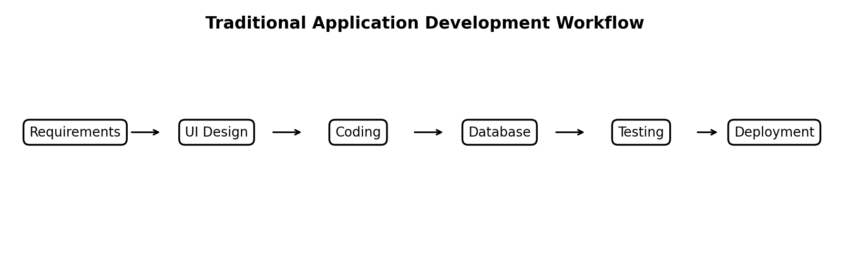
Figure 1: Traditional application development workflow
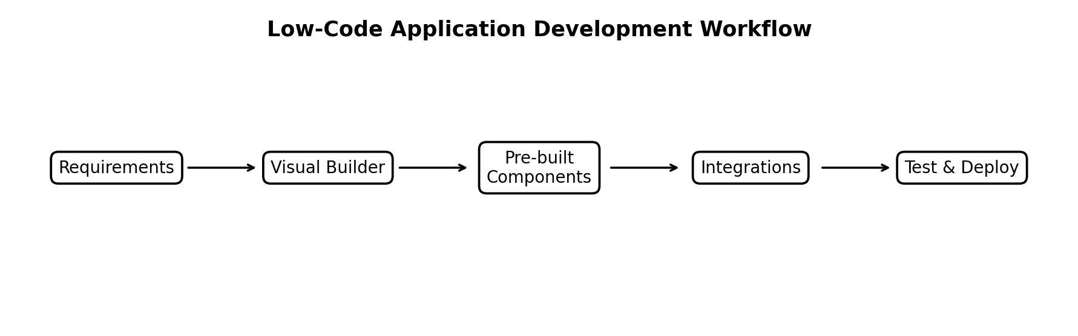
Figure 2: Low-code application development workflow
Aspect | Traditional Development | Low-Code Development
Development approach | Primarily hand-written code | Visual models, drag-and-drop tools and limited code
Development speed | Usually slower for repetitive business applications | Generally faster for suitable application types
Skill requirement | Strong programming and software engineering skills | Can involve both professional developers and business/citizen developers
Customization | Very high; developers control the full stack | High within platform capabilities; extension code may be available
Integration | Often built manually through APIs/SDKs | Pre-built connectors and integration tools can simplify connections
Maintenance | Code, libraries and infrastructure need direct maintenance | Platform handles many underlying concerns, while governance remains necessary
Deployment | Configured through conventional build/release pipelines | Often supported by built-in lifecycle and deployment features
Emerging trends include AI-assisted application development, natural-language interfaces, reusable components, API-first integration, cloud-native deployment, citizen development and stronger governance. Gartner's 2025 research describes enterprise low-code platforms as increasingly incorporating AI-assisted tooling, composable architectures and built-in governance. cite: Gartner, 2025 enterprise low-code research.

3. BENEFITS AND CHALLENGES IN LOW-CODE
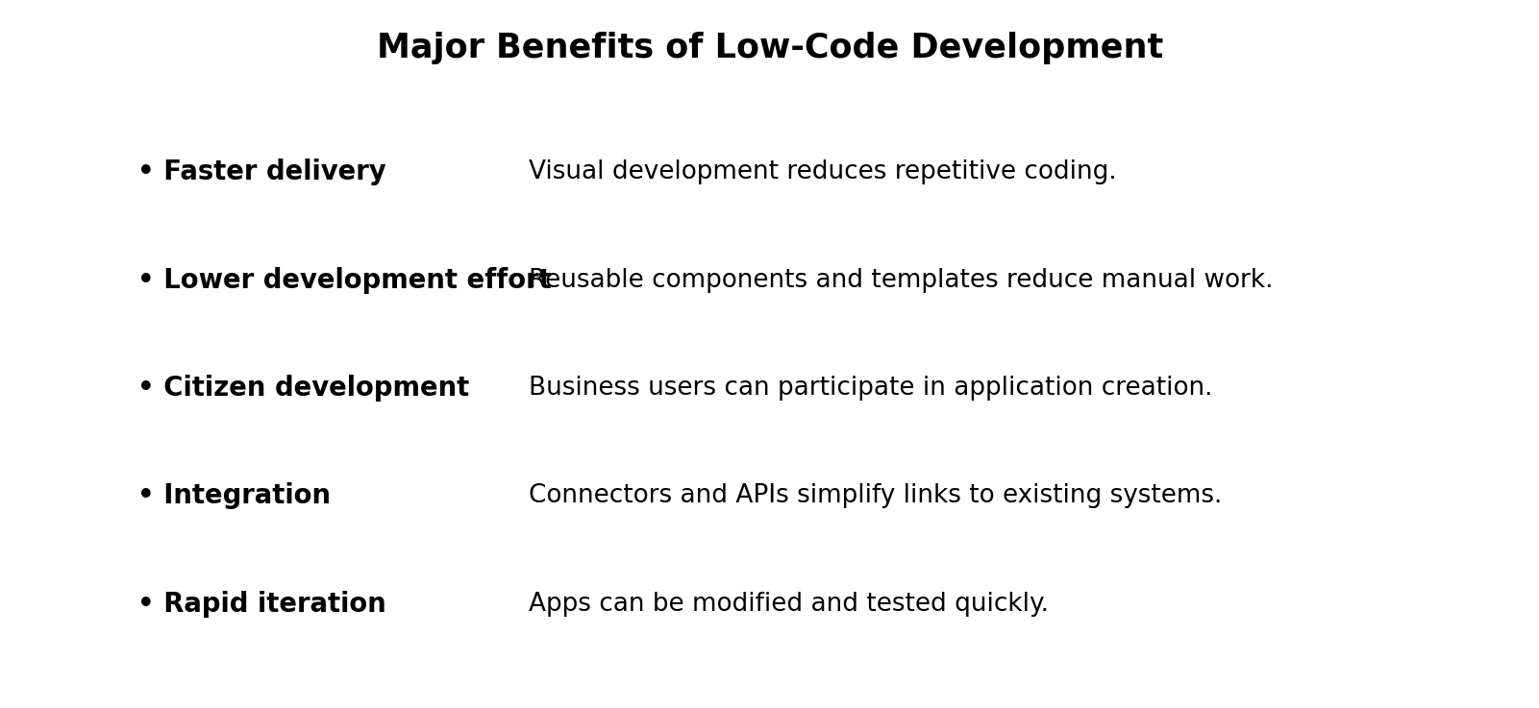
Figure 3: Major benefits of low-code development

Benefits
- Faster application delivery through visual development and reusable components.
- Reduced repetitive coding effort and easier prototyping.
- Greater participation of business users in application development.
- Simplified integration through connectors, APIs and platform services.
- Rapid modification and iteration when business requirements change.
- Useful support for digital transformation and modernization of suitable legacy processes.

Challenges
- Vendor lock-in can make migration to another platform difficult or costly.
- Licensing and platform costs can increase as application usage and users scale.
- Complex applications may still require professional developers and custom code.
- Poor governance can result in duplicated applications, inconsistent standards and security risks.
- Platform limitations may restrict deep customization compared with fully custom development.
- Teams must still address testing, security, compliance, data management and lifecycle maintenance.
Low-code does not eliminate software engineering; it changes where engineering effort is applied. Current industry guidance emphasizes governance, security, lifecycle management and controlled citizen development as adoption expands.

4. COMPARISON OF EXISTING LOW-CODE PLATFORMS
The following comparison considers commonly used enterprise and business-oriented low-code platforms. The table is descriptive rather than a ranking; suitability depends on application complexity, ecosystem, integration requirements, governance and cost.
Platform | Primary Focus | Notable Capability | Typical Use
Microsoft Power Apps | Business applications & workflows | Strong Microsoft ecosystem integration | Internal business apps, forms, workflows
OutSystems | Enterprise application development | Strong application lifecycle and customization capabilities | Complex web/mobile and enterprise apps
Mendix | Model-driven enterprise development | Visual modeling, collaboration and extensibility | Enterprise and industrial applications
Appian | Process automation & case management | Strong workflow/process orchestration | Process-centric enterprise applications
Zoho Creator | Business application development | Rapid app creation within Zoho ecosystem | SMB/business process applications
Google AppSheet | No-code/low-code business apps | Spreadsheet/data-driven app creation | Simple internal and data-driven apps
The 2025 Gartner enterprise low-code landscape included vendors such as Appian, Mendix, Microsoft, OutSystems, Oracle, Salesforce, SAP, ServiceNow and Zoho, illustrating the breadth of the current market.

5. RESULT
The survey was completed successfully. Traditional application development provides extensive control and customization but normally requires more direct programming effort. Low-code development reduces repetitive coding by using visual tools, reusable components, integrations and increasingly AI-assisted capabilities. The study also identified important challenges such as governance, security, scalability, licensing and vendor lock-in. Existing platforms differ in their target users, ecosystem integration and application focus, so platform selection should be based on the specific requirements of the organization and application.

REFERENCES
- Gartner, “Magic Quadrant for Enterprise Low-Code Application Platforms,” 28 July 2025.
- Gartner, “Best Practices for Successful Low-Code Adoption,” 24 June 2025.
- Gartner, “How to Support and Govern Low-Code Applications for Citizen Development,” 17 April 2025.
- Gartner, “Forecast Analysis: Low-Code Development Technologies, Worldwide,” 4 November 2025.
- IEEE Computer Society, “Supporting the Understanding and Comparison of Low-Code Development Platforms,” SEAA 2020.

