COS Assignment 1

Problem 1 :

1. ‘pwd’ command is used to check the current directory and ‘ls - l ‘ is used to list the content,now new directory is created namely ‘Linux Assignments’ by the use of command ‘mkdir’ and later change the current directory to ‘Linux Assignments’.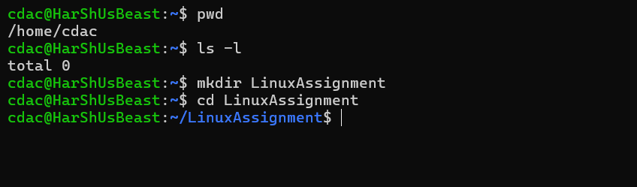
2. To create a new file ‘file.txt’ in a Linux Assignment directory ‘touch’ cmd is used :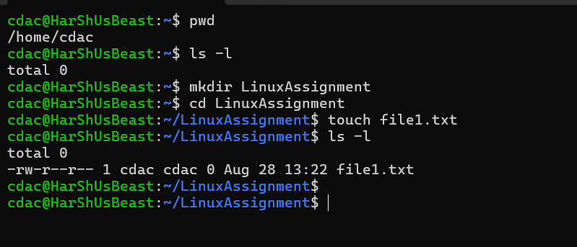
3. To create a new directory ‘mkdir’ cmd is used 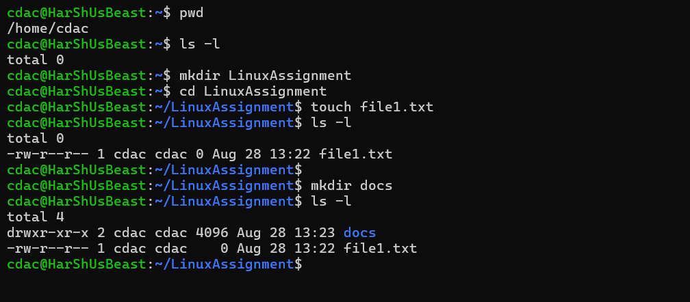
4. To copy file1.txt ‘cp ‘ is used and later to rename tht file ‘mv ‘ cmd is used 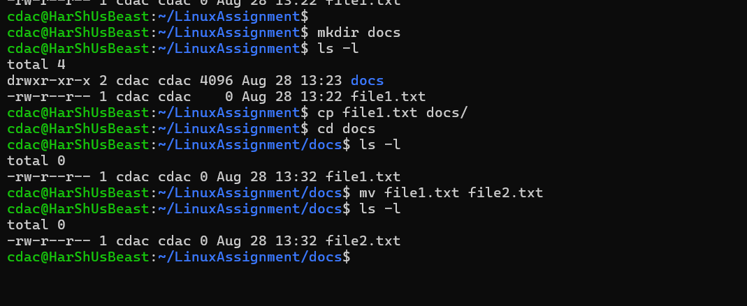
5. To change the permissions of file2.txt ‘chmod’ cmd is used and to change the ownership ‘chown’ is used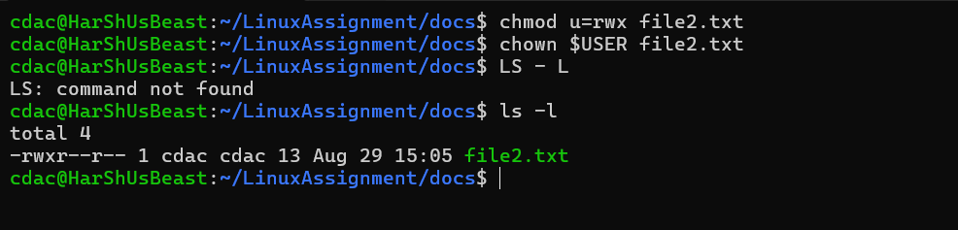
6. 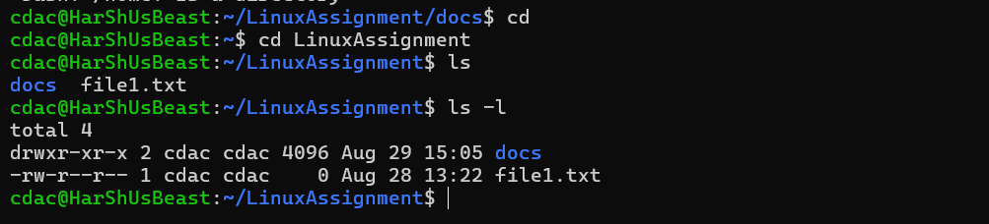
7. a. to search for the all the files of extension .txt 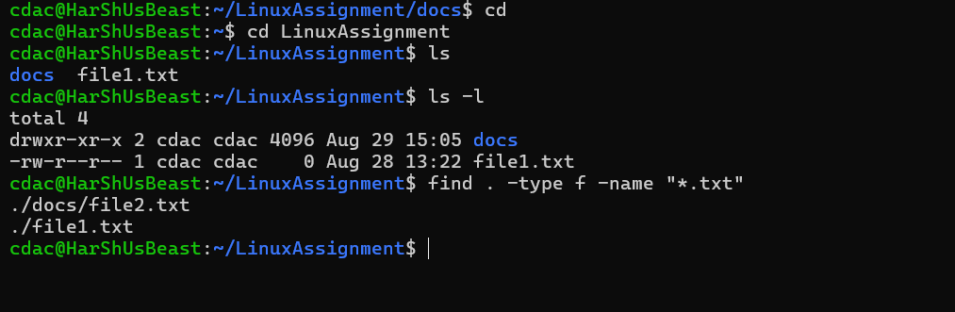

b.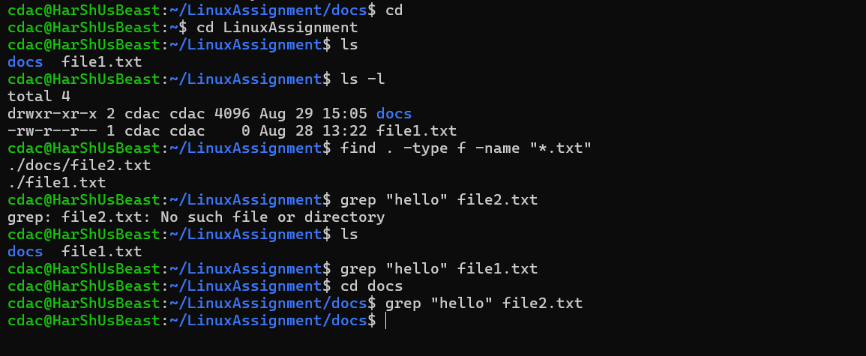

h) 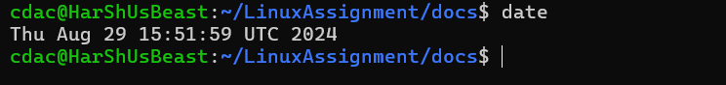

i) the cmd used to display the IP address of the system is ‘hostnme -I’

a. 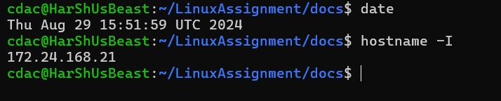

b.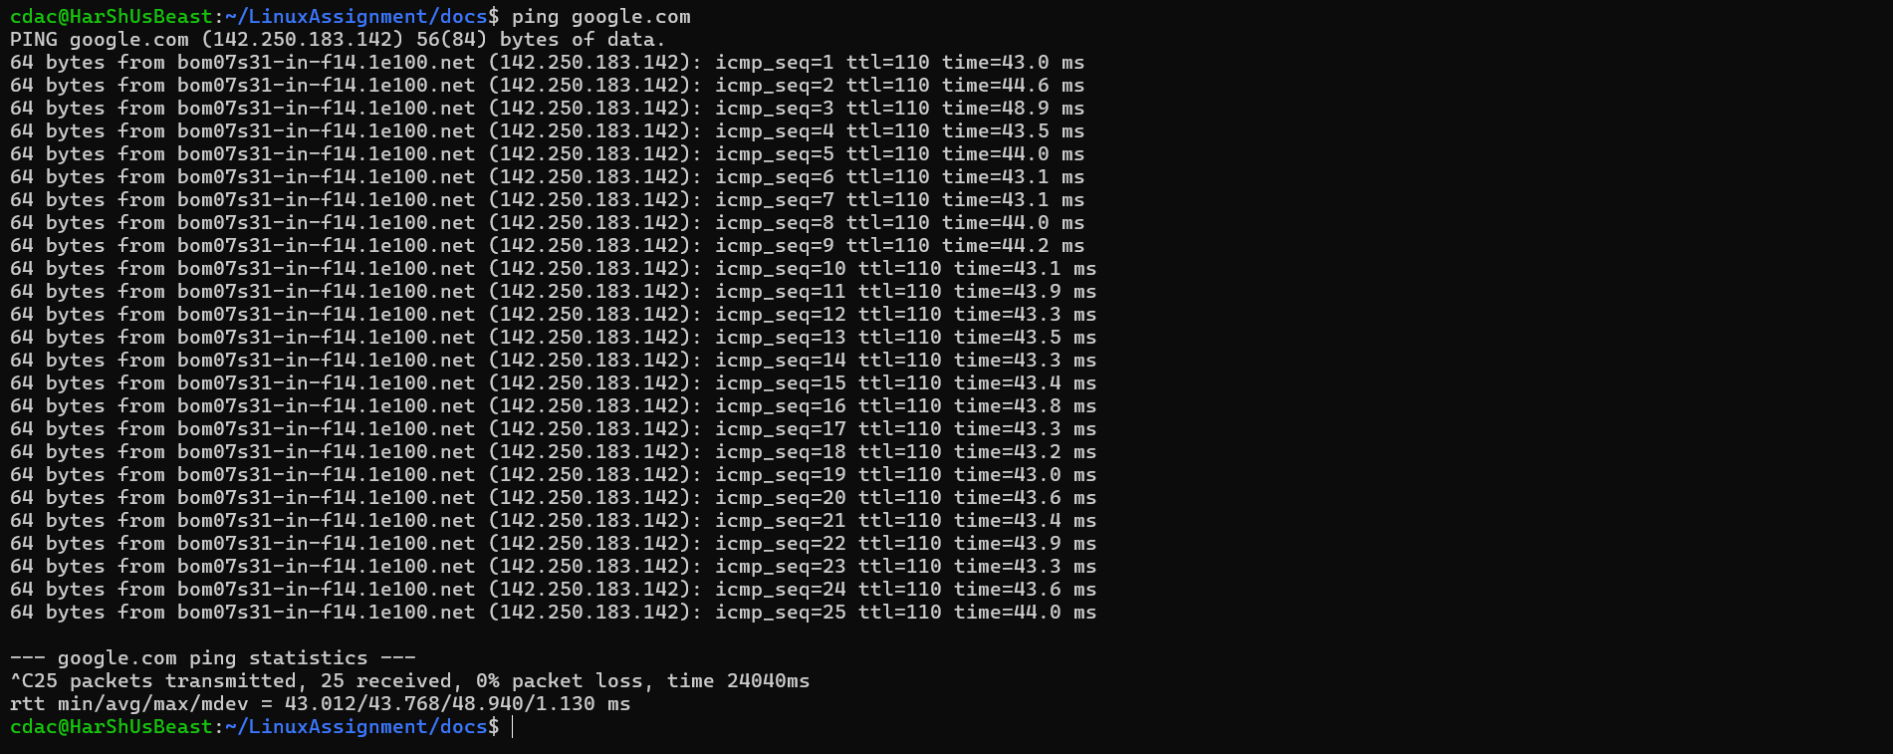

j)

A. Now to compress a file ‘zip’ command is used and if it is not installed, then install it using cmd ‘sudo apt install zip’

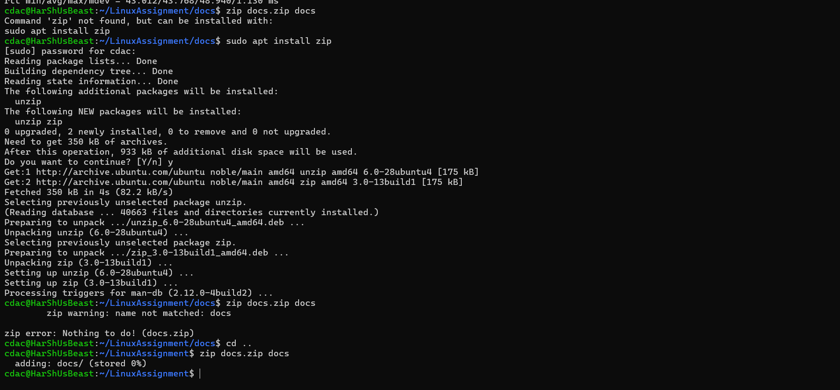

B.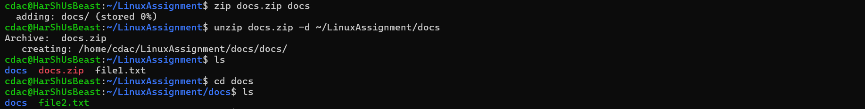

K)

A. To add content to a file ‘nano’ cmd is used 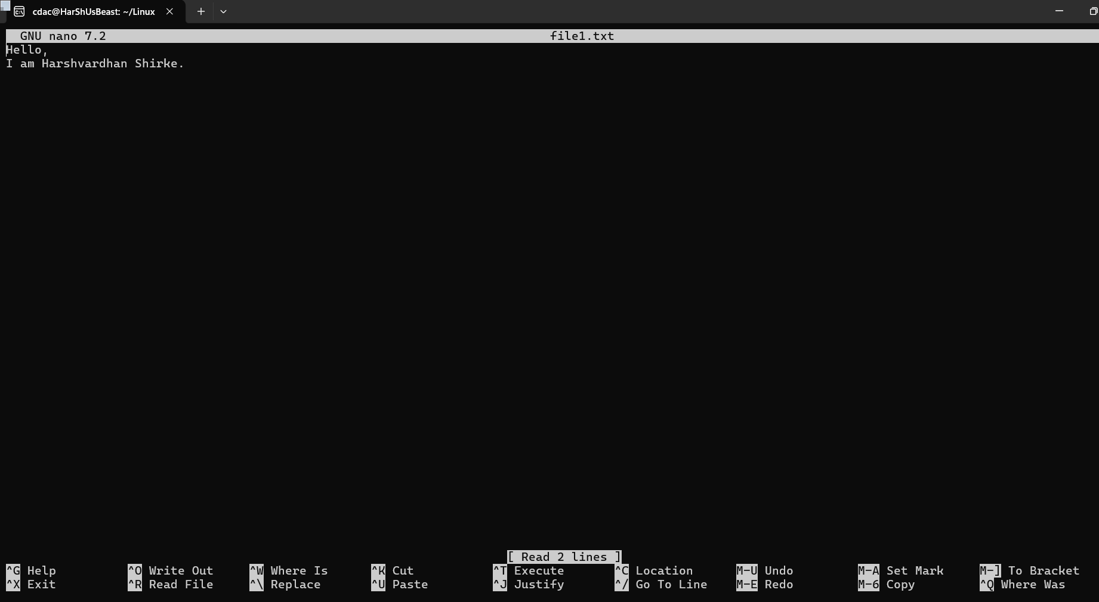

B. 

Problem 2 :

A. 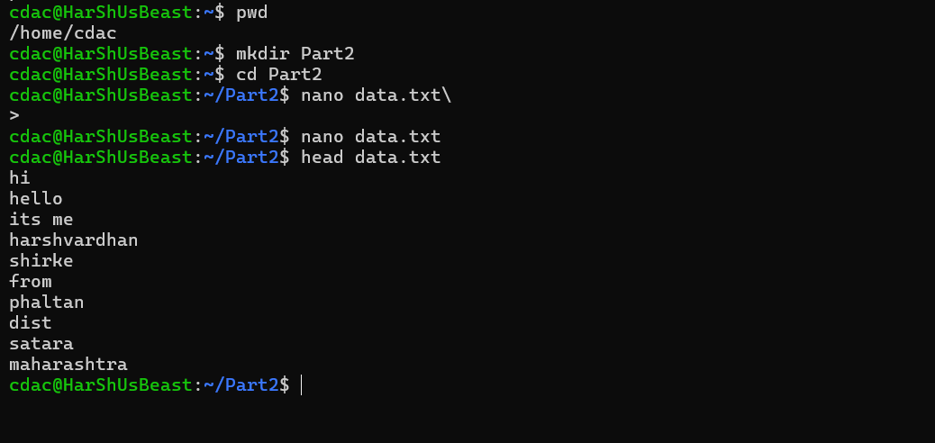

B. 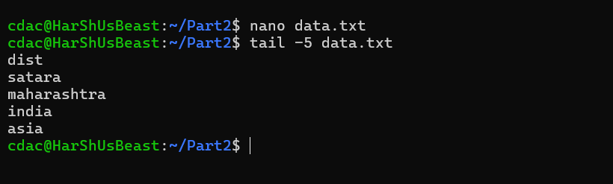

C.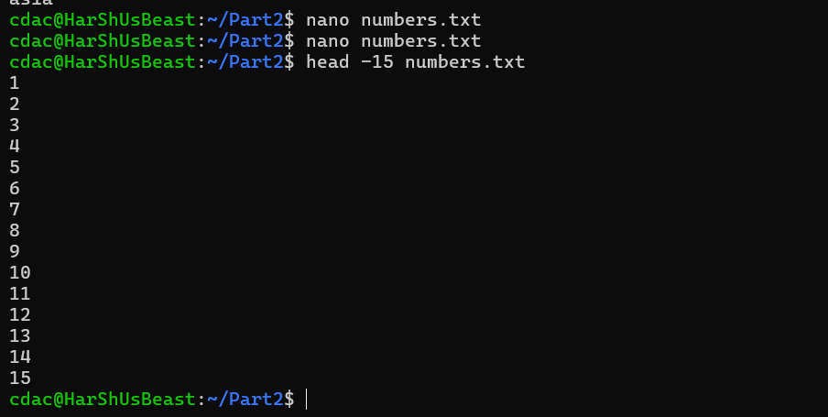

D.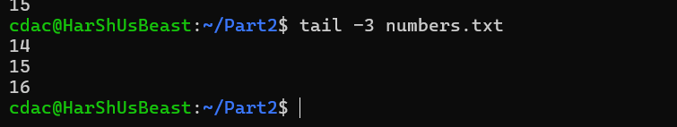

E.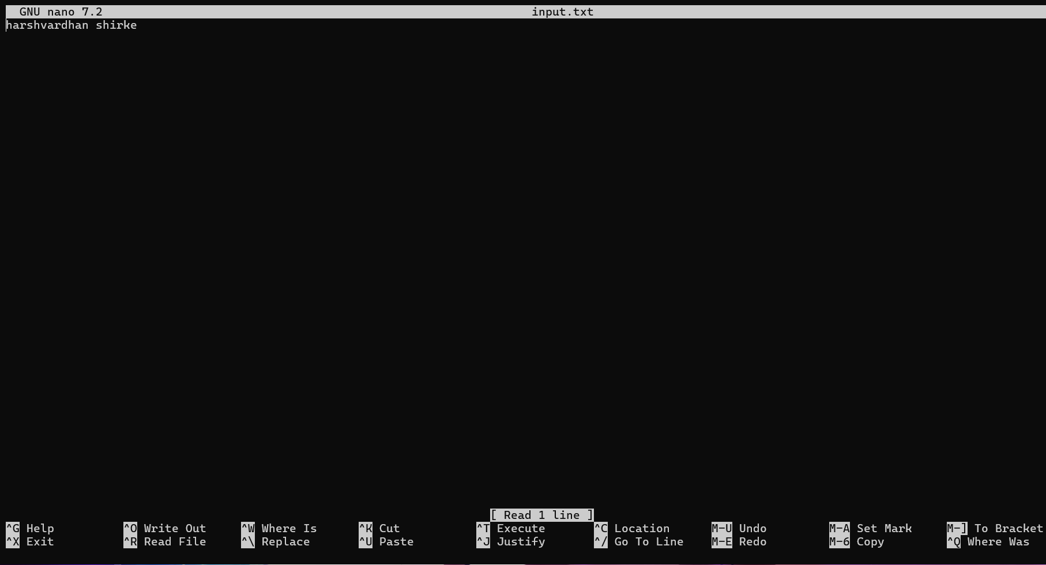

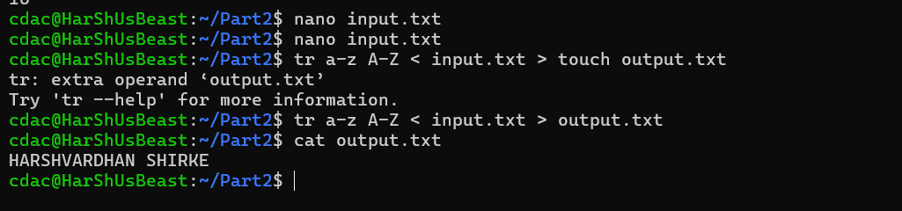

F.

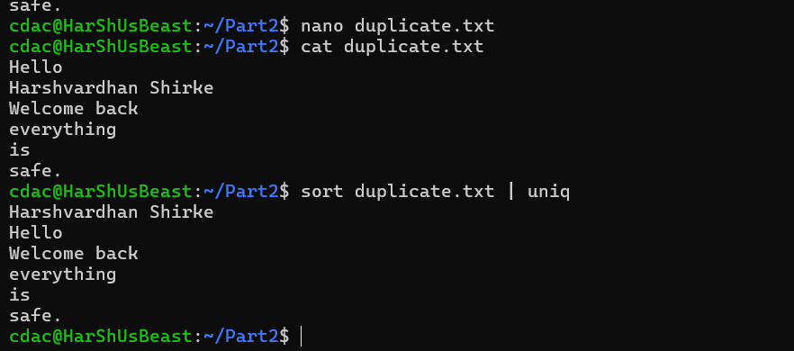

G.