1. Block Diagram

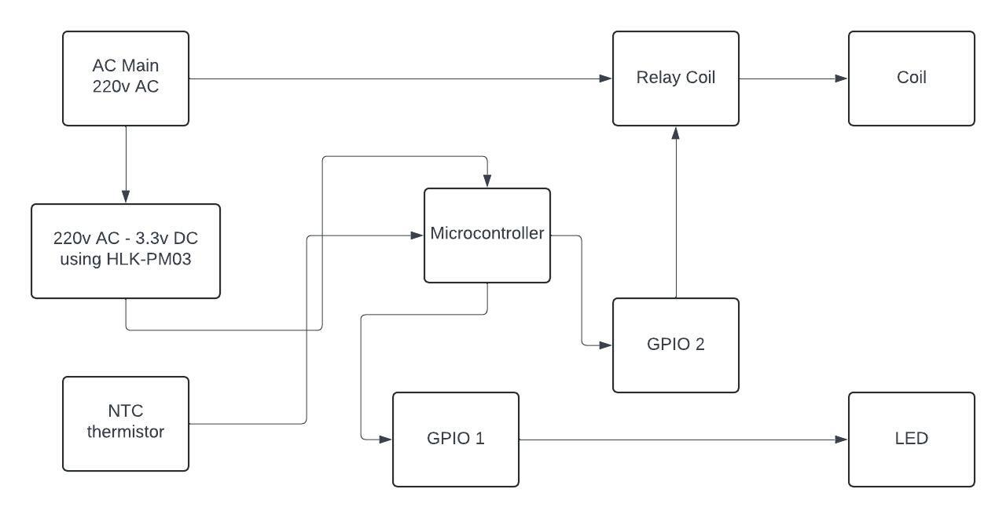

1. Schematic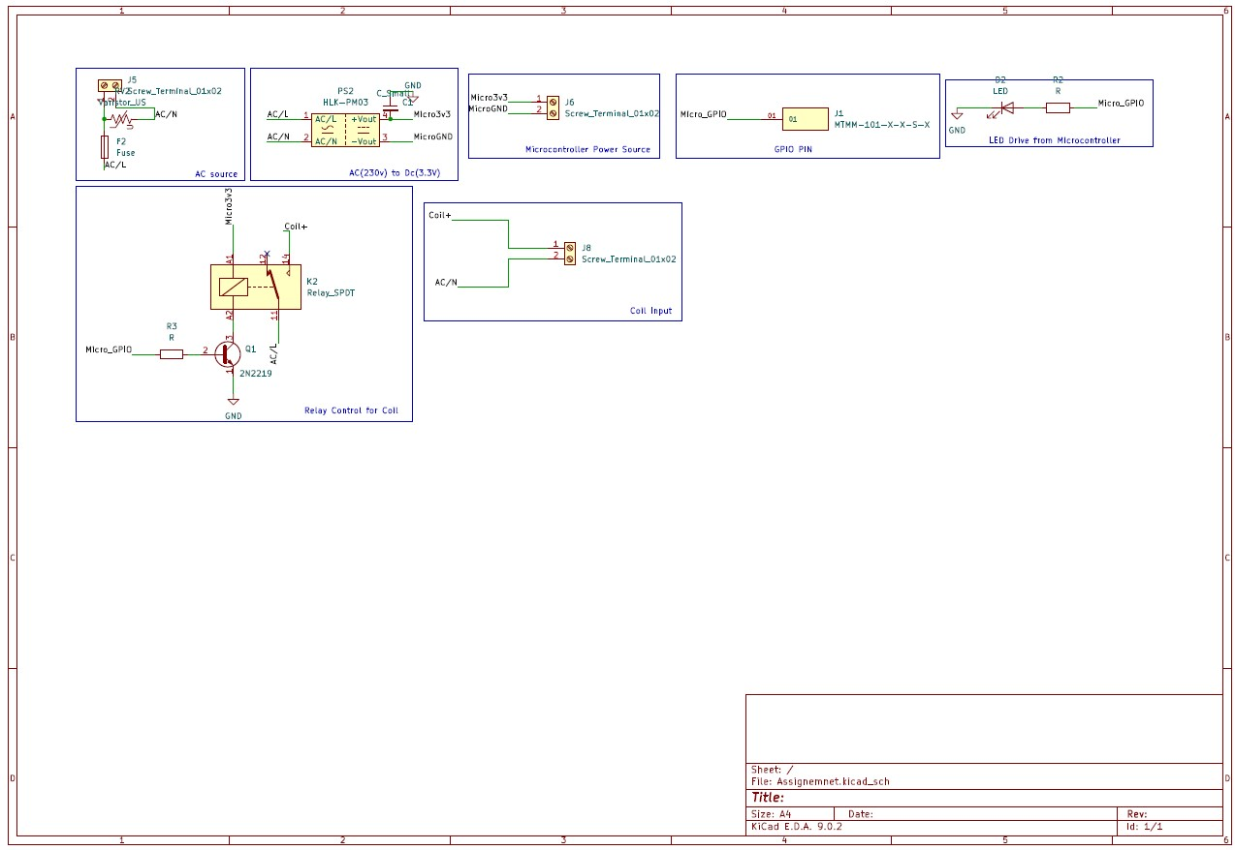
2. Explanation
   1. Power Flow: First the 220v AC is directly taken from the socket. The fuse is used to protect the PCB from high voltage and varistor is used for power surge.
   2. Sensor and relay logic: The relay is in normally open(NO) configuration. The 220V AC from mains is directly connected to one side of relay switch and the heater coil line pin is connected to another side of relay switch. Both neutral line are connected common. The relay is controlled by a microcontroller. Since the relay may consume more current we have used npn transistor 2N2219, through which we control relay. The base of the transistor is connected to GPIO pin, emitter is grounded and collector is connected to one side of the coil (A2) the another end of the coil is connected with 3.3v(A1). When microcontroller send “High” signal, the transistor turn on and connects to ground which make the circuit complete and relay will switch on.

To turn on buzzer/LED, the one side of LED is connected to one of GPIO pin of microcontroller and other side is connected with ground.

* 1. Safety & Fallback: At the input side we have used fuse to protect the PCB from high voltage and varistor is used for power surge. We can use thermos-fuse to protect from any malfunction that may occur while controlling temperature.
  2. Testing:

|  |  |  |
| --- | --- | --- |
| Test ID | Condition | Expected Behavior |
| T1 | Temperature < 60°C | Heater turns ON (relay energized) |
| T2 | Temperature reaches 90°C | Heater turns OFF (relay de-energized) |
| T3 | Temperature slowly cooling | Heater turns back ON once < 60°C |
| T4 | MCU disabled / removed | Thermal fuse / thermostat cuts heater power |

1. Working:

We can use Arduino software to dump following code to work for the given requirement.

* 1. Control Heater

int led_pin=3;

float temperature = read_temperature_from_adc();

if (temperature >= 90.0) {

digitalWrite(RELAY_PIN, LOW); // turn OFF heater

digitalwrite(led_pin, low)

}

else if (temperature <= 60.0) {

digitalWrite(RELAY_PIN, HIGH); // turn ON heater

digitalwrite(led_pin, high);

}

* 1. Data Logging

Serial.print("Temperature: ");

Serial.println(temperature);

Serial.print("Heater State: ");

Serial.println(digitalRead(RELAY_PIN));

1. PCB Layout: PCB size(60mmx40mm)

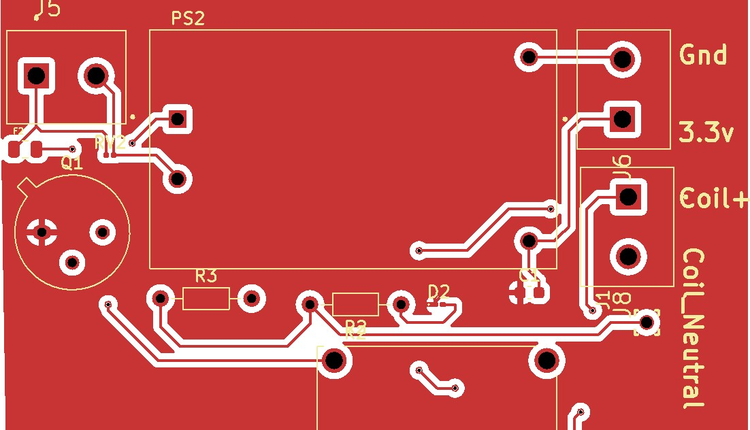

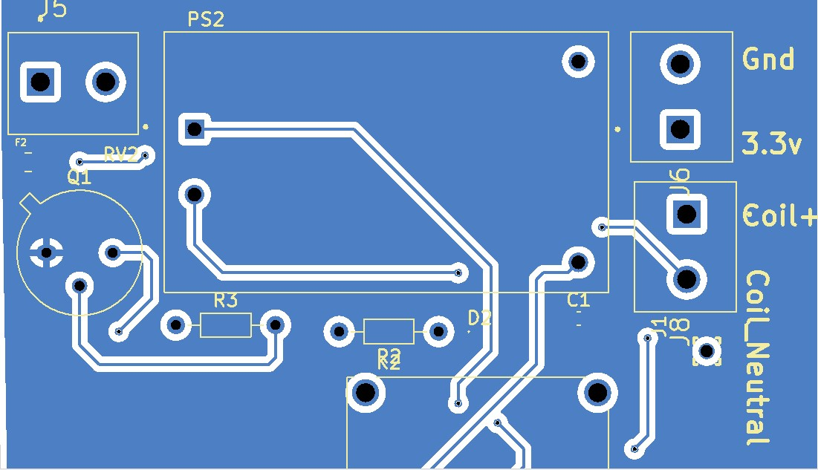

Repository link for Gerber and all other necessary document: https://github.com/harshu022511/PCB_Assignemnt.git