DEPARTMENT OF COMPUTER ENGINEERING

**GROCERY MARKET**

SPRINT BACKLOG 1 (VIRTURAL MOUSE)

* **IMPLEMENTING DIFFERENT GESTURE**
  + **NEUTRAL, V- SHAPE,ETC**

SPRINT BACKLOG 2 (GESTURE RECOGNITION)

* **INDEX FINDER , PALM GESTURE , L- SHAPE GESTURE**

# ARCHITECTURE DIAGRAM

SPRINT BACKLOG 3

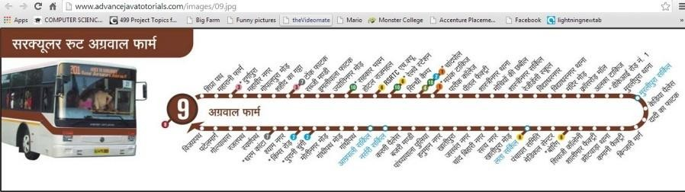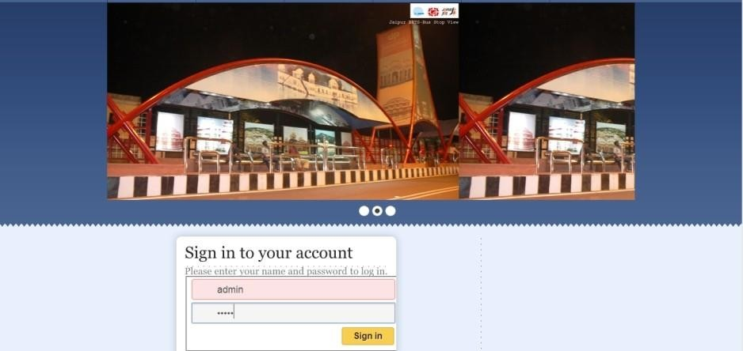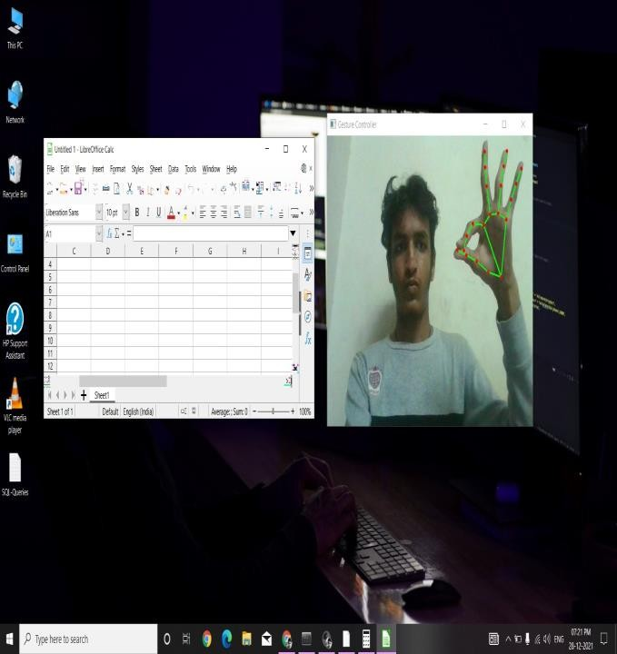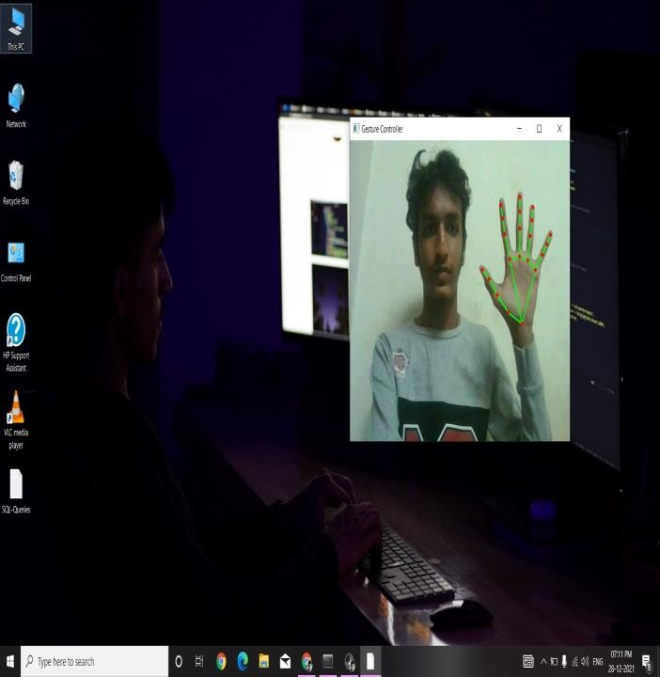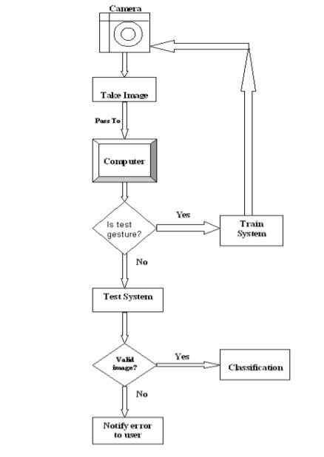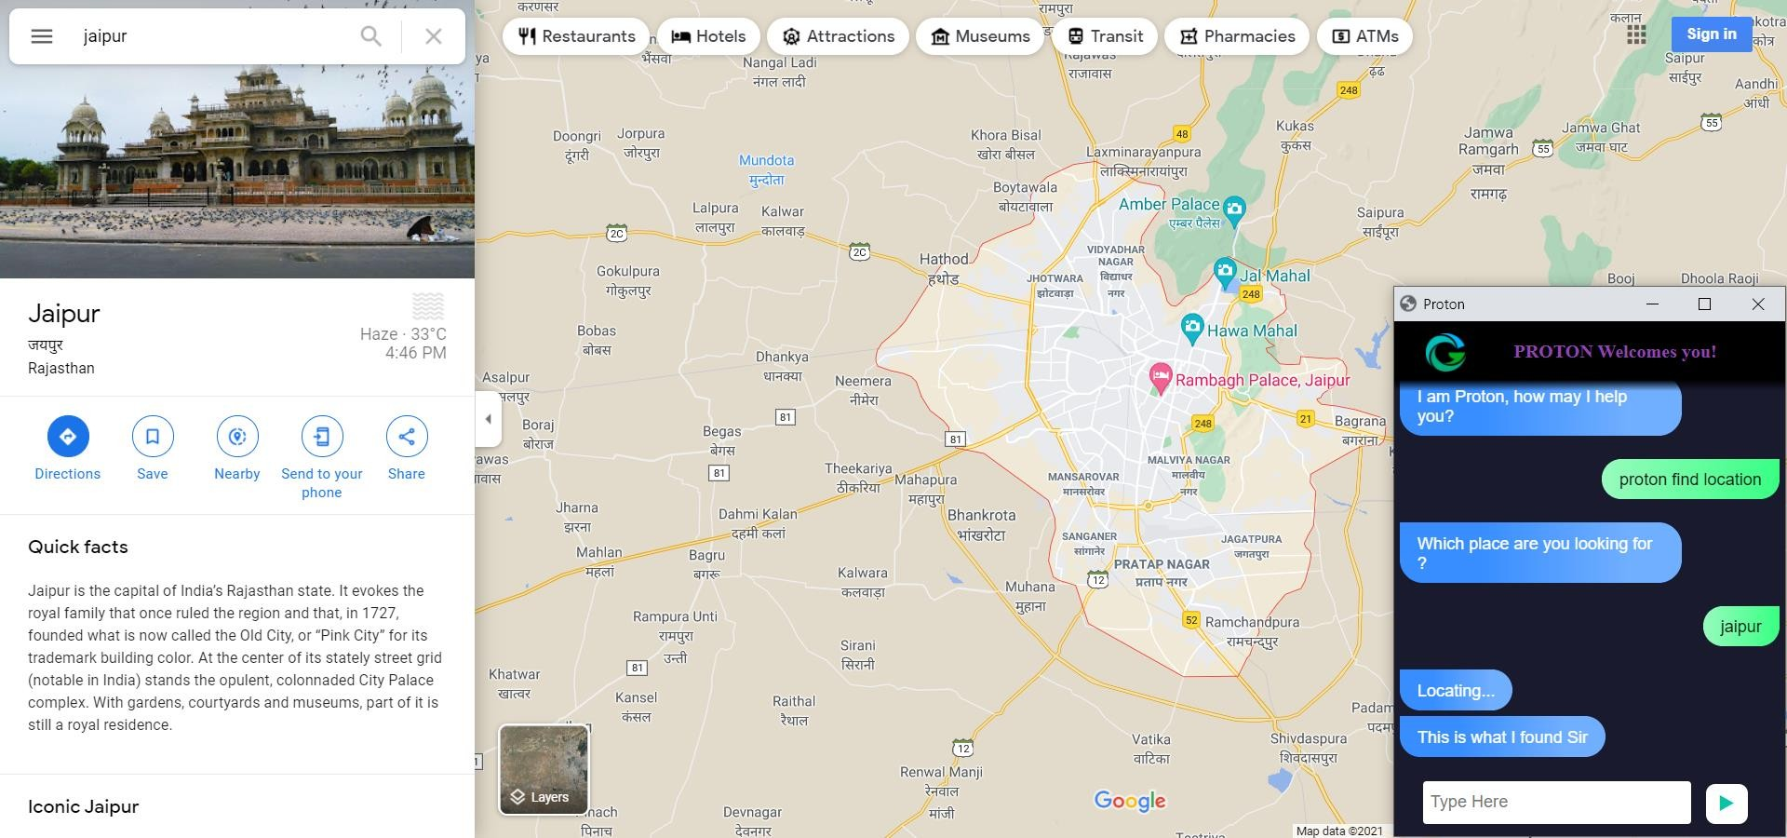

* **PROTON CHAT BOX**
  + **VOICE COMMAND CONTROL**

SPRINT BACKLOG 4 (FEATURES)

* **CURENT TIME COPY PASTE**

# APPLICATIONS

## IN SCHOOLS

* **COMPANIES**

## COLLEGES

|  |  |  |
| --- | --- | --- |
|  |  | **PROJECT GUIDE : MR. DEEPAK MOUD**  **HOD , PIET CS** |
| **PRJ21-22/04** | **AYUSH JAIN (CS/18/34), BHAVANI SHANKAR PUROHIT (CS/18/37), DHRUV SEVAK (CS/18/48)** | |