**CSI3007 – Advanced Python Programming**

**Lab Activity 6 (01-08-2025)**

**NAME : R.SONALI**

**REG NO : 22MID0061**

**Python Dictionary Quiz**

**Team Quiz:**

**Participants:**

Sonali R

Madayanthikaa R

Harshini Supriya J

Sriharsh S

Sushank S N

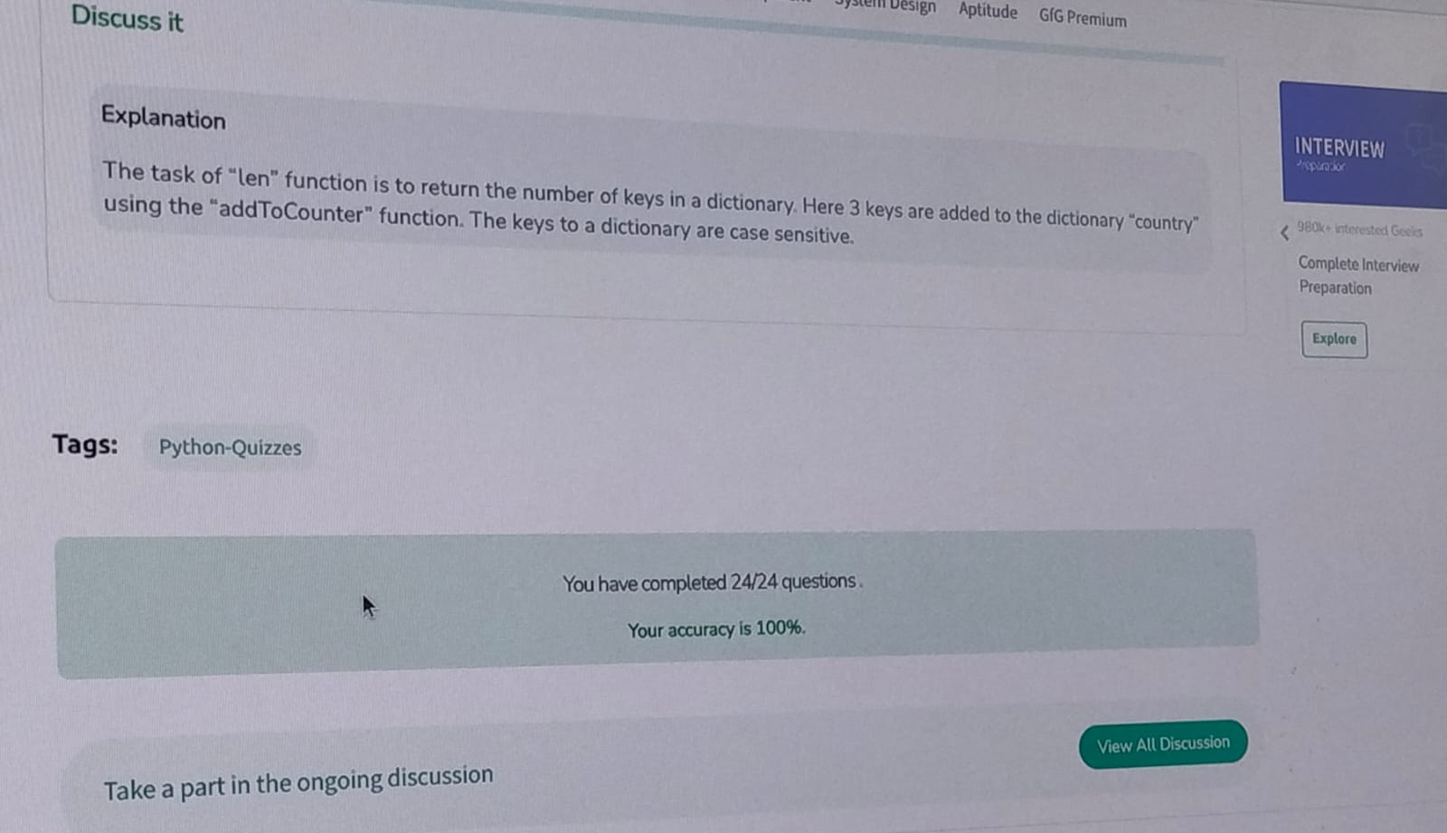

**Answered in LAB:**

Which method can be used to safely add a new key-value pair without overwriting existing keys?

A) dict.get()

✅ B) dict.setdefault()

C) dict.pop()

D) dict.update()