*A*

*Mini Project Report On*

# “Responsive Online Blogging System”

*Submitted By*

***Mr. Sudhakar S. Nagtilak (TYCSE_69) Mr. Siddharth S. Salunkhe (TYCSE_70) Mr. Shankar V. Chavan (TYCSE_71) Mr. Prasad S. Chinchkar (TYCSE_72)***

*Under the Guidance of*

***Prof. M. S. Koli***

*For The Award of the Degree of*

### Bachelor of Technology



DEPARMENT OF COMPUTER SCIENCE AND ENGINEERING

### S K N SINHGAD COLLEGE OF ENGINEERING

**Korti, Pandharpur 2021-2022**

### DEPARTMENT OF COMPUTER SCIENCE AND ENGINEERING

**SKN SINHGAD COLLEGE OF ENGINEERING**

### Korti, Pandharpur

CERTIFICATE

*This is to certify that, report entitled*

***“Responsive Online Blogging System”***

*Submitted by*

***Mr. Sudhakar S. Nagtilak (TYCSE_69) Mr. Siddharth S. Salunkhe (TYCSE_70) Mr. Shankar V. Chavan (TYCSE_71) Mr. Prasad S. Chinchkar (TYCSE_72)***

*In the partial fulfilment for the award of the Degree of*

***Bachelor Of Technology***

*This Dissertation work is a record of student’s own work carried out by him under my supervision and guidance during the academic year*

***2021-2022***

|  |  |  |  |
| --- | --- | --- | --- |
| Prof. M. S. Koli | Prof. S. V. Pingale | Prof. M. S. Koli | External |
| *Project Guide* | *Head of The Department* | *Project Coordinator* | Examiner |

# Acknowledgment

We have great pleasure in presenting this project report on **“Responsive Online Blogging System”** we take this opportunity to express sincere appreciation and deep sense of gratitude to our project guide **Prof. M. S. Koli** for his whole hearted cooperation, valuable guidance and perpetual encouragement, which had a great influence in bringing this project to success. We remain ever indebted to him for the keen interest shown and moral support offered all through pursuance of this work.

We also express our sincere thanks to, **Prof. S. V. Pingale** Head, Dept. of Computer Science and Engineering for extending all the facilities required for this project work. We express our sincere thanks to principal **Dr. K. J. Karande** for extending all facilities required for this project work.

We express our heartfelt thanks to all our colleague friends for their constant encouragement and full cooperation whenever required.

**Mr. Sudhakar S. Nagtilak (TYCSE_69) Mr. Siddharth S. Salunkhe (TYCSE_70) Mr. Shankar V. Chavan (TYCSE_71) Mr. Prasad S. Chinchkar (TYCSE_72)**

We the undersigned hereby declare that the declaration entitled **“Responsive Online Blogging System”** submitted by us to SKN Sinhgad College Of Engineering, Pandharpur for the award of the degree of Bachelor of Engineering in Computer Science and Engineering, under the guidance of Prof. M. S. Koli is our original work. We further declare that to the best of our knowledge and belief, this work has not been submitted to this or any other university.

**Mr. Sudhakar S. Nagtilak (TYCSE_69) Mr. Siddharth S. Salunkhe (TYCSE_70) Mr. Shankar V. Chavan (TYCSE_71) Mr. Prasad S. Chinchkar (TYCSE_72)**

A blog is a type of website of part of a website. Blogs are usually maintained by an individual with regular entries of commentary, descriptions of events, or material such as graphics or image. Entries are commonly displayed in reverse chronological order. Blog can also be used as a verb, meaning to maintain or add content to a blog. Educators are using blogs in many ways including as online portfolios, for teachers and students for provision of course content, as a record of field notes, as discipline specific spaces for knowledge sharing, as a space for student dialogue and for class administration.

A major contribution to knowledge comes from the paper’s analysis of the motivation behind blogging – providing a framework of seven different motivational schemes. Building on this, the paper explores why blogs are a valuable and reliable source of data for analysis. The paper illustrates how blogs can be used for analysis, highlighting the advantages and disadvantages of their use. The paper concludes with a brief note on some of the ethical considerations of using blogs for research.

**CONTENTS**

1. INTRODUCTION 01
   1. PROJECT INTRODUCTION 01
   2. WHY WE CHOOSE THIS PROJECT 01
   3. BENEFITS OF PROJECT 02
   4. APPLICATIOS 02
   5. SCOPE OF THE PROJECT 02
2. LITERATURE REVIEW 03
3. PROPOSED WORK 05
   1. PROBLEM STATEMENT. 05
   2. OBJECTIVE. 05
4. METHODOLOGY 06
5. PROJECT DESIGN. 07
   1. Data Flow Diagram 07
      1. Level 0 DFD 07
      2. Level 1 DFD. 08
      3. Level 2 DFD. 09
   2. UML Diagram 10
      1. Use Case Diagram 11
      2. Activity Diagram 12
      3. Sequence Diagram 13
6. SYSTEM TREQUIREMENTS. 14
   1. SOFTWARE REQUIREMENTS 14
   2. HARDWARE REQUIREMENTS 14
7. IMPLEMENTATION. 15
   1. Admin/User Interface Design. 15
      1. INTERFACE DESIGN: (Important Screenshots of Front End).16 i) Front Page of Website. 16
         1. User Registration Page. 16
         2. Admin/User Login Page. 17
         3. Admin Home Page 17
         4. User Home Page 17
         5. User Blogs Page 18
         6. Blog Create Page 18
         7. User Blog Categories Page 18
   2. Database Design. 19
      1. DATABASE TABLES: (Important Screenshots of table) 19
8. Shows database Tables 19
9. Blogs Table 20
10. Blog Categories Table 20
11. Editor Choice Table 20
12. Membership Users Table 21
13. Membership Groups Table 21
14. Page Hints Table 21
15. RESULT 22
16. CONCLUSION. 23
17. REFERENCES. 24

|  |  |  |
| --- | --- | --- |
| 4.1 | System Model | 06 |
| 5.1 | Level 0 DFD | 07 |
| 5.2 | Level 1 DFD | 08 |
| 5.3 | Level 2 DFD | 09 |
| 5.4 | Use Case Diagram | 11 |
| 5.5 | Activity Diagram | 12 |
| 5.6 | Sequence Diagram | 13 |
| 7.1 | Front Page of Website | 16 |
| 7.2 | User Registration Page | 16 |
| 7.3 | Admin/User Login Page | 17 |
| 7.4 | Admin Home Page | 17 |
| 7.5 | User Home Page | 17 |
| 7.6 | User Blogs Page | 18 |
| 7.7 | User Blogs Page | 18 |
| 7.8 | User Blog Categories Page | 18 |

|  |  |  |
| --- | --- | --- |
| 7.1 | Shows database Tables | 19 |
| 7.2 | Blogs Table | 20 |
| 7.3 | Blog Categories Table | 20 |
| 7.4 | Editor Choice Table | 20 |
| 7.5 | Membership Users Table | 21 |
| 7.6 | Membership Groups Table | 21 |
| 7.7 | Page Hints Table | 21 |

1. **INTRODUCTION OF PROJECT**

### PROJECT INTRODUCTION:

Blogging has become such a mania that a new blog is being created every second of every minute of hour of every day. A blog is your best bet for a voice among the online crowd. Blog were usually the work of a single individual occasionally of a small group, and often covered a single subject. More recently, “multi-author blogs” (MABs) have developed, with posts written by large numbers of authors and professionally edited. MABs from newspapers, other media outlets, universities, link tanks, advocacy groups, and similar institutions account for an increasing quantity of blog traffic. The rise of Twitter and other “microblogging” systems helps integrate MABs and single author blogs into societal new streams. Blog can also be used as a verb, meaning to maintain or add content to a blog. A novel is a long, fictional narrative which describes intimate human experiences.

WEBLOG is a combination of both Blog as well as Novels. Blog contain the Information of various things related to Technology, Education, News, International, Business, Sports, Entertainment and ongoing college activities. The main aim of this project is to provide data to students in only one site. Student can gather the information from one site as well as create their own blog. Student can post their views and thought and analyze themselves. Besides all such core functionalities, so as to provide a satisfactory experience.

### WHY WE CHOOSE THIS PROJECT:

In recent past time Blogs are store in the paper files and difficult to search or modify any information, for expanding the Blogs infrastructure, Awareness of environmental issues or any other issues related to education, health, digital technology, and search for greater safety give to information to all persons in all age groups and a new role within the education system, our group choose this project. As a result of these project initiatives phenomenal growth has taken place

in all the activities of blogs and any user can share its information related to any topic to all users.

### BENEFITS OF PROJECT:

This is a very simple design and implement. It has got following features:

* + - Data can be saved safely.
    - No other person cannot view other person’s detail
    - Greater efficiency
    - User friendliness
    - Minimum time required to process any action
    - Free of cost

### APPLICATIOS:

WEBLOG enables the users to create innovative and attractive information with photo in just few simple steps. The user just needs to upload some images of his choice and can also upload the information or can select from the given category list. This website will provide a personalized environment that contain the data in motion with images.

### SCOPE OF THE PROJECT:

* + - To use the personal images in greeting our loved ones.
    - To use the music of our choice to greet in the language we want.
    - To provide a personalized contents to the customers.
    - To satisfy the customers and provide them with the ordered images before time.

## LITERATURE REVIEW

There are many blog platforms out there that are miles ahead of the competition, offering the perfect mix of basic functionality and advanced features. These blog platforms each have their own unique take on just what blogging should be, so it’s important to consider their differences as well as their unifying characteristics.

**WordPress (Self-Hosted or Hosted)**

WordPress is one such advanced blogging tool and it provides a rich set of features. Through its Administration Panels, blogger can set options for the behaviour and presentation of its weblog. Via these Administration Panels, blogger can easily compose a blog post, push a button, and be published on the internet, instantly! WordPress goes to great pains to see that your blog posts look good, the text looks beautiful, and the html code it generates conforms to web standards. Matt Mullenweg and Mike Little were co-founders of the WordPress project. The core contributing developers include Ryan Boren, Mark Jaquith, Matt Mullenweg, Andrew Ozz, and Peter Westwood. Automatic manages the servers, the distribution and the management of the product. They also operate WordPress.com, which is a hosted version of WordPress. If users of WordPress don’t have their own server or don’t have web development background, they could sign up on WordPress.com and get an account which would give they access to their own WordPress blog.

**Blogger (Hosted)**

Blogger is a blog-publishing service that allows private or multi-user blogs with time-stamped entries. Generally, the blogs are hosted by Google at a subdomain of Blogspot.com. Blogspot.com is a weblog-hosting service run by the folks who make Blogger. Blogger has been around for quite awhile, bought by Google in 2003. Although Blogger has made many improvements over the years, people making the choice between it and WordPress typically go with the latter. All such blogs had to be moved to Google's own servers, with domains other than Blogspot.com

allowed via Custom URLs. Blogger is a good choice for those looking for a hosted platform and an easy setup (none really) to get started. Blogger supports drag- and-drop template editing, dynamic updating, geo-tagging for location-based blogging, and easy publication from editing tools like Google Docs, Microsoft Word, and Windows Live Writer.

**Movable Type (Self-Hosted or Hosted)**

Movable Type is a powerful all-in-one tool that lets you create blogs and entire websites with one platform. Movable Type has several notable features when it comes to blog management. This application supports static page generation and is backed by a huge community. Similar to WordPress, Movable Type offers a free self-hosted package (MovableType.org) as well as a service for non- developers who would like to host their blog for free (MovableType.com) and also user can have multiple user accounts on your MovableType blog. Movable Type is written in Perl, and supports storage of the weblog's content and associated data within MySQL natively. It stores posts, comments, and the like in a database just like WordPress does, but it creates static HTML pages from that data. This arrangement makes Movable Type a little leaner when serving up content, but publishing a post can take more time because each index page needs to be rebuilt.

**TypePad (Hosted)**

TypePad is another blogging site that has gained a reputation through its user friendly interface and ease of use. TypePad was launched in 2003 and it comes from Live Journal’s buyer, Six Apart. TypePad is based on Movable Type’s platform with the two sharing the same templates, technology and APIs. TypePad was Six Apart’s platform for the non-technical blogger. Unlike most blogging sites, TypePad is not free, but users do get their own .com domain names. TypePad is based on Movable Type platform, also shares technology with Movable Type like templates and APIs, but is marketed to users and includes additional features like multiple author support, photo albums and mobile blogging.

## PROPOSED WORK

### PROBLEM STATEMENT:

* + - To build and develop a responsive online blogging system.

### OBJECTIVE:

* + - To create responsive and user-friendly blog sharing website.
    - To develop a platform for users, where they can refer a new articles, new posts, latest information and case studies.
    - Knowledge transformation with the help of social platforms.

**MODULE:**

## METHODOLOGY

View Blog and Create

Blog

Login and Registration

Manage Blog

Fig.4.1: System Module

* + - **Login and Registration**

If user wants to upload a post on this site, it is necessary for the user to register first. Therefore this module allows the user to register on this site. While registration, users need to fill the details like name, Email-id, password. Once the users has registered, he can directly login any time.

* + - **Search Blog and Create blog**

In this module user are able to search blog and that blog, if user want to add new blog then he can create new blog.

* + - **Manage Blog**

In this module user can update blog and delete blog.

## PROJECT DESIGN

### Data Flow Diagram:

A Data Flow Diagram (DFD) is a traditional visual representation of the information flows within a system. A neat and clear DFD can depict the right amount of the system requirement graphically. It can be manual, automated, or a combination of both.

### Level 0 DFD:

The Level-0 DFD, also called context diagram of the result management system is shown in Fig.5.1

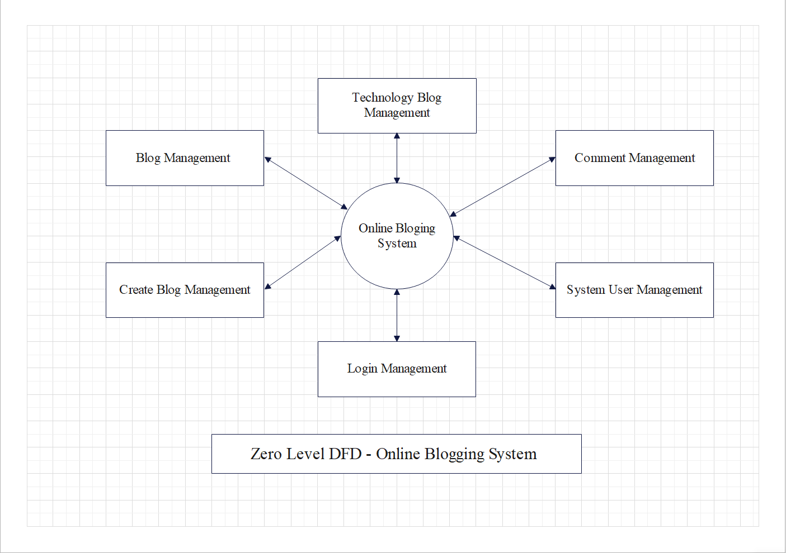

**Fig.5.1. Level 0 DFD**

* + 1. **Level 1 DFD:**

In 1-level DFD, a context diagram is decomposed into multiple bubbles/processes. In this level, we highlight the main objectives of the system and breakdown the high-level process of 0-level DFD into subprocesses.

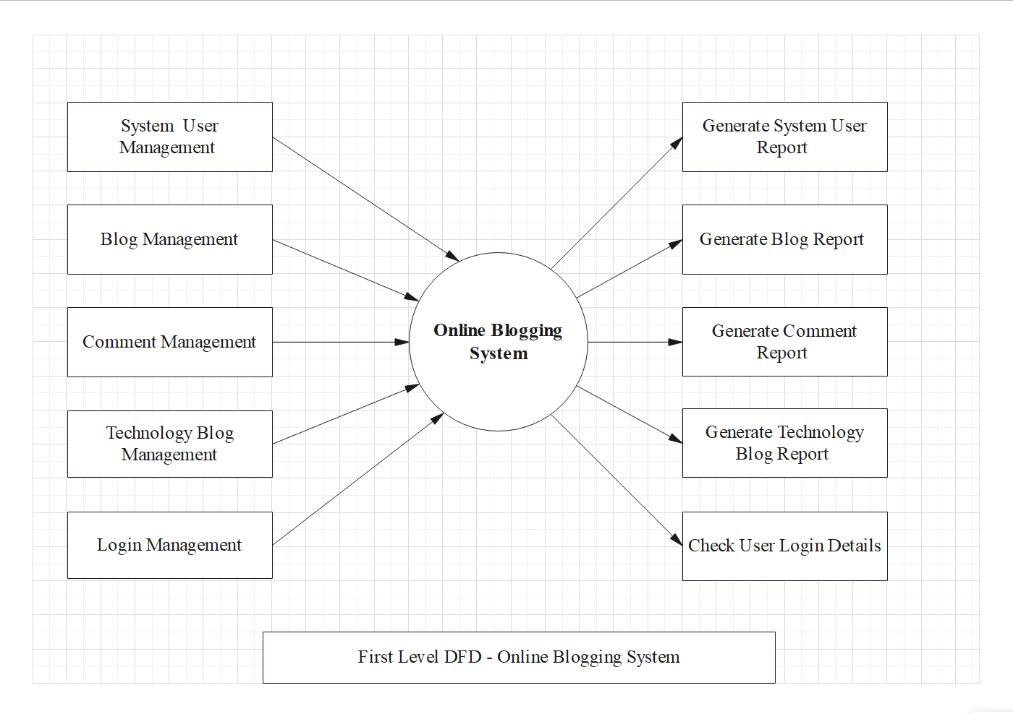

**Fig.5.2. Level 1 DFD**

### Level 2 DFD:

2-level DFD goes one process deeper into parts of 1-level DFD. It can be used to project or record the specific/necessary detail about the system's functioning.

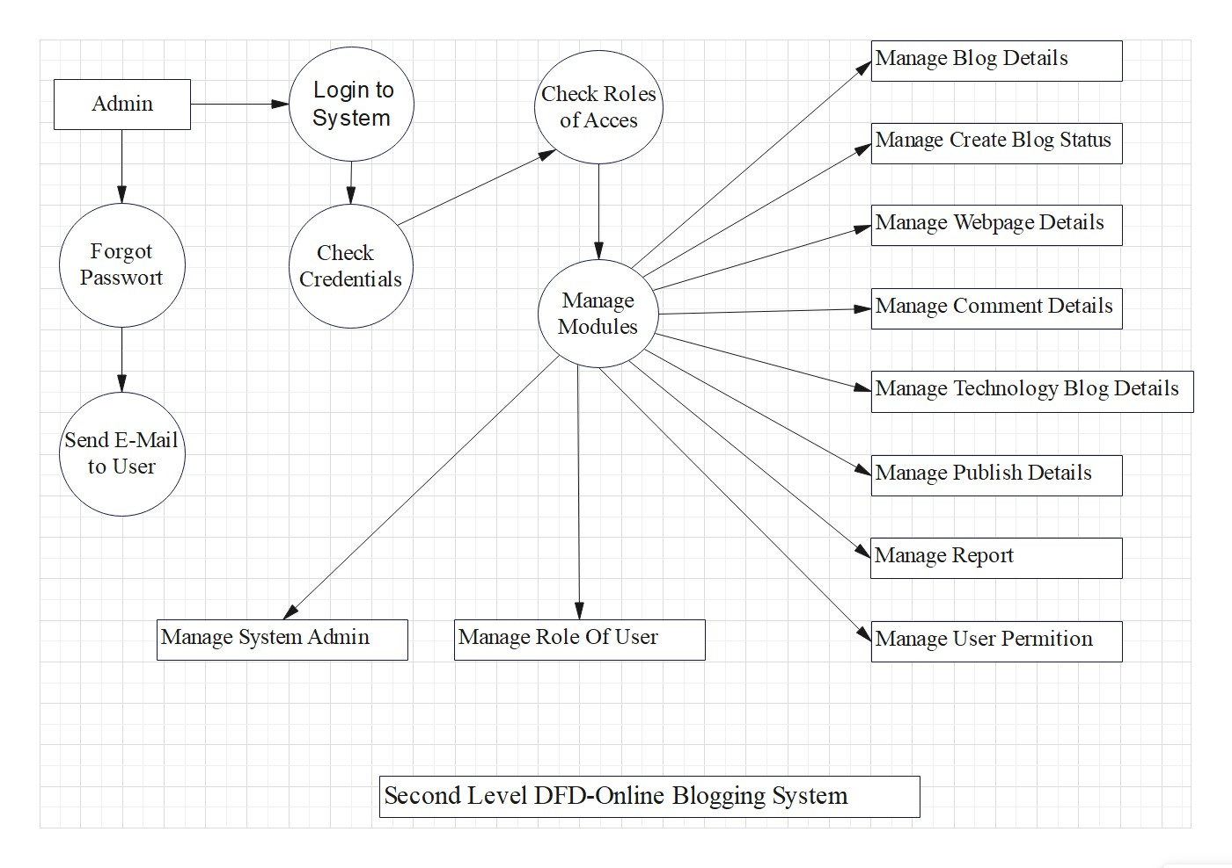

### Fig.5.3. Level 2 DFD

### UML Diagram:

The Unified Modeling Language is a standard visual modeling language intended to be used for modeling business and similar processes, analysis, design and implementation of software based systems. There are number of goals for developing UML but the most important is to define some general purpose modeling language which all modelers can use and also it means to be made simple to understand and use. UML diagrams are not only made for developers but also business users, common people and anybody interested to understand the system. The system can be software or non software. So it must be clear that UML is not development method rather it accompanies with processes to make a successful system.All the other element are used to make it complete one.

**UML include the following nine diagrams:**

1. Use Case Diagram
2. Activity Diagram
3. Sequence Diagram

### Use Case Diagram:

A use case diagram at its simplest is a representation of users interaction with the system that shows the relationship between the user and different use cases in which the user is involved.

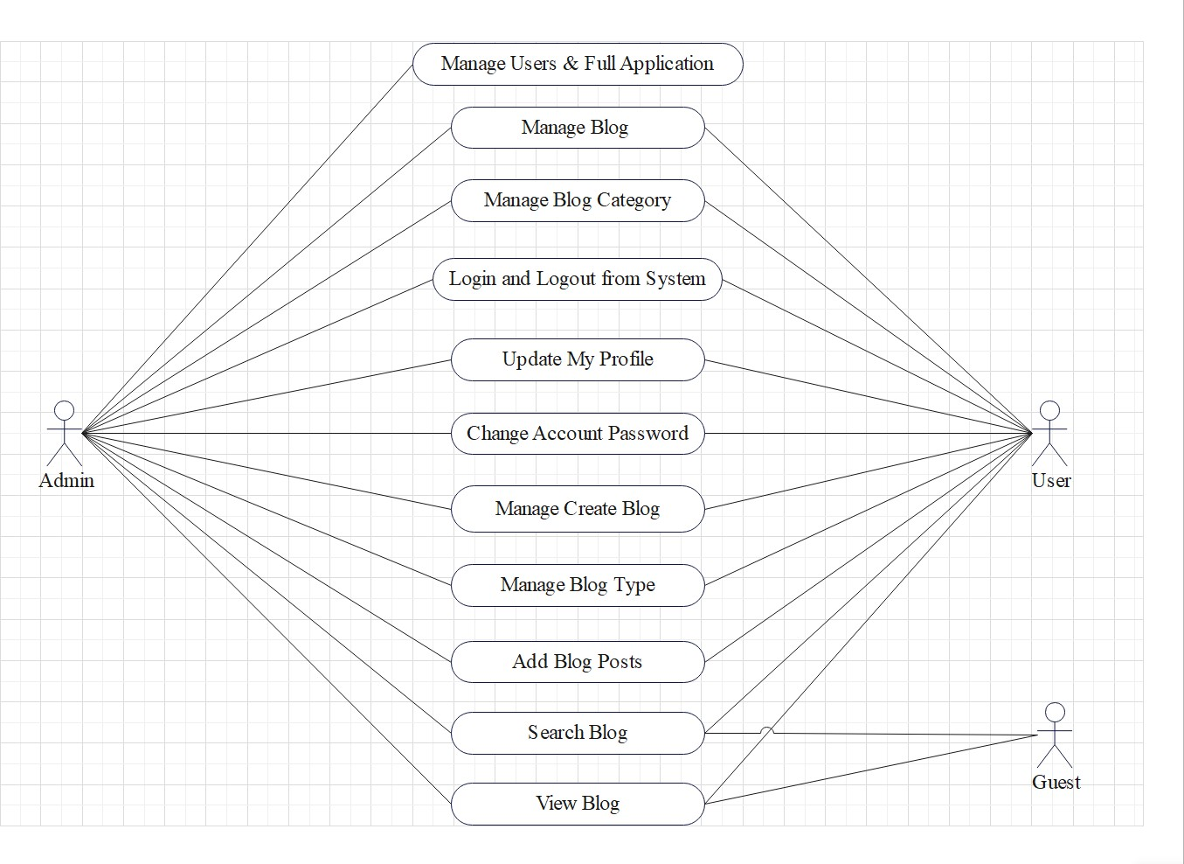

**Fig.5.4. Use Case Diagram**

### Activity Diagram:

An activity diagram illustrates one individual activity. In our context, an activity represents a business process. Fundamental elements of the activity are actions and control elements (decision, division, merge, initiation, end, etc.)

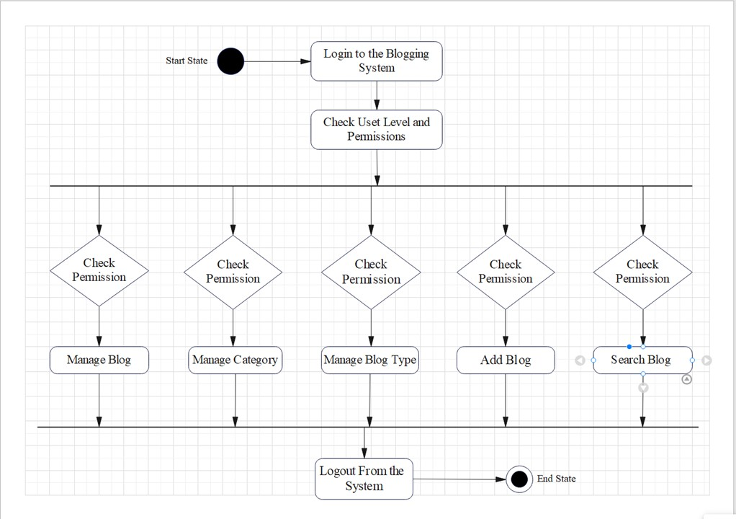

**Fig.5.5. Activity Diagram**

### Sequence Diagram:

A sequence diagram is an interaction diagram. From the name it is clear that the diagram deals with some sequences, which are the sequence of messages flowing from one object to another. Interaction among components of a system is very important from implementation and execution perspective. So sequence diagram is used to visualize the sequence of calls in a system to perform a specific functionality.

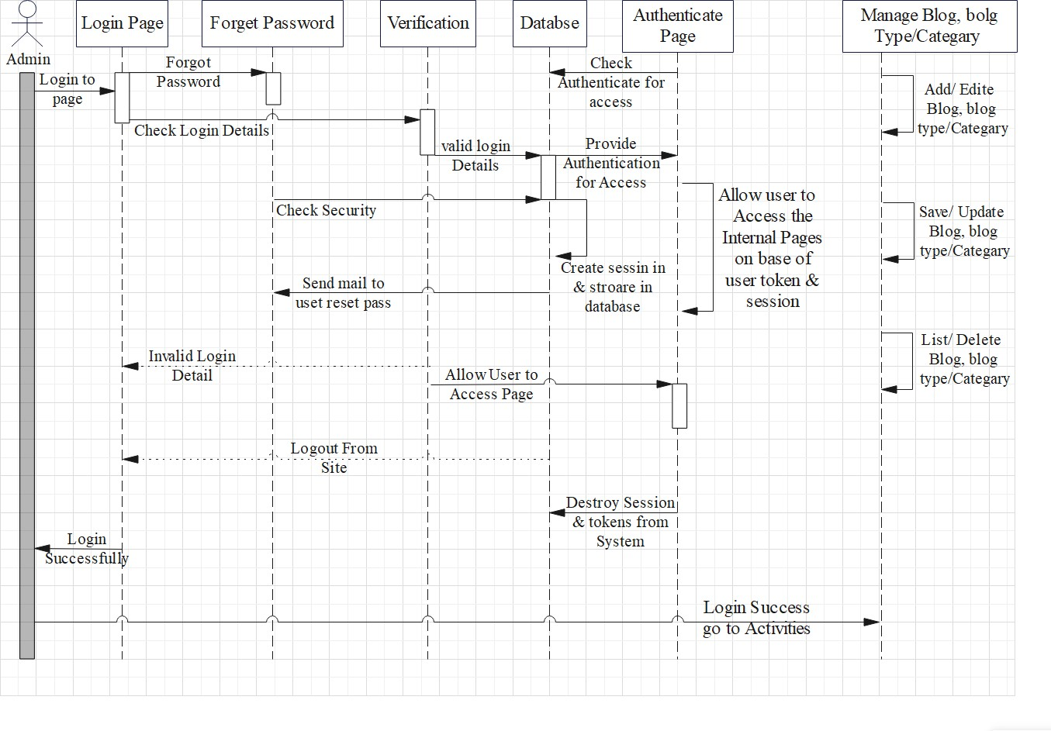

**Fig.5.6. Sequence Diagram**

## SYSTEM TREQUIREMENTS

### SOFTWARE REQUIREMENTS:

* + - Operating System: Windows
    - Front End: HTML, CSS, JavaScript
    - Back End: PHP
    - Database: MySQL
    - Xampp Server
    - Web Browser
    - Tool Used: VS code

### HARDWARE REQUIREMENTS:

* + - Processor: Minimum dual core processor
    - Hard Disk: 512GB Minimum
    - RAM: 4GB Minimum
    - Mouse
    - Keyboard

## IMPLEMENTATION DTAILS

Implementation is the stage in the project where the theoretical design is turned into the working system and is giving confidence to the new system for the users

i.e. will work efficiently and effectively. It involves careful planning, investigation of the current system and its constraints on implementation, design of method to achieve the changeover, an evaluation, of change over methods. A part from planning major task of preparing the implementation is education of users. The more complex system is implemented, the more involved will be the system analysis and design effort required just for implementation. An implementation coordinating committee based on policies of individual organization has been appointed. The implementation process begins with preparing a plan for the implementation for the system. According to this plan, the activities are to be carried out, discussions may regarding the equipment phase. The most critical stage is in achieving a successful new system and in giving the users confidence that the new system will work and be effective.

### Admin/User Interface Design:

Admin/User Interface Design is concerned with the dialogue between a user and the computer. It is concerned with everything from starting the system of logging into the system to the eventually presentation of desired inputs and outputs. The overall flow of screens and messages is called a dialogue.

**The following steps are various guidelines for Admin/User Interface Design:**

* + - The system admin/user should always be aware of what to do next.
    - The screen should be formatted so that various types of information, instructions and messages always appear in the same general display area.
    - Message, instructions or information should be displayed long enough to allow the system admin/user to read them.
    - Use display attributes sparingly.
    - Default values for fields and answered to be entered by the admin/user should be specified.
    - A use should not be allowed to proceed without correcting an error.
    - The system admin/user should never get an operating system message or fatal error.

**7.1.1) INTERFACE DESIGN: (Important Screenshots of Front End)**

1. **Fig.7.1. Front Page of Website:**

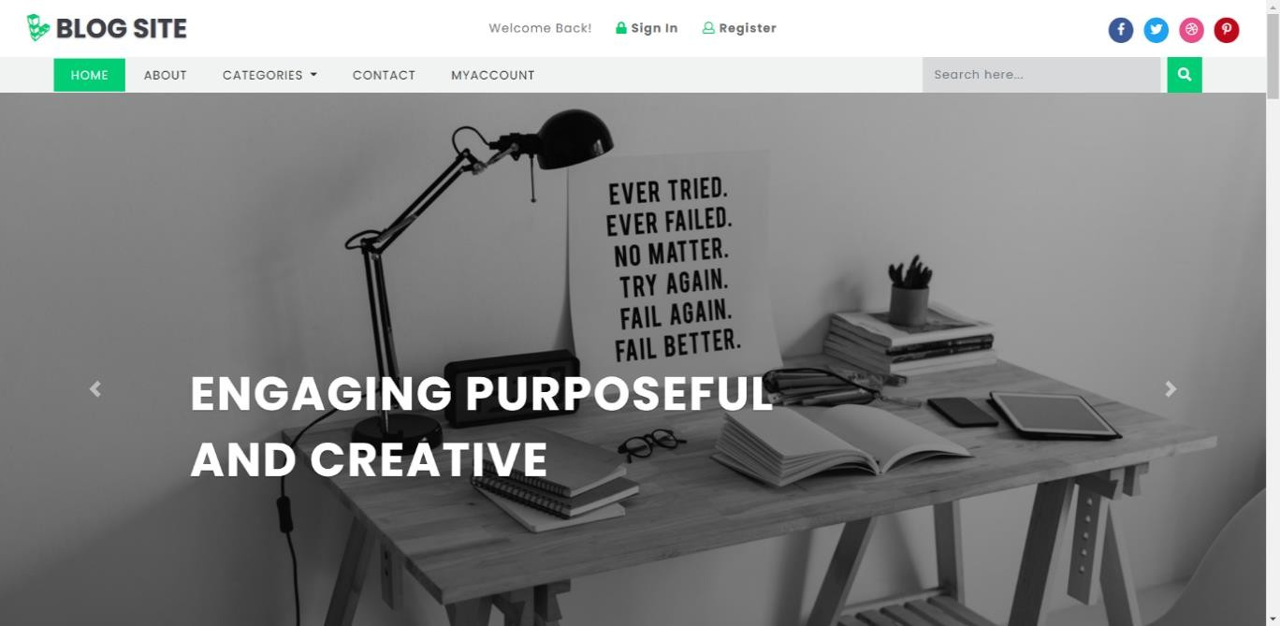

1. **Fig.7.2. User Registration Page:**

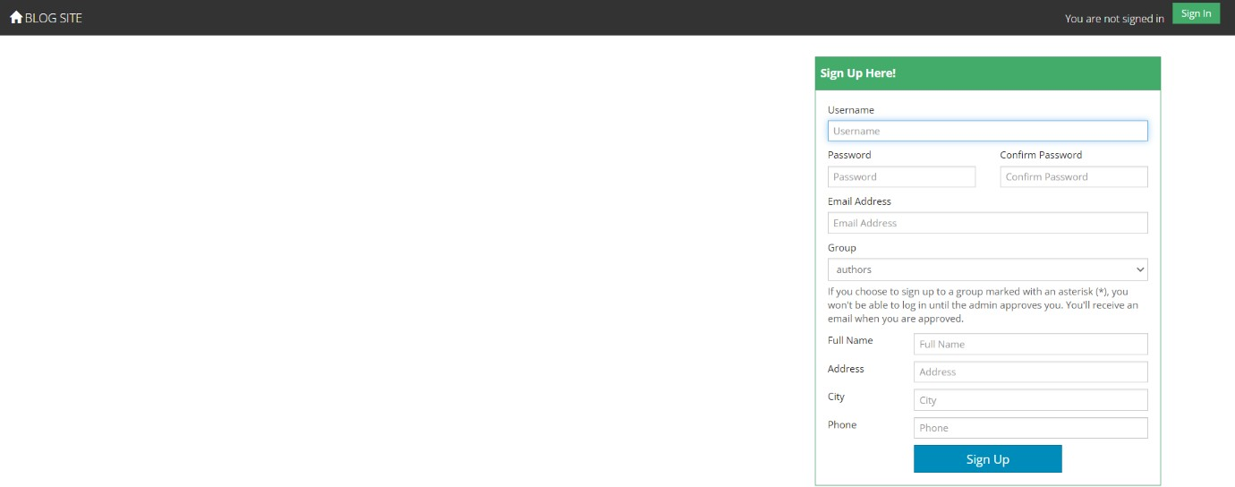

1. **Fig.7.3. Admin/User Login Page:**

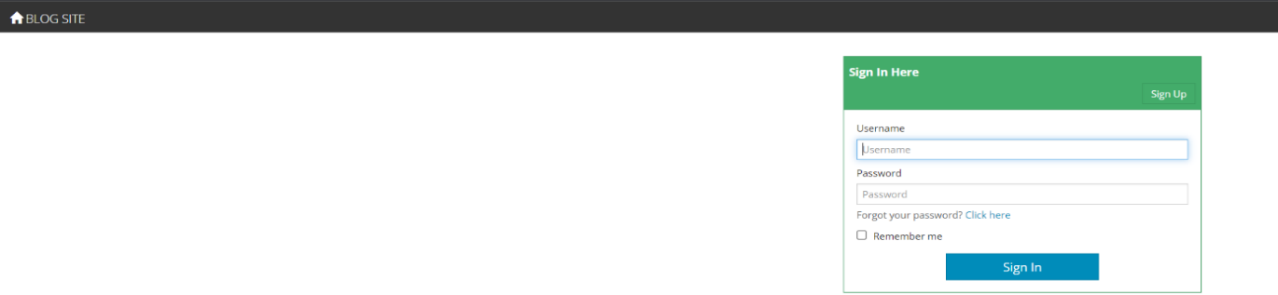

1. **Fig.7.4. Admin Home Page:**

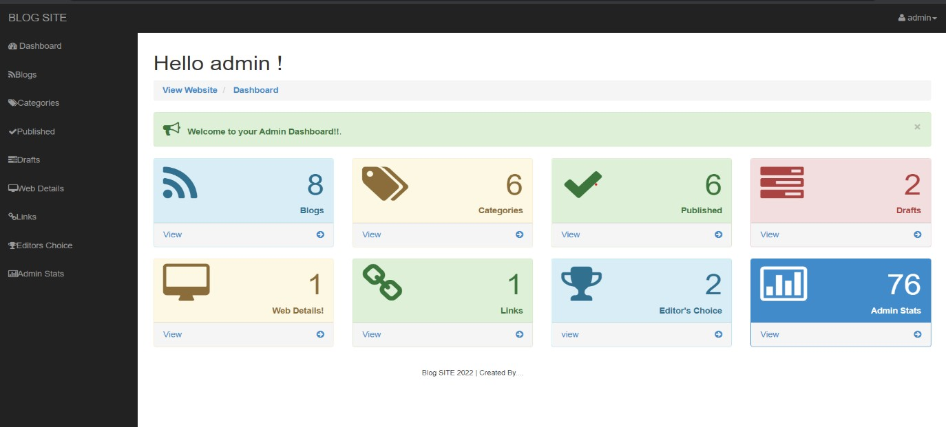

1. **Fig.7.5. User Home Page:**

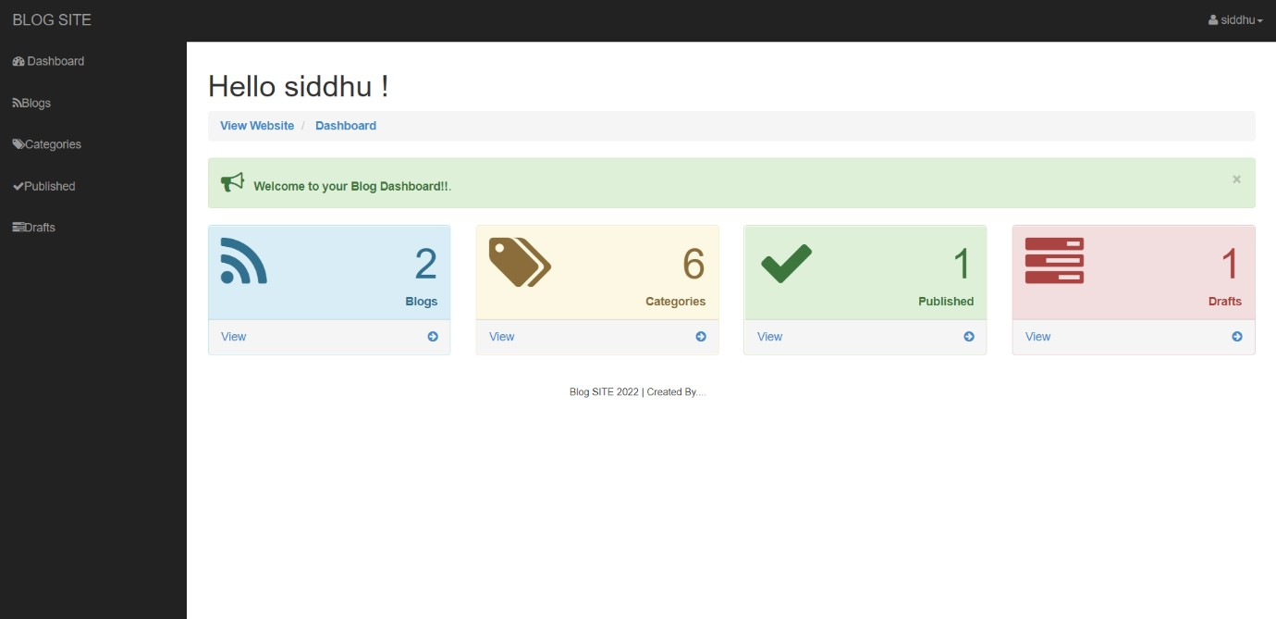

1. **Fig.7.6. User Blogs Page:**

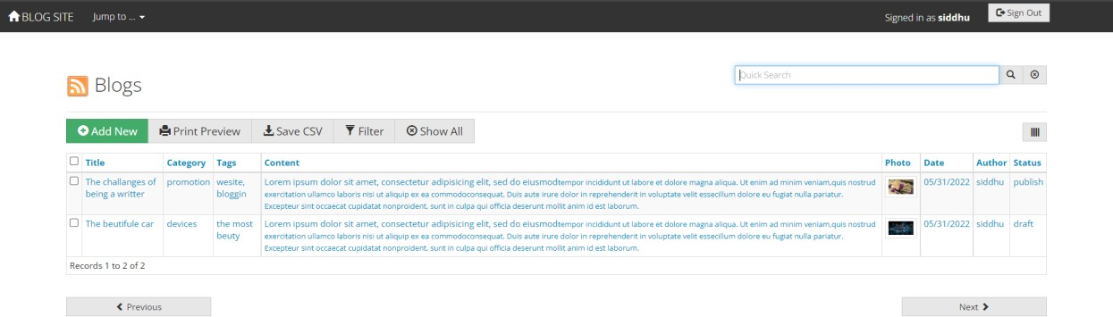

1. **Fig.7.7. Blog Create Page:**

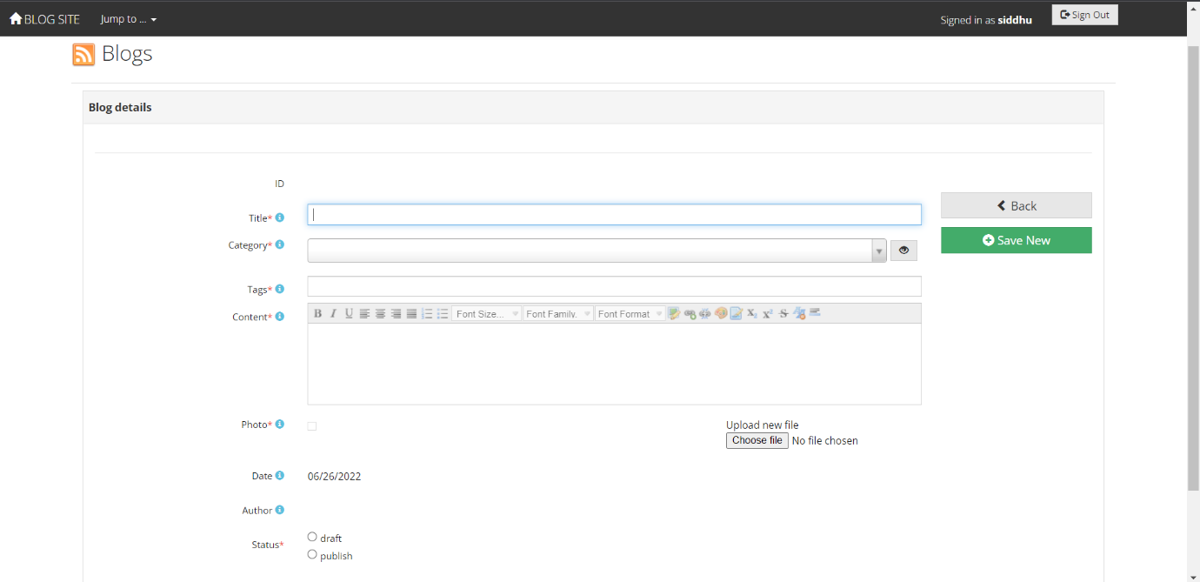

1. **Fig.7.8. User Blog Categories Page:**

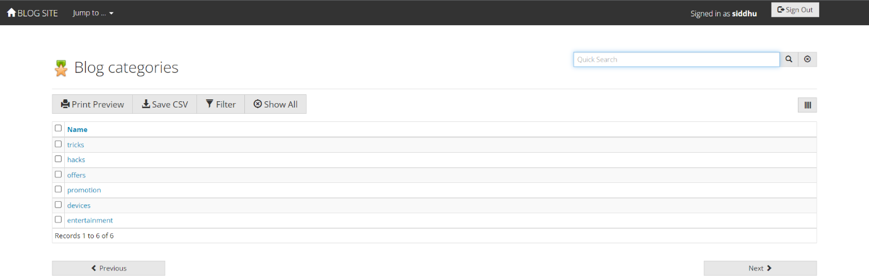

### Database Design:

Database is used to store the relevant information of the individuals. A database is a collection of rows and columns in which rows indicates the tuple and column indicates the domain of table. Database design is the process of producing a detailed data model of a database. This logical data model contain all the needed logical and physical design choices and physical storage parameters. Need to generate a design in a data definition language, which can then be used to create a database. A fully attributed data model contains detailed attributes for each entity. The term database design can be used to describe many different parts of the design of an overall database system. Principally, and most correctly, it can be thought of the logical design of the relation of the base data structure used to store the data. In the relational model these are the classes and named relationship. However, the term database design could also be used to apply to overall process of designing, not just the base data structure, but also the forms and queries used as part of the overall database application within the database management system (DBMS).

### 7.2.1) DATABASE TABLES: (Important Screenshots of table)

1. **Table7.1. Show database Tables**:

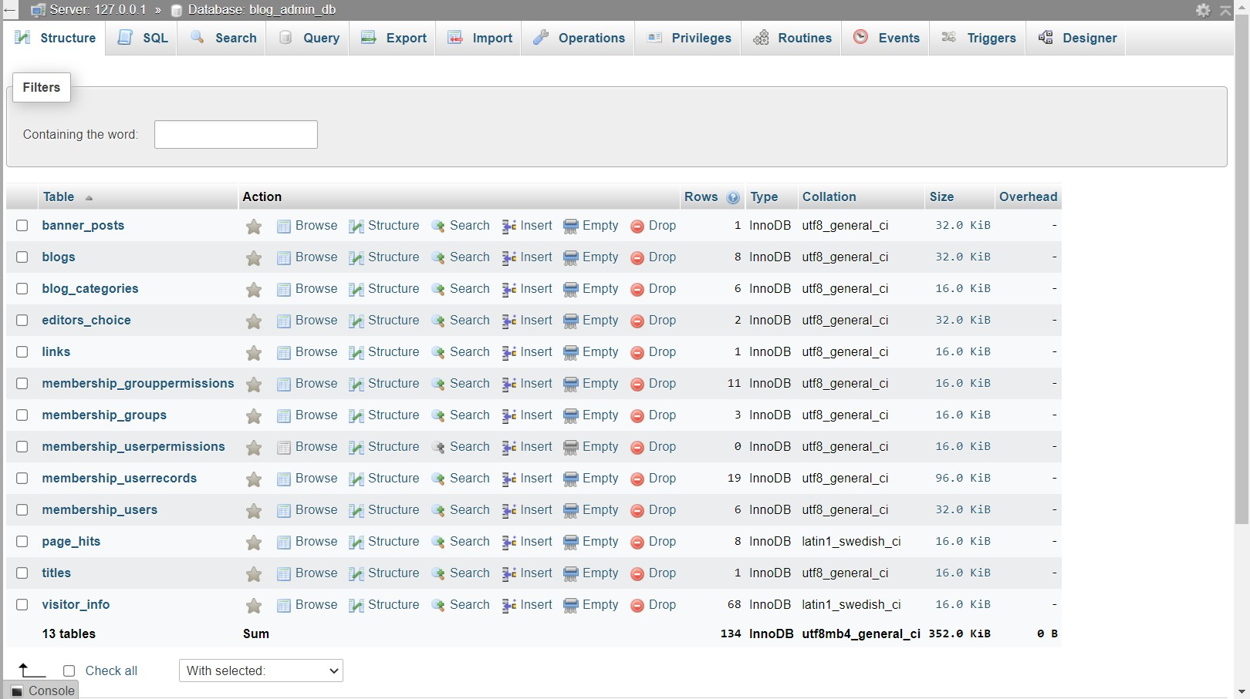

1. **Table7.2. Blogs Table:**

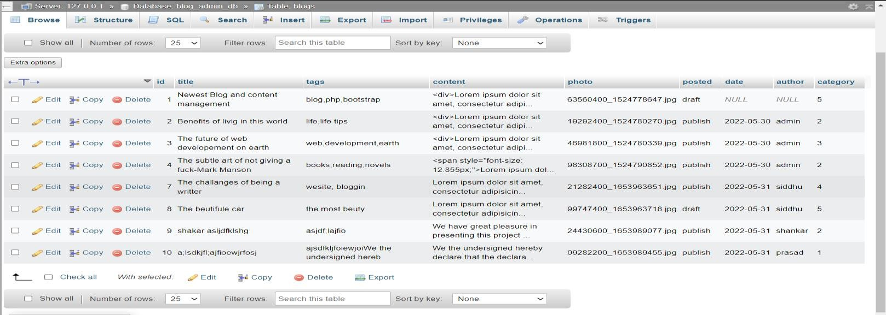

1. **Table7.3. Blog Categories Table:**

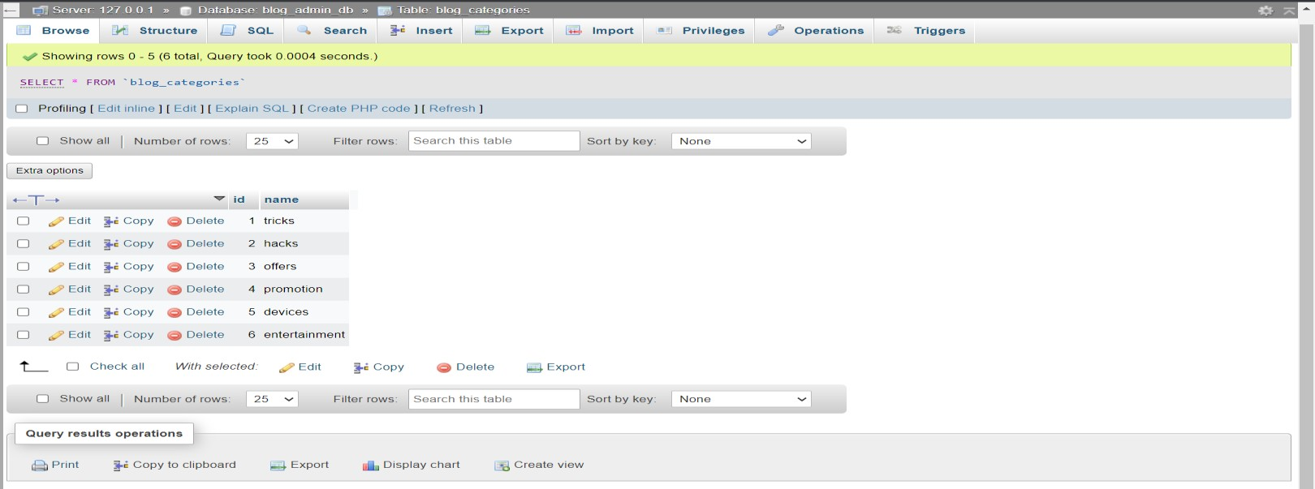

1. **Table7.4. Editor Choice Table:**

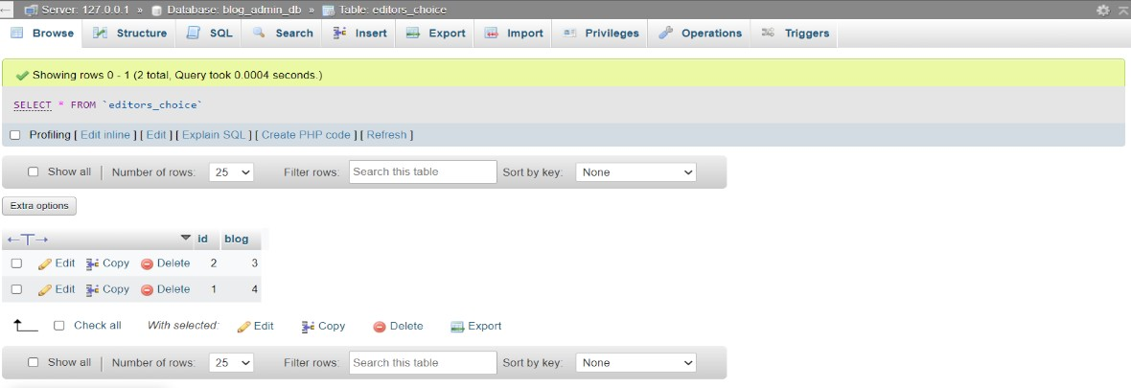

1. **Table7.5. Membership Users Table:**

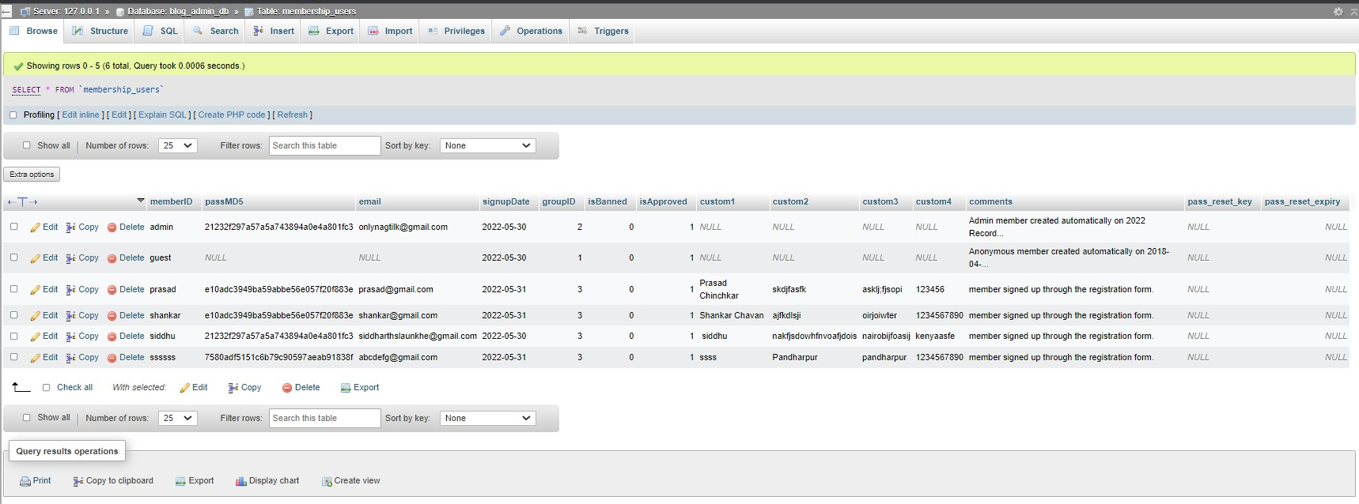

1. **Table7.6. Membership Groups Table:**

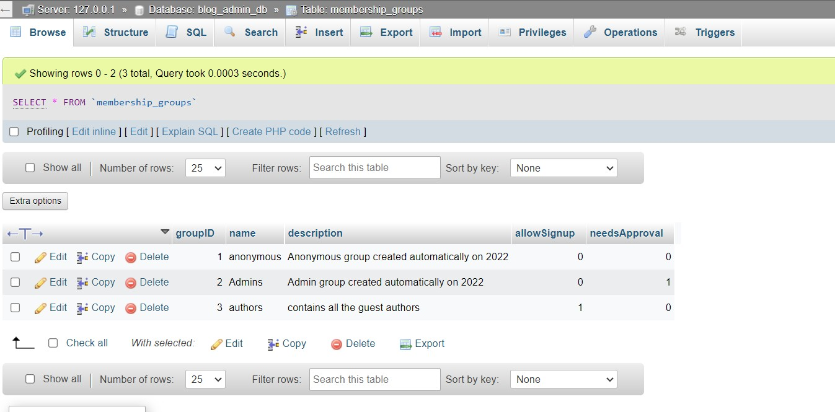

1. **Table7.7. Page Hints Table:**

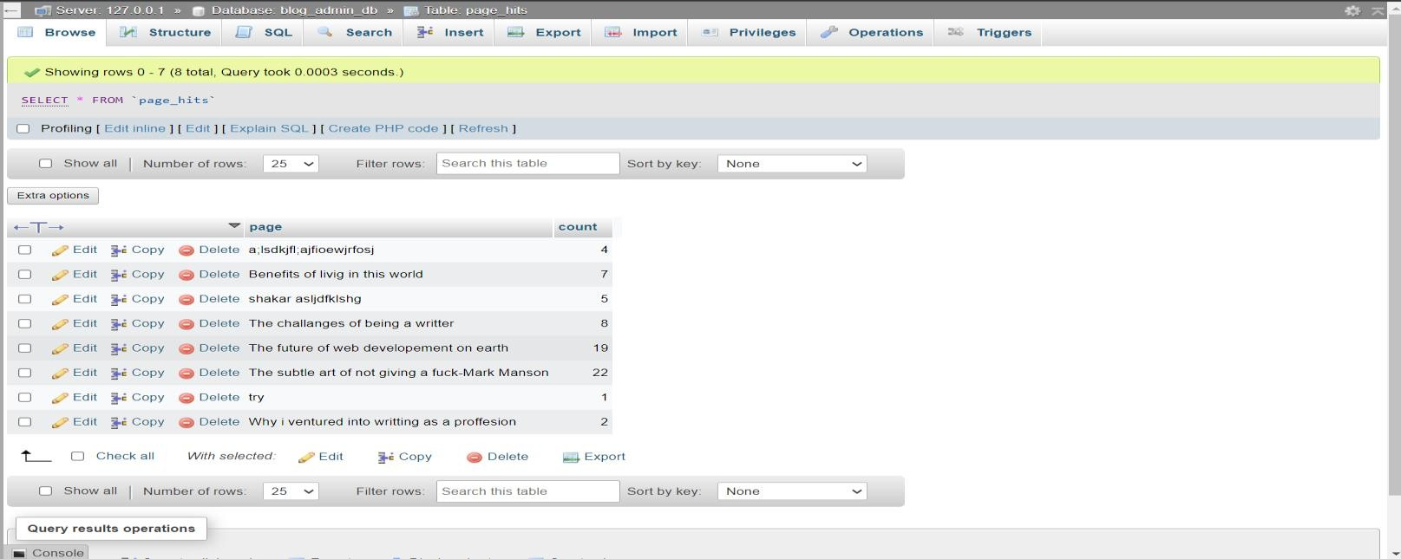

## RESULT

Responsive online blogging system was successfully designed and developed as per the specifications. It was extensively tested using a database which contain data similar to what can be expected in an actual database. The system was found to work satisfactorily without any errors under all conditions.

## CONCLUSION

While developing the system a conscious effort has made to create and develop a software package, making use of available tools, techniques and resources – that would generate a proper system for cases.

While making the system, an eye has been kept on making it user-friendly. As such one may hope that system will be acceptable to any user will adequately meet his/her needs. As in case of any system development process where there are a number of short comings, there have been some shortcomings in the development of this system also.

## REFERENCES

* + Turgeon, M. C. (2004). 10 Reasons why blogging is good for you. Available at <http://mcturgeon.com/blog/2004/11/24/10reasonstoblog/>
  + Hiler, J. (2002). Blogs as disruptive tech - How weblogs are flying under the radar of the content management giants. Internet World. Retrieved 01 December, 2007, from <http://www.webcrimson.com/ourstories/blogsdisruptivetech.htm>
  + [https://timesofindia.indiatimes.com/blogs/digital-mehta/career-in-](https://timesofindia.indiatimes.com/blogs/digital-mehta/career-in-blogging-for-next-5-years/) [blogging-for-next-5-years/](https://timesofindia.indiatimes.com/blogs/digital-mehta/career-in-blogging-for-next-5-years/)
  + <https://blog.hubspot.com/marketing/what-is-a-blog>
  + <https://themeisle.com/blog/types-of-blogs/>
  + [https://codewithawa.com/posts/how-to-create-a-blog-in-php-and-mysql-](https://codewithawa.com/posts/how-to-create-a-blog-in-php-and-mysql-database) [database](https://codewithawa.com/posts/how-to-create-a-blog-in-php-and-mysql-database)