Blood Pressure

. The Basic principle for measurement of blood pressure is the wave characteristics of the PPG signal.

. 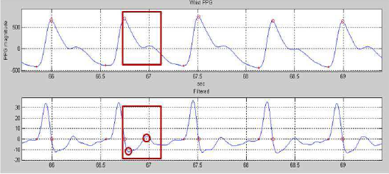

. As can be seen from the diagram, for traditional methods of continuous measurement of blood pressure, the ECG and fingertip PPG signals are to be used such that the peak points of the waves are found and the time of transit in between them are used to calculate the Blood pressure by means of Linear Regression [1], [2].

. 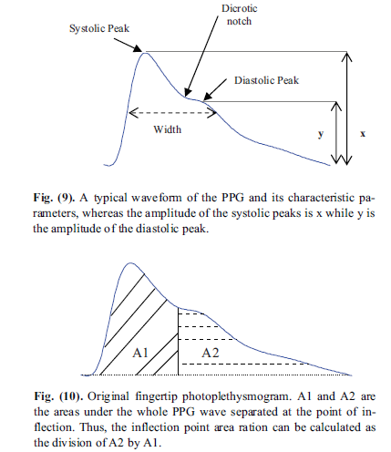

. Another method which uses only PPG signal can find the blood pressure from the signal diastolic time (peak to peak time of systolic and diastolic peak) or systolic time (peak to peak time between diastolic peak and minima on the farther side). We can also use ratio of areas as shown in the figure above [3].

. In all of these methods we find that certain parts of the PPG waveform and their time between peaks are used to fit the blood pressure value by means of regression.

. Thus the method that I have used for calculation of blood pressure can be found out by making use of the characteristics of the wave which changes with the transit times between various peaks.

. While the first three frequency components (frequency and amplitude) of the wave can be used to characterize the wave sufficiently I have used 5 components instead to characterize for the finer points of the signal.[3.5]

. While normally I would have used FFT (Fast Fourier Transform) to characterize the signal in terms of frequency and amplitude components I have used the Prony method instead.

. This is because the Prony method is very efficient in finding the characteristics (frequency and amplitude) of the signal given the window length and sampling time even without complete sampling. For example, if a sine wave has a frequency of 50 Hz then it will have a time period of 20 ms and the data window for FFT has to be at least 20 ms for orthogonality [3.6].

. On the other hand we can easily calculate the harmonics using a 10 ms data window using the Prony method for the same wave. Also selective calculation of harmonic components is more convenient in case of the Prony method [4].

. The disadvantage of Prony method lies in the fact that it fits a sum of damped sine waves from the Eigen space and assumes a linear prediction model. Hence minor changes in the wave can cause a large deviation especially for noisy signals. Also, it is poor in fitting a signal with more than 5 harmonic components. Thus, adequate filtering is required before the data can be fed to the method.

. Also for signals with varying frequency components it uses the same method as the STFT(Short Time Fourier Transform) i.e. it uses a small data window(enough to characterize the signal) to segment the data and find frequency from it’s various regions.

. Of course this can be overlooked for real time analysis as the data window is inherently small for real time analysis.

. The code for the Matlab implementation of the Prony method is shown below.

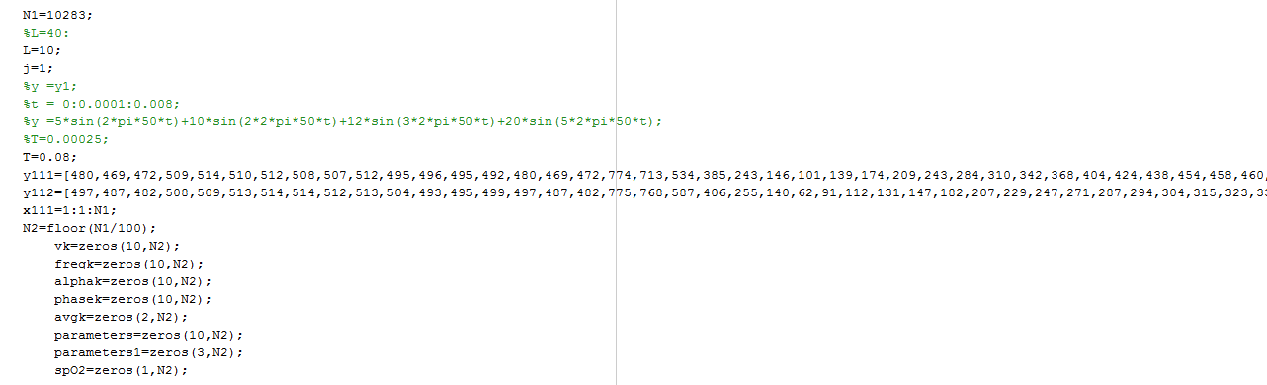

.N1 denotes the number of data points.

. L denotes the number of harmonic components

. j is a counter

. T is the sampling time in seconds

. y111 is the matrix storing data for the R signal in discrete time series format.

. y112 is the matrix storing data for the IR signal in discrete time series format.

. x111 is the index of the data point in either y111 or y112.

. N2 denotes number of iterations for data analysis. (Here the data is broken into short components of hundred data points each and the signal analysis is carried out for each).

. The next few variables denote voltage(magnitude) , frequency, sigma (exponential component), phase, R and IR average, blood pressure parameters , glucose parameters and spO2 respectively for each other N2 parameters stored in an array of row length N2.

. 10 parameters used for Blood pressure are 5 frequency and 5 amplitude components while 3 blood glucose components are R , IR averages and spO2 content.

. 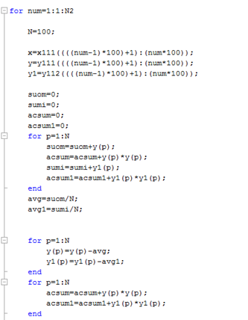

. x, y and y1 extract 100 data points from x111,y111 and y112 sequentially. This means that x first takes data points from 1 to 100 for first iteration and then takes data from 101 to 200 for the next iteration and so on. Iteration takes place N2 number of times.

. avg and avg1 calculate the average of the R and IR signals. ac and ac1 store the RMS(root mean square value) of the signals respectively.

. In the next part some basic butterwort filtering is done for the signal.

. The signals is removed of it’s dc component since this leads to the Prony method predicting incorrect exponential values which is true especially for small data windows.

. Now comes the main Prony analysis method. D and d are formed to create the linear prediction model.

. Then the ‘a’ vector is formed from which the characteristic equation in the z domain is formed from which we get the eigen roots of the characteristic equation stored in z.

. Next the power matrix ‘u’ and the prediction model y1 is used. For a better detail of the Prony method check reference [5].

. Now the amplitude, frequency, phase, sigma are calculated.

. 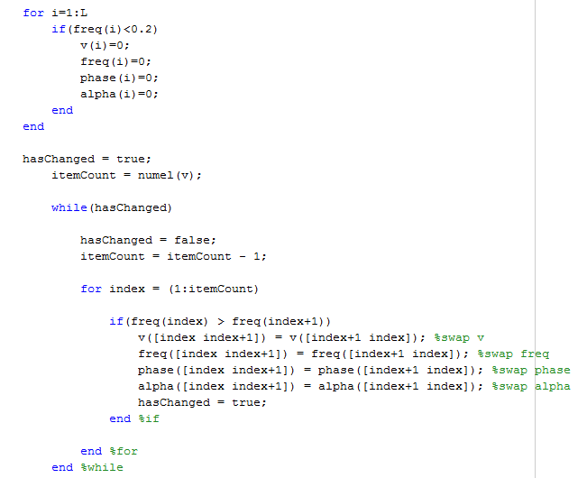

. First very low harmonics less than 0.2 Hz are removed. Then the components are arranged according to their frequencies in ascending order in order to be used as parameters.

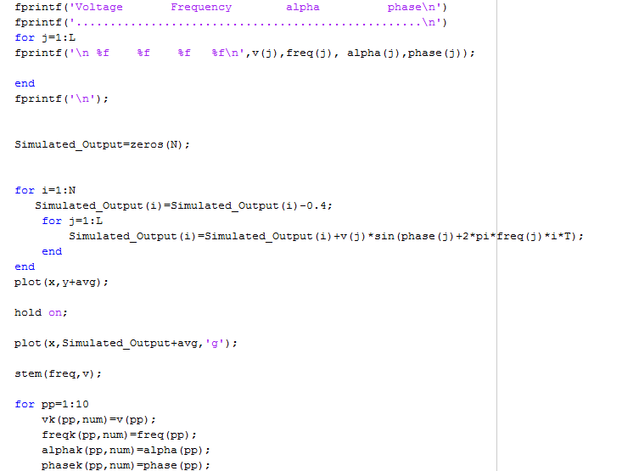

. Finally the arranged components are printed and output reconstructed from the original signal is plotted with the original signal plotted earlier to compare between the original and reconstructed signals.

. And yes another important point is that spO2 values are calculated for each of the iterations by (ac/avg)/(ac1/avg1)

.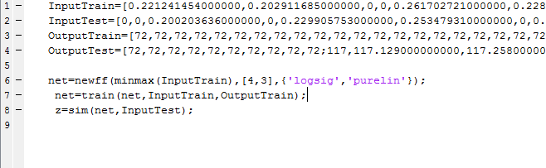

. Next comes the part of the neural network. For a basic understanding of the feedforward backpropogation neural network please check links [6] and [7].

. Basically the parameters used from the prony method(input) are trained with the blood pressure values obtained from the wrist blood pressure device(Output).

. Output test is obtained by us for checking later. Output test can be easily omitted from the program.

. Inbuilt matlab functions can be used to train the data obtained and form fitted co-efficients.

. The advantage of FF(feed forward) back propogation networks is that it can account for non linearities in fitting the variables. Since, changing the peak times of the wave can result in large changes in the dominant harmonics thus it is appropriate to use the neural network to fit the changes.

Glucose

. Glucose measurement is a very challenging process since No marketable product has been available yet for continuous non-invasive blood glucose monitoring. While reference [8] looks promising it is highly unreliable because it is a very small dataset.

. Nevertheless we will still try to understand blood glucose.

. In our case we are not trying to find the exact values of blood glucose. Instead we are trying to find as many possible classes to divide blood glucose levels into.

. Let me explain further. We obtained three parameters from the prony method for blood glucose.

. We then add age, sex, BMI, Minutesbefore food istaken(called minet) and heartbeat as clinical parameters for the blood glucose estimation.

. Then using the training data we try to classify the data for one person into a class of one of the previous blood glucose levels by using the RandomForest Classification Technique.

. It is to be noted that all training( Neural Network and Random Forest ) is done offline for the real time program. Training during real time process will slow down the process considerably.

. Check reference [9] and [10] to understand Random Forest thoroughly. It is important to understand that random forest accuracy increases with increase in the number of estimators although memory requirement increase as well. However, random forests works quite well because of it’s nature of voting using different trees for classification.

. Thus, the main variable parameters are spO2, and the R and IR averages. This, is because blood glucose has a weak relation with Oxygen saturation and we are trying to find out that weak relation using a large number of Random forest trees. Also IR average levels are somewhat chaged with change in blood sugar.

Motion-Kalman Filter

. While normally motion artifact are caused due to change in tissue thickness in case of our finger based ppg sensors not much is changed with the motion. On the other hand we find that a lot changes with motion due to saturation problems. [11]

. Thus, to remove saturation problems I have used a modified Kalman Filter. While the normal Kalman filter uses a fixed value of deviation(R)[12][13] I have decided to use a filter whose R value changes as the signal deviates from the original value.

. The most important point is that as long as the value is close to the average the value is trusted and the filtered value is close to the actual reading. However, if it moves away from the average value the R value modifies in such a way that the reading is not trusted and hence it does not change much from the previous value.

.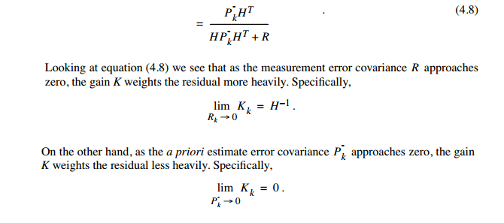

.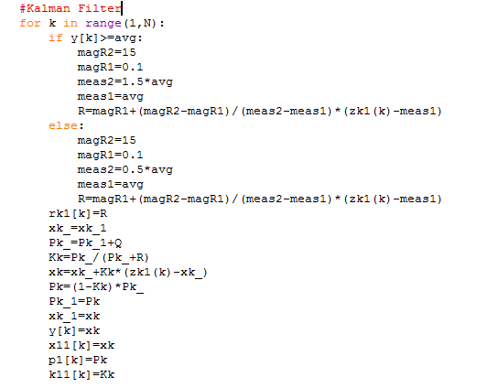

. Thus, for each iteration, R is first modified and then the state of the system is calculated. ( Here there is only one state which is equal to the output).

. This takes care of motion problems due to saturation.

References

[1] **Estimation of Blood Pressure Using**

**Photoplethysmography on the Wrist**

SH Song, JS Cho, HS Oh, JS Lee, IY Kim

Department of Biomedical Engineering, Hanyang University, Seoul, Korea

[3] **On the Analysis of Fingertip Photoplethysmogram Signals**

Mohamed Elgendi*

*School of Engineering and Information Technology, Charles Darwin University, Australia,*

*School of Electrical and Electronic Engineering, Nanyang Technological University, Singapore,*

*Institute of Media Innovation, Nanyang Technological University, Singapore,*

*Affiliated with Royal Darwin Hospital, Darwin, Australia*

[2] Non-Invasive Estimation of Systolic Blood Pressure and Diastolic Blood Pressure using Photo plethymograph Components

*Incheo Jeong, Sukhwan Jun, Daeia Um, Joonghwan Oh and Hyungro Yoon*

*Yonsei University, Wonju, Korea*

[3.5] Beat to Beat Blood Pressure Monitor

Sept2012_JSC_Tech_Briefs

Lyndon B. Johnson Space Center, Houston Texas

[3.6] <http://ms.mcmaster.ca/courses/20102011/term4/math2zz3/Lecture1.pdf>

[4] <https://www.google.co.in/url?sa=t&rct=j&q=&esrc=s&source=web&cd=9&cad=rja&uact=8&ved=0CEgQFjAIahUKEwjAwJOBhv3GAhXDjo4KHcbTBo8&url=http%3A%2F%2Fadsabs.harvard.edu%2Ffull%2F1989A%2526A...209..435B&ei=3gy3VcDZOcOdugTGp5v4CA&usg=AFQjCNG7mozGDVP_ofoyk6vy4CFqG6gVMw&bvm=bv.98717601,d.c2E>

[5]   
[www.**engr**.**uconn**.edu/~sas03013/docs/**Prony**Analysis.pdf](http://www.engr.uconn.edu/~sas03013/docs/PronyAnalysis.pdf)

[6] <http://www.webpages.ttu.edu/dleverin/neural_network/neural_networks.html>

[7] <http://www.heatonresearch.com/online/introduction-neural-networks-cs-edition-2/chapter-5>

[8] Non-invasive blood glucose monitoring using near-infrared spectroscopy

*Masab AAhmad, Awais Kamboh and Ahmed Khan*

[9] <http://blog.yhathq.com/posts/random-forests-in-python.html>

[10] <https://www.youtube.com/watch?v=3kYujfDgmNk>

[11] **Motion Artifact Reduction in**

**Photoplethysmographic Signals: A Review**

**Yadhuraj S.R**

Instrumentation Department ,RVCE Bangalore, India

**Harsha H**

Instrumentation Department ,RVCE Bangalore, India

[12] <http://bilgin.esme.org/BitsBytes/KalmanFilterforDummies.aspx>

[13] <http://www.cs.unc.edu/~tracker/media/pdf/SIGGRAPH2001_CoursePack_08.pdf>