**CS6313 – Information Visualization**

**Mini Project 1**

**By:** Harshul Jain, hj1393

**Visualization 1**

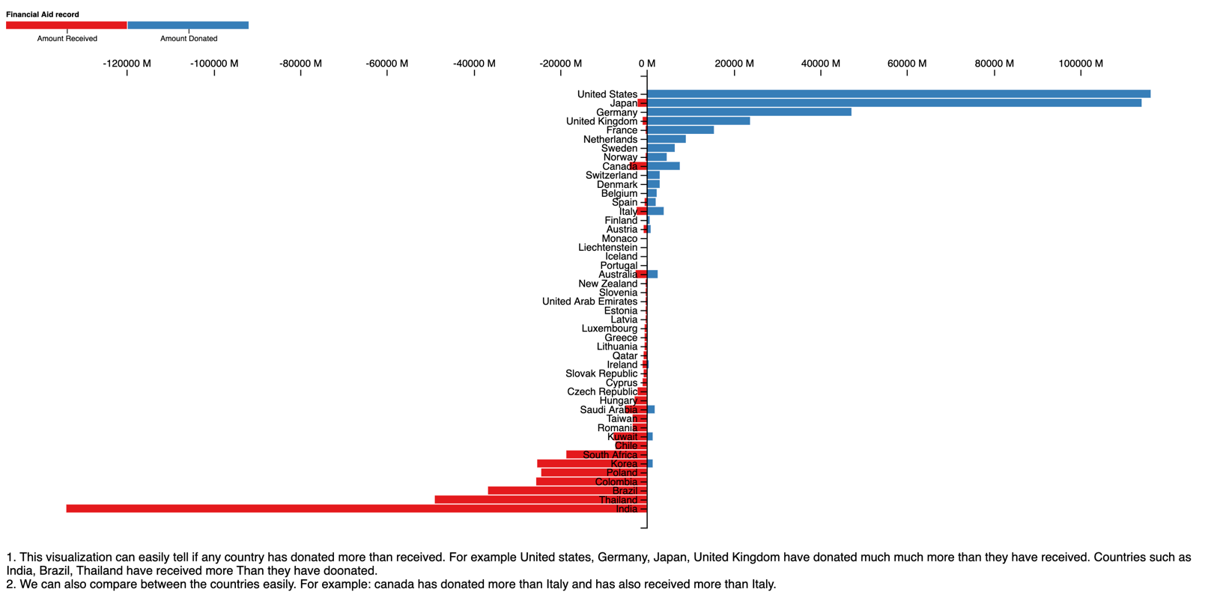

1. This visualization can easily tell if any country has donated more than received. For example United states, Germany, Japan, United Kingdom have donated much more than they have received. Countries such as India, Brazil, Thailand have received more Than they have donated.
2. We can also compare between the countries easily. For example: Canada has donated more than Italy and has also received more than Italy.

Hence, it is easy to answer the questions asked in visualization1

**Visualization 2**

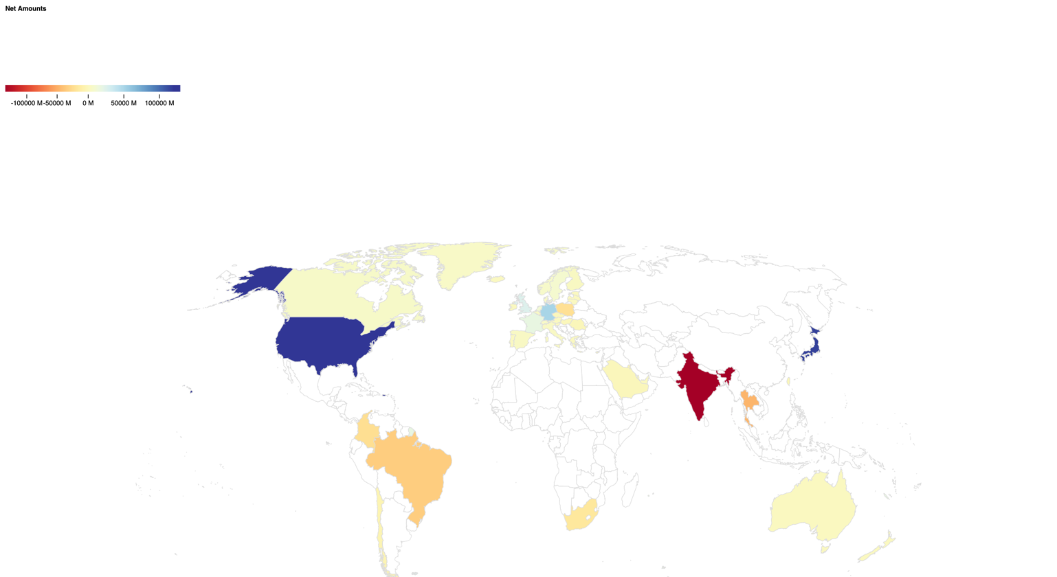

1. The country that receives the most is India and is part of Asia. The country that donates the most is USA.
2. In Europe there is Netherlands that donates but its neighbouring countries receives more.

Hence, it is easy to answer the questions asked in visualization2