Abstract

The COVID-19 disease is an infectious and contagious disease caused by a newly discovered coronavirus. People usually feel moderate fever, cough, fatigue, respiratory problems, and joint pain. However, this is not sufficient to diagnose this illness. Different individuals have shown a different set of symptoms too.[1]

Many outbreak prediction models for COVID-19 are in use by the concerned authorities and informed and planned decisions are being made based on that prediction. However, due to a high level of uncertainty and lack of essential data, standard models have shown low accuracy. Our algorithm produces promising results via transfer learning and VGG16. Since COVID-19 has a highly complex nature of symptoms, it becomes considerably challenging to rely entirely on individual test results. Instead, this algorithm combines datasets from different tests, namely antigen and RT-PCR tests.

Virologists and doctors work day and night to make test results more reliable by observations and hit and trial. All these results are limited to the human brain's computational capacity, which is brilliant in itself but also susceptible to errors. At this moment, it is high time we use neural networks and use their impeccable computational abilities.

The novel coronavirus has hampered economic growth all across the planet, and we need fast recovery. For that, we need to mingle technology with traditional methods. The algorithm will be useful in labs with vast amounts of data to increase its accuracy.

**Introduction**

The first human cases of COVID-19, the disease caused by the novel coronavirus causing COVID-19, subsequently named SARS-CoV-2, were first reported by officials in Wuhan City, China, in December 2019.[2]

Gradually it spreads throughout the world via means of people travelling abroad for trade or personal reasons. A 34 years old Chinese ophthalmologist Li Wenliang[3] raised the alarm about a new disease that could threaten humans. Initially, it was confused with the airborne disease SARS (Severe acute respiratory syndrome), which affected 26 countries and resulted in more than 8000 cases in 2003. However, the Chinese health department believed it to return after 16 long years.[4]

Coronavirus species already existed in nature. It was first recorded in 1920. However, the first case of human coronavirus infection was registered in the 1960s. In 2019 a man in Wuhan Province, China, is believed to be the first case of covid-19. This virus was utterly new to the recorded specimens. [5]

Viruses are known to mutate within months if given the proper environment. Novel Coronavirus disease is one such disease that infected tens of millions and affected billions of people's lives.

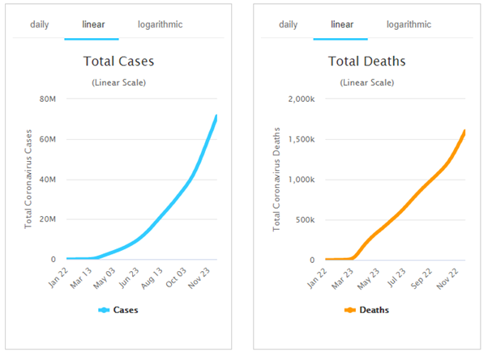

Humanity has survived other deadly viruses like Ebola where the mortality rate was as high as 88%. However it was highly improbable that the infected person will affect a big amount of population since the symptoms would show up in less than 5 days and the person would then be unable to move around because of fatigue.[6]

The coronavirus COVID-19 is affecting 218 countries and territories around the world and 2 international conveyances.[7]

However the person affected with Coronavirus would take somewhere between 15-21 days to show up symptoms like mild fever and headache. This time frame and ignorance of mistaking Coronavirus as common cold people wouldn’t quarantine themselves and this helped spreading of disease much faster all across the world.

To prevent load on healthcare systems many countries went to a series of countrywide lockdowns. Meanwhile millions of people were tested in different regions to quarantine the infected individuals.

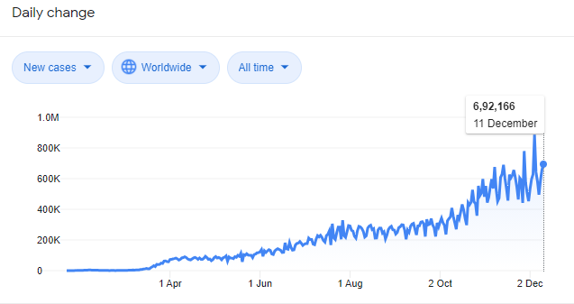

As observed in the above graph most of the cases were reported between mid of october to mid of november.

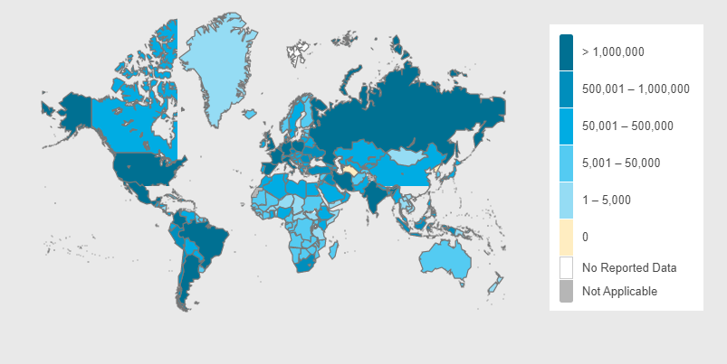[8]

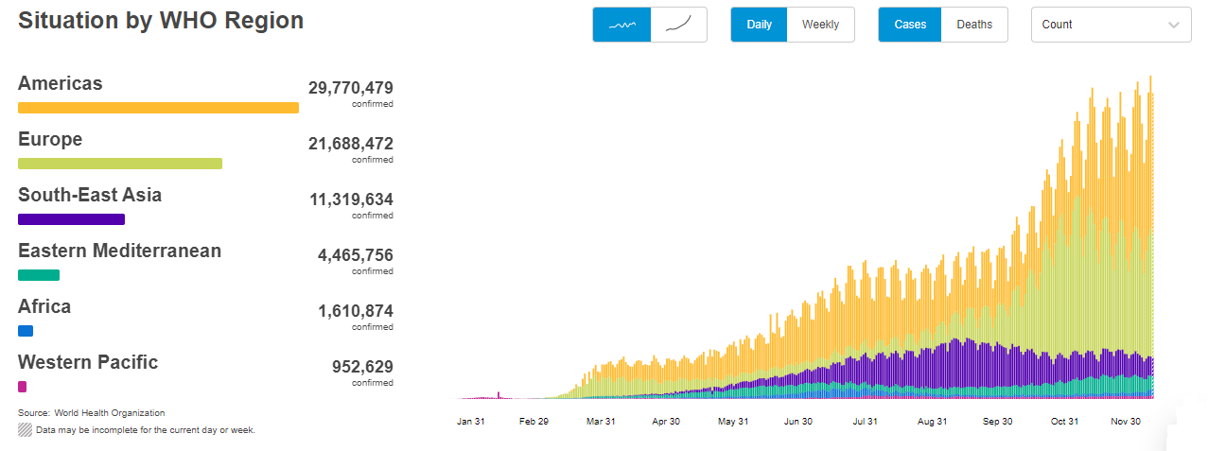[9]

**(Data as per 12th December, 2020)**

Reason being the temperature in the northern hemisphere starts to decline during the time frame and provides somewhat suitable conditions for the virus in tropical and subtropical countries. Also by this time due to huge economic losses the nations across the world had loosened the lockdown policies.

Furthermore not much known about the nature of the disease. There have been a few cases where individuals affected by the disease are showing symptoms of the same once again. Biologists and scientists across the world are doing research on the topic.[10] This puts a question mark on the concept of ‘herd immunity’[11].

The worldwide lockdown led to the collapse of the global economy. Millions[12] of people lost their jobs and GDP growth of developed and developing nations went in negative[13] phase. This led to even bigger problems. The people who lost their jobs will reduce their monthly expenditure, which will reduce the demand of goods, which in turn reduce the supply of goods and small and medium scale factories will fire more employees to meet their own expenses. This led to even more employment.[14]

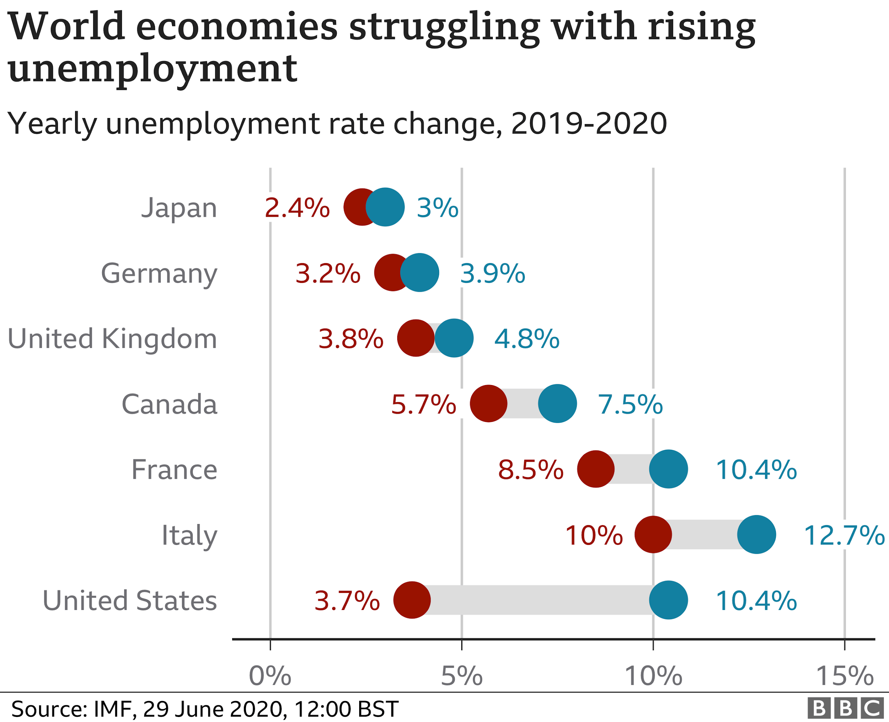

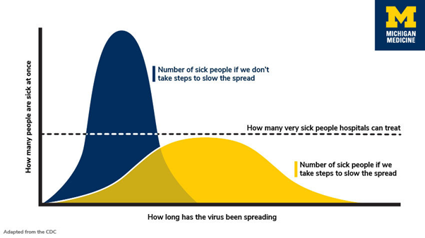[15]

However despite our exhaustive defensive strategies the nations worldwide failed to contain the virus. All they could do is strengthen their healthcare facilities like making more beds and ventilators available so that they can prepare beforehand.

Human immune systems have never seen this particular strain of virus before, so we haven't developed immunity. We don't have a very effective vaccine for it as of December 2020.

The growth curve of Covid19-is exponential. Also unlike initial spread where RT-PCR tests were common, today most of the hospitals are focusing on Antigen tests. Which has a benefit that it can give test results very rapidly but it comes with a major drawback. It can also give false negatives. Sometimes doctors suggest PCR tests to confirm the same.

**Related Work**

The Covid-19 pandemic is a social and economic crisis, just as it is a health crisis – its consequences, severe and far-reaching, are felt worldwide. From school closures to collapsed economies and millions of work losses – the social and economic costs of the pandemic are calculated in several ways. Covid-19 is threatening to deepen inequality everywhere and to reverse advances in global poverty and renewable energy, among others. The fixes are tests, therapies, and vaccinations – that would cost just a fraction of the significant economic damage done by the pandemic every week.

Coronaviruses (CoV) is a wide family of viruses that cause diseases ranging from common colds to more deadly illnesses such as Middle East Respiratory Syndrome (MERS-CoV) and Extreme Acute Respiratory Syndrome (SARS-CoV). The novel coronavirus (nCoV) is a new strain not previously described in humans. Coronaviruses are zoonotic, which suggests they are transmitted between animals and humans. Common signs of infection include respiratory symptoms, fever, cough, shortness of breath, and difficulty breathing. [16] The disease can cause pneumonia, severe acute respiratory syndrome, renal failure, and even death in more severe cases. Standard recommendations to eliminate spread of infection include daily hand washing, covering of mouth and nose whenever coughing and sneezing, thorough cooking of meat and eggs. Avoid direct contact with anyone with signs of respiratory disease, such as coughing and sneezing.

1,601,190 people died from the outbreak of coronavirus COVID-19 on 12 December 2020. Currently there seem to be 71,438,206 confirmed cases in 218 countries and territories.

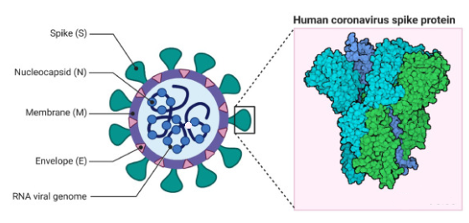

*Fig Coronavirus structure and protein virus*

**How do one detect Covid?**

There are two different types of tests; diagnostic and antibody tests. A diagnostic test can show whether you have an active coronavirus infection and should take steps to quarantine or isolate yourself from others. There are currently two types of diagnostic tests – molecular tests, such as RT-PCR tests, for identifying the genetic material of the virus, and antigen tests for identifying specific proteins from the virus.[17]

The antibody test looks for antibodies produced by your immune system to react to a threat, such as a particular virus. Antibodies can help tackle infection. Antibodies can take several days or weeks to develop after you have an illness and can linger in your blood for several weeks or more after recovery.[18]  Consequently, antibody tests should not be used to diagnose COVID-19.

Health image-based diagnosis in the form of Chest CT scans and X-ray scans.

The diagnostic techniques of AI-powered COVID-19 are shown to be effective, saving radiologist time. The fact that cough is one of the primary complications of COVID-19, but a symptom of even more than thirty non-COVID-19 related medical conditions, transfer learning would be exploited to overcome the lack of COVID-19 cough training data.[19]

Breathlessness or shortness of breath is a symptom of other severe diseases such as pneumonia almost in 50 percent of COVID-19 patients.[20]  Signal analysis, ML, and deep learning techniques can be applied to breathing sound to extract features and identify feedback into COVID-19 in

both positive and negative cases. Transmission analysis, the aim of the study was to estimate human-to-human transmissions and virus outbreaks if the virus was introduced in a new area.

**What's Machine Learning?**

Among the main diagnostic imaging methods, both chest x-ray and CT have rapidly produced a significant amount of data on COVID-19, enabling the development of machine learning algorithms, a type of artificial intelligence (AI). Well before the COVID-19 pandemic, the enthusiasm for machine learning technology in the field of medical imaging had risen significantly. Now, large datasets from China, and increasingly from European countries, have produced numerous publications documenting AI applications in COVID-19.

Machine learning-based CT analysis has also been suggested as a promising screening method for COVID-19, and in at least one study, real-time viral PCR testing has been outperformed. Machine learning algorithms are often modular, implying that new algorithms developed during this pandemic may be successfully replicated for other pulmonary diseases in the future.

Machine learning is a branch of artificial intelligence focused on developing applications that learn from and improve data accuracy over time without being programmed. In machine learning, algorithms are 'trained to identify patterns and features in massive amounts of data to make new data-based decisions and predictions. The better the algorithm, the more accurate the results and forecasts will become as more data is processed. Today, there are examples of machine learning all around us. Digital assistants will search the web and play music in response to our voice commands. Medical image processing systems help doctors to recognize tumors.

Machine learning techniques fall into three main categories:

**Supervised machine learning**

Supervised machine learning trains itself on a labeled data set to determine and classify how the model is to classify the data. For example, a computer vision model designed to identify purebred German Shepherd dogs can be trained on a data variety of various dog images. It requires less training data than other machine learning techniques and makes training more comfortable because the results of the model can be compared to the actual results labeled.

It's based on the training. During its training phase, the system is fed massive amounts of data which instruct the system on what output should be obtained from each specific input value. The trained model would then be equipped with test data to verify the effectiveness of the training and to evaluate the accuracy.

In neural network algorithms, the supervised learning process is accelerated by constantly monitoring the resulting effectiveness of the system and fine-tuning the system to get it closer to its target accuracy. The level of accuracy that can be obtained depends on two things: the data available and the algorithm in use.

**Unsupervised machine learning**

Unsupervised machine learning absorbs unidentified data—lots and lots of it—and uses algorithms to extract important information needed to label, sort, and classify data in real time, without human intervention. It's about identifying patterns and relationships. An unattended learning algorithm can evaluate vast volumes of emails and reveal features and patterns that indicate spam.

There are no labels or categories within the data sets used to train such systems; each piece of data passed through the algorithms during training is an unidentified input object or sample.

The objective of unsupervised learning for the algorithms to identify patterns within training data sets and to categorize input items based on patterns identified by the system itself. The algorithms examine the underlying structure of the data sets by extracting useful information or features from the data sets.

Thus these algorithms are expected to develop specific outputs from unstructured inputs by scanning for relationships between each sample or input object.

**Semi Supervised learning**

Semi-supervised learning includes a medium between supervised and unsupervised learning. During preparation, a smaller labeled data set is used to direct classification and feature extraction from a larger, unmarked data set. Semi-supervised learning can solve the benefit of not having enough labeled data to train a supervised learning algorithm.

Cluster analysis is a technique that aims to classify a dataset into homogeneous subgroups, meaning that similar subgroups of data in each group are different from other groups. Clustering is accomplished conventionally using unsupervised processes. Since the goal is to recognize similarities and differences between data points, no need for any specifics on the relationship between the data points.

However there are cases where certain cluster labels, outcome variables, or data relationship information are identified. This is where semi-supervised clustering is coming in. Semi-supervised clustering uses some recognized cluster knowledge to identify other unmarked data which means that now it uses both labeled and unmarked data, just like semi-supervised machine learning.

## **Reinforcement machine learning**

Reinforcement machine learning is a behavioral machine learning model that is similar to supervised learning, but the algorithm also isn't trained using sample data. This model learns how to use trial and error. The agent learns how to accomplish a target in an unpredictable, potentially complex environment. Artificial intelligence faces a game-like situation in reinforcement learning. The machine uses a trial and error to deal with the problem. In trying to get the system to do what the programmer wishes, artificial intelligence is either rewarded or punished for the actions it performs. Its goal is to maximize the net reward.

Whereas the designer sets the reward policy – that is, the rules of the game – he doesn't really give the model any hints or ideas on how to solve the game. It's up to the model to figure out how to perform the task of optimizing reward, starting with totally arbitrary trials and finishing with advanced methods and superhuman abilities. By leveraging the power of research and multiple tests, reinforcement learning is currently the most effective way to hint at computer ingenuity. Unlike humans, artificial intelligence will gather experience from thousands of parallel gameplays if a reinforcement learning algorithm is run on a reasonably robust computer infrastructure.

Objective:

A number of individuals tested negative for COVID-19 in rapid antigen tests (RAT) but with symptoms of the disease were found to have been infected by the viral infection in the RT-PCR test. [[1]](https://paperpile.com/c/7sOgPh/U2qa)

Proposed methods:

VGG16:

VGG16 is a convolutional neural network model designed by K. Simonyan and A. Zisserman from Oxford University.VGG16 uses a large number of hyper-parameters that concentrate on providing 3x3 convolution layers of stride 1 filter and always use the same padding and max pool layer of 2x2 stride 2 filters. This arrangement of convolution and max pool layers follows consistently across the entire design. It has 2 FC(full layers) followed by a softmax output. The 16 in VGG16 refers to it having 16 layers of weight. This network is extensive and has about 138 million (approximately) parameters. In this model, the VGG16 model is not trained, only used for image identification taking an input of 224x224 with 3 channels RGB with total parameters of 14,714,688 divided in trainable (14,714,688) and non-trainable(0). The model is trainable = false because the weights are not to be updated. Additional layers are added at the end of the pre-trained VGG model resulting in total parameters of 27,692,098 divided into 12,977,410 and non-trainable 14,714,688.

The VGG16 model is trained on the Adam optimizer on the metrics of the accuracy of it. The model trains on 10 epochs with the loss of 0.1198, accuracy of 96%, validation loss of 0.0755 and validation accuracy of 98%

VGG16 model summary:

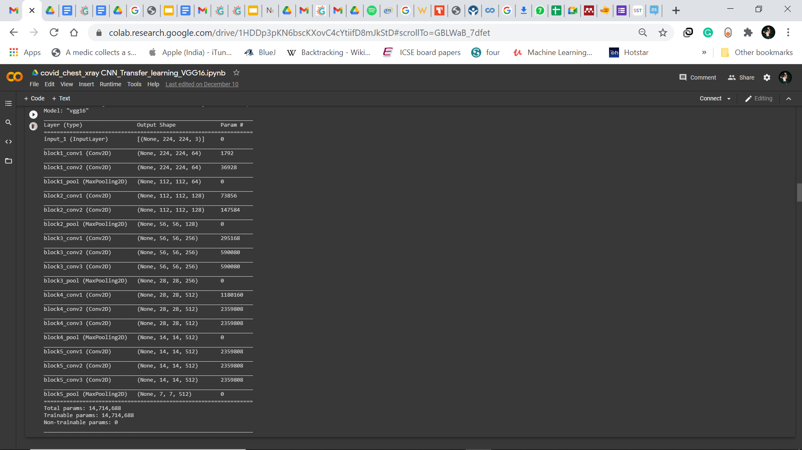

VGG16 model summary after adding the layers:

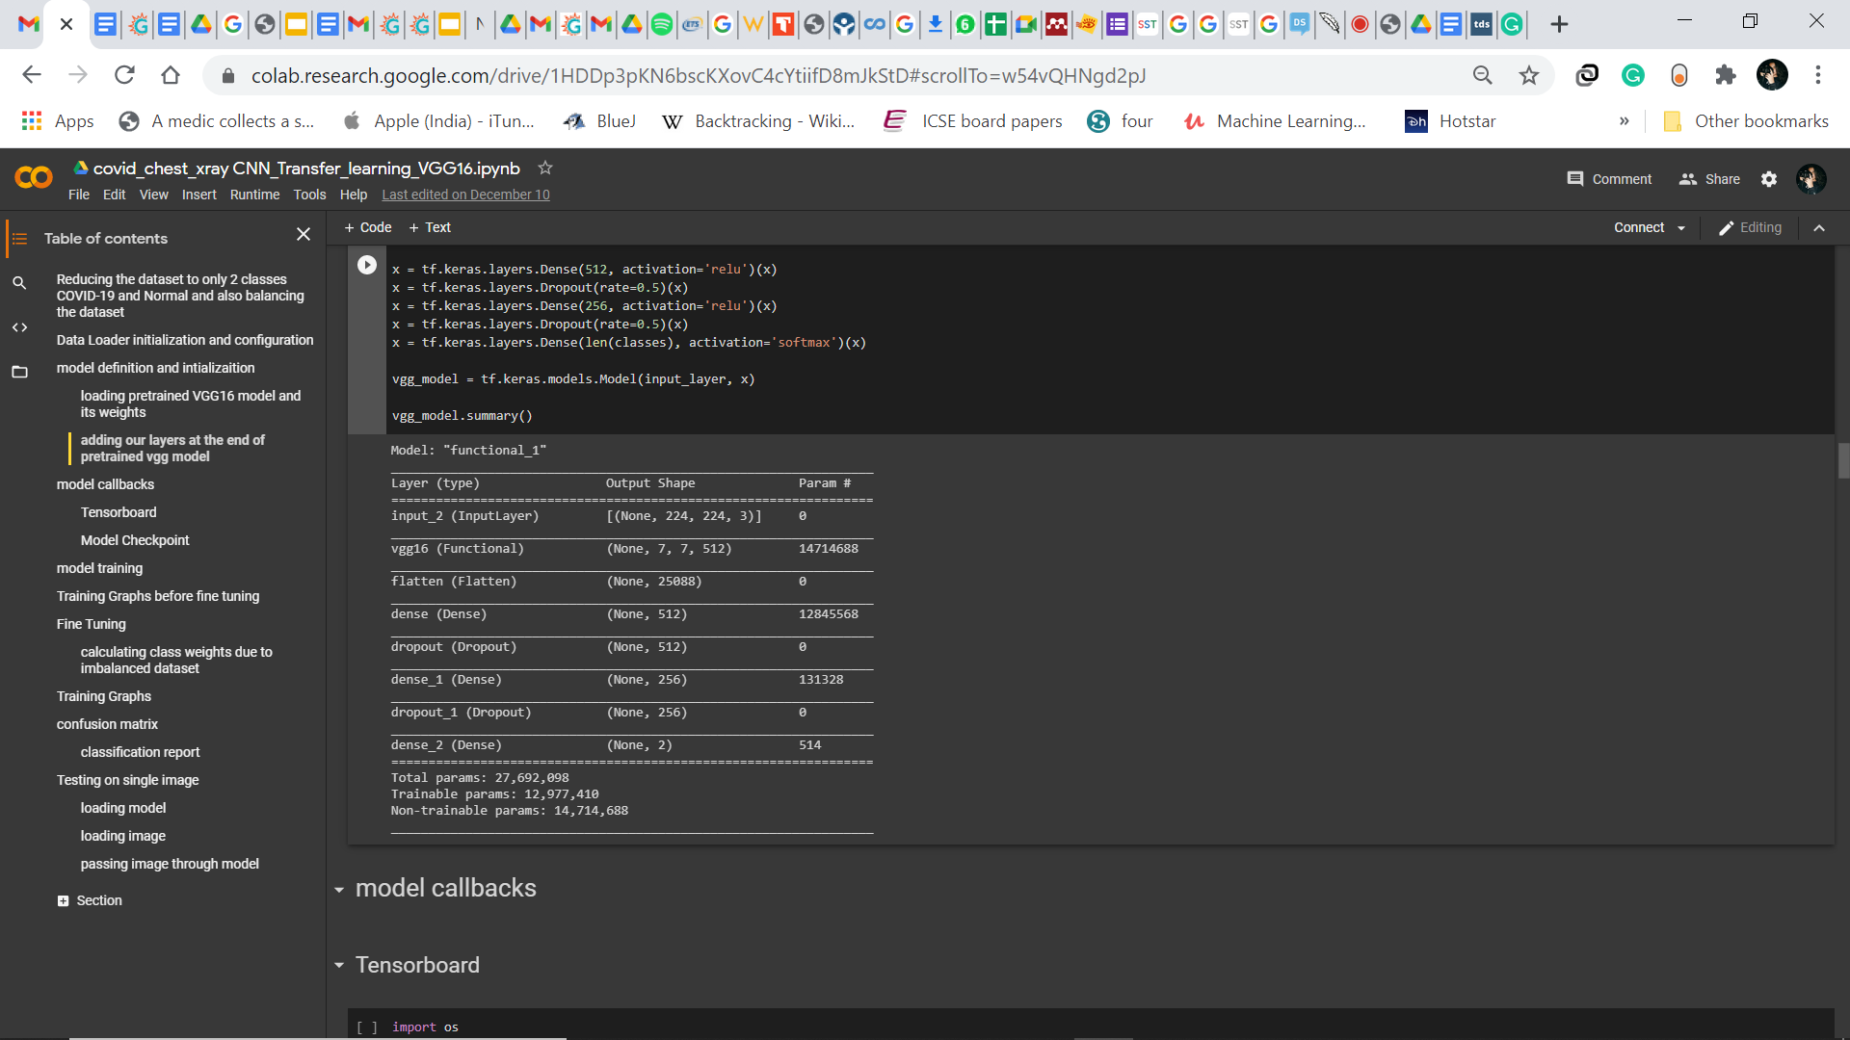

VGG16 Graphical representation:

Accuracy vs epoch

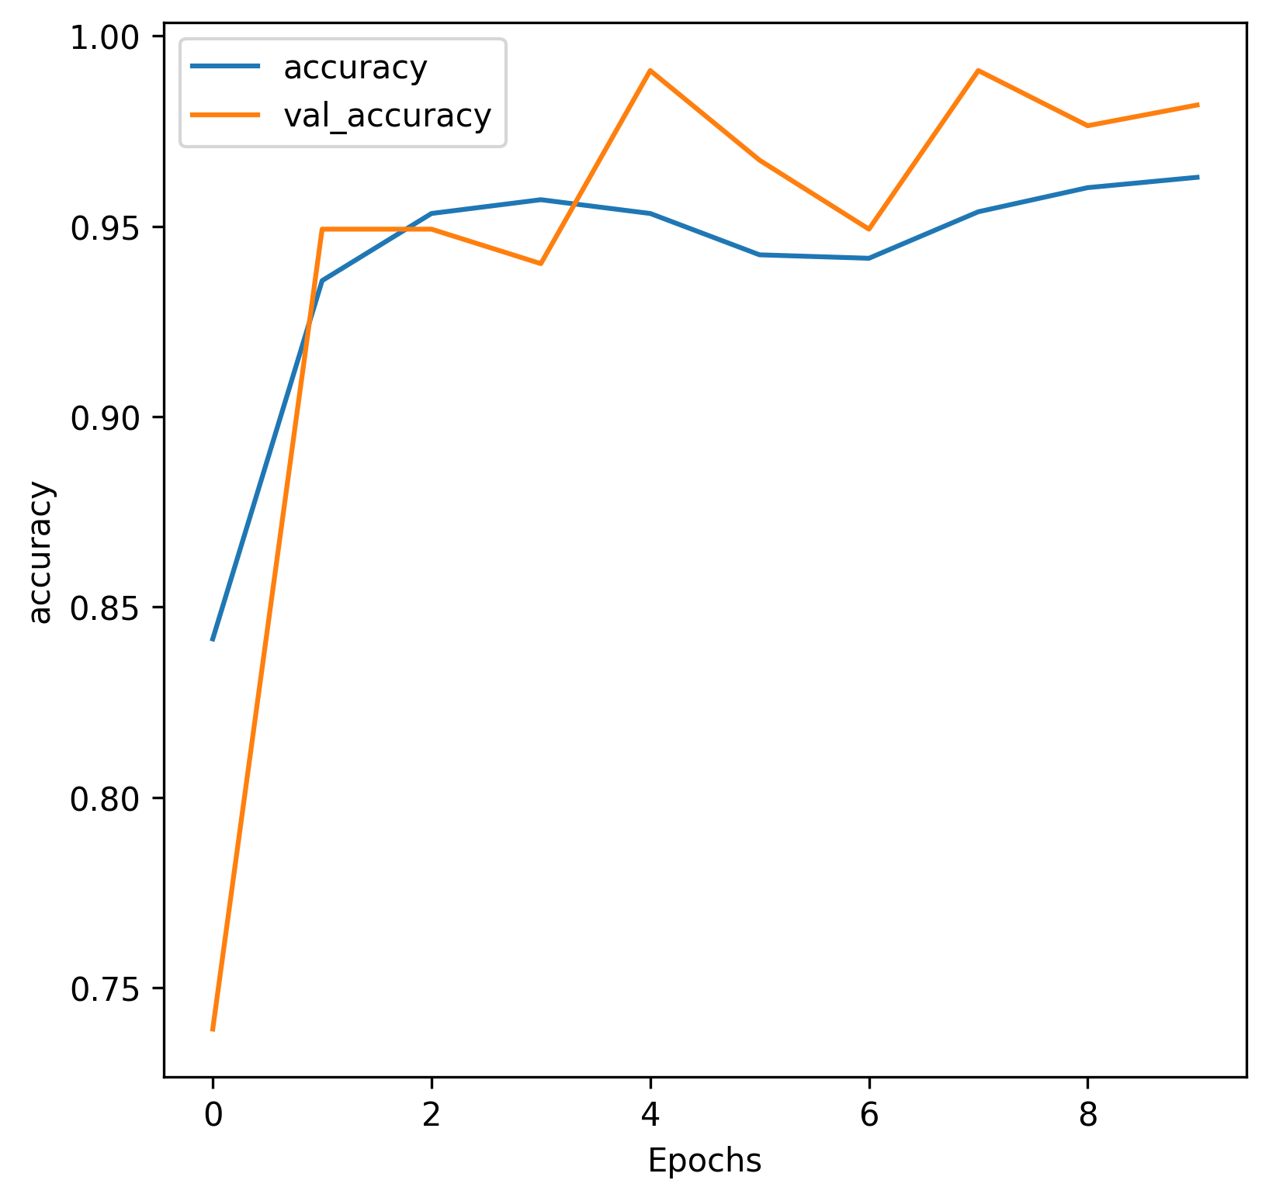

Loss vs epoch

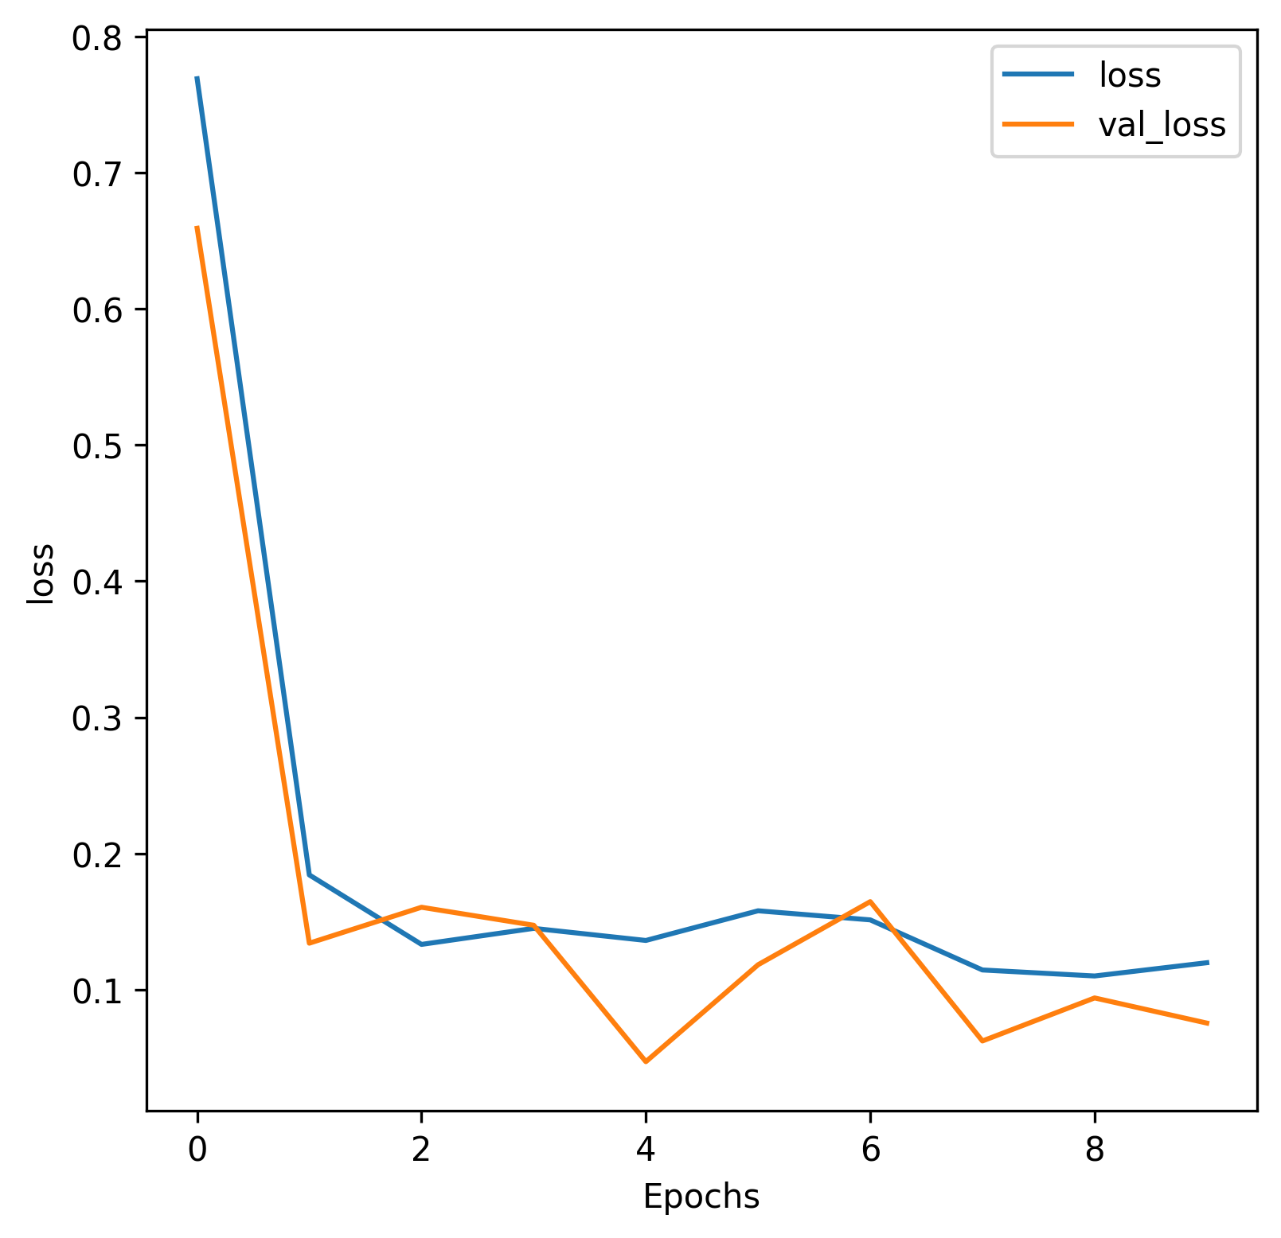

[1] [“11% Symptomatic Delhiites Who Tested Negative in Rapid Antigen Test Found Covid Positive in RT-PCR,” 06-Dec-2020. [Online]. Available:](http://paperpile.com/b/7sOgPh/U2qa) <https://www.news18.com/news/india/11-of-symptomatic-negative-cases-in-rat-found-covid-19-positive-through-rt-pcr-in-delhi-3151220.html>[. [Accessed: 10-Dec-2020].](http://paperpile.com/b/7sOgPh/U2qa)

[2] [M. Hussain, J. J. Bird, and D. R. Faria, “A Study on CNN Transfer Learning for Image Classification,” *Advances in Intelligent Systems and Computing*. pp. 191–202, 2019.](http://paperpile.com/b/7sOgPh/0Uv8)

Proposed Model:

This section introduces the dataset that is used in training and pre-processing of chest images. Also, the deep CNN model of covid-19 detection system that has been used for identification and classification of chest scans into covid-19 and normal categories through a given chest image has been explained. Initially images transform into a suitable form in which feature extraction becomes easy. It is done using image pre-processing techniques, after that features are extracted using different layers of CNN and at last by using these features finally it classifies into one of the categories.

Dataset:

[pending]

Image pre-processing:

Image pre-processing is a well known phrase appraised for transformation and noise removal, which is applied to the images before feeding them into the model. Rotation, centering (sample wise and feature wise), resizing, normalization, rescaling (gray scaling) and shear are the operations which are included under pre-processing. This technique is done by using Keras ImageDataGenerator which aids in augmenting images to the pertaining dataset.

VGG16 Model:

VGG16 is a convolutional network for classification and detection of images. It is a model proposed by K. Simonyan and A. Zisserman from the University of Oxford in the paper titled “Very Deep Convolutional Networks for Large-Scale Image Recognition”. VGG-16 is a convolutional neural network that is 16 layers deep. Here, a pre-trained version of the network trained on more than a million images from the ImageNet database was loaded. The network has an image input size of 224-by-224. This model was used as the dataset has images in thousands.

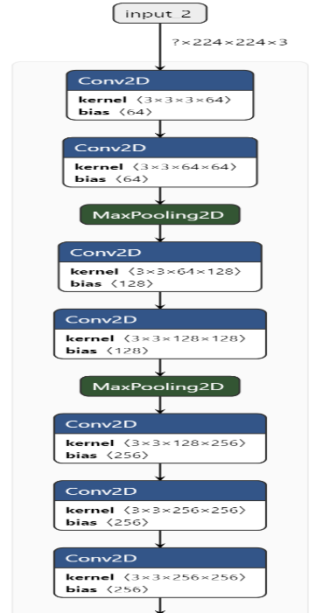

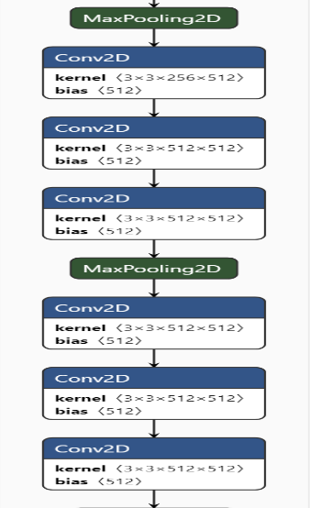

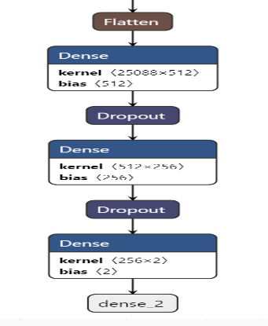

CNN [--]

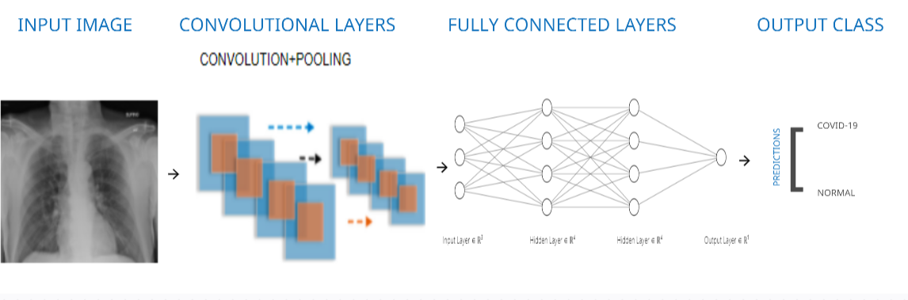

Table-- Data Augmentation

S.No. Transformation Operation Properties

1 Rotation range 10 degrees clockwise and anti-clockwise

2 Width shift range 0.1 fraction of total width

3 Height shift range 0.1 fraction of total height

4 Zoom range 0.2% smaller or larger of original image

5 Validation split 0.3 or 30% of data was taken as validation dataset.

6 Rescale 1/255 multiplied with image channel values to normalize input

7 Shear range 0.2 degrees clockwise and anti-clockwise

8 Brightness range 0.25-1.0 shift value

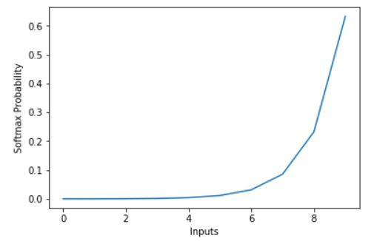

Softmax Function

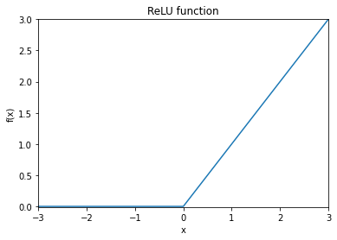

ReLu Function

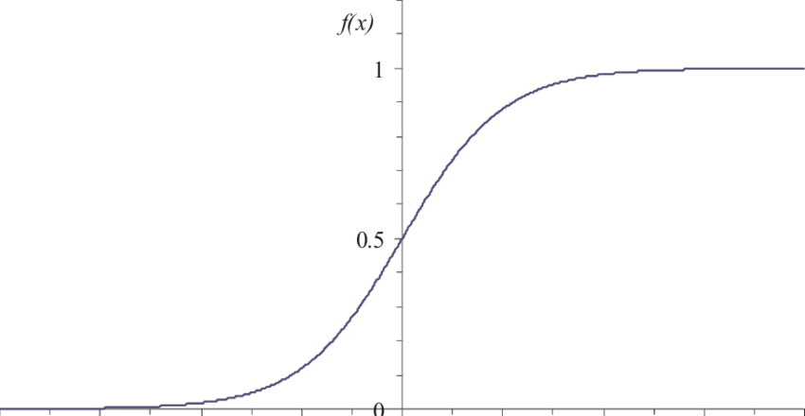

Sigmoid Function

Results and discussion:

In this work the proposed covid-detection has been tested on -- dataset reduced to two classes viz., COVID-19 and Normal. Cross-validation applies in the dataset in which 70% of the dataset from each class is used as training set and remaining 30% as validation set. Training dataset is utilized to train the model and it helps the model in gaining knowledge related to X-ray images. Validation dataset is availed to provide unbiased evaluation of a model fitted on the training data.

Table-- Model summary

Model: "functional_1"

_________________________________________________________________

Layer (type) Output Shape Param #

=================================================================

input_2 (InputLayer) [(None, 224, 224, 3)] 0

_________________________________________________________________

vgg16 (Functional) (None, 7, 7, 512) 14714688

_________________________________________________________________

flatten (Flatten) (None, 25088) 0

_________________________________________________________________

dense (Dense) (None, 512) 12845568

_________________________________________________________________

dropout (Dropout) (None, 512) 0

_________________________________________________________________

dense_1 (Dense) (None, 256) 131328

_________________________________________________________________

dropout_1 (Dropout) (None, 256) 0

_________________________________________________________________

dense_2 (Dense) (None, 2) 514

=================================================================

Total params: 27,692,098

Trainable params: 27,692,098

Non-trainable params: 0

_________________________________________________________________

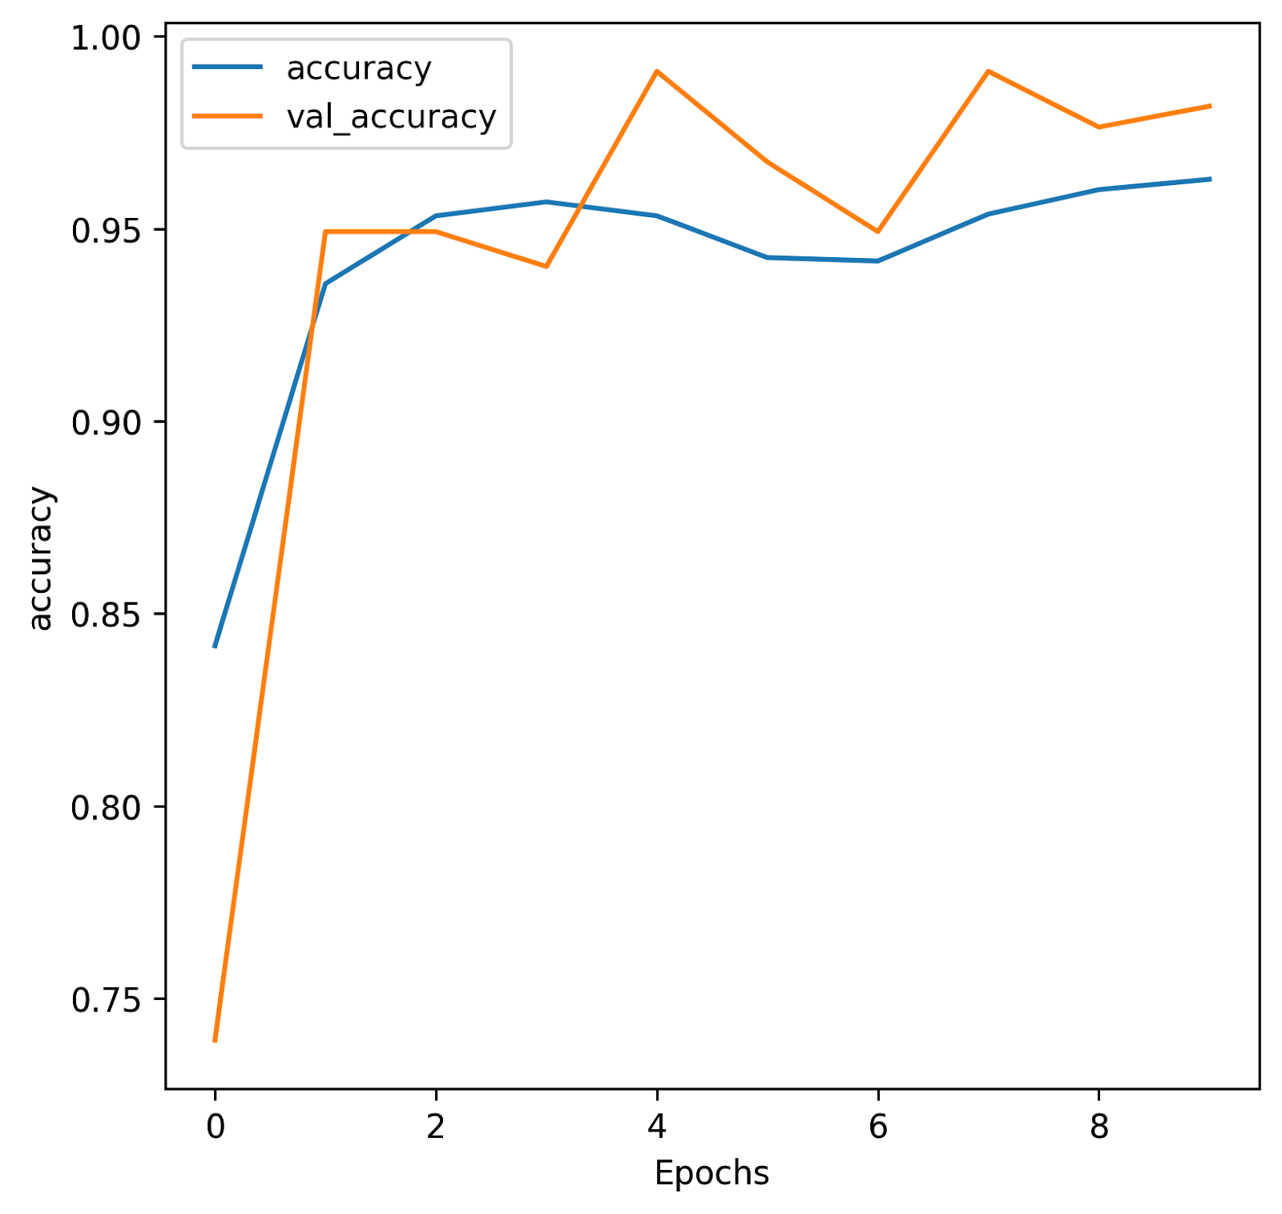

Fig. Model accuracy vs epoch

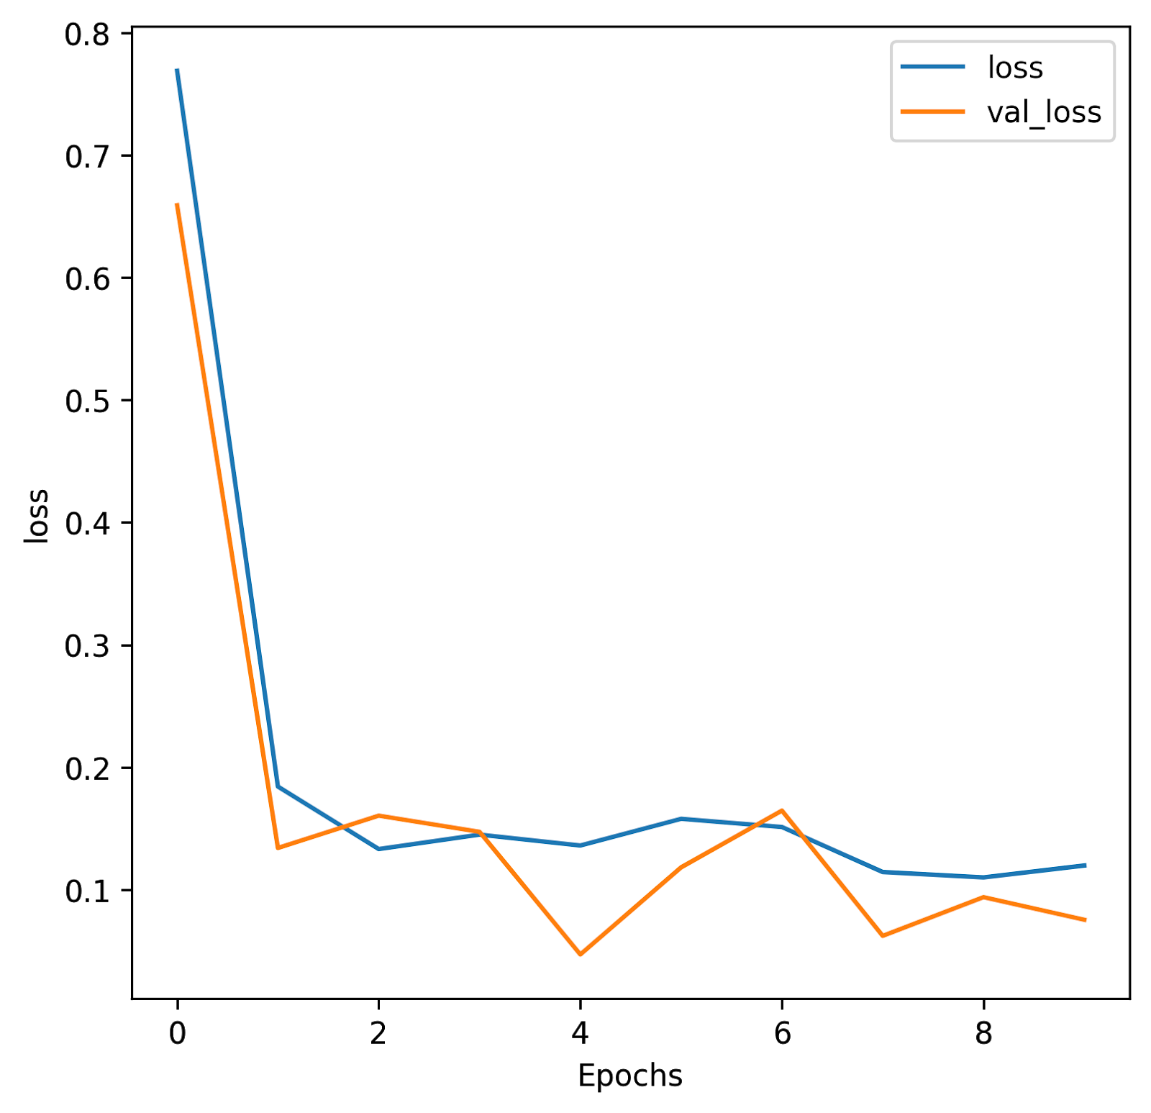

Fig. Model loss vs epoch

Figures -- and -- show the accuracy and loss according to each epoch of the training and validation. The accuracy of a model varies with the number of epochs and also due to regularization done by dropout method. When the number of epochs increases consequently, accuracy increases and thus loss percent decreases. The model gets the highest accuracy achievable without over-fitting, the training has stopped after 8 epochs and under this point the measured classification accuracy is 99%. After that, the validation and training loss starts to flatten and the loss gap increases between them.

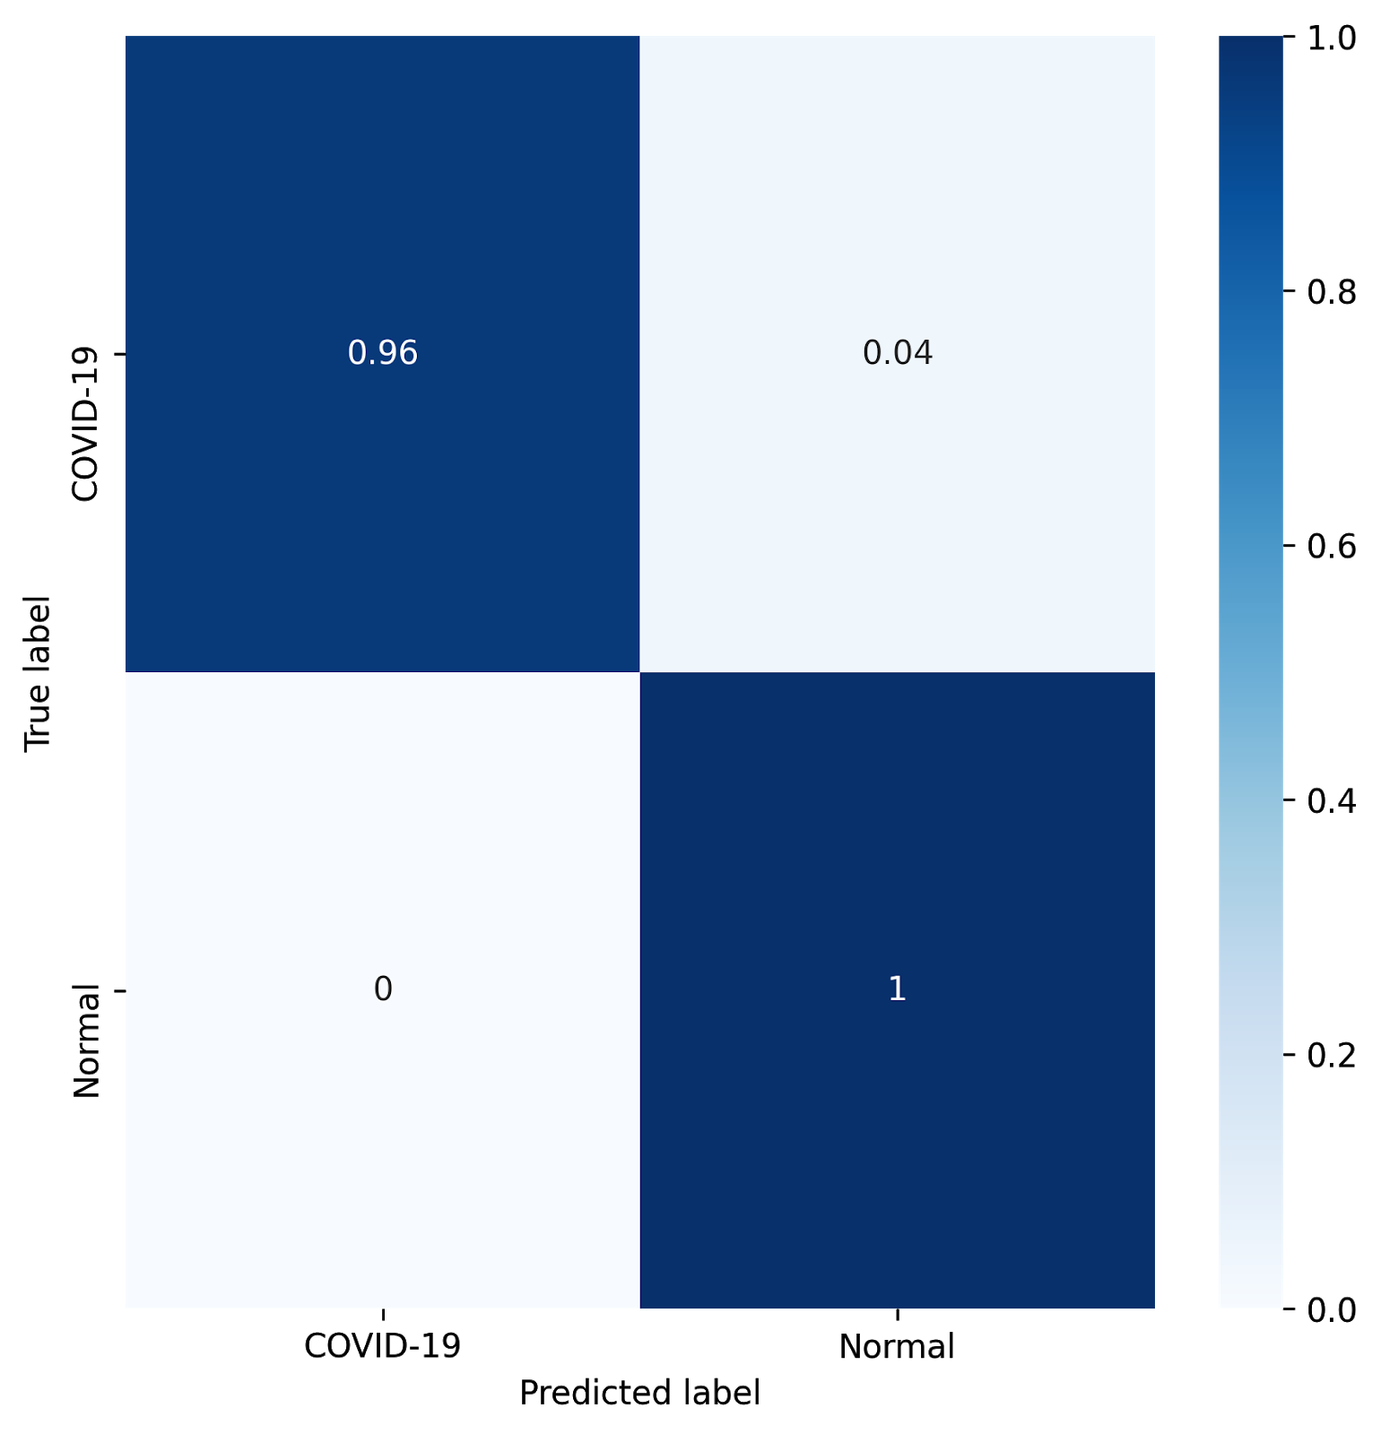

Fig Confusion matrix for prediction of COVID-19 and Normal chest scan images

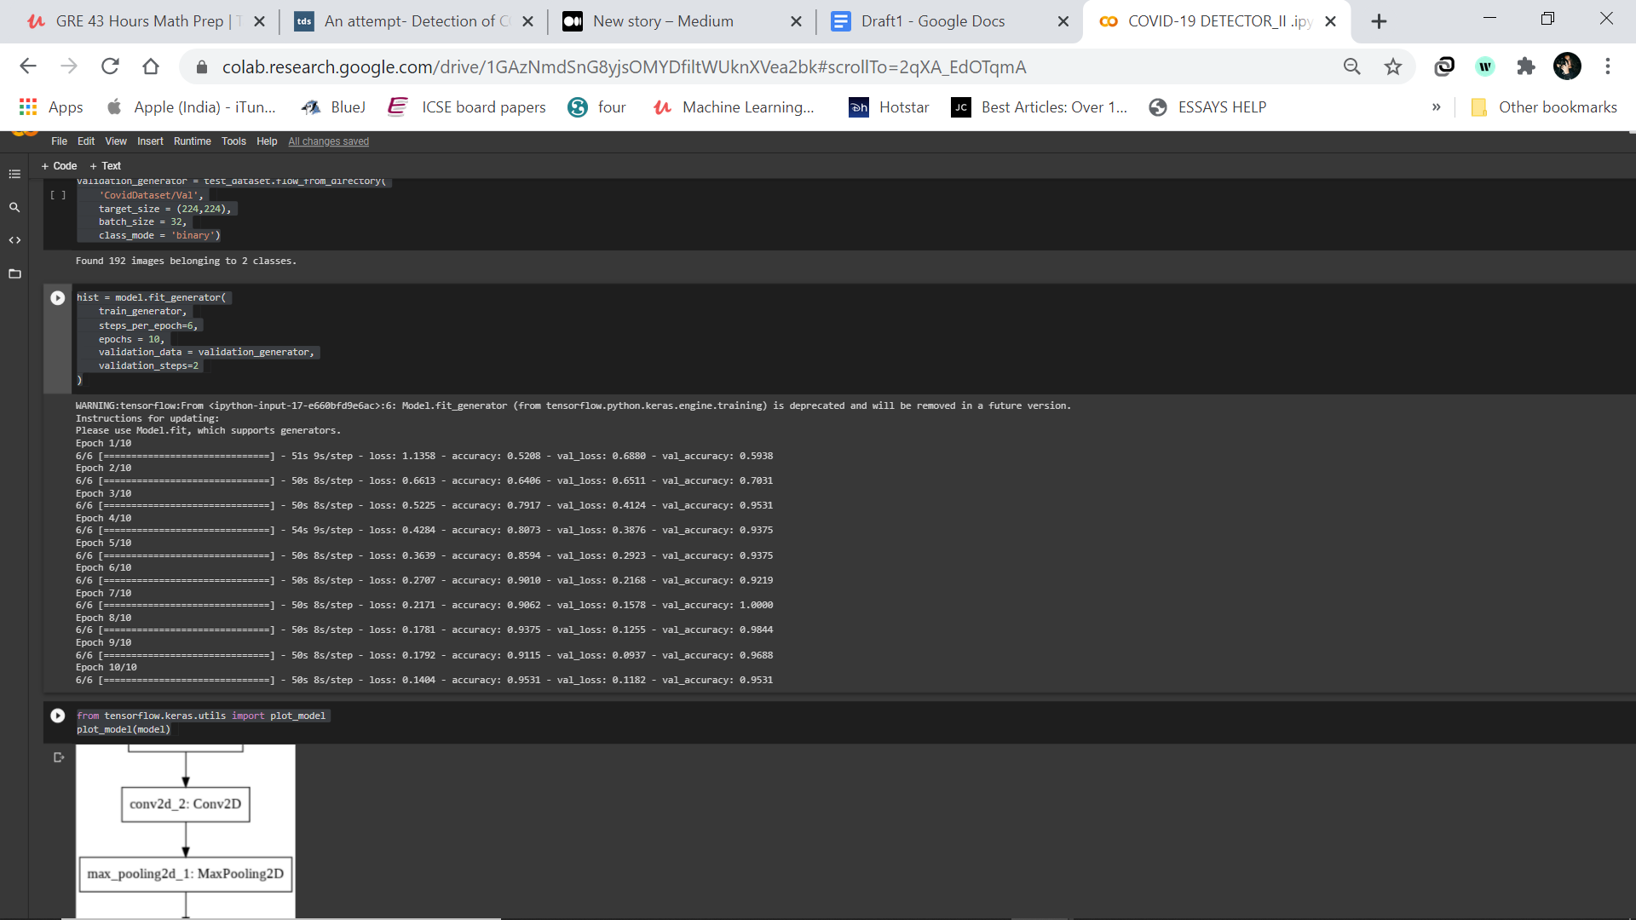

Table-- Confusion matrix report

precision recall f1-score support

COVID-19 1.00 0.98 0.99 256

Normal 0.98 1.00 0.99 296

accuracy 0.99 552

macro avg 0.99 0.99 0.99 552

weighted avg 0.99 0.99 0.99 552

Fig -- shows the confusion matrix for the prediction of *COVID-19* and *Normal* condition for the chest scan images. It represents a fraction of misclassification for both the categories. Here, it can be observed that *Normal* category of chest images are being correctly classified with the accuracy of 100%. Whereas, *COVID-19* are misclassified in some of the cases. It is correctly classified with the percentage of 96. It is due to the smaller number of training samples for the class. Overall, it can be said that it is decent accuracy for classification.

On the basis of the confusion matrix, calculate the precision, recall and f1-score for each class of chest images. It is represented in Table -- as a confusion matrix report.

1. "Advice for the public - World Health Organization." <https://www.who.int/emergencies/diseases/novel-coronavirus-2019/advice-for-public>. Accessed 12 Dec. 2020.
2. "Advice for the public - World Health Organization." <https://www.who.int/emergencies/diseases/novel-coronavirus-2019/advice-for-public>. Accessed 12 Dec. 2020.
3. "Li Wenliang: Coronavirus kills Chinese whistleblower doctor ...." 7 Feb. 2020, <https://www.bbc.com/news/world-asia-china-51403795>. Accessed 12 Dec. 2020.
4. "Severe Acute Respiratory Syndrome (SARS)." <https://www.who.int/health-topics/severe-acute-respiratory-syndrome>. Accessed 12 Dec. 2020.
5. "Coronavirus disease 2019 - Wikipedia." <https://en.wikipedia.org/wiki/COVID-19_pandemic>. Accessed 12 Dec. 2020.
6. "Ebola virus disease - World Health Organization." 10 Feb. 2020, <https://www.who.int/news-room/fact-sheets/detail/ebola-virus-disease>. Accessed 12 Dec. 2020.
7. "Coronavirus Update (Live) - Worldometer." <https://www.worldometers.info/coronavirus/>. Accessed 12 Dec. 2020.
8. "WHO Coronavirus Disease (COVID-19) Dashboard | WHO ...." <https://covid19.who.int/>. Accessed 13 Dec. 2020.
9. "WHO Coronavirus Disease (COVID-19) Dashboard | WHO ...." <https://covid19.who.int/>. Accessed 13 Dec. 2020.
10. ""Immunity passports" in the context of COVID-19 - World ...." 24 Apr. 2020, <https://www.who.int/news-room/commentaries/detail/immunity-passports-in-the-context-of-covid-19>. Accessed 13 Dec. 2020.
11. "Coronavirus disease (COVID-19): Herd immunity, lockdowns ...." 15 Oct. 2020, <https://www.who.int/news-room/q-a-detail/herd-immunity-lockdowns-and-covid-19>. Accessed 13 Dec. 2020.
12. "Around 12.2 crore people lost their jobs: How Covid-19 will ...." 21 Aug. 2020, <https://www.indiatoday.in/education-today/jobs-and-careers/story/around-12-2-crore-people-lost-their-jobs-how-covid-19-will-change-job-prospects-and-hiring-in-india-1713616-2020-08-21>. Accessed 12 Dec. 2020.
13. "Which top economies have suffered worst GDP fall due to ...." 1 Sep. 2020, <https://www.businesstoday.in/current/economy-politics/which-top-economies-have-suffered-worst-gdp-fall-due-to-covid-19/story/414683.html>. Accessed 12 Dec. 2020.
14. "Coronavirus: A visual guide to the economic impact - BBC News." 29 Jun. 2020, <https://www.bbc.com/news/business-51706225>. Accessed 12 Dec. 2020.
15. "Is social distancing working? Here's what you need to know ...." 1 Apr. 2020, <https://www.michiganradio.org/post/social-distancing-working-heres-what-you-need-know>. Accessed 12 Dec. 2020.
16. "COVID-19: What it is, what you need to know - Mayo Clinic ...." 7 Feb. 2020, <https://www.mayoclinichealthsystem.org/hometown-health/featured-topic/coronavirus-what-it-is-what-you-need-to-know>. Accessed 12 Dec. 2020.
17. "FDA authorizes first over-the-counter, non-prescription Covid ...." <https://www.gwinnettdailypost.com/features/health/fda-authorizes-first-over-the-counter-non-prescription-covid-19-test-system-for-home-use/article_5f90ccfc-8d2e-5b26-ac04-cdd5a6d659d5.html>. Accessed 12 Dec. 2020.
18. "Coronavirus Disease 2019 Testing Basics | FDA." 6 Nov. 2020, <https://www.fda.gov/consumers/consumer-updates/coronavirus-disease-2019-testing-basics>. Accessed 12 Dec. 2020.
19. "COVID-19 open source data sets: a comprehensive survey ...." 21 Sep. 2020, <https://link.springer.com/article/10.1007/s10489-020-01862-6>. Accessed 12 Dec. 2020.
20. "Congestive Cardiac Failure: Causes and Effects." 11 Feb. 2020, <https://nursinganswers.net/essays/congestive-cardiac-failure-causes-4729.php>. Accessed 12 Dec. 2020.