**UNIVERSITY OF PETROLEUM**

**AND ENERGY STUDIES**

**Assignment-1**

**SPCM**

**Submitted To-**

**Hitesh Kumar Sharma**

**Submitted by – SHIVAM PANDEY**

**Sap-Id 500061432**

**B.TECH-CSE-DEVOPS**

Steps:

1. First create a directory project-terraform and initialise terraform which is installed on your system by following command: Terraform init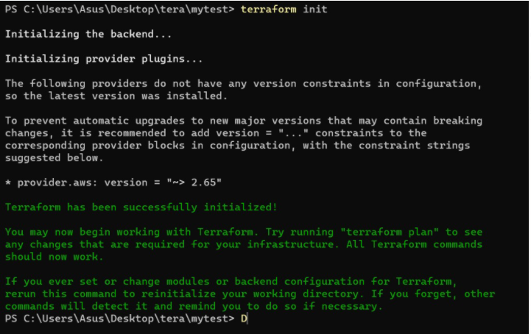

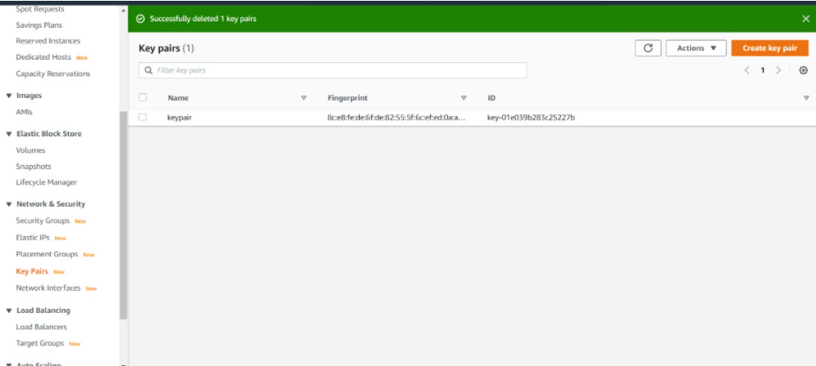

1. Now, create a file using vim which is will connect to aws and has the access and security key credenitials which you have downloaded and enter your region:

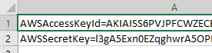

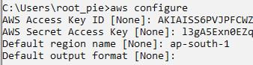

1. Then using vim create a file in terraform with .tf extension and add below commands and set the ami from the screen as shown below amd set the instance type as t2 micro and 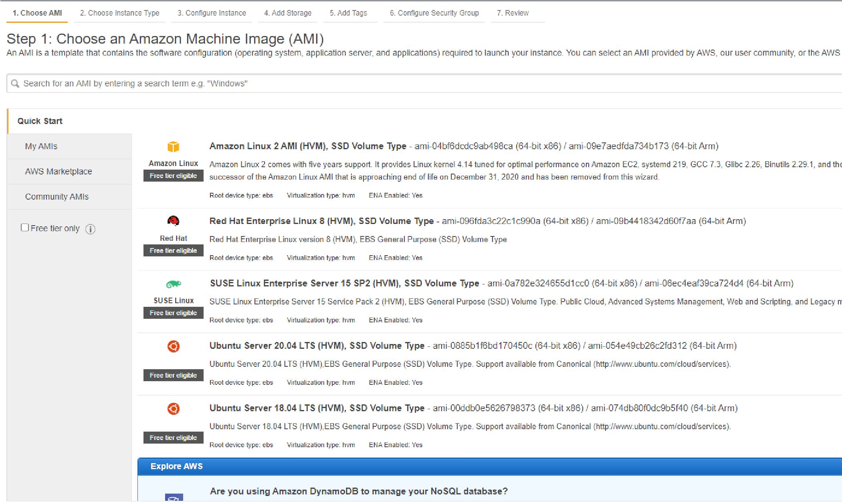key_name.

In this file, we add resources like instance creation, vpn and S3 bucket. All these steps to create these 3 added in this file.

provider "aws" {

region= "ap-south-1"

profile= "shivam pandey"

}

resource "aws_instance" "myFirstInstance" {

ami = "ami-0db0b3ab7df22e366"

count=2

key_name = "keypair"

instance_type = "t2.micro"

security_groups= [ "security_jenkins_port"]

tags= {

Name = "jenkins_instance"

}

}

resource "aws_s3_bucket" "tf_course" {

bucket = "ilovedevops987"

acl = "private"

}

resource "aws_vpc" "vpc" {

cidr_block = "10.0.0.0/16"

}

resource "aws_vpn_gateway" "vpn_gateway" {

vpc_id = aws_vpc.vpc.id

}

resource "aws_customer_gateway" "customer_gateway" {

bgp_asn = 65000

ip_address = "172.0.0.1"

type = "ipsec.1"

}

resource "aws_vpn_connection" "main" {

vpn_gateway_id = aws_vpn_gateway.vpn_gateway.id

customer_gateway_id = aws_customer_gateway.customer_gateway.id

type = "ipsec.1"

static_routes_only = true

}

resource "aws_security_group" "security_jenkins_port" {

name = "security_jenkins_port"

description = "security group for jenkins"

ingress {

from_port = 8080

to_port = 8080

protocol = "tcp"

cidr_blocks = ["0.0.0.0/0"]

}

ingress {

from_port = 22

to_port = 22

protocol = "tcp"

cidr_blocks = ["0.0.0.0/0"]

}

# outbound from jenkis server

egress {

from_port = 0

to_port = 65535

protocol = "tcp"

cidr_blocks = ["0.0.0.0/0"]

}

tags= {

Name = "security_jenkins_port"

}

}

1. Now Apply, terraform apply command through which the script will run:

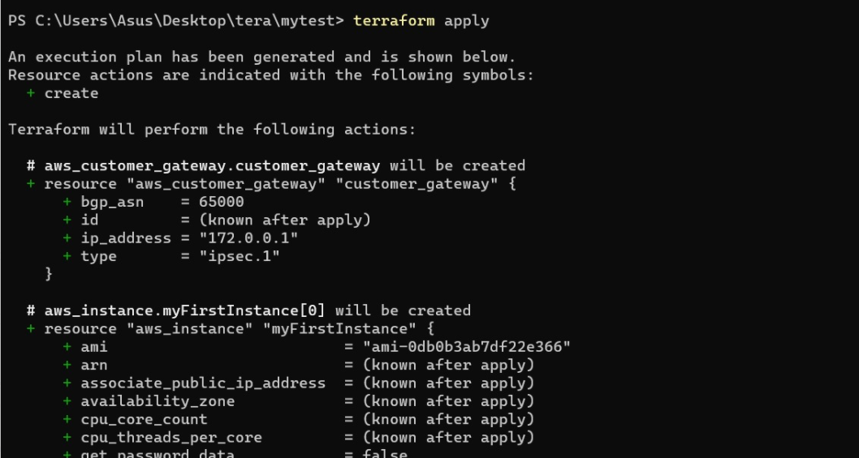

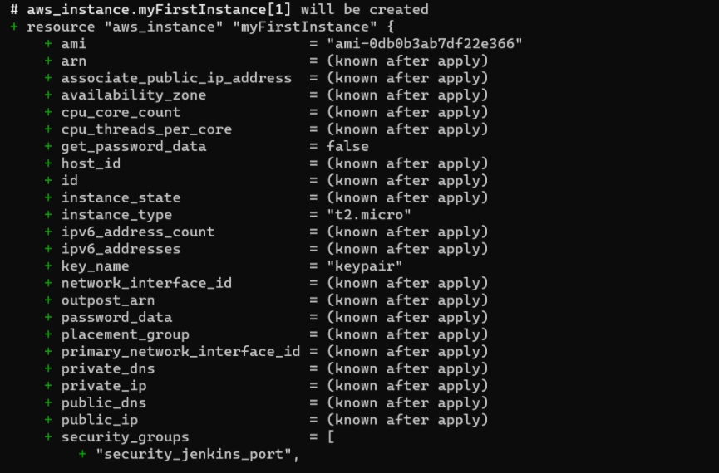

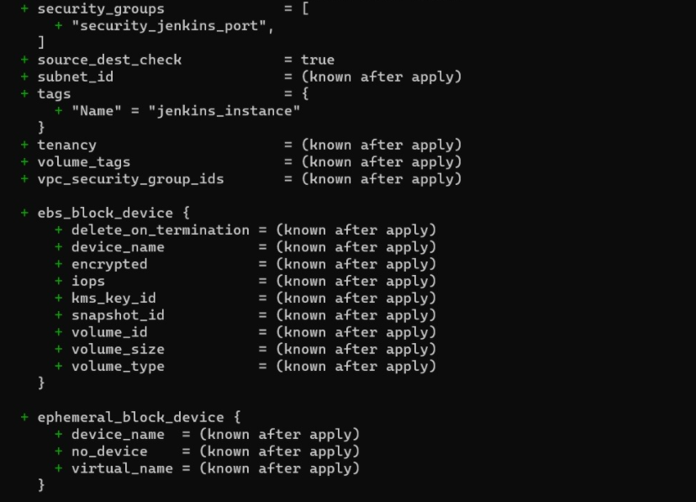

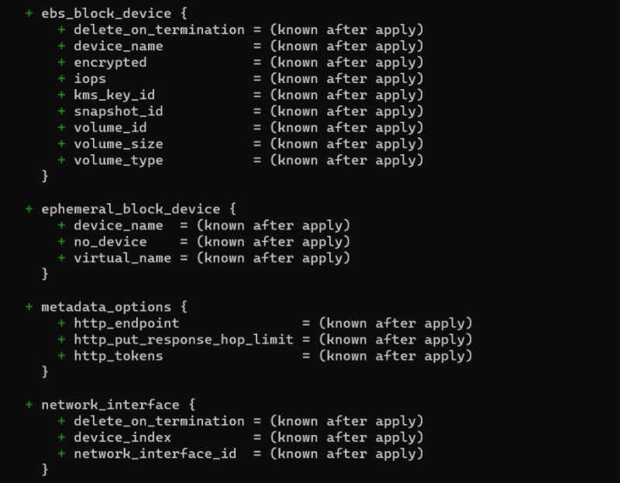

1. Some resourcs are created and some are still in process as shown below

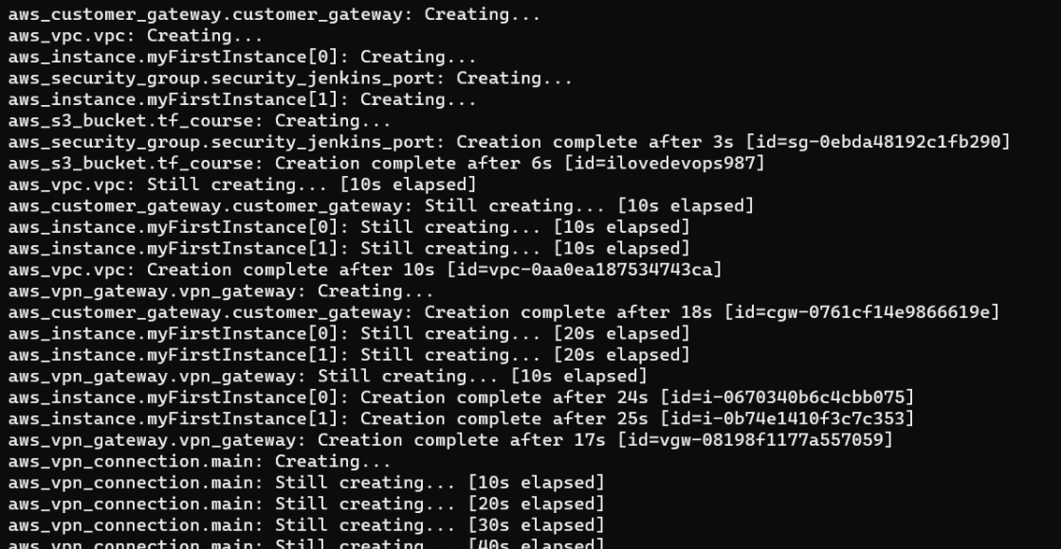

1. Now, You can visit your aws management console and see 2 EC2 instances have been created , VPN is created and S3 bucket is also created:

