**Assignment-1**

**SPCM**

**SHUBHAM BANSAL**

**R171217057**

**500060901**

**B.TECH-CSE-DEVOPS**

Steps:

1. Create a directory first named as project-terraform and initialise it by following command.

**Terraform init**

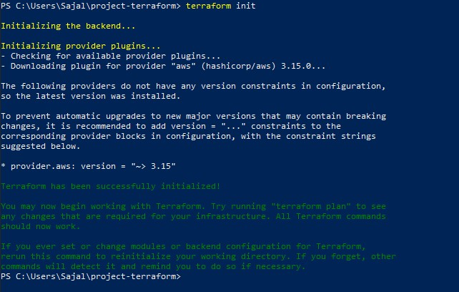

1. Now next task will be to create an access key and secret key which you can create and download from your aws management console.

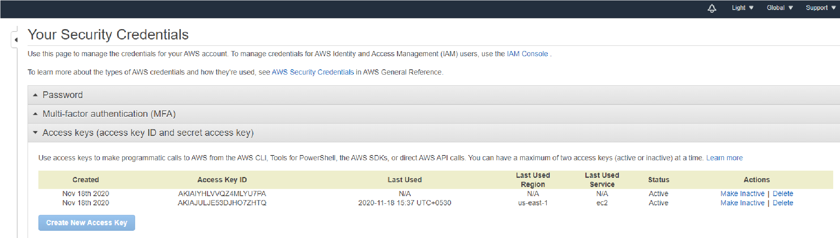

Now, create a file using vim which is will connect to aws and has the access and security key credenitials which you have downloaded and enter your region:

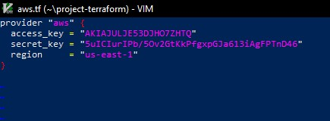

1. Using any editor create a file with “**.tf**” and add the below commands set the ami from the screen as shown below amd set the instance type as t2 micro and key_name as “mykey”:

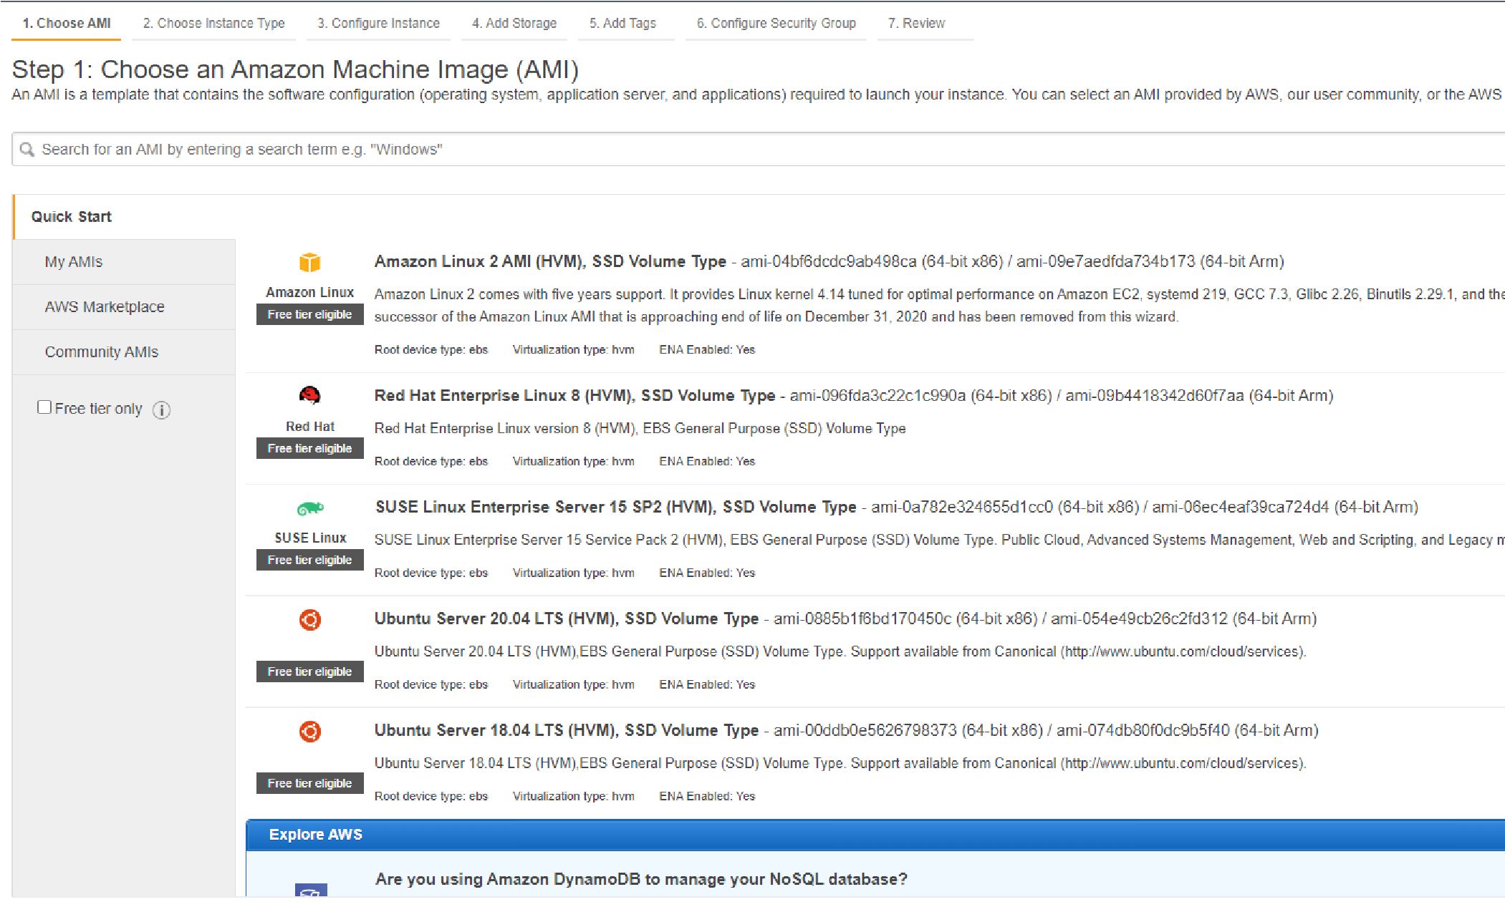

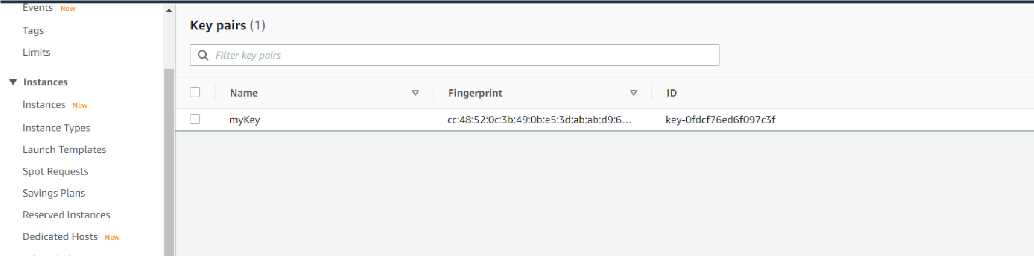

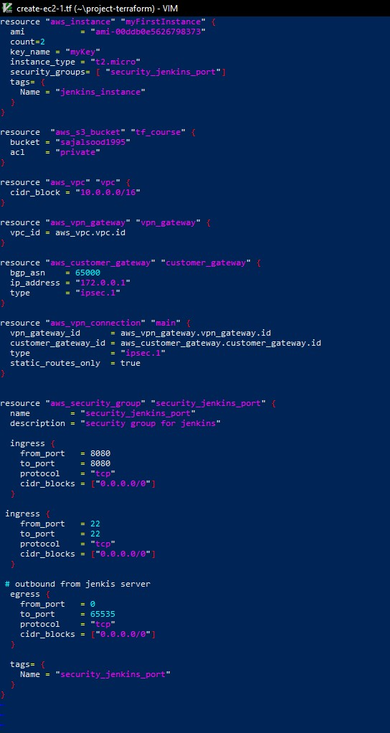

In this file, we add resources like instance creation, vpn and S3 bucket. All these steps to create these 3 added in this file.

1. Now, apply the command terraform plan which depicts all the plans that the file has to perform:

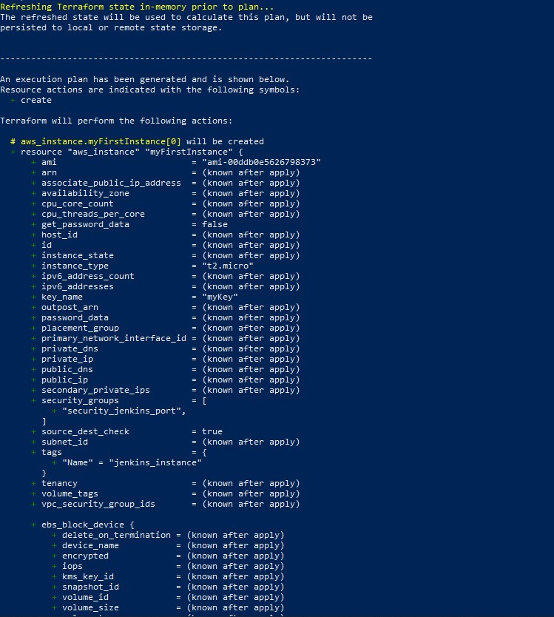

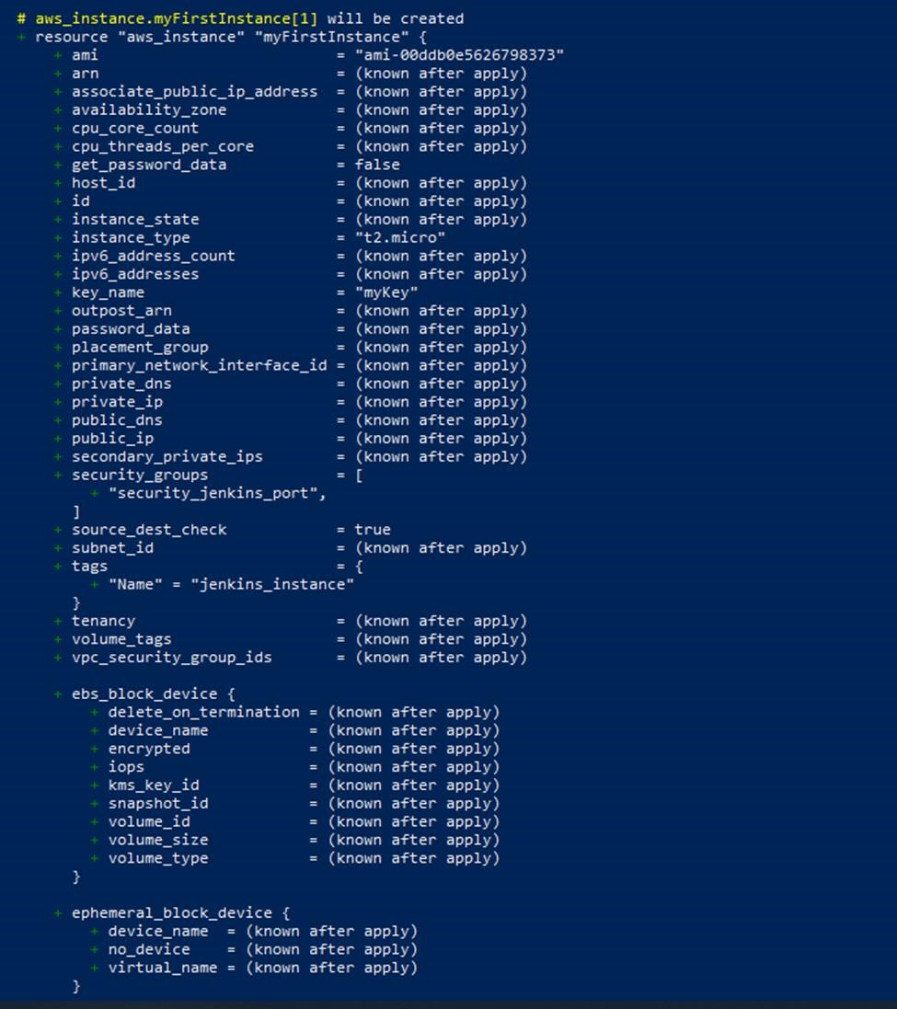

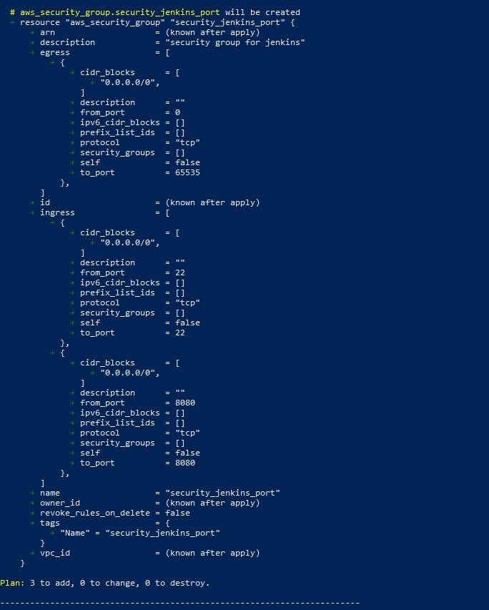

As we can see plans are added:

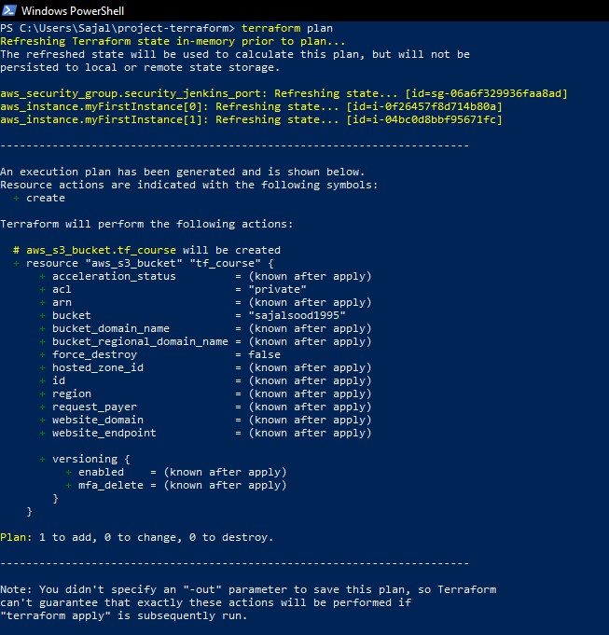

1. Now run the script using the “**terraform apply**” command :

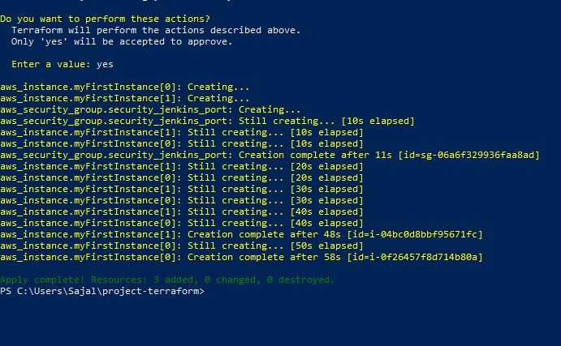

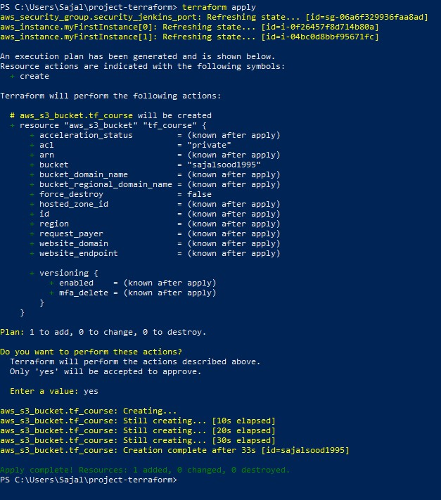

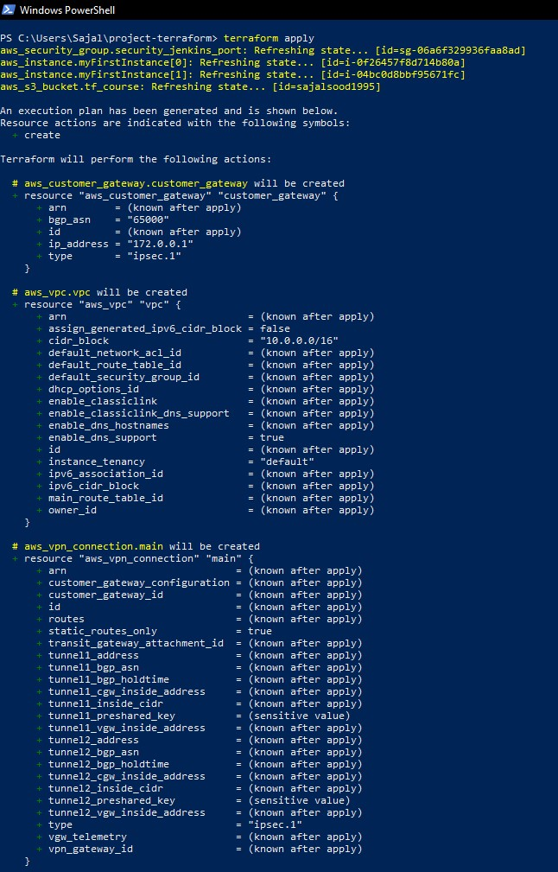

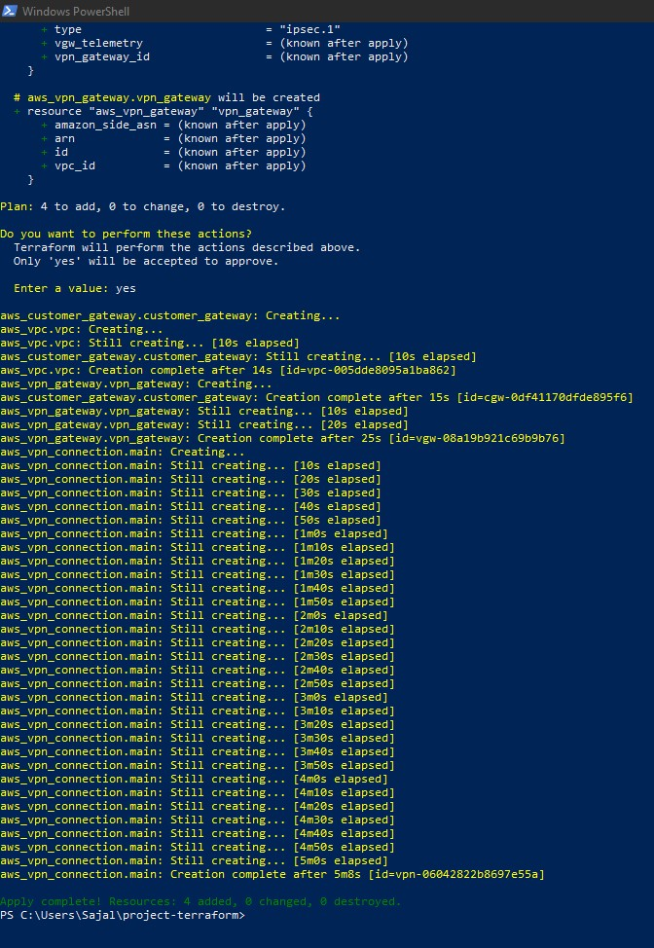

1. Now, You can visit your AWS management console and watch EC2 instances have been created, VPN is created and S3 bucket is also created:

