Academic Project Technical Report
AI FIT TRACK API
AI-powered Fitness Tracking and Workout Management System
Backend API Documentation

AI FIT TRACK API
AI-powered Fitness Tracking and Workout Management System
DESCRIPTION:
FitTrack is an AI-powered fitness tracking system designed to help users log, monitor, and improve their exercise routines. It uses artificial intelligence to analyze a user's workout history and generate personalized recommendations and fitness insights automatically. The system reduces the need for manual progress tracking by allowing users to record workouts, review statistics, and receive AI-driven guidance on training and calorie management. FitTrack helps users stay consistent, understand their progress, and reach their fitness goals faster with data-backed suggestions.
Scenario-Based Case Study -- FitTrack
Case Study: AI-Assisted Workout Tracking for Fitness Enthusiasts
Scenario:
A growing number of fitness enthusiasts want to track their workouts -- type, duration, and calories burned -- but manually calculating trends and progress is tedious and error-prone. Users need instant, personalized guidance without hiring a personal trainer.
To solve this problem, the platform introduces FitTrack -- an AI-Powered Fitness Tracking API. Users register and log in securely, record workouts across categories such as Cardio, Strength Training, Yoga, Running, Cycling, and Walking, and request AI-generated workout recommendations and fitness insights based on their logged history.
For example, if a user has logged 18 workouts averaging 45 minutes each, FitTrack's AI service analyzes this data and returns a tailored insight encouraging consistency and suggesting progressive overload to accelerate results.
Problem Statement
Traditional fitness tracking requires users to manually calculate progress, plan workouts, and interpret their own data with no expert guidance. This leads to repetitive manual effort and inconsistent training decisions.
Therefore, there is a need for an AI-powered workout tracking system that can:
- Provide instant, personalized workout recommendations based on a user's profile and goals.
- Understand and store workout history securely for every user.
- Generate AI-based fitness insights from cumulative training data.
- Maintain secure, authenticated access to personal fitness data.
- Support complete CRUD operations for workout records.
- Improve the overall speed and accessibility of personal fitness tracking.
Proposed Solution
FitTrack provides a secure, authenticated backend where users can register, log workouts, and interact with an AI service (Google Gemini) that analyzes fitness goals and workout history to generate personalized recommendations and progress insights. This creates a faster, guided fitness-tracking experience without requiring manual analysis.
1. Software Requirements
- Operating System: Windows 10/11, macOS, or Linux (supports cross-platform operations).
- Node.js (v18 or above): Runtime ecosystem running server logic and routing infrastructure.
- npm (v9 or above): Node package manager to control operational dependencies.
- Express.js (v4/v5 Ecosystem): Lightweight routing web framework to construct backend RESTful entry points.
- MongoDB / Mongoose ODM: Document NoSQL engine storing application users and workout data entities.
- Postman / ThunderClient: API verification toolkit to assert schema validation responses across protected routes.
- Code Editor: Visual Studio Code or similar IDE environment.
2. Hardware Requirements
- Processor: Intel Core i5 (8th Gen or above) / AMD Ryzen 5 or equivalent.
- RAM: 8 GB minimum (16 GB recommended for concurrent instances of MongoDB processing layers).
- Storage: 1 GB of available disk workspace.
Epic 1: Project Architecture
The FitTrack API exposes structured endpoints handled by a layered server architecture model. Incoming requests undergo authentication and validation before interacting with data services.
Components Definition
- Interface: API tools like Thunder Client / Postman query distinct route paths to extract JSON entities.
- Express Server Gateway: Monitors network ports, maps explicit HTTP methods (GET, POST, PUT, DELETE), parses incoming JSON payloads, and handles CORS headers.
- Authentication Middleware: Extracts tokens from headers, validates user context signatures, and evaluates authorization thresholds for guarded resource paths.
- Controllers (Logic Modules): authController, workoutController, and aiController enforce isolated domain rules for user sessions and workout data operations.
- Database Interface Layer: Mongoose translates operational application logic into performant native MongoDB queries.
- AI Flow (Service Integration): geminiService.js connects to Google Gemini AI, letting the controller layer offload workout-recommendation and fitness-insight generation.
Key Structural Entities
1. User Entity
- _id (Primary Key - ObjectId)
- name (String, Required)
- email (String, Required, Unique)
- password (String, Hashed, Required)
- createdAt
- updatedAt
2. Workout Entity
- _id (Primary Key - ObjectId)
- workoutName (String, Required)
- category (String, Required -- Cardio, Strength Training, Yoga, Running, Cycling, Walking)
- duration (Number, Minutes, Required)
- caloriesBurned (Number, Required)
- workoutDate (Date, Default: Now)
- user (Foreign Key referencing User Collection)
- createdAt
- updatedAt
Key Structural Mappings
User → Workout (One-to-Many): A registered user can create and manage multiple workout records.
Workout → AI Service (Logical Relationship): Workout history is aggregated and sent to the AI service to generate recommendations and insights.
Key Features
- JWT Authentication & Authorization: Secure token-based authentication protects private API endpoints.
- AI Workout Recommendations: Google Gemini AI generates personalized workout plans from age, goal, and experience.
- AI Fitness Insights: Google Gemini AI analyzes cumulative workout stats and returns tailored progress feedback.
- Complete CRUD Operations: Create, Read, Update, and Delete workout records.
- Password Encryption: User passwords are securely hashed using bcrypt before storage.
- Centralized Error Handling: Standardized API error responses improve reliability and debugging.
- Schema Validation: Mongoose validation ensures data integrity before database persistence.
- RESTful API Architecture: Modular Express.js routes provide scalable backend services.
- MongoDB Integration: Efficient NoSQL document storage using Mongoose ODM.
Roles and Responsibilities
Registered User
- Register and log in securely.
- Create, view, update, and delete personal workout records.
- View personal profile information.
- Request AI-generated workout recommendations.
- Request AI-generated fitness insights based on workout history.
MVC Architecture Pattern
The system architecture structures its source configuration layers around the Model-View-Controller design pattern to completely decouple components:
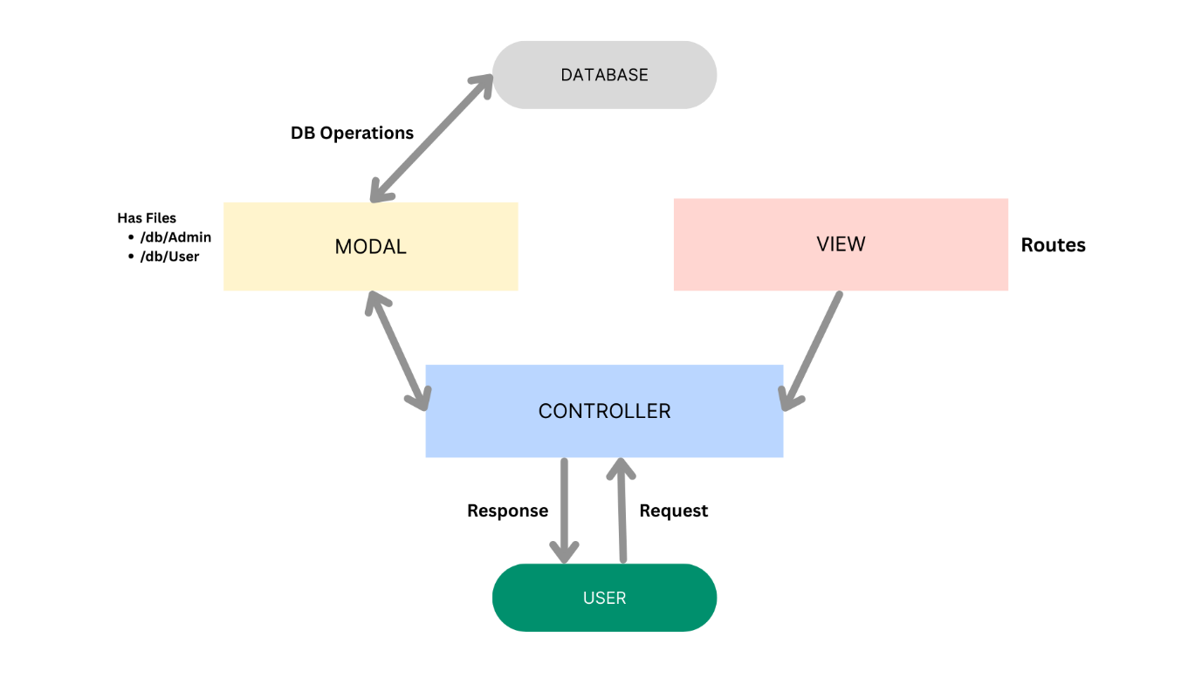
Model Layer (Data Blueprint)
Defines structural blueprints via strongly enforced Mongoose schemas (User.js, Workout.js) mapping explicit fields into raw collection items inside MongoDB. It sets field rules and defaults before validation persistence occurs.
Controller Layer (Execution Matrix)
The intermediary brain of the ecosystem. authController, workoutController, and aiController capture request vectors from execution routes, check structural request constraints, delegate processing workflows directly to models or services, and package resultant output into standard JSON return arrays.
View Layer (Routing Network Interface)
In this pure headless backend service context, standard user-interface template views do not exist. Instead, the interface layer lives as an API Routing Layer (authRoutes.js, workoutRoutes.js, aiRoutes.js) that links network requests on specified paths directly to their associated controller handler logic maps.
Epic 2: Project Setup and Configuration
Creating Project Folder
1. Create a new folder named FitTrack.
2. Inside that folder, create a new subfolder named src.
3. Now open that folder in VS Code.
Server Setup (npm init)
Open your root folder terminal in VS Code and run:
npm init -y
npm install express mongoose dotenv cors jsonwebtoken bcryptjs @google/genai
Project Folder Structure
Before diving into the backend implementation, the screenshots below show the actual VS Code Explorer view of the project once the folder structure from Epic 2 is set up. The source code is organized inside the src/ directory into config, controllers, middleware, models, routes, services, and utils sub-folders, following the layered MVC architecture described earlier.
Figure: Initial view of the src folder showing the config and controllers sub-folders, including db.js and aiController.js.
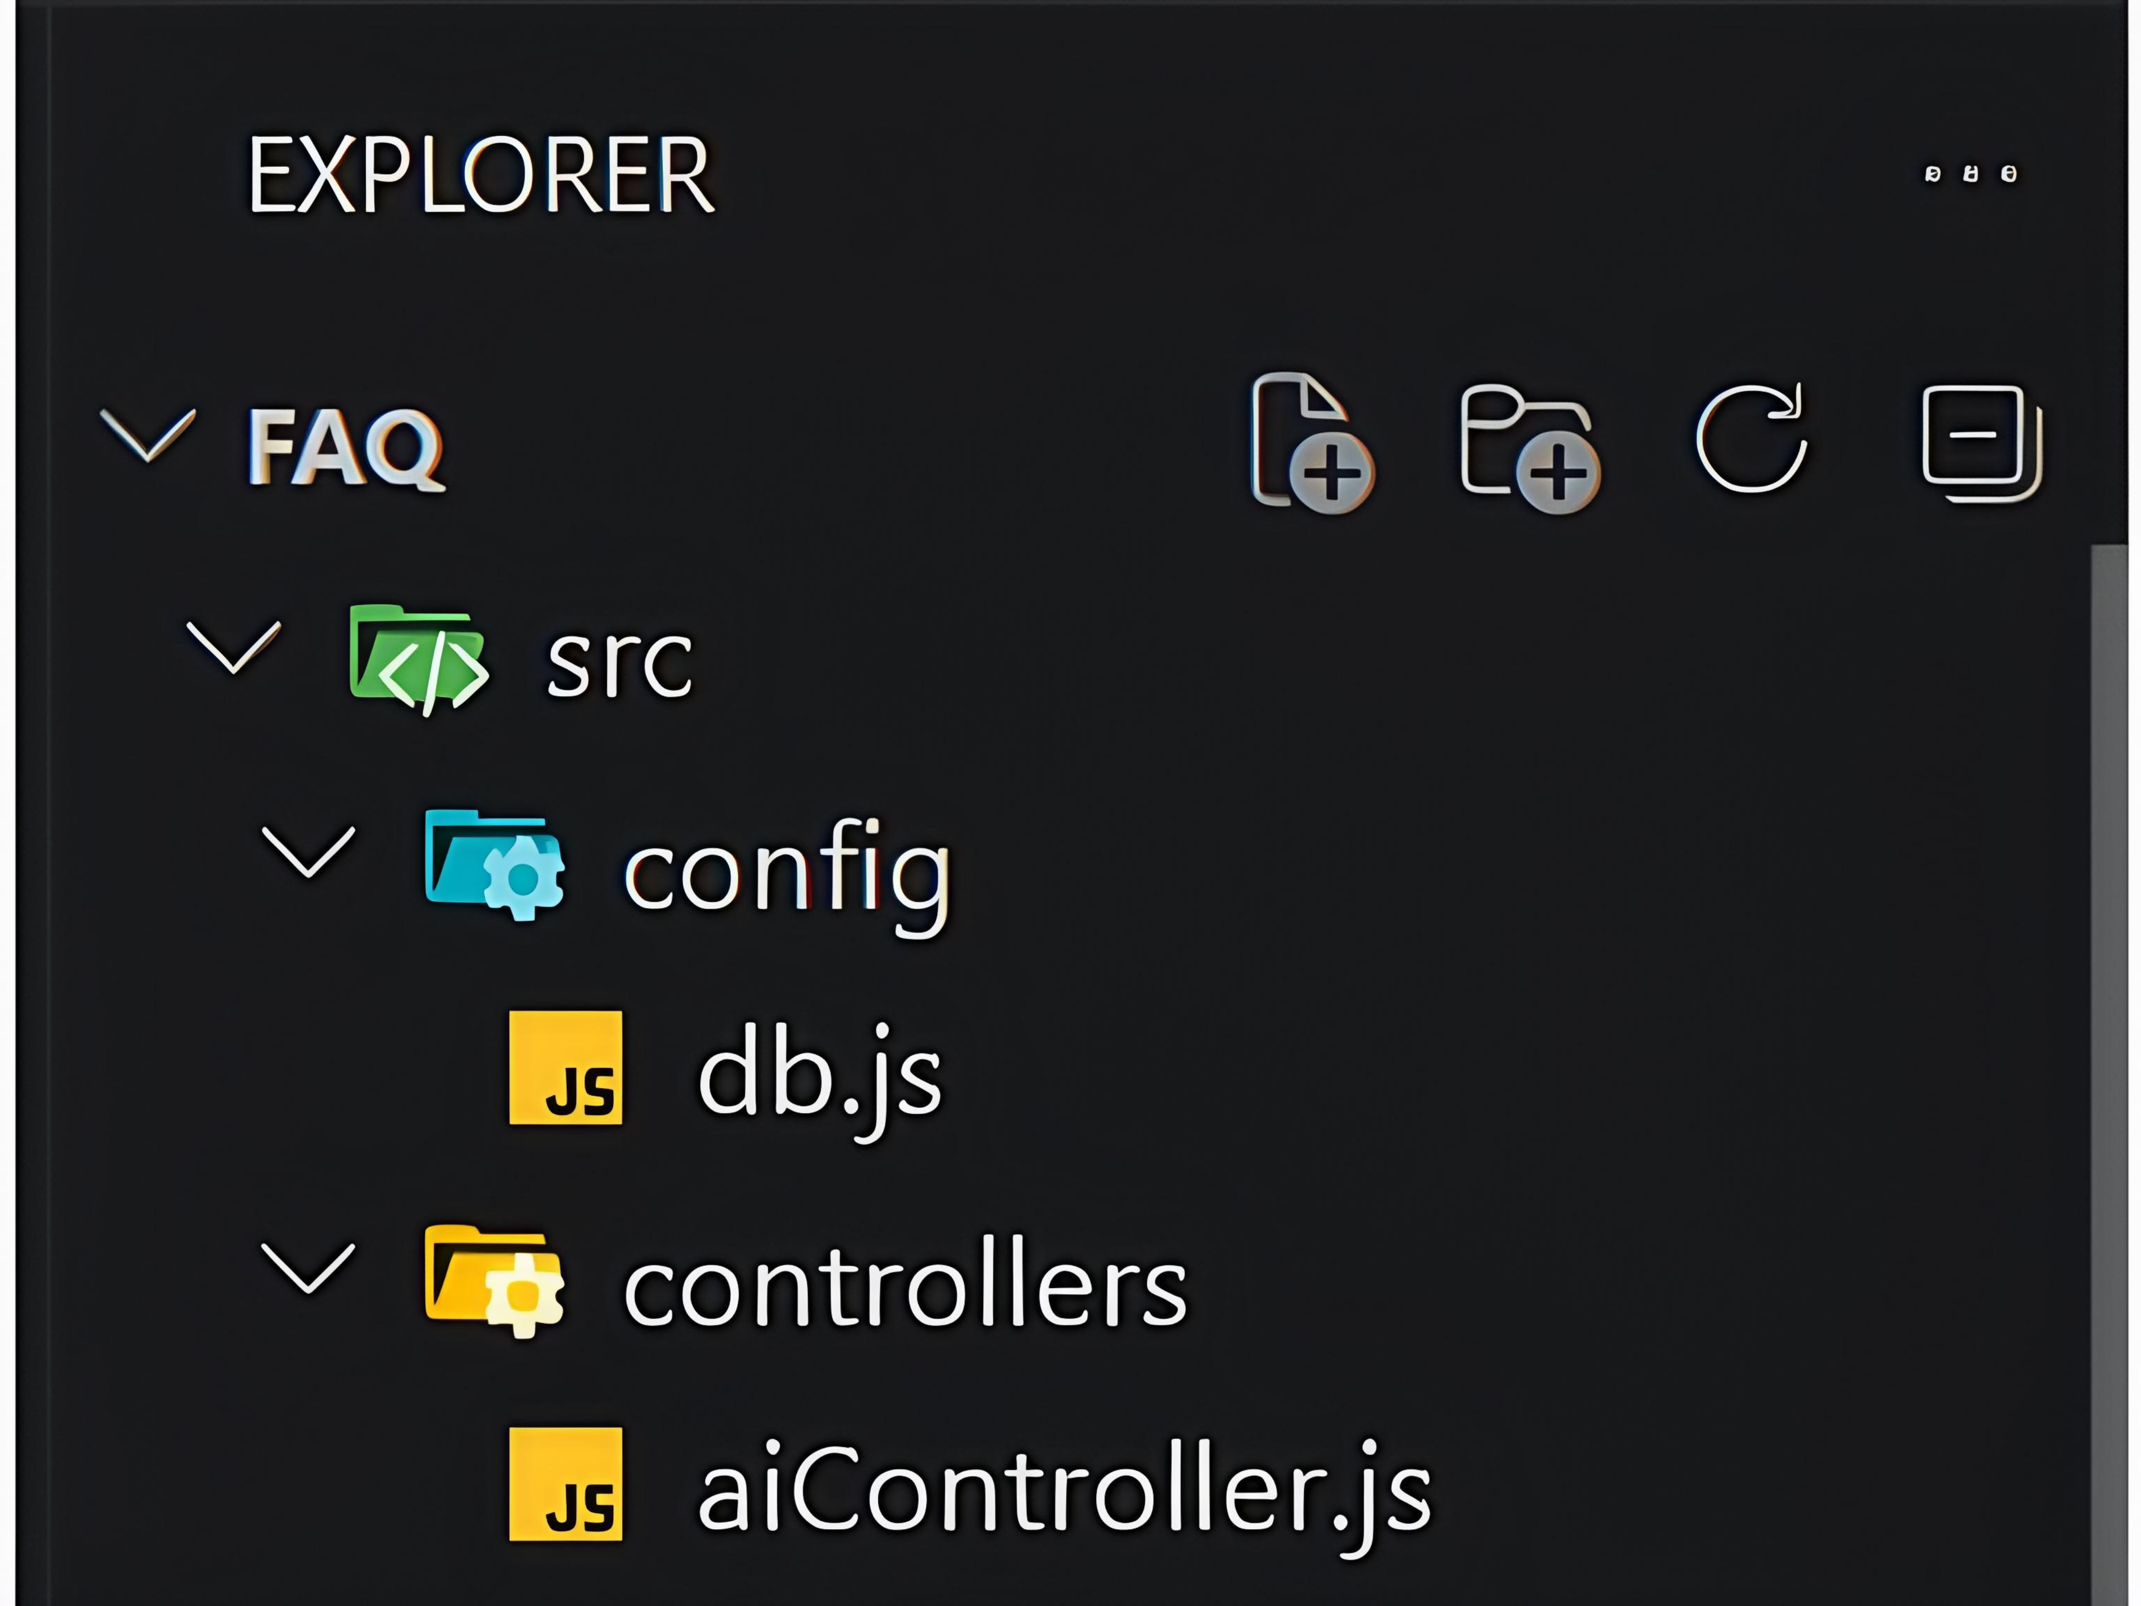
Figure: Complete project structure - controllers (aiController.js, authController.js, faqController.js), middleware (authMiddleware.js, errorMiddleware.js, validationMiddleware.js), models, routes, services (geminiService.js) and utils, along with the app.js, server.js and .env files.
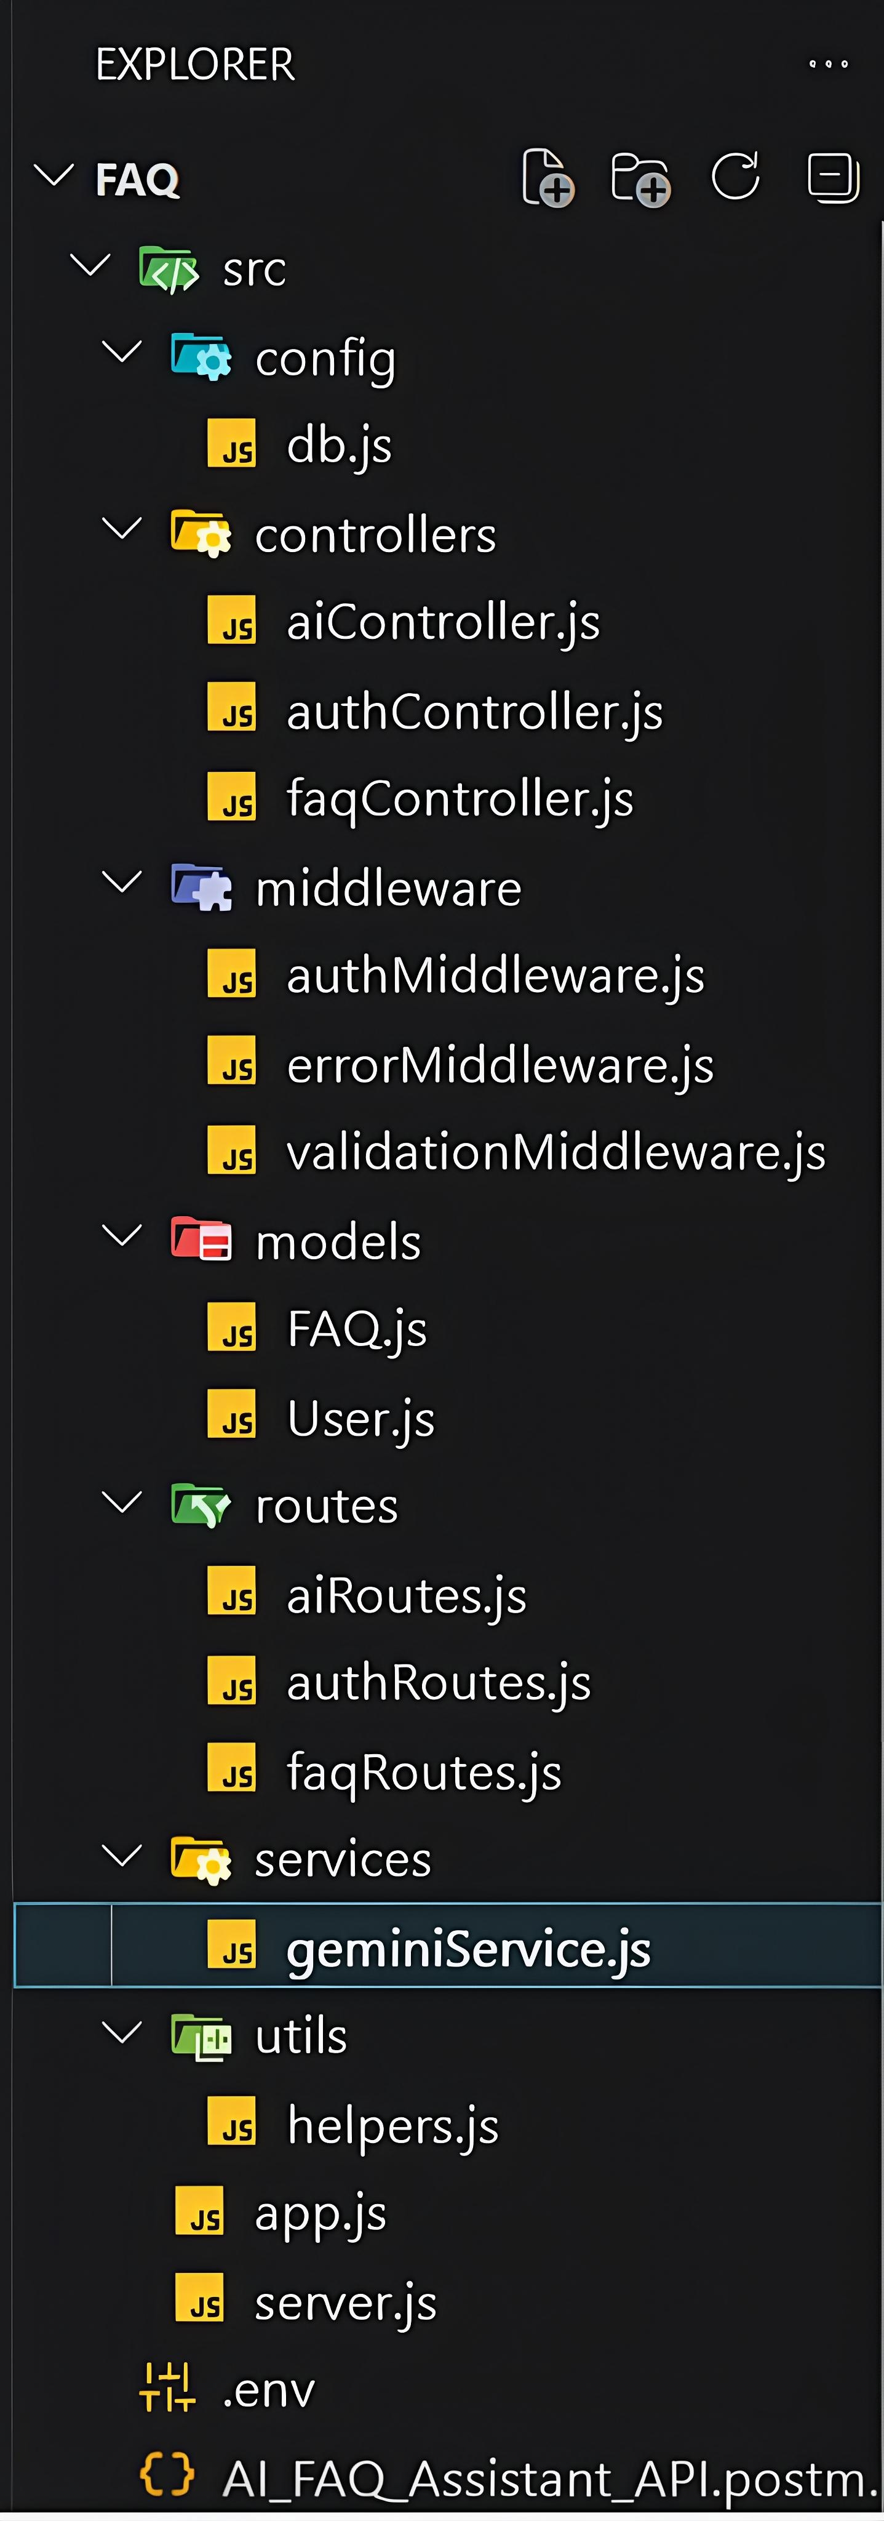
Epic 3: Backend Development
Core System Script Implementations
1. Database Connection Setup (src/config/db.js)
Establishes and manages the MongoDB connection using Mongoose, logging the connected host on success and exiting the process cleanly on failure:
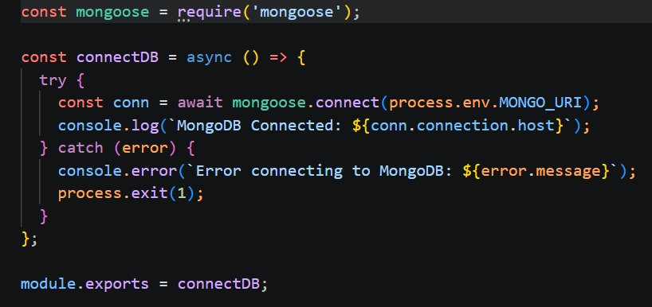
Epic 4: Database Configuration
Mongoose Schema Definitions
1. Identity Resource Document Schema (src/models/User.js)
Enforces profile field criteria validations and hooks password hashing steps prior to user document persistence:
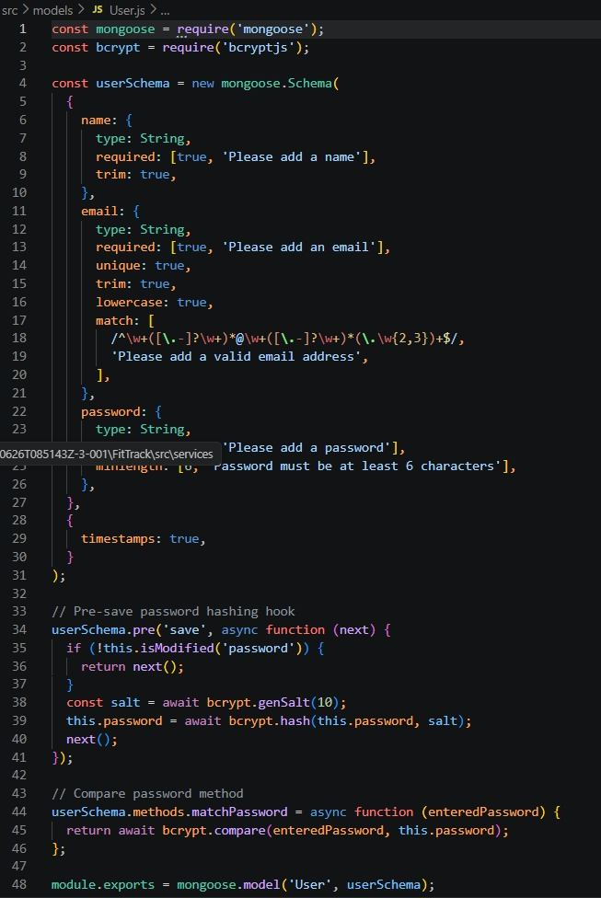
2. Workout Resource Document Schema (src/models/Workout.js)
Models core workout properties -- name, category, duration, and calories burned -- and maps a distinct relational reference link back to the source creator (User) document:
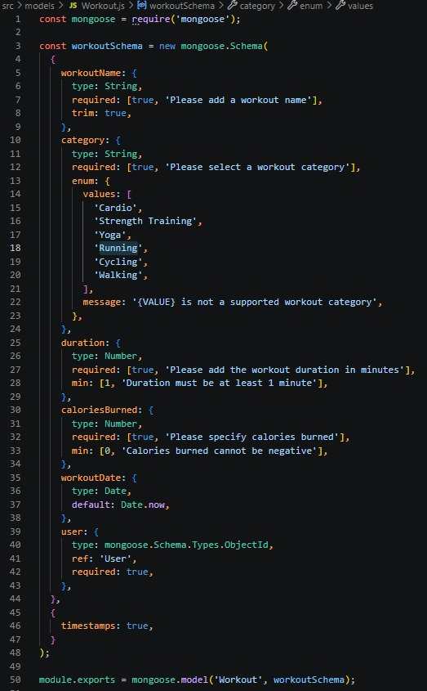
Epic 5: Project Executions
Running the API Application
- Install Postman or ThunderClient (VS Code extension).
- Start the backend development server environment parameters:
npm run dev
API Testing Specification Demo
To verify operational structural integrity via execution endpoints, map endpoints using the configurations below:
1. Identity Onboarding Path Registration
- Route: POST /api/auth/register
- Access: Public
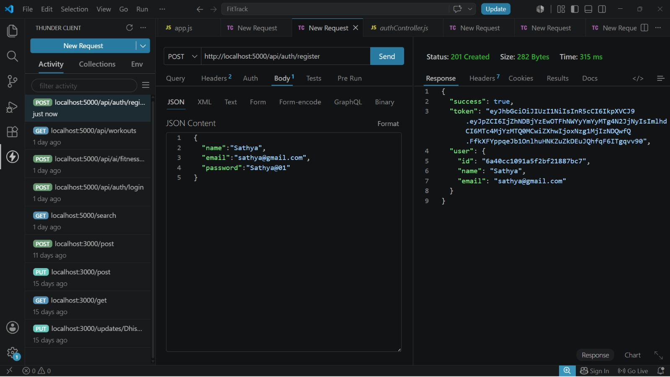
2. Profile Login Verification Query
- Route: POST /api/auth/login
- Access: Public
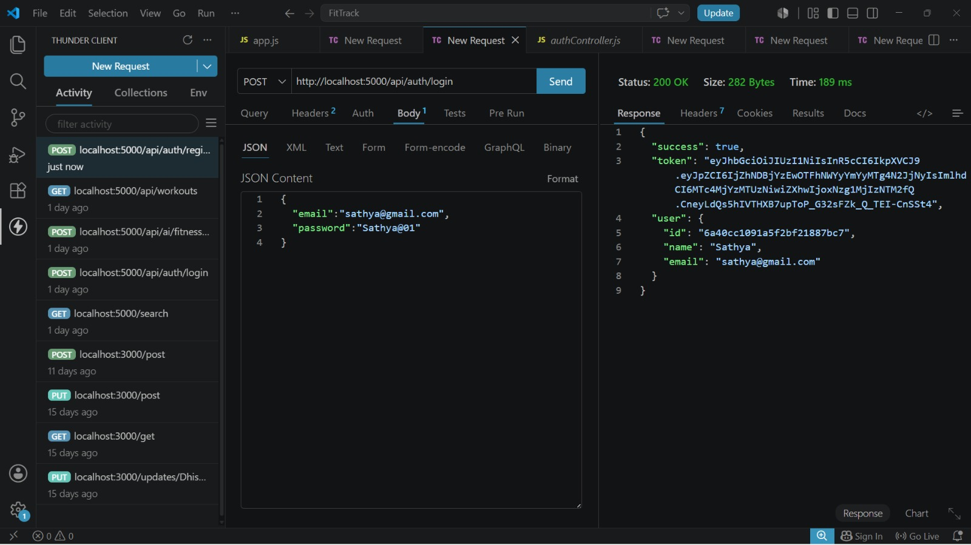
3. Authenticated Profile Fetch
- Route: GET /api/auth/profile
- Access: Private (Bearer <JWT Token>)
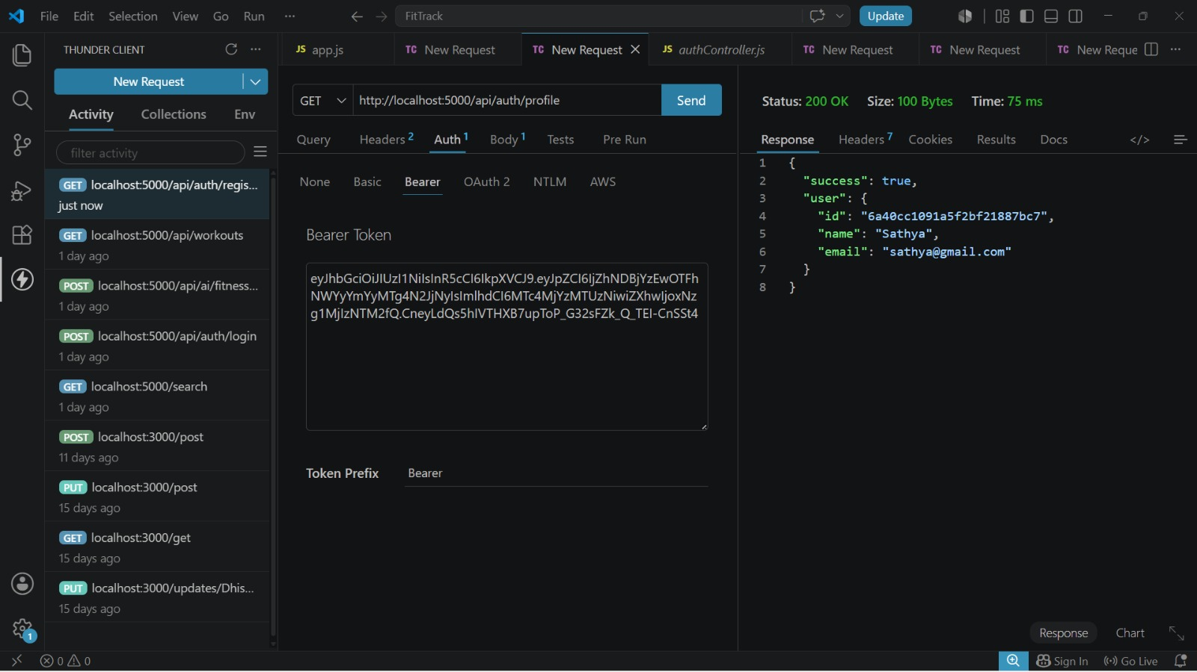
4. Resource Entity Creation (Workout)
- Route: POST /api/workouts
- Access: Private (Bearer <JWT Token>)
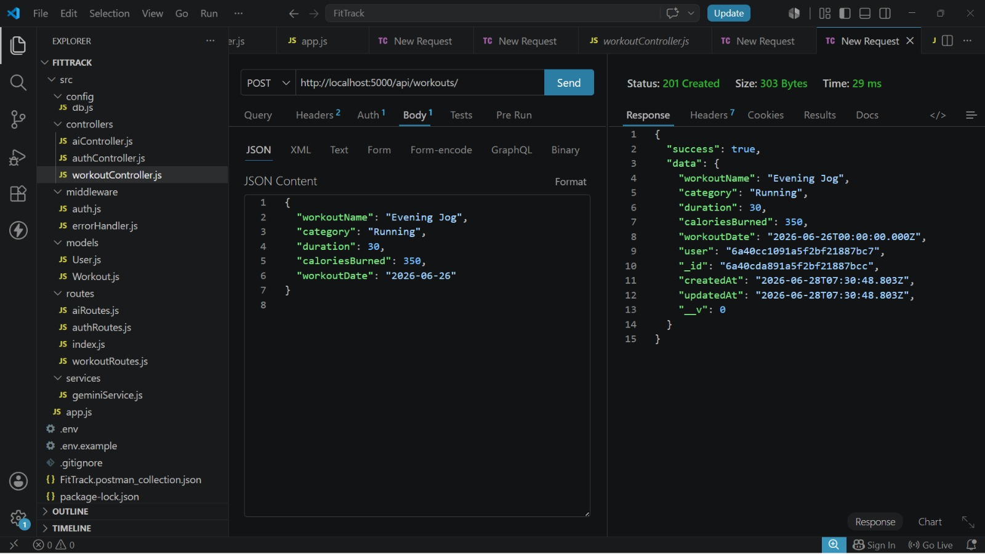
5. Resource Entity Listing (All Workouts)
- Route: GET /api/workouts
- Access: Private (Bearer <JWT Token>)
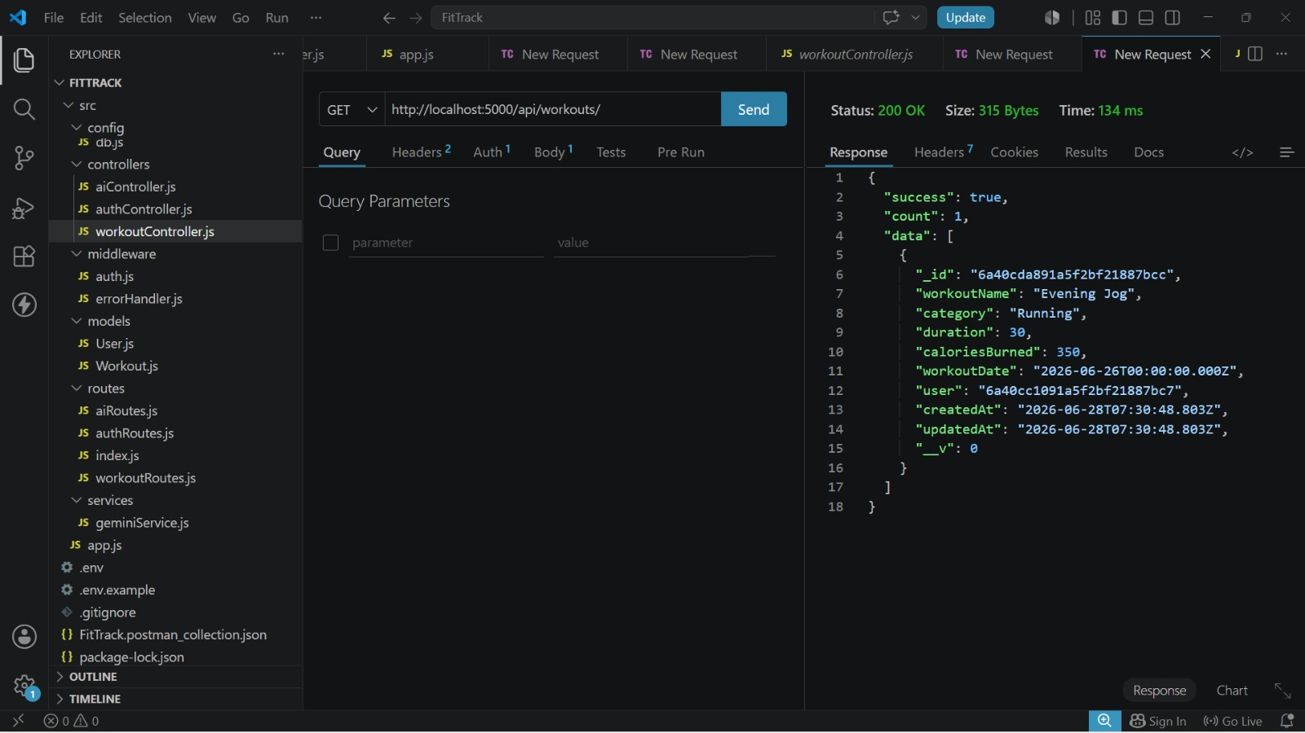
6. Resource Entity Fetching (Workout by ID)
- Route: GET /api/workouts/:id
- Access: Private (Bearer <JWT Token>)
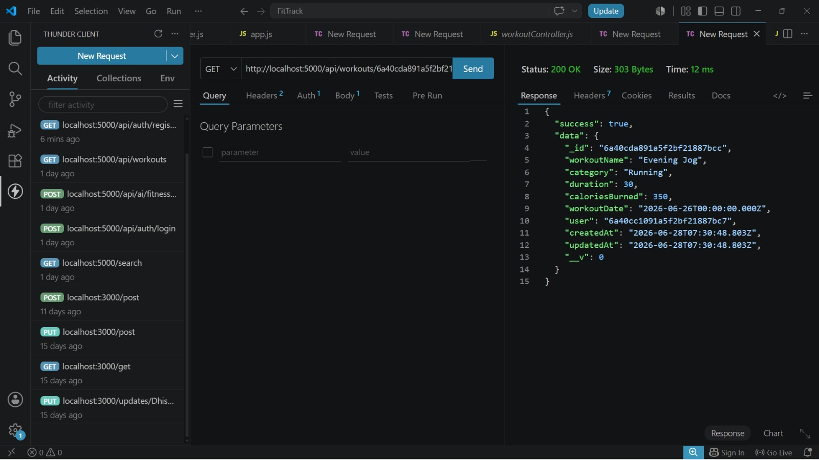
7. Resource Entity Update (Workout)
- Route: PUT /api/workouts/:id
- Access: Private (Bearer <JWT Token>)
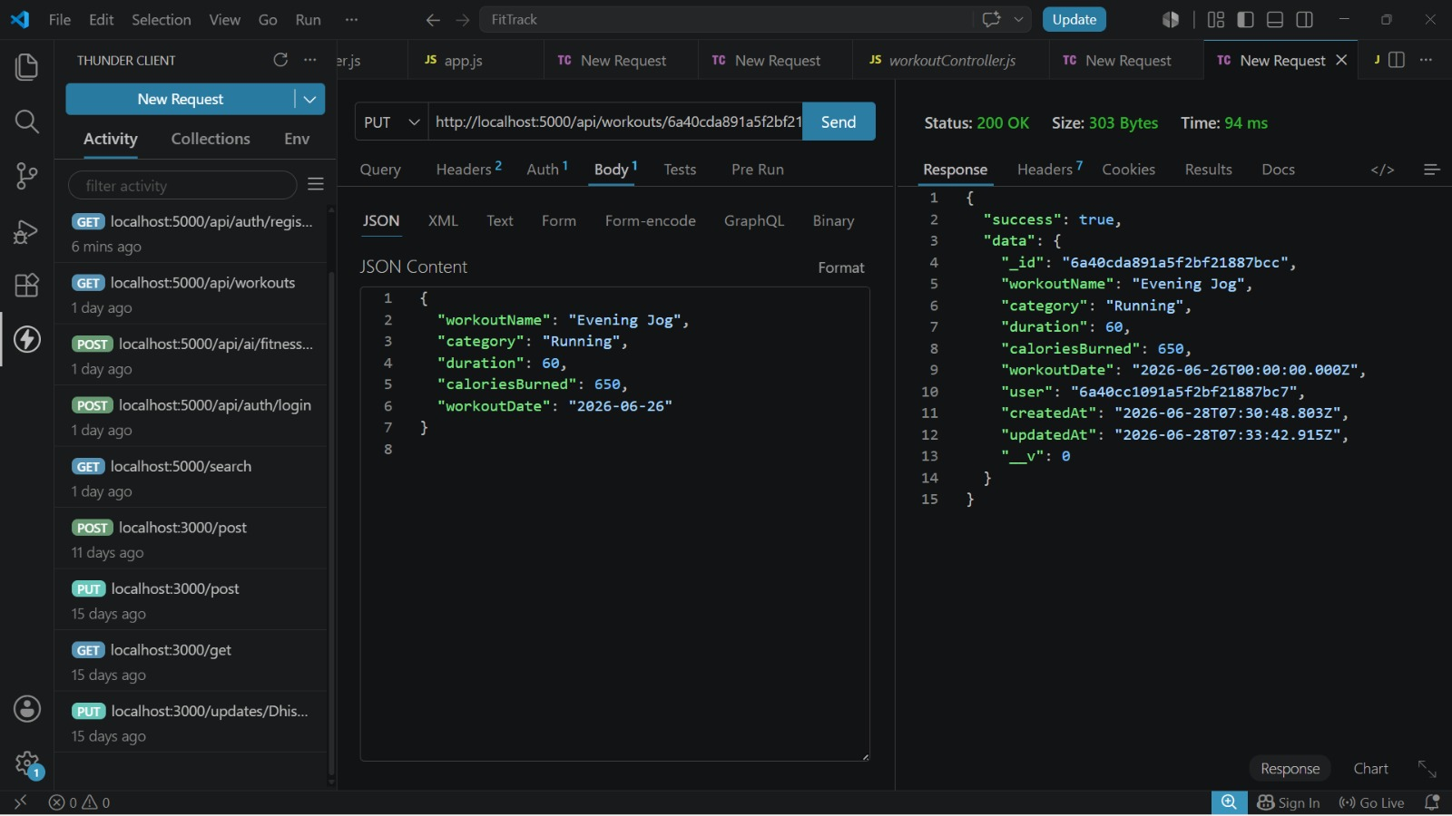
8. Resource Entity Deletion (Workout)
- Route: DELETE /api/workouts/:id
- Access: Private (Bearer <JWT Token>)
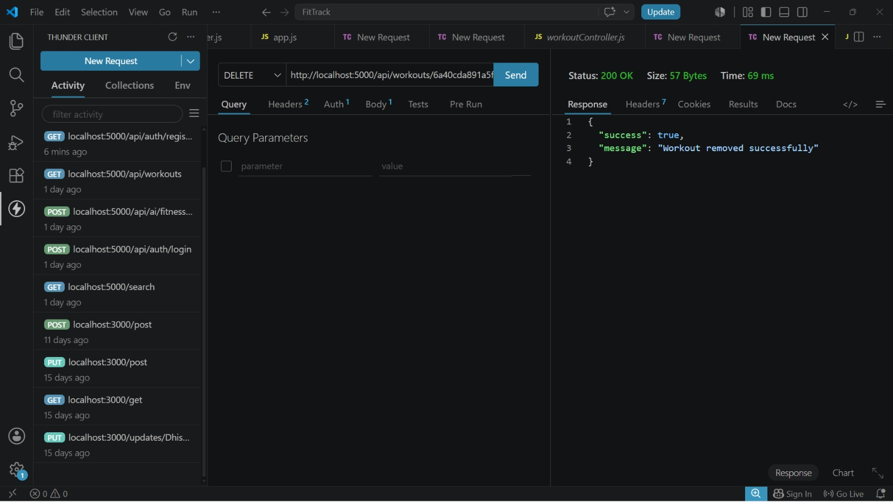
9. AI Intelligent Content Automation (Workout Recommendation)
- Route: POST /api/ai/workout-recommendation
- Access: Private (Bearer <JWT Token>)
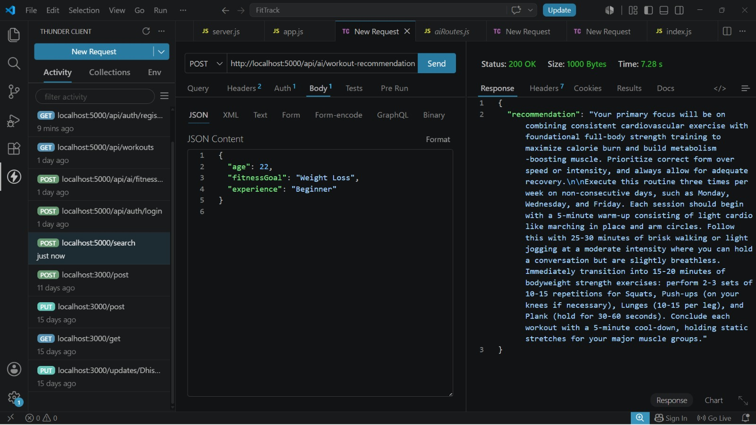
10. AI Intelligent Content Automation (Fitness Insights)
- Route: POST /api/ai/fitness-insights
- Access: Private (Bearer <JWT Token>)
