**Topic**

# Website concept

# Website Users List

# Website Diagram- Workflow

# Website theme

# Website Header Pages

# Website Search Option

# Website Registration Process

1. Email verification
2. Text Verification

# End User: Participant Registration Form

# End-User- Participant Dashboard - Back End

# End-User- Participant “Request for Service” Form

# End User: Registration Form - Support Worker

# Service Provider: Registration Form-Support Coordinator

# Service ProviderRegistration Form- Real Estate Companies- Agencies

# Service ProviderRegistration Form- e-commerce companies

# Service Provider: Registration Form - Disabled Vehicle for sale

# End User Dashboard - Functionalities - Participants

# End User Dashboard - Functionalities - Support Workers

# Admin Dashboard - Functionalities - Support Coordinators

# Admin Dashboard - Functionalities - Service Providers

# Admin Dashboard - Functionalities - e-Commerce Solution

# Admin Dashboard - Functionalities - Disabled Vehicle for Sale

# Master Admin ( Owner Admin ) Functionalities - Participants

# Master Admin ( Staff Admin) Admin Functionalities - Support Workers

# Website footer

# Event Management

# Payment Gateway

# Lead Management

# Free Map ( Paid Map)

# Address auto-complete

# Multi-criteria rating

# Search Results in order

# Google Analytics for reporting

# Event Calendar

# Advance live search

# Advance Instant filter

# Ads Management

# Advance review and management

# Auto-locate

# Check-out process

# Branding and Design

# Ready to blog

# Category Management

# Custom Form Fields

# Claim Verify listing

# Drage and drop page builder

# Easy Set-up Assistant

# Email Management

# Deals and Coupons

# Auto-fill Google API

# Flag and Report a listing

# Grid and List view

# Invoice System

# Location by Predefined

# Lead Generation

# Near me

# Near By

# Mobile X

# Pain Plan and Packages by Role Management

# Quick preview

# Social Logins

# SEO ready

# Social Share

# Save and Bookmark

# Spam Protection

# Statistics

# Special Credit on Banner

# Schema ready?

# Tax System

# Video Banner

# Inbox

# Audio to script

# Font zoomer icon

# Featured listing

# Newsletter

# Others

1. 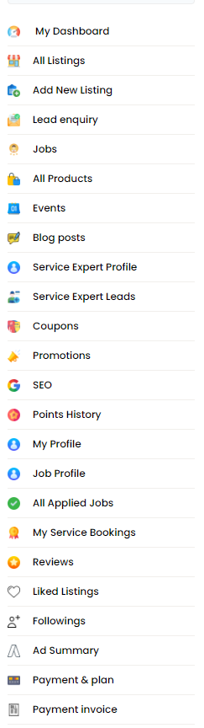

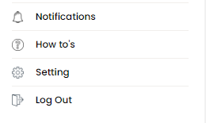

1. Website concept

This website that I am considering deploying is for NDIS-disabled participants.

End User for the website

**NDIS Participant**

**Support Worker**

**Support Coordinator**

The end users will go on the website to find the best services, support workers and coordinators nearest to their location to achieve their day to day goal i.e service like gardening, home cleaning, assisting them with daily life etc

The Govt Body NDIS registers the service providers. We need an NDIS-REGISTRED logo on each business listing. In future,we might include unregistered service providers too

The functions of the website will be

1. Disabled People ( Participants) will post their service requests and those service leads will be visible to paid subscription service providers
2. Disabled people ( Participants) can also choose service providers after finding them for the search button near to their suburbs
3. The service provider will be able to post the accommodation (home vacancy online as per the subscription plan
4. The support worker and Support Coordinator will be able to upload their Bio-data ( Job profile similar to the freelancer website) and service providers will be able to offer them job based on their days, weeks availability or offer permanent positions
5. The service provider can post the job and these jobs can be viewed by the support worker and support coordinator
6. The support worker and support worker can also post ‘ looker for a job’

The service providers will buy the paid subscriptions plan to promote their business and increase revenue

ndisONE website is a self-managed online platform to provide all kinds of services and needs to Disabled People ( Participants)

**For Participants ( similar to** <https://www.serviceseeking.com.au/> )

-The participants can choose and control the right service provider on the website. All service providers will register on my website to list their services. **( RFS - Request for Service)**

- The participants can post their needs on the website, and relevant service providers can only view and contact them via email. This will be visible to specific providers depending on the subscription plan on the website

**For Support Worker/Support Coordinator ( similar to upwork.com freelancer and see.com.au)**

-All Support Worker and Support Coordinators will upload their profile so the participants, agency and partners can view their profile and recruit them directly according to their viabilities

- e-learning course and certification

- Support Workers and Support coordinators will have a dashboard to the public if they are 'looking for a job.'

**Service Providers ( similar to yellow pages or Whitepage www.yellowpages.com.au)**

- All service providers will register

- Will have NDIS consultants

- Will have NDIS certification bodies i.e. GCC

- Will have a listing of NDIS software

- Will have a listing of the Training Institute

**Service Provider e-Commerce Consumable ( similar to www.ebay.com.au)**

- Will have NDIS-approved product listing and have reasonable prices to benchmark the market

- All providers, including participants can buy the product online

**Real Estate ( Similar to www.realestate.com.au)**

- Will have a home vacancy for SDA, MTA, STA ( Respite)

- NDIS properties for sale

- Builders and Home modifications approved service providers listing

**Disabled Vehicle For Sale ( Similar** [**www.carsale.com.au**](http://www.carsale.com.au)**)**

- Registered Provider of vehicle modification

- Disabled Vehicle for sale listing

1. Website Users List

**The end User** and **Service Provider** are the two primary users

End user - Participants ( Disabled People) - Free Registration

End-user - Support worker - Registration required- Yearly Charges

End-user - Support Coordinator - Registration Required - Yearly Charges

Service Providers - Paid Subscription Plans

Real Estate Providers, Real Estate Company - Paid Subscription Plans

E-commerce Providers, online product selling - 15% commission on the total selling(Phase -2 )

Vehicle Sales Services - Paid Subscription Plans ( Phase -2)

General user - Free - only view certain items

1. Website Diagram- Workflow

To be added

1. Website theme

<https://www.serviceseeking.com.au/>

1. Website Header Pages

| **Participant** | | **Providers** | | **Accommodation** | | **Support Worker** | | **Register** | | **Login** | |
| --- | --- | --- | --- | --- | --- | --- | --- | --- | --- | --- | --- |
| Post Service Request | | When you click on Providers, it will take you next screen. | | Home Vacancy | | Job Board | |  | |  | |
| Service Leads ( Disable - Only Gold Subscription Plan can see the leads for the area they have registered. | |  | | SDA | | Looking for a Job | |  | |  | |
|  | |  | | MTA | |  | |  | |  | |
|  | |  | | STA (Respite) | |  | |  | |  | |
|  | |  | | NDIS Property for Sale | |  | |  | |  | |
|  | |  | | Accessible Holliday Destination | |  | |  | |  | |

1. Website Search Option
2. Website Registration Process
3. End User- Participant Registration

Options for asking for registration

[NDIS Participant Registration Form](https://docs.google.com/forms/d/1MSGICp80yu4wenn061Z-x9PASOPuVl-IBNgQZdRyA3g/edit)

Follow the above form and try to design it in such a way that disabled people can choose the option easily and fill it in without trouble.

Use advanced form template ( link to admin panel)

Website reference to see how the form should be designed

<https://clickability.com.au/requestmatch#service>

Other website form references given below

1. Keep the registration button right-hand side as per below.

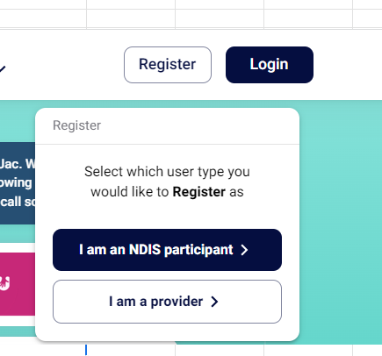

1. When end users try to look for the services, prompt them to register.

Registration form from the **REGISTER** button

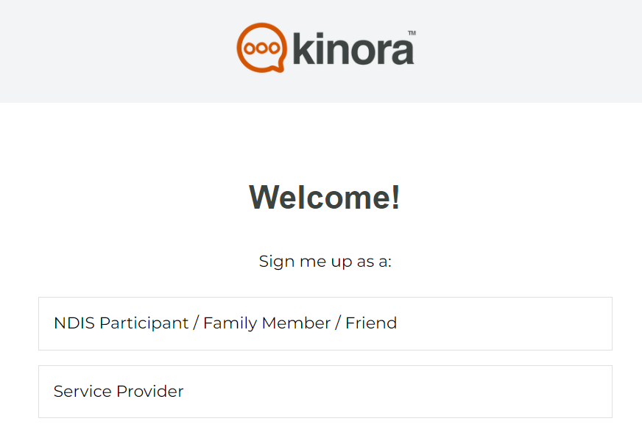

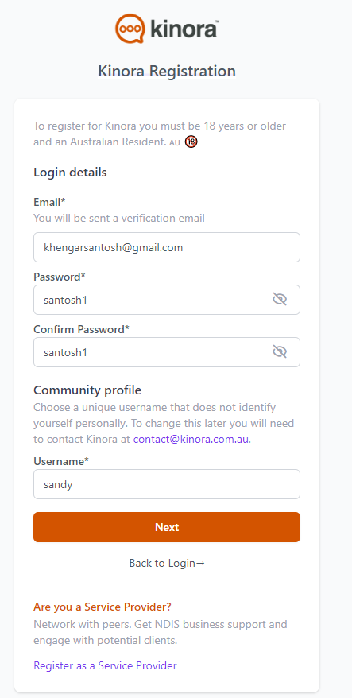

<https://app.kinora.com.au/signup>

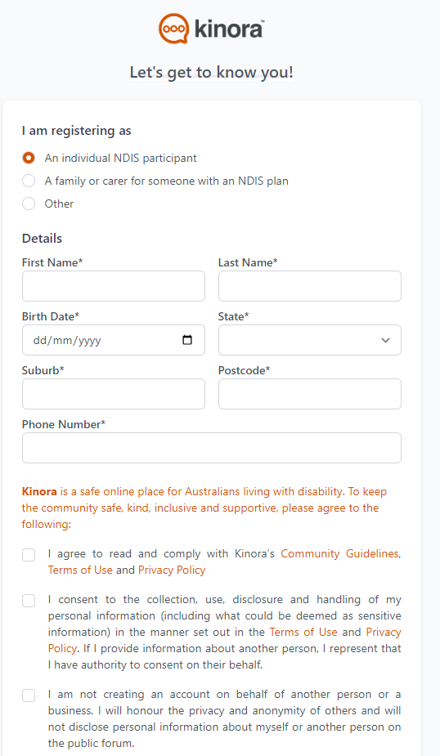

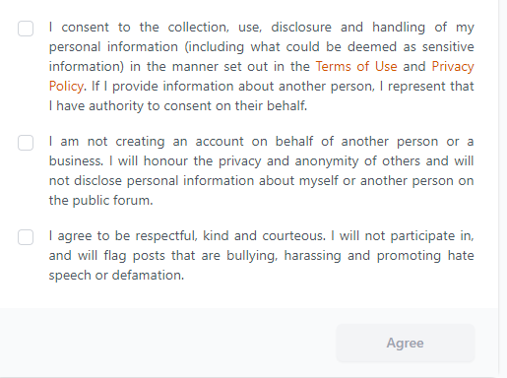

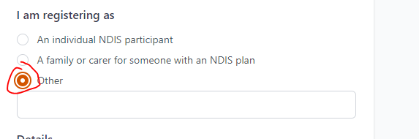

9. End-User- Participant Dashboard - Back End

[**Back End- Participant Dashboard**](https://docs.google.com/spreadsheets/d/1Uo1nxwZcJ8iCbTIUHTDiR9RDIj2hougzNJBoVFpX9aY/edit#gid=0)

Refer to the above Participant Dashboard Template

Create a compatible dashboard to connect with End User Admin Panel, Service Provider Panel and Master Admin Panel.

10. End-User Participant - Request for Service

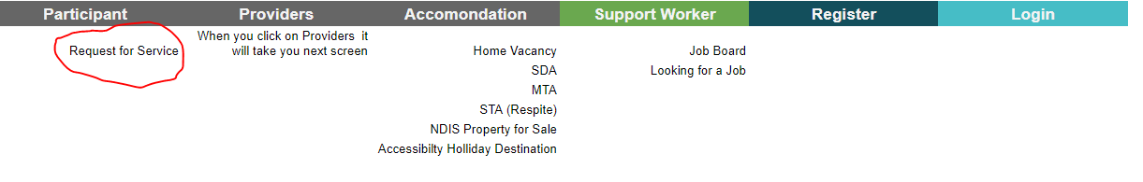

[**Participant - Request for Service**](https://docs.google.com/forms/d/e/1FAIpQLSc7ANuMpN_dqUzKt0F3nTDVXqoFyEVKh-8b85IY5oinss5Npw/viewform)