- MODEL CONTROL PROTOCOL (MCP)
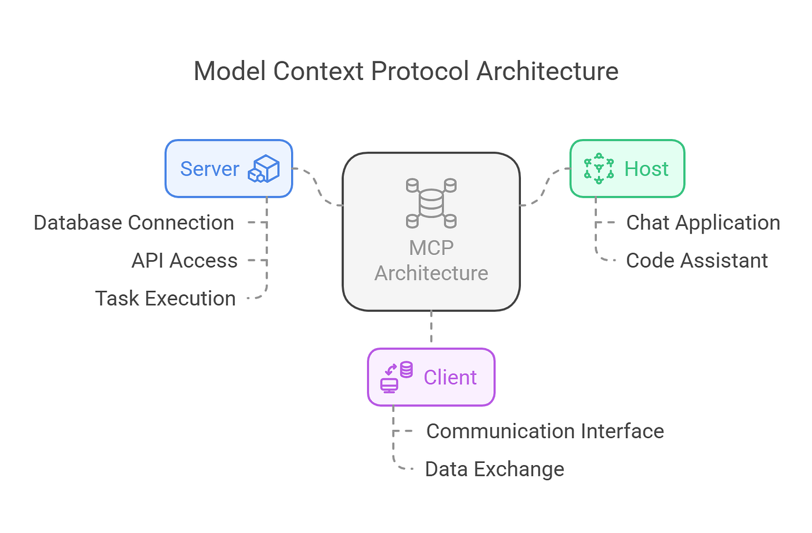
MCP (Model Context Protocol) is an open, standardized protocol that defines how AI models securely discover, request, and use external context, tools, and data at runtime.
Think of MCP as “USB-C for LLMs”: one clean interface that lets models plug into many different data sources and tools without custom glue code each time.

Why MCP exists (the real problem it solves)
Before MCP, every app did this:
- Custom tool schemas
- Custom auth logic
- One-off function calling
- Tight coupling between model ↔ tool
- Hard to reuse across models or vendors
This led to:
- Fragile integrations
- Vendor lock-in
- Poor security boundaries
- Agents that only worked in one stack

MCP standardizes this boundary
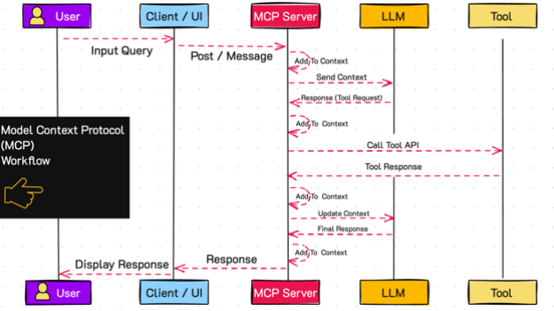

Step 1: MCP server declares capabilities
A server exposes:
- tools
- resources
- prompts
With:
- schemas
- descriptions
- permissions
Example (conceptual):
I can:
- read_repo_file(path)
- search_code(query)
- list_files()

Step 2: Model connects as MCP client
The model:
- discovers what’s available
- does not assume anything
- sees only allowed capabilities
This is capability-based security.

Step 3: Model requests context when needed
Instead of RAG dumping chunks:
Model: “I need file X”
MCP Server: returns file X
This is pull-based context, not push-based.

Step 4: Tool execution is isolated
- Model never sees credentials
- Server validates inputs
- Server controls side effects
The model requests, the server decides.

Step 5: Structured response flows back
Results are:
- typed
- bounded
- auditable
Perfect for:
- tracing
- debugging
- compliance

When MCP is used (correct usage)
✅ Use MCP when ALL of these are true
You have:
- multi-step reasoning
- multiple tools or data sources
- long-running agents
- changing tools over time
- security concerns
Examples:
- repo-reading AI
- internal enterprise assistants
- coding agents
- research agents
- autonomous workflows

❌ Do NOT use MCP when
You only need:
- a single API call
- a basic chatbot
- static RAG over PDFs
- one-off scripts
MCP adds architecture, not magic.

