**Paper Title**

**Author Names**

Affiliation

|  |  |
| --- | --- |
| ***Article History:***  ***Received:*** *dd-mm-yyyy*  ***Revised:*** *dd-mm-yyyy*  ***Accepted:*** *dd-mm-yyyy* | **Abstract:**  A concise summary of the research, including the purpose, methods, results, and conclusions. Typically, the abstract is 150-250 words.  **Keywords**: A list of relevant keywords or phrases, usually 4-6, that represent the main topics of the paper. |

1. **Introduction**

Background Information and Context: The prevalence of chronic diseases such as diabetes and hypertension has been on the rise globally, posing significant challenges to public health systems. Despite advances in medical research and technology, managing these conditions effectively remains a daunting task. Recent studies have shown that lifestyle interventions, such as diet and exercise, can play a crucial role in controlling these diseases. However, there is still a lack of comprehensive strategies that integrate these interventions into routine healthcare practices.

Problem Statement or Research Question: This study addresses the critical problem of integrating lifestyle interventions into the management of chronic diseases in primary healthcare settings. The central research question is: How can primary healthcare providers effectively incorporate lifestyle interventions to improve patient outcomes for chronic disease management? Also elaborate the objectives of the study.

Significance and Contribution of the Research: This research is significant because it addresses a pressing need for more effective chronic disease management strategies. By integrating lifestyle interventions into primary care, the study has the potential to enhance patient outcomes and reduce the burden on healthcare systems. Additionally, the findings will provide valuable insights for policymakers and healthcare providers, contributing to the development of more holistic and patient-centred care models. This study also introduces an innovative framework for evaluating and implementing lifestyle interventions, which can be adapted to various healthcare settings globally.

1. **Literature review**

The Literature Review section is crucial for situating your research within the existing body of knowledge. It demonstrates your understanding of the topic and provides a foundation for your study by highlighting relevant previous research.

1. **Methods used**

In this section, specify whether the study is qualitative, quantitative, or mixed-methods. Also Indicate if the study is experimental, quasi-experimental, correlational, descriptive, etc. Explain the overall structure of the study, including how variables will be controlled and manipulated (if applicable). Explain the sampling method (e.g., random sampling, convenience sampling) and sample size. Provide demographic details of the participants, such as age, gender, ethnicity, socioeconomic status, etc. List and describe the instruments, tools, or materials used for data collection (e.g., surveys, interviews, observation checklists, lab equipment). Specify the statistical or analytical methods used to analyze the data (e.g., t-tests, ANOVA, regression analysis, thematic analysis). Describe the measures taken to protect participants’ data (e.g., data encryption, secure storage).

1. **Results and discussion**

The Results section is where you present the findings of your research clearly and systematically. This section should be organized logically, often following the sequence of your research questions or hypotheses. Use tables to present detailed numerical data in a structured format. Use figures (e.g., graphs, charts, images) to illustrate trends, patterns, and key findings. Ensure each table and figure is labelled clearly and includes a descriptive caption. Reference each table and figure in the text, explaining what each one shows. Acknowledge any limitations in your study that might affect the interpretation of the results. Suggest areas for future research to address these limitations.

**4.1 Presentation of Findings Using Text, Tables, and Figures**

The analysis revealed significant differences in health outcomes between the intervention and control groups over the 12-month period.

* Textual Description:
  + Participants in the intervention group showed a marked improvement in glycemic control, with mean HbA1c levels decreasing from 8.2% at baseline to 6.9% at 12 months (Table 1, Figure 1).
  + The control group showed no significant change in HbA1c levels, which remained stable around 8.1% throughout the study period (Table 1).
* Tables and Figures:

Table 1. Changes in HbA1c Levels Over Time

| Group | Baseline Mean (%) | 6 Months Mean (%) | 12 Months Mean (%) |
| --- | --- | --- | --- |
| Intervention | 8.2 | 7.4 | 6.9 |
| Control | 8.1 | 8.0 | 8.1 |

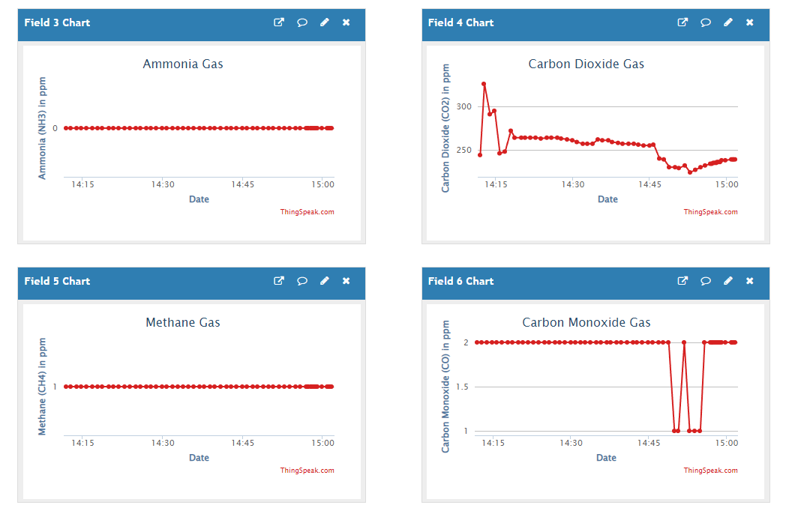

Figure 1. Mean HbA1c Levels in Intervention and Control Groups Over 12 Months

1. **Conclusions**

In summary, restate the research question or thesis, and summarize key findings. Discuss the implications of the findings, and mention the field or topic. Briefly mention any limitations, the study provides a foundation for future research, suggest future research areas or practical applications. Overall, restate the main conclusion or argument, reiterate the significance of your research.

**Acknowledgments**

This work was supported by the Toronto Metropolitan University, Faculty of Engineering and Architecture Science Funding Programs and the Natural Sciences and Engineering Research Council of Canada (NSERC) discovery grant funding.

**Conflicts of Interest:** The authors declare no conflict of interest.

**References:**

1. Nikhil P. M., Rakshith R. P., Shreyas G., Sushmitha, Sathisha. (2022). Intelligent Hygiene Monitoring System for Public Toilets. International Journal of Engineering Research & Technology (IJERT), 11(06), 2278-0181.
2. Shah, P., Siroya, D., Prusty, S., Kavedia, M., & Hatekar, A. (2022, April 21). IoT Based Washroom Feedback System for Quality Monitoring. In IJRASET (Vol. 41706, pp. ISSN 2321-9653). IJRASET.
3. Das, A. K., & Roy, P. (2021). Development of an IoT-Based System for Monitoring and Controlling Air Quality in Public Toilets. Journal of Sensors, 2021, 1-8.
4. Gupta, S., Saini, S., & Singla, S. (2021). An IoT-Based System for Real-Time Monitoring and Control of Air Quality in Public Toilets. International Journal of Automation and Control, 15(2), 201-215.