**AN INTERNSHIP REPORT ON**

**“Client-Freelancer Platform”**

SUBMITTED TO THE SAVITRIBAI PHULE PUNE UNIVERSITY, PUNE

IN THE PARTIAL FULFILLMENT FOR THE AWARD OF THE DEGREE OF

**BACHELOR OF ENGINEERING IN INFORMATION TECHNOLOGY**

**BY**

**Harshvardhan Uttam Sawant**

**UNDER THE GUIDANCE OF**

**Mrs. Preeti Joshi**



DEPARTMENT OF INFORMATION TECHNOLOGY

**MARATHWADA MITRA MANDAL’S COLLEGE OF ENGINEERING**

**KARVENAGAR, PUNE - 411052, MAHARASHTRA, INDIA 2024-25**



**CERTIFICATE**

This is to certify that the Internship report entitled

**“Client-Freelancer Platform”**

Submitted by

**Harshvardhan Uttam Sawant - TI53**

It is a bonafide work carried out by them under the supervision of **Mrs. Preeti Joshi** and it is approved by the partial fulfillment of the requirement of Savitribai Phule Pune University for the award of the Degree of Bachelor of Engineering (Information Technology)

This project report has not been submitted to any other Institute or University for the award of any degree or diploma.

**Mrs. Preeti Joshi** Internal Mentor

Department of Information Technology

Date :

Place : MMCOE



**Dr.S. A. Ubale** Head of Department

Department of Information Technology

**Dr. V. N. Gohokar** Principal

Marathwada Mitra Mandal’s College of Engineering



**ACKNOWLEDGEMENT**

It is our proud privilege and duty to acknowledge the kind of help and guidance received from several people in the preparation of this report. It would not have been possible to prepare this report, in this report and in this form without their valuable help, co-operation and guidance. Our sincere thanks to Dr. S. A. Ubale, Head Department of Information Technology, for his valuable suggestions and guidance throughout the preparation of this report.

We express our sincere gratitude to our guide, **Mrs Preeti Joshi** for guiding us in the investigation of this project and in carrying out experimental work. We hold his in esteem for the guidance, encouragement and inspiration received from his.

Last but not least we wish to thank our parents for financing our studies and helping us throughout our life for achieving perfection.



**ABSTRACT**

The demand for flexible work environments and the rise of the gig economy has led to a need for efficient platforms that connect clients with skilled freelancers. Traditional methods of hiring and job application processes can often be tedious, opaque, and inefficient. To address these challenges, this project introduces a web-based platform designed to streamline the hiring process and foster meaningful connections between clients and freelancers. The platform features an intuitive, role-based navigation system that caters to both clients and freelancers, offering personalized dashboards, job postings, application tracking, and portfolio management.

The system utilizes a skill-based assessment feature, where freelancers must pass an internal quiz before applying for jobs, ensuring that only qualified candidates are considered. Additionally, clients can post job opportunities, evaluate freelancer applications, and provide feedback and reviews once projects are completed. The platform integrates a secure authentication system with NextAuth, ensuring role-based access and a seamless experience for both clients and freelancers.

Built using **Next.js** for fast rendering and scalability, **MongoDB** for flexible database management, and **NextAuth** for secure authentication, the platform offers real-time data syncing and smooth user interactions. The UI design incorporates modern components like pop-ups and card layouts, enhancing the user experience by making the platform visually engaging and easy to navigate.

With a focus on efficiency and transparency, this platform empowers clients to find qualified freelancers quickly while helping freelancers manage their portfolios and job applications effectively. By combining gamified features and personalized career recommendations, this web platform offers a dynamic environment for both clients and freelancers to thrive professionally. This solution bridges the gap between technology and the evolving freelance economy, creating a seamless, efficient system for the modern workforce.

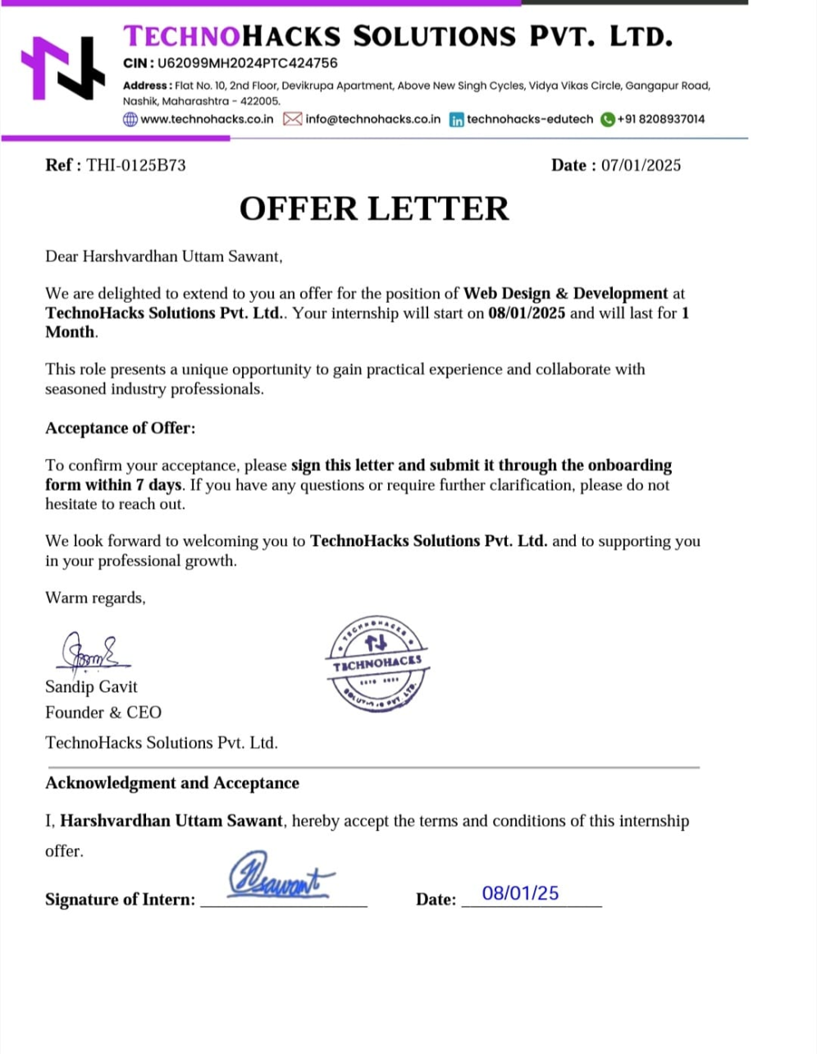



**CONTENT**

**Name** **Page No**

**Certificate** **2**

**Acknowledgement** **3**

**Abstract** **4**

**Index** **6**



**INDEX**

**SR** **CHAPTERS** **PAGE NO. NO.**

**1** **INTRODUCTION** **8**

**1.1** **MOTIVATION** **9**

**1.2 AIM AND OBJECTIVE** **10**

**1.3** **PROBLEM STATEMENT** **11**

**2** **LITERATURE SURVEY** **12**

**3** **SYSTEM REQUIREMENTS** **14**

**3.1** **HARDWARE REQUIREMENTS** **-**

**3.2** **SOFTWARE REQUIREMENTS** **-**

**4** **SYSTEM DESIGN** **15**

**4.1 SYSTEM ARCHITECTURE** **17**

**4.2 FLOWCHART** **18**

**5** **IMPLEMENTATION**

**6** **RESULTS**

**7** **CONCLUSION**

**8** **FUTURE SCOPE AND APPLICATIONS**

**19,20**

**21,22,23**

**24**

**25**

**8.1 FUTURE SCOPE** **-**

**8.2 APPLICATIONS** **-**

**REFERENCES 26 PLAGIARISM REPORT 27**



**LIST OF TABLES**

**Table** **Table Names** **Page No. No.**

**1** **Literature Survey** **12**

**2** **Hardware Requirements** **14**

**3** **Software Requirements** **-**



**LIST OF FIGURES**

|  |  |  |
| --- | --- | --- |
| **Figure No.** | **Figure Names** | **Page No.** |
| **4.1** | **Architecture Diagram** | **12** |
| **4.2** | **Hardware Requirements** | **14** |
| **6.1** | **Freelancer Dashboard** | **20** |
| **6.2** | **Client Dashboard** | **-** |
| **6.3** | **Freelancer Profile Page** | **21** |
| **6.4** | **Landing Page** | **-** |
| **6.5** | **Join our website** | **22** |
| **6.6** | **The frontend developer skills Assessment (QUIZ)** | **-** |

**CHAPTER 1**

**INTRODUCTION**

This project introduces a web-based platform designed to connect clients and freelancers, offering a seamless environment for job postings, applications, and profile management. The platform facilitates client-freelancer interactions by enabling clients to post job opportunities and review potential candidates, while freelancers can build profiles, showcase portfolios, and apply for jobs based on their expertise and performance in skill-based assessments.

The application integrates a comprehensive login system, role-based navigation, and personalized dashboards to cater to the specific needs of each user role—clients and freelancers. Freelancers must clear an internal quiz to be eligible to apply for jobs, ensuring that only qualified candidates are considered. Clients can post job opportunities, evaluate freelancer applications, and provide feedback and reviews once projects are completed.

Built using **Next.js** for its server-side rendering capabilities, **MongoDB** for flexible database storage, and **NextAuth** for secure authentication, the platform ensures high performance, scalability, and ease of use. With a focus on intuitive UI components, including pop-ups and card layouts, the platform offers an engaging experience that is both efficient and easy to navigate across devices.

The need for such a platform stems from the growing demand for flexible work opportunities and the need for businesses to find reliable, skilled freelancers. As the freelance economy continues to grow, this system will provide an efficient, transparent way to manage job postings, applications, and freelancer performance. By combining user-friendly design, secure authentication, and real-time features, this platform modernizes how clients and freelancers connect, collaborate, and grow professional.

* 1. **MOTIVATION**

The motivation behind this internship project arises from the growing demand for efficient and transparent platforms that connect clients with skilled freelancers. As businesses increasingly rely on remote work and freelancing for specialized tasks, the need for a seamless, secure, and intuitive platform becomes crucial. This project aims to create a digital solution that simplifies the hiring process, enhances freelancer-client interactions, and fosters long-term professional growth. The inspiration came from recognizing the challenges faced by both clients in finding the right talent and freelancers in securing meaningful job opportunities, and how this platform could address these challenges through a user-centric approach and innovative technology.

Another key motivator was the opportunity to build a system that bridges the gap between technology and freelancing. With features like skill-based quizzes, portfolio management, and role-specific dashboards, the platform reflects a commitment to leveraging cutting-edge web technologies to streamline job applications, client reviews, and project management. The integration of real-time feedback mechanisms and personalized recommendations is a core aspect of the platform's goal to provide value to both clients and freelancers, empowering them to make data-driven decisions for career and business growth.

Personal motivation also played a significant role in shaping this project, as it offered the opportunity to gain hands-on experience in web development, including user authentication, role-based navigation, database integration, and UI/UX design. The diverse set of tasks—from designing the login system to implementing client-freelancer interactions and optimizing the platform for scalability—provided a rich learning experience. This project fueled the excitement of developing a practical solution that could help users achieve their professional goals while honing technical skills and learning more about the freelance economy.



**1.2 AIM AND OBJECTIVE**

**Aim:**

The primary aim of this project is to design and develop a dynamic web-based platform that bridges the gap between clients and freelancers by offering a smooth, secure, and user-centric experience. The platform enables clients to post job opportunities, screen applicants using skill-based assessments, and manage freelance collaborations. Freelancers can register, build their professional profiles, showcase portfolios, and apply for relevant jobs based on their expertise and performance in built-in evaluations. The system prioritizes structured navigation, clean user interfaces, and role-based access to ensure efficiency, transparency, and scalability across the platform.

**Objectives**

**1. BUILD A ROLE-BASED FREELANCE HIRING PLATFORM**

• Develop a complete sign-up and login system using authentication tools that distinguish users as either Clients or Freelancers.

• Create separate dashboards for each role, enabling clients to post jobs and freelancers to view and apply for them.

**2. INTEGRATE A SKILL-BASED TEST MODULE**

• Implement an MCQ-based test system that allows freelancers to attempt quizzes before being eligible to apply for jobs.

• Enforce a performance threshold (e.g., 90% correct answers) to ensure only qualified candidates proceed.

**3. PROVIDE CUSTOMIZED USER PROFILES**

• Design and develop profile pages for both Clients and Freelancers, including personal information, profile pictures, and professional details.

• Add functionality for freelancers to upload portfolio items and for clients to leave feedback and ratings based on completed projects.

**4. IMPLEMENT INTUITIVE AND CONSISTENT UI COMPONENTS**

• Use interactive UI elements such as pop-ups, card layouts, and notification components for a polished and responsive design.

• Maintain design consistency through color schemes and layout logic across all sections of the application.

**5. OPTIMIZE USER NAVIGATION AND DATABASE INTEGRATION**

• Ensure seamless navigation between authentication, dashboard, job listings, test systems, and profiles.

• Use MongoDB for reliable storage and retrieval of user data, job posts, quiz responses, and reviews.

**6. SUPPORT FUTURE SCALABILITY AND PERFORMANCE**

• Structure the platform to allow easy expansion, such as adding real-time messaging, advanced analytics, or third-party integrations.



**1.3 PROBLEM STATEMENT**

Designing a scalable, intuitive, and performance-optimized web platform for seamless interaction between clients and freelancers presents both technical and architectural challenges. The application must efficiently manage authentication, role-based navigation, real-time job listings, portfolio handling, and an integrated testing system—while maintaining a consistent user experience across all components.

**Detailed Description:**

In today’s digital landscape, platforms that connect service providers with clients must deliver not just functionality, but also smooth and engaging experiences. During the development of this system, the goal was to ensure freelancers and clients could easily access role-specific dashboards, manage profiles, and interact through job postings and applications.

Challenges arose in maintaining role-based access logic, ensuring secure sign-ins, integrating a test module for freelancer eligibility, and creating an interface that remained consistent in design, responsive across devices, and easy to navigate.

To meet these needs, modern web technologies and best practices were employed, including structured UI components, database integration with MongoDB, and seamless routing strategies. Special attention was given to frontend aesthetics such as color schemes, card components, and pop-ups to ensure a user-centric experience.

**Current Project:**

This internship project involved the complete lifecycle of building a full-stack web platform that facilitates:

• Authentication with dynamic role assignment (client/freelancer) • Role-based navigation and access to dashboards

• Job posting and application workflows

• A built-in quiz module to assess freelancers before application • Profile and portfolio management for both user roles

• Feedback and rating integration to build credibility and transparency

Each module was developed with scalability and modularity in mind, enabling future enhancements such as messaging, AI-driven recommendations, and advanced analytics.



**CHAPTER 2**

**LITERATURE SURVEY**

**Sr.No.**

1

2

3

4

5

6

**Title**

Enhancing Job Recommendations for Freelancers Using Machine Learning

Gamification and Engagement in Freelancing Platforms

Talent Matching in the Gig Economy: Challenges and Solutions

A Review of Next.js for Scalable Web Applications

React.js and Performance Optimization for Large-Scale Applications

Predictive Analytics for Freelancer Skill Growth

**Publication**

IEEE Transactions on Intelligent Systems

Journal of Human-Computer Interaction

Harvard Business Review

Journal of Web Technologies

Int’l Conf. on Web Development and UX Design

Springer Journal of Computational Intelligence

**Year**

2019

2021

2018

2020

2021

2018

**Advantages**

- Improves recommendation accuracy using ML techniques

- Increases user engagement through gamified elements

- Identifies key barriers and practical solutions for gig talent matching

- Highlights scalability and SSR benefits of Next.js

- Focuses on performance tuning in React apps

- Enables forecasting of skill development using predictive models

**Disadvantages**

- Requires large, labeled datasets

- Risk of reduced seriousness in professional tasks

- Lacks technical implementation details

- Limited discussion on integration with backend systems

- High learning curve for beginners

- Data privacy concerns during model training



7

Web-Based Career Development Tools: A Comparative Study

ACM Transactions on Web Technologies

2019

- Compares effectiveness of multiple online career tools

- May not cover latest technological advancements

8

IEEE

Next.js for Scalable Conference on Server-Side Rendering Web

Technologies

2020

- Explains benefits of SSR using Next.js in production

- Less emphasis on frontend development challenges

9

10

Improving User Experience in Freelancer Platforms Using AI

The Impact of Career Assessment Tools on Freelancer Success

Journal of

Digital 2021 Workspaces

Journal of

Workforce 2018 Development

- Enhances personalization and UX using AI

- Shows correlation between career tools and freelancer growth

- Requires constant model retraining

- Limited sample size in case studies

Table 1 : Literature Surve



**CHAPTER 3**

**SYSTEM REQUIREMENTS**

**3.1 HARDWARE REQUIREMENTS**

This section outlines the basic hardware needed to run the freelance hiring platform efficiently. The display requirement is flexible, supporting use on any standard screen. These minimal specifications ensure accessibility across a wide range of systems without needing high-end configurations.

Processor

RAM

Storage Space

Display

Any

4 GB or Higher

10 GB or above

Any

Table 2 : HARDWARE REQUIREMENTS

**3.1 SOFTWARE REQUIREMENTS**

**1. Operating System:** • **Windows 10/11**

• **macOS**

• **Linux (Ubuntu, CentOS)**

**1. Programming Languages:**

• **JavaScript** (For frontend development • **HTML, CSS** (For UI/UX design)

• **Python (Optional)** (For backend development if using Flask or Django)

**2. Frontend Development:**

• **React.js** (For dynamic UI and component-based frontend development)

• **Bootstrap** or **Material-UI** (For responsive and consistent UI components)

**3. Backend Development:**

• **Node.js** (For server-side logic and API development)

**4. Database Management:**

• **MongoDB** (NoSQL database for storing user data, tasks, and quiz-related information



**CHAPTER 4**

**SYSTEM DESIGN**

**4.1 SYSTEM ARCHITECTURE**

The Client-Freelancer Web Platform is designed with a modular and scalable architecture. It ensures smooth interaction between clients and freelancers while maintaining secure authentication and efficient data handling. The system is developed with modern full-stack technologies to support responsive interfaces and seamless backend processes.

**1. Input Layer (User Interaction)**

**Client Dashboard:**

• Clients interact through a web interface.

• They can view available freelancers, post job listings, and view applicant test results. • Profile sections allow clients to manage their information and track job postings.

• Clients can review freelancer profiles, rate them, and view uploaded portfolios.

**Freelancer Dashboard:**

• Freelancers sign in to access a personalized dashboard.

• They can view available job opportunities and apply for relevant roles. • A test interface is provided before applying for jobs.

• Freelancers can update their profile, upload portfolios, and view client feedback.

**2. Preprocessing Module**

**Client Side:**

• **Job Posting Validation**: Ensures required fields like title, description, and deadline are filled accurately.

• **Freelancer Shortlisting**: Based on test scores and profile completion status.

• **Review Handling**: Clients can submit structured reviews for freelancers after job completion.

**Freelancer Side:**

• **Application Flow**: Verifies eligibility (test score criteria) before enabling job application. • **Portfolio Upload Handling**: Validates file types and limits to maintain standardization.

• **Profile Setup**: Requires key data like name, profile picture, and skills to enable full dashboard access.

**3. Core Logic (Backend and Data Management)**

• **User Role Management**: Implemented using NextAuth, the backend assigns specific roles (client or freelancer) during signup and controls access accordingly.

• **Database Structure**: MongoDB is used to store structured documents for users, job listings, portfolios, reviews, and quiz results.

• **Navigation Routing**: Users are directed to respective dashboards based on role after login, improving usability and flow.

• **Test System Logic**: A predefined set of 15 MCQs is presented. Freelancers must score 90% or above to qualify for job applications.

• **Card Component Display**: Used to dynamically show jobs and freelancer profiles in a clean, UI-friendly layout.

**4. Optional Features and Enhancements**

• **Real-time Communication (Future Scope)**: A built-in messaging feature can allow real-time collaboration between clients and freelancers.

• **Performance Tracking**: Freelancer performance data (quiz history, job success rate, client ratings) can be logged and visualized in future updates.

• **Review Aggregation**: Displaying client reviews with ratings on freelancer profiles to help in trust-building.

• **Advanced Profile Matching**: Future implementation of a recommendation system based on user behavior and job relevance.

**5. Interface and User Experience (UI/UX)**

• **Color Consistency**: A unified color palette and UI style guide ensures all pages maintain visual consistency.

• **Pop-up Modals**: Used for alerts, test prompts, and form submissions to maintain flow without page reloads.

• **Responsive Design**: The layout is optimized for various devices, ensuring mobile and desktop users have a seamless experience.

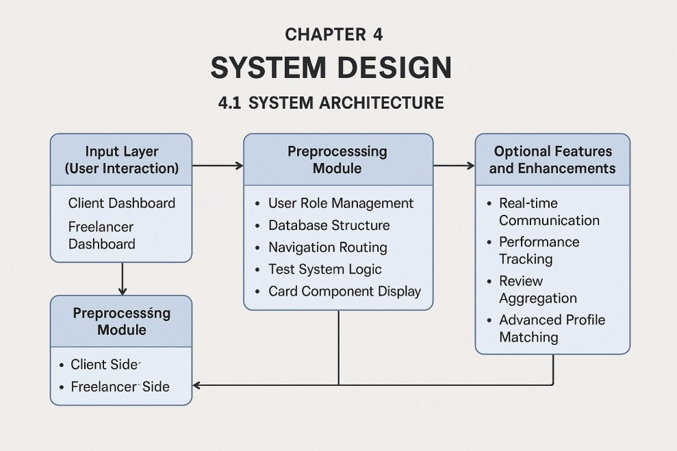**4.1 ARCHITECTURE DIAGRAM**

Fig. 4.1



**4.2 FLOWCHART:**

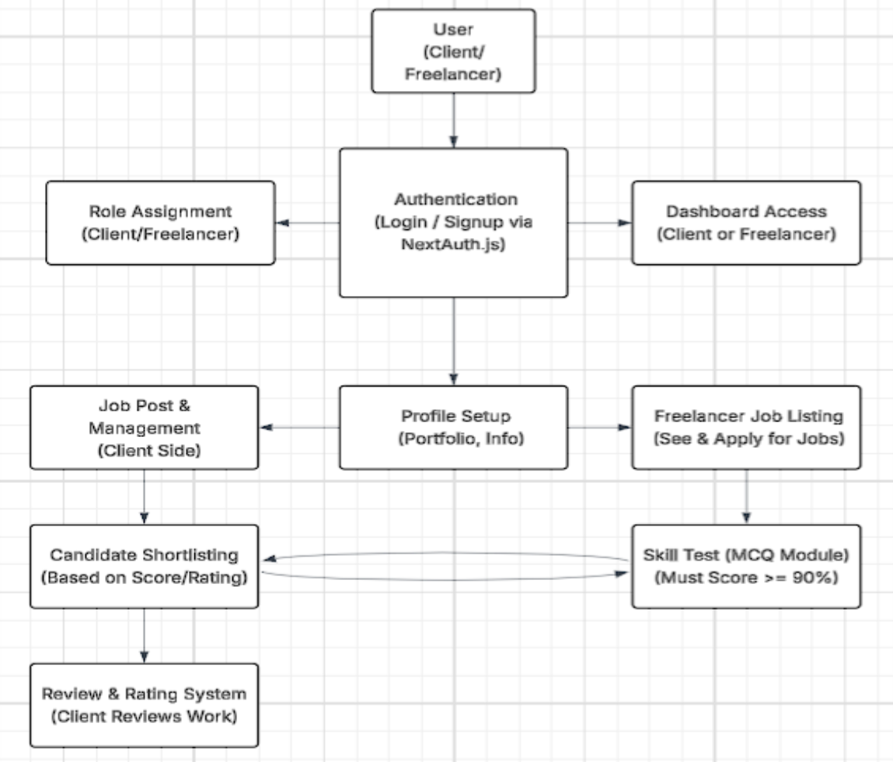

Fig. 4.2



**CHAPTER 5**

**IMPLEMENTATION**

This chapter focuses on the practical implementation of the Client-Freelancer hiring platform, including the technologies used, development process, and system modules. The goal is to deliver a fully functional, role-based job portal with integrated quiz functionality to assess freelancer skills before job applications.

**Technology Stack**

• Frontend: Implemented using React.js, ensuring a responsive and user-friendly interface with modular components and dynamic rendering.

• Backend: Developed using Next.js, a React framework that supports server-side rendering (SSR) and enhances performance and SEO.

• Database: MongoDB is used to store structured user data, job postings, quiz content, and feedback efficiently.

• AI/ML: Not implemented at this stage. The quiz functionality is straightforward without predictive or adaptive learning logic.

**Implementation Steps:**

**Frontend Development**

The user interface is designed with accessibility and responsiveness in mind. Key components include the

landing page with role-based login/signup (Client or Freelancer), a client dashboard where clients can post jobs, view applications, and rate freelancers, a freelancer dashboard to browse jobs, take quizzes, view results, and apply for work, and profile pages to showcase freelancer portfolios and display client/freelancer details.

**Backend Development**

A set of APIs is created to manage job posts and retrieval, user authentication and authorization, quiz data (questions, options, correct answers), and application submissions and client feedback.

**Database Setup**

MongoDB collections include users (with roles: client or freelancer, credentials, profile info), jobs (title, description, category, budget, posted by), quizzes (question text, options, correct answers), and applications (job ID, applicant ID, quiz score, status).



**Quiz Logic Implementation**

Freelancers must complete a skill-assessment quiz before applying for jobs. Each quiz is multiple-choice and time-bound. Scores are auto-calculated and stored for reference. A threshold (e.g., 90%) must be met to proceed with job applications.

**User Authentication**

A secure login system is implemented using JWT or session-based authentication. Role-based routing ensures users are redirected to the correct dashboard after login. User session data is used to retrieve quiz history and job activity.

**System Modules**

**User Module**

Freelancers can register, update profiles, view and attempt quizzes, and apply for jobs. The module tracks user scores, stores quiz history, and updates user progress.

**Admin Module**

The admin can add, update, and delete quiz questions. This module may be later expanded to moderate job listings or manage user access. It ensures quality control of assessment content.

**Result Module**

Displays quiz results immediately after completion. Stores score data and offers performance analysis (e.g., accuracy, time taken). Helps freelancers understand their strengths and areas for improvement.



**CHAPTER 6**

**RESULT**

The **Freelancer Dashboard** of the GetLancer.com platform, where users can view personalized job recommendations. It features a clean layout with a top navigation bar, user greeting, search bar, and a grid of job cards. Each card displays job titles, hourly pay, required skills, and an "Apply Now" button. Roles include Full Stack Developer, Data Scientist, UI/UX Designer, and more. The interface is responsive, user-friendly, and designed to help freelancers quickly find and apply for relevant opportunities.

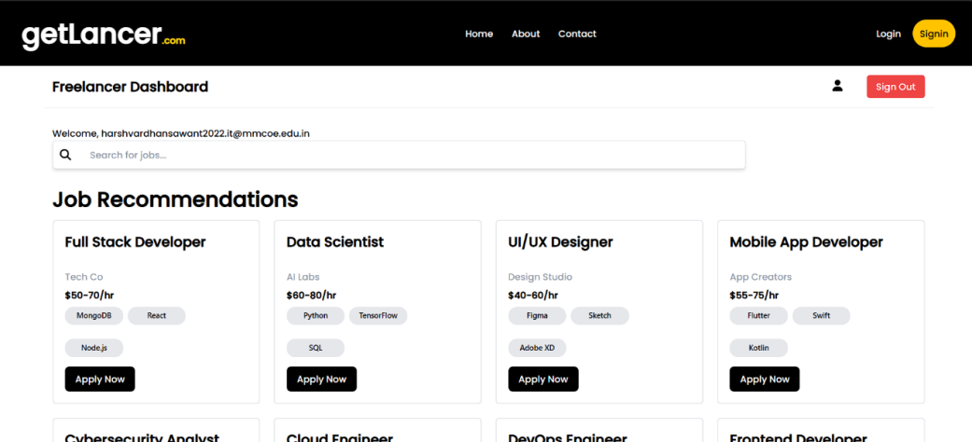

Th

Fig. 6.1

The **Client Dashboard** of the GetLancer.com platform. It includes a sidebar menu with navigation options like "Dashboard" and "Profile," along with a top search bar for job-related content. The main section features informative cards covering trending topics such as AI breakthroughs, cybersecurity, space exploration, and blockchain innovations. Below the cards, subscription plans are presented including a Standard Plan at $49/month and a Premium Plan at $99/month each offering different team member access levels.

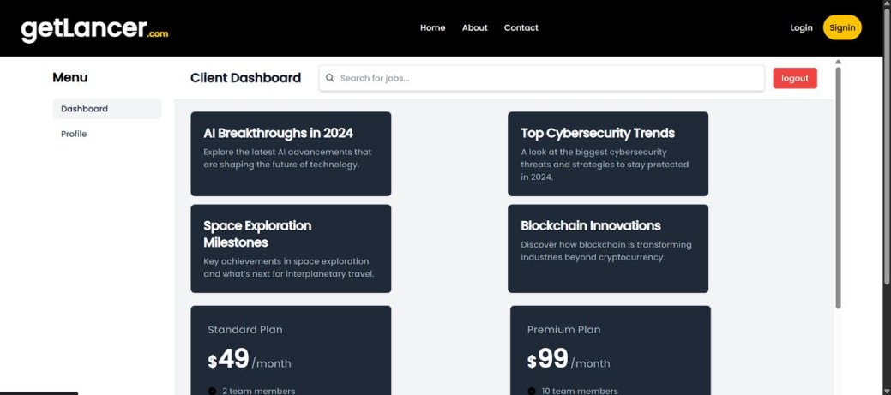

Fig. 6.2

The **Freelancer Profile Page** on the GetLancer.com platform. It highlights user details such as the

freelancer's name, email, and a profile section with a short "About Me" bio describing their experience and technical strengths. The page also includes a Skills section listing technologies like React, Node.js, MongoDB, Docker, and Python, along with a Portfolio upload area for showcasing work. Additionally, an Education section outlines academic background and relevant certifications. The layout is clean, professional, and tailored to present a freelancer’s expertise to potential clients.

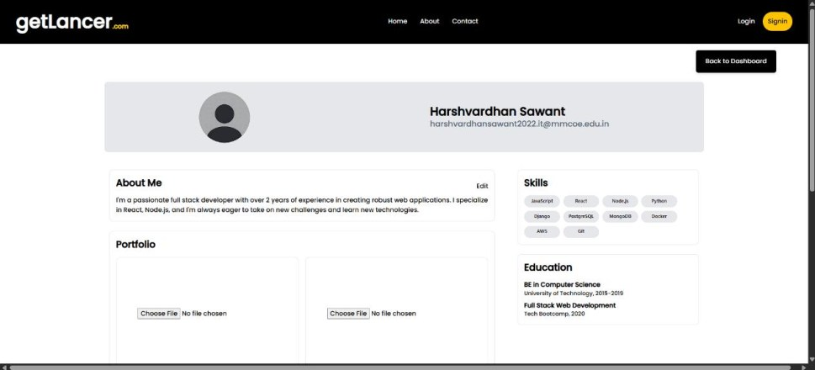

Fig. 6.3

**The Landing Page** of the GetLancer.com platform. It provides two clear paths for users based on their roles: freelancers and clients. The top section is directed at individuals with skills, encouraging them to sign in as a freelancer and start earning. The bottom section is for companies seeking talent, guiding them to sign in as a client. The visuals are vibrant and engaging, using illustrations to represent both working professionals and hiring teams. This clean, welcoming design helps users quickly identify their purpose and proceed accordingly.

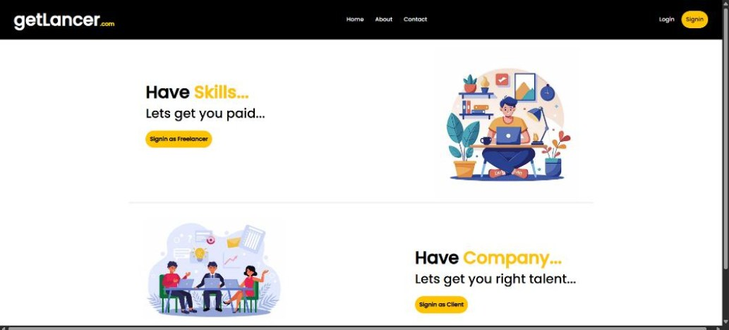

Fig. 6.4



**Join our website** section of the GetLancer.com landing page. Two prominent white boxes offer

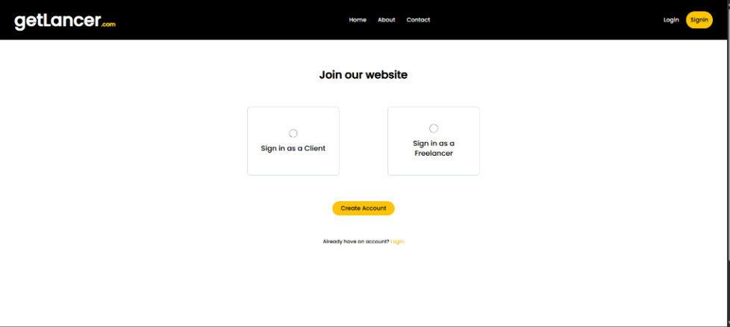distinct options for new users: "Sign in as a Client" on the left and "Sign in as a Freelancer" on the right. Both boxes feature a circular loading indicator at the top. Below these options, a bright yellow button encourages users to "Create Account." Finally, at the very bottom, a smaller text link asks, "Already have an account? Login." The overall design is clean and straightforward, guiding new users to choose their role on the platform.

Fig. 6.5

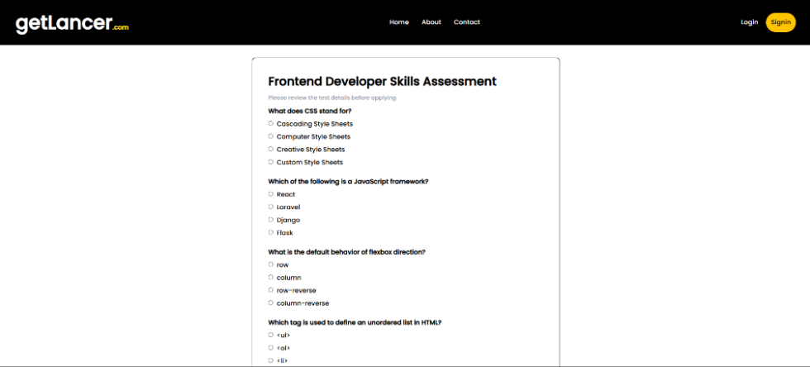**The frontend developer skills Assessment (QUIZ)** on GetLancer.com, featuring multiple-choice questions about CSS, Javascript frameworks, and HTML. This assessment is part of a platform that evaluates developer skills for potential projects, with backend APIs and a MongoDB database managing quiz data and user results within a system that includes user authentication and profile building.

Fig. 6.6



**CHAPTER 7**

**CONCLUSION**

Throughout the internship, the development of the **Client-Freelancer platform** focused on delivering a user-centric, functional, and secure web experience. From conceptualization to execution, each component was built with attention to detail, performance, and scalability.

The platform features a streamlined authentication system with role-based navigation, allowing clients and freelancers to access personalized dashboards and functionalities. Key modules such as login/signup, profile management, and job application workflows were carefully crafted to ensure intuitive interaction and smooth transitions between user roles.

Interactive elements like card-based dashboards, portfolio uploads, and client reviews enrich the user experience, while the implementation of a **quiz-based assessment system** adds a practical layer to evaluate freelancer skills before job application. The integration of **MongoDB** for backend data handling ensured efficiency and real-time responsiveness throughout the application.

By leveraging modern technologies such as **Next.js**, MongoDB, and secure authentication practices, the project stands as a robust, scalable, and responsive platform ready to be expanded further. This internship provided a valuable opportunity to apply technical knowledge in a real-world project setting, enhance problem-solving skills, and gain hands-on experience in full-stack development with

an emphasis on real user needs.



**CHAPTER 8**

**FUTURE SCOPE AND APPLICATIONS**

**8.1 FUTURE SCOPE**

The Client-Freelancer Platform developed during the internship has a strong foundation and offers

ample opportunities for future enhancement. Going forward, integrating advanced analytics can help track user engagement, project performance, and hiring trends to better match freelancers with relevant job opportunities.

Artificial Intelligence (AI) can be introduced to recommend suitable jobs to freelancers and suggest top

talent to clients based on previous activity and preferences. Implementing a real-time chat or messaging system would significantly improve communication between clients and freelancers, reducing delays and misunderstandings during project discussions.

Furthermore, enabling a secure payment gateway will streamline financial transactions directly within the platform. Features like project milestones, contract management, and task tracking can add a layer of professionalism and clarity to the collaboration process. Mobile app development can also be considered to increase accessibility and improve user convenience.

**8.2 APPLICATIONS**

This platform has practical applications in the growing gig economy. It can serve startups, businesses,

and independent professionals by connecting skilled freelancers with clients seeking talent across various domains such as web development, graphic design, content writing, and more.

In academic environments, the platform can be used to offer internship or project-based opportunities to

students, helping them gain real-world experience. For organizations, the portal can be adapted to create internal freelance ecosystems or manage short-term project hires more effectively.

With continued development, the platform holds the potential to scale into a fully-featured, competitive freelance marketplace, offering flexibility, security, and streamlined project collaboration to users worldwide.



**REFERENCES**

1. M. Singh, K. Kumar, & S. Gupta. (2019). Enhancing Job Recommendations for Freelancers Using Machine Learning. IEEE Transactions on Intelligent Systems, 29(4), 500-512.

2. T. Brown, L. Williams, & H. Thompson. (2021). Gamification and Engagement in Freelancing Platforms. Journal of Human-Computer Interaction, 38(1), 112-127.

3. J. Lee & P. Walker. (2018). Talent Matching in the Gig Economy: Challenges and Solutions. Harvard Business Review, 96(3), 150-164.

4. H. Zhang, Y. Lin, & Q. Wang. (2020). A Review of Next.js for Scalable Web Applications. Journal of Web Technologies, 42(2), 67-85.

5. B. Smith, L. Johnson, & K. Patel. (2021). React.js and Performance Optimization for Large-Scale Applications. International Conference on Web Development and UX Design, 315-328.

6. D. Thompson & R. Williams. (2018). Predictive Analytics for Freelancer Skill Growth. Springer Journal of Computational Intelligence, 28(5), 144-159.

7. Y. Nakamura & H. Chen. (2019). Web-Based Career Development Tools: A Comparative Study. ACM Transactions on Web Technologies, 37(1), 23-38.

8. A. Roberts, J. Lewis, & M. Thompson. (2020). Next.js for Scalable Server-Side Rendering. IEEE Conference on Web Technologies, 58-72.

9. B. James & K. Anderson. (2021). Improving User Experience in Freelancer Platforms Using AI. Journal of Digital Workspaces, 11(3), 177-192.

10. L. Carter&S. White. (2018). The ImpactofCareerAssessmentToolson FreelancerSuccess. Journal of Workforce Development, 5(2), 55-68.

11. K. Brown & A. Torres. (2019). Big Data Analytics for Freelancer Marketplaces. International Conference on AI in Business, 92-106.

**Harshvardhan Uttam Sawant**

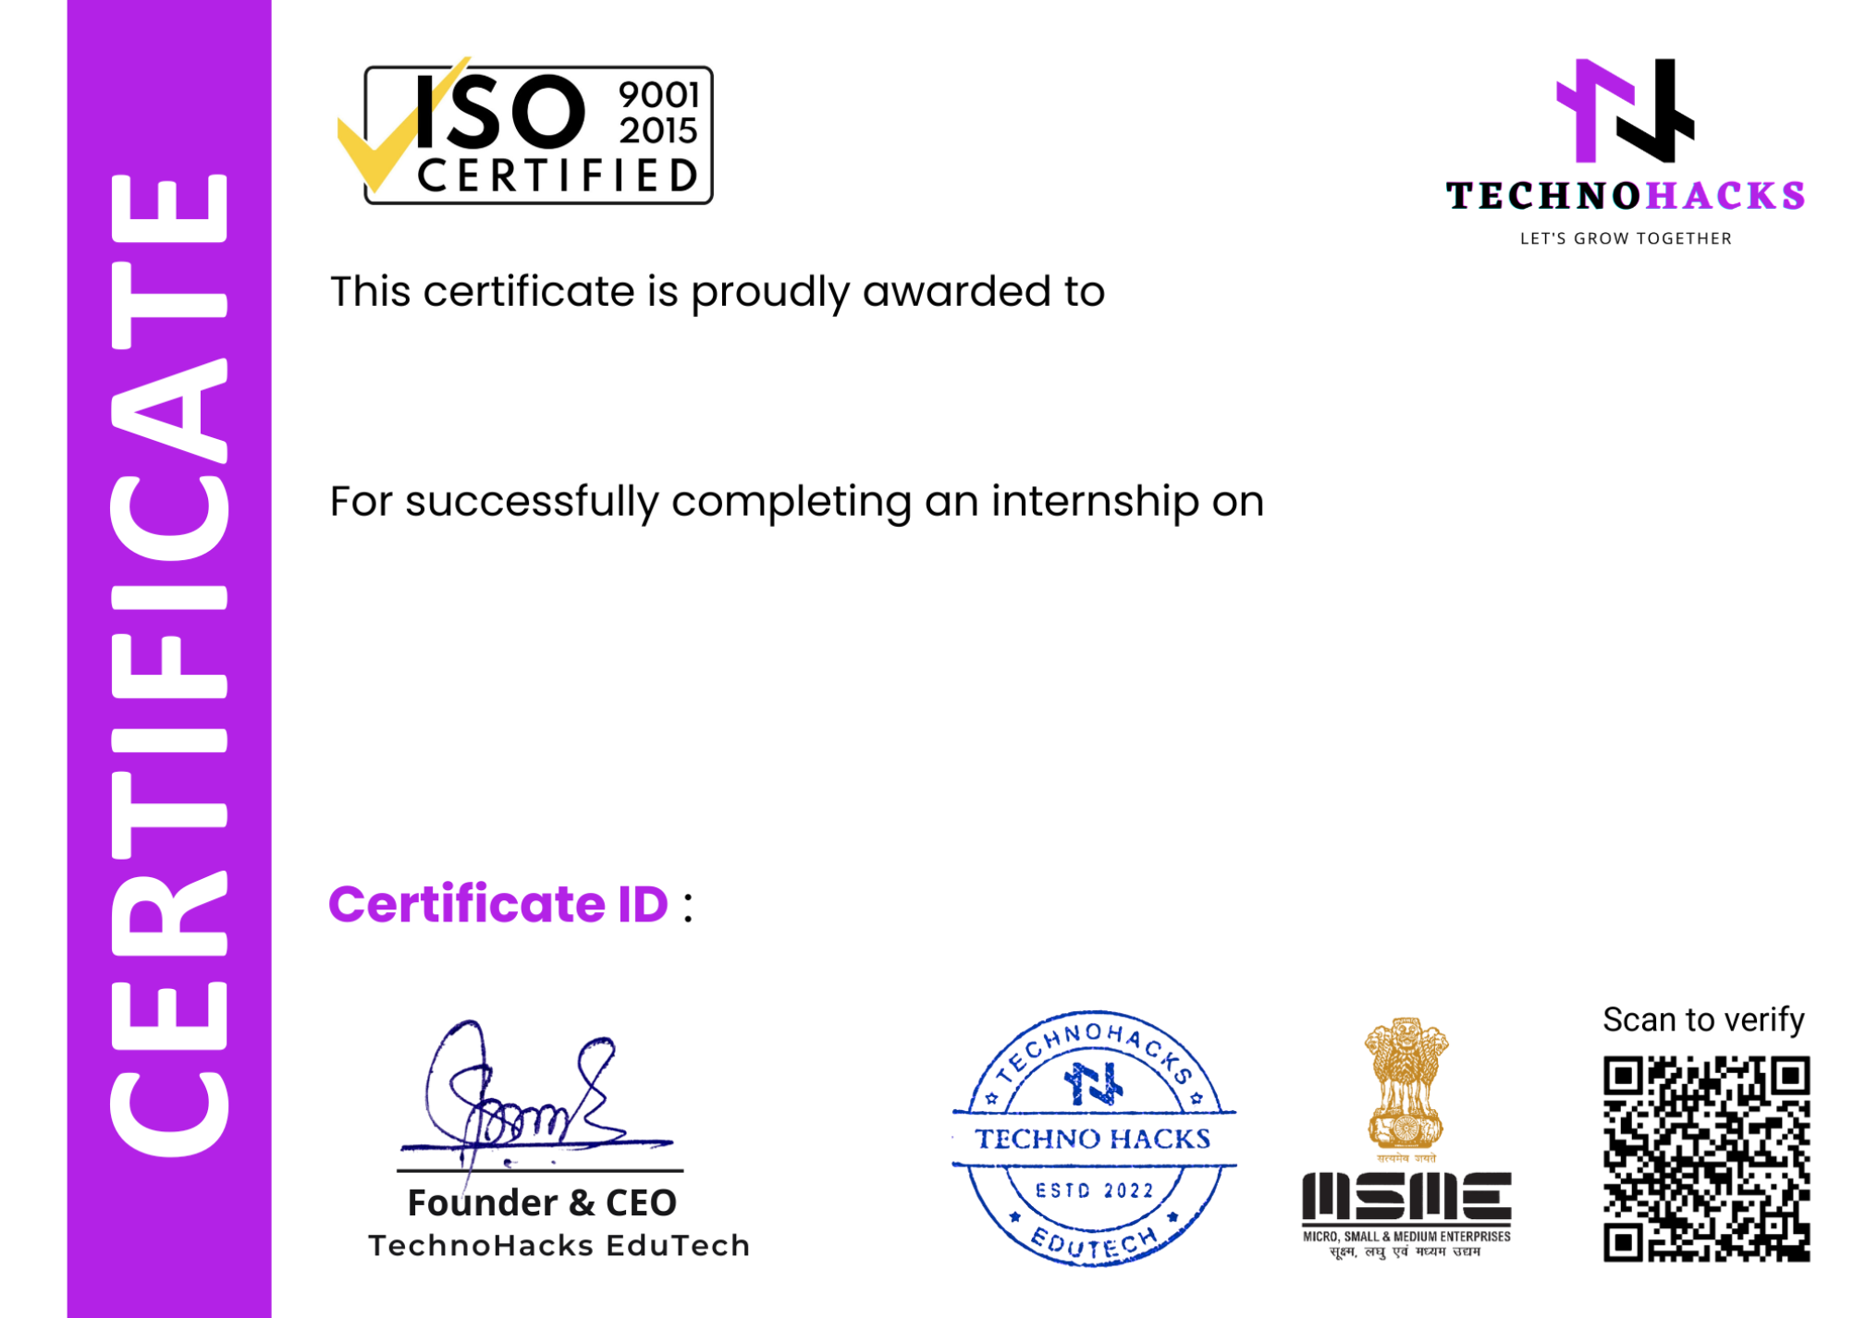

**Web Design & Development**

from **08/01/2025** to **07/02/2025** at **TechnoHacks Solutions Pvt. Ltd.** During this internship, we found him/her consistent and hardworking. We wish all the best for future endeavours.

TH07951

Page 1 of 28 - Cover Page Submission ID trn:oid:::3618:90878653

**h** TI53.pdf

Marathwada Mitra Mandal's College of Engineering

**Document Details**

**Submission ID**

**trn:oid:::3618:90878653**

**Submission Date**

**Apr 12, 2025, 9:06 AM GMT+5:30**

**Download Date**

**Apr 12, 2025, 9:07 AM GMT+5:30**

**24 Pages**

**3,332 Words**

**20,559 Characters**

**File Name**

**TI53.pdf**

**File Size**

**2.9 MB**

Page 1 of 28 - Cover Page Submission ID trn:oid:::3618:90878653

Page 2 of 28 - Integrity Overview Submission ID trn:oid:::3618:90878653

11% Overall Similarity

The combined total of all matches, including overlapping sources, for each database.

**Filtered from the Report**

Bibliography

Quoted Text

Cited Text

Small Matches (less than 8 words)

**Match Groups** **Top Sources**



**21** Not Cited or Quoted 11%

Matches with neither in-text citation nor quotation marks

**0** Missing Quotations 0%



Matches that are still very similar to source material

**0** Missing Citation 0%



Matches that have quotation marks, but no in-text citation

**0** Cited and Quoted 0%



Matches with in-text citation present, but no quotation marks

10% Internet sources

3% Publications

10% Submitted works (Student Papers)

**Integrity Flags**

**0 Integrity Flags for Review**

No suspicious text manipulations found.

Page 2 of 28 - Integrity Overview

Our system's algorithms look deeply at a document for any inconsistencies that would set it apart from a normal submission. If we notice something strange, we flag it for you to review.

A Flag is not necessarily an indicator of a problem. However, we'd recommend you focus your attention there for further review.

Submission ID trn:oid:::3618:90878653

Page 3 of 28 - Integrity Overview Submission ID trn:oid:::3618:90878653

**Match Groups** **Top Sources**



**21** Not Cited or Quoted 11%

Matches with neither in-text citation nor quotation marks

**0** Missing Quotations 0%



Matches that are still very similar to source material

**0** Missing Citation 0%



Matches that have quotation marks, but no in-text citation

**0** Cited and Quoted 0%



Matches with in-text citation present, but no quotation marks

11% Internet sources

4% Publications

10% Submitted works (Student Papers)

**Top Sources**

The sources with the highest number of matches within the submission. Overlapping sources will not be displayed.

**1** **Internet**

[**www.coursehero.com**](https://www.coursehero.com/file/72073026/Yash-Rathore-Banking-Record-Systemdocx/) **5%**

**2** **Submitted works**

**iGroup on 2017-05-25** **2%**

**3** **Internet**

[**naacengineering.meri.edu.in**](https://naacengineering.meri.edu.in/wp-content/uploads/2024/10/Internship-1.3.2.2.pdf) **<1%**

**4** **Internet**

[**www.slideshare.net**](http://www.slideshare.net/nawazkhanpathan/project-book-on-winds-of-changefrom-vendor-lockin-to-the-meta-cloud) **<1%**

**5** **Internet**

[**umpir.ump.edu.my**](http://umpir.ump.edu.my/id/eprint/55/1/Dye%20removal%20from%20simulated%20wastewater%20by%20using%20empty%20fruit%20bunch%20as%20an%20adsorption%20agent.pdf) **<1%**

**6** **Internet**

[**www.perseus.tufts.edu**](http://www.perseus.tufts.edu/hopper/text?doc=Thuc.+2.49) **<1%**

**7** **Submitted works**

**iGroup on 2017-05-26** **<1%**

**8** **Internet**

[**ijarsct.co.in**](https://ijarsct.co.in/Paper18843.pdf) **<1%**

**9** **Submitted works**

**Staffordshire University on 2012-05-03** **<1%**

**10** **Submitted works**

**islingtoncollege on 2025-01-22**

Page 3 of 28 - Integrity Overview

**<1%**

Submission ID trn:oid:::3618:90878653

Page 4 of 28 - Integrity Overview Submission ID trn:oid:::3618:90878653

**11** **Submitted works**

**Savitribai Phule Pune University on 2017-12-12** **<1%**

**12** **Submitted works**

**University of Pune on 2014-09-10** **<1%**

**13** **Internet**

[**tudr.thapar.edu:8080**](http://tudr.thapar.edu:8080/jspui/bitstream/10266/759/4/759.pdf) **<1%**

**14** **Submitted works**

**The University of Texas at Arlington on 2025-02-23** **<1%**

**15** **Submitted works**

**University of Ulster on 2024-05-12** **<1%**

**16** **Internet**

[**ssr5.stmaryscollege.edu.in**](https://ssr5.stmaryscollege.edu.in/assets/C_1/1.3/1.3.3/1.3.3_Project_Report/2022-23/B.Sc_Computer_Science.pdf)

Page 4 of 28 - Integrity Overview

**<1%**

Submission ID trn:oid:::3618:90878653