INTERNSHIP COMPLETION REPORT
Junior Web Developer – E-Governance & Digital Services
YuvaIntern
JanSeva Digital Service Platform (JSDSP)

Internship Duration: 07 August 2026 – 04 September 2026
Mode: Remote
Prepared by: Harshvardhan Singh
Programme: B.Tech Computer Science & Engineering
Semester / Section: 5th Semester • 3CSE25
Submitted as the consolidated record of the four-week internship journey: planning → responsive prototype → QA strategy → final audit

Declaration
I, Harshvardhan Singh, declare that this report presents my consolidated internship work for the Junior Web Developer – E-Governance & Digital Services role at YuvaIntern. It combines the four weekly deliverables produced during the internship period and reflects the project scope, design work, QA planning, and final audit documented in those deliverables.
Scope note The JanSeva prototype is a demonstration project. Government-service details shown in the prototype are illustrative and should not be read as actual government policy.

Acknowledgement
I would like to thank YuvaIntern for the internship opportunity and for the practical exposure to web development, digital-service design, quality assurance, accessibility, and security-oriented thinking. I also acknowledge the value of structured weekly deliverables, which helped me move from requirements and architecture to interface design, testing strategy, and a final evidence-based audit.

Internship Particulars
Item | Details
Organization | YuvaIntern
Role / Designation | Junior Web Developer – E-Governance & Digital Services
Start date | 07 August 2026
End date | 04 September 2026
Duration | 4 weeks
Mode | Remote
Primary project | JanSeva Digital Service Platform (JSDSP)
Representative service journey | Income Certificate – prototype / demonstration journey

Report Basis
This completion report consolidates the Week 1 project plan and technical roadmap, Week 2 responsive prototype report, Week 3 QA and testing strategy, and Week 4 performance/accessibility/security audit. The report keeps the same terminology and preserves the distinction between evidence observed in the static prototype and work that remained planned for a future interactive or production environment.

Executive Summary
The internship followed a four-week progression centred on the JanSeva Digital Service Platform, a proposed reusable e-governance service layer designed to make public services understandable, accessible, trackable, and secure. The platform concept covers service discovery, identity, applications, document exchange, workflow, status tracking, notifications, grievances, reporting, and interoperability, while keeping departmental policy and operational ownership explicit.
Week 1 established the foundation: project vision, 14 functional requirements, 11 non-functional quality areas, six personas, an 11-step citizen journey, proposed architecture, security/data principles, a phased delivery roadmap, risks, governance, and acceptance criteria.
Week 2 translated that plan into a concrete responsive front-end prototype. The implementation focused on one complete citizen-facing journey for an Income Certificate demonstration service, represented across ten prototype screens. The work included information architecture, user flow, reusable UI components, design system, wireframes, high-fidelity mockups, responsive behaviour, accessibility considerations, and a testing log.
Week 3 converted the earlier high-level testing approach into a structured QA strategy with five test levels, requirement-to-test traceability, ten test case scenarios, automation guidance, performance/security/accessibility strategies, a QA risk register, defect management, metrics, and release exit criteria. Execution-dependent checks were clearly marked Planned or Not Tested rather than overstated as completed.
Week 4 performed the final performance, accessibility, and security audit of the published prototype. The audit found a strong zero-external-dependency starting point and solid semantic/contrast foundations, but also documented concrete accessibility and security gaps that must be addressed before real citizen data or backend services are connected. The final result is therefore an honest, well-documented prototype foundation rather than a claim of production readiness.
Overall outcome A complete four-week engineering record was produced, linking requirements, UI implementation, QA planning, and evidence-based audit findings into one traceable internship story.

Contents
1. Internship Overview
2. Project Background and Vision
3. Week 1 – Planning & Technical Roadmap
4. Week 2 – Responsive Web Prototype
5. Week 3 – QA & Testing Strategy
6. Week 4 – Performance, Accessibility & Security Audit
7. Technology, Tools & Working Approach
8. Cross-Week Results and Evidence
9. Challenges, Learning & Skills Gained
10. Future Scope and Production Roadmap
11. Conclusion
Appendix A – Selected Prototype Evidence
Appendix B – Selected QA & Audit Evidence
Appendix C – Key References

1. Internship Overview

1.1 Role and Expectations
The offer letter defines the internship as a four-week remote Junior Web Developer – E-Governance & Digital Services placement at YuvaIntern. The responsibilities include designing, coding, and modifying websites according to specifications and collaborating with cross-functional teams to develop user-friendly interfaces and improve user experience.

1.2 Internship Objective
- Understand how a digital public-service platform can be planned around citizen needs and departmental workflows.
- Translate requirements and user journeys into a responsive, reusable interface prototype.
- Develop a practical QA strategy that connects requirements to test cases, risks, and release criteria.
- Assess the prototype using performance, accessibility, and security lenses and produce a prioritized improvement plan.
- Document the work in a form suitable for technical review and internship completion submission.

1.3 Four-Week Progression
Week | Primary focus | Main output
Week 1 | Planning & technical blueprint | Project plan, requirements, personas, user journey, architecture, roadmap, risks and acceptance criteria
Week 2 | Responsive UI/UX execution | 10-screen JanSeva front-end prototype, wireframes, mockups, design system and testing log
Week 3 | Quality assurance | Test strategy, traceability, 10 test cases, risk register, defect workflow and exit criteria
Week 4 | Final evidence-based audit | Performance/accessibility/security audit, findings, scorecard and prioritized improvement plan

Engineering principle Throughout the internship, the reports intentionally separated what was demonstrated in the current static prototype from what required a real backend, staging environment, automated tooling, or third-party integrations.

2. Project Background and Vision
The working project name is JanSeva Digital Service Platform (JSDSP). The Week 1 plan describes it as a configurable public-sector service layer rather than a replacement for every departmental system. Departments remain responsible for policy and operational workflows while the platform standardizes the citizen experience and provides shared capabilities such as identity, notifications, document exchange, case tracking, analytics, and interoperability.

2.1 Vision and Goals
- Citizen simplicity – reduce unnecessary steps, duplicate data entry, and repeated visits.
- Inclusion – support mobile-first access, low-bandwidth conditions, accessibility, local language and assisted channels.
- Transparency – explain eligibility, required actions, status and expected next steps.
- Operational efficiency – digitize routing, validation, queues, approvals and service-level monitoring.
- Interoperability – connect departmental systems using open, documented APIs and adapters.
- Trust and security – apply privacy-by-design, least privilege, strong authentication and audit logging.
- Continuous improvement – use analytics and feedback to improve journeys.

2.2 Representative Citizen Journey
- Discover a service through catalogue/search.
- Understand eligibility, documents, fees and processing time.
- Sign in and verify identity.
- Complete a validated application with save/resume support.
- Attach documents and declarations.
- Submit and receive a reference number.
- Allow department workflow and verification.
- Receive status notifications and requests for action.
- Review the decision and next step.
- Complete service fulfilment or payment/refund where applicable.
- Provide feedback, raise a grievance, or request support.

2.3 High-Level Architecture
Layer | Planned direction
Presentation | Responsive web app with reusable accessible components
Backend | Modular versioned APIs using Node.js/TypeScript or Java/Spring Boot
Identity | Approved government identity provider; OAuth 2.0/OpenID Connect where appropriate
Data | PostgreSQL for transactions; object storage for documents; cache where justified
Integration | API gateway, adapters, events/message broker and legacy integration
Workflow | Configurable workflow engine or clear service/state-machine approach
Operations & deployment | Centralized logs/metrics/traces plus containers, CI/CD and approved cloud/private-cloud environment

3. Week 1 – Planning & Technical Roadmap
Week 1 established the project foundation. The planning document defined the platform scope, research-informed design direction, functional requirements, non-functional requirements, personas, service flow, architecture, security principles, delivery roadmap, risk register, governance model, and testing/acceptance approach.

3.1 Requirements Baseline
Area | Representative requirements
FR-01 Service discovery | Search, categories, filters, plain-language descriptions and eligibility prompts
FR-02 Account & identity | Secure registration/sign-in, pluggable identity provider and recovery
FR-03 Application | Save/resume, validation, declarations, consent, receipt and reference number
FR-04 Documents | Upload, metadata, size/type validation and secure storage hooks
FR-05 Workflow | Queues, assignment, verification, approvals/rejections and escalations
FR-06 Status | Citizen-facing timeline with current stage and next action
FR-07 Payments | Approved gateway, receipt and reconciliation
FR-08 Notifications | Event-driven notifications and delivery logs
FR-09 Grievance | Complaint/feedback capture, routing and closure
FR-10 Admin | Service configuration, forms, workflows, roles and permissions
FR-11 Reporting | Operational dashboards and service metrics
FR-12 Integration | Versioned APIs, events and legacy adapters
FR-13 Audit | Tamper-evident logs for privileged/sensitive actions
FR-14 Assisted service | Staff-assisted application mode and accessible alternatives

3.2 Non-Functional Priorities
- Performance: typical user-facing page/API responses targeted below 2 seconds under normal load.
- Availability: 99.9% monthly target for core citizen journeys with maintenance windows documented.
- Security: threat modelling, encryption, RBAC, MFA for privileged users, vulnerability management and secure SDLC.
- Privacy: data minimization, purpose limitation, retention schedules and legally required access/correction workflows.
- Accessibility: WCAG 2.2 AA target with keyboard operation, screen-reader semantics, contrast and clear errors.
- Usability: plain language, consistent components, responsive mobile-first layouts and tested task completion.

3.3 Personas and Design Implications
Persona | Need | Design response
Asha – Citizen | Find, understand, apply and track without repeated office visits | Simple language, prominent search, save/resume, status timeline and notifications
Ravi – Assisted-Service Operator | Help citizens complete applications and resolve issues | Consistent UI patterns, assisted mode and clear validation
Meera – Service Officer | Process complete evidence with clear queues | Work queues, validation, workflow, SLA alerts and audit trail
Khan – Department Manager | Monitor quality and bottlenecks | Dashboard metrics, SLA trends and exportable reports
Priya – Platform Administrator | Configure services and access controls | RBAC, configuration, audit logs and deployment controls
Arjun – Integration/Security Lead | Connect external and departmental systems safely | API management, monitoring, key rotation and security/integration testing

3.4 Roadmap
Phase | Timing | Key outputs
Discovery | Weeks 1–3 | Research, service inventory, data classification, technical discovery and pilot selection
Alpha | Weeks 4–8 | Prototype catalogue, eligibility, identity mock, application journey, accessibility and usability testing
Beta | Weeks 9–16 | Production-like APIs, workflow, documents, notifications, audit, dashboards and security testing
Pilot | Weeks 17–22 | Limited public release; measure completion, reliability, accessibility and operational workload
Scale | Weeks 23–36 | Improve from evidence and onboard additional services/departments

4. Week 2 – Responsive Web Prototype
Week 2 converted the Week 1 plan into a concrete interface. The scope was deliberately narrowed to a responsive front-end prototype demonstrating one complete Income Certificate citizen journey. The report explicitly states that service details are illustrative demonstration content rather than government policy.

4.1 Information Architecture and Screen Set
The design organized the portal around recurring citizen activities: finding a service, managing an application, getting help, giving feedback, and managing the account. The user journey was expressed as ten prototype screens spanning discovery through grievance/support, with an optional officer dashboard.
Screen | Purpose
Home | Service discovery and prominent search
Service Catalogue | Browse/filter services
Service Details | Eligibility, requirements and start action
Sign In | Demo identity concept
Application Form | Stepwise data entry with progress
Review & Submit | Confirm entered information
Submission Confirmation | Reference number and completion state
Application Status | Timeline, next action and grievance path
Notifications / Help / Feedback | Support and communication states
Officer Dashboard | Queue, KPI cards and case table demonstration

4.2 Reusable Components
- Navigation header with responsive mobile menu.
- Search bar reused across home and catalogue.
- Category/service cards for scanning and discovery.
- Form fields with labels, hints, and validation states plus a multi-step progress indicator.
- Document upload control with type/size guidance and missing-document warning.
- Status timeline for completed, active, and pending stages.
- Alert banners for information, warning, success and error states.
- Button variants and status pills for tabular data.

4.3 Selected Prototype Evidence
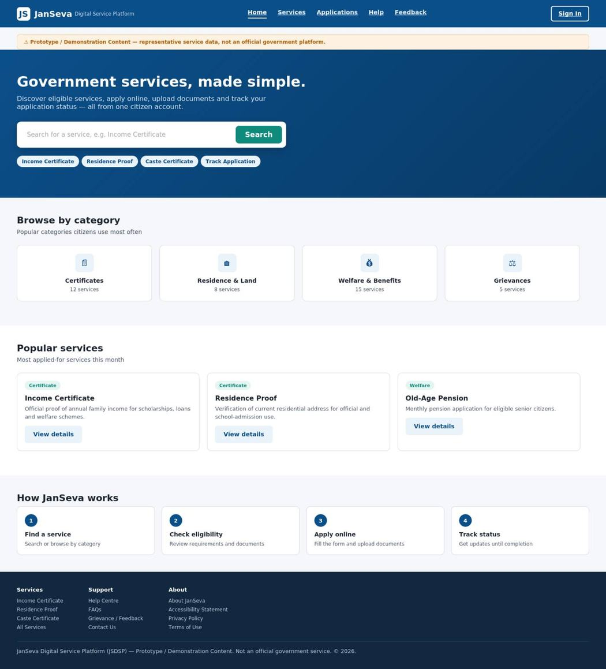
Figure 1. JanSeva home page – responsive citizen-facing prototype.

4.4 Service Discovery and Application Experience
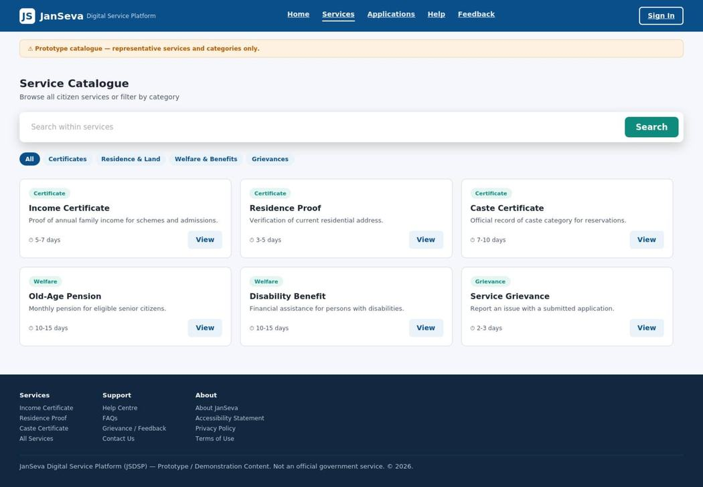
Figure 2. Service catalogue view with reusable service-card pattern.
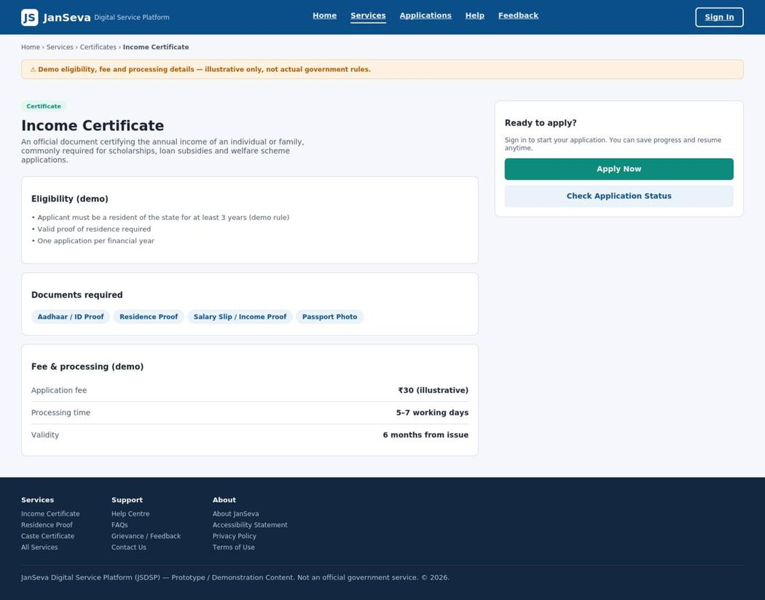
Figure 3. Income Certificate service-details view used to surface eligibility and required documents before application.
A key design choice was to place eligibility and required documents before the Apply action so that a citizen can self-screen before spending time on a form. The application was split into steps with a progress indicator to make recovery and save/resume concepts easier to understand.

4.5 Responsive Design and Accessibility
The Week 2 prototype was designed around three reference widths: 1440px desktop, 768px tablet, and 390px mobile. Layout behaviour used responsive CSS patterns, including Flexbox/Grid, a four-to-two-to-one card-grid transition, and single-column forms on narrow screens.
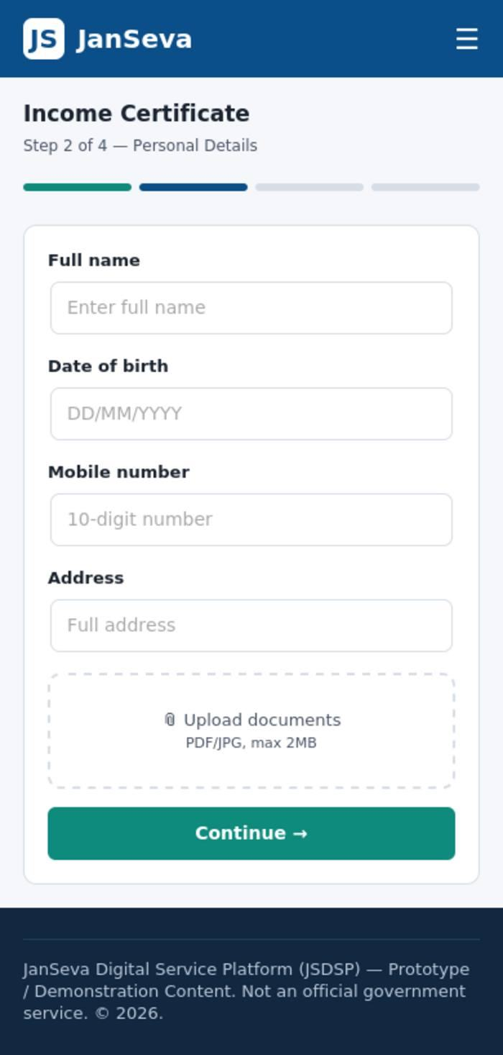
Figure 4. Mobile home view showing the mobile-first treatment.
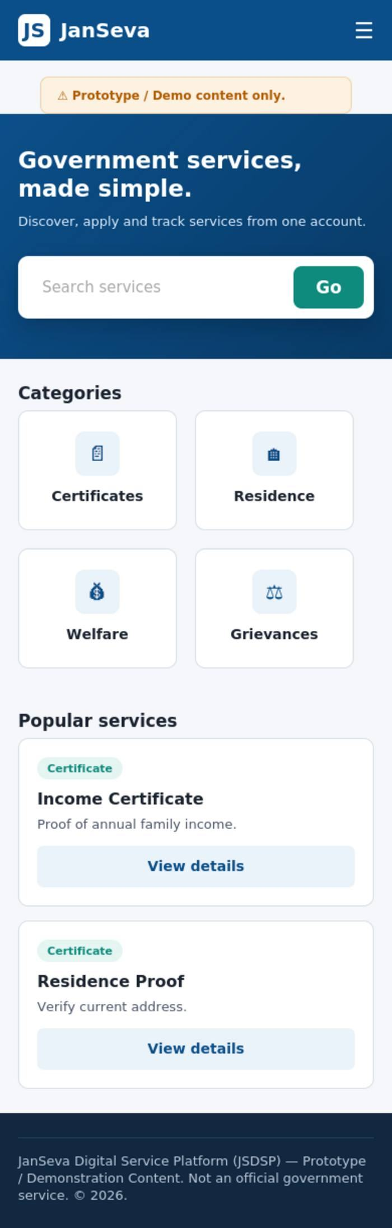
Figure 5. Mobile application form layout using a single-column pattern.

4.6 Week 2 Testing Position
The Week 2 report records UI/prototype checks as evidence while keeping execution-dependent activities separate. Examples marked Not Tested required interactive browser execution beyond the static visuals, including keyboard navigation, screen-reader behaviour, automated accessibility scanning, cross-browser rendering, and form validation logic.
Design rationale Search was kept prominent, service cards were used for quick scanning, status was presented as a timeline, mobile forms were single-column, and accessibility-related labels/focus styles were considered from the wireframe stage.

5. Week 3 – QA & Testing Strategy
Week 3 shifted from design to evaluation. The deliverable defined how JSDSP should be verified before real citizens and department staff rely on it, while clearly distinguishing prototype evidence from testing that requires an interactive build, staging infrastructure, or real integrations.

5.1 Test Levels
Level | Purpose | Examples
Unit / component | Validate isolated logic and reusable UI pieces | Field rules, components, business-rule functions
Integration / API | Validate service-to-service contracts and data exchange | Identity, documents, notifications, payment APIs
System / End-to-end | Validate complete citizen and officer journeys | Discovery → application → submission → status
UAT | Validate real-world task completion and service usability | Representative citizens and service staff
Non-functional | Validate quality attributes and risk controls | Performance, accessibility, security, resilience

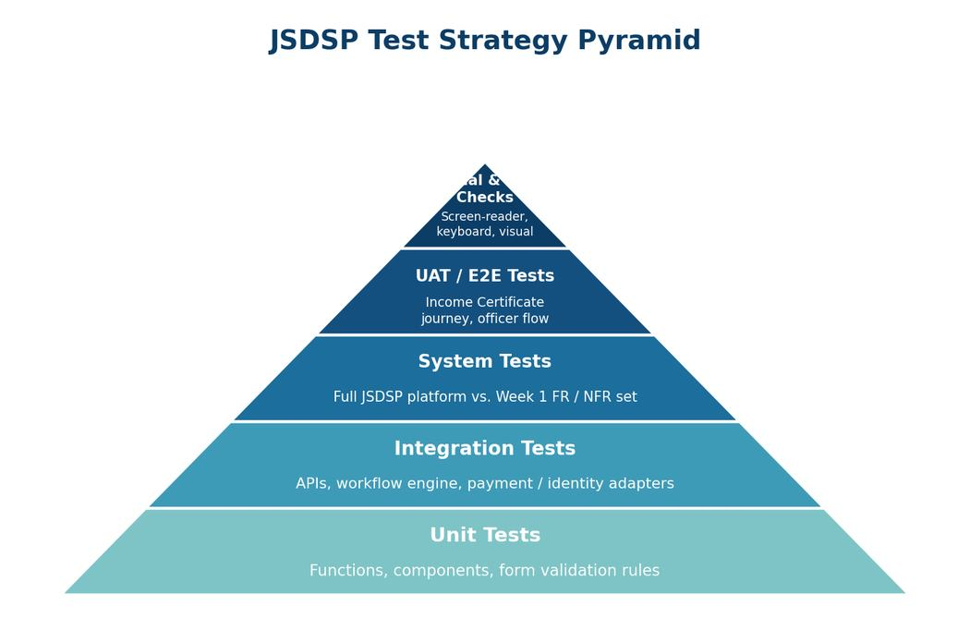
Figure 6. QA test-strategy pyramid from the Week 3 deliverable.

5.2 Test Case Coverage
Test ID | Scenario | Status basis
TC-01 | Authenticated start / sign-in | Planned for interactive authenticated build
TC-02 | Service discovery and catalogue | Prototype/UI review evidence available
TC-03 | Application form validation and save/resume | Strategy defined; live logic execution planned
TC-04 | Document upload validation | UI state reviewed; server/storage testing planned
TC-05 | Submission and reference number | Journey defined; backend execution planned
TC-06 | Officer workflow | Planned for workflow-enabled build
TC-07 | Status and notification update | UI state reviewed; state-transition testing planned
TC-08 | Payment / duplicate submission protection | Planned for gateway integration
TC-09 | Authorization, audit and security boundary | Planned for authenticated backend
TC-10 | Keyboard-only and screen-reader walkthrough | Manual + automated accessibility test planned

5.3 Evidence vs Planned Execution
Test area | Evidence available | Week 3 status | Next step
Navigation / screen flow | Prototype links reviewed | Pass – prototype review | Repeat in interactive E2E test
Service discovery | Search, categories and service cards reviewed | Pass – prototype review | Execute functional search/filter tests
Application form | Desktop/mobile layout and labels reviewed | Pass – prototype review | Execute validation and save/resume tests
Document upload state | Upload control and missing-document warning visible | Pass – UI state review | Execute type/size/scanning/storage tests
Status timeline | Current stage, next action and grievance path visible | Pass – UI state review | Execute state-transition/notification tests
Responsive behaviour | Desktop/tablet/mobile layouts reviewed | Pass – prototype review | Run browser/device matrix
Accessibility foundations | Headings, labels, focus styling and contrast checks | Partial | Run keyboard, screen-reader and automated scans
Authentication / RBAC / audit | Intent documented; no live security boundary | Planned | Execute on authenticated build
Performance / load / stress | No staging environment | Planned | Run k6/JMeter on staging
Payment / reconciliation | Flow documented; no real gateway | Planned | Run sandbox integration tests

5.4 Automation and Defect Management
Automation was prioritised for repeatability: unit tests on every commit, integration/API tests on merge, end-to-end tests nightly and before release, performance tests before major releases, CI-integrated security scans, and accessibility scans each release with periodic manual screen-reader checks. Manual testing remains important for visual quality, plain language, and human judgement.
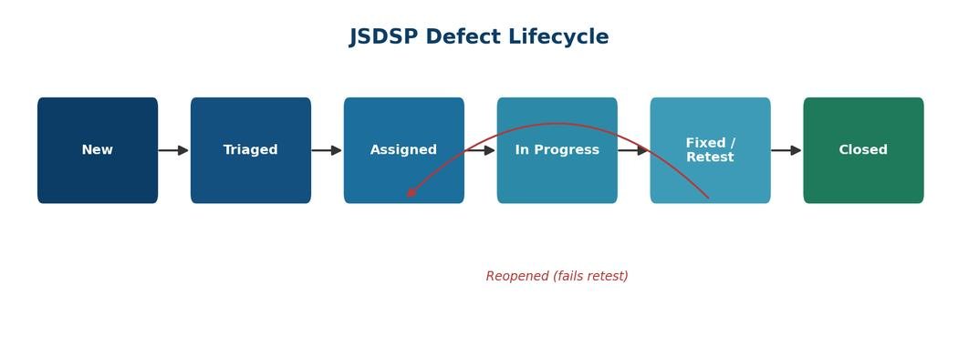
Figure 7. Defect lifecycle with retest/reopen path.
Release gate Zero open Critical defects, controlled High defects, complete relevant requirement coverage, no critical accessibility violations on core screens, target response time demonstrated under load, and no open Critical/High security findings before pilot go-live.

6. Week 4 – Performance, Accessibility & Security Audit
Week 4 is the final internship deliverable. It audited the published JSDSP prototype against performance targets, WCAG 2.2-oriented accessibility checks, and OWASP-aligned security design principles. The audit also cross-checked the Week 3 QA package and CI smoke-check workflow in the project repository.
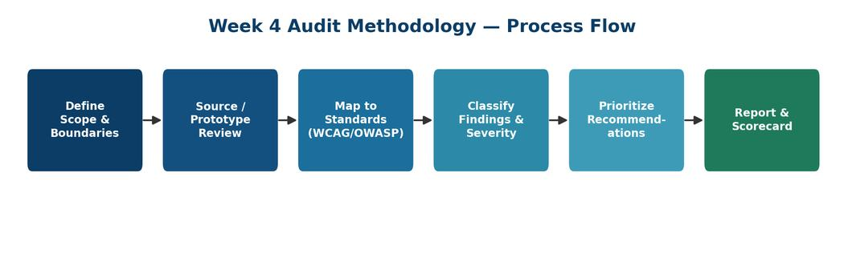
Figure 8. Week 4 audit execution methodology.

6.1 Performance Findings
The prototype uses a self-contained single-file architecture with no third-party scripts, fonts, or trackers. This is a strong performance starting point because the dependency footprint is minimal. However, the audit found no production build pipeline, no minification, and no caching strategy, so the prototype should not be interpreted as having demonstrated production Core Web Vitals.
Performance dimension | Audit conclusion
Architecture | Good starting point; zero external dependencies reduce request and supply-chain overhead
Build pipeline | Not yet productionized; CSS/JS remain inline and unminified
Caching | No production caching strategy documented
Measurement | Production-representative field/lab measurements not claimed
Recommended targets | LCP ≤2.5s, INP ≤200ms, CLS ≤0.1, TTFB ≤0.8s as audit benchmarks

6.2 Accessibility Findings
The audit identified several positive foundations: semantic landmarks, labelled form fields, clear heading structure, and WCAG-AA-passing checked colour pairs. It also identified concrete gaps, including missing required-field indication, missing live-region announcements for errors, missing focus management on route changes, and a missing skip link. Keyboard, screen-reader and 400% zoom behaviour were not fully verified in the static prototype.
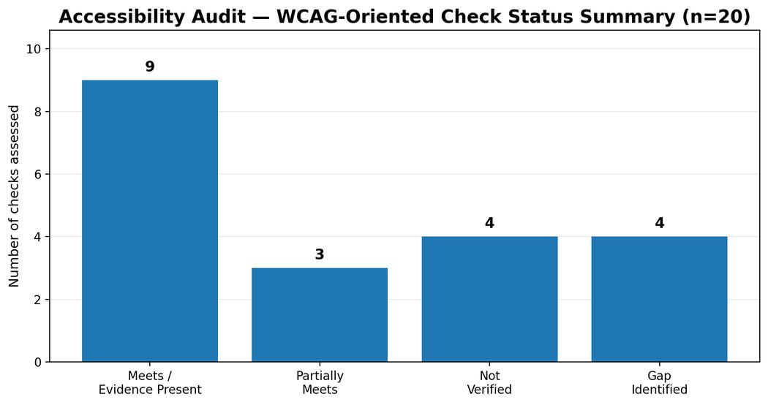
Figure 9. Accessibility audit summary from Week 4.

6.3 Security Findings
The current prototype has low immediate exploitability because it contains no live backend, database, authentication service, payment gateway, or real citizen data. Nevertheless, the audit documented design-stage security gaps that must be closed before backend integration, including authentication enforcement, RBAC, security headers, documented input handling, rate limiting, audit logging, and one unsafe innerHTML interpolation pattern identified in source review.
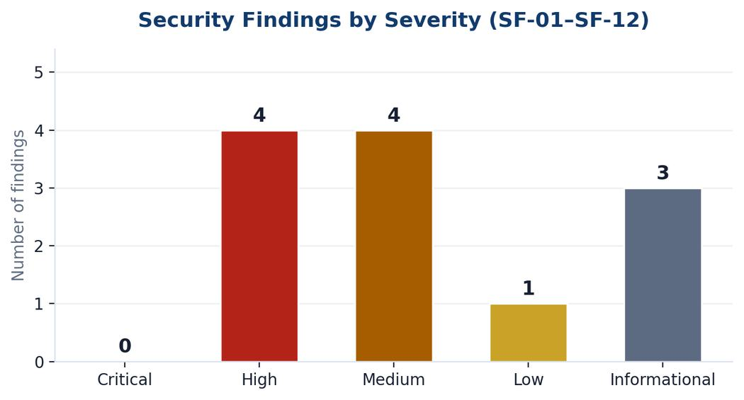
Figure 10. Distribution of Week 4 security findings by severity.

6.4 Cross-Dimension Findings and Improvement Plan
The final audit highlights that performance, accessibility and security are connected. For example, missing focus management harms both accessibility and usability; lack of field validation creates both functional and accessibility problems; and the future production build pipeline should run performance optimisation and security scanning together.
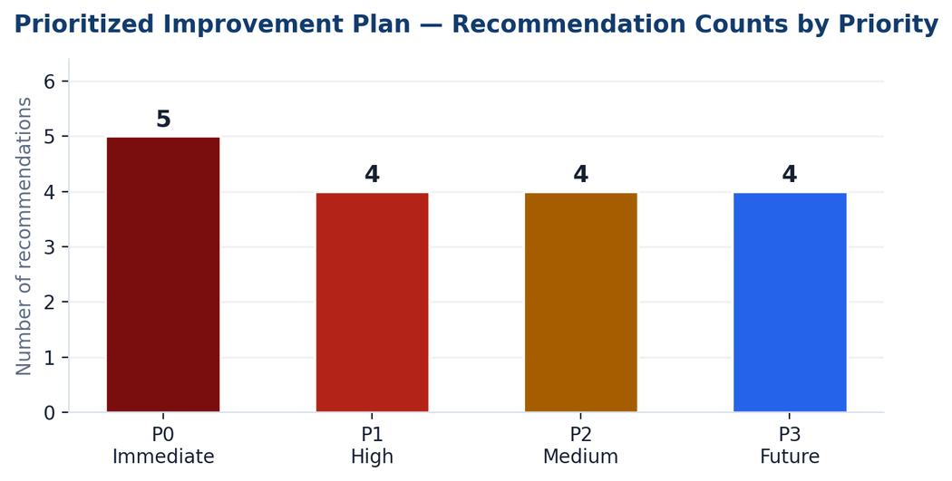
Figure 11. Prioritized improvement recommendations by priority tier.
Priority | Action focus
P0 – Immediate | Required/aria-required fields, aria-live errors, route-change focus management, skip link, mobile menu aria-expanded
P1 – Before backend / Alpha | Authentication design, RBAC, rate limiting/lockout, security headers/CSP, safe input-handling policy
P2 – Quality & robustness | Alert variants, upload validation, stronger component/quality controls
P3 – Future / infrastructure-dependent | Production performance validation, dynamic security testing and deeper operational readiness

Final audit conclusion The prototype is a credible, well-documented and structurally sound foundation, but it is not production-ready. The report intentionally stops at that narrower, evidence-supported claim and provides a concrete path toward a safe pilot.

7. Technology, Tools & Working Approach

7.1 Project / Design Technologies
Area | Technologies / approaches reflected in the internship
Frontend direction | HTML5, CSS3, JavaScript prototype; React/Next.js + TypeScript recommended for production direction
Responsive UI | CSS Flexbox/Grid, breakpoint-based layouts, mobile-first forms
Design | Information architecture, low-fidelity wireframes, high-fidelity mockups, reusable components and design system
Versioning / delivery | Git/GitHub repository workflow
QA | Jest, React Testing Library, Supertest/Postman-Newman, Playwright/Cypress
Performance | k6 or Apache JMeter; Core Web Vitals target framework
Security | SAST/dependency scanning, OWASP-aligned manual review, penetration testing planned for pilot
Accessibility | axe-core/WAVE plus NVDA/VoiceOver manual testing

7.2 Working Method
- Trace requirements forward into UI decisions and test cases.
- Use representative personas and one complete service journey to make a large platform demonstrable.
- Use reusable components instead of one-off page layouts.
- Separate verified evidence from planned implementation.
- Treat accessibility, security and performance as engineering concerns rather than final-stage decoration.
- Use risk and priority to decide what must be fixed before the next phase.

7.3 Documentation Discipline
A major learning from the internship was that a strong technical record should state both what is present and what is absent. The Week 3 and Week 4 documents repeatedly label backend-dependent checks as Planned or Not Tested, which improves the credibility and usefulness of the final audit.

8. Cross-Week Results and Evidence

8.1 What Was Produced
Deliverable | Evidence / outcome
Week 1 project plan | Reusable e-governance vision, 14 functional requirements, 11 non-functional areas, personas, journey, architecture, roadmap and risks
Week 2 UI prototype | Ten-screen responsive interface representing the Income Certificate citizen journey plus optional officer dashboard
Week 3 QA package | Five test levels, traceability, ten test cases, automation plan, QA risk register, defect process and exit criteria
Week 4 audit | Performance/accessibility/security findings, scorecard, cross-dimension analysis and prioritized improvement roadmap
Completion presentation | Consolidated four-week PPT aligned to the same project story and evidence

8.2 Representative Prototype Results
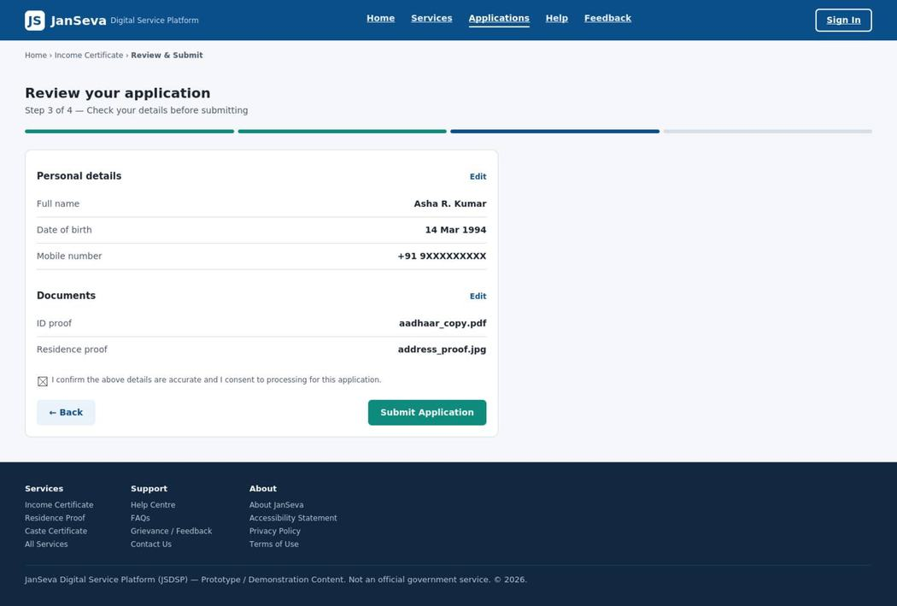
Figure 12. Desktop application form view.
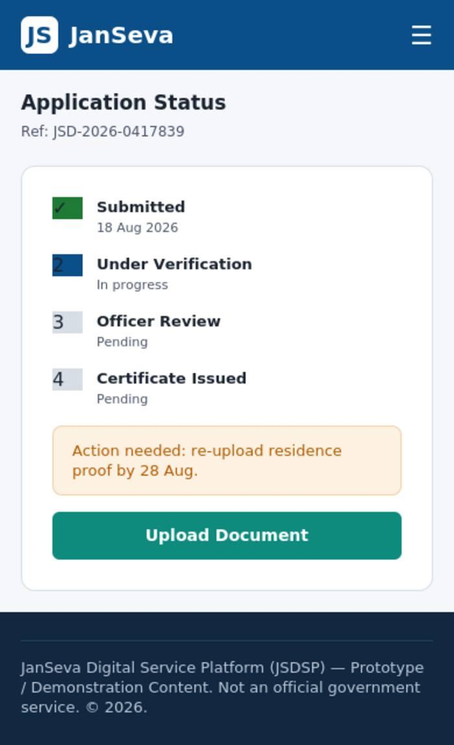
Figure 13. Application status timeline view.
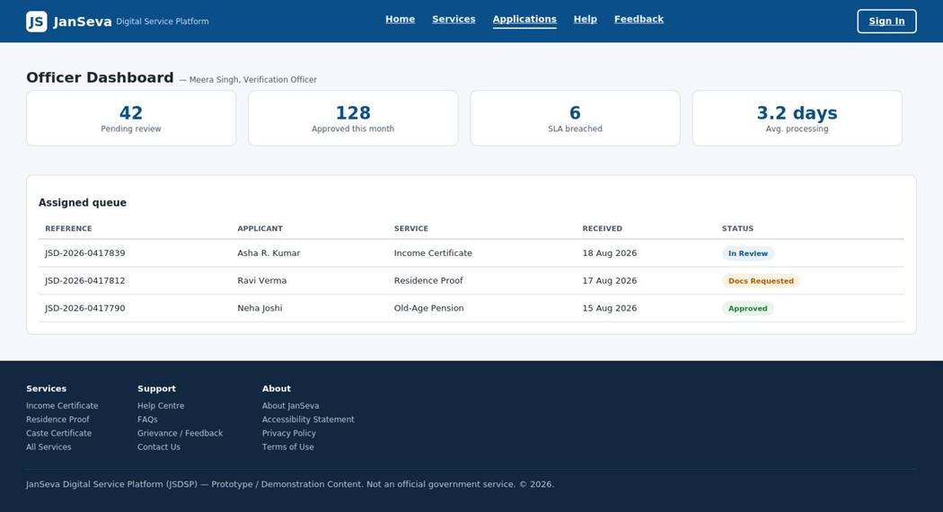
Figure 14. Officer dashboard demonstration view.

9. Challenges, Learning & Skills Gained

9.1 Challenges Addressed
- Scoping a broad e-governance platform into one demonstrable journey without losing the larger architecture and roadmap.
- Balancing realistic public-service presentation with the need to avoid inventing real government policy details.
- Keeping responsiveness concrete by documenting reference widths and visible UI behaviour rather than only describing mobile support.
- Creating credible QA evidence without pretending that missing backend, staging, identity or payment infrastructure already existed.
- Translating an audit into practical priorities instead of listing disconnected issues.

9.2 Skills Developed
Skill area | Evidence from internship
Web UI development | Responsive HTML/CSS/JS prototype and reusable component thinking
UI/UX | Information architecture, wireframing, mockups, user flow and design rationale
Requirements analysis | FR/NFR mapping, personas, acceptance criteria and traceability
Quality assurance | Test levels, test cases, automation strategy, metrics and defect lifecycle
Accessibility | WCAG-oriented thinking, labels, focus, contrast and assistive-technology planning
Security awareness | Authentication/RBAC/input handling/security-header considerations and OWASP-aligned review
Performance thinking | Dependency footprint, build pipeline, caching and Core Web Vitals targets
Technical documentation | Structured reports, evidence matrices, findings registers and prioritization
Professional communication | Consolidating weekly work into a clear completion narrative and presentation

9.3 Personal Takeaways
The internship strengthened the understanding that web development is not only about writing interface code. Good delivery requires understanding users, translating requirements into reusable UI, defining how behaviour will be tested, checking non-functional quality, documenting limitations honestly, and planning the next engineering step.

10. Future Scope and Production Roadmap
The project is intentionally positioned as a prototype foundation. The next phase would move from static demonstration into a controlled Alpha/Beta implementation with real service contracts, authentication, workflow, document handling, notifications, audit logging, observability and production-grade performance/security controls.

10.1 Immediate Next Steps
- Add required and aria-required attributes plus accessible inline error messaging.
- Add keyboard focus management and a skip-to-content link.
- Complete mobile-menu accessibility semantics such as aria-expanded.
- Fix unsafe innerHTML interpolation and establish a safe rendering/input policy.
- Document authentication, RBAC, security headers, lockout/backoff and audit logging before backend work begins.

10.2 Alpha / Beta Next Steps
- Connect the approved identity provider and implement real session/authentication boundaries.
- Introduce backend APIs, persistent storage and controlled document handling.
- Implement workflow/case management, officer queues, notifications and audit logs.
- Add automated unit, integration and end-to-end regression coverage in CI/CD.
- Run accessibility scans plus keyboard/screen-reader testing on an interactive build.
- Run performance/load testing against staging and monitor real-user performance after deployment.
- Perform security scanning and penetration testing before pilot go-live.

10.3 Broader Service Expansion
Once the reusable component and workflow model are proven, the catalogue can be extended beyond the Income Certificate demonstration journey to additional services. The Week 2 report specifically recommends validating generalisability with two or three additional service types and adding localization to support the inclusion goal.

11. Conclusion
The four-week Junior Web Developer internship at YuvaIntern provided a practical progression from problem framing to interface implementation, quality planning, and technical audit. The JanSeva Digital Service Platform served as a concrete project through which requirements analysis, responsive web design, QA strategy, accessibility, security, performance, documentation, and prioritization were connected.
The final internship record demonstrates a complete development-thinking cycle: define what a public-service platform should achieve; translate that into a usable responsive interface; specify how the system should be tested; and assess the prototype honestly against quality and risk dimensions. The work deliberately avoids claiming production capabilities that were not present in the static prototype and instead provides an actionable roadmap for the next stage.
Internship outcome The internship resulted in a coherent four-week project record, a reusable digital-service prototype concept, a structured QA foundation, and an evidence-based production-readiness roadmap.

Internship Completion Details
Field | Value
Organization | YuvaIntern
Designation | Junior Web Developer – E-Governance & Digital Services
Period | 07 August 2026 – 04 September 2026
Duration | 4 weeks
Project | JanSeva Digital Service Platform (JSDSP)
Representative journey | Income Certificate – demonstration prototype
Certificate number | YI/2026/184736/410723
Certificate issue date | 04 September 2026

Appendix A – Selected Prototype Evidence

Home / Service Discovery – prototype evidence from Week 2.

Service Catalogue – prototype evidence from Week 2.

Service Details – prototype evidence from Week 2.

Application Form – prototype evidence from Week 2.
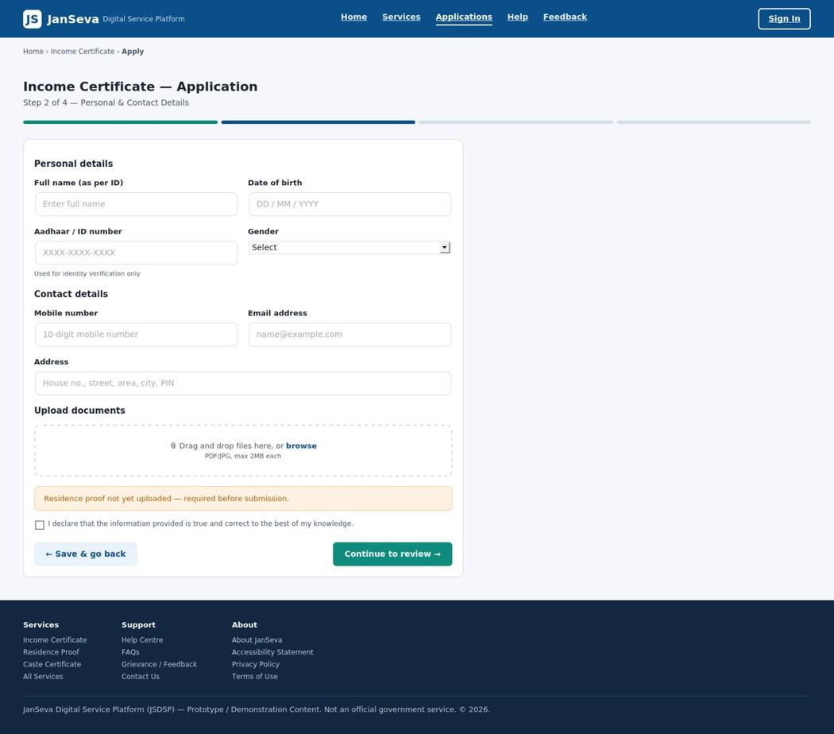
Review And Submit – prototype evidence from Week 2.

Application Status – prototype evidence from Week 2.

Mobile Home – prototype evidence from Week 2.

Mobile Application Form – prototype evidence from Week 2.

Appendix B – Selected QA & Audit Evidence

Qa Test Strategy Pyramid – evidence from the final weekly deliverables.

Defect Lifecycle – evidence from the final weekly deliverables.

Final Audit Methodology – evidence from the final weekly deliverables.

Accessibility Findings – evidence from the final weekly deliverables.

Security Findings – evidence from the final weekly deliverables.

Prioritized Improvement Plan – evidence from the final weekly deliverables.
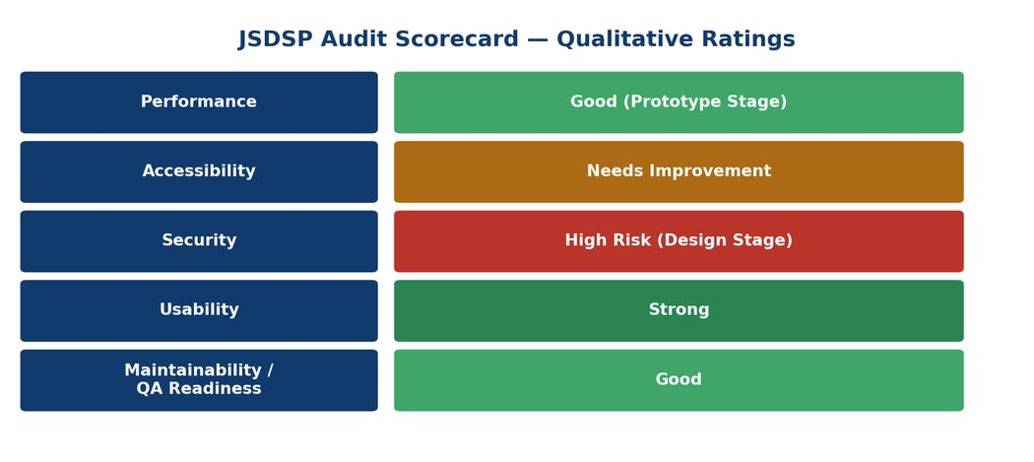
Qualitative Audit Scorecard – evidence from the final weekly deliverables.

Appendix C – Key References

Internal Internship Deliverables
- Week 1 – E-Governance Digital Service Platform: Project Plan & Technical Roadmap (15 August 2026).
- Week 2 – JanSeva Responsive Web Prototype Report (22 August 2026).
- Week 3 – JanSeva QA & Testing Strategy Report (28 August 2026).
- Week 4 – JanSeva Performance, Accessibility & Security Audit (28 August 2026).
- YuvaIntern internship offer letter for Junior Web Developer – E-Governance & Digital Services (07 August–04 September 2026).
- YuvaIntern internship completion certificate no. YI/2026/184736/410723, issued 04 September 2026.

Standards / Public Sources Cited in the Weekly Deliverables
- W3C – Web Content Accessibility Guidelines (WCAG) 2.2.
- OWASP – OWASP Top 10:2025.
- Google web.dev – Core Web Vitals / Web Vitals framework.
- MDN Web Docs – HTML, ARIA and web-security reference documentation.
- Government of India / NeGD – UMANG.
- GOV.UK Service Standard / Service Manual.
- World Bank GovTech guidance and maturity frameworks.
- UN DESA – UN E-Government Survey 2024.

Repository Reference
JanSeva project repository referenced in the weekly QA/audit documentation: https://github.com/harshvardhansingh9936-design/janseva-digital-service-platform

Submission Note
This document is the consolidated internship completion report for the four-week Web Developer internship. It is intended to be uploaded alongside the internship presentation and internship certificate in the designated GitHub submission repository.

