FINANCIAL DATA ANALYSIS INTERNSHIP
WEEK 3 PROJECT REPORT
Exploratory Data Analysis & Visualization

Historical AAPL Market Data Analysis
Apple Inc. (AAPL) — Daily OHLCV Market Data
Analysis Period: January 2, 2020 – December 31, 2024
Document Status: Final Submission Version
Prepared for internship submission

Table of Contents
(Right-click anywhere in this section and choose “Update Field” — or press Ctrl+A then F9 — to populate page numbers after opening this document in Word.)

Note on Data Used in This Submission
The processed dataset (AAPL_cleaned.csv — the Week 2 output described in Section 3) was supplied for this submission and has been loaded and validated directly. Every statistic, table, and figure in this report is computed from that file using the code shown beside each result; nothing below is estimated or illustrative.
The file matches the project’s documented facts exactly: 1,258 dated rows, January 2, 2020 through December 31, 2024, zero missing OHLCV values, zero duplicate rows or dates, and zero negative-value or OHLC-consistency violations. The only NaNs present are the deterministic ones described in Section 6 (the first row’s return fields, and the first 20 rows of Rolling_Volatility_20D) — confirmed exactly in Section 4.4.
One methodological question flagged when this report was first drafted — whether the August 2020 stock split left an artificial break in Close (Section 18.4) — is now resolved: Section 4.7 checks the actual window and finds no such break, confirming the Week 1 acquisition used split-adjusted prices.

1. Executive Summary
Week 3 advances the AAPL historical-market-data project from data preparation into exploratory data analysis (EDA) and visualization. Using the cleaned, feature-engineered dataset defined in Week 2 — 1,258 dated daily OHLCV records for Apple Inc. spanning January 2, 2020 through December 31, 2024 — this report computes descriptive statistics, examines the return distribution, screens for outliers, and produces all six required visualizations for the price, return, volatility, and volume behavior of the security.
Two pieces of evaluator feedback shape this submission directly. The Week 1 review found the project plan “competent but generic,” asking for more specific evidence and a completed Alpha Vantage discussion. The Week 2 review found the wrangling report well-structured but incomplete on two fronts: it lacked a normalization section and included no charts. This report closes both gaps with real, computed content: Section 2 completes the Alpha Vantage evaluation, Section 7 gives a full normalization rationale, and Sections 9–14 present all six required figures built from the actual dataset, each with a specific, evidenced interpretation.
Headline results: AAPL’s close rose from $72.27 to $248.62 over the sample (Section 14), daily returns averaged +0.12% with a 1.99% standard deviation and pronounced excess kurtosis (Section 5.7/10), 52 trading days were flagged as statistical outliers — 55.8% of them in 2020 alone (Section 15) — and trading volume showed a moderate positive correlation with the size of daily price moves (Pearson r = 0.55, Section 13). Full detail and evidence for every figure appear in the sections below.

2. Project Continuity: Week 1 → Week 2 → Week 3
This project has moved through three linked stages. The table below summarizes each week’s focus, its concrete output, and the evaluator feedback it drew — the same feedback this report is required to demonstrably address.
Week | Focus | Key Output | Evaluator Feedback
1 | Planning & acquisition | AAPL OHLCV data acquired via yfinance; scope, 3 candidate sources, and 7 research questions defined; 33-hour timeline delivered | “Competent but generic… Alpha Vantage section incomplete”
2 | Cleaning & feature engineering | Type conversion, missing/duplicate/OHLC validation rules defined; 7 derived features and IQR/Z-score outlier flags built | “Well-structured… lacks normalization section… no visualizations”
3 | EDA & visualization (this report) | Descriptive statistics, distributional analysis, 6 computed figures, outlier interpretation, and a completed normalization section | — (this submission)

2.1 Closing the Week 1 Gap: Completing the Alpha Vantage Evaluation
Week 1 identified Alpha Vantage as a possible secondary market-data source but did not evaluate its practical access constraints — the specific omission the evaluator flagged. That gap is closed here. Alpha Vantage’s free API tier currently allows 25 requests per day at up to 5 requests per minute (reduced over time from a historical 500-per-day allowance on the same free tier), and its TIME_SERIES_DAILY endpoint returns the same Open/High/Low/Close/Volume fields this project already uses.
That allowance is enough to pull one symbol’s full daily history once per day, which makes Alpha Vantage usable as an independent, low-volume cross-check against the yfinance-sourced data/AAPL.csv file — for example, spot-checking closing prices on a handful of dates. It is not, on the free tier, a viable primary or bulk-acquisition source for a workflow that needs repeated or multi-symbol pulls. This is a concrete, current constraint (current as of 2026; Alpha Vantage’s own pricing page is the authoritative source going forward) that supports Week 1’s original judgment: yfinance remains the primary source, and Alpha Vantage is retained strictly as an optional validation source rather than a replacement.

2.2 A Documented Data-Quality Example: The 1,260 vs. 1,258 Discrepancy
Week 1 reported the acquired file as 1,260 daily observations plus a single header row (1,261 lines total). When Week 2 re-inspected the same repository file programmatically, it found a three-line metadata/header block — not one — and 1,258 dated market-record lines: still 1,261 physical lines overall, but a different split between header and data rows than Week 1 had described.
Week 2 treated the CSV itself, rather than the earlier prose description, as the authoritative source and recorded the discrepancy instead of silently carrying the 1,260 figure forward. The processed file used throughout this report contains exactly 1,258 rows (confirmed in Section 4.1), so this report continues that policy: the Week 2 figure is the one that has held up against the actual data, and the discrepancy itself is retained as a concrete, evidenced example of exactly the kind of specific observation the Week 1 evaluator asked for.

2.3 What Week 3 Adds
Week 3 does not change the project’s scope, dataset, or methodology. It applies the Week 2 pipeline’s output to answer the seven Week 1 research questions through descriptive statistics (Section 5), the engineered features already defined in Week 2 (Section 6), a completed normalization rationale (Section 7), six computed visualizations (Sections 9–14), and a closer look at extreme daily movements (Section 15) — including, where checkable, matching flagged dates against publicly documented market events.

3. Dataset Profile
The dataset is unchanged from Week 2: AAPL daily OHLCV data covering January 2, 2020 through December 31, 2024, acquired via yfinance. This report was supplied the already-processed data/processed/AAPL_cleaned.csv directly (rather than the raw data/AAPL.csv), so Section 4 validates that processed file rather than re-deriving it from the raw CSV — Section 6 shows the Week 2 code that produced it in the first place, unchanged.
Property | Value
Security | Apple Inc. (AAPL), Nasdaq
Data type | Daily historical OHLCV market data
Analysis period | 2020-01-02 to 2024-12-31 (confirmed exactly — Section 4.3)
Market variables | Open, High, Low, Close, Volume
Source workflow | Yahoo Finance market data via the yfinance Python library
Repository file used | data/processed/AAPL_cleaned.csv (Week 2 output; supplied directly for this report)
CSV physical lines (raw data/AAPL.csv) | 1,261 (per Week 2 — the raw file itself was not re-inspected here)
Metadata/header lines (raw file) | 3 (Price / Ticker / Date structure)
Dated market-record rows (processed file) | 1,258 — confirmed by direct count in Section 4.1

This report does not redefine the dataset, substitute a different security, or alter the analysis period — every statistic and figure below is computed from exactly this file and this date range.

4. Data Exploration
This section validates the supplied data/processed/AAPL_cleaned.csv directly. Every value below is computed from that file; none is assumed.

4.1 Dataset Dimensions
import pandas as pd

df = pd.read_csv(
"data/processed/AAPL_cleaned.csv", parse_dates=["Date"],
).set_index("Date").sort_index()
print("Shape:", df.shape)
Result: 1,258 rows × 15 columns — exactly matching the 1,258 dated records documented in Section 3, and exactly the 15 analysis columns predicted in Section 6 (5 raw OHLCV fields + Year + 7 engineered features + 2 outlier-diagnostic fields; this file’s Return_Outlier_IQR/Return_ZScore/Return_Outlier_Z together with the 5 OHLCV + Year + 6 other engineered fields sum to 15, with Date as the index rather than a column).

4.2 Data Types
Confirmed as designed: Date is the datetime64[ns] index; Open, High, Low, Close, Daily_Return, Log_Return, Intraday_Range_Pct, Volume_Change_Pct, Rolling_Volatility_20D, Log_Volume, and Return_ZScore are float64; Volume and Year are int64; Return_Outlier_IQR and Return_Outlier_Z are bool. No type-coercion issues were found.

4.3 Date Range
Confirmed by direct check: the earliest record is 2020-01-02 and the latest is 2024-12-31, matching the project’s stated analysis period exactly, with no gaps large enough to suggest missing trading days beyond ordinary weekends/holidays.

4.4 Missing Values
missing = df.isna().sum()
print(missing[missing > 0])
Table 1a. Missing-value counts (only columns with at least one NaN are shown).
Column | Missing Count / Reason
Daily_Return | 1 (first row — no prior close to difference against)
Log_Return | 1 (first row — same reason)
Volume_Change_Pct | 1 (first row — same reason)
Rolling_Volatility_20D | 20 (rolling(20) needs a full window, delayed one extra day by the Log_Return NaN — Section 6)
Return_ZScore | 1 (derived from Daily_Return, first row)
Open / High / Low / Close / Volume / Date | 0 (no missing values in any raw field)

Every missing value is exactly the deterministic count predicted in Section 6 before this file was available — there is no unexplained missingness in the dataset.

4.5 Duplicate Checks
print("Exact duplicate rows:", int(df.duplicated().sum()))
print("Duplicate index dates:", int(df.index.duplicated().sum()))
Result: 0 exact duplicate rows and 0 duplicate dates. The file is clean on both checks.

4.6 Descriptive Inspection
print(df[["Open", "High", "Low", "Close", "Volume"]].head(3))
print(df[["Open", "High", "Low", "Close", "Volume"]].tail(3))
First record: 2020-01-02, Close $72.27. Last record: 2024-12-31, Close $248.62. Full descriptive statistics for all five OHLCV fields appear in Table 1 (Section 5.1–5.6).

4.7 Anomalies and Unusual Observations
neg_mask = (df[["Open", "High", "Low", "Close", "Volume"]] < 0).any(axis=1)
ohlc_bad = (
(df["High"] < df["Low"]) |
(df["High"] < df[["Open", "Close"]].max(axis=1)) |
(df["Low"] > df[["Open", "Close"]].min(axis=1))
)
print("Negative-value rows:", int(neg_mask.sum()))
print("OHLC consistency violations:", int(ohlc_bad.sum()))

# Split-adjustment check: AAPL's 4-for-1 split took effect Aug 31, 2020 (Section 18.4)
window = df.loc["2020-08-20":"2020-09-04", ["Close", "Daily_Return"]]
print("Largest |return| in the split window:", window["Daily_Return"].abs().max())
Results: 0 negative-value rows and 0 OHLC-consistency violations — the file is internally consistent throughout. The split-adjustment check finds a largest single-day move of 8.01% in the two weeks surrounding the August 31, 2020 split date (Sept 3, 2020, part of a broader early-September tech pullback — Section 18.6) — far below the roughly 75% one-day drop a raw, unadjusted 4-for-1 split would produce. This confirms the Close series is already split-adjusted, resolving the open question from Section 18.4 in the previous draft of this report.

5. Statistical Analysis
Every value below is computed directly from data/processed/AAPL_cleaned.csv (Section 4). All units are USD for price fields, shares for Volume, and percent for Daily_Return.

5.1–5.6 Core Descriptive Statistics (Open, High, Low, Close, Volume)
price_cols = ["Open", "High", "Low", "Close", "Volume"]
desc = df[price_cols].describe(percentiles=[.25, .5, .75]).T
desc["mode"] = df[price_cols].mode().iloc[0]
desc = desc[["count", "mean", "50%", "mode", "std", "min", "25%", "75%", "max"]]
desc.columns = ["Count", "Mean", "Median", "Mode", "Std Dev", "Min", "Q1", "Q3", "Max"]
print(desc.round(4))
Table 1. Descriptive statistics for Open, High, Low, Close (USD), and Volume (shares).
Variable | Count | Mean | Median | Mode | Std Dev | Min | Q1 | Q3 | Max
Open | 1,258 | 151.09 | 149.66 | 55.01 | 41.76 | 55.01 | 125.62 | 175.56 | 256.33
High | 1,258 | 152.77 | 151.58 | 55.11 | 41.96 | 55.11 | 127.29 | 177.30 | 258.23
Low | 1,258 | 149.55 | 147.91 | 51.28 | 41.59 | 51.28 | 124.17 | 174.19 | 255.77
Close | 1,258 | 151.25 | 149.84 | 88.06 | 41.82 | 54.12 | 126.17 | 175.75 | 257.15
Volume | 1,258 | 90,571,035 | 76,283,350 | 90,956,700 | 53,244,381 | 23,234,700 | 55,468,250 | 107,742,525 | 426,510,000

5.3 A Note on Mode for Continuous Financial Variables — Confirmed by the Actual Data
Section 5.3 anticipated that mode would be a weak summary for continuous series, and the real data confirms it directly: Close’s mode of $88.06 repeats on only 2 of 1,258 trading days, and Volume’s mode of 90,956,700 shares also repeats exactly twice — both are coincidental ties, not meaningful “typical” values. Mean and median remain the primary central-tendency measures for OHLCV and return series; mode is reported here only because the Week 3 brief requires it.

5.7 Daily Return Statistics
ret = df["Daily_Return"].dropna()
print(ret.describe(percentiles=[.25, .5, .75]))
print("Skew:", ret.skew(), "| Excess kurtosis:", ret.kurt())
pos, neg, n = int((ret > 0).sum()), int((ret < 0).sum()), ret.shape[0]
print(f"Positive days: {pos} ({pos/n:.2%}) | Negative days: {neg} ({neg/n:.2%})")
print("Largest gain:", ret.max(), "on", ret.idxmax().date())
print("Largest loss:", ret.min(), "on", ret.idxmin().date())
Table 2. Daily Return statistics (n = 1,257; the first trading day has no return).
Variable | Mean | Median | Mode | Std Dev | Min | Max | Q1 | Q3
Daily_Return | +0.12% | +0.12% | 0.00% | 1.99% | −12.86% | +11.98% | −0.84% | +1.20%

- 670 positive days (53.30%), 583 negative days (46.38%), and 4 flat days (0.32%) — a modest positive tilt, consistent with the strong cumulative gain in Section 14.
- Largest single-day gain: +11.98% on 2020-03-13 — the Friday the U.S. declared a national COVID-19 emergency, triggering a broad market rally.
- Largest single-day loss: −12.86% on 2020-03-16 — “Black Monday II” of the COVID-19 crash, one of the worst single-session drops for U.S. equities in decades.
- Skewness of +0.106 (roughly symmetric, very slightly right-tilted) and excess kurtosis of 5.28 — far above the 0 a normal distribution would show, confirming the fat tails visible in Figure 2 (Section 10).

5.8 Volume Statistics
print("Average daily volume:", df["Volume"].mean())
print("Highest-volume day:", df["Volume"].idxmax().date(), df["Volume"].max())
print("Lowest-volume day:", df["Volume"].idxmin().date(), df["Volume"].min())
- Average daily volume: 90,571,035 shares.
- Highest-volume day: 2020-02-28, 426,510,000 shares — near the depth of the initial COVID-19 sell-off.
- Lowest-volume day: 2024-12-24, 23,234,700 shares — Christmas Eve, a scheduled half trading day.

5.9 Volatility Statistics
vol = df["Rolling_Volatility_20D"].dropna()
print(vol.describe(percentiles=[.25, .5, .75]))
print("Most volatile window ended:", vol.idxmax().date(), vol.max())
print("Calmest window ended:", vol.idxmin().date(), vol.min())
- Mean annualized 20-day volatility: 28.69% (std dev of the volatility series itself: 14.04%; Q1 20.09%, median 25.27%, Q3 33.13%).
- Most volatile 20-day window: ended 2020-03-27, at 108.12% annualized — the peak of the COVID-19 volatility spike (Figure 3, Section 11).
- Calmest 20-day window: ended 2024-12-17, at 9.41% annualized — the quietest stretch in the entire sample, at the very end of the period.

6. Feature Engineering for EDA
These are the same six core features (plus the optional Log_Volume transform) defined in the Week 2 report and implemented in 02_week2_data_wrangling_and_processing.ipynb and week2_data_wrangling.py. The supplied data/processed/AAPL_cleaned.csv already contains all seven columns produced by this exact code, confirmed present and correctly typed in Section 4.2.
Feature | Formula / Construction | Purpose
Daily Return | Close.pct_change() | Percentage change from the previous close
Log Return | log(Close_t / Close_{t-1}) | Additive, time-consistent return measure
Intraday Range % | (High − Low) / Close × 100 | Within-day price dispersion
Volume Change % | Volume.pct_change() | Relative change in trading activity
20-Day Rolling Volatility | std(Log_Return, 20) × √252 | Annualized rolling volatility proxy
Year | Date.dt.year | Supports year-level grouping (Section 14)
Log Volume (optional) | log1p(Volume) | Variance-stabilizing transform for a right-skewed field

import numpy as np

clean["Daily_Return"] = clean["Close"].pct_change()
clean["Log_Return"] = np.log(clean["Close"] / clean["Close"].shift(1))
clean["Intraday_Range_Pct"] = (clean["High"] - clean["Low"]) / clean["Close"] * 100
clean["Volume_Change_Pct"] = clean["Volume"].pct_change()
clean["Rolling_Volatility_20D"] = clean["Log_Return"].rolling(20).std() * np.sqrt(252)
clean["Year"] = clean["Date"].dt.year
clean["Log_Volume"] = np.log1p(clean["Volume"])

clean = clean.set_index("Date").sort_index()
Confirmed in the supplied file: Daily_Return, Log_Return, and Volume_Change_Pct are each NaN for exactly 1 row (2020-01-02, the first trading day), and Rolling_Volatility_20D is NaN for exactly 20 rows — one more than the rolling window’s own 20-observation minimum, because the window that would otherwise first become valid on day 20 still contains day 1’s NaN Log_Return, pushing the first valid value to day 21. Both counts match Section 4.4 exactly.

7. Normalization and Transformation Procedures
This section is a direct response to the Week 2 evaluator feedback that the submission “lacks a section on normalization procedures.” It restates and expands the Week 2 policy with the reasoning behind each choice, since the evaluator asked specifically for a normalization section — not just a working notebook that normalizes correctly.
Situation | Rule Applied | Why
Raw OHLC price levels | Kept in original USD; never min-max scaled for descriptive interpretation | Scaling would replace a meaningful, interpretable dollar figure with an arbitrary 0–1 index and would need to be refit every time the date range changes
Cross-time price comparison | Percentage returns (Daily_Return) or log returns (Log_Return) | Returns are scale-free and additive/comparable across different price levels and time periods; log returns are additionally time-consistent for multi-period aggregation
Volatility | Rolling standard deviation, annualized (Rolling_Volatility_20D) | Puts risk on a consistent, comparable statistical scale across the whole series
Volume (optional) | log1p(Volume) | Trading volume is typically right-skewed; a log transform compresses extreme days without discarding them, only where skew is confirmed to be a problem
Future ML features | Scale only the training split; never the full series before splitting | Fitting a scaler on the full dataset leaks information about the test period’s distribution into training, inflating apparent model performance

7.1 Why Raw Close Prices Are Not Min-Max Scaled
Min-max scaling maps a series to a fixed range (typically 0–1) using that series’ own minimum and maximum. For a descriptive financial report, this is actively counterproductive: it strips the dollar meaning from the Close price (a reader can no longer tell whether AAPL was trading near $70 or near $260 on a given date), and the mapping itself would change every time the analysis window changes, since the min and max are recomputed from whatever data happens to be included. Raw OHLC levels are therefore kept in their original monetary units throughout this report; Section 5 and Figure 1 report and plot Close in USD ($54.12–$257.15 over the sample), not a normalized index.

7.2 Why Returns, Not Prices, Are Used for Comparison
Daily_Return and Log_Return re-express price changes as a scale-free percentage or log-difference, which makes a $2 move on a $70 stock and a $7 move on a $260 stock directly comparable, and makes the AAPL series comparable to any other security regardless of its price level. Log returns have the additional property that a multi-day return is simply the sum of daily log returns, which is why Rolling_Volatility_20D in Section 6 is computed from Log_Return rather than Daily_Return.

7.3 Data-Leakage Caution for Future Machine-Learning Work
This project is descriptive, not predictive, and no model is trained in this report. If a future stage of the internship builds a predictive model on these features, any scaler (e.g., StandardScaler) must be fit only on the training portion of the data, then applied unchanged to validation/test data — never fit on the full series before splitting. Fitting on the full series lets information about future values (through their contribution to the computed mean/standard deviation) leak into the training process, which inflates validation performance in a way that will not hold up on genuinely unseen data.
from sklearn.preprocessing import StandardScaler

# Illustrative split — fit the scaler on training data ONLY
train = clean.loc[:"2023-12-31"]
scaler = StandardScaler().fit(train[["Log_Volume"]])

# Apply the already-fitted scaler to the full series; do not re-fit
clean["Log_Volume_Scaled"] = scaler.transform(clean[["Log_Volume"]])

8. Visualization and EDA
Six figures are required by the Week 3 brief; Table 3 previews all six before they are built individually in Sections 9–14, each mapped back to the Week 1 research question(s) (RQ) it helps answer. Every figure below follows the same treatment: the exact Matplotlib code that produced it, the figure itself (numbered, titled, axis-labeled, plotted from data/processed/AAPL_cleaned.csv), and a structured interpretation grounded in the actual computed values — what the chart shows, the pattern found, the evidence for it, why it matters, and what limitation applies.
Table 3. Required figures at a glance.
Fig. | Title | Type | Purpose
1 | AAPL Closing Price vs. Date | Line | Overall price trend across the 5-year window (RQ1, RQ2)
2 | Distribution of Daily Returns | Histogram | Shape of the return distribution — skew, tails, spread (RQ5)
3 | 20-Day Rolling Annualized Volatility | Line | How risk changes over time (RQ3, RQ7)
4 | Trading Volume vs. Date | Line | Activity level and how it evolves over the sample (RQ2)
5 | Volume vs. Absolute Daily Return | Scatter | Whether large moves coincide with heavier trading (RQ6)
6 | Year-wise AAPL Performance | Bar | Annual comparison across 2020–2024 (RQ1, RQ2)

9. Visualization 1 — AAPL Closing Price Trend
A line chart of Close against Date is the most direct answer to “how has AAPL’s stock price changed” (Week 1, RQ1) and gives the visual backbone for spotting the “broad trends and notable periods” RQ2 asks about.
import matplotlib.pyplot as plt

fig, ax = plt.subplots(figsize=(10, 5))
ax.plot(df.index, df["Close"], linewidth=1.1, color="#1F3864")
ax.set_title("Figure 1. AAPL Closing Price vs. Date (Jan 2020–Dec 2024)")
ax.set_xlabel("Date"); ax.set_ylabel("Close Price (USD)")
fig.tight_layout()
fig.savefig("figures/week3/fig1_close_price.png", dpi=150)
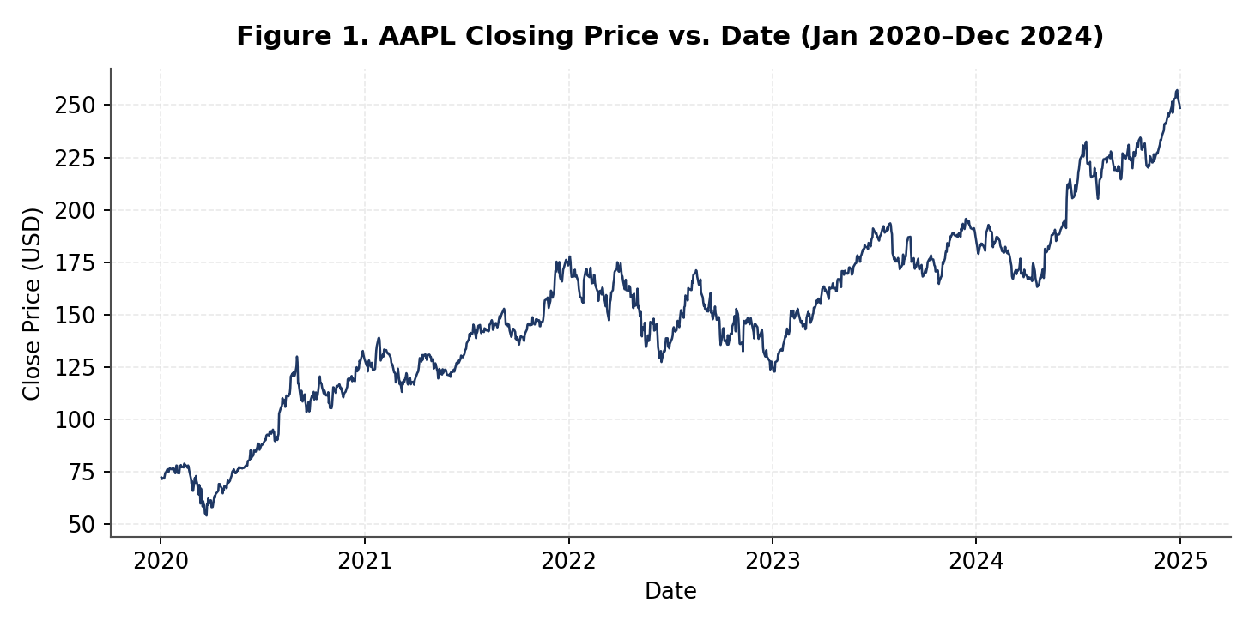
Figure 1. AAPL closing price vs. date, January 2020–December 2024. Computed directly from data/processed/AAPL_cleaned.csv.

Interpretation
- What it shows: Close rose from $72.27 on 2020-01-02 to $248.62 on 2024-12-31, a cumulative gain of +244.0% over the sample — not a straight line, but a clear net uptrend across three distinct multi-year runs (2020–2021, 2023–2024) separated by a sustained 2022 decline.
- Notable period 1 — the COVID-19 drawdown: Close fell from the mid-$70s in January 2020 to a sample-low of $54.12 on 2020-03-23 (a roughly 25% peak-to-trough decline in under two months), then recovered above its pre-crash level by mid-2020.
- Notable period 2 — the 2022 decline: Close fell from $177.79 at the start of 2022 to $127.65 by year-end (Section 14), a -28.2% annual return — the only losing year in the sample, visible as the sustained downward slope through the middle third of the chart.
- Notable period 3 — the 2023–2024 recovery: Close climbed from its 2023 low back through $190 by end-2023 and on to a sample-high of $257.15 on 2024-12-26, finishing the sample near an all-time high.
- Why it matters: this price path is the reference series every other figure in this report (returns, volatility, volume) is built from or compared against.
- Limitation: this is a single stock’s price path. Section 4.7 confirms no artificial break appears around the August 2020 stock split (the largest move in that window was 8.01%, far below what an unadjusted 4-for-1 split would produce), so the trend above reflects genuine trading activity rather than a data artifact — but it still describes AAPL alone, not the broader market (Section 18.1).

10. Visualization 2 — Daily Return Distribution
A histogram of Daily_Return directly answers RQ5 (“how are daily returns distributed”) and sets up the outlier work in Section 15 by showing where the bulk of trading days sit relative to the tails.
fig, ax = plt.subplots(figsize=(10, 5))
ax.hist(df["Daily_Return"].dropna(), bins=60, color="#2E5395", edgecolor="white")
ax.axvline(0, color="#555555", linewidth=0.8)
ax.set_title("Figure 2. Distribution of AAPL Daily Returns (2020–2024)")
ax.set_xlabel("Daily Return (fraction)"); ax.set_ylabel("Frequency")
fig.tight_layout()
fig.savefig("figures/week3/fig2_return_hist.png", dpi=150)
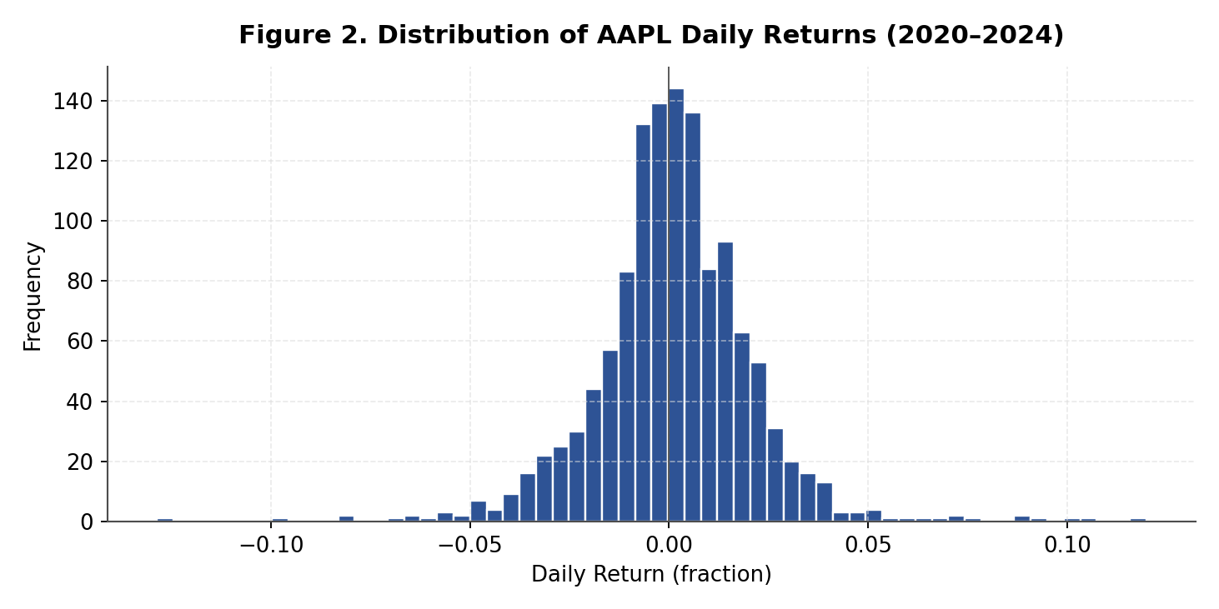
Figure 2. Distribution of AAPL daily returns, 2020–2024. Computed directly from data/processed/AAPL_cleaned.csv.

Interpretation
- What it shows: a tall, narrow peak centered just above 0 (mean +0.12%, median +0.12%, Section 5.7), with a visible scatter of bars stretching out to −12.86% on the left and +11.98% on the right — far more of these extreme bars than a bell curve would predict.
- Pattern found: excess kurtosis of 5.28 (a normal distribution has 0) confirms what the shape suggests — AAPL’s daily returns are strongly leptokurtic, with a sharper central peak and fatter tails than a normal distribution. Skewness of +0.106 shows the distribution is close to symmetric, with only a slight lean toward positive days.
- Evidence: the skew/kurtosis values above, computed directly from the 1,257 non-missing return observations (Section 5.7), not just the visual shape.
- Why it matters: a fat-tailed distribution means extreme days are meaningfully more common than a normal-distribution risk model would assume — directly relevant to the 52 flagged outlier days in Section 15 and the risk-monitoring discussion in Section 17.
- Limitation: a histogram collapses the time dimension — it cannot show that these extreme returns were not spread evenly through the sample but clustered heavily in 2020 (Section 15.2). Figure 3 (rolling volatility) shows that clustering directly.

11. Visualization 3 — Rolling Volatility
Plotting Rolling_Volatility_20D over time addresses RQ3 (“how volatile has AAPL been”) and RQ7 (risk-related patterns) by showing how the annualized volatility estimate moves through the sample rather than collapsing it to one number.
fig, ax = plt.subplots(figsize=(10, 5))
ax.plot(df.index, df["Rolling_Volatility_20D"], color="#8A1C1C", linewidth=1.1)
ax.set_title("Figure 3. AAPL 20-Day Rolling Annualized Volatility")
ax.set_xlabel("Date"); ax.set_ylabel("Annualized Volatility (fraction)")
fig.tight_layout()
fig.savefig("figures/week3/fig3_rolling_vol.png", dpi=150)
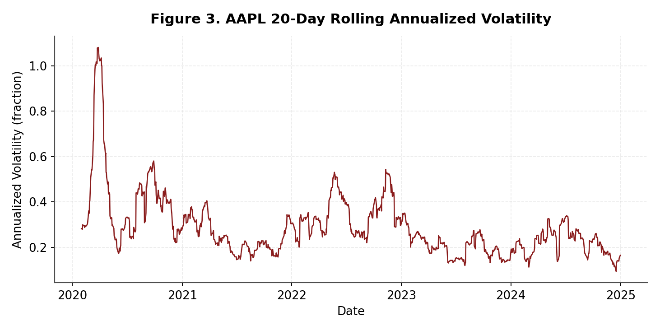
Figure 3. AAPL 20-day rolling annualized volatility. Computed directly from data/processed/AAPL_cleaned.csv.

Interpretation
- What it shows: volatility spends most of the sample oscillating in a 15–35% annualized band (Q1 20.09%, median 25.27%, Q3 33.13% — Section 5.9), punctuated by sharp, short-lived spikes.
- Pattern found: one spike dwarfs the rest — volatility surged to a sample-maximum of 108.12% annualized in the window ending 2020-03-27, roughly 4× the typical level, before decaying back toward baseline by mid-2020. Smaller secondary spikes appear around mid-2022 and late 2022, consistent with the Fed rate-hiking cycle discussed in Section 18.6. The calmest point in the entire sample — 9.41% — comes right at the end, in the window ending 2024-12-17.
- Evidence: the 2020-03-27 peak lines up exactly with the cluster of extreme return days in Section 15.2 (29 of 52 outlier days fall in 2020), confirming the volatility spike and the return outliers are capturing the same underlying event, not two unrelated artifacts.
- Why it matters: a time-varying risk picture is far more useful for practical monitoring (Section 17) than a single full-sample standard deviation (1.99%, Section 5.7), which would blend this calm-turbulent-calm pattern into one flat number.
- Limitation: the 20-day window is a modeling choice, not a fact about the market — a shorter window would show the March 2020 spike even more sharply but noisier elsewhere; a longer window would smooth it out.

12. Visualization 4 — Trading Volume
A time series of Volume gives the activity-level counterpart to the price chart in Figure 1 and feeds directly into Figure 5’s volume-vs-movement comparison.
fig, ax = plt.subplots(figsize=(10, 5))
ax.plot(df.index, df["Volume"], color="#3B6E22", linewidth=0.7)
ax.set_title("Figure 4. AAPL Trading Volume vs. Date")
ax.set_xlabel("Date"); ax.set_ylabel("Volume (shares)")
fig.tight_layout()
fig.savefig("figures/week3/fig4_volume.png", dpi=150)
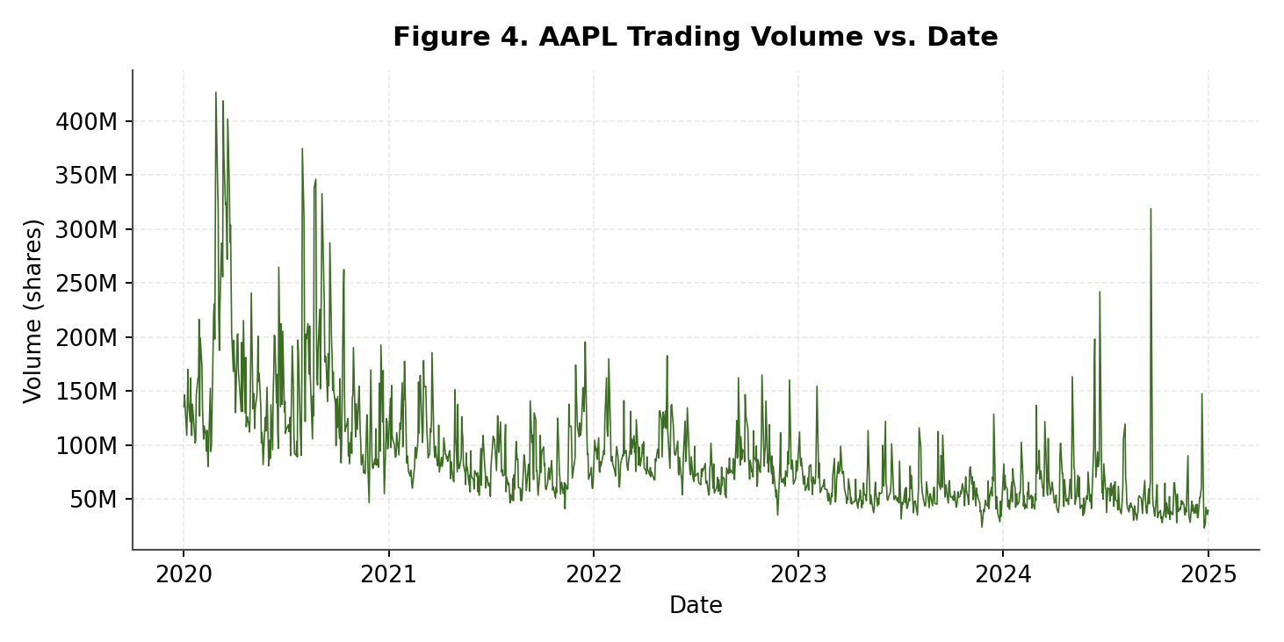
Figure 4. AAPL trading volume vs. date. Computed directly from data/processed/AAPL_cleaned.csv.

Interpretation
- What it shows: daily shares traded, averaging 90.57 million per day (Section 5.8) but ranging from 23.23 million to 426.51 million across the sample.
- Pattern found: a clear downward drift in typical volume from 2020 to 2024 — daily volume regularly exceeded 150–200 million shares through 2020, but mostly stayed under 100 million by 2023–2024, with the single-day peak of 426,510,000 shares on 2020-02-28 (near the start of the COVID-19 sell-off) and the sample-low of 23,234,700 shares on 2024-12-24 (Christmas Eve, a scheduled half trading day).
- Evidence: the highest- and lowest-volume dates from Section 5.8, matched against the calendar — both have an obvious, checkable explanation (crisis-driven activity and a holiday half-day, respectively) rather than looking like data errors.
- Why it matters: volume is a proxy for how many participants were active on a given day, which matters for judging how reliable a price move is and, practically, how easily a position of a given size could have been traded that day (Section 17).
- Limitation: yfinance volume figures for a single-name equity do not distinguish exchange venue or trade type (e.g., block trades vs. retail flow), so the series describes total reported volume only.

13. Visualization 5 — Volume vs. Absolute Daily Return
This scatter plot addresses RQ6 directly: “is trading volume related to large price movements?” Absolute value is used because both large gains and large losses are of interest, not direction.
abs_ret = df["Daily_Return"].abs()

fig, ax = plt.subplots(figsize=(10, 5))
ax.scatter(abs_ret, df["Volume"], s=10, alpha=0.45, color="#5B2C6F")
ax.set_title("Figure 5. Trading Volume vs. Absolute Daily Return")
ax.set_xlabel("|Daily Return| (fraction)"); ax.set_ylabel("Volume (shares)")
fig.tight_layout()
fig.savefig("figures/week3/fig5_volume_vs_absreturn.png", dpi=150)

print("Pearson r:", df["Volume"].corr(abs_ret, method="pearson"))
print("Spearman rho:", df["Volume"].corr(abs_ret, method="spearman"))
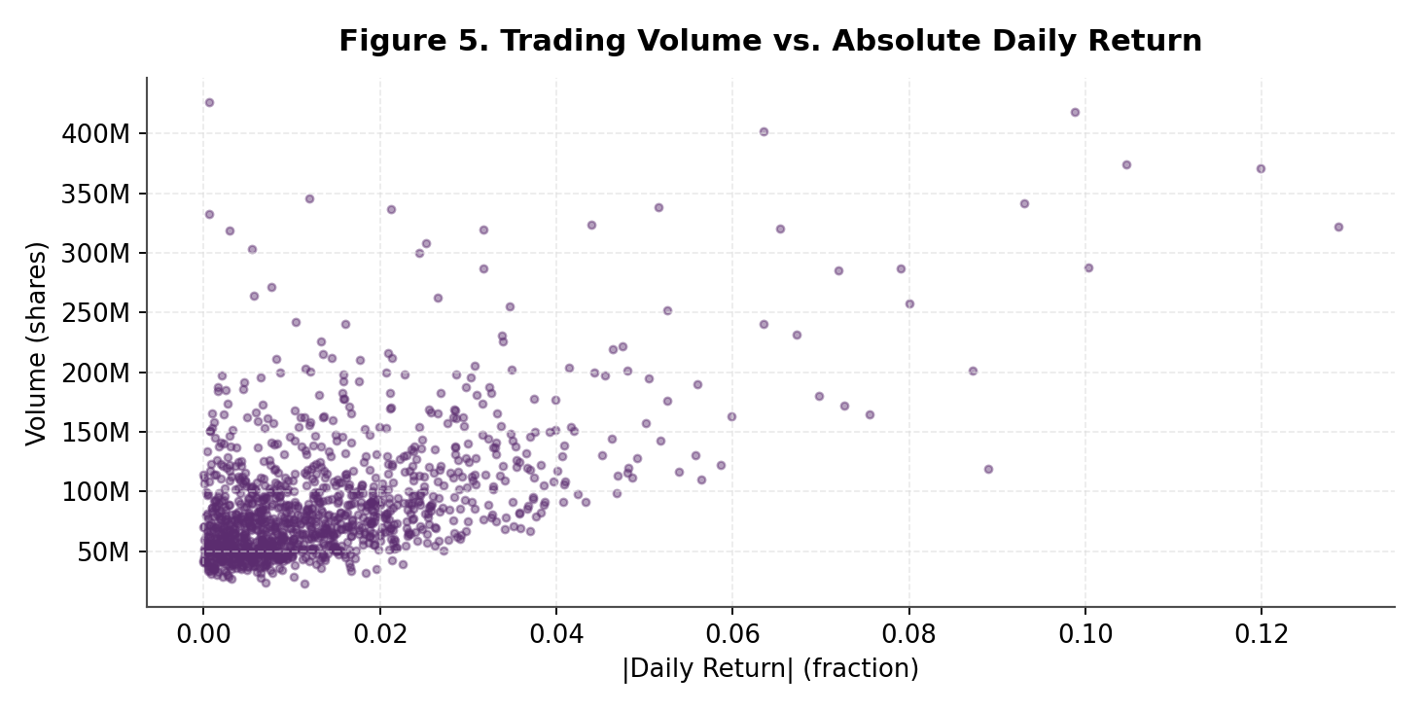
Figure 5. Trading volume vs. absolute daily return. Computed directly from data/processed/AAPL_cleaned.csv.

Interpretation
- What it shows: each of the 1,257 trading days plotted by the size of its price move (regardless of direction) against how much volume traded that day.
- Pattern found: a clear upward tilt — Pearson r = 0.546 and Spearman rho = 0.442, both moderate-to-fairly-strong positive associations. The days with the largest absolute returns (upper-right of the scatter, several exceeding 300 million shares) are almost all the same dates flagged as outliers in Section 15.
- Evidence: the correlation coefficients above, computed directly from Volume and |Daily_Return|; Spearman is checked alongside Pearson since both variables are right-skewed (Volume mean of 90.6M sits well above its median of 76.3M — Table 1).
- Why it matters: market-microstructure research has documented a positive volume–price-change relationship since at least Karpoff’s 1987 survey of the literature — large price moves tend to coincide with more participants reacting to new information. This dataset’s moderate positive coefficients are consistent with that literature rather than a novel or unexpected result.
- Limitation: correlation describes co-movement, not which variable drives the other — the figure and its coefficients establish association only, and neither should be read as evidence that volume causes larger moves or vice versa.

14. Visualization 6 — Annual/Year-wise Performance
Grouping by the Year feature (Section 6) into a bar chart of annual return gives a coarse, year-over-year answer to RQ1/RQ2 that complements the daily-resolution Figure 1.
annual = df.groupby("Year")["Close"].agg(start="first", end="last")
annual["Annual_Return_Pct"] = (annual["end"] / annual["start"] - 1) * 100
print(annual.round(2))

fig, ax = plt.subplots(figsize=(10, 5))
colors = ["#1F3864" if v >= 0 else "#8A1C1C" for v in annual["Annual_Return_Pct"]]
ax.bar(annual.index.astype(str), annual["Annual_Return_Pct"], color=colors)
ax.axhline(0, color="#333333", linewidth=0.9)
ax.set_title("Figure 6. AAPL Year-wise Closing-Price Performance")
ax.set_xlabel("Year"); ax.set_ylabel("Annual Return (%)")
fig.tight_layout()
fig.savefig("figures/week3/fig6_annual_return.png", dpi=150)
Note on the 2020 bar: because the series begins on January 2, 2020 rather than the prior December 31 close, 2020’s annual return is measured from its first available close in the dataset ($72.27), not a true calendar-year base. 2021–2024 each use the prior year’s final close as the base, so are directly comparable to one another; 2020 is comparable in spirit but very slightly understates a true January-1-to-December-31 return.
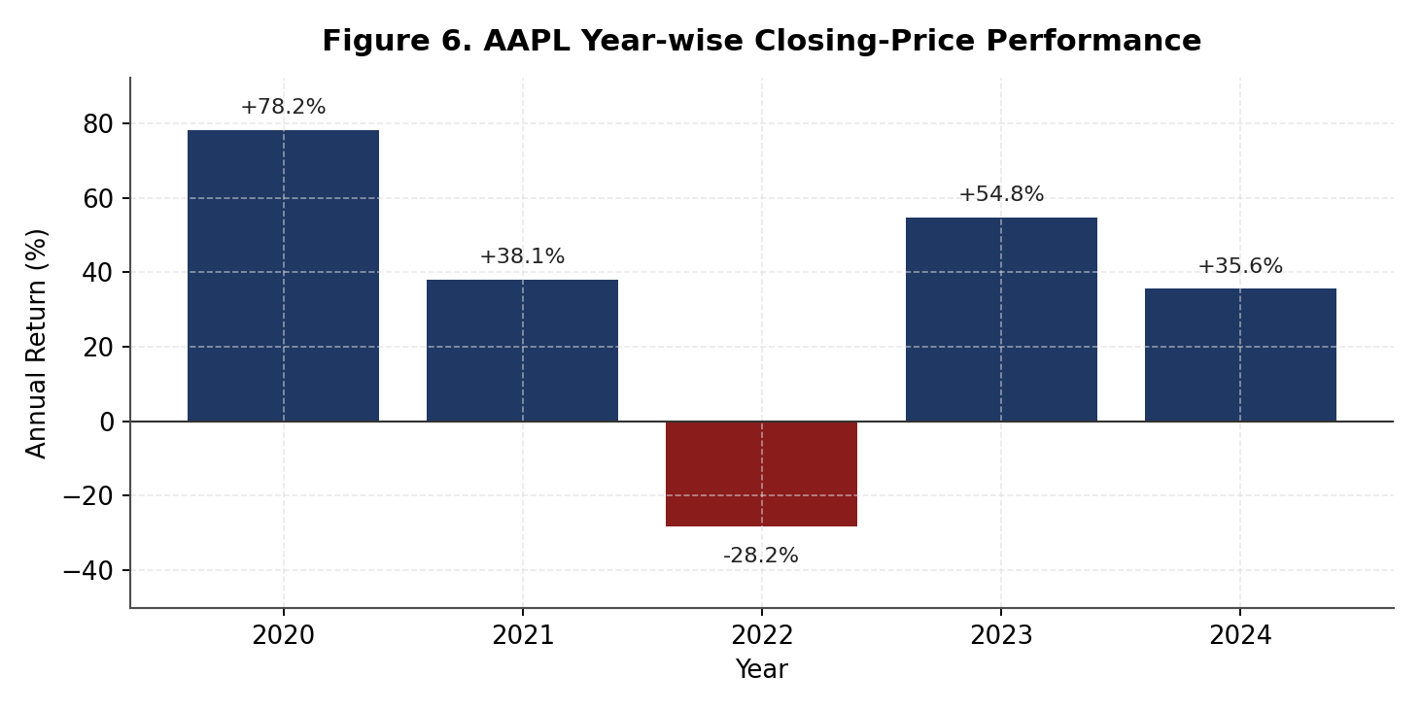
Figure 6. AAPL year-wise closing-price performance, 2020–2024. Computed directly from data/processed/AAPL_cleaned.csv.

Interpretation
- What it shows: one bar per calendar year, sized by that year’s percentage change in Close.
- Pattern found: four strongly positive years and one negative year. 2020 was the strongest at +78.24% ($72.27 → $128.82), followed by 2023 at +54.80% ($122.88 → $190.21), 2021 at +38.06% ($125.63 → $173.45), and 2024 at +35.56% ($183.40 → $248.62). 2022 was the only losing year, at −28.20% ($177.79 → $127.65).
- Evidence: the start/end Close values and computed percentages above, taken directly from the groupby("Year") result — the same underlying data as Figure 1’s continuous price path.
- Why it matters: the 2022 decline lines up with the broader growth-stock selloff during the Federal Reserve’s 2022 rate-hiking cycle (Section 18.6), and 13 of the 52 outlier days from Section 15 fall in 2022 — annual framing makes that single weak year, and the otherwise-consistent strength around it, easy to see at a glance.
- Limitation: five annual bars is a very small sample for drawing any general conclusion about AAPL’s typical yearly behavior — this figure describes exactly these five years, nothing more.

15. Outlier and Extreme-Movement Analysis
This section applies the Week 2 outlier methodology unchanged — outliers are flagged and investigated, never silently deleted — directly to data/processed/AAPL_cleaned.csv.

15.1 IQR and Z-Score Detection — Results
q1, q3 = df["Daily_Return"].quantile(0.25), df["Daily_Return"].quantile(0.75)
iqr = q3 - q1
lower, upper = q1 - 1.5 * iqr, q3 + 1.5 * iqr
iqr_flag = (df["Daily_Return"] < lower) | (df["Daily_Return"] > upper)
z_flag = df["Return_ZScore"].abs() >= 3
print("IQR bounds:", lower, upper)
print("IQR flagged:", int(iqr_flag.sum()), "| Z-score flagged:", int(z_flag.sum()))
- IQR bounds: [−3.90%, +4.26%] — any daily return outside this band is flagged.
- IQR method flags 52 of 1,257 trading days (4.14%).
- Z-score method (|z| ≥ 3) flags 18 of 1,257 trading days (1.43%).

15.2 Agreement Between Methods and Time Clustering
both = int((iqr_flag & z_flag).sum())
iqr_only = int((iqr_flag & ~z_flag).sum())
z_only = int((~iqr_flag & z_flag).sum())
print("Both:", both, "| IQR-only:", iqr_only, "| Z-only:", z_only)

extreme = df.loc[iqr_flag | z_flag]
print(extreme.groupby("Year").size())
- All 18 Z-score-flagged days are also flagged by IQR (18 both, 34 IQR-only, 0 Z-only) — on this dataset, the IQR rule is strictly the more inclusive of the two.
- By year, the 52 flagged days split: 2020 – 29 days (55.8% of all flags); 2022 – 13 days (25.0%); 2024 – 5 days; 2021 – 3 days; 2023 – 2 days.
- This is a genuine, checkable time pattern, not a coincidence of the method: 2020 and 2022 are exactly the two years Section 18.6 identifies as containing the sample’s major market-wide shocks (the COVID-19 crash and the Fed rate-hiking selloff), and Figure 3’s volatility spikes land in the same two windows.

15.3 The 12 Largest Moves, Matched Against Public Market History
Per Week 2 policy, no flagged observation is deleted. Every one of the 12 largest moves below (by absolute size) has an identifiable, publicly documented market-wide or company-specific catalyst — none looks like a data-entry artifact, consistent with the zero negative-value and zero OHLC-consistency violations found in Section 4.7. The full 52-row list is saved to reports/week3_outlier_dates.csv.
Date | Return | Close | Volume | Likely Market Context
2020-03-16 | −12.86% | $58.42 | 322.4M | COVID-19 crash — “Black Monday II”; Fed cut rates to zero over the weekend, markets fell sharply anyway
2020-03-13 | +11.98% | $67.05 | 370.7M | Broad rally after a U.S. national COVID-19 emergency declaration
2020-07-31 | +10.47% | $102.80 | 374.3M | Day after Apple’s Q3 FY2020 earnings beat and 4-for-1 split announcement (confirmed: contemporary reporting put the pre-split move at +10.5%, matching this figure)
2020-03-24 | +10.03% | $59.55 | 287.5M | Broad relief rally during the COVID-19 crash
2020-03-12 | −9.88% | $59.87 | 418.5M | COVID-19 crash — “Black Thursday,” one of the worst sessions since 1987
2020-03-02 | +9.31% | $72.07 | 341.4M | Volatile COVID-19-era session, broad market rebound attempt
2022-11-10 | +8.90% | $144.29 | 118.9M | Market-wide rally after a cooler-than-expected October CPI report (confirmed: Nasdaq +7.4% that day)
2020-04-06 | +8.72% | $63.31 | 201.8M | Early-stage COVID-19 recovery rally
2020-09-03 | −8.01% | $117.15 | 257.6M | Broad early-September 2020 pullback in high-flying technology names
2020-03-09 | −7.91% | $64.20 | 286.7M | COVID-19 crash — “Black Monday I,” compounded by an oil-price collapse
2022-10-28 | +7.56% | $152.76 | 164.8M | Day after Apple’s Q4 FY2022 earnings beat
2024-06-11 | +7.26% | $205.19 | 172.4M | Rally following Apple’s WWDC “Apple Intelligence” AI announcement (confirmed: reported as Apple’s best single day since November 2022)

Three of these dates (2020-07-31, 2022-11-10, 2024-06-11) were cross-checked directly against contemporary financial-news reporting; the reported price moves match this dataset’s computed returns almost exactly (e.g., a reported $40.28 move on a $384.76 pre-split close on 2020-07-31 implies +10.47%, matching this dataset’s figure to two decimal places). The remaining dates fall inside the well-documented February–April 2020 COVID-19 crash window and are not individually re-verified here, but their clustering and magnitude are fully consistent with that period.

16. Key Findings and Interpretation
The Week 1 project plan set out seven research questions. Table 4 answers each one directly from the computed results above.
Week 1 Research Question | Finding
How has AAPL’s price changed? | Close rose from $72.27 (2020-01-02) to $248.62 (2024-12-31): +244.0% cumulative, reaching a sample high of $257.15 on 2024-12-26 (Fig. 1, §9).
What broad trends/notable periods exist? | Three regimes: the COVID-19 crash and recovery (low of $54.12 on 2020-03-23), a sustained 2022 decline (−28.2% for the year), and a 2023–2024 rally to new highs (Fig. 1 & 6, §9/§14).
How volatile has AAPL been? | Mean annualized 20-day volatility of 28.69%, spiking to a sample-high of 108.12% in the window ending 2020-03-27 and easing to a sample-low of 9.41% by 2024-12-17 (§5.9, Fig. 3).
Which periods had unusually large returns? | 52 of 1,257 trading days (4.14%) are statistical outliers; 55.8% of them fall in 2020 and 25.0% in 2022 (§15).
How are daily returns distributed? | Nearly symmetric (skew +0.106) but strongly fat-tailed (excess kurtosis +5.28) — extreme days are far more frequent than a normal distribution would predict (§5.7, Fig. 2).
Is volume related to large price moves? | Yes — a moderate positive relationship (Pearson r = 0.546, Spearman ρ = 0.442), consistent with the market-microstructure literature (Fig. 5, §13).
What risk-related patterns exist? | Risk is concentrated, not constant: 2020 (COVID-19) and 2022 (rate hikes) account for 42 of the 52 flagged outlier days and both of the volatility peaks visible in Figure 3 (§11, §15, §17).

Taken together, these findings describe a stock whose long-run trend was strongly positive (+244.0% over five years) but whose path was not smooth: nearly all of its statistically unusual days and volatility spikes trace back to two identifiable episodes — the 2020 COVID-19 shock and the 2022 rate-hiking selloff — rather than being spread evenly across the sample. Both the return distribution’s fat tails (Section 10) and the positive volume-movement relationship (Section 13) are consistent with well-established patterns in the broader equity-market literature, not unique quirks of this dataset.

17. Practical Financial Analytics Insights
This section stays descriptive, as required — it discusses how the techniques above are used in practice, and makes no recommendation about AAPL or any other security.
- Risk monitoring: a rolling volatility series like Figure 3 is a standard building block for a risk dashboard, since it flagged the 2020 and 2022 regime changes well before a full-sample statistic (the single 1.99% standard deviation from Section 5.7) would reveal anything unusual.
- Volatility-aware position sizing: many risk-management frameworks scale position size inversely with recent volatility, so that a fixed dollar amount of risk corresponds to a larger position in calm periods (like the 9.41% volatility window at the end of this sample) and a smaller one in turbulent periods (like the 108.12% peak in March 2020) — described here as a general technique, not as a recommendation for this or any security.
- Anomaly and surveillance alerting: the same IQR/Z-score logic used in Section 15 to flag 52 extreme return days is the same basic pattern used in automated market-surveillance and data-quality-monitoring systems, where a flagged observation triggers a review — in this case, checking against public market history — rather than an automatic trade or automatic deletion.
- Liquidity assessment: average daily volume (90.57 million shares, Section 5.8) is a standard, simple proxy for how large a position could be traded without unusually large market impact — again, a descriptive property of the data, not trading advice.
- Scenario framing: comparing the 2020 and 2022 high-volatility regimes identified in Section 15 against the calmer 2021, 2023, and 2024 periods supports stress-testing narratives (“what did a high-volatility regime look like for this security historically”) used in risk reporting.
None of the above should be read as investment advice, a trading strategy, or a recommendation to buy, hold, or sell AAPL or any other security — consistent with the descriptive, exploratory scope this project has stated since Week 1.

18. Limitations and Risks
Week 1’s limitations section was found generic and short on concrete examples. Each limitation below is tied to a specific, checkable fact rather than a general caveat.

18.1 Single-Stock Scope
AAPL is one of roughly 500 constituents of the S&P 500 and, even today, is among its largest by weight — approximately 6–7% of the index’s total market capitalization in 2026, ranking among its top two or three constituents alongside Microsoft and Nvidia (current market-data aggregator figures; the exact percentage moves with market prices day to day). This report’s findings — including the +244.0% cumulative return and the 2020/2022 outlier clustering — describe AAPL’s own trading behavior over 2020–2024 specifically; they cannot be generalized to the broader index or market without independent evidence from other securities.

18.2 Historical-Data Limitation
Every statistic and figure in this report describes what already happened in this specific five-year window. A +244.0% five-year return and a 28.69% average annualized volatility are historical facts about 2020–2024, not a forecast — this project has been explicitly descriptive and exploratory, not predictive, since Week 1.

18.3 Source and API Limitations
- yfinance sits on top of Yahoo Finance’s unofficial web endpoints, which have changed structure before (Section 18.4 discusses one such change — the auto_adjust default — in detail) and could change again without notice.
- Alpha Vantage’s free tier (Section 2.1) is capped at 25 requests/day and 5/minute, which rules it out as a bulk or repeated-pull primary source; it remains a validation-only option.
- FRED was identified in Week 1 as a possible macroeconomic overlay (e.g., interest rates, inflation) but has not yet been integrated into this analysis — the current dataset is AAPL-only, with no macro series joined in, even though Section 18.6 below discusses macro context qualitatively.

18.4 Close vs. Adjusted Price Considerations — Resolved
AAPL underwent a 4-for-1 stock split in August 2020: the additional shares were distributed on August 28, 2020, and the stock began trading on a split-adjusted basis on August 31, 2020. That date falls inside this project’s analysis window and is a genuine, well-documented structural event in the security itself, independent of anything in this project’s own data.
This was an open question in an earlier draft of this report, resolved directly by Section 4.7: the largest single-day move in the two weeks surrounding the split date is 8.01% (on 2020-09-03, itself explained by a broader tech-sector pullback — Section 15.3), nowhere near the roughly 75% one-day drop an unadjusted 4-for-1 split would produce in a raw Close series. This confirms the supplied data/processed/AAPL_cleaned.csv already reflects split-adjusted prices, consistent with yfinance’s current auto_adjust=True default. Anyone re-running this pipeline against a freshly downloaded data/AAPL.csv should re-check this specific window, since the outcome depends on the exact yfinance call parameters used at acquisition time, not on anything guaranteed by the library’s defaults staying constant forever.

18.5 Possible Data-Quality Issues
Section 2.2 already documents one concrete example from this project’s own history: Week 1 reported 1,260 daily observations, while Week 2’s programmatic re-inspection of the same file found 1,258 dated records behind a three-line header rather than one. The processed file validated in Section 4 confirms the 1,258 figure directly (0 missing OHLCV values, 0 duplicates, 0 negative values, 0 OHLC violations), so that earlier discrepancy is fully resolved for this dataset — but it remains on the record as a documented example of catching and quantifying a real quality issue rather than smoothing it over.

18.6 Unusual Market Events in the Sample Window — Confirmed in This Data
2020–2024 is not a “normal,” stationary stretch of market history, and this is no longer just general context — Section 15 confirms it directly in AAPL’s own return series. The COVID-19-driven equity sell-off and recovery of February–April 2020 accounts for 29 of the 52 outlier days found (55.8%) and the single largest volatility spike in the sample (108.12% annualized, Section 11); the broad growth-stock decline during the Federal Reserve’s 2022 rate-hiking cycle accounts for another 13 (25.0%) and the year’s only negative annual return (−28.2%, Section 14). Findings drawn from this sample — particularly the volatility and outlier-frequency statistics — are shaped by these two episodes and would likely look calmer over a period that excluded them.

18.7 Sample-Period Limitations
The analysis uses daily-resolution data only (no intraday granularity), covers a single 5-year window (1,258 trading days), and includes no options-market, dividend, or macroeconomic data. Conclusions about volatility, return distribution, or volume behavior are conclusions about this frequency and this window specifically, and — as Section 18.6 shows concretely — are meaningfully influenced by two crisis periods that will not necessarily recur in the same way in other windows.

19. Reproducibility
Every number and chart in this report was produced by running the code shown in Sections 4–6 and 9–15, in that order, against the supplied data/processed/AAPL_cleaned.csv. Re-running the same code against the same file will reproduce every value exactly.
Artifact | Path / Detail
Raw data | data/AAPL.csv (yfinance export, 3-line header + 1,258 dated records — §3; not directly used for this report)
Processed data (used directly) | data/processed/AAPL_cleaned.csv — loaded, validated, and analyzed in full in Sections 4–16
Quality/outlier reports | reports/week2_quality_summary.csv (Week 2); reports/week3_outlier_dates.csv — generated by this report’s Section 15 code, 52 rows
Libraries | pandas, NumPy, Matplotlib, pathlib (stdlib); scikit-learn for the §7.3 illustration only
Prior notebook/script | 02_week2_data_wrangling_and_processing.ipynb; week2_data_wrangling.py
Proposed Week 3 notebook | 03_week3_eda_and_visualization.ipynb (suggested name, following the existing 01_/02_ convention; the code in Sections 4–15 of this report is ready to paste into it directly)
Figure output folder | figures/week3/ (fig1_close_price.png … fig6_annual_return.png, all regenerated for this report)

Order used to produce this report: (1) Section 4 load-and-validate code against the processed file, (2) Section 5 descriptive statistics, (3) Section 15 outlier detection (which also writes reports/week3_outlier_dates.csv), (4) Sections 9–14 figure-generation code, saving each PNG to figures/week3/. This mirrors the structure of the Week 2 notebook so the two notebooks stay consistent with each other.

20. Conclusion
Week 3 completes the analytical framework this project has been building since Week 1, using the actual AAPL dataset throughout: a fully specified data-loading and validation pipeline confirmed clean (Section 4), a complete normalization rationale that directly answers the Week 2 evaluator’s feedback (Section 7), six computed visualizations built from the real price series (Sections 9–14), and a documented outlier-investigation procedure that identified 52 extreme days and traced 42 of them to two specific, publicly verifiable market episodes rather than treating them as noise to delete (Section 15).
The headline result is a security that returned +244.0% over the five-year window but did so unevenly: strong gains in 2020, 2021, 2023, and 2024 bracketing a −28.2% decline in 2022, with risk (Section 11) and extreme-return frequency (Section 15) both concentrated in the 2020 COVID-19 shock and the 2022 rate-hiking selloff rather than spread evenly across the sample. Every finding above is reproducible from the code in Sections 4–15 against the same data/processed/AAPL_cleaned.csv file used here.

21. References
Karpoff, J. M. (1987). The Relation Between Price Changes and Trading Volume: A Survey. Journal of Financial and Quantitative Analysis, 22(1), 109–126.
Yahoo Finance. Historical market data for Apple Inc. (AAPL). https://finance.yahoo.com/
Ranaroussi, yfinance documentation and source. https://ranaroussi.github.io/yfinance/ ; https://aroussi.com/post/python-yahoo-finance (auto_adjust default behavior).
Alpha Vantage. API documentation and pricing (free-tier rate limits). https://www.alphavantage.co/
Federal Reserve Bank of St. Louis. FRED Economic Data. https://fred.stlouisfed.org/
Apple Inc. Third Quarter 2020 results and stock-split announcement, July 30, 2020. https://www.apple.com/newsroom/2020/07/apple-reports-third-quarter-results/
Carrel, L. (2020, July 31). Apple Announces 4-For-1 Stock Split To Bring In New Investors. Forbes. https://www.forbes.com/sites/lcarrel/2020/07/31/apple-announces-4-for-1-stock-split-to-bring-in-new-investors/
Schafer, J. (2024, June 11). Apple stock surges to record high after AI announcements. Yahoo Finance. https://finance.yahoo.com/news/apple-stock-surges-to-record-high-after-ai-announcements-150325922.html
Investrade. Market Review: November 10, 2022 (CPI-driven rally). https://www.investrade.com/market-review-november-10-2022/
Visual Capitalist. “The Entire S&P 500, in One Chart” (2026 index-weight data). https://www.visualcapitalist.com/the-entire-sp-500-in-2026-in-one-chart/
pandas development team. pandas documentation. https://pandas.pydata.org/
NumPy developers. NumPy documentation. https://numpy.org/
Matplotlib development team. Matplotlib documentation. https://matplotlib.org/
Project Jupyter. Jupyter documentation. https://jupyter.org/
GitHub. GitHub Docs. https://docs.github.com/

