

PROJECT REPORT

Student Performance Analysis and Feedback System
https://github.com/harshvardhantailor/AIML-project-vityarthi.git
Fundamentals in ai and ml (CSA2001)

BY Harshvardhan tailor (25BCE10948)

suneet joshi sir
Faculty

INTRODUCTION
This report presents the development of a Student Performance Analysis and Feedback System, designed to help students evaluate their academic performance in a structured and meaningful way. The system is implemented using Python and utilizes libraries such as Matplotlib, NumPy, and Statistics for data processing and visualization.
The application allows users to input subject-wise marks and class averages, calculates CGPA, analyzes performance, and provides personalized feedback. Additionally, it generates a graphical representation to visually compare individual performance with class averages.

PROBLEM STATEMENT
Students often lack a clear understanding of how their academic performance compares with their peers. Without proper analysis, it becomes difficult to identify weak areas and improve effectively.
There is a need for a simple and efficient system that can:
· Calculate academic performance metrics such as CGPA
· Compare individual marks with class averages
· Provide meaningful and personalized feedback
· Visually represent performance for better understanding

REQUIREMENTS
Functional Requirements
· Accept subject names, individual marks, and class average marks as input
· Calculate grade points and CGPA
· Compute average marks using statistical methods
· Provide subject-wise feedback based on performance
· Compare performance with class average
· Predict overall performance level
· Identify weak subjects
· Generate graphical visualization of performance
Non-Functional Requirements
Reliability: The system produces accurate results and consistent outputs
Usability: The command-line interface is simple and easy to use
Maintainability: The code is modular and easy to understand
Efficiency: The system performs calculations and graph generation quickly

SYSTEM ARCHITECTURE
The system follows a simple single-tier architecture:
· Input Layer: Takes user input for subjects, marks, and class averages
· Processing Layer: Performs calculations such as CGPA, averages, and feedback generation
· Output Layer: Displays results and visualizes data using graphs

DESIGN DECISIONS & RATIONALE

Python Choice: Selected for its simplicity and strong support for data analysis libraries
Matplotlib: Used for creating graphical visualizations of performance
NumPy: Used for handling numerical operations efficiently
Statistics Module: Used to calculate mean values for performance analysis
Rule-Based Logic: Implemented to generate personalized feedback and performance prediction based on predefined conditions
Grouped Bar Graph: Chosen instead of stacked graphs to provide a clear comparison between individual marks and class averages

IMPLEMENTATION DETAILS
The system is implemented using a modular approach:
· calculate_grade_point(): Converts marks into grade points
· main(): Handles input, processing, and output
applies The program collects subject-wise data, calculates CGPA and averages, and rule-based logic to generate feedback and predictions.
A grouped bar chart is created to visually compare individual marks with class averages, with a fixed scale from 0 to 100 for accuracy.

RESULTS
The system successfully performs the following:
· Calculates CGPA based on grade points
· Computes average marks and compares with class average
· Provides subject-wise personalized feedback
· Predicts overall performance level
· Identifies weak subjects needing improvement
· Generates a bar graph comparing marks
Example Outcome:
· If a student scores higher than the class average, the system indicates above-average performance
· Subjects where marks are lower than class average are highlighted for improvement
Screenshot of output attached : 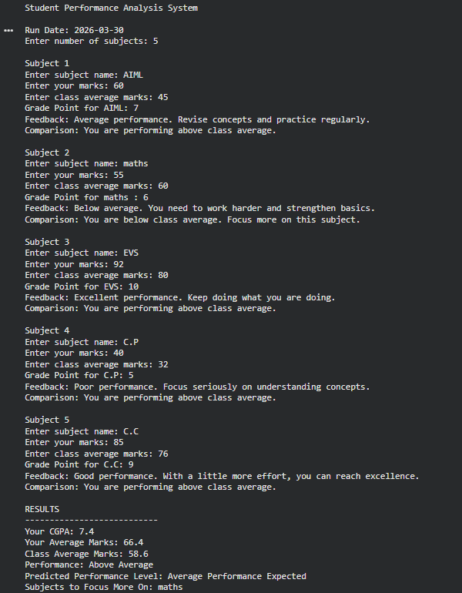
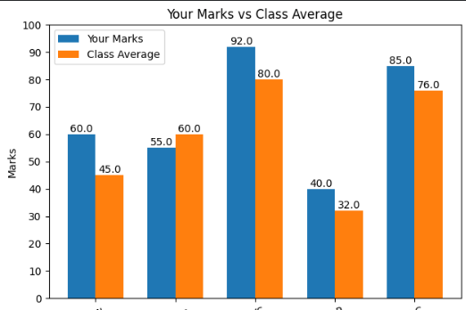

LEARNINGS & KEY TAKEAWAYS
· Gained understanding of data analysis and visualization techniques
· Learned how to use Python libraries for real-world applications
· Understood the importance of statistical measures like mean
· Implemented rule-based decision systems for feedback generation
· Improved problem-solving and logical thinking skills
FUTURE ENHANCEMENTS
· Integration of machine learning models for prediction
· Storage of data using files or databases
· Development of a graphical user interface (GUI)
· Tracking performance over time for trend analysis

Repository link : https://github.com/harshvardhantailor/AIML-project-vityarthi.git

