# Hands On with NodeJs

1. Install Nodejs to set up the project environment.

**OUTPUT :**

1. Create a function expression in node js to count the number of items in an array.

**OUTPUT :**

1. Create a module that contains three functions and export the same using nodejs.

**OUTPUT :**

1. Create a module to import the above created function and utilize it.

**OUTPUT :**

1. Create a server using http module and listen to port 3000.

**OUTPUT :**

1. Display three different users(Student, admin and default) html pages as per the requested url.

**OUTPUT :**

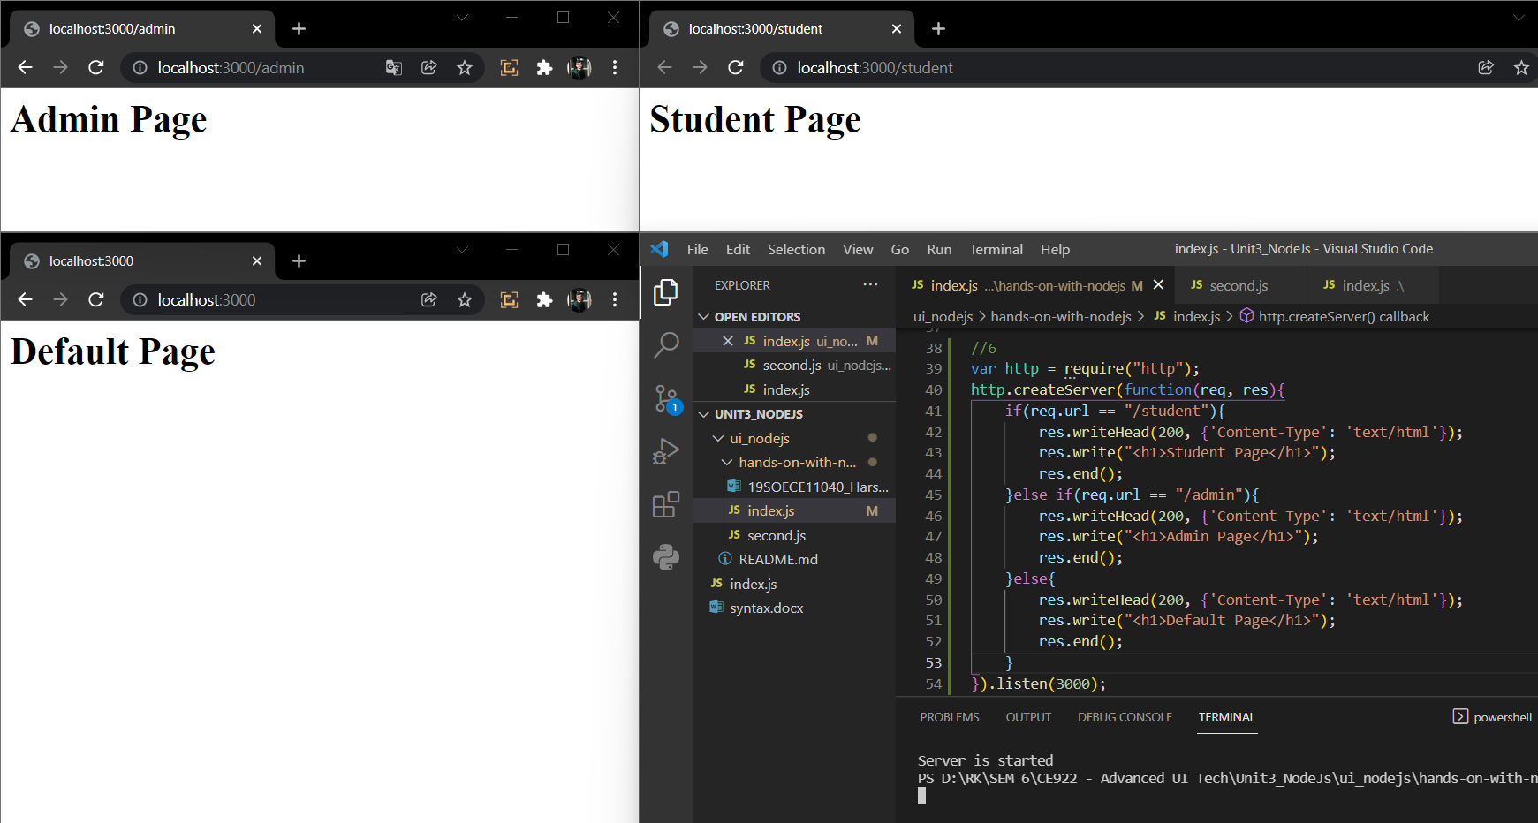

1. Create and import the class type object to display the full name of the user.

**OUTPUT :**

