Minor Project 2
Wine Style Segmentation for a Winery
Unsupervised Machine Learning — Clustering Wines by Chemical Composition

Approach: Unsupervised Learning (K-Means, Hierarchical Clustering, DBSCAN)
Dataset: UCI Machine Learning Repository — Wine Dataset (Aeberhard, Coomans & de Vel, 1991)
Dataset Link: https://archive.ics.uci.edu/dataset/109/wine
Submission Date: July 2026

1. Title
Wine Style Segmentation for a Winery: An Unsupervised Clustering Approach to Grouping Wines by Chemical Composition Without Labeled Data.

2. Problem Statement
A winery or wine distributor regularly receives large batches of wine that have been chemically analyzed in the laboratory — alcohol content, acidity, phenols, color intensity, and other measurable properties — but has no information about which style, cultivar, or quality tier each batch belongs to. There are no pre-assigned labels available at the time a new batch arrives.
Business objective: group incoming wine samples into meaningful chemical "families" (clusters) so that the winery can (a) design targeted marketing and pricing tiers without manually tasting every batch, (b) flag chemically unusual or outlier batches for manual quality review, and (c) understand which chemical properties drive the biggest differences between wine styles.
Because no ground-truth labels are available at decision time, this is naturally an unsupervised learning problem, and clustering is the appropriate family of techniques. This project deliberately picks a problem framing distinct from the common "customer segmentation" example, while following an identical rigorous unsupervised-learning workflow.
Note: the dataset used does include a cultivar label recorded by the original chemists. This label is deliberately withheld from every clustering model and is used only once, at the very end, purely as an external sanity check to see whether the discovered clusters correspond to a real, independently known grouping — mirroring real-world deployment where such labels are usually unavailable or too costly to collect.

3. Dataset Description
Source: UCI Machine Learning Repository — "Wine" dataset, originally contributed by Aeberhard, Coomans and de Vel (1991/1992), and accessed for this project via scikit-learn's sklearn.datasets.load_wine() (an offline, exact copy of the UCI dataset bundled for reproducibility).
Dataset link: https://archive.ics.uci.edu/dataset/109/wine
The dataset contains results of a chemical analysis of 178 wines grown in the same region of Italy but derived from three different grape cultivars. It has 13 numeric features and no missing values.
Feature | Description
alcohol | Alcohol content (%)
malic_acid | Malic acid concentration
ash | Ash content
alcalinity_of_ash | Alkalinity of ash
magnesium | Magnesium content
total_phenols | Total phenols
flavanoids | Flavanoid content
nonflavanoid_phenols | Non-flavanoid phenols
proanthocyanins | Proanthocyanin content
color_intensity | Color intensity
hue | Hue
od280/od315_of_diluted_wines | Protein content proxy (OD ratio)
proline | Proline (amino acid) content

For reference only (not used in training), the true cultivar distribution is: Cultivar 0 = 59 samples, Cultivar 1 = 71 samples, Cultivar 2 = 48 samples.

4. Data Preprocessing Steps
Missing values check: 0 missing values found across the entire dataset — no imputation was required.
Duplicate rows check: 0 duplicate rows found — no rows were removed.
Feature encoding: not required, since all 13 features are already numeric (no categorical columns are present).
Feature scaling: the 13 features are on very different numeric scales (e.g. proline ranges into the hundreds while hue is below 2). Because K-Means, Hierarchical clustering and DBSCAN all rely on Euclidean distance, features with larger numeric ranges would otherwise dominate the distance calculation. StandardScaler (zero mean, unit variance) was applied to every feature before modeling.
Outlier check: boxplots on the standardized data (Figure 3) revealed a small number of mild outliers (e.g. in malic_acid and color_intensity) but none extreme enough to be data-entry errors, so all 178 rows were retained.

5. Exploratory Data Analysis
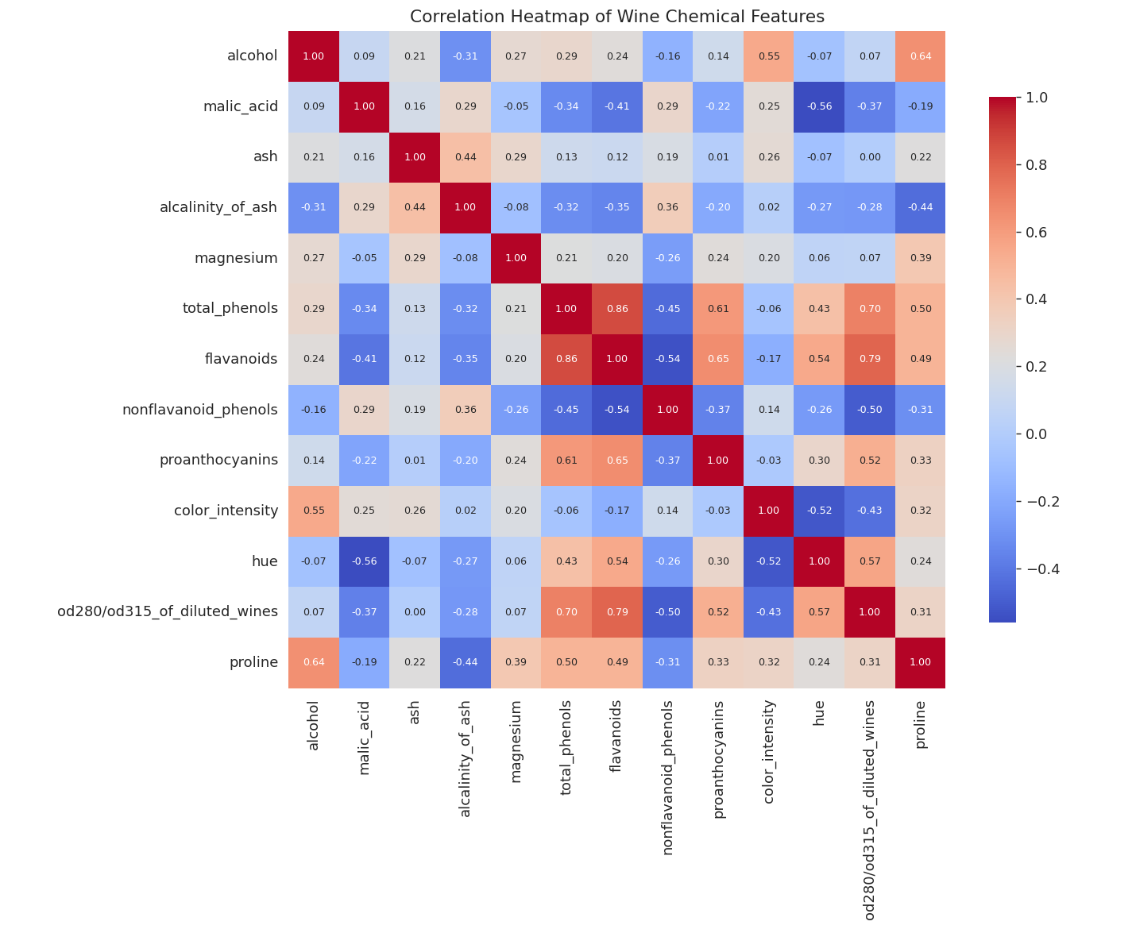
Figure 1. Correlation heatmap of the 13 chemical features.
flavanoids correlates strongly with total_phenols (both are phenolic compounds) and with od280/od315_of_diluted_wines. alcohol correlates with proline and color_intensity. These relationships suggest that a small number of underlying chemical "factors" drive most of the variation in the data — a good sign for clustering.
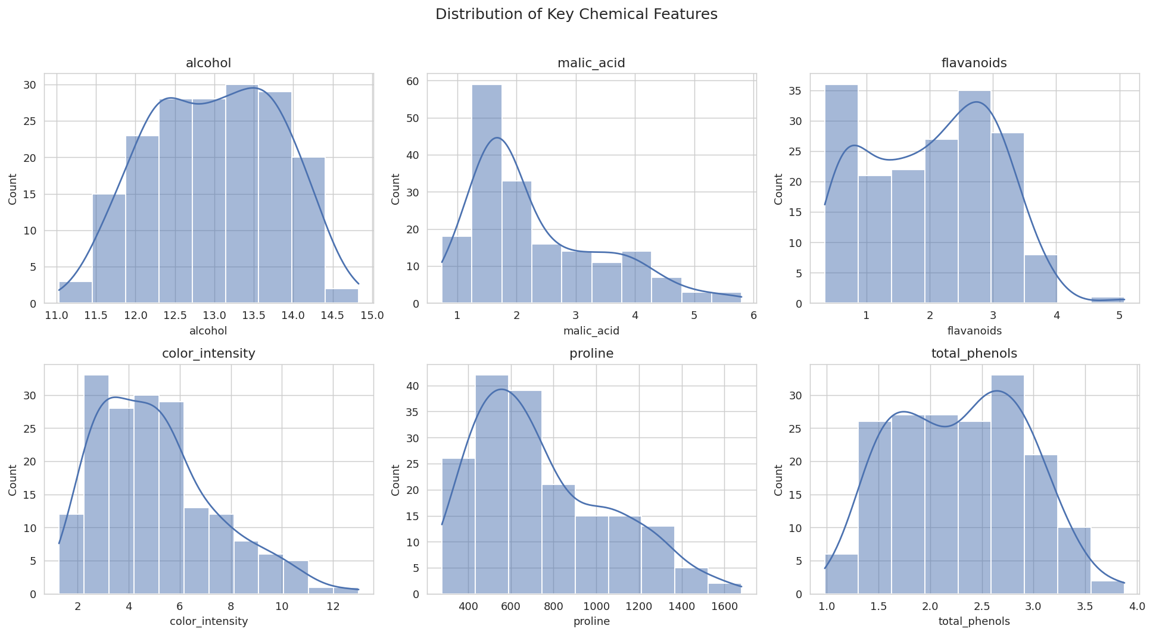
Figure 2. Distribution of six key chemical features.
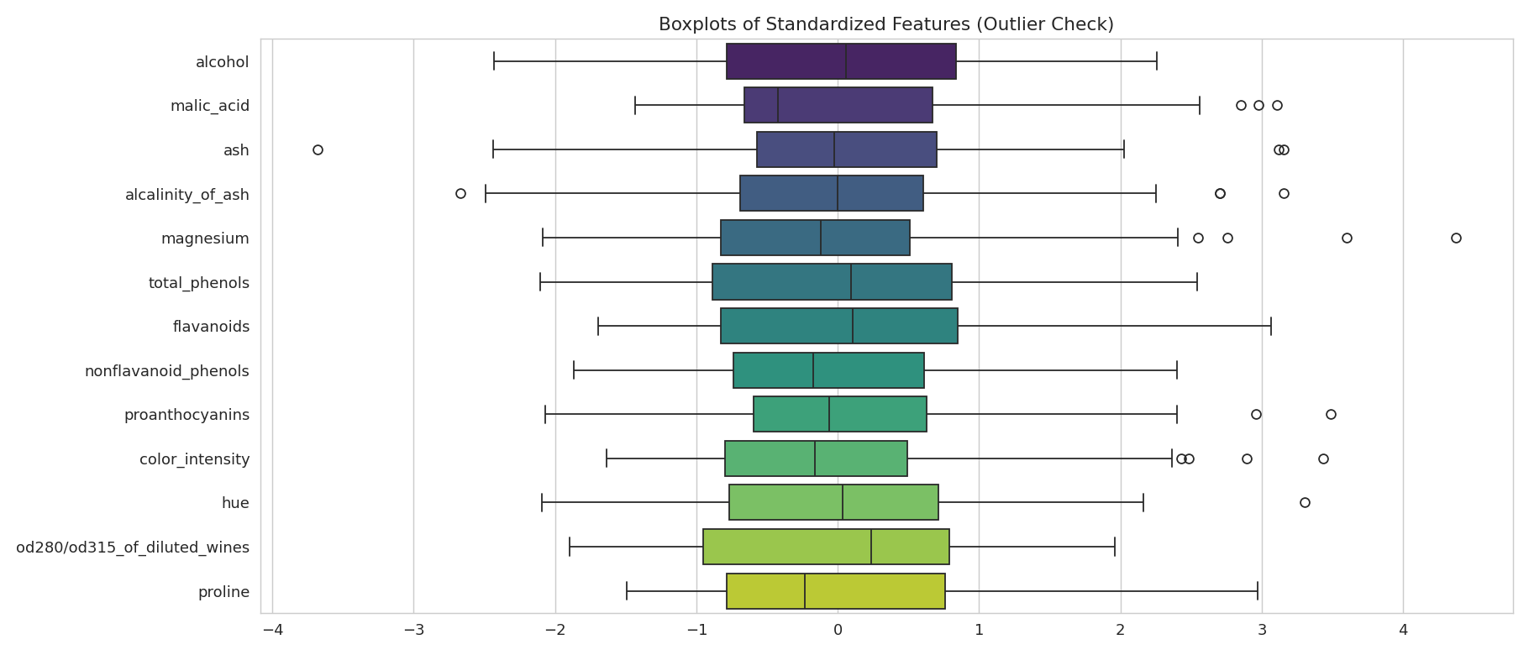
Figure 3. Boxplots of standardized features (outlier check).
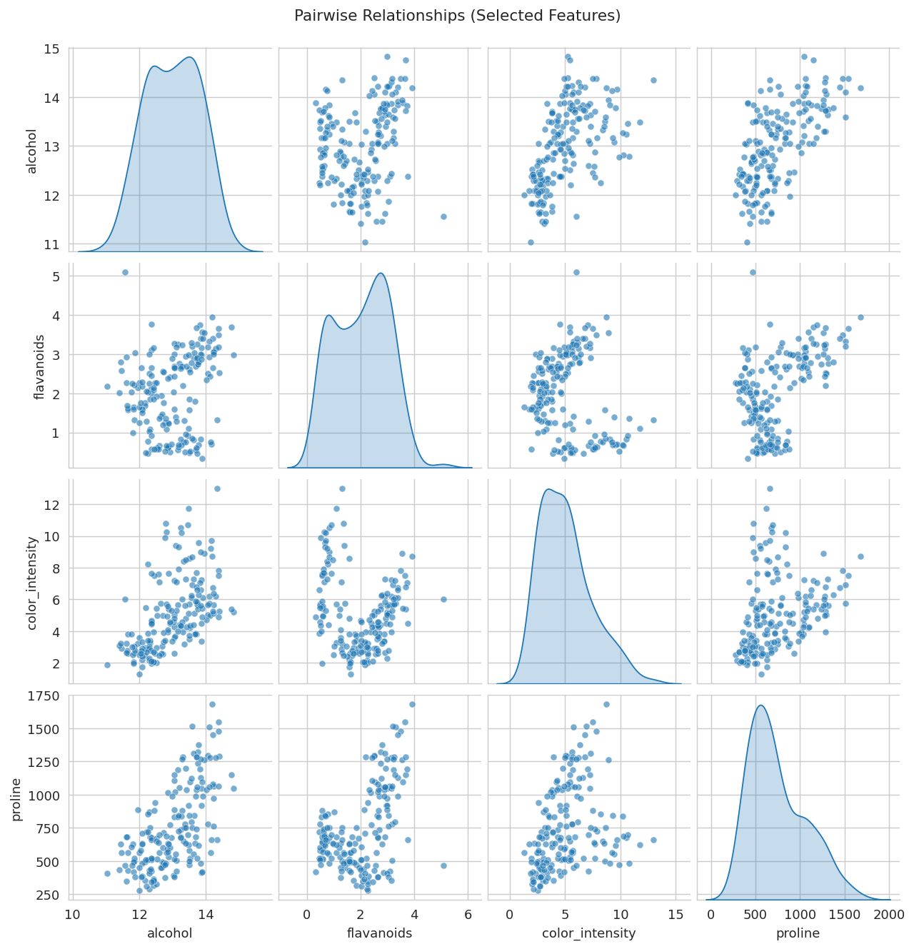
Figure 4. Pairwise relationships between four representative features.
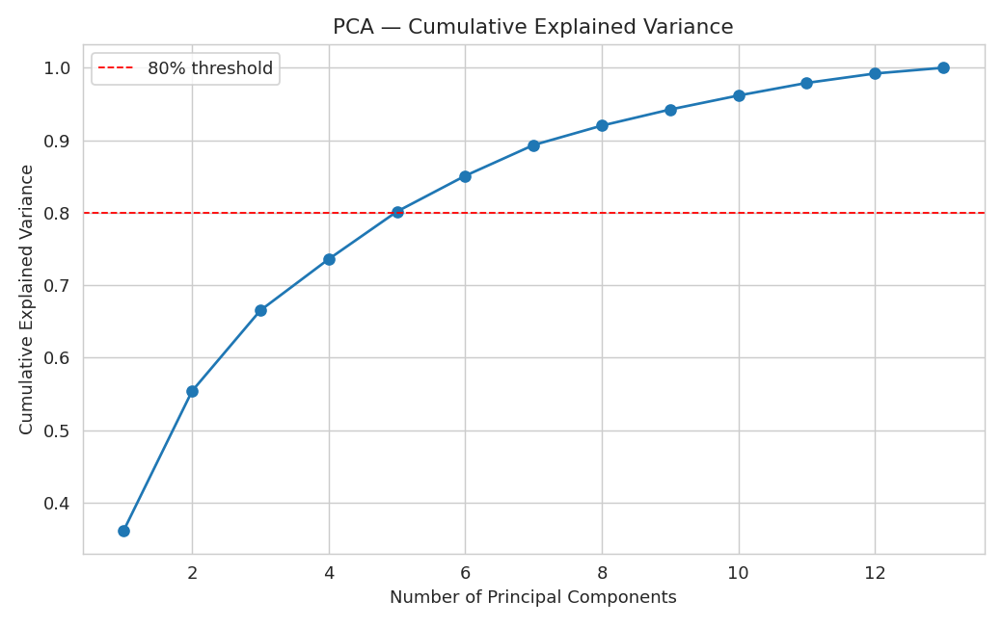
Figure 5. PCA cumulative explained variance across components.
The first two principal components together capture only 55.4% of the total variance, so PCA is used here strictly for 2D visualization of the clusters — the clustering models themselves are trained on the full 13-dimensional standardized feature space so that no genuine information is discarded before modeling.

6. Model Used
Three unsupervised clustering algorithms were trained and compared, as required by the assignment brief:
- 1. K-Means Clustering (primary / final model)
- 2. Agglomerative (Hierarchical) Clustering — Ward linkage (comparison model)
- 3. DBSCAN — density-based clustering (comparison model)

7. Training Process

7.1 K-Means — choosing the number of clusters (k)
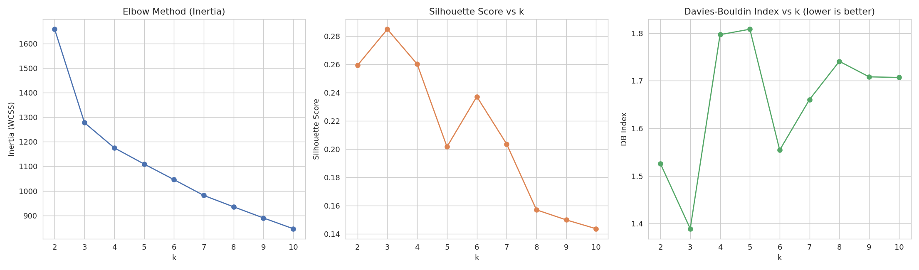
Figure 6. Elbow method, Silhouette score, and Davies-Bouldin index across k = 2..10.
Both the elbow in the inertia curve and the peak of the silhouette score occur at k = 3, which also happens to coincide with the number of grape cultivars used to make these wines — a fact used only afterwards, for external validation, and not to choose k. K-Means was therefore trained with k = 3, using 10 random centroid initializations (n_init = 10) to avoid poor local optima, on the full standardized 13-feature dataset.
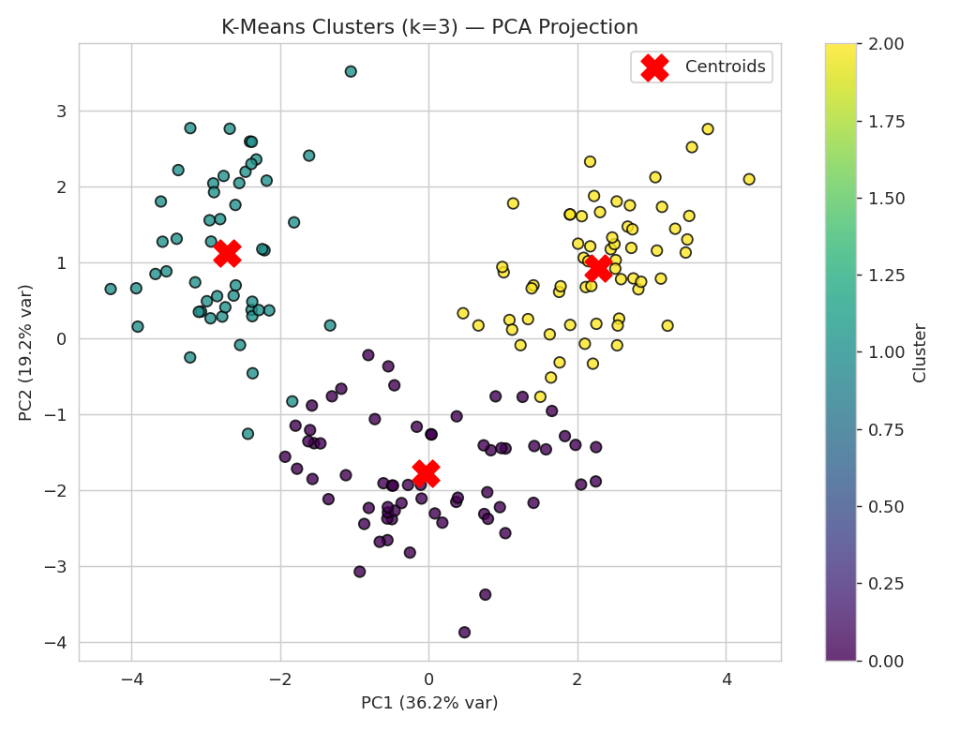
Figure 7. Final K-Means clusters (k=3), projected onto the first two principal components for visualization, with centroids marked.

7.2 Hierarchical Clustering
Agglomerative clustering with Ward linkage (which minimizes within-cluster variance at each merge, similar in spirit to K-Means) was applied to the same standardized feature set. The dendrogram below was used to visually confirm that cutting the tree into 3 clusters is a natural choice.
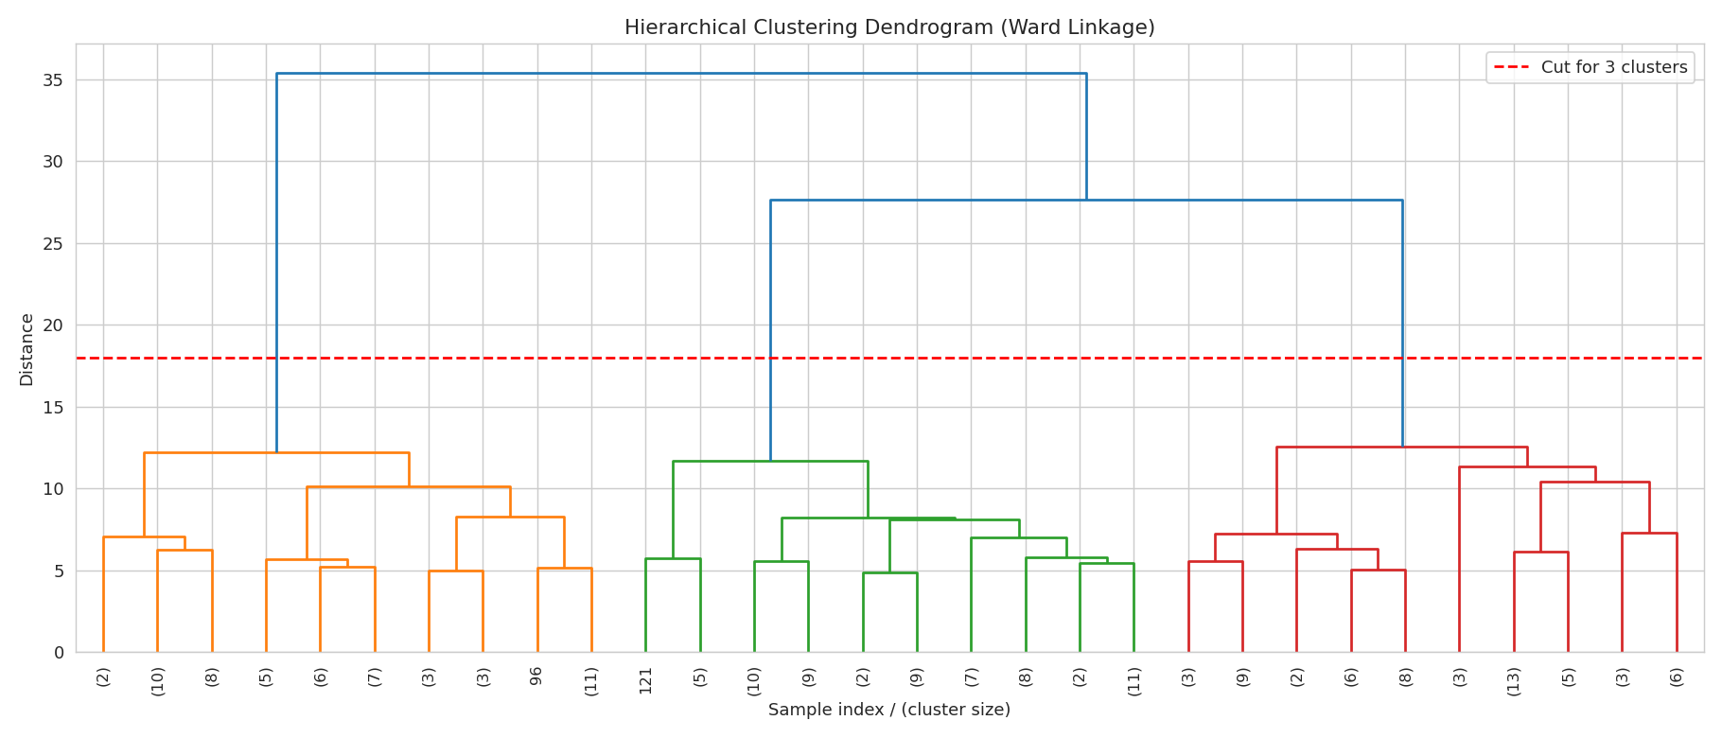
Figure 8. Ward-linkage dendrogram (truncated to the last 30 merges for readability).
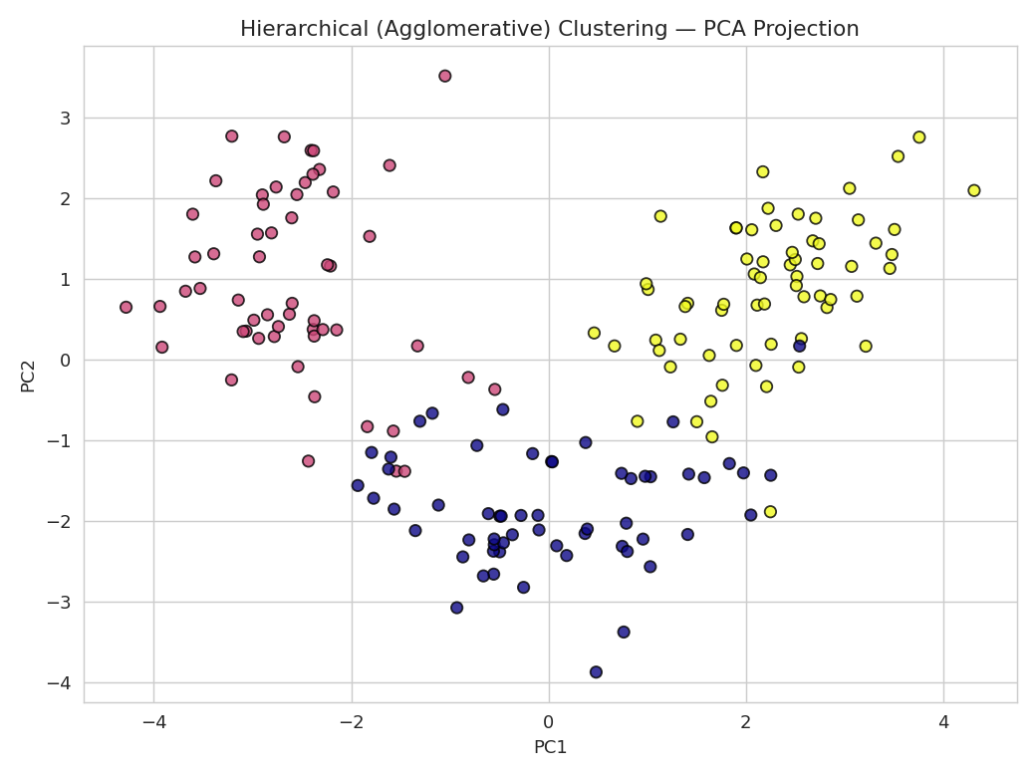
Figure 9. Hierarchical clustering result, PCA projection.

7.3 DBSCAN
A k-distance graph (5th nearest-neighbor distance, sorted) was used to select a reasonable eps value by looking for the "knee" of the curve. After testing several eps / min_samples combinations, eps = 2.2 and min_samples = 3 were selected as producing the most informative (non-degenerate) result on the standardized data.
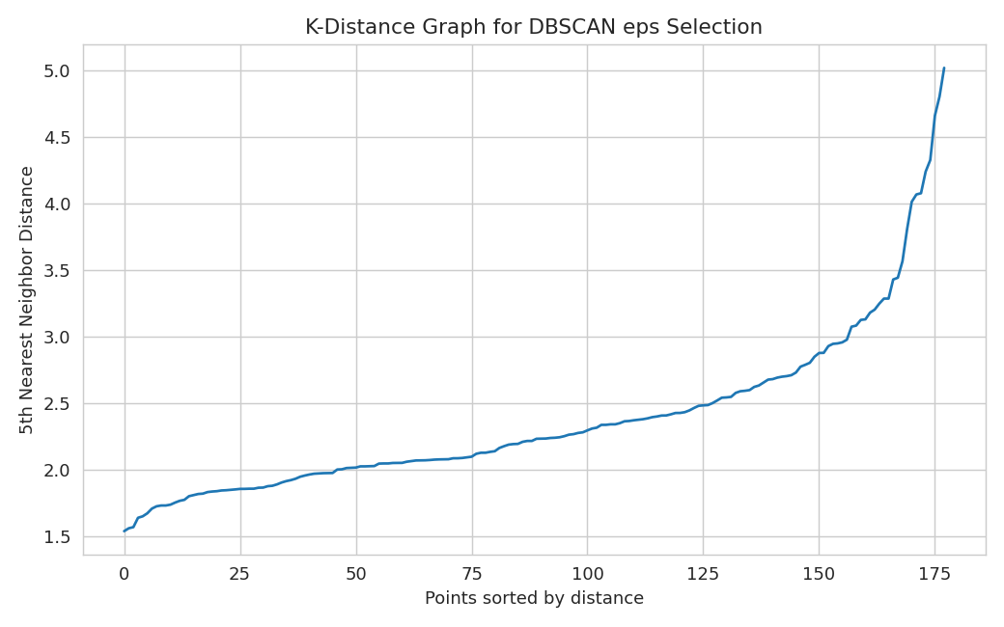
Figure 10. K-distance graph used to guide DBSCAN's eps parameter.
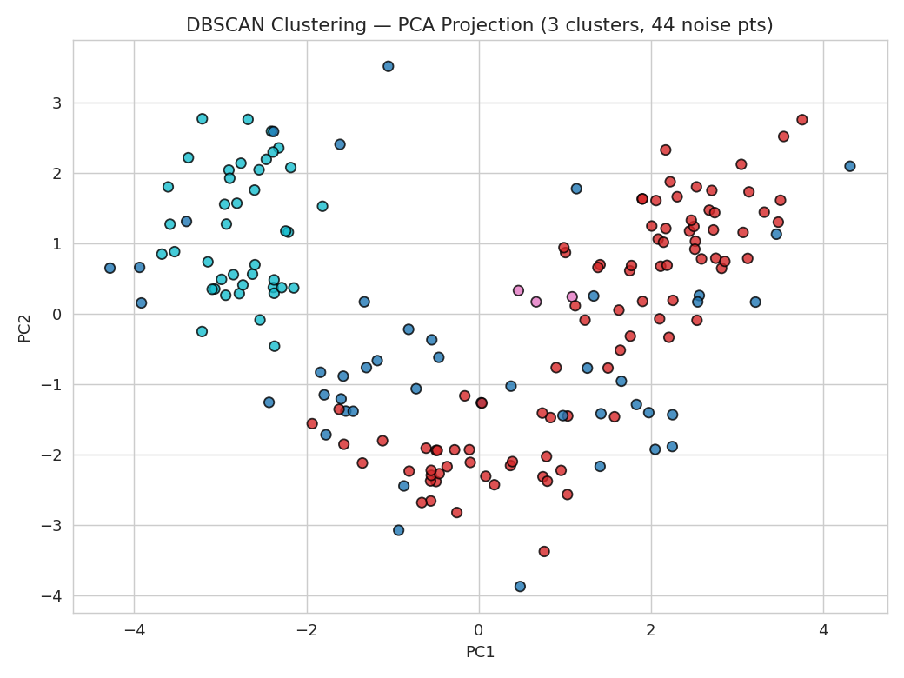
Figure 11. DBSCAN clustering result, PCA projection (noise points shown separately).
DBSCAN identified 3 cluster(s) and labeled 44 points as noise. It performed noticeably worse than K-Means and Hierarchical clustering on this dataset because the wine clusters are roughly globular and of comparable density rather than arbitrarily shaped with varying density — exactly the situation DBSCAN is designed for. This is a genuine, informative negative result: algorithm choice must match the geometric and density assumptions of the data.

8. Evaluation Metrics and Results
Because this is unsupervised learning, there are no ground-truth labels to compute accuracy / precision / recall / F1 / a confusion matrix against during training. Clustering quality was instead evaluated using internal validation metrics that do not require labels:
- Silhouette Score (range −1 to 1, higher is better): measures how similar a point is to its own cluster compared to other clusters.
- Davies-Bouldin Index (lower is better): the average similarity between each cluster and its most similar counterpart.
- Calinski-Harabasz Score (higher is better): the ratio of between-cluster dispersion to within-cluster dispersion.
Model | Silhouette Score | Davies-Bouldin | Clusters Found
K-Means (k=3) | 0.285 | 1.389 | 3
Hierarchical (Ward, k=3) | 0.277 | 1.419 | 3
DBSCAN (eps=2.2, min_samples=3) | 0.073 | n/a | 3

As an external sanity check only (never used during training or model selection), the K-Means and Hierarchical cluster assignments were compared against the real cultivar labels supplied with the dataset, using the Adjusted Rand Index (ARI) and Normalized Mutual Information (NMI):
Model | ARI vs. true cultivar | NMI vs. true cultivar
K-Means (k=3) | 0.897 | 0.876
Hierarchical (Ward, k=3) | 0.790 | —

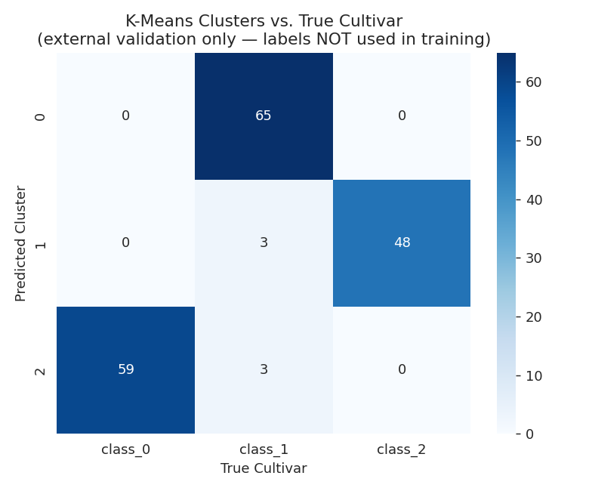
Figure 12. K-Means clusters vs. true cultivar labels (used only for external validation, playing the role of a confusion matrix).
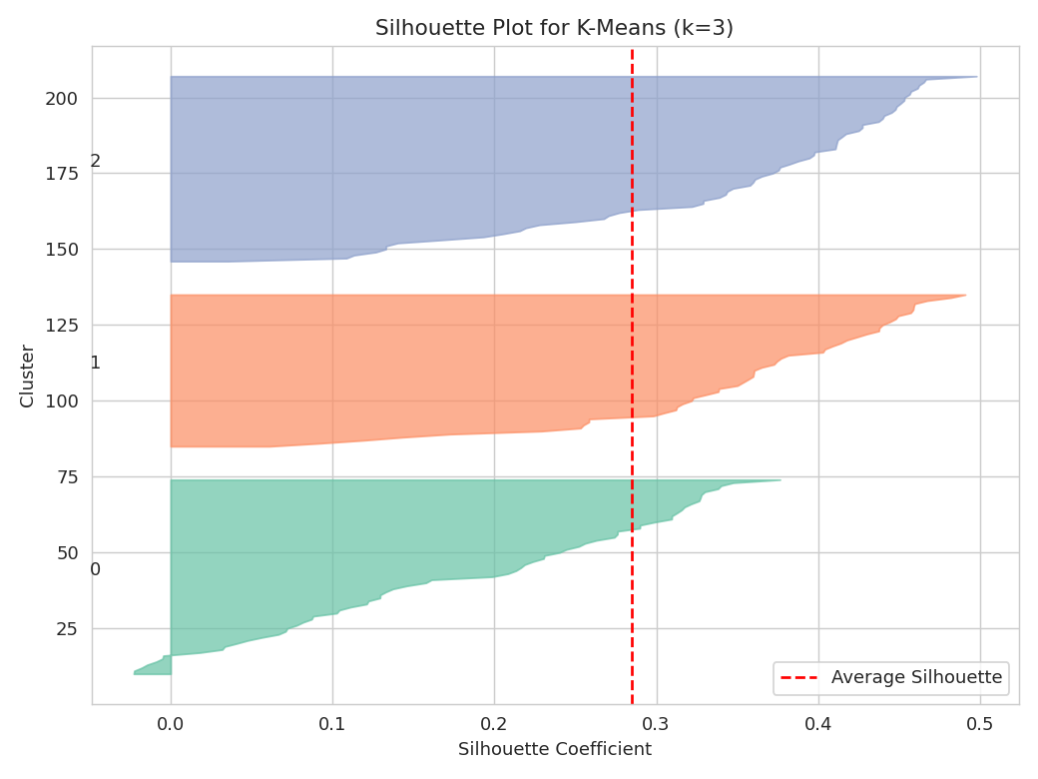
Figure 13. Per-sample silhouette plot for the final K-Means model (k=3).

Interpretation and Analysis: K-Means with k = 3 was the best-performing model, achieving the highest silhouette score (0.285) and the lowest Davies-Bouldin index (1.389) among the three algorithms tested. More importantly, when checked against the real, independently-recorded cultivar labels (a check the model never saw during training), it achieved an Adjusted Rand Index of 0.897 — meaning that clustering purely on chemical composition, with zero labels, recovered almost exactly the three real grape cultivars. This is strong evidence that the discovered clusters are chemically meaningful groupings and not an arbitrary partition of the data. The silhouette plot (Figure 13) further shows that all three clusters have a majority of samples with positive silhouette coefficients above the average line, indicating reasonably well-separated, cohesive clusters. Hierarchical clustering produced very similar (slightly less clean) results, confirming the K-Means solution is stable and not an artifact of random centroid initialization. DBSCAN under-performed on this dataset as explained above.

9. Conclusion
This project applied unsupervised machine learning to segment wines purely from their chemical composition, with no access to labels during training. K-Means clustering with k = 3 was identified as the best model using internal metrics (Silhouette Score, Davies-Bouldin Index), and was independently validated against real cultivar labels (ARI ≈ 0.90), confirming that the discovered clusters correspond to genuinely distinct, chemically-driven wine styles.
Business takeaway: a winery could deploy the trained K-Means model to automatically route new, unlabeled chemical-analysis batches into one of three style/pricing tiers, and flag any wine sample whose distance to the nearest cluster centroid is unusually large for manual quality review as a potential outlier or mislabeled batch — achieving the original business objective without requiring manual tasting or labeling of every batch.
The comparison across three algorithms also reinforced an important general lesson in unsupervised learning: algorithm choice should match the geometric and density assumptions of the data. K-Means and Ward-linkage Hierarchical clustering, which both assume roughly globular clusters, performed well; DBSCAN, which assumes density-separated clusters of arbitrary shape, did not suit this particular dataset.

10. References
- Aeberhard, S., Coomans, D., & de Vel, O. (1991, 1992). Wine [Dataset]. UCI Machine Learning Repository. https://archive.ics.uci.edu/dataset/109/wine
- Pedregosa, F. et al. (2011). Scikit-learn: Machine Learning in Python. Journal of Machine Learning Research, 12, 2825-2830. https://scikit-learn.org
- Rousseeuw, P. J. (1987). Silhouettes: A graphical aid to the interpretation and validation of cluster analysis. Journal of Computational and Applied Mathematics, 20, 53-65.
- Davies, D. L., & Bouldin, D. W. (1979). A Cluster Separation Measure. IEEE Transactions on Pattern Analysis and Machine Intelligence, PAMI-1(2), 224-227.
- Ester, M., Kriegel, H.-P., Sander, J., & Xu, X. (1996). A Density-Based Algorithm for Discovering Clusters in Large Spatial Databases with Noise. Proceedings of KDD-96.

Appendix: Conceptual Questions

A1. Semantic vs Instance vs Panoptic Segmentation
These are three related but distinct tasks in computer-vision image segmentation.
- Semantic Segmentation assigns a class label to every pixel in an image, but does not distinguish between different objects of the same class. For example, in a street scene, all pixels belonging to any car are labeled "car" — two different cars are not told apart.
- Instance Segmentation goes further: it detects and segments each individual object instance separately, but typically only for "countable" (thing) classes. Two cars in the same image would get two separate masks (car #1, car #2), while background/stuff classes like sky or road are usually ignored.
- Panoptic Segmentation unifies both: every pixel gets a class label (as in semantic segmentation) and individual object instances are separated (as in instance segmentation). Countable "thing" classes (cars, people) are separated instance-by-instance, while uncountable "stuff" classes (sky, road, grass) are labeled semantically without instance IDs, giving one complete, non-overlapping picture of the scene.
In short: Semantic = "what class is each pixel"; Instance = "which specific object does each pixel belong to (things only)"; Panoptic = "both, for the whole image, with no overlaps or gaps."

A2. What is Fuzzy Logic, and how is it different from Boolean Logic?
Boolean Logic is two-valued: every statement is either completely True (1) or completely False (0). There is no in-between — e.g., "the water is hot" is either true or false based on a fixed threshold.
Fuzzy Logic, introduced by Lotfi Zadeh in 1965, allows a statement to have a degree of truth anywhere in the range [0, 1], captured by a membership function. Instead of a sharp cutoff, "the water is hot" might be 0.8 true and "the water is warm" might be 0.3 true at the same time, reflecting real-world vagueness rather than forcing a hard boundary.
Aspect | Boolean Logic | Fuzzy Logic
Truth values | Exactly 0 or 1 | Any real number in [0, 1]
Set membership | Crisp (in or out) | Partial / graded membership
Handles vagueness | No — needs a hard threshold | Yes — models linguistic terms like "hot", "tall", "fast" naturally
Typical use | Digital circuits, classical program conditions | Control systems (washing machines, AC thermostats), approximate reasoning, expert systems

Fuzzy logic is not "less rigorous" than Boolean logic — it is a strict mathematical generalization of it: Boolean logic is the special case where every membership value is forced to be exactly 0 or 1.

A3. Customer Dataset with Age, Annual Income, and Spending Score — No Labels Provided
(a) Is this a supervised or unsupervised learning problem? This is an unsupervised learning problem. There is no target/output variable — no "correct segment" is given for any customer — we only have input features. The goal is to discover hidden structure/groupings in the data on our own, which is the defining characteristic of unsupervised learning.
(b) Which clustering algorithm would you choose first, and why? K-Means would be the natural first choice. With only three numeric, well-scaled features, it is simple, fast, and easy to interpret. The elbow method and silhouette score can quickly and visually suggest a sensible number of segments (e.g. "budget", "average", and "premium" spenders). It is also the standard, well-understood baseline that marketing stakeholders can easily act on (e.g. "Cluster 2 = high income, high spending — target with premium offers"). If an initial K-Means/PCA plot reveals non-globular or unevenly dense groupings, Hierarchical clustering or DBSCAN would be tried next as a follow-up.
(c) What assumptions does that algorithm make about the data? K-Means makes the following assumptions:
- Clusters are roughly spherical (globular) and similar in size/variance, since K-Means uses Euclidean distance to the centroid.
- Clusters are of comparable size and density — performance degrades if one true segment is much larger or denser than another.
- The number of clusters, k, must be specified in advance (via the elbow method or silhouette analysis) — K-Means does not discover k on its own.
- Features must be on comparable scales, since the algorithm relies on Euclidean distance (e.g. Age in years vs. Income in tens of thousands would otherwise let Income dominate the distance calculation) — features should be standardized first.
- Features are continuous and numeric — K-Means does not natively handle categorical variables without additional encoding or adaptation (e.g. K-Modes / K-Prototypes for mixed data).

