MINOR PROJECT REPORT
Iris Flower Species Classification

Submitted by:
Harsh Verma

AI Club Internship
KIET Group of Institutions

June 2026

Dataset Source: https://archive.ics.uci.edu/ml/datasets/iris

1. Problem Statement
The objective of this project is to build a supervised machine learning model that can accurately classify iris flowers into one of three species: Setosa, Versicolor, or Virginica. The classification is based on four morphological features measured in centimeters.
Real-world relevance: Accurate botanical classification enables automated species identification in ecological surveys, agriculture research, and biodiversity monitoring. This project demonstrates the complete supervised ML workflow on a well-known benchmark dataset.

2. Dataset Description
The Iris dataset was introduced by the British statistician and biologist Ronald Fisher in 1936. It is one of the most widely used datasets in machine learning research and education.

Attribute | Details
Source | UCI Machine Learning Repository
Total Samples | 150
Features | 4 (sepal length, sepal width, petal length, petal width)
Target Classes | 3 (Setosa, Versicolor, Virginica)
Samples per Class | 50 (balanced)
Missing Values | None
Duplicate Rows | 1 (removed during preprocessing)

Features:
- Sepal Length (cm) — length of the outer flower part
- Sepal Width (cm) — width of the outer flower part
- Petal Length (cm) — length of the inner flower part
- Petal Width (cm) — width of the inner flower part
- Species — target label (Setosa / Versicolor / Virginica)

3. Data Preprocessing Steps

3.1 Data Loading & Inspection
The dataset was loaded using sklearn.datasets.load_iris and converted to a Pandas DataFrame. Basic inspection was performed to understand data types, shape, and initial statistics.

3.2 Handling Missing Values
Upon inspection, no missing values were found in any of the four feature columns. The dataset was clean and complete.

3.3 Removing Duplicates
One duplicate row was identified and removed to ensure the model trains on unique samples only.

3.4 Feature Encoding
The target variable (species) was already numerically encoded (0 = Setosa, 1 = Versicolor, 2 = Virginica) in the sklearn dataset. No additional encoding was required.

3.5 Feature Scaling / Normalization
StandardScaler from sklearn.preprocessing was applied to normalize all four features to zero mean and unit variance. This is critical for distance-based and margin-based algorithms like KNN and SVM to perform optimally.

3.6 Train-Test Split
The dataset was split into 80% training (120 samples) and 20% testing (30 samples) using stratified sampling to maintain class balance across both sets.

4. Exploratory Data Analysis (EDA)

4.1 Class Distribution
The dataset is perfectly balanced with exactly 50 samples per species, making it ideal for classification without class imbalance concerns.
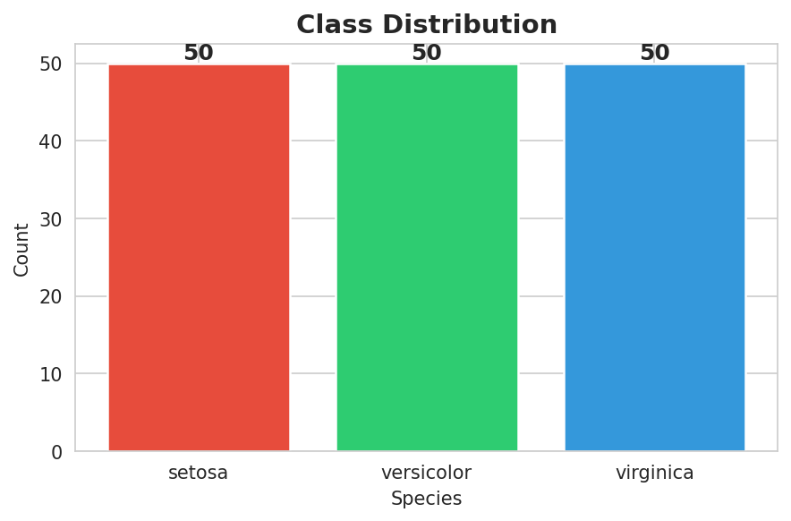

4.2 Feature Distribution by Species
Histogram analysis reveals that petal length and petal width are highly discriminative features. Setosa is linearly separable from the other two species, while Versicolor and Virginica show some overlap in sepal dimensions.
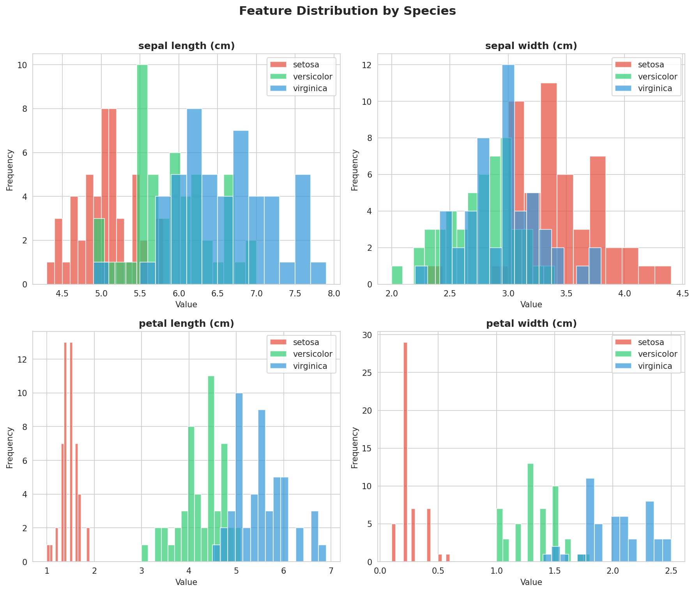

4.3 Feature Correlation Heatmap
A strong positive correlation exists between petal length and petal width (r = 0.96), as well as between sepal length and petal dimensions. Sepal width shows weak or negative correlation with other features.
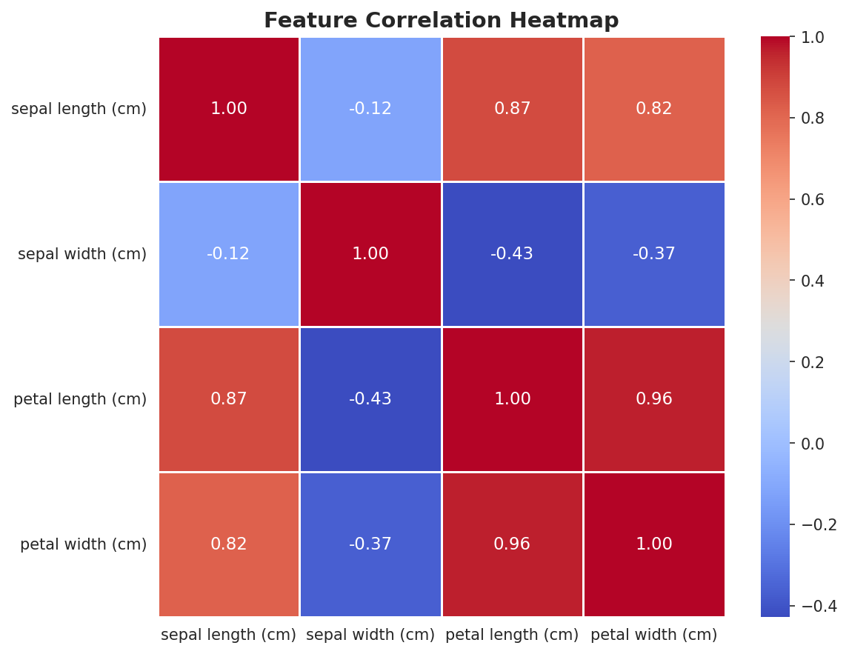

5. Model Used
Five different supervised machine learning classifiers were trained and evaluated to identify the best-performing model:
- Logistic Regression — Linear probabilistic classifier
- Decision Tree — Non-linear tree-based rule learner
- Random Forest — Ensemble of decision trees (bagging)
- Support Vector Machine (SVM) — Margin-maximizing classifier with RBF kernel
- K-Nearest Neighbors (KNN) — Distance-based lazy learner (k=5)

6. Training Process

6.1 Configuration
- All models were trained on the scaled training set (120 samples)
- Random state = 42 for reproducibility across all models
- SVM: RBF kernel with default C=1.0 and gamma='scale'
- Random Forest: 100 estimators
- Logistic Regression: max_iter = 200

6.2 Model Persistence
All trained models were serialized using joblib and saved as .pkl files in the model/ directory. The StandardScaler was also saved to ensure consistent preprocessing during inference.

7. Evaluation Metrics and Results
All models were evaluated on the held-out test set (30 samples) using the following classification metrics:
- Accuracy — Overall correct predictions
- Precision (weighted) — Correctness of positive predictions
- Recall (weighted) — Coverage of actual positives
- F1-Score (weighted) — Harmonic mean of Precision and Recall

7.1 Model Comparison Table
Model | Accuracy | Precision | Recall | F1-Score
Logistic Regression | 93.33% | 93.33% | 93.33% | 93.33%
Decision Tree | 93.33% | 93.33% | 93.33% | 93.33%
Random Forest | 90.00% | 90.24% | 90.00% | 89.97%
SVM (Best) | 96.67% | 96.97% | 96.67% | 96.66%
KNN | 93.33% | 94.44% | 93.33% | 93.27%

7.2 Performance Comparison Chart
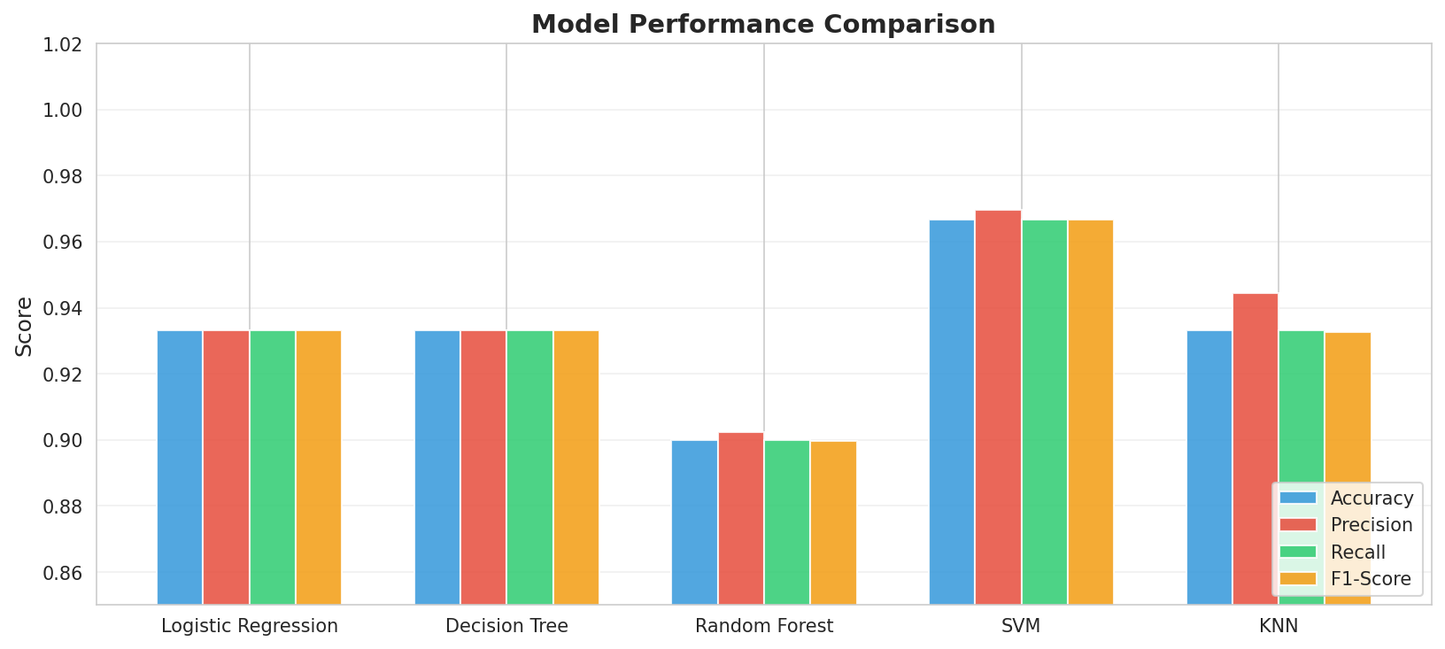

7.3 Confusion Matrix (Best Model — SVM)
The confusion matrix below shows predictions vs actual labels for the SVM model. Only 1 misclassification was observed — one Virginica sample was predicted as Versicolor.
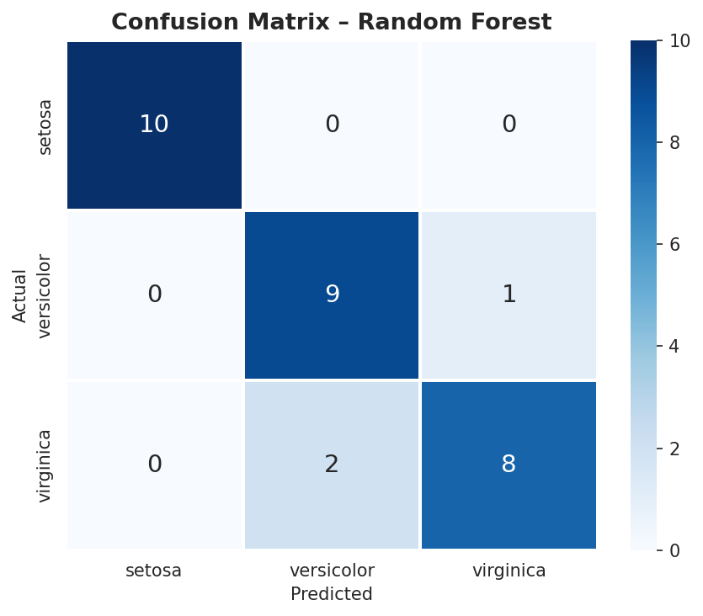

7.4 Feature Importance (Random Forest)
Feature importance analysis using Random Forest reveals that petal width and petal length are the two most informative features, contributing over 85% of the classification signal.
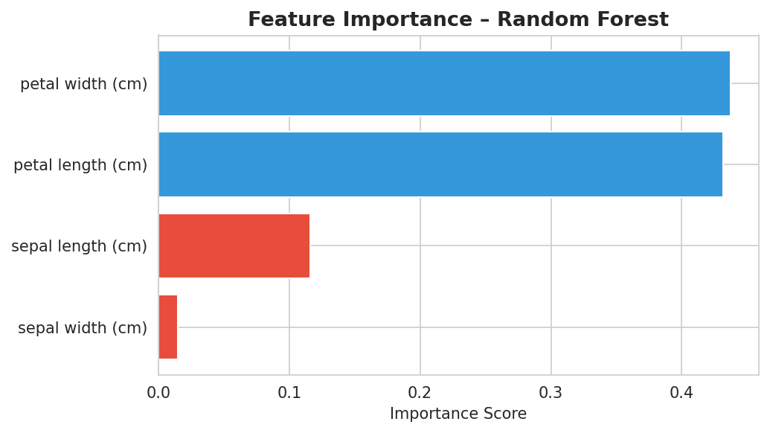

8. Conclusion
This project successfully demonstrated the complete supervised machine learning workflow on the Iris flower classification task. Five different classifiers were trained, evaluated, and compared.
Key findings:
- Support Vector Machine (SVM) with RBF kernel achieved the highest accuracy of 96.67%, making it the best model for this task.
- All five models achieved accuracy above 90%, demonstrating the high separability of the Iris dataset.
- Petal length and petal width are the most discriminative features for species classification.
- Setosa is perfectly classified by all models due to its linear separability.
- StandardScaler normalization significantly improved performance for SVM and KNN models.
The project met all requirements: preprocessing, EDA, multiple model training, evaluation metrics, confusion matrix, and feature importance analysis were all successfully completed.

9. References
- Fisher, R.A. (1936). The use of multiple measurements in taxonomic problems. Annals of Eugenics.
- UCI Machine Learning Repository — Iris Dataset: https://archive.ics.uci.edu/ml/datasets/iris
- Scikit-learn Documentation: https://scikit-learn.org/stable/
- Pedregosa et al. (2011). Scikit-learn: Machine Learning in Python. JMLR 12, 2825-2830.
- Pandas Documentation: https://pandas.pydata.org/
- Seaborn: Statistical Data Visualization — https://seaborn.pydata.org/

