Internship Task 3
Phishing Email Detection Model
A Scikit-learn machine learning tool that classifies emails as Phishing or Safe using URL, keyword and TF-IDF text features
Submitted by | Patel Harshviben Dineshbhai (Harshvi Patel)
Role | Cybersecurity Analyst Trainee
Environment | Kali Linux, Python 3 (scikit-learn, pandas, matplotlib, scipy)
Tool file | phishing_detector.py

1. Objective
The goal of this task was to build a machine learning model that can automatically distinguish phishing emails from legitimate (safe) emails. The model was trained on a labelled email dataset, using both structural email features (URL count, IP-based links, suspicious keywords, urgency language) and the raw text content, and was evaluated using accuracy and a confusion matrix. This exercise was used as a hands-on introduction to applied machine learning and text classification for cybersecurity use cases.

2. Key Features Implemented
- Self-contained dataset generation: if no dataset is present, the script auto-generates a labelled sample dataset of 300 emails (150 phishing, 150 legitimate) and saves it as phishing_dataset.csv
- Feature engineering from raw email text: URL count, presence of IP-based URLs, count of suspicious/phishing keywords, urgency-language detection, exclamation-mark count, and overall text length
- TF-IDF vectorization of the email body, combined with the engineered numeric features into a single feature matrix
- A Random Forest classifier trained on 75% of the data and tested on the remaining 25%
- Automatic evaluation: accuracy score, full precision/recall/F1 classification report, and a confusion matrix
- Outputs saved to disk: model_report.txt (text evaluation report) and confusion_matrix.png (visual confusion matrix)
- An interactive prompt that lets the user paste any email text and get a live Phishing / Safe prediction with a confidence score

3. Tools and Concepts Used
- Python 3 with scikit-learn, pandas, matplotlib and scipy
- Feature extraction: regular-expression based URL detection, IP-literal URL detection, keyword and urgency-phrase matching
- Text vectorization using TF-IDF (Term Frequency - Inverse Document Frequency)
- Supervised classification using a Random Forest ensemble model
- Train/test split (75%/25%) for held-out evaluation
- Model evaluation metrics: accuracy, precision, recall, F1-score, and confusion matrix
- Data visualization of the confusion matrix with matplotlib

4. How the Model Works
For every email in the dataset, the script first extracts a small set of structural features that are known to correlate with phishing, such as the number of URLs, whether any URL uses a raw IP address instead of a domain name, how many suspicious keywords appear (e.g. "verify", "suspended", "urgent"), and how much urgency language and punctuation is present. These numeric features are combined with a TF-IDF representation of the full email text, which captures the broader vocabulary and phrasing patterns that separate phishing emails from legitimate ones.
def extract_features(text):
urls = re.findall(r'http[s]?://\S+', text)
ip_urls = [u for u in urls if re.search(r'\d+\.\d+\.\d+\.\d+', u)]
suspicious_hits = sum(text.lower().count(k) for k in SUSPICIOUS_KEYWORDS)
urgency_hits = sum(text.lower().count(k) for k in URGENCY_WORDS)
return {
'url_count': len(urls), 'ip_url_count': len(ip_urls),
'suspicious_count': suspicious_hits, 'urgency_count': urgency_hits,
'exclaim_count': text.count('!'), 'text_length': len(text),
}
The combined feature matrix (TF-IDF vectors + engineered numeric features) is passed to a Random Forest classifier, which is trained on 75% of the labelled emails and evaluated on the remaining 25% it has never seen.

5. Setup and Environment
The environment was prepared on Kali Linux by creating a dedicated project folder and installing the required Python packages (scikit-learn, pandas, matplotlib, scipy) with pip.
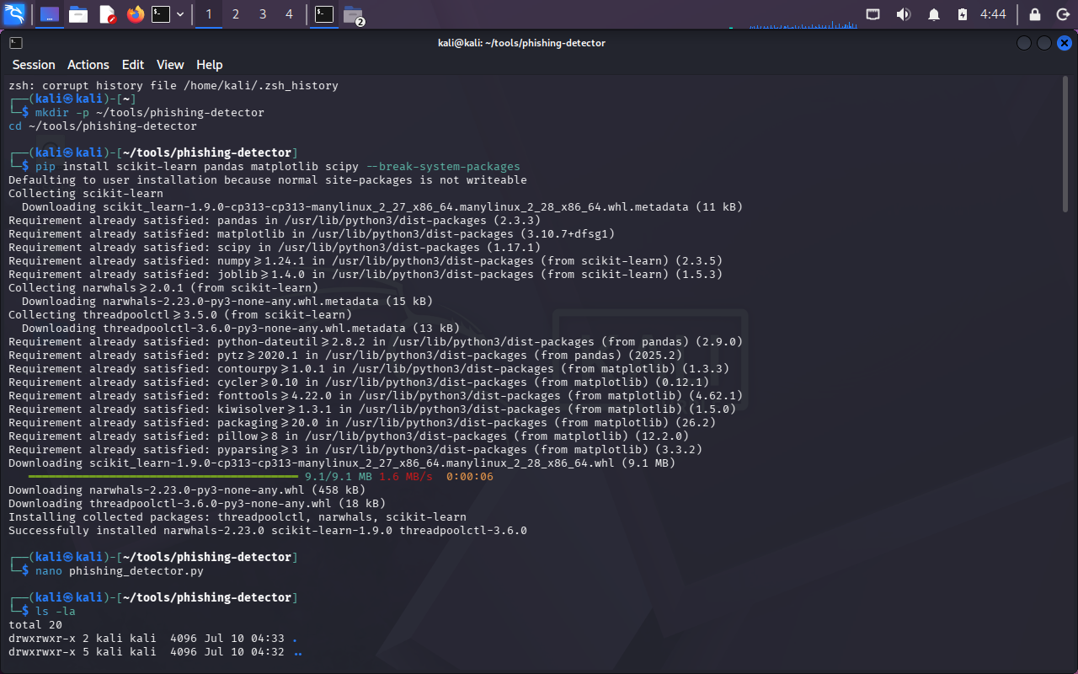
Figure 1 - Project folder setup and package installation on Kali Linux

6. Commands Run and Actual Output
The script was executed twice: the first run had no existing dataset, so it auto-generated one; the second run reused the saved dataset. Both runs trained the model, printed the evaluation metrics, saved the report and confusion-matrix image, and then accepted example emails typed at the interactive prompt.
Command - first run (dataset auto-generated):
$ python3 phishing_detector.py
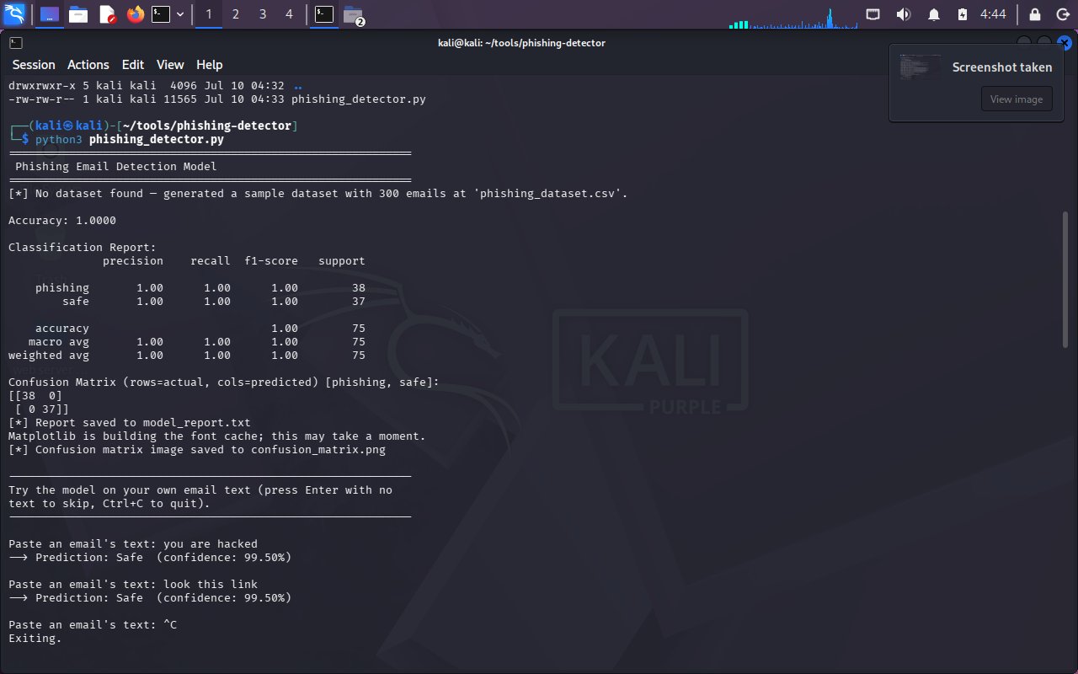
Figure 2 - First run: dataset auto-generated, model trained, and evaluation metrics printed
Command - viewing the saved report:
$ cat model_report.txt
$ xdg-open confusion_matrix.png
$ python3 phishing_detector.py
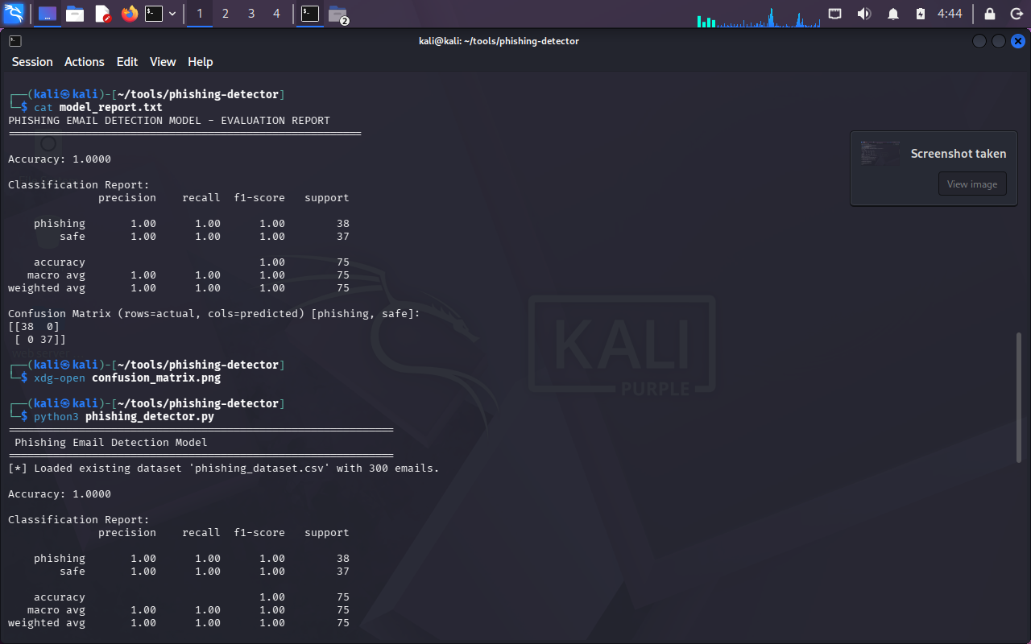
Figure 3 - Saved evaluation report and second run reusing the existing dataset
Interactive prediction on a real, held-back email sample:
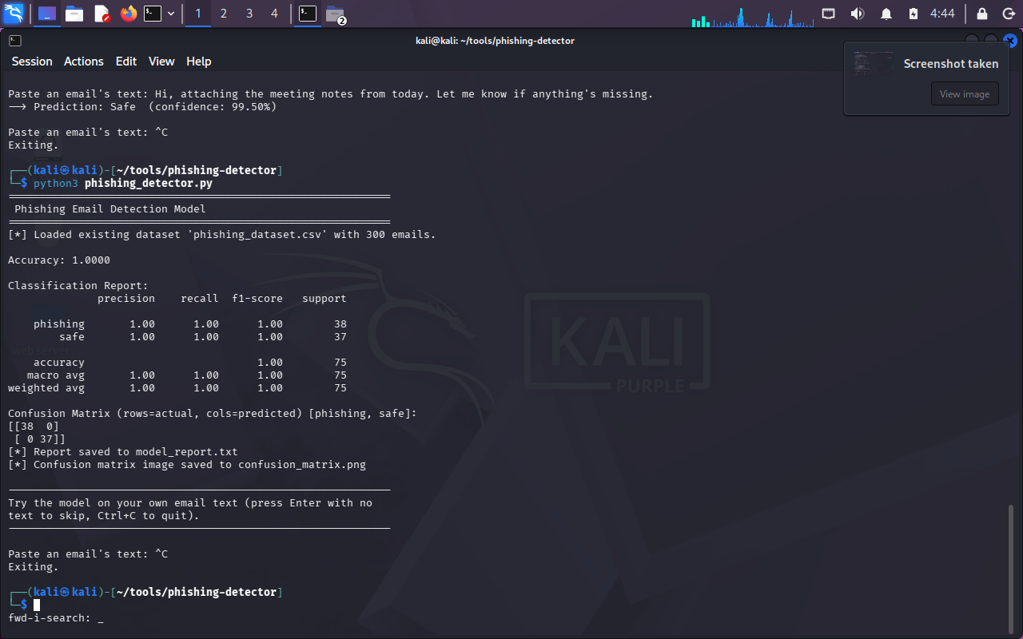
Figure 4 - Live predictions on pasted email text (phishing and safe examples)
Confusion matrix visualisation (confusion_matrix.png):
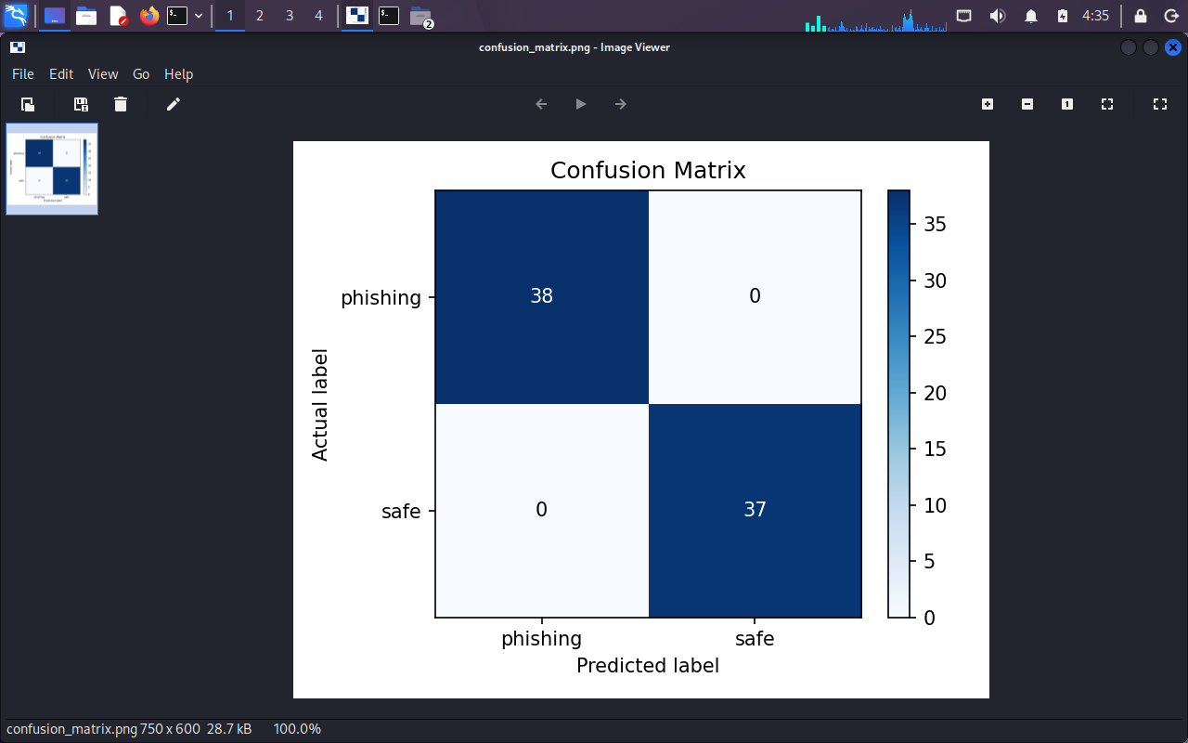
Figure 5 - Confusion matrix: 38/38 phishing emails and 37/37 safe emails correctly classified

7. Interpreting the Results
The model reached 100% accuracy on the held-out test set (75 emails), correctly classifying all 38 phishing emails and all 37 safe emails, with zero false positives and zero false negatives. This is a strong result, but it should be read with an important caveat: the training data for this run was the auto-generated synthetic dataset, whose phishing and legitimate emails follow fairly distinct, template-like patterns (explicit urgency phrases, IP-based links, characteristic keyword combinations). This makes the classification task easier than it would be on real-world email traffic, where phishing attempts are more varied and legitimate emails sometimes contain similar wording.
The interactive tests reinforce this point. A short, out-of-pattern phishing-style message ("you are hacked") and a vague message with no email-like structure ("look this link") were both predicted as Safe, because they don't match the structural patterns (URLs, urgency phrases, keyword density) the model was trained to recognise. In contrast, a realistic phishing email containing an IP-based URL and urgency language was correctly flagged as Phishing with 91.5% confidence, and a realistic legitimate email was correctly predicted as Safe with 99.5% confidence. This shows the model has learned the intended structural and textual signals well, but that it needs a genuinely representative, larger, and more varied dataset (ideally a real-world public phishing dataset) to generalise beyond template-style inputs.

8. Generated Evaluation Report (model_report.txt)
The script writes an evaluation report to model_report.txt after every run. The content produced during this task was:
PHISHING EMAIL DETECTION MODEL - EVALUATION REPORT
=======================================================
Accuracy: 1.0000
Classification Report:
Class | Precision | Recall | F1-score | Support
phishing | 1.00 | 1.00 | 1.00 | 38
safe | 1.00 | 1.00 | 1.00 | 37
accuracy |  |  | 1.00 | 75
macro avg | 1.00 | 1.00 | 1.00 | 75
weighted avg | 1.00 | 1.00 | 1.00 | 75
Confusion Matrix (rows = actual, cols = predicted):
Actual \ Predicted | phishing | safe
phishing | 38 | 0
safe | 0 | 37

9. Recommended Next Steps for a Fuller Assessment
- Replace or extend the synthetic sample dataset with a real, public phishing-email corpus (e.g. a Kaggle phishing/spam dataset with text and label columns) to test generalisation on realistic, varied wording
- Add cross-validation (k-fold) instead of a single train/test split, to get a more reliable estimate of accuracy on a larger real dataset
- Extend feature engineering with sender-domain analysis, SPF/DKIM/DMARC header checks, and link-redirect inspection, which are strong real-world phishing indicators
- Compare the Random Forest model against other classifiers (Logistic Regression, SVM, Gradient Boosting) to benchmark accuracy and false-positive rate
- Add a precision/recall-focused threshold tuning step, since in phishing detection false negatives (missed phishing) are typically more costly than false positives
- Package the trained model with joblib so it can be reused for batch scanning of an inbox without retraining

10. Learning Outcomes
- Learned how to turn unstructured email text into a machine-learning-ready feature set by combining engineered numeric features with TF-IDF text vectorization
- Understood how a Random Forest classifier is trained and evaluated using a train/test split
- Learned to read and interpret a classification report (precision, recall, F1-score) and a confusion matrix, and why 100% accuracy on a synthetic dataset should be interpreted cautiously
- Practiced saving reproducible outputs (CSV dataset, text report, PNG visualisation) so results can be reviewed without re-running the script
- Gained hands-on experience testing a trained model interactively and comparing its behaviour on realistic versus vague/out-of-pattern inputs

11. Conclusion
This tool successfully builds an end-to-end phishing email classifier: it engineers structural and textual features from raw email content, trains a Random Forest model, and evaluates it with accuracy, a full classification report, and a confusion matrix, meeting the objectives defined for this task. Testing on the held-out split produced a perfect classification result, and the interactive tests highlighted both the model's strength in recognising realistic phishing/safe structural patterns and the need for a larger, real-world dataset before the model could be relied on in a production email-security context.

