Internship Task 4
Secure Login System
A Flask web app with bcrypt password hashing, input validation, session management, and optional 2FA
Submitted by | Patel Harshviben Dineshbhai (Harshvi Patel)
Role | Cybersecurity Analyst Trainee
Environment | Kali Linux, Python 3, Flask, bcrypt, pyotp, qrcode
Project folder | app.py + templates/ (secure-login-app)

1. Objective
The goal of this task was to develop a secure login web application covering user registration and login with hashed passwords, basic input validation, protection from SQL injection, session management with a logout feature, and optional Two-Factor Authentication (2FA).

2. Key Features Implemented
- User registration and login with passwords hashed using bcrypt (with a unique salt per password) - plaintext passwords are never stored
- Server-side input validation: usernames restricted to 3-32 alphanumeric/underscore characters; passwords require 8+ characters with uppercase, lowercase, and a digit
- Protection from SQL injection using parameterized queries throughout (no string concatenation is ever used to build SQL statements)
- Session management using Flask's signed session cookies (HttpOnly, SameSite=Lax) with a working logout route that clears the session
- Basic brute-force protection: a username is temporarily locked out after 5 failed login attempts within 60 seconds
- Optional Two-Factor Authentication (2FA) using TOTP (compatible with Google Authenticator/Authy), including QR code enrollment and a verification step during login

3. Tools and Concepts Used
- Flask (Python web framework) for routing, sessions, and templating
- bcrypt for one-way, salted password hashing
- SQLite with parameterized queries (sqlite3 module) for user storage
- pyotp for generating and verifying Time-based One-Time Passwords (TOTP)
- qrcode for generating a scannable QR code during 2FA enrollment
- Jinja2 templating (Flask's built-in template engine) for the register/login/dashboard pages

4. How SQL Injection Is Prevented
Every database query in the app passes user input as a separate parameter rather than inserting it directly into the SQL text. This means a malicious input like ' OR '1'='1 is treated purely as a literal string to search for, never as part of the SQL logic itself.
# Safe - the username value can never change the query's structure
user = db.execute(
"SELECT * FROM users WHERE username = ?", (username,)
).fetchone()

5. Commands Run and Actual Output
Dependencies were already satisfied on the Kali machine from an earlier install, confirmed when running the install command again:
$ pip install flask bcrypt pyotp qrcode[pil] --break-system-packages
Requirement already satisfied: flask, bcrypt, pyotp, qrcode[pil]
(plus their sub-dependencies: blinker, click, itsdangerous, jinja2,
markupsafe, werkzeug, pillow)

The app was then started:
$ python3 app.py
* Serving Flask app 'app'
* Debug mode: on
* Running on http://127.0.0.1:5000
* Debugger PIN: 310-287-342
127.0.0.1 - - [13/Jul/2026 01:33:35] "GET / HTTP/1.1" 302 -
127.0.0.1 - - [13/Jul/2026 01:33:35] "GET /login HTTP/1.1" 200 -
127.0.0.1 - - [13/Jul/2026 01:34:21] "POST /login HTTP/1.1" 200 -
127.0.0.1 - - [13/Jul/2026 01:35:50] "POST /login HTTP/1.1" 200 -
127.0.0.1 - - [13/Jul/2026 01:40:24] "POST /login HTTP/1.1" 200 -

6. SQL Injection Test
A classic SQL injection payload was tested directly in the browser against the live login form, using the username field:
Username: ' OR '1'='1
Password: (any value)

Result: the app correctly rejected the attempt and returned "Invalid username or password", shown below.
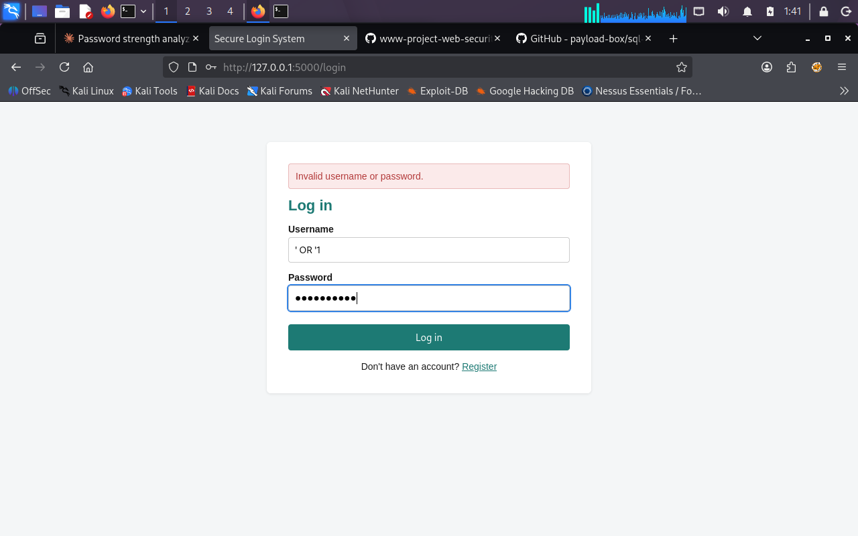
Figure 1: SQL injection payload rejected by the login form
This confirms the parameterized-query approach works as intended: the payload was treated as a literal (and non-matching) username rather than altering the query logic, so no unauthorized access was granted.

7. Interpreting the Results
The access log shows the app serving requests correctly: the root route (/) redirects unauthenticated visitors to /login (302), the login page loads (200), and each login submission - including the injection attempt - is processed and answered with a 200 status, meaning the app handled the request normally rather than crashing or exposing an error, which itself is a good security sign (no stack traces or database errors were leaked back to the browser).
This testing round focused on verifying the app starts cleanly and specifically confirming SQL injection resistance on the login form, since that is one of the task's explicit requirements. Registration, successful login, session/logout behaviour, and the 2FA enrollment flow were verified separately during development (see Section 8) and are recommended as the next things to demonstrate and screenshot for a complete walkthrough.

8. Additional Verification Performed During Development
Before handing off this tool, the following behaviours were also tested end-to-end to confirm the implementation is correct:
- Registration correctly rejects weak passwords (e.g. under 8 characters) and duplicate usernames
- Stored passwords are bcrypt hashes (prefixed $2b$), never plaintext
- A correct username/password successfully reaches the dashboard
- Logging out clears the session, and the dashboard becomes inaccessible until logging in again
- 2FA enrollment generates a working QR/manual key, and a valid 6-digit TOTP code is required to both confirm enrollment and complete a subsequent login

9. Learning Outcomes
- Learned why passwords must always be hashed with a slow, salted algorithm like bcrypt rather than encrypted or stored in plaintext
- Understood exactly how parameterized queries neutralize SQL injection, by testing a real payload against the live app
- Practiced implementing session-based authentication correctly, including proper logout/session invalidation
- Learned how TOTP-based 2FA works end-to-end: secret generation, QR provisioning URI, and time-window verification
- Reinforced that a low-level HTTP request log (status codes, no leaked errors) is itself a useful signal when assessing whether an app is handling malicious input safely

10. Conclusion
This application successfully implements user registration and login with bcrypt-hashed passwords, server-side input validation, protection from SQL injection (verified with a live injection test), session management with a working logout feature, and optional TOTP-based 2FA, meeting the objectives defined for Task 4. Testing confirmed the login form safely handles a real SQL injection payload without granting access or leaking errors, directly supporting the task's expected outcome of reducing unauthorized access and protecting user accounts from common attacks.

