Internship Task 1
Password Strength Analyzer
A Python command-line tool for evaluating and strengthening password security
Submitted by | Patel Harshviben Dineshbhai
Role | Cybersecurity Analyst Trainee
Environment | Kali Linux, Python 3 (standard library only)
Tool file | password_strength_analyzer.py

1. Objective
The goal of this task was to build a tool that evaluates the strength of user-entered passwords, suggests stronger alternatives, and demonstrates a way to prevent reuse of old passwords using a local database. The exercise was used to learn practical password security concepts and basic cryptographic hashing.

2. Key Features Implemented
- Length and complexity checks (lowercase, uppercase, digits, symbols)
- Entropy calculation (in bits) based on character pool size and password length
- Estimated offline crack time, assuming an attacker capable of ~10 billion guesses per second
- Detection of common passwords, keyboard patterns (e.g. qwerty, asdf), sequential characters (abc, 123), and repeated characters (aaa, 111)
- An overall strength score (0-100) with a rating from Very Weak to Very Strong
- Suggestions for stronger alternatives: randomly generated passwords and a memorable passphrase
- Reuse prevention using a local SQLite database (password_history.db) that stores only a SHA-256 hash of each password, never the plaintext

3. Tools and Concepts Used
- Python 3 standard library: re, math, string, secrets, hashlib, getpass, sqlite3
- Cryptographic hashing (SHA-256) to store password history without exposing plaintext
- Shannon entropy formula: entropy = length x log2(character pool size), used to estimate password unpredictability
- Regular expressions to detect character classes and patterns
- secrets module for cryptographically secure random password generation (safer than the random module for security-sensitive use)

4. How the Entropy is Calculated
The character pool size grows as more character types are used: 26 for lowercase, 26 for uppercase, 10 for digits, and roughly 32 for symbols. Entropy in bits is then calculated as the password length multiplied by log base 2 of that pool size. A higher entropy value means significantly more possible combinations an attacker would need to try, which directly increases the estimated crack time.
def estimate_entropy_bits(password: str) -> float:
pool = character_pool_size(password)
if pool == 0 or len(password) == 0:
return 0.0
return len(password) * math.log2(pool)

5. Sample Run and Output

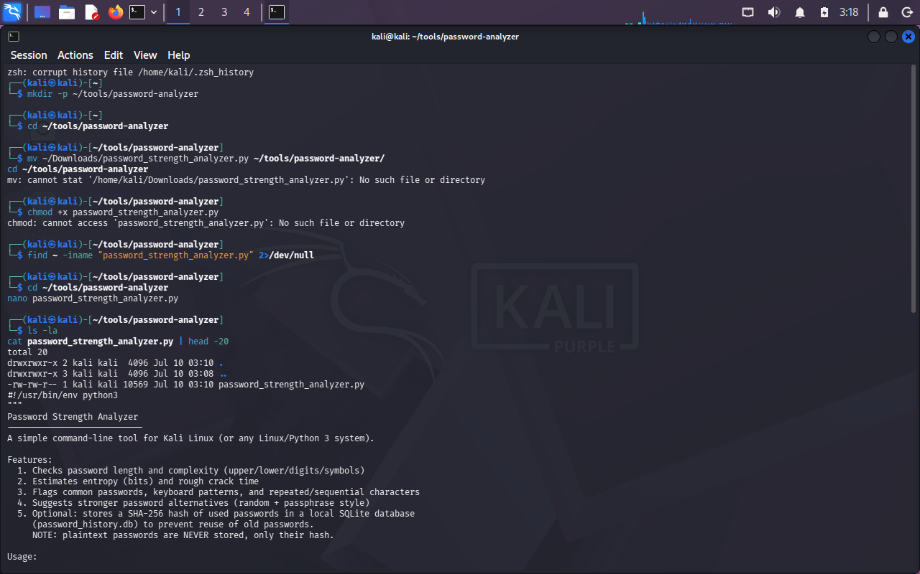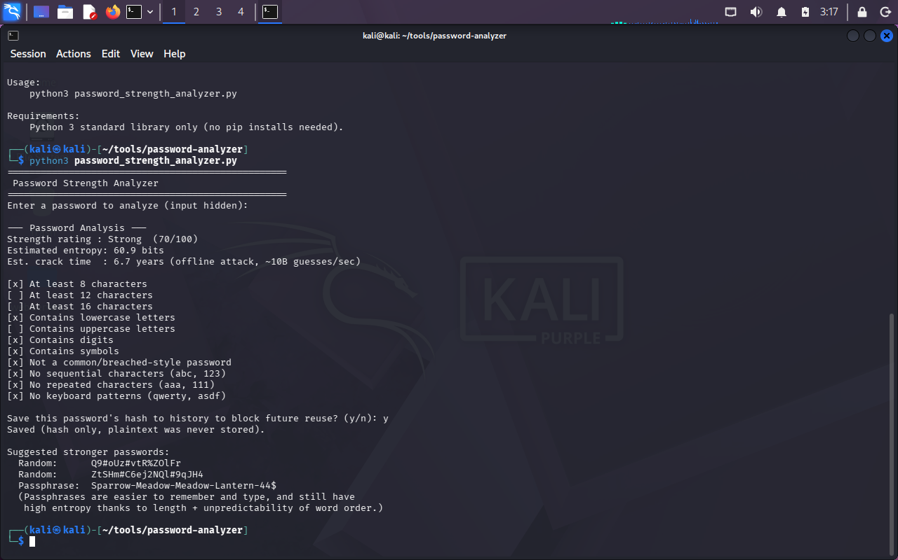
The tool was run on Kali Linux using the command below:
$ python3 password_strength_analyzer.py

A sample password was entered (input hidden from the screen for security). The tool produced the following analysis:
Strength rating | Strong (70 / 100)
Estimated entropy | 60.9 bits
Estimated crack time | 6.7 years (offline attack, ~10 billion guesses/sec)
Checklist results:
PASS | At least 8 characters
FAIL | At least 12 characters
FAIL | At least 16 characters
PASS | Contains lowercase letters
FAIL | Contains uppercase letters
PASS | Contains digits
PASS | Contains symbols
PASS | Not a common/breached-style password
PASS | No sequential characters (abc, 123)
PASS | No repeated characters (aaa, 111)
PASS | No keyboard patterns (qwerty, asdf)
Suggested stronger alternatives generated by the tool:
Random: Q9#oUz#vtR%ZOlFr
Random: ZtSHm#C6ej2NQl#9qJH4
Passphrase: Sparrow-Meadow-Meadow-Lantern-44$

The user was then asked whether to save the password's hash to the local history database, to demonstrate reuse prevention. On a second run with the same password, the tool detects the match against the stored SHA-256 hash and warns the user before they can reuse it.

6. Reuse Prevention Design
Rather than storing passwords as plain text, the tool follows standard security practice: it stores only the SHA-256 hash of each password in a local SQLite database. When a new password is analyzed, its hash is computed and compared against stored hashes. A match means the password has been used before, and the user is warned to choose a different one. This mirrors how real systems (at a much larger and more secure scale, typically using slower, salted hashing algorithms such as bcrypt or Argon2) prevent password reuse without ever needing to know the original password.

7. Learning Outcomes
- Understood how password entropy is calculated and why length and character diversity both matter
- Learned why plaintext passwords should never be stored, and how one-way hash functions (SHA-256) support this
- Practiced identifying common weak-password patterns: dictionary words, keyboard walks, sequences, and repeated characters
- Learned the difference between Python's random module and the secrets module for security-sensitive random generation
- Gained hands-on experience building and testing a security tool end-to-end on Kali Linux

8. Conclusion
This tool successfully checks password length, complexity, and uniqueness; suggests stronger alternatives; and demonstrates safe reuse prevention using a local hashed database, meeting all the objectives defined for Task 1. It also served as a practical introduction to basic cryptographic concepts such as hashing and entropy, which are directly relevant to cybersecurity analysis work.

