**E-LEARNING**

**TEAM:**

**17BCI0064 - HARSH VORA**

17BCE0390 – SERENA ELAN

17BCE0598 – HITANSH JAIN

**PROCESS MODEL**

Why waterfall model ?

The process model that will be suitable for this project according to me is

- **waterfall model** because the **requirements as of now are pretty clear** and they seem to be **consistent** because requirements are – resources for learning , payment portals and registration portals.

-So, these requirements are **unlikely to change rapidly.**

Why not other models ?

1. **Evolutionary model:**

This is used when the requirements are unclear and feedback plays a major role in further developing of the project.

Neither we need prototyping for this project.

1. **Component based software engineering:**

**This model could be used instead of waterfall model.**

but waterfall model is actually better beacause of the following disadvantages of this model:

-requirements are compromised because existing components are used which may not serve the actual purpose .

***For ex:-the requirement of the cutomer was to get a comment box so that the users can give their views on the resources used .But the available component is serving a reviews section where the faculties have already given their views.***

1. **Spiral model:**

This model is for large projects which need continuous development and risk assessment. In this case it wont be suitable because the model of the project is clear and just once we need to assess the risks and we are done.

1. **Incremental model:**

This model is not applicable as the limit of the project is fixed.there wont be any future increments in this project so the model is to be developed once and no need of prioritizing the requirements and modify the model.

1. **RAD:** compatibility issues-would not be compatible with the upcoming technology.

**PROCESS BASED GANTT CHART:**

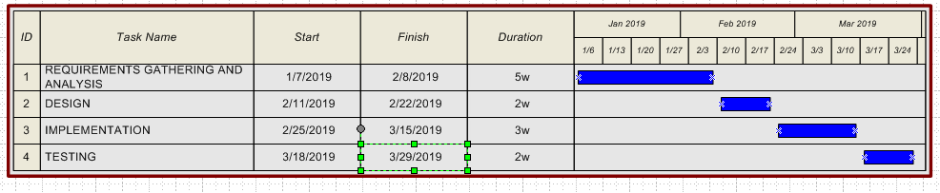

**PRODUCT BASED GANTT CHART:**

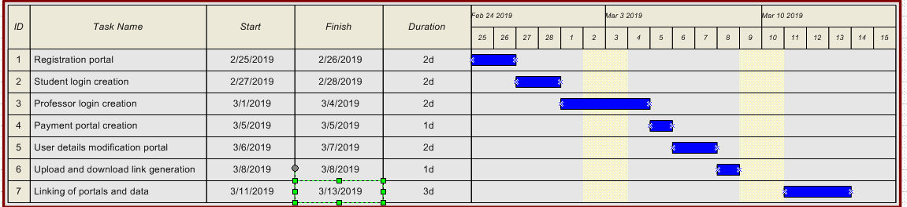

**Work Breakdown Structure :**

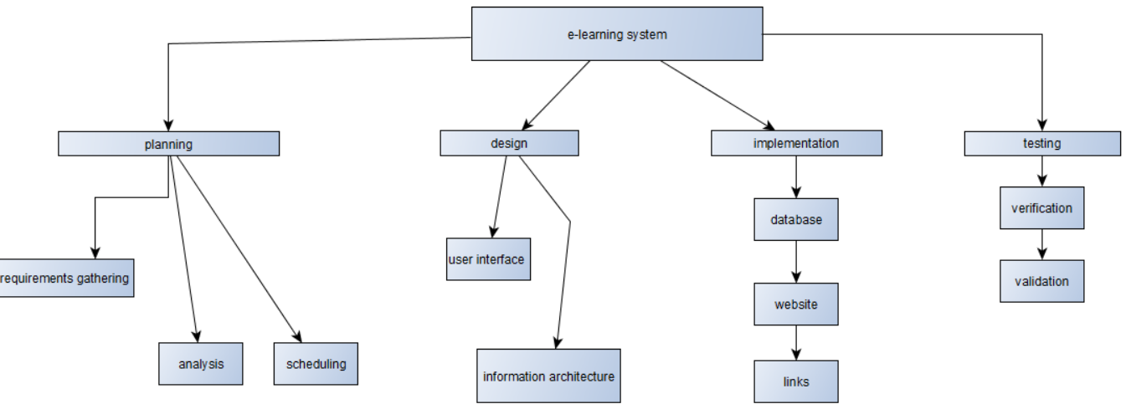

**PERT CHART:**

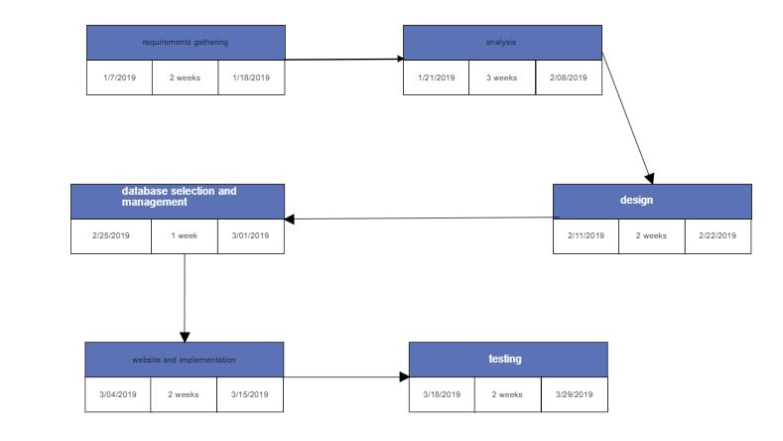

**Risk Management :**

**Risks:**

1. Process failure - when project is not completed within the imposed constraints (ex: time, scope budget, quality etc.).
2. Expectation failure - when the systems do not correspond with user expectations.
3. Interaction failure - when users express negative attitude towards the system.
4. Correspondence failure - when there is no match between planned objectives and the system.

**Risk types:**

1. Process failure: technology
2. Expectation failure: organizational
3. Interaction failure: technology
4. Correspondence failure: requirements and technology

**Probabilities:**

1. Process failure: moderate .
2. expectation failure: low.
3. Interaction failure: moderate.
4. Correspondence failure: low.

**Consequences:**

a) The management of the organization does not have a centralized and organized knowledge about learning processes already defined

b) Inappropriate choice of suppliers, with no minimal experience in the specific knowledge

c) Improperly defined goals to obtain and expectations towards e-learning

implementation

d) Top management did not state the importance of the deployment among

employees which translates into a lack of support for the project

e) System Tests carried out inaccurately and/or incompletely, which leads to a

failure in detecting system errors

f) The implemented system does not correspond to the requirements and safety procedures and/or formal-legal regulation.

**Risk avoidance/minimization:**

**Technical risk:**

**Plan 1:**

It is important to figure out how implementation will translate into (previously mapped) learning processes. There is also a need to organize an efficient and effective communication between departments involved in implementation process. Preliminary analysis of experienced, external consultant is also useful.

**Plan 2:**

The availability of adequate resources to carry out tests must be guaranteed. When tests are successfully completed, it is required to obtain a tester’s signature of the conducted scenarios. Tests must be performed on real data.

**Plan 3:**

Project manager, who will not allow for many initially unplanned changes – scope creep. Any changes must always be accompanied by justification and careful analysis in terms of impact on the project. Change management process will ensure essential documentation.

**Organizational risk:**

**Plan 1:** Obtain a formal assignment of employees who are dedicated to the project

**Plan 2:** Conduct an overall, preliminary analysis to determine business needs in the context of selection of an appropriate IT solution.