**CONTENTS**

|  |  |  |
| --- | --- | --- |
| **S.NO** | **CONTENTS** | **PAGE NO.** |
| **1.** | **ACKNOWLEDGEMENT** | **2** |
| **2.** | **ABSTRACT** | **4** |
| **3.** | **INTRODUCTION** | **5** |
| **4.** | **LITERATURE REVIEW** | **6** |
| **5.** | **PROPOSED METHOD** | **8** |
| **6.** | **RESULT SNAP** | **8** |
| **7.** | **INFERENCES** | **9** |
| **8.** | **GRAPH COMPARISON** | **10** |
| **9.** | **CONCLUSION AND FUTURE SCOPE** | **12** |
| **10.** | **REFERENCES** | **12** |

**ABSTRACT**

Feelings are a piece of human correspondence. Mind-set, emotions and identity of any person can be perceived through his feelings.

Individuals have constantly discovered music critical in their lives. Music is a dialect of a feeling. Music much of the time communicates enthusiastic characteristics and characteristics of human identity, for example, glad, misery, forcefulness, delicacy and so forth. Music has a focal job in human culture since it so unequivocally inspires sentiments and influences social exercises and associations.

Canny music player is an android application which perceives a temperament of the client and after that as per his mind-set it produces playlist of melodies that suits his mind-set from the accessible tune list.

**INTRODUCTION**

In this undertaking will make a database of the tunes will be implemented. At that point implementing programming dialects will create our music player. Fundamentally, we will see the diverse scan calculations and think about them for this case. The main point of consideration will be time and space complexity.

Optimization of the existing search algorithm for better results. The interface will be displayed which will show various types of tunes. Presently we will perform seek calculation and show the rundown of the melody with a similar state of mind. The chose melody will show the client state of mind and rundown of the tunes will show up before client with a similar disposition.

The key distinction between numerous other keen music players and our music player is the type of info it takes.

**LITERATURE REVIEW**

Music and its utilization for feeling control forms, still remains an unanswered inquiry. Numerous exploratory designs including its every day life utilize and clinical applications crosswise over various societies and main-lands have saved music as a self-regulative apparatus. Music intercession and feeling control measures were seen and included just when at any rate types of music interest (singing, playing, tuning in, and commitment) were noted in the investigation and consequences for feeling control were specifically estimated [2]. The interrelations between the impacts of music on feeling direction what's more, the utilization of it as a deliberate instrument, e.g. instructive or remedial capacities, yielded constrained outcomes, music intercessions for particular. Music has a' regulative limit of itself', yet is restricted as important instrument for particular feeling direction intercessions.

Feelings can show up in many parts of human-to-human correspondence and regularly give extra data about a message. As some feeling articulations are socially autonomous even in an outside dialect where we don't comprehend the importance of words it is moderately simple for anybody to perceive shock, terrify, outrage, and so forth in the message. Additionally in the delineation of our face appearances it isn't so critical on the off chance that we experienced childhood in USA, Britain or China, a large portion of such articulations are fundamentally the same as and have a comparable significance. The issue emerges with content reports. Any sentence or archive is emphatically subject to the dialect it was composed in. Likewise comparable dialects have frequently extraordinary spelling and regularly likewise somewhat unique [2].

In this way, music melodies in the ongoing years have turned into a prevalent decision to delineate human feelings. At first, it was a dull assignment to mark tunes dependent on the feelings they delineate from a gathering on vast database of tunes. Be that as it may, sound and verses of melodies progress toward becoming methods for extricating the feelings and recognized the diverse human feelings. Knowing the many existing methodologies for demonstrating the ambiguities of melodic temperament, an entire framework would need to fuse some level of individual profiling to alter its forecasts. The music in a path determines the enthusiastic mind-set of a person as melodies portray feelings i.e. they are significant words orchestrated in a succession to pass on contemplations or messages to others [2].

The clinical and the non-clinical investigations, all exhibit the compelling utilization of music as self-regulative device for feelings. Despite the contrast between the examination structures, utilizing dynamic music making and listening versus intelligent what's more, non-exploratory utilization of music, all examinations uncovered the individual uses of music for individual utilize, advancing self regulative abilities for positive compromise, which are socially separate between every single tried society. These executions support the general assention of this audit music listening is most much of the time utilized with a substantial range of objectives and methodologies for enthusiastic control purposes.

**PROPOSED METHOD**

As stated above we are going to create the database for our project. We are doing all this thing by using python. for creating this database of songs by python we will use sqlite3 database.

Sqlite3- SQLite is a relational database management system contained in a C programming library In contrast to many other database management systems, SQLite is not a client–server database engine. Rather, it is embedded into the end program.

After creating database in sqlite3 we can directly access this database by using python. We will import library of this and use built in function to read the database of this songs.

To play the songs we will use the pygame library. It is very easy to implement and useful to play ,pause and to perform many music function by using single line function.

By using the pygame library we can directly play the songs.

As we will be doing all these things with the help if GUI. To create this GUI we will use PYQT4 GUI -

Overall, we will create the buttons and interactive display to display our music player. Now the main component comes. We know in many music players the player gets hanged or slows down if our database for song is too big. The searching of song based on the genre cannot be done efficiently. Now to increase the efficiency of this we will create the new search algorithm as our engineering component in project. First of all we show this problem through measuring the time of old search algorithms. Now we will improvise this search algorithms compare each of them with the search by using time and space complexity. We will show this using the graphs and we will provide reasons for our improvised search algorithm

For search algorithms instead of starting each string from start point we will set needles at each point and start searching from that point. This reduces our searching time.

***SEARCHING ALGORITHM LOGIC***

We are using searching algorithms logic of Knuth-Morris-Pratt (or KMP) is where we are founding needle in haystack. We will make tag column associated with each record and than search using that tag value in our program. We can easily implement the above and see the time stamp values .Thus we can can reduction in searching time and we have reduced our time complexity.

**RESULT SNAP**

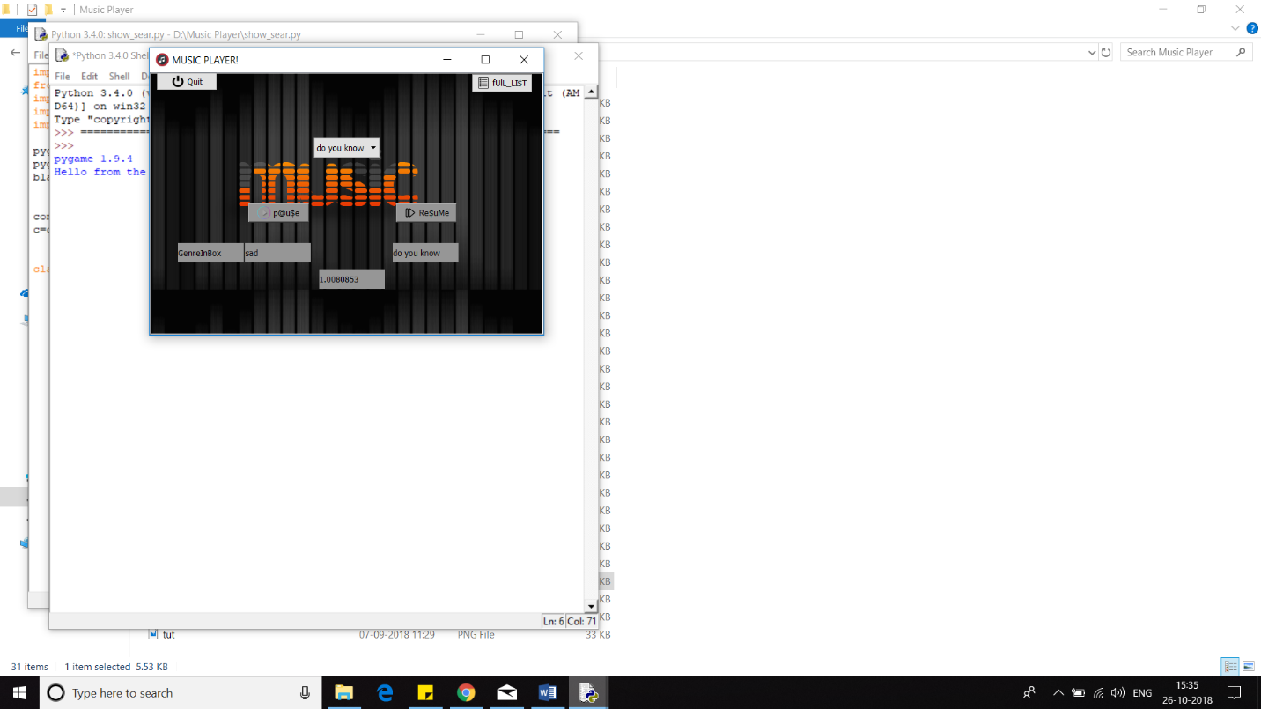

**INFERENCES**

Perceiving melodic inclination remains a testing issue. In the previous 5 years, the execution of computerized frameworks for music feeling acknowledgment utilizing a wide range has progressed altogether. The majority of the media player give rundown of tunes in client's music library and alternative to choose or look through the melody however it turns out to be progressively troublesome undertaking .Our framework will give better satisfaction to the music audience members by giving the most reasonable or fitting tune to the client as per his present temperament. In this paper, we present a proposed framework and a methodology for the programmed production of mind-set based playlist. The proposed framework will decrease the endeavors of client in making and overseeing playlist It won't as it were encourage client yet in addition the melodies are methodically arranged.

***GRAPH COMPARISON***

***TIME COMPLEXITY***

We know that the time complexity of the linear search in worst case is ***“O(n)”.***Seeing from our time stamp and the time complexity of our search algorithm(***modified KMP***) is “***log(n)”*** which is lesser that is less than the linear search. The graph below shows the comparison.

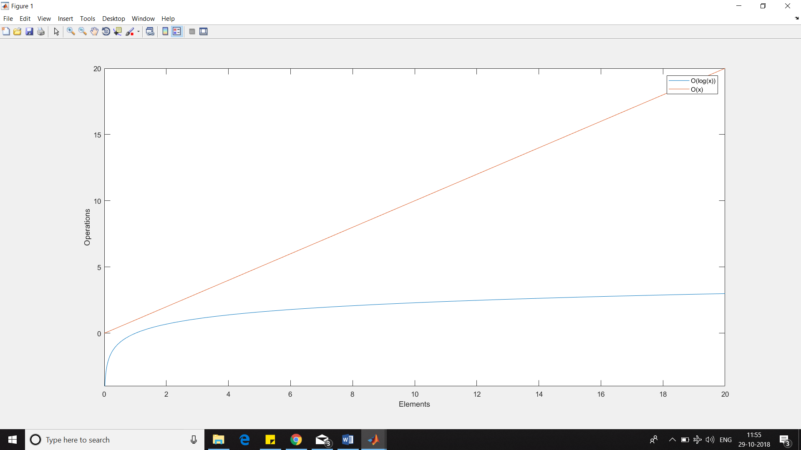

**CONCLUSION AND FUTURE REFERANCES**

Experimental results have shown that the time required for audio feature extraction is negligible (around 0.0006 sec) and songs are stored pre-handed the total estimation time of the proposed system is proportional to the time required for extraction of facial features (around 0.9994 sec).Also the various classes of emotion yield a better accuracy rate as compared to previous existing systems. The computational time taken is 1.000sec which is very less thus helping in achieving a better real time performance and efficiency.

The system thus aims at providing the Windows operating system users with a cheaper, additional hardware free and accurate emotion based music system. The Emotion Based Music System will be of great advantage to users looking for music based on their mood and emotional behavior. It will help reduce the searching time for music thereby reducing the unnecessary computational time and thereby increasing the overall accuracy and efficiency of the system. The system will not only reduce physical stress but will also act as a boon for the music therapy systems and may also assist the music therapist to therapize a patient. Also with its additional features mentioned above, it will be a complete system for music lovers and listeners

The future scope in the system would to design a mechanism that would be helpful in music therapy treatment and provide the music therapist the help needed to treat the patients suffering from disorders like mental stress, anxiety, acute depression and trauma. The proposed system also tends to avoid in future the unpredictable results produced in extreme bad light conditions and very poor camera resolution

**REFERENCES**

1. <https://medium.com/python-pandemonium/that-one-substring-algorithm-8ea7b4ba22d1>
2. <https://pythonprogramming.net/basic-gui-pyqt-tutorial/>
3. <https://www.youtube.com/watch?v=pq4nwICEB4U&index=4&list=PLQVvvaa0QuDezJh0sC5CqXLKZTSKU1YNo>
4. <https://pythonprogramming.net/pygame-python-3-part-1-intro/>