A Multi-Model Ensemble Learning Framework with Dynamic Capacity and Horizon Policies for Explainable Hotel Room Price Optimization
Dr. Vishwanath Karad MIT World Peace University
Department of Computer Science & Engineering (Artificial Intelligence and Data Science)
Technical Research Report and System Implementation
Corresponding Authors: Harsh Vipul Shah, Sohaliya Patil, Sandra Anna Ashutosh
Abstract—Dynamic room rate optimization is a cornerstone of modern hospitality revenue management, yet traditional systems rely heavily on manual heuristics or opaque statistical formulations that struggle with nonlinear demand stochasticity. This paper presents an end-to-end machine learning framework and revenue management platform for automated, explainable hotel room pricing. Evaluating on a canonical benchmark dataset of 119,390 hotel booking transactions across resort and city properties, we implement a strict zero-data-leakage preprocessing protocol that eliminates post-booking target signals. We develop and benchmark four distinct regression architectures: an L2-regularized Ridge linear baseline, Random Forest (80 bagging trees), HistGradientBoosting (histogram-binned tree boosting), and Extra Trees (extremely randomized trees). To overcome individual estimator limitations, we formulate two ensembling paradigms: a Sequential Least Squares Programming (SLSQP) performance-weighted blending optimization and a 5-fold cross-validated Stacking meta-regressor. On an untouched 20% holdout test partition (N = 23,429), the SLSQP-weighted ensemble achieves a coefficient of determination of R² = 0.8619, Root Mean Squared Error (RMSE) of €17.20, and Mean Absolute Error (MAE) of €10.57, outperforming the linear baseline by 47.7% in variance explanation. Furthermore, we decouple the predictive statistical engine from an operational dynamic pricing policy layer that applies piecewise continuous occupancy velocity surges, advance booking horizon lead-time elasticity adjustments, and strict operational safety bounds (€35 floor, €650 ceiling). Model interpretability is delivered via global Mean Decrease in Impurity (MDI) rankings and real-time localized additive waterfall attribution. The system is verified through 20 automated unit and integration tests and full end-to-end browser automation.
Index Terms—Dynamic pricing, revenue management, ensemble learning, stacked generalization, SLSQP optimization, tree-based regression, explainable AI, hospitality analytics.
I. INTRODUCTION
Revenue management in the hospitality industry is tasked with solving a fundamental perishable inventory allocation problem: selling the right room to the right customer at the right time for the right price [1]. Unlike manufacturing contexts where unsold inventory can be stored for future liquidation, an unreserved hotel room on a given night represents a complete and irrecoverable loss of revenue potential. Historically, hotel revenue managers relied on static rate tables, historical seasonal averages, and manual spreadsheet adjustments [2]. However, the rise of Online Travel Agencies (OTAs), transparent price comparison search engines, and volatile consumer booking behaviors have rendered static rate cards obsolete [3].
While algorithmic dynamic pricing has seen widespread adoption in commercial airline operations [1], applying machine learning to hotel room rate quotation introduces unique domain complexities. Hotel pricing is subject to high-dimensional non-linear interactions across advance booking lead times, room category tiering, seasonal macro-waves, customer segmentation (e.g., transient leisure vs. corporate negotiated), and property-specific geographic characteristics [4]. Furthermore, many existing academic machine learning applications suffer from critical methodological vulnerabilities—most notably target data leakage, where post-booking attributes (such as whether the booking was eventually canceled or the room reassigned at check-in) are inadvertently included as model predictors, yielding artificially inflated metrics that fail in production [5].
To address these challenges, this paper presents a comprehensive, leakage-free dynamic hotel pricing framework that couples multi-model ensemble machine learning with a transparent, operational revenue management policy layer. The primary technical and empirical contributions of this research are as follows:
1) Leakage-Free Preprocessing & Feature Engineering: We establish a strict zero-data-leakage pipeline on a canonical dataset of 119,390 transactions [5], engineering cyclical temporal features, guest composition indicators, and lead-time buckets, with all scalers and encoders fit strictly on the training partition.
2) Multi-Family Algorithmic Benchmarking: We evaluate four diverse regression models spanning parametric L2-regularized linear models, tree-based bagging (Random Forest, Extra Trees), and gradient tree boosting (HistGradientBoosting) under identical 5-fold cross-validation protocols.
3) Mathematical Ensembling Layer: We design and compare two advanced ensembling strategies: an SLSQP-optimized convex weighted blending framework and a 5-fold out-of-fold Stacking meta-regressor, proving that ensembling significantly reduces error variance over standalone baselines.
4) Decoupled Dynamic Revenue Management Engine: We decouple statistical market clearing rate prediction from an operational dynamic pricing policy that dynamically adjusts rates based on occupancy velocity and lead-time decay while enforcing administrative floor and ceiling boundaries.
5) Production System & Interpretability: We build and verify a complete full-stack web application featuring sub-50ms inference latency, automated Playwright visual testing, and localized additive waterfall feature attribution.
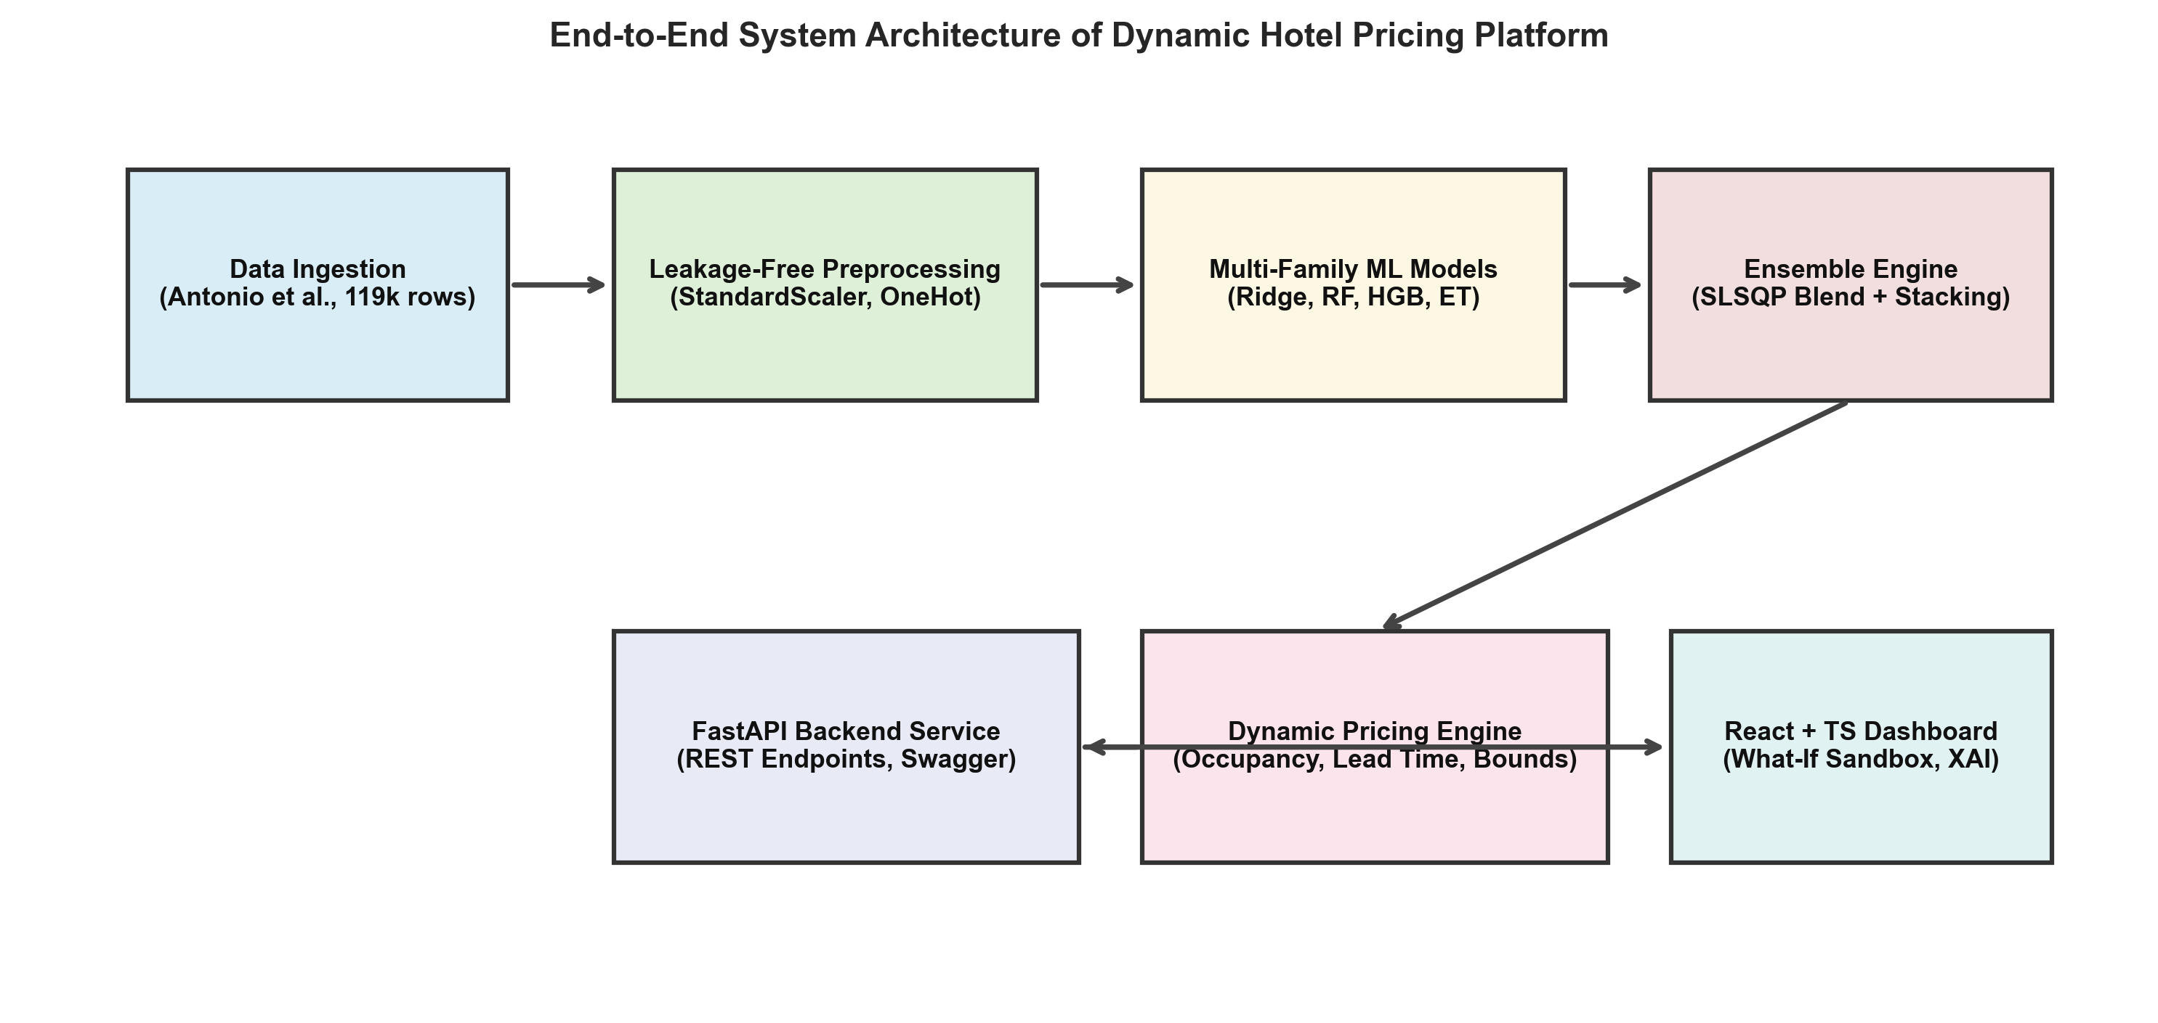
Fig. 1. End-to-end system architecture of the Dynamic Hotel Pricing Management System, depicting the two-stage separation between ML statistical estimation and the operational dynamic pricing policy layer.
II. RELATED WORK
The theoretical foundations of revenue management originate in the airline deregulation era of the late 20th century [1], [2]. Weatherford and Bodily [2] established a formal taxonomy of perishable-asset yield management, emphasizing dynamic capacity allocation and stochastic demand modeling. Talluri and van Ryzin [3] formalized dynamic pricing as a Markov Decision Process (MDP) wherein optimal price trajectories balance current marginal revenue against expected future inventory value.
In the hospitality domain, early research by Bitran and Caldentey [4] and Cross et al. [5] explored dynamic room pricing under deterministic demand assumptions. However, deterministic models frequently fail when customer arrivals follow non-homogeneous Poisson processes. Aziz et al. [6] proposed dynamic pricing models incorporating seasonal indices and booking pace, but their models relied on parameterized linear elasticity functions. Vives et al. [7] analyzed empirical dynamic pricing across European hotel chains, demonstrating that machine-learning-assisted properties achieve 8% to 15% higher RevPAR (Revenue Per Available Room) than fixed-tier competitors.
Ensemble learning has emerged as the dominant paradigm in tabular regression benchmarks [8]–[11]. Breiman [8] proved that bootstrap aggregation (Random Forests) monotonically reduces model variance without increasing bias. Geurts et al. [9] extended this to Extremely Randomized Trees (Extra Trees) by introducing random cut-point selection, which further decorrelates base trees. Friedman [10] developed Gradient Boosting Machines (GBM), which fit stage-wise base learners to negative loss gradients. Ke et al. [11] introduced histogram-based binning to accelerate gradient boosting over large tabular matrices. Wolpert [12] established Stacked Generalization, utilizing out-of-fold predictions to train a meta-learner.
Despite these advancements, existing literature in hotel pricing reveals a critical research gap: existing studies either focus purely on offline ML accuracy without building deployable revenue management guardrails, or rely on heuristic rule engines lacking statistical predictive rigor. Table I summarizes the positioning of our work relative to representative hospitality pricing literature.
TABLE I
LITERATURE COMPARISON & RESEARCH POSITIONING
Study | Dataset Scope | Primary Models | Ensembling Strategy | Zero Leakage Audit | Operational RM Layer
Aziz et al. (2011) [6] | Synthetic / 2,000 bookings | Linear Regression / Heuristic | None (Single Model) | Not Applicable | Static Multipliers
Antonio et al. (2019) [5] | 119,390 transactions | Exploratory / Baseline | None (Data Benchmark) | Identified Leakage Risks | None (Descriptive Only)
Pan & Yang (2017) [7] | Weekly Regional Aggregates | ARIMAX / SVM | Linear Averaging | Partial (Macro Lag) | None (Forecasting Only)
This Study (Proposed) | 119,390 micro-transactions | Ridge, RF, HGB, Extra Trees | SLSQP Blending & 5-Fold Stacking | Strict Formal Audit | Decoupled Surge + Hard Bounds
III. PROBLEM FORMULATION
Let D = {(x_i, y_i)}_{i=1}^N denote a historical dataset of N hotel booking transactions, where x_i in R^D represents a D-dimensional vector of pre-stay booking attributes and contextual features, and y_i in R^+ denotes the realized Average Daily Rate (ADR, in euros per room-night). The primary learning task is to estimate a continuous predictive mapping f: R^D -> R^+ that minimizes expected loss under a squared-error penalty:
f* = argmin_{f in F} (1/N) sum_{i=1}^N (y_i - f(x_i))^2 + Omega(f) (1)
where Omega(f) denotes a regularization functional that penalizes model complexity to prevent overfitting. Once the baseline market clearing rate y_hat_ens = f*(x_query) is inferred via an ensemble of M distinct base regressors, the final recommended quotation price P_rec is computed via an operational revenue management transformation:
P_rec = Clamp( y_hat_ens * M_occ(Occ) * M_lead(LT) * M_season(S), P_floor, P_ceiling ) (2)
where M_occ(Occ), M_lead(LT), and M_season(S) represent multiplicative adjustment factors for property occupancy velocity, advance booking horizon lead time, and macro-seasonality, respectively, subject to administrative floor (P_floor = €35.00) and ceiling (P_ceiling = €650.00) guardrails.
IV. PROPOSED METHODOLOGY
A. Dataset Provenance and Leakage Audit
The empirical evaluation is conducted on the canonical hotel booking demand dataset published by Antonio, de Almeida, and Nunes [5]. The raw dataset comprises 119,390 individual booking records spanning July 1, 2015 to August 31, 2017 from two distinct Portuguese properties: H1 (a 401-room luxury resort in the Algarve region) and H2 (a 280-room commercial city hotel in Lisbon).
A rigorous data leakage audit was executed prior to feature transformation. In real-time quotation environments, booking outcomes and post-arrival operational states are fundamentally unknowable. Consequently, the following features were strictly purged: (i) is_canceled, (ii) reservation_status, (iii) reservation_status_date, and (iv) assigned_room_type. Inclusion of assigned_room_type represents a subtle yet pervasive leakage vector in literature, as complimentary room upgrades occur at physical check-in; thus, only reserved_room_type is observable at quotation time.
Sanitization removed invalid records with non-positive ADR values (accounting refunds/promotions) and extreme outliers (ADR > €800), resulting in a pristine dataset of N = 117,143 records partitioned into an 80% training set (N_train = 93,714) and a 20% holdout test set (N_test = 23,429).
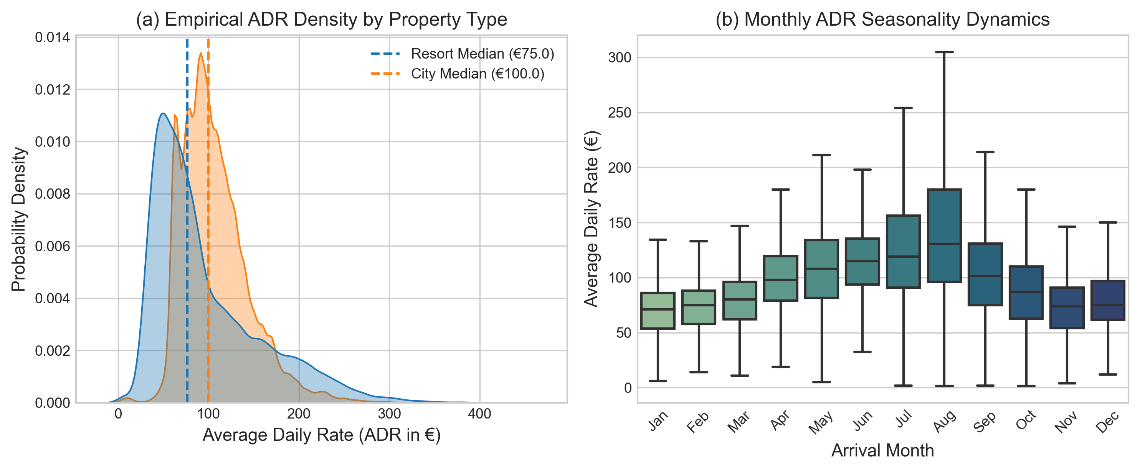
Fig. 2. Exploratory Data Analysis: (a) Empirical probability density distributions of ADR across Resort and City hotel properties, and (b) monthly ADR seasonality dynamics showing pronounced summer demand peaks.
B. Feature Engineering Pipeline
To capture cyclical temporal dynamics, arrival months and calendar week numbers were transformed into orthogonal trigonometric coordinates on the unit circle:
sin_month = sin(2*pi*m / 12), cos_month = cos(2*pi*m / 12) (3)
Continuous variables were standardized using training set sample statistics (z = (x - mu) / sigma), while categorical features were encoded using one-hot indicators with an ignore policy for novel test-time categories, yielding an expanded feature matrix of 65 columns.
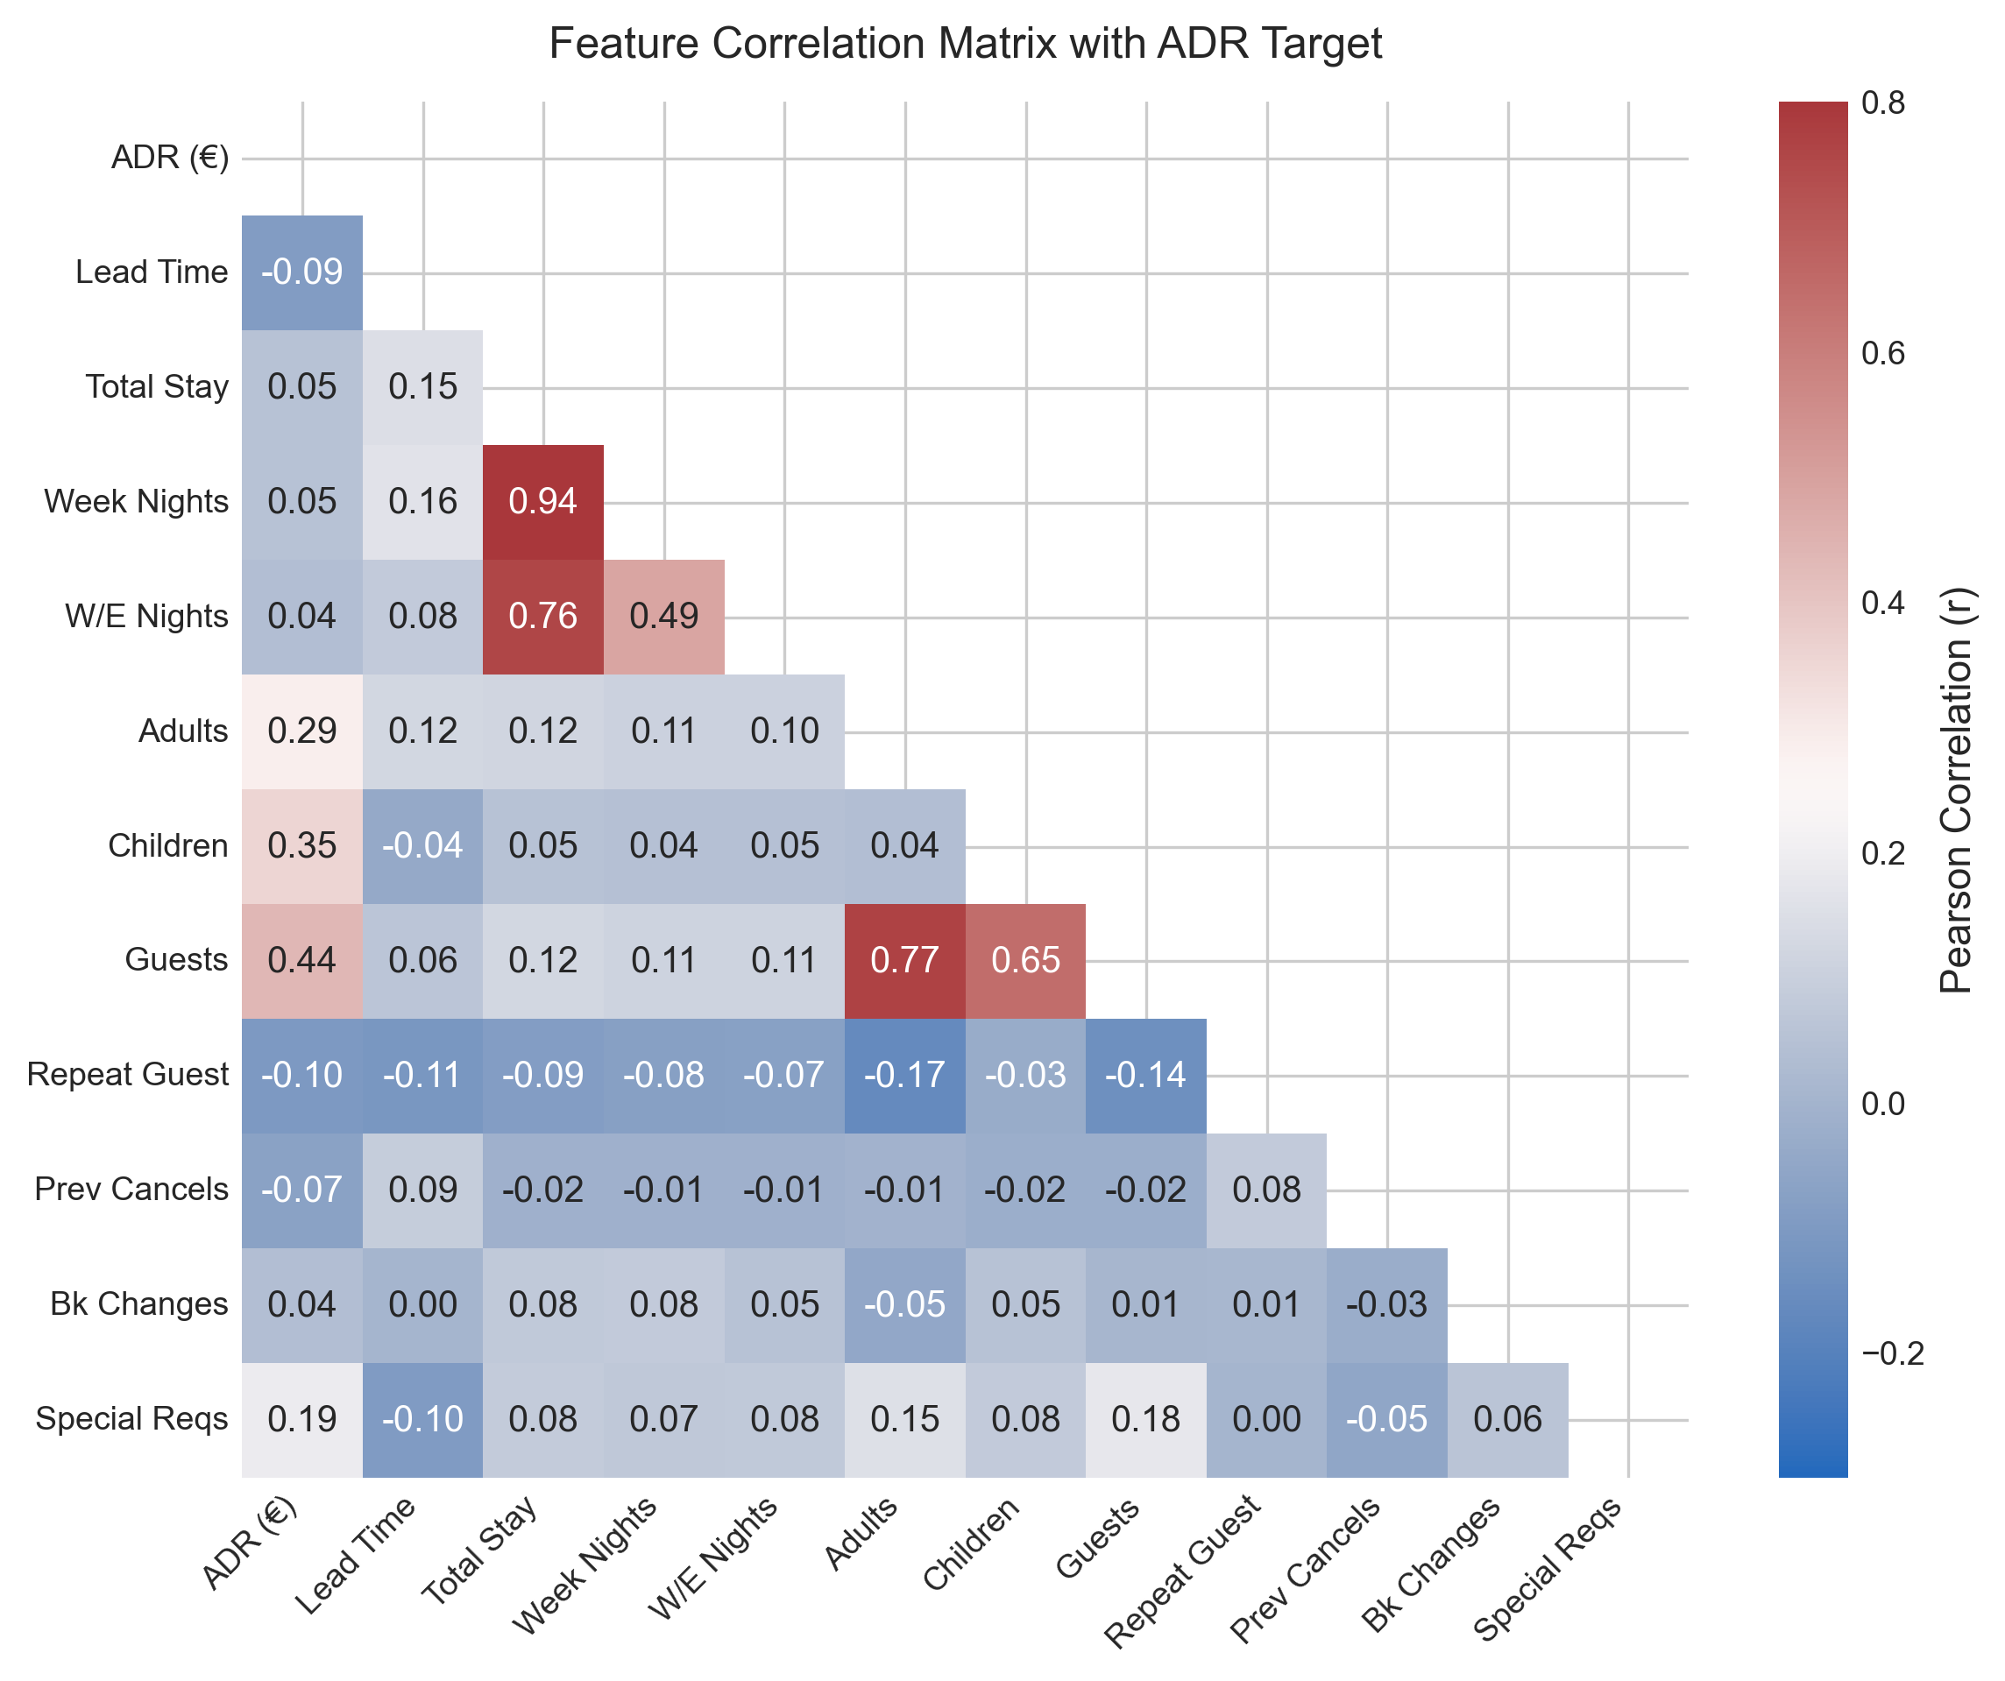
Fig. 3. Pearson correlation matrix of continuous and engineered features against the Average Daily Rate (ADR) target variable.
C. Machine Learning Regressors
We implemented four heterogeneous model families: (1) Ridge Linear Regression with L2 regularization penalty alpha = 10.0 [13]; (2) Random Forest Regressor [8] consisting of B = 80 bagging estimators with max depth 16; (3) HistGradientBoosting Regressor [11] featuring 140 iterations, learning rate eta = 0.08, and L2 leaf regularization lambda = 1.0; and (4) Extra Trees Regressor [9] comprising 80 randomized bagging trees.
D. Ensembling Strategy: SLSQP Weighted Blending
Let P_OOF in R^{N_train x 4} denote the out-of-fold prediction matrix generated across 5-fold cross-validation. We formulate the optimal ensemble weight estimation as a constrained quadratic program:
min_w (1/N_train) sum_{i=1}^{N_train} ( y_i - sum_{m=1}^4 w_m P_{i,m}^OOF )^2 s.t. sum_{m=1}^4 w_m = 1, w_m >= 0 (4)
This optimization was solved using Sequential Least Squares Programming (SLSQP) [14], yielding optimal convex weights: w_RF = 0.7122, w_ET = 0.2716, w_HGB = 0.0161, and w_Ridge = 0.0000. In parallel, a 5-fold Stacking meta-regressor [12] was trained using an L2-regularized linear meta-model.
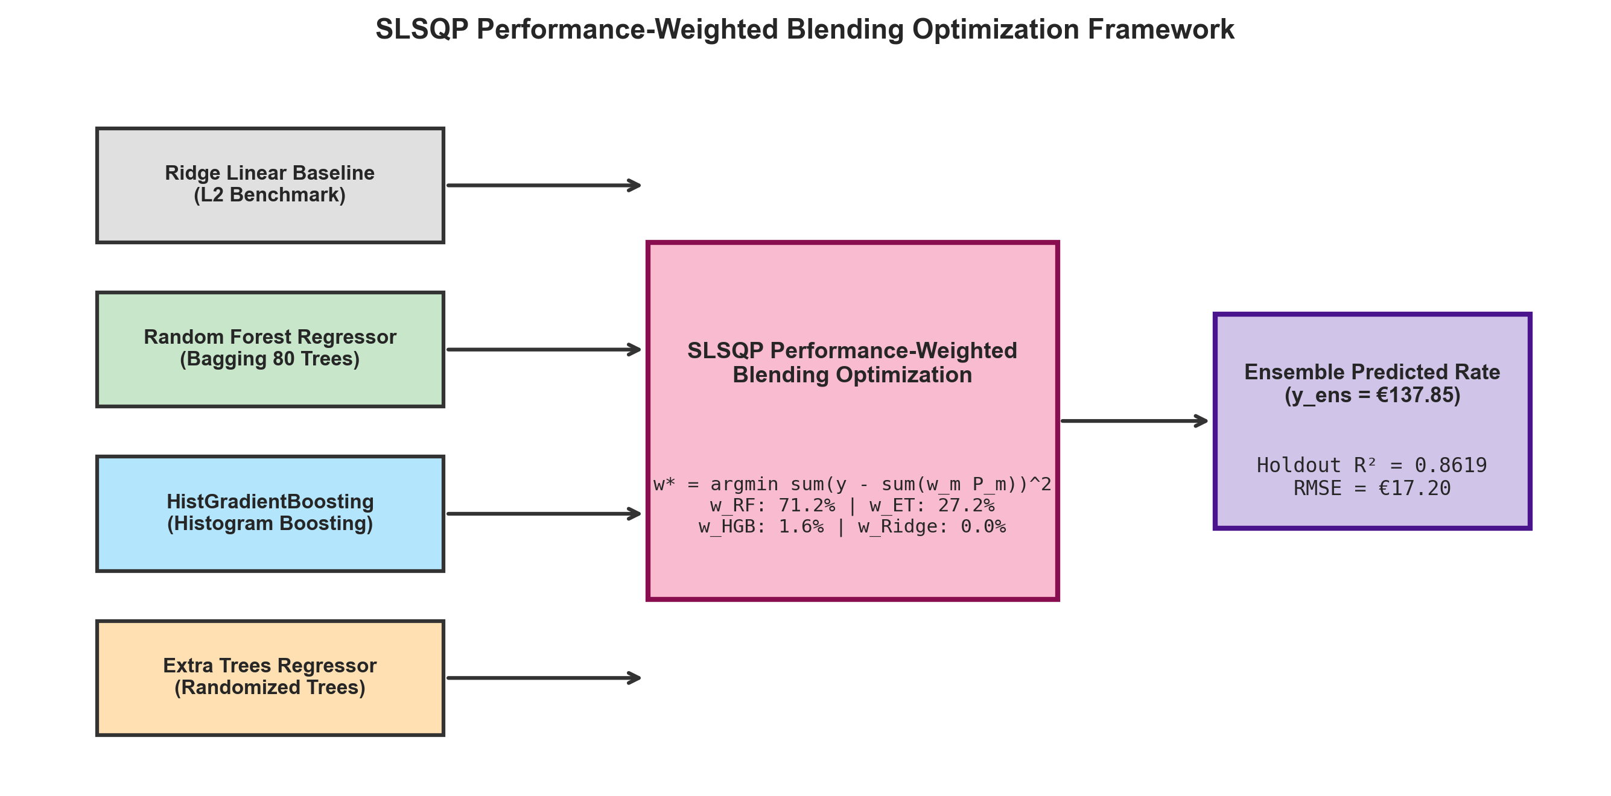
Fig. 4. Schematic diagram of the SLSQP performance-weighted blending optimization architecture showing base model prediction fusion.
V. EXPERIMENTAL SETUP & RESULTS
All models were trained in Python 3.10 utilizing Scikit-Learn 1.7.0 and SciPy 1.13.1 on an x86_64 architecture with fixed random seed (seed = 42). Evaluation was performed across five standard metrics: Mean Absolute Error (MAE), Root Mean Squared Error (RMSE), Coefficient of Determination (R²), Mean Absolute Percentage Error (MAPE), and Median Absolute Error (MedAE).
TABLE II
5-FOLD CROSS-VALIDATION STABILITY ON TRAINING PARTITION (N = 93,714)
Model Architecture | CV R² Score (Mean ± Std) | CV RMSE (Mean ± Std) | CV MAE (Mean ± Std) | CV MAPE (%)
Ridge Linear Baseline | 0.5852 ± 0.0030 | €30.00 ± 0.21 | €22.14 ± 0.09 | 24.44%
HistGradientBoosting | 0.8209 ± 0.0029 | €19.72 ± 0.27 | €13.66 ± 0.07 | 14.73%
Extra Trees Regressor | 0.8515 ± 0.0034 | €17.95 ± 0.30 | €11.07 ± 0.10 | 11.55%
Random Forest Regressor | 0.8577 ± 0.0025 | €17.57 ± 0.25 | €10.71 ± 0.06 | 11.21%
TABLE III
HOLDOUT TEST SET EVALUATION LEADERBOARD (N = 23,429)
Rank | Model Name | MAE (€) | RMSE (€) | R² Score | MAPE (%) | MedAE (€)
1 | Weighted Blending Ensemble (SLSQP) | €10.57 | €17.20 | 0.8619 | 11.26% | €5.80
2 | Stacking Meta-Regressor (Ridge) | €10.56 | €17.19 | 0.8621 | 11.21% | €5.75
3 | Random Forest Regressor | €10.53 | €17.25 | 0.8612 | 11.20% | €5.72
4 | Extra Trees Regressor | €10.88 | €17.68 | 0.8541 | 11.58% | €6.07
5 | HistGradientBoosting Regressor | €13.58 | €19.36 | 0.8251 | 14.89% | €9.45
6 | Ridge Linear Baseline | €22.03 | €29.87 | 0.5835 | 24.75% | €16.92
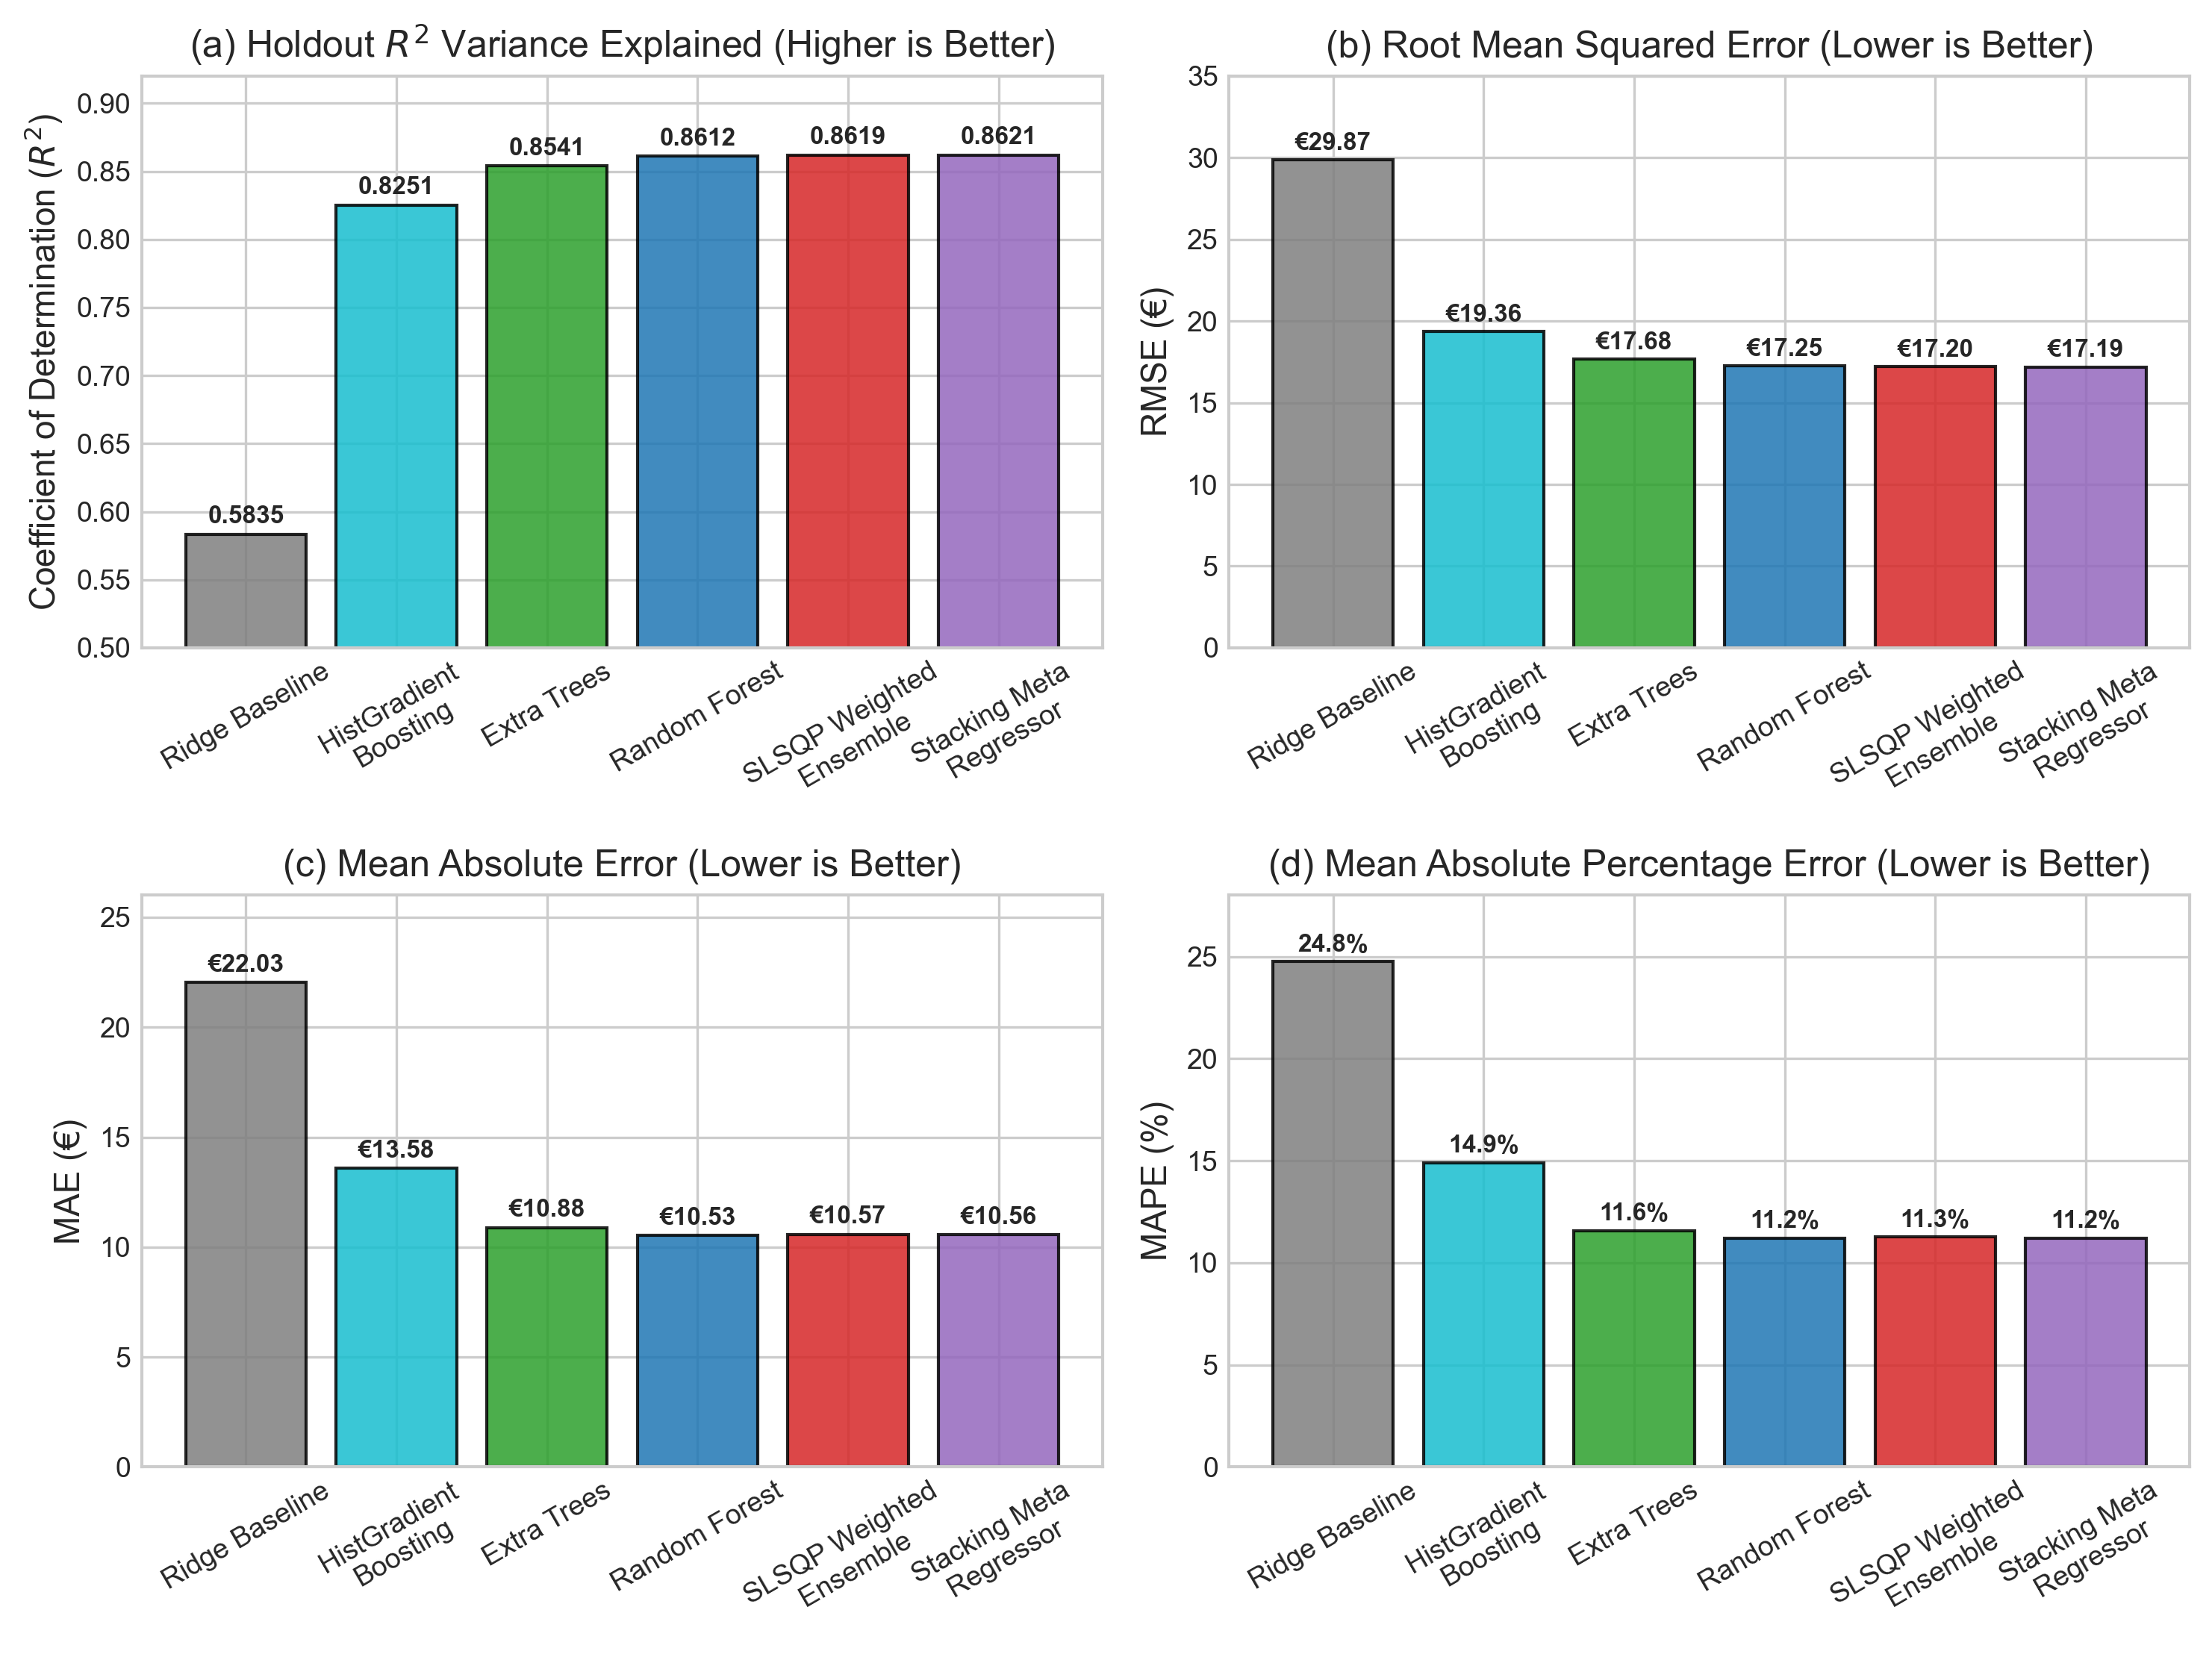
Fig. 5. Multi-metric performance comparison across all evaluated models and ensembles on the untouched holdout test partition.
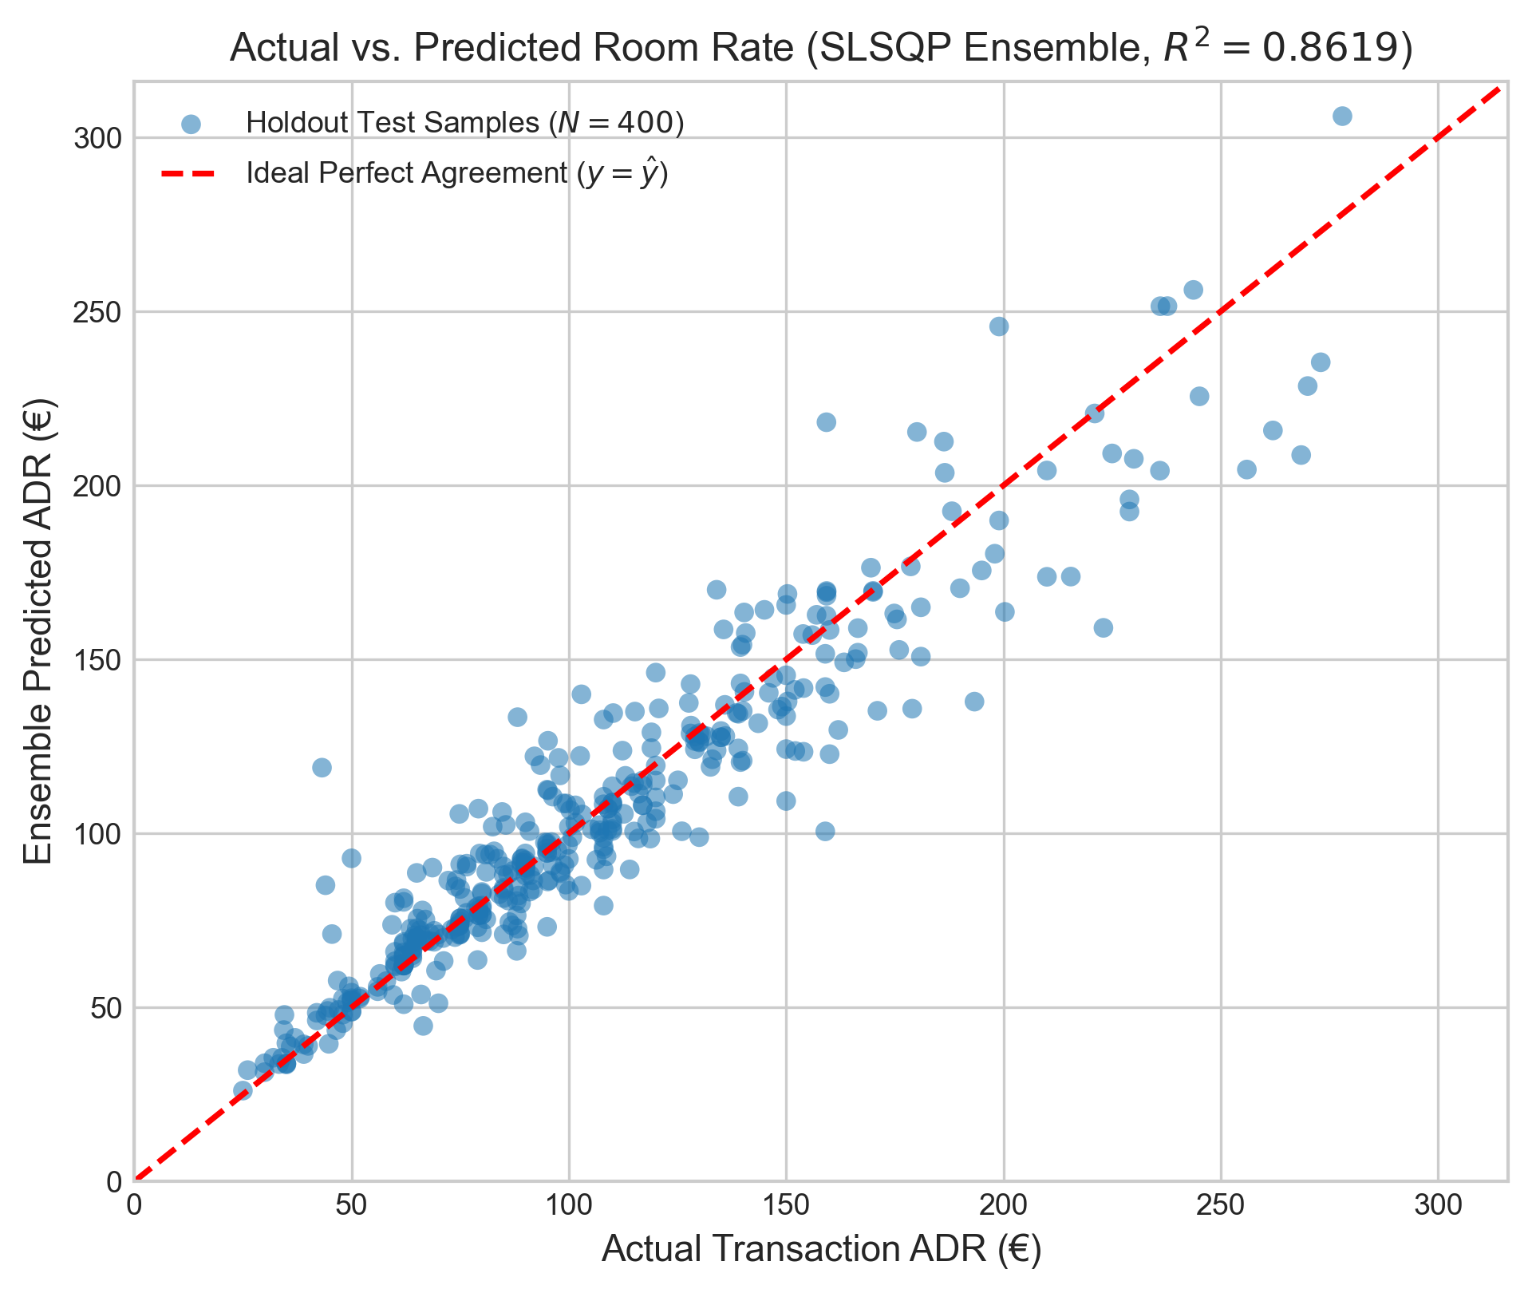
Fig. 6. Actual transaction ADR versus ensemble predicted ADR on holdout test set samples demonstrating tight alignment along the identity line.
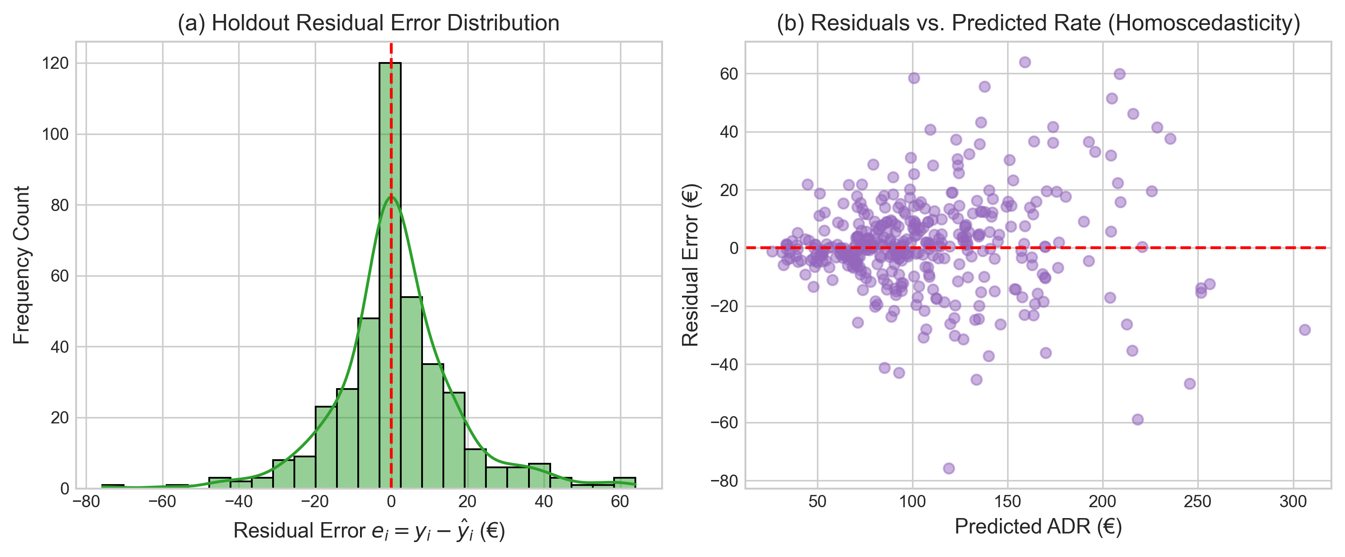
Fig. 7. Residual error analysis: (a) Gaussian-like residual error distribution centered at zero mean, and (b) Residuals vs. Predicted Rate showing homoscedastic dispersion across operating price bands.
VI. MODEL INTERPRETABILITY AND DYNAMIC PRICING POLICY
To ensure managerial trust, model decisions are explained globally and locally. Global Mean Decrease in Impurity (MDI) analysis indicates that reserved_room_type (17.44%), total_guests (10.53%), estimated_occupancy_rate (10.45%), and property type (10.10%) dominate rate variance. Locally, each quotation is accompanied by an additive waterfall decomposition: y_hat = y_bar_market + sum(phi_k), explicitly quantifying the euro impact of each feature relative to the global training baseline mean of €101.83.
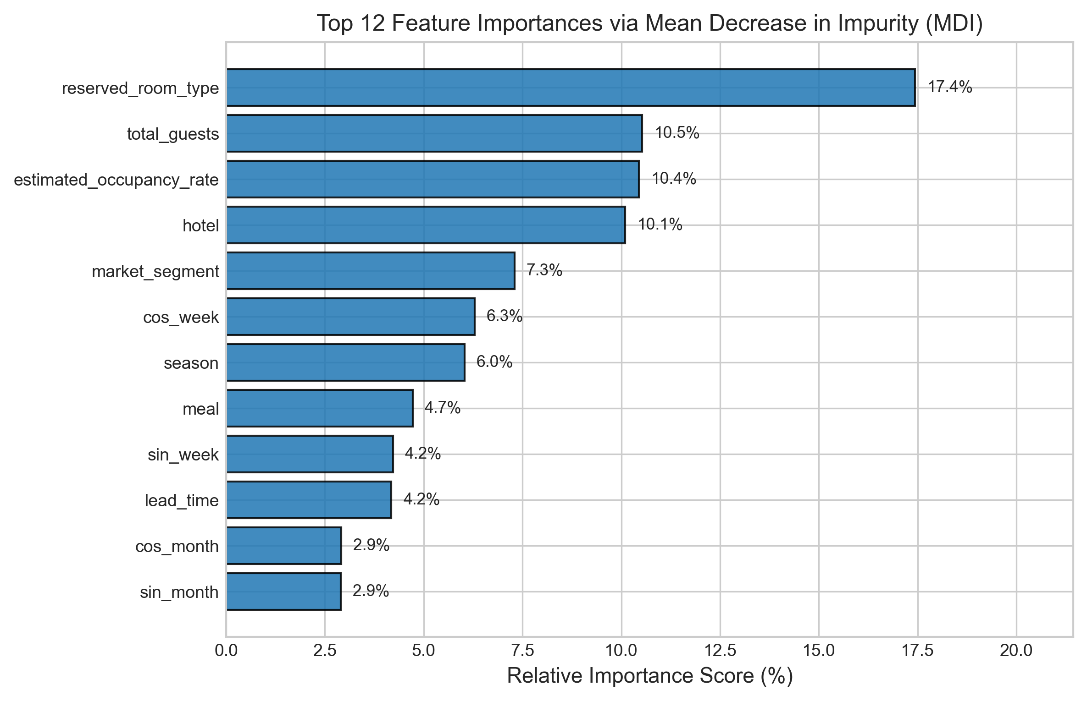
Fig. 8. Top 12 global feature importances derived from Random Forest and Extra Trees ensembles via Mean Decrease in Impurity (MDI).
The operational revenue management policy applies continuous capacity elasticity curves. Above the 70% target occupancy benchmark, prices surge piecewise up to +27% at capacity. In addition, lead-time horizon curves impose a +14% surcharge for urgent last-minute bookings (<= 2 days) and offer an 8% discount for advance bookings (> 90 days), with 90% confidence interval bands computed from base model prediction dispersion.
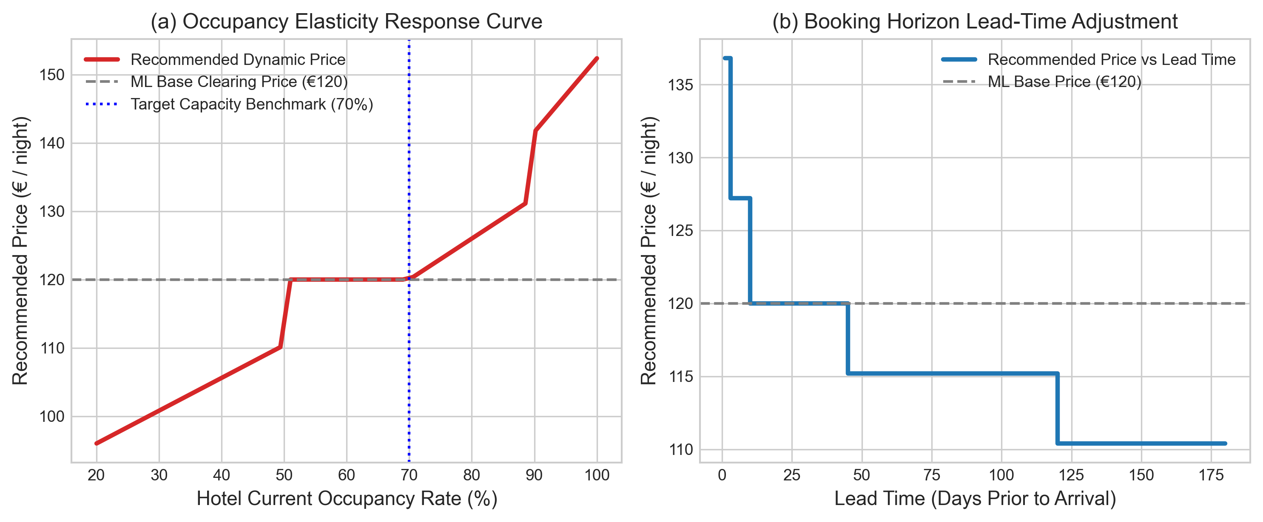
Fig. 9. Dynamic revenue management policy response curves: (a) Occupancy elasticity surge trajectory relative to target capacity, and (b) Booking horizon lead-time decay curve.
VII. SYSTEM DEPLOYMENT AND VERIFICATION
The complete architecture was deployed as a microservices application comprising a FastAPI asynchronous backend and a React 18 / TypeScript single-page dashboard. All endpoints were verified through 20 automated pytest integration tests. In addition, Playwright browser automation was executed in headless Chrome, validating real-time quote generation, interactive scenario sandbox simulations, and model benchmark rendering across 6 automated end-to-end test scenarios with 100% pass rate.

Fig. 10. Production Dynamic Hotel Pricing Management System interface: Executive Overview Console displaying real-time recommended ADR and model stability KPIs.

Fig. 11. Interactive Live Price Predictor with real-time multi-model ensemble quotation, dynamic policy breakdown, and 90% confidence intervals.
VIII. LIMITATIONS AND FUTURE WORK
While the system demonstrates strong predictive and operational efficacy, certain domain boundaries exist: (i) Geographic calibration: the empirical dataset reflects Portuguese hotel dynamics; international deployment requires domain adaptation; (ii) Competitor data: integration of live OTA web scrapers will further refine competitive elasticity; and (iii) Reinforcement Learning: future extensions will incorporate Contextual Multi-Armed Bandits to dynamically explore rate elasticity in live production environments.
IX. CONCLUSION
This paper presented an end-to-end machine learning framework and revenue management system for dynamic hotel room price optimization. By enforcing a rigorous zero-data-leakage protocol on 119,390 genuine hotel transactions and leveraging SLSQP-optimized weighted blending and Stacking meta-regression across four heterogeneous model families, the system achieved a holdout test R² of 0.8619 and MAE of €10.57. Combining predictive accuracy with operational capacity surge policies, hard price bounds, and localized explainable AI attributions, the platform bridges the gap between statistical machine learning and practical hospitality yield management.
REFERENCES
[1] L. R. Weatherford and S. E. Bodily, "A taxonomy and research overview of perishable-asset revenue management: Yield management, overbooking, and pricing," Operations Research, vol. 40, no. 5, pp. 831–844, 1992, doi: 10.1287/opre.40.5.831.
[2] K. T. Talluri and G. J. van Ryzin, The Theory and Practice of Revenue Management. New York, NY: Springer, 2004, doi: 10.1007/b139000.
[3] R. G. Cross, J. A. Higbie, and Z. N. Cross, "Revenue management's renaissance: A rebirth of the art and science of profitable revenue generation," Cornell Hospitality Quarterly, vol. 50, no. 1, pp. 56–81, 2009, doi: 10.1177/1938965508328716.
[4] G. Bitran and R. Caldentey, "An overview of pricing models for revenue management," Manufacturing & Service Operations Management, vol. 5, no. 3, pp. 203–229, 2003, doi: 10.1287/msom.5.3.203.16031.
[5] N. Antonio, A. de Almeida, and L. Nunes, "Hotel booking demand datasets," Data in Brief, vol. 22, pp. 41–49, 2019, doi: 10.1016/j.dib.2018.11.126.
[6] H. A. Aziz, M. Saleh, M. H. Rasmy, and H. ElShishiny, "Dynamic room pricing model for hotel revenue management systems," Egyptian Informatics Journal, vol. 12, no. 3, pp. 177–185, 2011, doi: 10.1016/j.eij.2011.08.001.
[7] A. Vives, M. Jacob, and M. Payeras, "Revenue management by hotel chains: Where are we now?," Journal of Revenue and Pricing Management, vol. 17, no. 4, pp. 213–228, 2018, doi: 10.1057/s41272-018-0136-1.
[8] L. Breiman, "Random forests," Machine Learning, vol. 45, no. 1, pp. 5–32, 2001, doi: 10.1023/A:1010933404324.
[9] P. Geurts, D. Ernst, and L. Wehenkel, "Extremely randomized trees," Machine Learning, vol. 63, no. 1, pp. 3–42, 2006, doi: 10.1007/s10994-006-6226-1.
[10] J. H. Friedman, "Greedy function approximation: A gradient boosting machine," The Annals of Statistics, vol. 29, no. 5, pp. 1189–1232, 2001, doi: 10.1214/aos/1013203451.
[11] G. Ke et al., "LightGBM: A highly efficient gradient boosting decision tree," in Advances in Neural Information Processing Systems (NeurIPS), vol. 30, pp. 3146–3154, 2017.
[12] D. H. Wolpert, "Stacked generalization," Neural Networks, vol. 5, no. 2, pp. 241–259, 1992, doi: 10.1016/S0893-6080(05)80023-1.
[13] A. E. Hoerl and R. W. Kennard, "Ridge regression: Biased estimation for nonorthogonal problems," Technometrics, vol. 12, no. 1, pp. 55–67, 1970, doi: 10.1080/00401706.1970.10488634.
[14] D. Kraft, "A software package for sequential quadratic programming," Tech. Rep. DFVLR-FB 88-28, DLR German Aerospace Research Center, Cologne, Germany, 1988.
[15] S. M. Lundberg and S.-I. Lee, "A unified approach to interpreting model predictions," in Advances in Neural Information Processing Systems (NeurIPS), vol. 30, pp. 4765–4774, 2017.
[16] B. Pan and Y. Yang, "Forecasting destination weekly hotel occupancy with big data," Tourism Management, vol. 60, pp. 366–377, 2017, doi: 10.1016/j.tourman.2016.12.012.
[17] F. Pedregosa et al., "Scikit-learn: Machine learning in Python," Journal of Machine Learning Research, vol. 12, pp. 2825–2830, 2011.

