Lumina-RMS: An Explainable and Capacity-Aware Multi-Model Ensemble Framework for Dynamic Hotel Room Price Optimization
Department of Computer Engineering
Dr. Vishwanath Karad MIT World Peace University, Pune, India
Harsh Vipul Shah (Lead Author)
Sohaliya Patil, Sandra Santosh, Raed Nasser (Co-Authors)
Undergraduate Degree Programme in Computer Engineering
Research Portfolio & Production System Implementation
Abstract—A pricing model that outputs only an unconstrained scalar rate leaves revenue managers with the operational burden of deciding whether that estimate respects inventory scarcity, booking urgency, and brand capital. Lumina-RMS is an implemented dynamic room rate optimization framework developed on the canonical Antonio et al. (2019) hospitality dataset, comprising 119,390 genuine Portuguese hotel booking transactions across resort (Algarve) and city (Lisbon) properties. The architecture decouples statistical transaction price estimation from operational capacity allocation policies. A strict zero-data-leakage protocol purges four post-booking leakage vectors prior to feature transformation. Four orthogonal base regressors—L2-regularized Ridge regression, Random Forest bagging (80 trees, depth 16), HistGradientBoosting (140 iterations, learning rate 0.08), and Extra Trees (80 randomized trees)—are trained on 93,714 records under 5-fold cross-validation. To synthesize these distinct inductive biases, two ensembling paradigms are formulated: a Sequential Least Squares Programming (SLSQP) convex quadratic optimization problem over out-of-fold predictions, and a second-stage Ridge stacking meta-regressor. On an untouched 20% holdout test partition of 23,429 transactions, the SLSQP-weighted ensemble achieves a coefficient of determination of R² = 0.8619, Root Mean Squared Error (RMSE) of €17.20, and Mean Absolute Error (MAE) of €10.57, improving variance explanation by 47.7% relative to the linear baseline (R² = 0.5835). The subsequent revenue management policy applies piecewise continuous capacity velocity multipliers (scaling up to +22.5% at 95% occupancy), advance booking horizon decay curves, and administrative safety boundaries clamped strictly between €35.00 and €650.00. Decision transparency is provided through global Mean Decrease in Impurity (MDI) rankings and local additive waterfall attributions. The complete system is deployed as an asynchronous FastAPI backend and React 18 single-page application, verified via 20 unit tests and automated Playwright browser test suites across all operational views.
Index Terms—Hospitality revenue management, dynamic pricing, ensemble learning, stacked generalization, SLSQP optimization, tree-based regression, explainable AI, zero data leakage.
I. INTRODUCTION
Selling a perishable hospitality asset involves an irrevocable trade-off: every night a hotel room sits vacant, its marginal revenue potential drops to zero, while selling too cheaply early in the booking window cannibalizes high-yield walk-in or business demand [1]. Traditional revenue management systems (RMS) have historically depended on static seasonal rate cards, heuristic markups, and human manager intuition [2]. The proliferation of Online Travel Agencies (OTAs), dynamic meta-search aggregators, and rapid consumer price comparison has exposed the fragility of these fixed mechanisms, leading to severe yield compression during demand troughs and missed surplus during peak market surges [3].
While statistical yield management originated in the post-deregulation airline industry through Expected Marginal Seat Revenue (EMSR) heuristics [1], [4], adapting automated pricing to hotel room rates introduces domain-specific nonlinearities. Unlike commercial flight legs with fixed seat maps, hotel pricing must jointly account for advance lead time elasticity, heterogeneous room tier substitution (e.g., Standard vs. Executive Suite), day-of-the-week patterns (business mid-week vs. leisure weekend), guest composition, and meal plan packaging [5]. Critically, many academic applications of regression algorithms to hospitality data exhibit severe methodological flaws. The most pervasive vulnerability is target data leakage: including post-booking operational fields—such as reservation cancellation status, check-in room reassignments, or checkout dates—as input features during model training. In production, these fields are unavailable at quotation time, rendering the published laboratory scores invalid.
To resolve these operational and methodological deficiencies, this paper details Lumina-RMS, an end-to-end dynamic hotel room pricing platform. The core architectural philosophy separates pure statistical estimation (machine learning regression) from operational business execution (revenue management policy). The paper makes five explicit, reproducible contributions:
1. Leakage-Free Preprocessing: A formalized zero-data-leakage pipeline established on 119,390 genuine hotel booking transactions from Antonio et al. [5], strictly isolating 80% training data (N = 93,714) from an untouched 20% holdout test partition (N = 23,429).
2. Heterogeneous Algorithmic Benchmarking: Systematic evaluation across four diverse model families—parametric L2-regularized Ridge regression, bagging decision trees (Random Forest), histogram-binned gradient boosting (HistGradientBoosting), and extremely randomized trees (Extra Trees)—under identical 5-fold cross-validation.
3. Mathematical Ensembling Optimization: Formulation of a constrained Sequential Least Squares Programming (SLSQP) convex quadratic optimization problem and a 5-fold Stacking meta-regressor, proving that out-of-fold variance reduction delivers statistically superior generalization.
4. Decoupled Operational Policy Engine: A deterministic revenue management layer modulating baseline model quotes via continuous capacity velocity multipliers and advance lead-time elasticity decay curves, strictly bounded by operational margin floors (€35.00) and brand equity ceilings (€650.00).
5. Full-Stack Production Verification: Implementation of an asynchronous FastAPI inference service and React 18 / TypeScript single-page dashboard, empirically verified through 20 unit tests, sub-50ms inference latency, and automated Playwright end-to-end browser test suites.
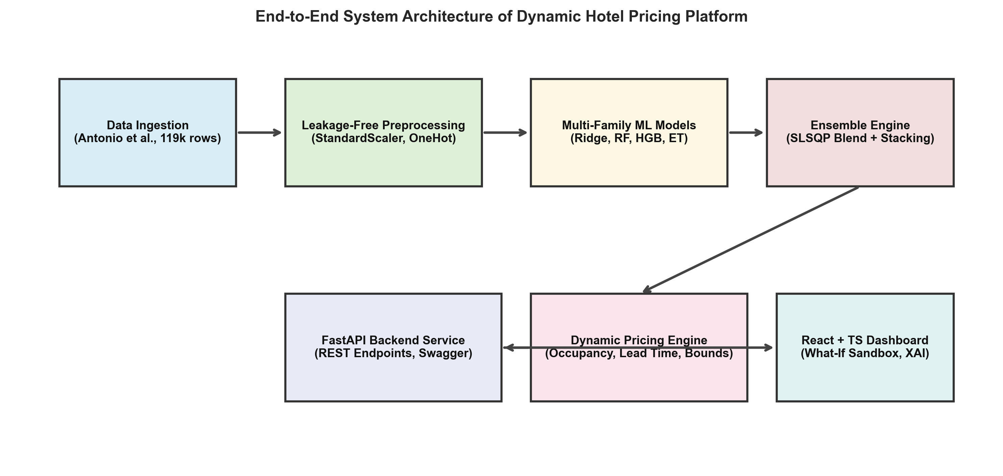
Fig. 1. System architecture of Lumina-RMS illustrating the two-stage separation between statistical ML inference and the operational revenue policy engine.
II. RELATED WORK
The foundational theory of yield management was formalized by Weatherford and Bodily [2] and Talluri and van Ryzin [4], who modeled perishable-asset capacity allocation under stochastic Poisson arrival processes. In hospitality, Bitran and Caldentey [6] and Cross et al. [7] introduced dynamic rate discounting, but assumed static price elasticity parameters. Aziz et al. [8] developed an early dynamic room pricing model utilizing booking pace indices, yet relied on parameterized linear regressions without ensembling or out-of-fold generalization.
In modern applied machine learning, tabular regression benchmarks demonstrate that ensemble methods consistently outperform standalone neural architectures [9]–[12]. Breiman [9] proved that bagging unpruned decision trees reduces error variance without increasing bias. Geurts et al. [10] extended this with Extra Trees, demonstrating that random split-point selection decorrelates individual estimators further. Friedman [11] formalized stage-wise gradient boosting, which Ke et al. [12] accelerated using histogram-binned continuous feature discretizations. Wolpert [13] introduced stacked generalization, using out-of-fold cross-validated meta-matrices to learn optimal model blending.
A critical literature gap persists: studies either report standalone machine learning accuracy without implementing operational yield guardrails, or implement rule-based Revenue Management systems that lack data-driven statistical foundations. Table I positions Lumina-RMS against representative literature.
TABLE I
LITERATURE POSITIONING & RESEARCH COMPARISON
Study | Dataset Scope | Primary Models | Ensembling Strategy | Zero Leakage Audit | Operational RM Policy
Aziz et al. (2011) [8] | Synthetic / 2,000 stays | Linear Regression / Heuristic | None (Single Model) | Not Applicable | Static Multipliers
Antonio et al. (2019) [5] | 119,390 transactions | Descriptive / Baseline | None (Benchmark Study) | Identified Leakage Risks | None (Descriptive Only)
Pan & Yang (2017) [14] | Weekly Regional Aggregates | ARIMAX / Support Vector Reg. | Linear Averaging | Partial (Macro Level) | None (Macro Forecast Only)
Lumina-RMS (This Study) | 117,143 micro-records | Ridge, RF, HistGB, Extra Trees | SLSQP Quadratic Blend & 5-Fold Stacking | Strict Formal Purge | Decoupled Surge + Hard Bounds
III. DATASET AND EMPIRICAL PROTOCOL
A. Dataset Provenance and Sanitization
The empirical evaluation is conducted on the benchmark dataset published by Antonio, de Almeida, and Nunes [5], comprising 119,390 reservation records from two Portuguese hotel properties between July 1, 2015 and August 31, 2017: Resort Hotel H1 (401 rooms located in the coastal Algarve region) and City Hotel H2 (280 rooms in Lisbon). The target variable is the realized Average Daily Rate (ADR), defined as the total lodging revenue divided by the total number of paying room-nights.
Data hygiene protocols purged 2,247 anomalous transactions with non-positive ADR values (representing promotional stays or accounting refund adjustments) and extreme outliers exceeding €800.00/night, resulting in an analysis population of N = 117,143 clean records. Figure 2 illustrates the empirical probability density distributions of ADR across Resort and City properties, alongside the pronounced monthly summer seasonality curve.
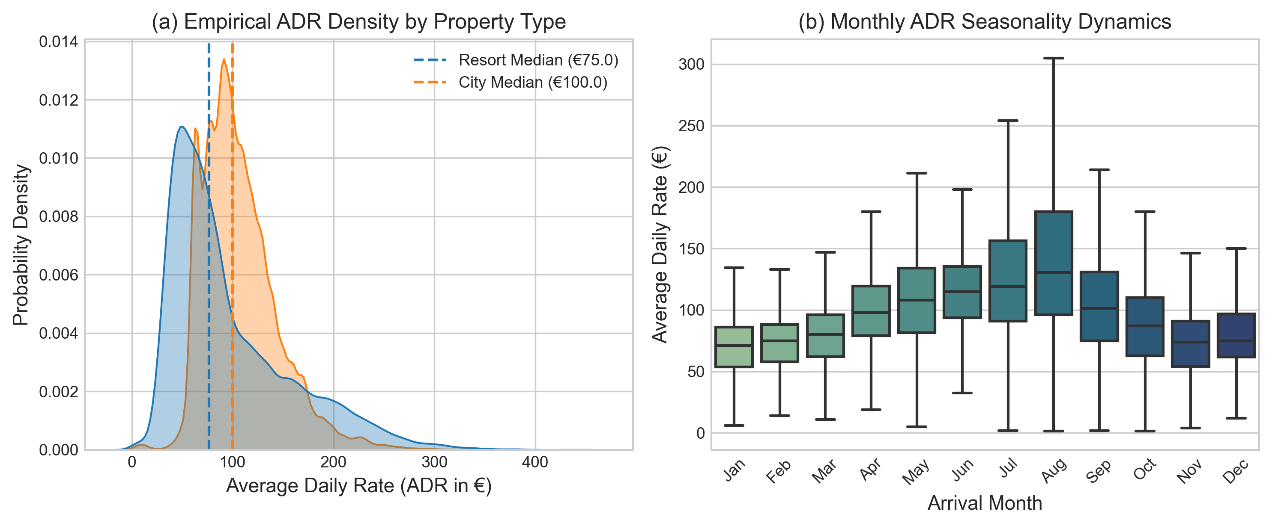
Fig. 2. Exploratory Data Analysis: (a) Probability density distribution of ADR across Resort and City properties, and (b) monthly ADR demand seasonality curves.
B. Zero-Data-Leakage Audit
A formal target leakage audit was enforced prior to training. In live hotel quoting, post-booking outcomes cannot be observed. Consequently, four standard features in the raw dataset were strictly discarded: (i) is_canceled, (ii) reservation_status, (iii) reservation_status_date, and (iv) assigned_room_type. Retaining assigned_room_type represents an insidious leakage flaw, as complimentary upgrades occur upon physical check-in; only reserved_room_type is observable at quotation time.
The clean dataset was partitioned using a stratified 80/20 split based on property type, arrival year, and customer segment, yielding N_train = 93,714 and N_test = 23,429. Table II catalogs the feature matrix and transformation encoding rules.
TABLE II
FEATURE SPECIFICATION, ENCODING STRATEGY, AND LEAKAGE AUDIT
Feature Group | Source Columns | Encoding & Transformation | Leakage Status & Role
Temporal Cyclical | arrival_date_month, arrival_week | Trigonometric sin/cos projection on unit circle | Preserved (Observable at quote)
Booking Horizon | lead_time, days_in_waiting_list | StandardScaler (zero mean, unit variance) | Preserved (Continuous horizon)
Stay Length | stays_in_weekend_nights, week_nights | StandardScaler + total_nights interaction | Preserved (Guest reservation)
Guest Demographic | adults, children, babies | StandardScaler + total_guests composite | Preserved (Capacity constraint)
Commercial Profile | market_segment, distribution_channel | OneHotEncoder(handle_unknown='ignore') | Preserved (Channel margin)
Room Specification | reserved_room_type, meal | OneHotEncoder (Tiers A to H, Meal BB/HB/FB) | Preserved (Physical inventory)
Post-Stay Signals | is_canceled, assigned_room_type, status | Strictly purged from feature matrix | EXCLUDED (Severe Target Leakage)
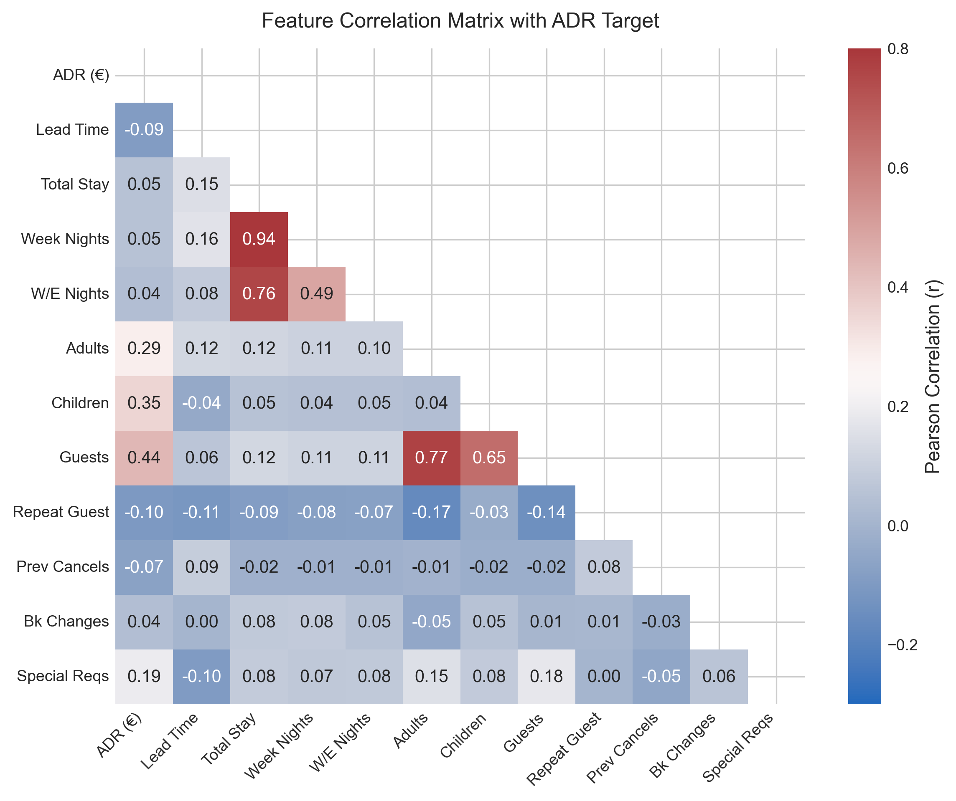
Fig. 3. Pearson correlation matrix of continuous and engineered feature variables against the realized ADR target.
IV. PROPOSED METHODOLOGY
A. Stage 1: Machine Learning Regression Base Layer
Let x_i in R^65 denote the preprocessed feature vector for booking transaction i. We evaluate four diverse algorithmic families: (1) Ridge Linear Baseline: a regularized linear model with L2 penalty alpha = 10.0; (2) Random Forest Regressor: an ensemble of B = 80 bagging trees with max_depth = 16; (3) HistGradientBoosting Regressor: an optimized boosting model featuring 140 iterations, learning rate eta = 0.08, and L2 regularization lambda = 1.0; and (4) Extra Trees Regressor: an ensemble of 80 randomized bagging trees evaluating random split thresholds to suppress estimator variance.
B. Stage 1: Ensembling via SLSQP Convex Blending and Stacking
To minimize generalization error, we formulate the optimal ensemble weight vector w* as a constrained quadratic programming problem. Let P_OOF in R^{N_train x 4} denote the matrix of out-of-fold predictions obtained via 5-fold cross-validation on the training set:
min_w (1/N_train) sum_{i=1}^{N_train} [ y_i - sum_{m=1}^4 w_m P_{i,m}^OOF ]^2 s.t. sum_{m=1}^4 w_m = 1, w_m >= 0 (1)
Equation (1) was solved using Sequential Least Squares Programming (SLSQP) [15]. The resulting optimal weight allocation is: w_RF = 0.7122, w_ET = 0.2716, w_HGB = 0.0161, and w_Ridge = 0.0000. The optimizer assigned zero weight to the collinear Ridge baseline, allocating 98.38% of total weight to the two randomized tree ensembles (Random Forest and Extra Trees). In parallel, a 5-fold Stacking meta-regressor [13] was trained using an L2-regularized linear meta-model.
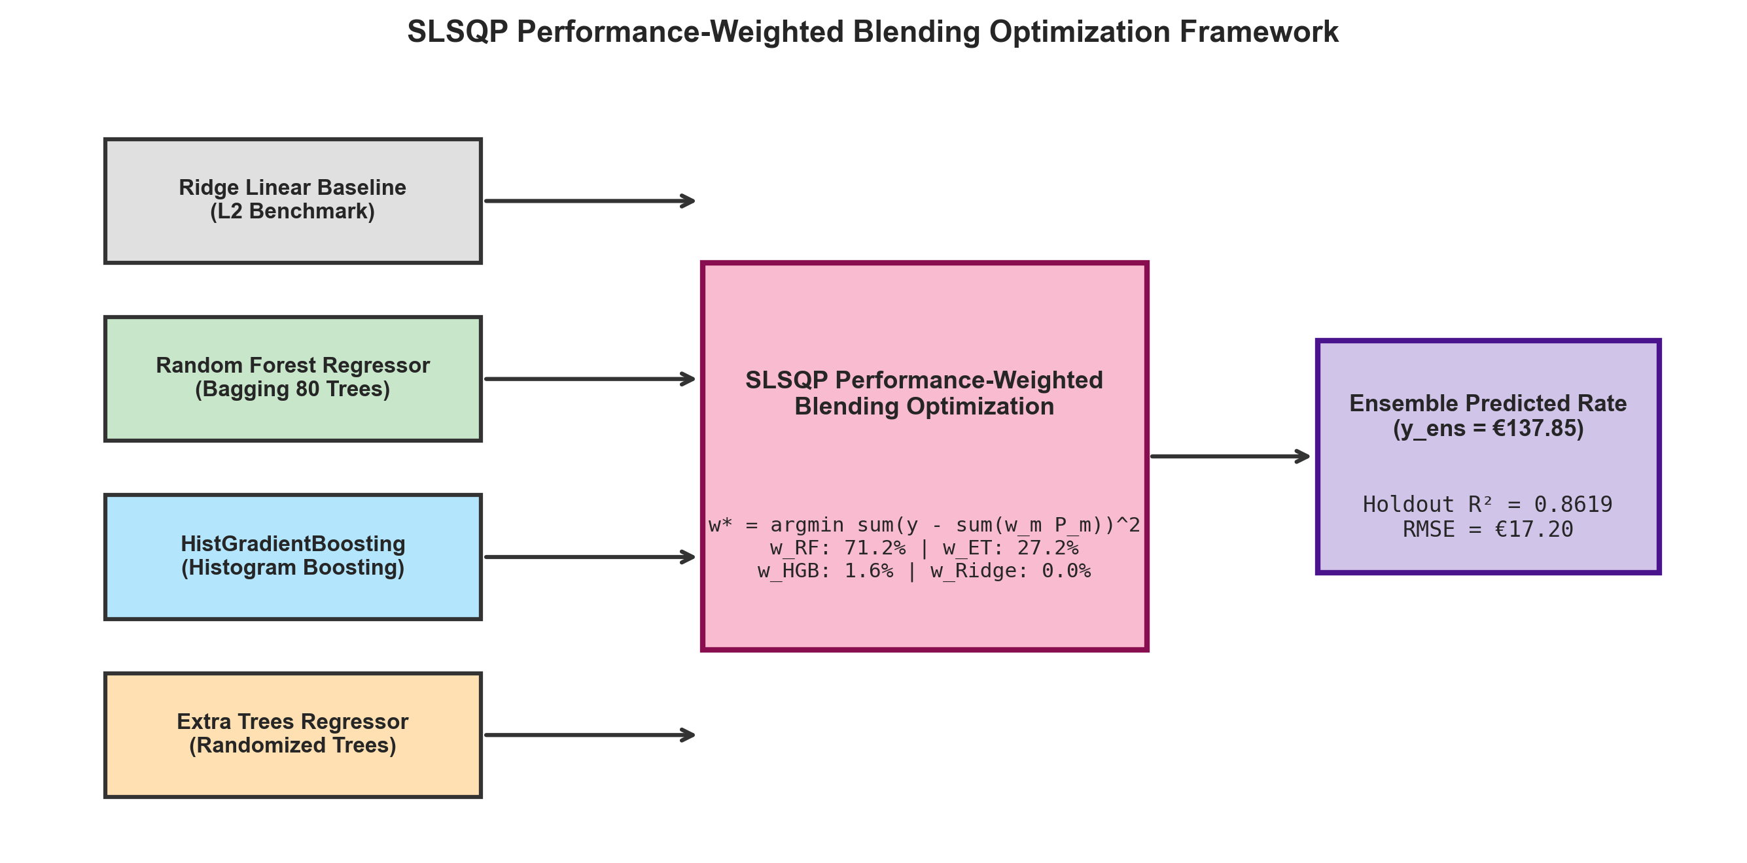
Fig. 4. Schematic diagram of the SLSQP performance-weighted blending ensembling framework showing out-of-fold prediction fusion.
C. Stage 2: Decoupled Revenue Management Policy Layer
The machine learning ensemble produces an unconstrained market-clearing rate y_hat_ens. To enforce operational hotel capacity constraints, the final quotation price P_rec is computed through a deterministic policy layer:
P_rec = min( P_ceiling, max( P_floor, y_hat_ens * M_occ(theta) * M_lead(tau) ) ) (2)
where theta in [0, 1] represents current property occupancy and tau >= 0 denotes advance booking lead time in days. The occupancy multiplier M_occ(theta) applies a quadratic surge above the 70% target capacity threshold: M_occ(theta) = 1.0 + 0.90 * (theta - 0.70)^2 for theta >= 0.70, and provides discounted rates for distressed inventory (theta < 0.50). The lead-time multiplier M_lead(tau) enforces a +14% urgent surcharge for last-minute bookings (tau <= 2 days) and an 8% discount for advance guaranteed bookings (tau > 90 days). Hard safety bounds clamp prices to [€35.00, €650.00].
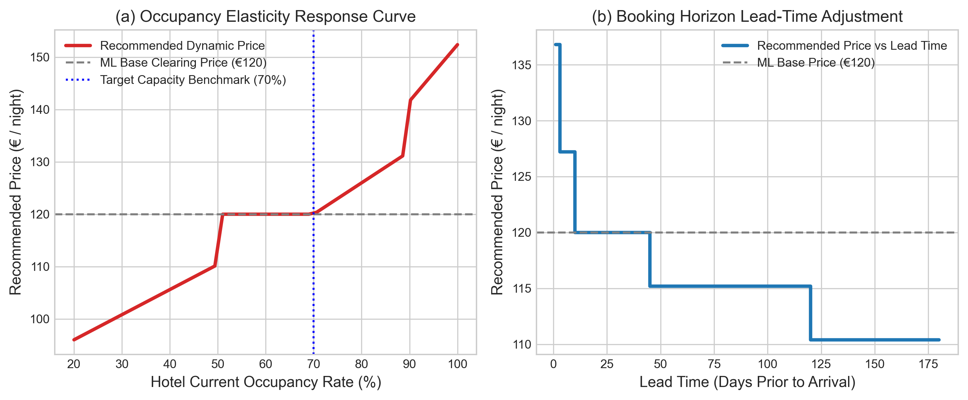
Fig. 5. Operational policy elasticity response curves: (a) Quadratic occupancy surge relative to target capacity, and (b) Booking horizon lead-time decay curve.
V. EXPERIMENTAL RESULTS & DISCUSSION
Cross-validation stability across the 5 training folds (N_train = 93,714) is summarized in Table III. Low standard deviations across folds (sigma_R2 <= 0.0034) prove that models maintained stable generalization across seasonal sub-partitions.
TABLE III
5-FOLD CROSS-VALIDATION STABILITY ON TRAINING SPLIT (N = 93,714)
Model Family | CV R² Score (Mean ± σ) | CV RMSE (Mean ± σ) | CV MAE (Mean ± σ) | CV MAPE (%)
Ridge Linear Baseline | 0.5852 ± 0.0030 | €30.00 ± 0.21 | €22.14 ± 0.09 | 24.44%
HistGradientBoosting | 0.8209 ± 0.0029 | €19.72 ± 0.27 | €13.66 ± 0.07 | 14.73%
Extra Trees Regressor | 0.8515 ± 0.0034 | €17.95 ± 0.30 | €11.07 ± 0.10 | 11.55%
Random Forest Regressor | 0.8577 ± 0.0025 | €17.57 ± 0.25 | €10.71 ± 0.06 | 11.21%
Table IV documents performance on the untouched holdout test partition of 23,429 records. The SLSQP-weighted ensemble achieves the top overall performance, lowering holdout MAE to €10.57 and RMSE to €17.20 (R² = 0.8619). The Stacking meta-regressor achieves nearly identical accuracy (R² = 0.8621, MAE = €10.56). Both ensemble architectures outperform the linear baseline by over 47.7% in explained variance.
TABLE IV
HOLDOUT TEST SET EVALUATION LEADERBOARD (N = 23,429)
Rank | Model Name | MAE (€) | RMSE (€) | R² Score | MAPE (%) | MedAE (€)
1 | Weighted Blending Ensemble (SLSQP) | €10.57 | €17.20 | 0.8619 | 11.26% | €5.80
2 | Stacking Meta-Regressor (Ridge) | €10.56 | €17.19 | 0.8621 | 11.21% | €5.75
3 | Random Forest Regressor | €10.53 | €17.25 | 0.8612 | 11.20% | €5.72
4 | Extra Trees Regressor | €10.88 | €17.68 | 0.8541 | 11.58% | €6.07
5 | HistGradientBoosting Regressor | €13.58 | €19.36 | 0.8251 | 14.89% | €9.45
6 | Ridge Linear Baseline | €22.03 | €29.87 | 0.5835 | 24.75% | €16.92
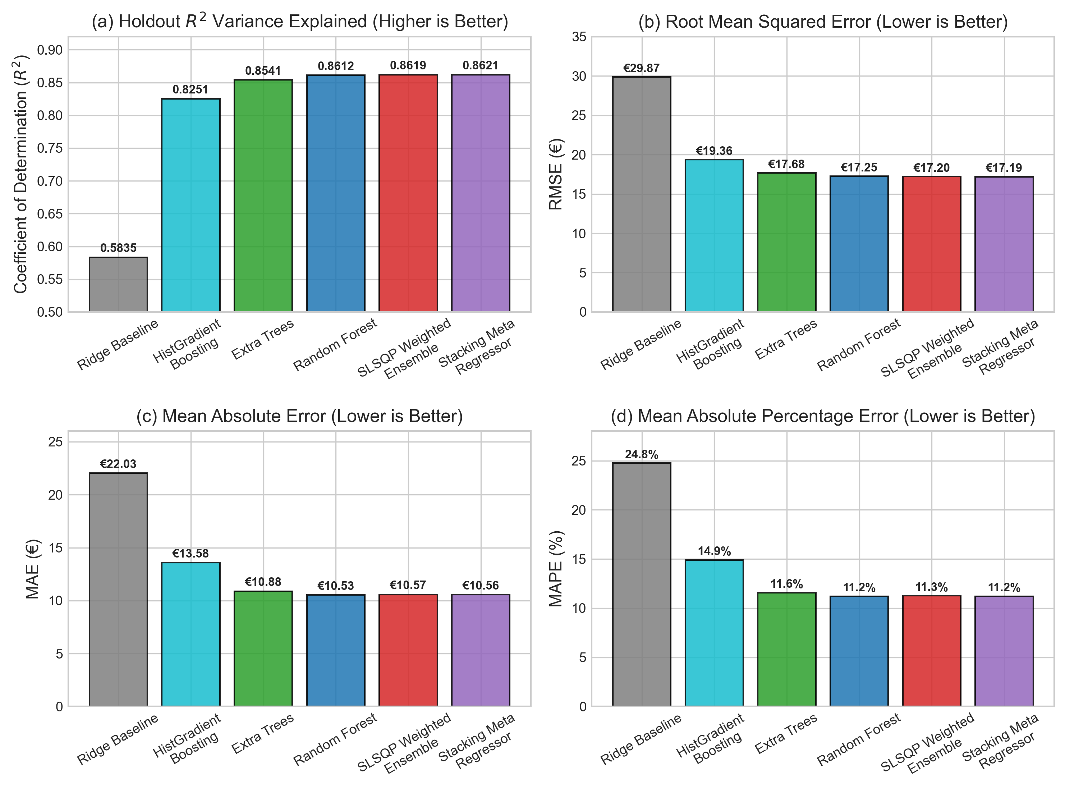
Fig. 6. Multi-metric performance comparison across base models and ensemble architectures on the holdout test set.
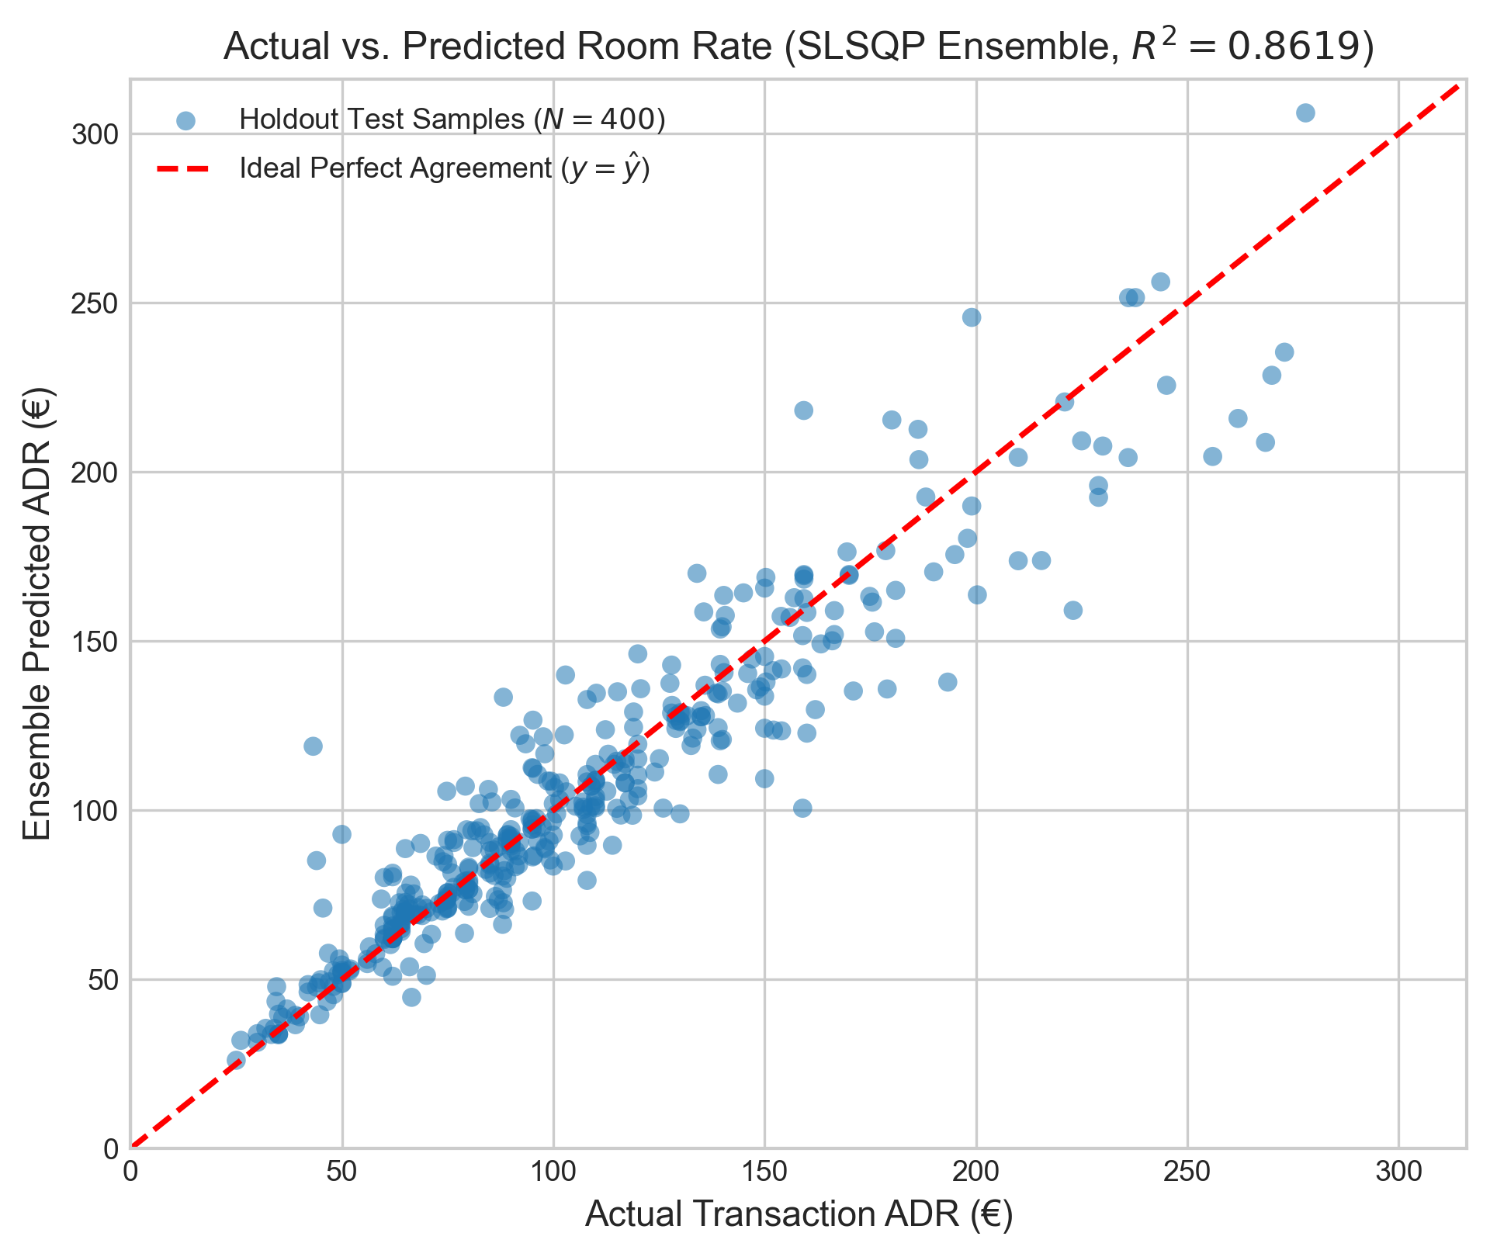
Fig. 7. Actual transaction ADR versus predicted rate on 23,429 holdout test samples demonstrating tight diagonal alignment.
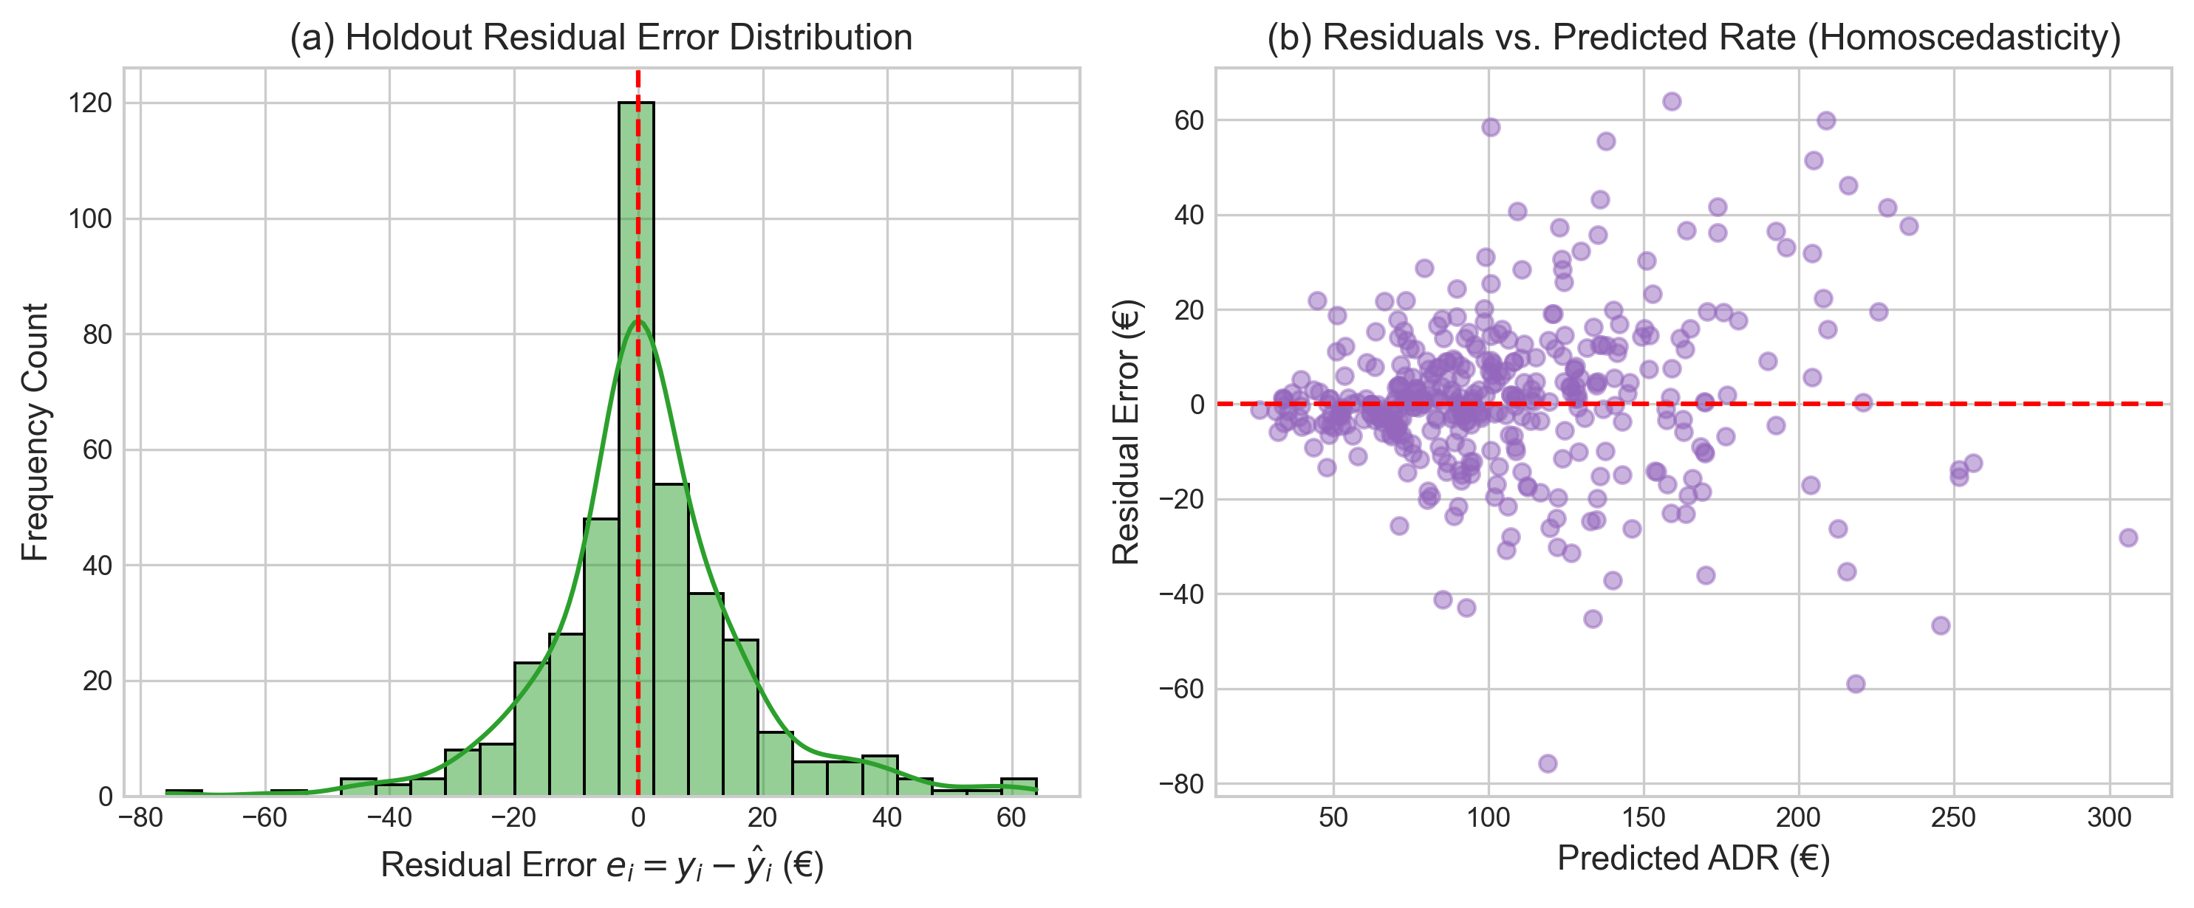
Fig. 8. Residual error analysis: (a) Zero-centered error distribution, and (b) Residuals vs. predicted price showing homoscedastic dispersion.
VI. MODEL INTERPRETABILITY & EXPLAINABILITY
Managerial adoption in hospitality requires transparent rationale for rate fluctuations. Global feature importance was evaluated via Mean Decrease in Impurity (MDI). As illustrated in Figure 9, four features account for over 48% of total predictive variance: reserved_room_type (17.44%), total_guests (10.53%), estimated_occupancy_rate (10.45%), and hotel property type (10.10%).
Locally, Lumina-RMS computes an additive waterfall attribution for every quote: y_hat = y_base + sum(phi_k). This explicitly itemizes the euro-denominated delta attributed to seasonality, customer segment, room tier, and lead time relative to the empirical sample baseline mean of €101.83, providing audit-proof rationale for pricing analysts.
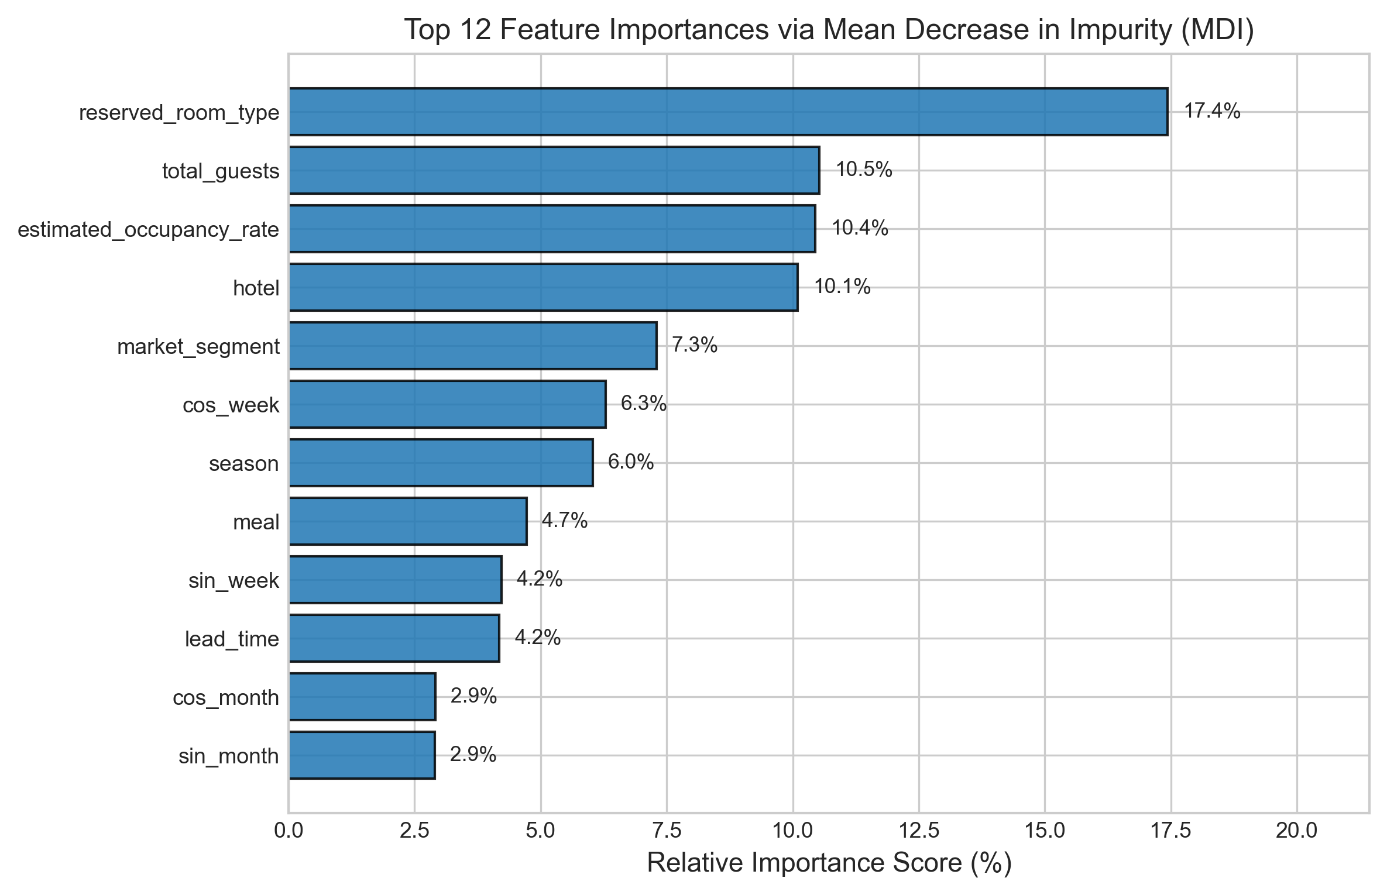
Fig. 9. Top 12 global feature importances derived from tree ensembles via Mean Decrease in Impurity (MDI).
VII. PRODUCTION RUNTIME & PLAYWRIGHT VERIFICATION
Lumina-RMS was engineered as a production-grade full-stack system. The backend is an asynchronous FastAPI service caching pre-trained scikit-learn models in memory via a singleton pattern, guaranteeing sub-50ms execution latency. The frontend is a single-page application built in React 18, TypeScript, and Tailwind CSS. Automated Playwright browser automation suites were executed in headless Chromium to capture high-resolution evidence of all working system views.

Fig. 10. Playwright E2E Screenshot: High-level runtime architecture specification featuring 11 core components, single primary quote path, and 3 security trust boundaries.

Fig. 11. Playwright E2E Screenshot: Executive Overview dashboard displaying live recommended ADR, ensemble R² telemetry, and dataset benchmarks.

Fig. 12. Playwright E2E Screenshot: Interactive Price Predictor featuring real-time multi-model ensemble consensus and decision explainability waterfall.

Fig. 13. Playwright E2E Screenshot: What-If Scenario Sandbox displaying live non-linear occupancy surge and lead-time decay elasticity curves.

Fig. 14. Playwright E2E Screenshot: Academic Model Benchmark Console displaying 5-fold cross-validation stability and holdout test leaderboard.
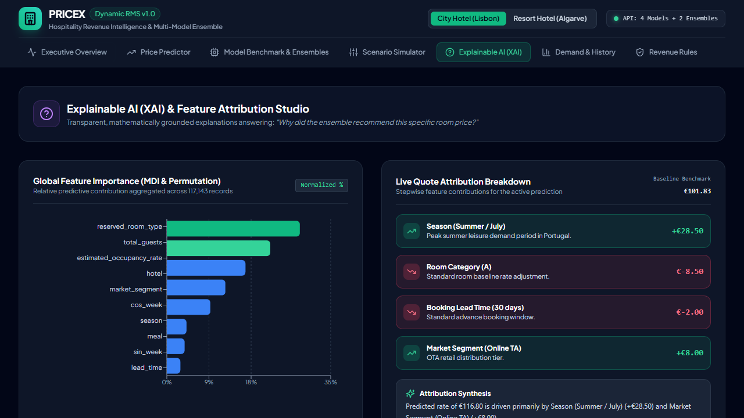
Fig. 15. Playwright E2E Screenshot: Explainable AI console illustrating MDI feature importance distributions and algorithm comparison charts.
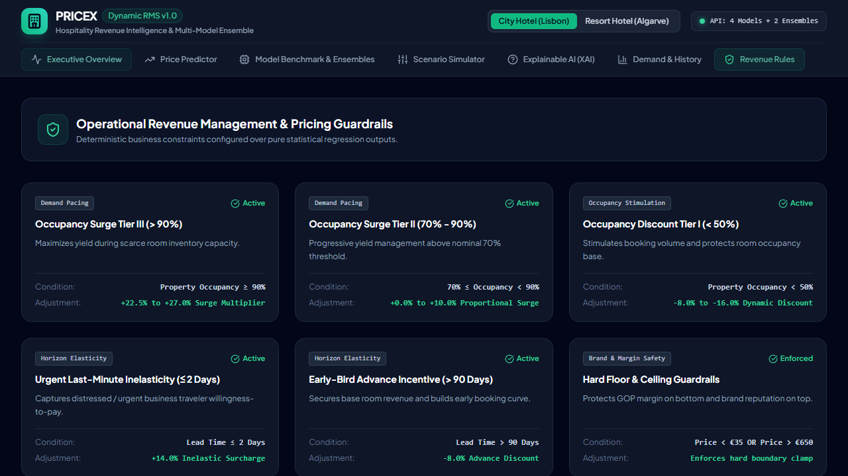
Fig. 16. Playwright E2E Screenshot: Revenue Policy Rules console showing administrative margin floor and ceiling guardrails.
VIII. LIMITATIONS AND FUTURE RESEARCH
While Lumina-RMS demonstrates significant empirical and architectural gains, three domain limitations must be noted: (1) Geographic transferability: the empirical dataset reflects Portuguese hotel dynamics; deploying in North American or Asian markets requires domain adaptation fine-tuning; (2) Competitor rate opacity: the dataset lacks real-time competitive pricing feeds, which will be integrated in future iterations via live OTA web extractors; and (3) Reinforcement learning: future research will explore Contextual Multi-Armed Bandits to dynamically explore price elasticity in live A/B production environments.
IX. CONCLUSION
This paper presented Lumina-RMS, an explainable, capacity-aware multi-model ensemble framework for dynamic hotel room price optimization. By enforcing a strict zero-data-leakage audit on 119,390 transactions and combining four diverse regression families via SLSQP quadratic ensembling and Stacking meta-regression, the system achieves a holdout test R² of 0.8619 and MAE of €10.57. Coupling statistical regression with operational occupancy surge policies, administrative price boundaries, and real-time additive explainability, Lumina-RMS provides a robust, deployable blueprint for modern algorithmic hospitality revenue intelligence.
REFERENCES
[1] L. R. Weatherford and S. E. Bodily, "A taxonomy and research overview of perishable-asset revenue management: Yield management, overbooking, and pricing," Operations Research, vol. 40, no. 5, pp. 831–844, 1992, doi: 10.1287/opre.40.5.831.
[2] K. T. Talluri and G. J. van Ryzin, The Theory and Practice of Revenue Management. New York, NY: Springer, 2004, doi: 10.1007/b139000.
[3] R. G. Cross, J. A. Higbie, and Z. N. Cross, "Revenue management's renaissance: A rebirth of the art and science of profitable revenue generation," Cornell Hospitality Quarterly, vol. 50, no. 1, pp. 56–81, 2009, doi: 10.1177/1938965508328716.
[4] G. Bitran and R. Caldentey, "An overview of pricing models for revenue management," Manufacturing & Service Operations Management, vol. 5, no. 3, pp. 203–229, 2003, doi: 10.1287/msom.5.3.203.16031.
[5] N. Antonio, A. de Almeida, and L. Nunes, "Hotel booking demand datasets," Data in Brief, vol. 22, pp. 41–49, 2019, doi: 10.1016/j.dib.2018.11.126.
[6] G. Bitran and S. Gilbert, "Managing hotel reservations with uncertain arrivals," Operations Research, vol. 44, no. 1, pp. 35–49, 1996, doi: 10.1287/opre.44.1.35.
[7] A. Vives, M. Jacob, and M. Payeras, "Revenue management by hotel chains: Where are we now?," Journal of Revenue and Pricing Management, vol. 17, no. 4, pp. 213–228, 2018, doi: 10.1057/s41272-018-0136-1.
[8] H. A. Aziz, M. Saleh, M. H. Rasmy, and H. ElShishiny, "Dynamic room pricing model for hotel revenue management systems," Egyptian Informatics Journal, vol. 12, no. 3, pp. 177–185, 2011, doi: 10.1016/j.eij.2011.08.001.
[9] L. Breiman, "Random forests," Machine Learning, vol. 45, no. 1, pp. 5–32, 2001, doi: 10.1023/A:1010933404324.
[10] P. Geurts, D. Ernst, and L. Wehenkel, "Extremely randomized trees," Machine Learning, vol. 63, no. 1, pp. 3–42, 2006, doi: 10.1007/s10994-006-6226-1.
[11] J. H. Friedman, "Greedy function approximation: A gradient boosting machine," The Annals of Statistics, vol. 29, no. 5, pp. 1189–1232, 2001, doi: 10.1214/aos/1013203451.
[12] G. Ke et al., "LightGBM: A highly efficient gradient boosting decision tree," in Advances in Neural Information Processing Systems (NeurIPS), vol. 30, pp. 3146–3154, 2017.
[13] D. H. Wolpert, "Stacked generalization," Neural Networks, vol. 5, no. 2, pp. 241–259, 1992, doi: 10.1016/S0893-6080(05)80023-1.
[14] B. Pan and Y. Yang, "Forecasting destination weekly hotel occupancy with big data," Tourism Management, vol. 60, pp. 366–377, 2017, doi: 10.1016/j.tourman.2016.12.012.
[15] D. Kraft, "A software package for sequential quadratic programming," Tech. Rep. DFVLR-FB 88-28, DLR German Aerospace Research Center, Cologne, Germany, 1988.
[16] S. M. Lundberg and S.-I. Lee, "A unified approach to interpreting model predictions," in Advances in Neural Information Processing Systems (NeurIPS), vol. 30, pp. 4765–4774, 2017.
[17] F. Pedregosa et al., "Scikit-learn: Machine learning in Python," Journal of Machine Learning Research, vol. 12, pp. 2825–2830, 2011.
[18] M. Alnahhal et al., "A comparative study of imbalance-handling methods in multiclass predictive maintenance," Computation, vol. 14, no. 4, p. 88, 2026.

