Project Report
On

(BIT25437A0B) Community Engagement Project
SY B.Tech (IT) DIV A
“Inclusive Crowdsourcing: A Multilingual, SMS/Voice-Based Framework for Bridging Accessibility Gaps in Disaster Data Collection”

Submitted to the
Dept of Information Technology
Army Institute of Technology, Pune
by
RAJ KARSHNIA |  | Roll No. : 4240
HARSHWARDHAN |  | Roll No. : 4223
HARMANNAT |  | Roll No. : 4221
HIMANSHU |  | Roll No. : 4224

Under the guidance of

Dr. Priya Nerkar


Department of Information Technology
Army Institute of Technology
Dighi Hills, Dighi, Pune - 411 015.

2026-2027

CERTIFICATE

This is to certify that the project report entitled

INCLUSIVE CROWDSOURCING: A MULTILINGUAL, SMS/VOICE-BASED FRAMEWORK FOR BRIDGING ACCESSIBILITY GAPS IN DISASTER DATA COLLECTION
Submitted by

Raj Karshnia | Roll No. : 4240
Harshwardhan | Roll No. : 4223
Harmannat | Roll No. : 4221
Himanshu | Roll No. : 4224

is a bonafide work carried out by them under the supervision of Dr. Priya Nerkar for completion of Community Engagement Project.

Dr. Priya Nerkar | Dr. Sangeeta Jadhav
Guide | Head of Department
Department of Information Technology | Department of Information Technology

Place:
Date:

I

Abstract

Floods in Pune affect neighbourhoods along the Mutha river every monsoon, and coordinators increasingly rely on reports from residents to understand what is happening on the ground. Most crowdsourced disaster-data systems, however, are built for English-speaking smartphone users. Residents who speak Marathi or Hindi, use basic phones or have low digital literacy are under-represented in exactly the data that is meant to help them.

This project designs and implements AwaazSetu (“voice bridge”), an inclusive, multilingual reporting framework for community flood drills. Residents can report in Marathi, Hindi or English through a web form, a recorded voice note, SMS or Telegram. Each report is converted into structured fields by an AI extraction step with an offline multilingual rules fallback, located against a gazetteer of 450 Pune places, given a transparent priority score with listed reasons, and merged with likely duplicates only under conservative rules. A private coordinator console provides a map, a priority queue, incident review, a coverage dashboard and a notification outbox that replies to residents in their own language.

The system was verified with 88 automated backend tests, 10 browser-based interface tests and a 150-case synthetic triage suite covering all three languages, on which the rules engine matched every expected field. Report intake took a median of 7.4 ms in local measurement. The synthetic suite is a regression check and not a measure of field accuracy.

The work shows that an inclusive channel can be built at low cost and can make visible who is still missing from disaster data. Validation with real residents in a supervised community drill is the next step.

III
INDEX
CHAPTER |  | TITLE |  | PAGE NO.
 |  | ABSTRACT |  | 3
1. |  | INTRODUCTION |  | 5
2. |  | BACKGROUND AND LITERATURE REVIEW |  | 6
 | 2.1 | Crowdsourced and Volunteered Data in Disasters |  | 6
 | 2.2 | Research Gap |  | 6
3. |  | OBJECTIVES |  | 8
 | 3.1 | Project Objectives |  | 8
4. |  | METHODOLOGY AND IMPLEMENTATION |  | 9
 | 4.1 | System Architecture |  | 9
 | 4.1.1 | Module Design |  | 9
 | 4.2 | User Interfaces |  | 10
5. |  | RESULT |  | 14
 | 5.1 | Testing and Evaluation |  | 14
 | 5.1.1 | Performance Measurements |  | 14
 | 5.2 | Limitations |  | 15
6. |  | CONCLUSIONS AND FUTURE WORK |  | 16
 | 6.1 | Conclusion |  | 16
 | 6.1.1 | Future Work |  | 16
7. |  | REFERENCES |  | 17

1. INTRODUCTION
Natural hazards such as floods increasingly depend on information that comes directly from affected people. Citizen reports, social-media posts and volunteered geographic information (VGI) give disaster coordinators a real-time picture that sparse physical sensors cannot provide. In Pune, low-lying neighbourhoods along the Mutha river such as Ekta Nagar, Sinhagad Road, Warje and Dattawadi are regularly affected during heavy monsoon rainfall, and community coordinators need to know quickly where water is entering homes and who is trapped.
Most existing crowdsourced disaster-data systems, however, are designed around English-language, Twitter-centric and smartphone-based input. This creates a critical blind spot. A large part of the population communicates in regional languages such as Marathi and Hindi, has limited digital literacy, or has only a basic mobile phone with SMS. The people who are most vulnerable during a flood — elderly residents, low-income households and families without reliable internet — are therefore often the least represented in the very data systems meant to help them.
This project, carried out under the Community Engagement Project course, addresses that gap. We designed an inclusive crowdsourcing framework that captures, processes and validates flood reports across languages and access levels, and implemented it as a working prototype called AwaazSetu (आवाज़ सेतु, “voice bridge”). Residents can report by web, voice, SMS or Telegram in Marathi, Hindi or English. A private coordinator console turns those reports into a mapped, prioritised and explained queue, and a coverage dashboard shows which languages, channels and areas are under-represented.
The prototype is designed for supervised community drills. It is clearly labelled as a drill system and is not connected to emergency dispatch. The remainder of this report reviews related literature (Chapter 2), states the objectives (Chapter 3), describes the methodology and implementation (Chapter 4), presents results (Chapter 5) and concludes with future work (Chapter 6).

2. BACKGROUND AND LITERATURE REVIEW

2.1 Crowdsourced and Volunteered Data in Disasters
A review of 92 papers on VGI and crowdsourcing data quality in disaster management found that VGI enables low-cost, real-time and large-scale data collection, but that its quality varies because contributors are non-experts, leading to inconsistent accuracy, geographic bias and limited trust among professionals [1]. Credibility can be scored automatically: a model tested on Brisbane flood reports used distance from the incident, flood hazard level and spatial clustering to classify reports as high or low credibility [2]. Studies of Mumbai floods combined Twitter and VGI with elevation data to locate urban flood hotspots, while noting the effort required to filter duplicate and irrelevant posts [3].
Reviews of urban flood monitoring show that webcams, social media and citizen science can complement conventional monitoring but differ in quality and availability [4]. User-generated content mined with crawlers and natural-language processing can track flooding hotspots [5], and logistic regression or fuzzy logic can estimate the uncertainty of social-media observations [6]. Machine-learning and deep-learning work focuses on flood mapping from satellite imagery [7], disaster prediction from weather data [8] and river streamflow forecasting [9].
Recent citizen-science applications are closest to this project. A systematic review of 607 publications proposes a pipeline from social-media data analysis to event detection, situational awareness, risk mapping and emergency response [10]. A prototype app in Germany’s Ahr Valley showed that personal risk perception drives participation and that privacy by design reduces friction, but also exposed gaps in offline support, location accuracy and validation [11]. A mobile and web application for flood data collection in Indonesia showed the value of structured data over unstructured posts, at a modest prototype scale [12].

2.2 Research Gap
Table 2.1 summarises the surveyed literature. Across these studies, credibility and quality are assessed for the reports that arrive, but almost no work asks who is missing from the dataset because of language or access barriers. Most pipelines are optimised for English text and smartphone users, while flood-prone communities in India often have basic phones and speak regional languages. AwaazSetu therefore treats data quality as an inclusion problem: it accepts low-tech channels and regional languages, and it measures coverage explicitly.
Table 2.1: Summary of surveyed literature
No. | Paper | Year / source | Key finding
1 | Role of VGI in disaster management: data quality | 2023, Taylor & Francis | VGI quality varies; high-risk regions under-represented
2 | Credibility of VGI in flood crisis | 2022, Procedia Computer Science | Distance, hazard and clustering score credibility
3 | Mumbai floods with crowdsourced data | 2024, Urban Climate | Tweets + VGI + HAND map locate hotspots
4 | Crowdsourcing in urban flood monitoring | 2021, Env. Modelling & Software | Crowdsourced sources complement monitoring
5 | UGC to track urban flooding hotspots | 2021, Transactions in GIS | Crawlers and NLP map hotspots
6 | Quality of crowdsourced social media data | 2021, CEUS | Fuzzy logic estimates uncertainty
7 | Deep learning for flood mapping | 2022, HESS | CNN/RNN mapping; weak transfer to new regions
8 | ML for disaster prediction | 2023, Frontiers Env. Sci. | ML enables faster early warnings
9 | Deep learning for streamflow forecasting | 2021, IEEE Access | LSTM/GRU outperform CNN
10 | Social media-enabled flood informatics | 2025, JAG | End-to-end pipeline; authenticity open
11 | Citizen science app, Ahr Valley | 2026, NHESS | Privacy by design; offline gaps
12 | Mobile/web flood data collection app | 2025, Earth Sci. Informatics | Structured data enables web-GIS

3. OBJECTIVES

3.1 Project Objectives
The aim of the project is to build an inclusive, multilingual flood-reporting framework and a working prototype for Pune community drills. The specific objectives are:
1. To accept flood reports in Marathi, Hindi and English through web, voice, SMS and Telegram, so that residents with basic phones are included.
2. To extract structured facts — incident type, people affected, water level and vulnerable residents — using AI extraction with a multilingual rules fallback that works offline.
3. To resolve informal landmark names to locations using a local gazetteer, and to ask the reporter for clarification instead of guessing when a place is unclear.
4. To give every report a transparent priority score with listed reasons, and to merge duplicate reports only under conservative rules.
5. To keep reporters informed in their own language through acknowledgements, status updates and opt-in area alerts.
6. To measure inclusion by showing which languages, channels and areas are under-represented.
7. To protect privacy through explicit consent, encrypted contact details and human review of every decision.
The scope is a supervised community drill: the system does not dispatch help and is not an emergency service.

4. METHODOLOGY AND IMPLEMENTATION

4.1 System Architecture
Figure 4.1 shows the block diagram. A report enters through one of four channels and passes through intake, extraction, location resolution and triage before it is stored as an incident. Coordinators review incidents in a private console, and the notification module sends acknowledgements and status updates back to the reporter, closing the feedback loop. Every automated step is advisory; a coordinator verifies an incident before any action is taken.
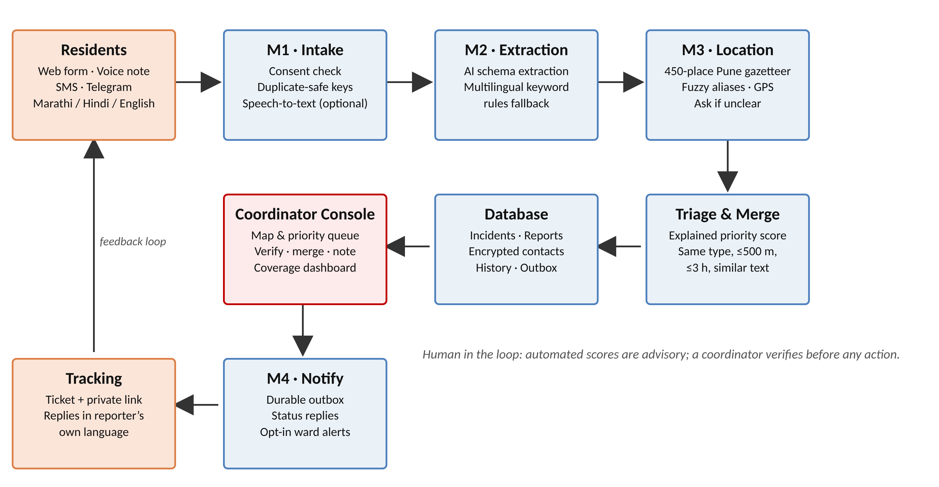
Figure 4.1: Block diagram of the proposed framework
The backend is written in Python with FastAPI and SQLAlchemy and stores data in SQLite for the drill, with PostgreSQL supported. The frontend is a React application built with Vite, using Leaflet for maps and Recharts for charts. OpenAI models are used optionally for structured extraction and speech transcription; without an API key the system runs entirely on its rules engine.

4.1.1 Module Design
M1 – Intake. Web and voice reports require explicit consent. SMS reports arrive from an Android SMS gateway through a signed webhook, and Telegram reports through a bot with a secret token. Idempotency keys prevent a retried submission from creating a duplicate report. Voice notes are limited to two minutes and are transcribed only with consent; on the web the resident reviews and corrects the transcript before sending.
M2 – Extraction and triage. The extractor produces a strict schema: language, incident type, people count, vulnerable groups, water level, needs, location text and flags for trapped residents, medical emergencies and water entering homes. The rules fallback uses multilingual keyword lists with negation handling, so “no one is trapped” is not treated as a rescue. The priority score adds transparent points for each signal (Table 4.1), capped at 100 and grouped into critical (70+), high (45+), medium (25+) and low bands.
Table 4.1: Transparent priority scoring rules
Signal | Points
Rescue or trapped residents | 40
Medical emergency reported | 30
Water entering a home | 20
Water at roof or chest level | 25
Water at waist level | 15
Water at knee level | 8
Vulnerable resident reported | 15
Road waterlogging | 10
Five or more people reported | 10
Three or more distinct reporters | 10
Night-time report | 5

M3 – Location. Place names are matched against a gazetteer of 450 Pune places built from OpenStreetMap data, with Marathi, Hindi and romanised aliases and fuzzy matching for small spelling errors. GPS coordinates are accepted when they fall inside the pilot area. If a name is ambiguous or unknown, the system asks the reporter for a nearby landmark instead of guessing. Two reports are merged automatically only if they share an incident type, lie within 500 m of each other, arrive within three hours and have highly similar text.
M4 – Notification and coverage. A durable outbox queues acknowledgements and status replies in the reporter’s language and retries failed deliveries. Residents can opt in to ward-level drill alerts by sending JOIN with their language and area, and opt out with STOP. The coverage module compares report counts per language, channel and pilot area with an explicit drill baseline.

4.2 User Interfaces
The resident form (Figure 4.2) is available in Marathi, Hindi and English, guides the resident to describe people affected, water level and a nearby landmark, and supports voice recording, optional GPS and a private tracking link. The same form works on a phone (Figure 4.3).
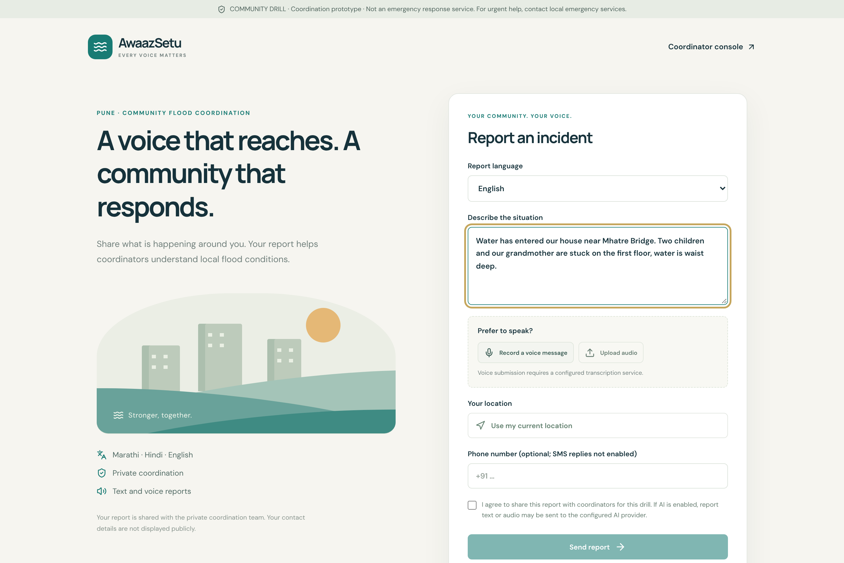
Figure 4.2: Resident report form (desktop, English)
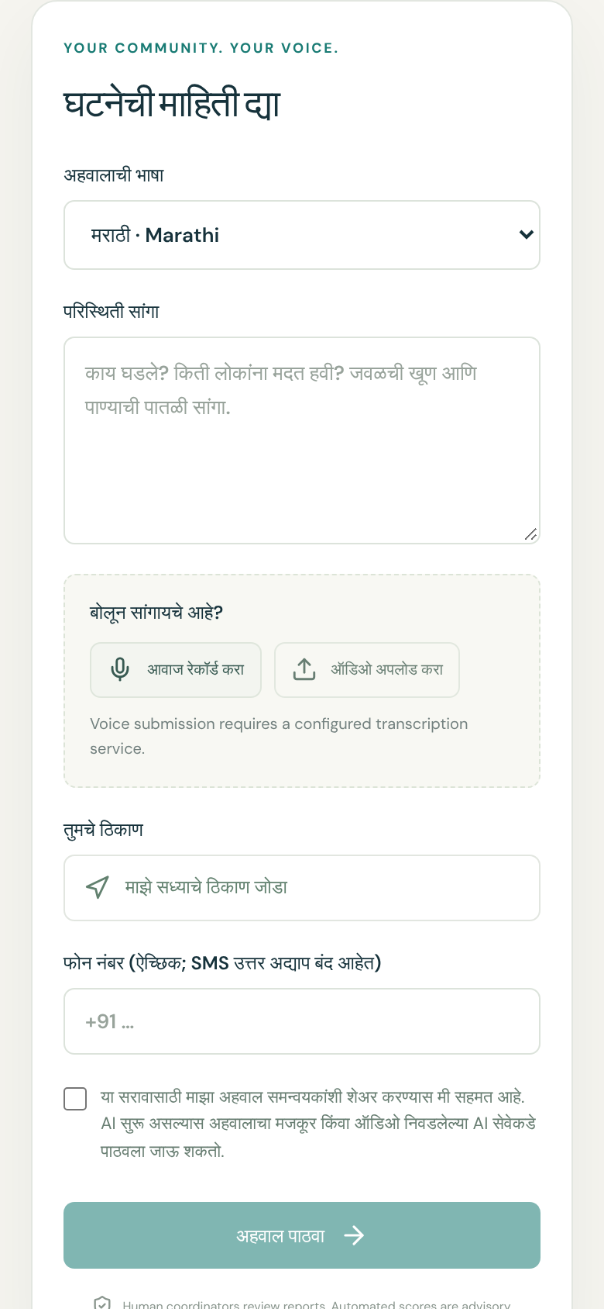
Figure 4.3: Resident report form on a phone (Marathi)
The coordinator console (Figure 4.4) shows summary counts, a private incident map and a live priority queue with filters by status, priority, language and channel. Opening an incident (Figure 4.5) shows its score reasons, the original messages and actions to verify, respond, resolve or dismiss, add notes, and merge duplicates with a written reason. The notifications page (Figure 4.6) shows the message outbox and the area-alert form.
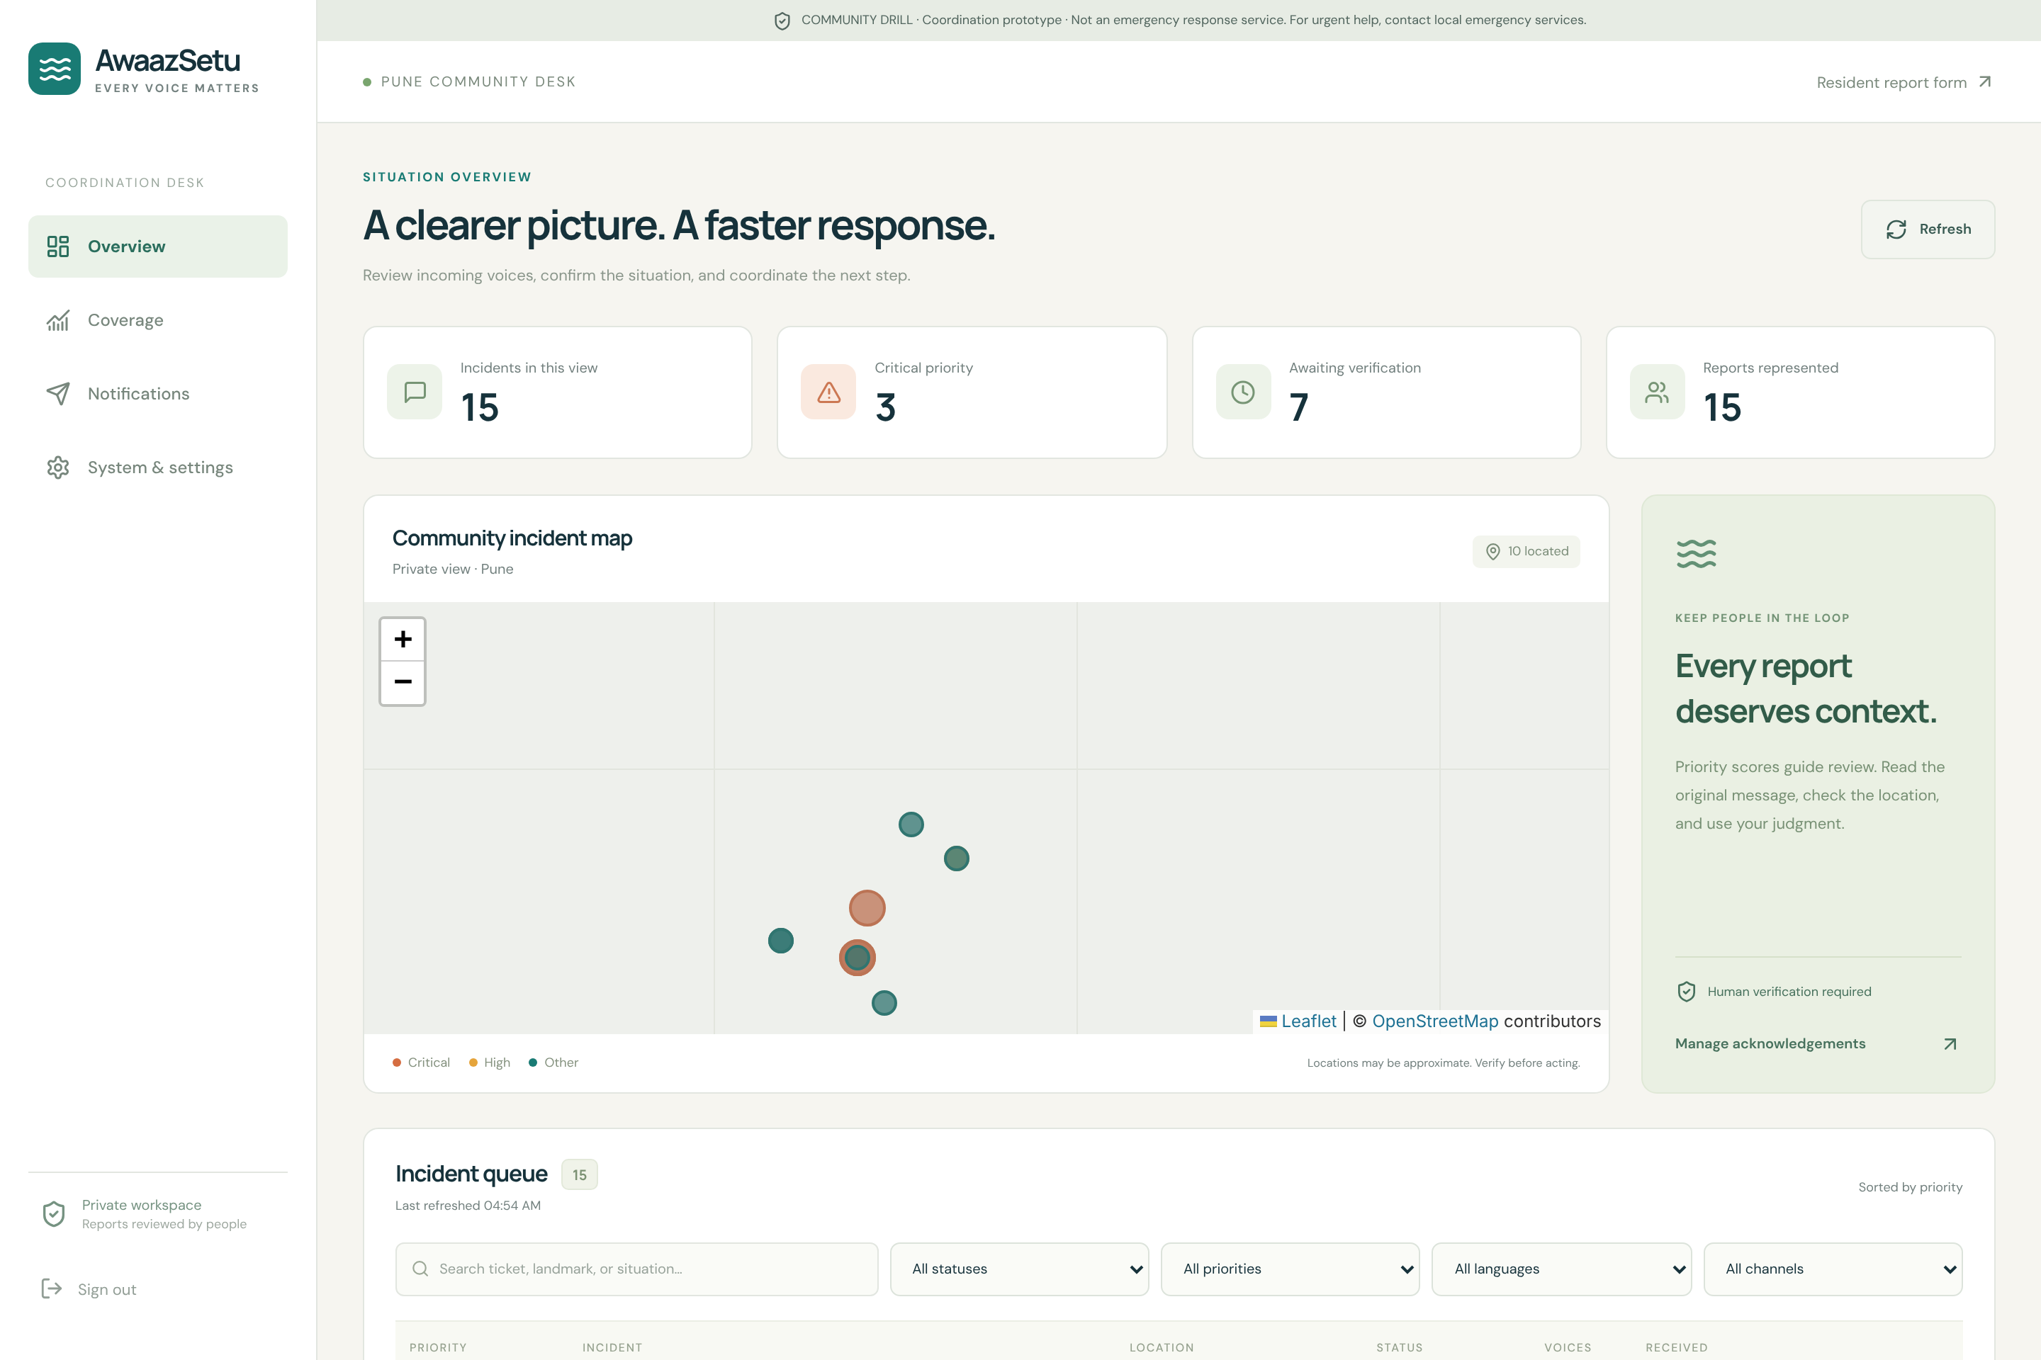
Figure 4.4: Coordinator overview dashboard
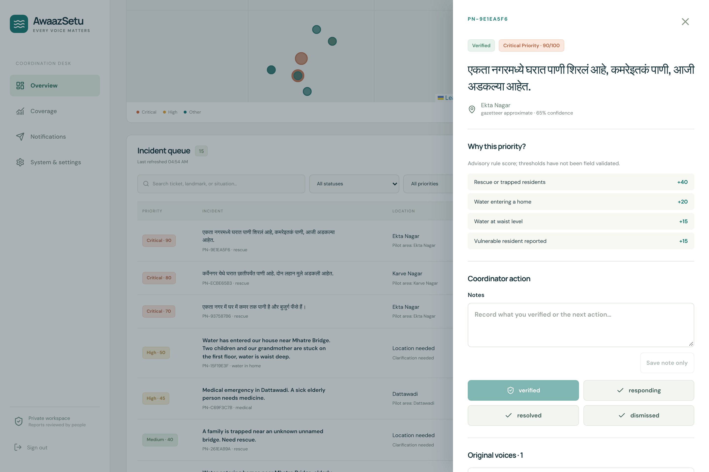
Figure 4.5: Incident detail with explained priority score
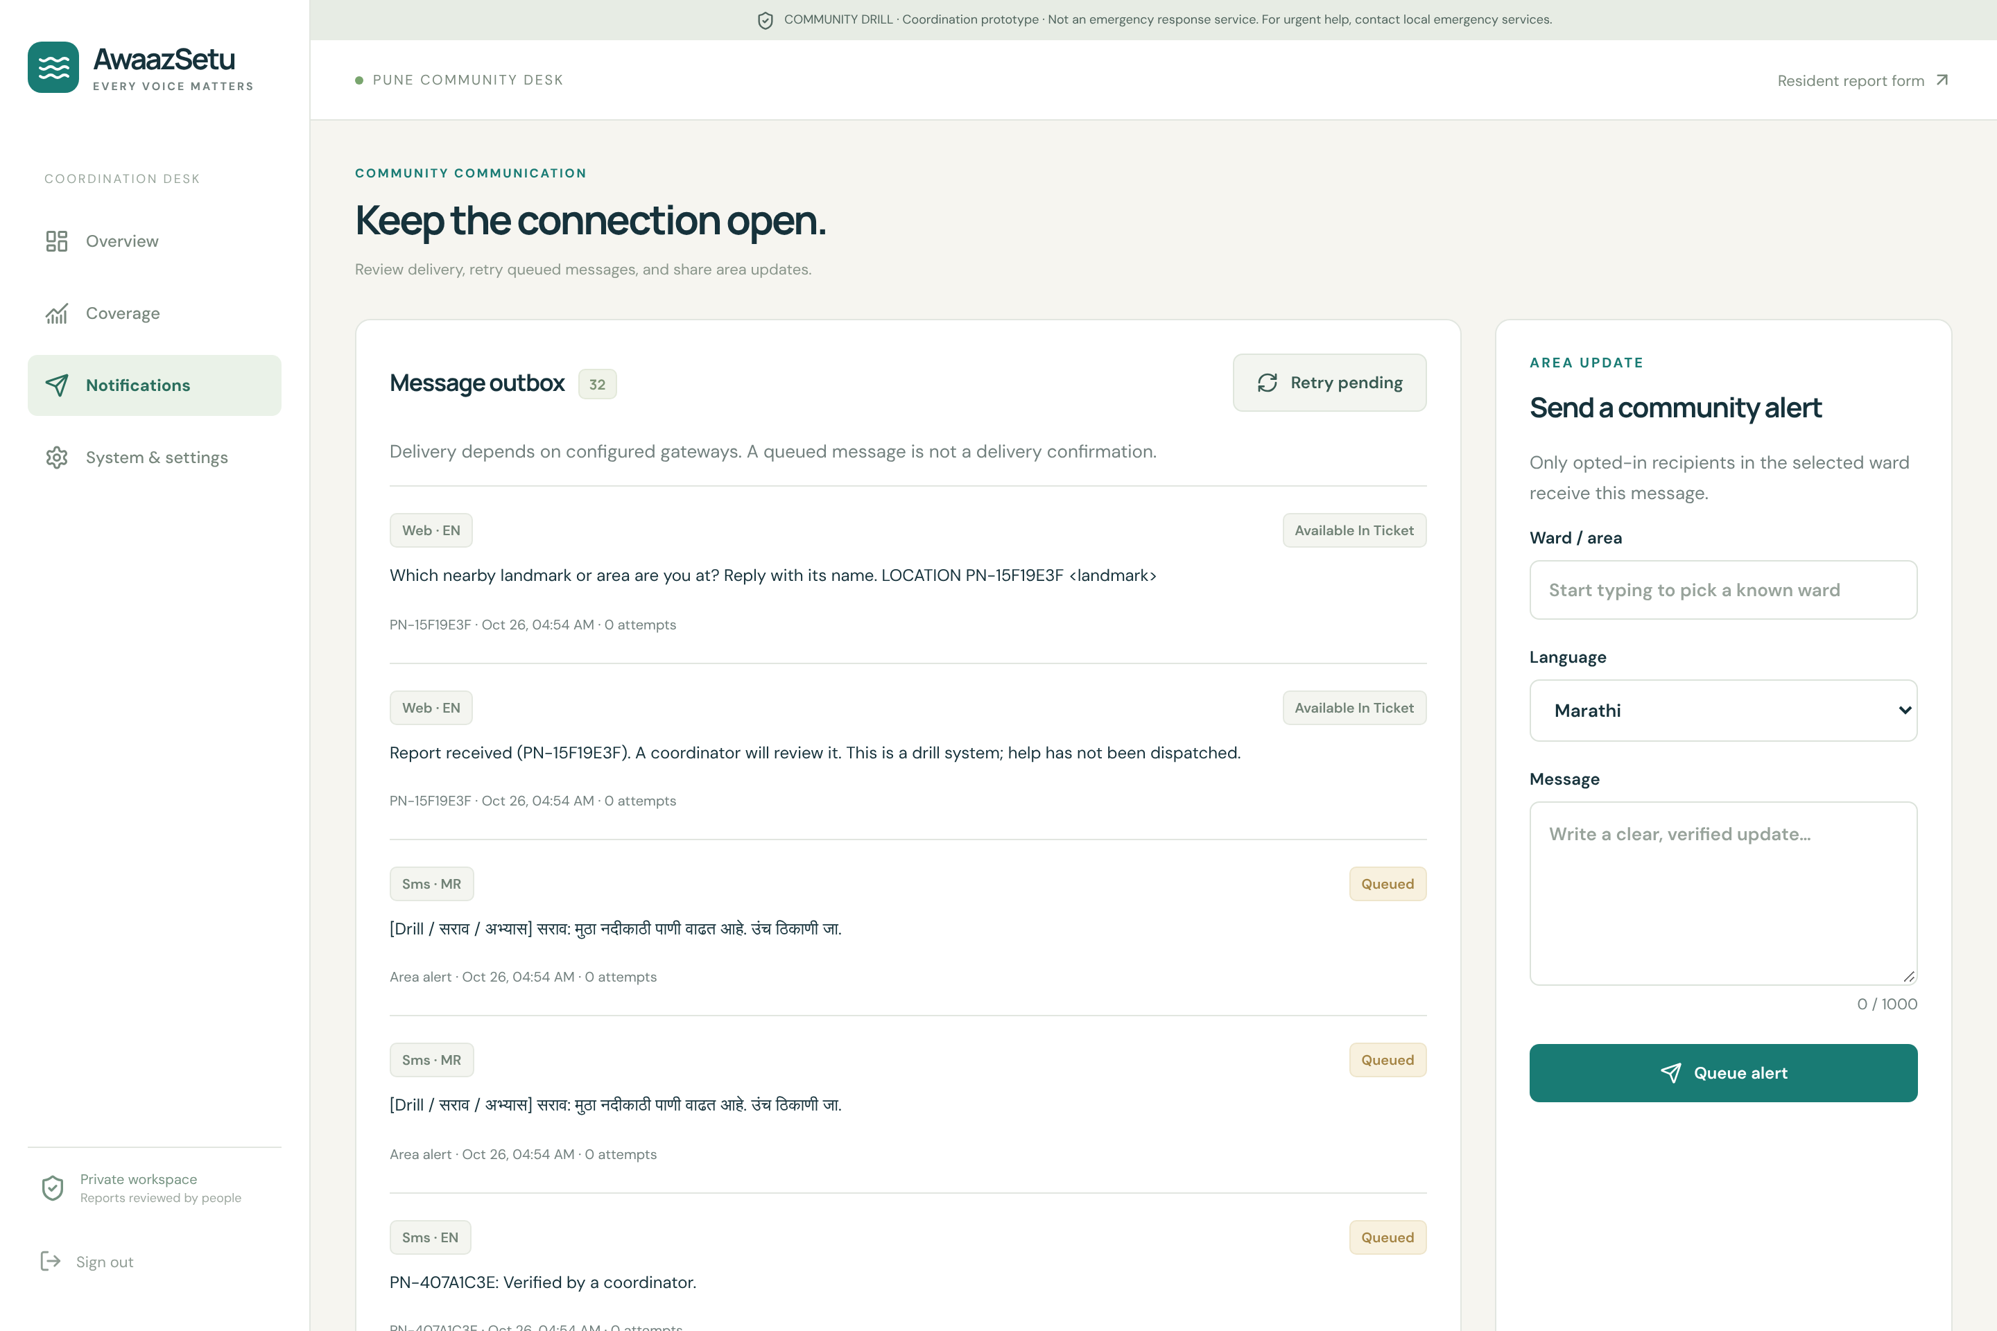
Figure 4.6: Notifications and area alerts

5. RESULT

5.1 Testing and Evaluation
The prototype was tested with automated tests and an offline evaluation suite. Table 5.1 summarises the results. All tests and the evaluation run automatically on every code change through continuous integration.
Table 5.1: Summary of test and evaluation results
Test / metric | Result | Notes
Backend automated tests | 88 / 88 passed | API, triage, location, delivery, voice
Browser interface tests | 10 / 10 passed | Resident and coordinator workflows
Synthetic triage suite | 150 / 150 exact match | 50 cases each in English, Hindi, Marathi
Report intake latency | Median 7.4 ms, p95 9.8 ms | 200 local reports, rules mode
Location lookup | 0.24 ms per query | 450-place gazetteer

On the synthetic suite the rules engine matched all seven evaluated fields — incident type, trapped, medical emergency, water entering home, water level, vulnerable groups and people count — for all 150 cases, 50 in each language. The tests also cover security-relevant behaviour such as webhook authentication, replay protection, rate limiting, consent validation and protection of CSV exports against formula injection.

5.1.1 Performance Measurements
Report intake, including extraction, location, triage, storage and queuing of the acknowledgement, took a median of 7.4 ms (95th percentile 9.8 ms) over 200 local reports in rules mode. Location lookup took 0.24 ms per query. These figures show that the rules engine can serve a community drill on free-tier hosting without AI cost. Figure 5.1 shows the coverage dashboard with reports by language and channel and the ward gap index from a local drill dataset.
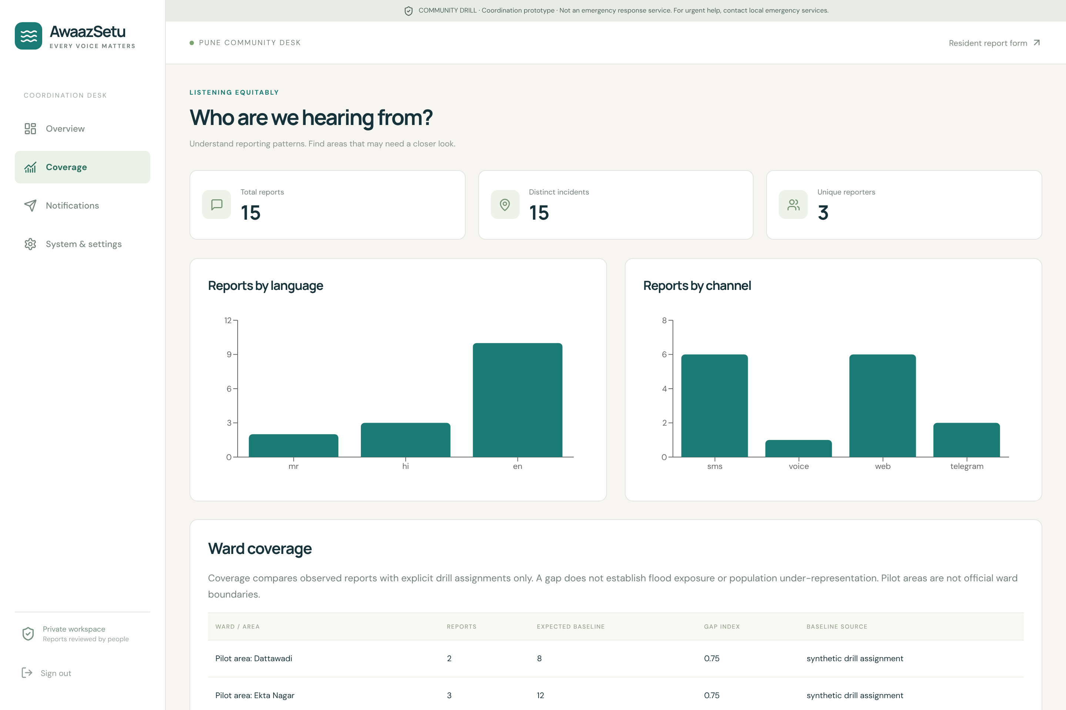
Figure 5.1: Coverage dashboard (local drill data)

5.2 Limitations
The synthetic suite is built from templates and is a developer regression check, not a measure of field accuracy. Speech-recognition accuracy on native Marathi and noisy voice notes, duplicate-merge accuracy on held-out labelled reports, landmark accuracy with real residents and SMS acknowledgement latency on the drill phone still require a supervised community drill. Scoring thresholds are a drill policy and have not been validated in the field, and the pilot areas are not official ward boundaries.

6. CONCLUSIONS AND FUTURE WORK

6.1 Conclusion
AwaazSetu demonstrates that an inclusive, multilingual, SMS- and voice-ready channel can turn scattered flood reports into a reviewed, located and prioritised picture for coordinators. Explained scores, conservative merging and an “ask, don’t guess” approach to location keep people in control of every decision. The coverage dashboard directly addresses the gap identified in the literature by making visible who is still missing from the data, rather than only judging the reports that arrive.

6.1.1 Future Work
1. Provision the Android SMS gateway and Telegram bot for the drill.
2. Run a supervised community drill with consenting participants in pilot areas along the Mutha river.
3. Collect labelled reports and recordings to measure speech accuracy, duplicate-merge F1 and landmark accuracy.
4. Add verification of phone ownership before web-submitted numbers receive SMS.
5. Extend the gazetteer with community-verified landmarks and add further regional languages.

REFERENCES

The following sources were used in preparing this project report.

[1] “Unpacking the role of volunteered geographic information in disaster management: focus on data quality,” Geomatics, Natural Hazards and Risk, Taylor & Francis, 2023. doi: 10.1080/19475705.2023.2300825.
[2] “A method for assessing the credibility of volunteered geographic information in case of flood crisis,” Procedia Computer Science, Elsevier, 2022. [Online]. Available: https://www.sciencedirect.com/science/article/pii/S1877050922011012
[3] “Analysis of Mumbai floods in recent years with crowdsourced data,” Urban Climate, Elsevier, 2024. [Online]. Available: https://www.sciencedirect.com/science/article/abs/pii/S2212095524000117
[4] “Opportunities for crowdsourcing in urban flood monitoring,” Environmental Modelling & Software, Elsevier, 2021. doi: 10.1016/j.envsoft.2021.105124.
[5] “Integrating user-generated content to track urban flooding hotspots and foster emergency management: a case study in Central China,” Transactions in GIS, Wiley, 2021. doi: 10.1111/tgis.12836.
[6] “Quality assessment of crowdsourced social media data for urban flood management,” Computers, Environment and Urban Systems, Elsevier, 2021. doi: 10.1016/j.compenvurbsys.2021.101690.
[7] “Deep learning methods for flood mapping,” Hydrology and Earth System Sciences, vol. 26, Copernicus, 2022. [Online]. Available: https://hess.copernicus.org/articles/26/4345/2022/
[8] “Machine learning for disaster prediction and preparedness,” Frontiers in Environmental Science, 2023. doi: 10.3389/fenvs.2023.1194918.
[9] “Comparison of deep learning techniques for river streamflow forecasting,” IEEE Access, vol. 9, 2021. [Online]. Available: https://ieeexplore.ieee.org/document/9423961
[10] “A systematic review of social media-enabled flood disaster informatics: method, technology and application,” International Journal of Applied Earth Observation and Geoinformation, Elsevier, 2025. doi: 10.1016/j.jag.2025.104935.
[11] “Prototype citizen and community science app for urban heavy rainfall risk management in the Ahr Valley, Germany,” Natural Hazards and Earth System Sciences, Copernicus, 2026. doi: 10.5194/nhess-26-1795-2026.
[12] “Mobile and web-based application for flood data collection based on citizen science,” Earth Science Informatics, Springer, 2025. doi: 10.1007/s12145-024-01664-1.
[13] OpenStreetMap contributors, “OpenStreetMap,” 2026. [Online]. Available: https://www.openstreetmap.org (data under ODbL).
[14] FastAPI, “FastAPI documentation,” 2026. [Online]. Available: https://fastapi.tiangolo.com
[15] React, “React documentation,” 2026. [Online]. Available: https://react.dev
[16] Leaflet, “Leaflet: an open-source JavaScript library for interactive maps,” 2026. [Online]. Available: https://leafletjs.com

