***Microsoft Sync Framework is a comprehensive synchronization platform that enables collaboration and offline scenarios for applications, services and devices. Developers can build sync ecosystems that integrate any application, any type of data, using any protocol over any network.***

## Enable Collaboration and Offline Capabilities for Applications, Services, and Devices

Highlights

* Add sync support to new and existing applications, services, and devices
* Enable collaboration and offline capabilities for any application
* Roam and share information from any data store, over any protocol, and over any network configuration
* Leverage sync capabilities exposed in Microsoft technologies to create sync ecosystems
* Extend the architecture to support custom data types including files

Build occasionally connected solutions capable of synchronizing, roaming and sharing on any platform, application or device. Build applications and web services that provide rich offline experiences. Easily integrate new and existing endpoints to form a sync enabled ecosystem where content flows seamlessly across disparate endpoints over any protocol and in any network topology.

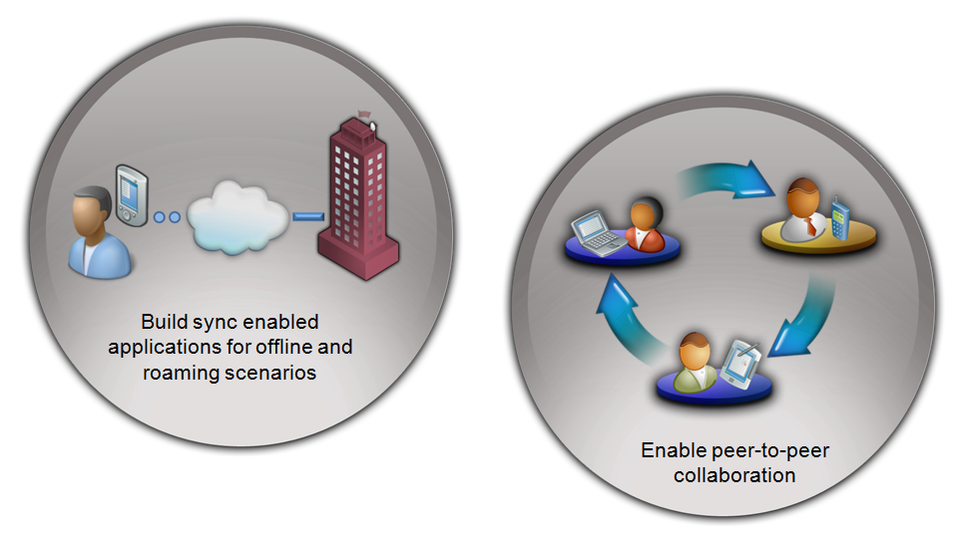Use the Microsoft Sync Framework to build collaboration and offline scenarios such as the following:

* Seamless online/offline data access for rich internet applications (RIA) and line-of-business applications
* Peer-to-peer collaboration on content such as files/folders, email, contacts, appointments, audio, video and settings across any number of PCs, services, and devices

## Powerful

Use the comprehensive capabilities of the Microsoft Sync Framework to create rich applications that empower users to access any type of data they need, wherever and whenever they need it.   
The framework consists of:

* Core sync runtime that provides universal synchronization functionality agnostic of data types and protocols
* Ability to create and consume Simple Sharing Extensions (SSE) feeds
* Components to enable the rapid development of sync solutions on platforms including Microsoft SQL Server™ 2008, Microsoft Visual Studio™ 2008, NTFS file systems and removable drives
* An extensible provider model that integrates data sources into the sync ecosystem
* Rich conflict handling for automatic and custom resolution
* Built in support for filters to sync subsets of collections such as mailboxes or media libraries
* Minimize network traffic with property-level sync

## Flexible

The Microsoft Sync Framework provides developers with ultimate flexibility by implementing a rich metadata model to enable collaboration and offline scenarios for virtually any endpoint without requiring changes to be made to the data store itself.

**Any Store**

Add synchronization to a wide range of applications, services, and devices, from enterprise-level services to simple USB storage devices.

## Any Data Type

Easily integrate new data types to sync using the Microsoft Sync Framework’s flexible metadata-based synchronization technology. Synchronize any type of data including databases, personal information manager (PIM) data and digital media files.

## Any Protocol

Synchronize data using existing architectures and protocols. Integrate sync into a variety of protocols, including over-the-air and embedded devices, using the Microsoft Sync Framework’s

transport-agnostic architecture. Enable web services to expose and synchronize data with any platform by creating a data feed based on the Simple Sharing Extensions (SSE) open specification.

## Any Network Configuration

Sync-enable your applications, devices, and services in true peer-to- peer and hub/spoke topologies. Recover easily from network interruptions without losing data integrity. Reduce network traffic using efficient change enumeration. Create web services to expose data via SSE.

## Productive

Leverage sync capabilities exposed in Microsoft technologies to rapidly create sync ecosystems. Boost productivity by using a common synchronization platform for all applications, services and devices.

* Design rich offline applications using Visual Studio 2008 and Sync Services for ADO.NET
* Leverage the power of change tracking in SQL Server 2008 to easily detect changes
* Configure the Microsoft Sync Framework’s File Sync Provider to sync files and folders
* Easily sync to remote services by producing and consuming SSE feeds

## Available on Multiple Platforms and Development Environments

Build sync aware applications and services on Microsoft Windows® and Windows Mobile® using managed or unmanaged code. Add support for other platforms through commercial licensing and porting kits.

## Additional Information

For more information about the Microsoft Sync Framework, visit <http://msdn.microsoft.com/sync>