OTP : Register page is getting loaded along with OTP page.
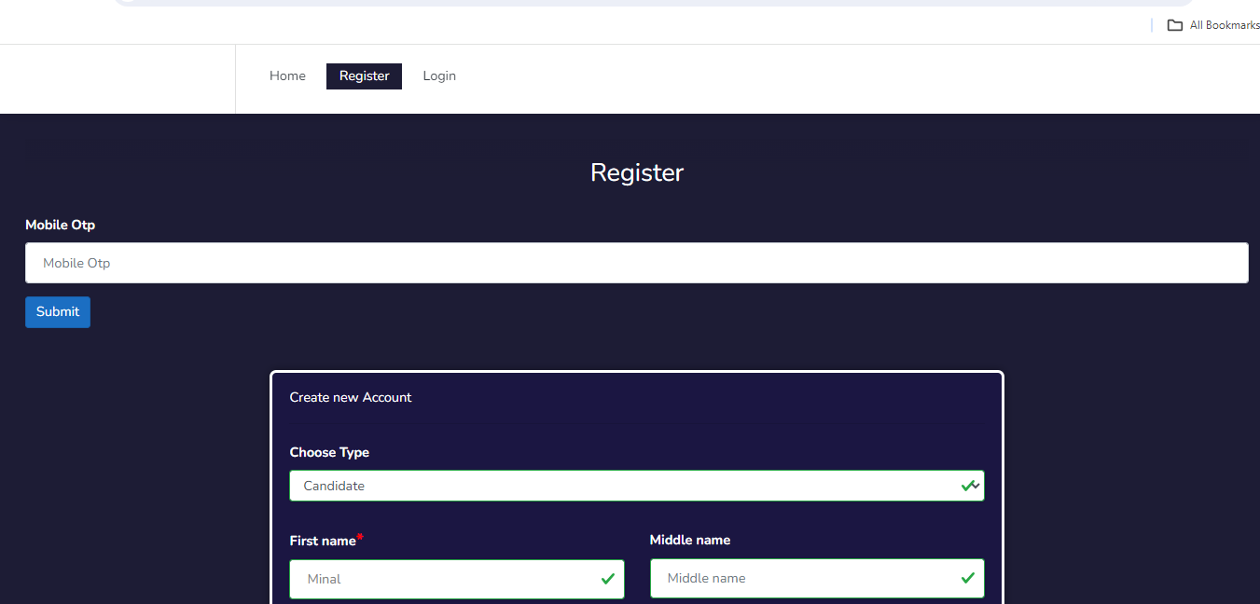

Login Page : - User is on login page. Still Register link is highlighted.
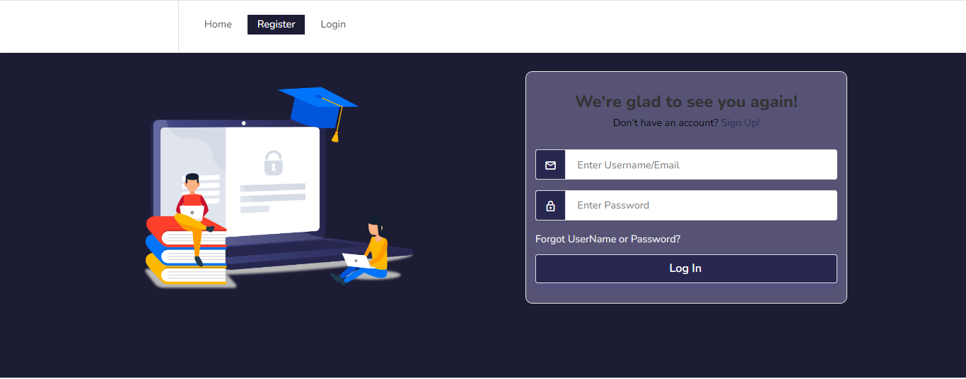

Assessment : - Without giving exam, Congratulations message is displayed.
