**Mini Project Report**

**On**

**Loan Eligibility System Using Machine Learning**



**Submitted To: Graphic Era University Submitted By: Harsh Yadav**

**University Roll Number: 2014397**

**Semester – VI**

For fulfillment of the Award of the Degree

Bachelor of Technology, VI Semester

Session – 2021-2022

In

Computer Engineering

**Introduction**

How great would it be, if we could predict, whether our request for a loan, will be approved or not, simply by the use of machine learning, from the ease and comfort.

This is not only be a practical project, which is applicable in the current times but also adds more to our knowledge of how the system of Loan Approval works.

To ease the project with the help of a Machine Learning model named the **Support Vector Machine**.

We see, any bank, approves a loan based on the two most vital points:

1) How risky is the borrower currently, (This is the factor, on which the interest rate of the borrower will depend), and

2) Should they lend the money to the borrower at the given risks?

If both of these conditions give an affirmatory result, the bank proceeds with the loan approval.

**A brief about Support Vector Machine Model**

The algorithm that has been used for this purpose, is the Support Vector Machine. Support Vector Machine (SVM), falls under the “**supervised machine learning algorithms**” category. It can be used for classification, as well as for regression. In this model, we plot each data item as a unique point in an n-dimension (where n is actually, the number of features that we have) with the value of each of the features being the value of that particular coordinate. Then, we perform the process of classification by finding the hyper-plane that differentiates the two classes.

Take a look at the graph below:

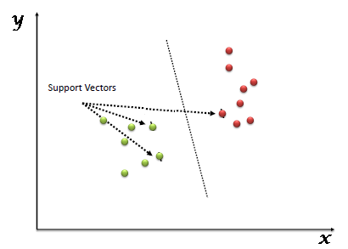

## **Why choose Support Vector Machine over other algorithms?**

Why SVM, and not the other commonly used algorithms like Logistic Regression, etc. Well, we see there are no such algorithms, which we can strictly say, are better than the other. It all depends on the type of operations we are performing, and the type of data we are dealing with.

SVM is preferred over other algorithms when:

1)The data is not regularly distributed.

2)SVM is generally known to not suffer the condition of overfitting.

3)Performance of SVM, and its generalization is better on the dataset.

4)And, lastly, SVM is known to have the best results for classification types of problems.

## **Support Vector Machine Project**

Now that we are aware of the algorithm that we are going to use, let us plan the tasks that lie ahead of us to achieve the ultimate predictive goals.

Let us divide the tasks, and represent them in a workflow.

It must look something like this:

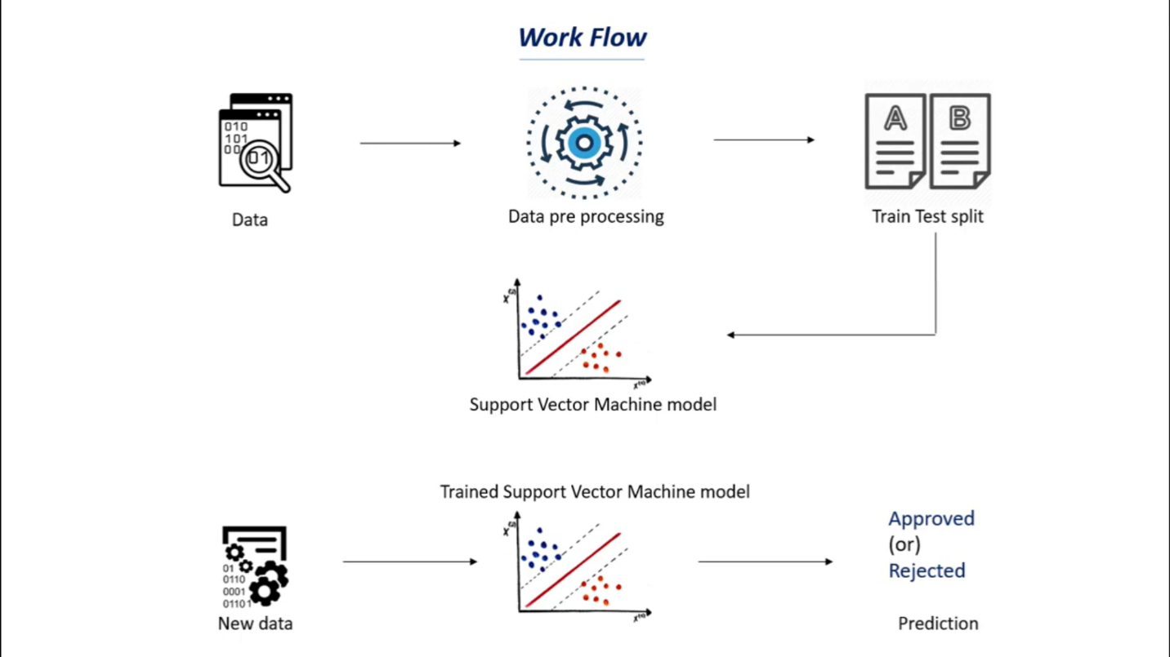

Image 1

Now that we are aware of what lies ahead of us, let us complete each of these tasks step by step.

#### **Dataset**

The foremost thing that is needed the most, in a machine learning project, is a dataset.

A dataset, as the name says, is a set or collection of data. It contains all the values that we need to work with, to get the necessary results.

For this project, the dataset that I have used is the one I found on Kaggle. We can use any dataset available on the internet that you feel comfortable working with.

The link to the dataset I have used is: [link](https://www.kaggle.com/ninzaami/loan-predication).

**Note**: You must always keep in mind the fact, that, the more the number of training values present in the dataset, the better will be the prediction that our trained model will be making. Although, a bigger dataset, means that it will consume more time to train the model.

**Let’s code!**

For this project, I have used python. You can use any python editing environment that you like, eg. PyCharm, Jupyter Notebook, Sublime, Atom, VSCode, etc.

What I have used is a Jupyter Notebook.

The benefit of using a Jupyter notebook is that we need to run all the things locally. All the processes are run on the local server. All we do not need an Internet Connection.

#### **Importing Dependencies**:

Let us first import all the modules and libraries that we are going to use in the future while making the project. The dependencies that we will be using are:

numpy, pandas, seaborn, and ScikitLearn.

import numpy as np

import pandas as pd

import seaborn as sns

from sklearn.model_selection import train_test_split

from sklearn import svm

from sklearn.metrics import accuracy_score

When we move on, we will get to know the use of each of these.

#### Data Collection and Processing

Simply downloading the dataset will not do. We need to link the dataset to our code so that our code can read the data from the table.

The dataset will be in the format of a CSV. Thus to read it, we will be taking the help of the pandas method, called read_csv()

We are strong the dataset in the variable called “loan_dataset”. We can thus now refer to the entire dataset by this variable name.

loan_dataset = pd.read_csv('Dataset.csv')

To get a glance at the first 5 rows of the dataset, use the head () method:

loan_dataset.head()

It gives the following output:

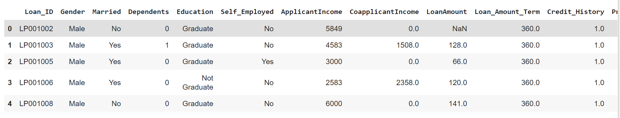

The meaning of the terms in the row headings can be found out on the website, from which we have downloaded the dataset.

Now, let us check the number of rows and columns in the dataset. We run the command:

loan_dataset.shape

It gives the output:

(614,13)

Now, the most important part, let us check, how many values are missing from the dataset. We use the command:

loan_dataset.isnull().sum()

We find: Gender:13

Married: 3

Dependents: 15

Self_Employed: 32

And so on…

Now, thus to get rid of the missing values, let us drop them using the command:

loan_dataset = loan_dataset.dropna()

Now again let us verify whether there are any more missing values left:

loan_dataset.isnull().sum()

No, we find that there are no missing values present in the dataset anymore.

Now what we will do, is called **label encoding**.

We will be replacing the loan status of ‘Y’ with 1, and ‘N’ with 0, for better reference.

Let us count the frequency of each value in the “Dependent” column:

loan_dataset[‘Dependents’].value_counts()

We find:

0 274

2 85

1 80

3+ 41

Name: Dependents, dtype: int64

So, we will replace the value of 3+ with 4 to better performance.

loan_dataset = loan_dataset.replace(to_replace='3+', value=4)

Again, what we will do is, convert the categorical columns, to numerical values for better reference.

loan_dataset.replace ({'Married':{'No':0,'Yes':1},'Gender':{'Male':1,'Female':0},'Self_Employed':{'No':0,'Yes':1},

'Property_Area': {'Rural':0,'Semiurban':1,'Urban':2},'Education': {'Graduate':1,'Not Graduate':0}},inplace=True)

Now when we run:

loan_dataset.head()

We find that all the values have been changed to numerical values.

Splitting Data and Label:

Let us split the data and label into the X and Y variables:

X = loan_dataset.drop(columns=['Loan_ID','Loan_Status'],axis=1)

Y = loan_dataset['Loan_Status']

Thus now, X will store all the features on which the loan status depends, excluding the loan status itself.

Y will store only the Loan Statuses.

#### **Splitting X and Y into Training and Testing Variables**

Now, we will be splitting the data into four variables, viz., X_train, Y_train, X_test, Y_test.

X_train, X_test,Y_train,Y_test = train_test_split(X,Y,test_size=0.1,stratify=Y,random_state=2)

Let’s understand each of the variables by knowing what type of values they will be storing:

**X_train:** contains a random set of values from variable ‘X ‘

**Y_train:** contains the output (the Loan Status) of the corresponding value of X_train.

**X_test:** contains a random set of values from variable ‘X ‘, excluding the ones already present in X_train(as they are already taken).

**Y_train:** contains the output (the Loan Status) of the corresponding value of X_test.

**test_size:** represents the ratio of how the data is distributed among X_trai and X_test (Here 0.2 means that the data will be segregated in the X_train and X_test variables in an 80:20 ratio). You can use any value you want. A value < 0.3 is preferred.

### **Training our Support Vector Machine model**

Let us name the SVM model “**classifier**”.

Let us define the model:

classifier = svm.SVC(kernel='linear')

Now, let us train our defined model.

classifier.fit(X_train,Y_train)

Now that our model is trained, let us train it with the values of X_train, let us now check its accuracy, by comparing it to Y_train.

X_train_prediction = classifier.predict(X_train)

training_data_accuray = accuracy_score(X_train_prediction,Y_train)

Let us print the Accuracy Score:

Print ('Accuracy on training data: ', training_data_accuray)

The Accuracy Score came out to be: **0.7986111111111112**

Now let us do the same thing with the Testing Values:

X_test_prediction = classifier.predict(X_test)

test_data_accuray = accuracy_score(X_test_prediction,Y_test)

And again, let us print the accuracy score:

Print ('Accuracy on test data: ', test_data_accuray)

The output came out to be:

Accuracy on test data: **0.8333333333333334**

Thus, it seems our trained model performed better on the testing set than the training set.

#### **Scope of Improvements**

Now the thought must have crossed your mind, that how can we improve our results if at all.

As we have seen here, our training prediction score was a tad lower, than the testing prediction score. This is okay. Yes, it sounds awkward, but it’s actually fine. You must also be thinking, why did I check the prediction score on the training data at all? Well, to check for a condition, that sometimes arises while training a model in Machine Learning, called as **Over-Training**.

A short brief of Overfitting is: The model is so poorly trained, that it gives a very high score on the training data (eg: >90%), but gives an extremely low score on the testing data (eg: <15%).

So, to check for that, we see the scores for both cases.

Now, coming to the scope of improvements and modifications, we can improve the accuracy score, by doing some of the following, though it is **not guaranteed**, that the results will change for the better.

1)**Taking a bigger dataset** with versatile and large training data. But keep in mind while taking a large dataset, the bigger the dataset, the more processing time will the execution take.

2) **Checking for various algorithms**. There is no such convention, that we must use a specific algorithm, for a specific problem set. We chose the algorithm based on the type of dataset. You might even have to opt for the method of “trial & error”.

3)**Optimize the parameters**. If you don’t do a grid search for the parameters (C, kernel parameters), it’s a matter of luck if your SVM model does well. The libsvm website has Matlab code explaining this case.

## **The practicality of this Project**

## Is the above code ready to be deployed in the banking systems?

## A straightforward answer will be **NO**.

The reasons are:

1) I have used an extremely small dataset. Thus, the training dataset is not enough for the model to predict for the various kinds of people that dwell on this earth, with various backgrounds.

2) Real-life scenarios are quite different than what we discuss in theory. There arise many exceptions, that need to be dealt with, and even, the decision-making supremacy, whether a person can be sanctioned a loan or not, cannot be given to a machine that predicts on the basis of these few lines of codes. Humans do have to intervene in those exceptional cases.

But does this mean, all that we did was a sheer waste?

Well, **no again**. We can use this concept to act as a parallel decision-making feature in the banks, that might be used to second the decisions of the bank people. But it must not be used solely, without the intervention of humans.

## **End Notes**

As we saw in this project, we first train a machine learning model, then use the trained model for prediction. Similarly, any model can be made much more precise and accurate for predictions, by feeding a very large dataset, to get a very accurate and realistic score.

That’s it for now.