Ques 1:Create HTML for web-page.jpg

Ans: HTML CODE WITH BOOTSTRAP CLASSES

<**html**>

<**head**>

<**meta charset="utf-8"**>

<**meta name="viewport"**>

<**link rel="stylesheet" href="https://maxcdn.bootstrapcdn.com/bootstrap/4.4.1/css/bootstrap.min.css"**>

*<!-- jQuery library -->*

<**script src="https://ajax.googleapis.com/ajax/libs/jquery/3.4.1/jquery.min.js"**></**script**>

*<!-- Popper JS -->*

<**script src="https://cdnjs.cloudflare.com/ajax/libs/popper.js/1.16.0/umd/popper.min.js"**></**script**>

*<!-- Latest compiled JavaScript -->*

<**script src="https://maxcdn.bootstrapcdn.com/bootstrap/3.4.1/js/bootstrap.min.js"**></**script**>

<**style type="text/css"**>

**body**

{

**background-color**: **rgba**(84,84,84,0.95);

}

**#mybrand**

{

**color**: **#ffffff**;

**font-size**: 40**px**;

}

**h1**

{

**color**: **#ffffff**;

**font-family**: **arial**, **Helvetica**, **sans-serif**;

}

**#ref-style a**

{

**color**: **#ffffff**;

**font-family**: **arial**, **Helvetica**, **sans-serif**;

}

**#firstsection**

{

**background-color**: **#545454**;

}

**#secondsection**

{

**height**: **auto**;

**width**: **auto**;

**background-color**: **#ffffff**;

}

**#img-style**

{

**margin-top**: 10**px**;

}

**#caption-style**

{

**background-color**: **rgba**(139,139,139,0.2);

**border-radius**: 2**px**;

}

.**shift-style**

{

**padding-left**: 18**px**;

**font-family**: **arial**, **Helvetica**, **sans-serif**;

**font-size**: **medium**;

**color**: **white**;

}

.**shift-style1**

{

**padding-left**: 310**px**;

**font-family**: **arial**, **Helvetica**, **sans-serif**;

**font-size**: **medium**;

**color**: **white**;

}

**#footer-style**

{

**background-color**: **black**;

}

**#footer-style p**

{

**color**: **#ffffff**;

}

</**style**>

</**head**>

<**body**>

<**div class="container"**>

<**div class="row" id="firstsection"**>

<**div class="col-md-12"**>

<**a id="mybrand" href=""**>TO THE NEW</**a**>

<**nav id="ref-style" class="navbar navbar-expand-lg navbar-light bg-dark"**>

<**button class="navbar-toggler" type="button" data-toggle="collapse" data-target="#navbarNavAltMarkup" aria-controls=" navbarNavAltMarkup" aria-expanded="false" aria-label="Toggle navigation"**>

<**span class="navbar-toggler-icon"**></**span**>

</**button**>

<**div class="collapse navbar-collapse" id="navbarNavAltMarkup"**>

<**div class="navbar-nav"**>

<**a class="nav-item nav-link " href="#"**>Text Link </**a**>

<**a class="nav-item nav-link" href="#"**>Text Link</**a**>

<**a class="nav-item nav-link" href="#"**>Text Link</**a**>

<**a class="nav-item nav-link" href="#"**>Text Link</**a**>

<**a class="nav-item nav-link" href="#"**>Text Link</**a**>

*<!--*

*<a class="nav-item nav-link disabled" href="#" tabindex="-1" aria-disabled="true">Disabled</a> -->*

</**div**>

</**div**>

</**nav**>

</**div**>

</**div**>

</**div**>

<**section**>

<**div class="container"**>

<**div id="secondsection" class="row"**>

<**div class="col-md-12"**>

<**div id="img-style" class="col-md-12 col-sm-8 mb-3"**>

<**img src="ugTtPzn-deadpool-wallpaper-hd.jpg" class="card-img-top" alt="..." height="360" width="960"**>

</**div**>

<**div id="caption-style" class="col-md-12 col-sm-8 mb-3"**>

<**p class="card-text"**>Some quick example text to build on the card title and make up the bulk of the card's content.</**p**>

</**div**>

<**div class="row col-md-12 col-sm-8 mb-3"**>

<**p** >Latest from the gallery</**p**>

</**div**>

<**div class="row col-md-12 col-sm-8 mb-3"**>

*<!-- sgdjfks -->*

<**div class="card-group"**>

<**div class="card"**>

<**img src="Nw8omE6-deadpool-wallpaper-hd.jpg" class="card-img-top" alt="..." height="315" width="215"**>

<**div class="card-body"**>

<**p class="card-text"**>Image caption here</**p**>

</**div**>

</**div**>

<**div class="card"**>

<**img src="Nw8omE6-deadpool-wallpaper-hd.jpg" class="card-img-top" alt="..." height="315" width="215"**>

<**div class="card-body"**>

<**p class="card-text"**>Image caption here</**p**>

</**div**>

</**div**>

<**div class="card"**>

<**img src="Nw8omE6-deadpool-wallpaper-hd.jpg" class="card-img-top" alt="..." height="315" width="215"**>

<**div class="card-body"**>

<**p class="card-text"**>Image caption here</**p**>

</**div**>

</**div**>

<**div class="card"**>

<**img src="Nw8omE6-deadpool-wallpaper-hd.jpg" class="card-img-top" alt="..." height="315" width="215"**>

<**div class="card-body"**>

<**p class="card-text"**>Image caption here</**p**>

</**div**>

</**div**>

</**div**>

</**div**>

</**div**>

</**div**>

<**div id="footer-style" class="row"**>

<**div class="col-sm-12 col-md-12 mb-3"**>

<**span class="shift-style"** >Copyright © 2019-2020 ALL RIGHTS RESERVED-"Harsh Yadav"</**span**> <**span class="shift-style1"**>WEB LAYOUT BY Harsh Yadav</**span**>

</**div**>

</**div**>

</**div**>

</**div**>

</**section**>

</**body**>

</**html**>

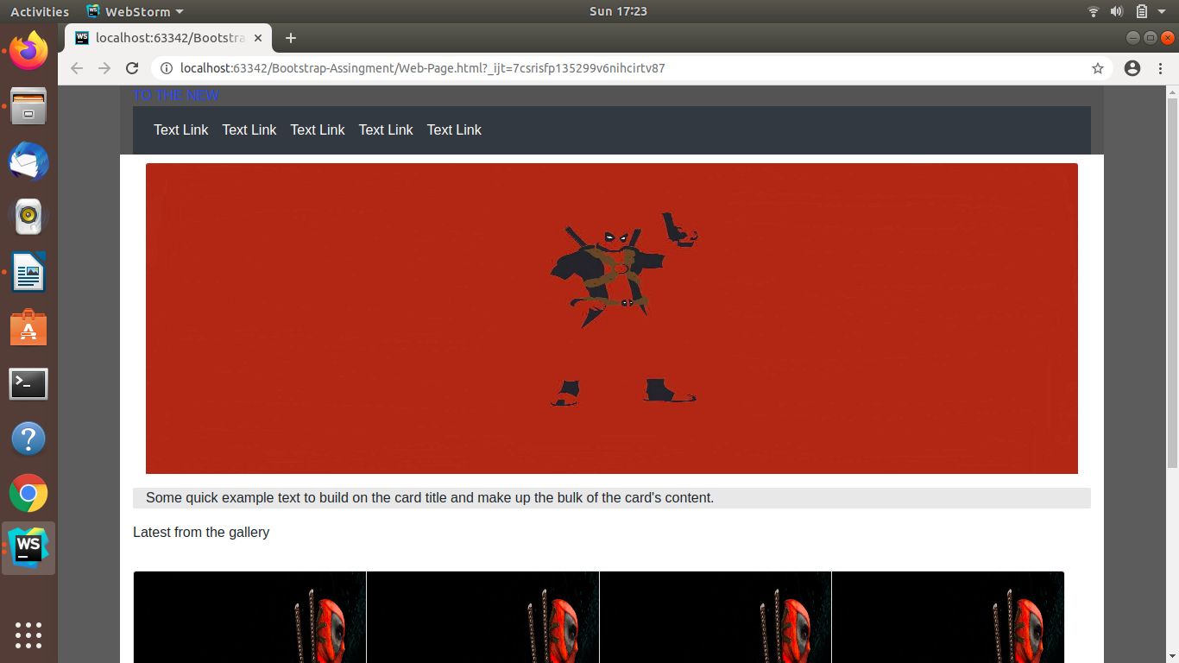

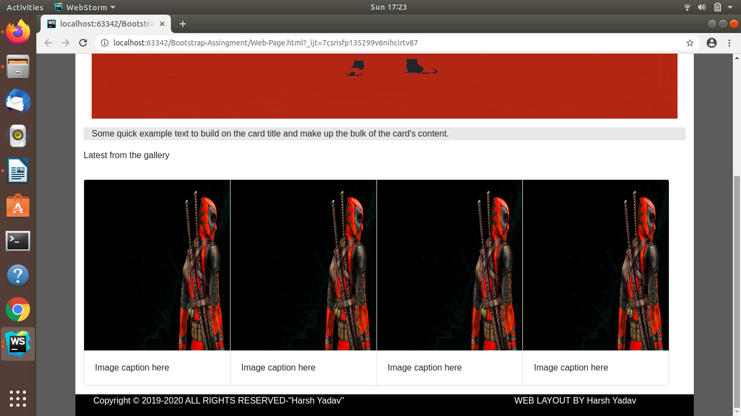

Ques 2:Create HTML for form.png

Ans:HTML CODE WITH BOOTSTRAP CLASSES

<!DOCTYPE **html**>

<**html**>

<**head**>

<**link rel="stylesheet" href="https://maxcdn.bootstrapcdn.com/bootstrap/3.4.1/css/bootstrap.min.css"**>

*<!-- jQuery library -->*

<**script src="https://ajax.googleapis.com/ajax/libs/jquery/3.4.1/jquery.min.js"**></**script**>

*<!-- Popper JS -->*

<**script src="https://cdnjs.cloudflare.com/ajax/libs/popper.js/1.16.0/umd/popper.min.js"**></**script**>

*<!-- Latest compiled JavaScript -->*

<**script src="https://maxcdn.bootstrapcdn.com/bootstrap/3.4.1/js/bootstrap.min.js"**></**script**>

<**title**>BOOTSTRAP FORM</**title**>

<**style type="text/css"**>

**#y**

{

**width**: 300**px**;

}

</**style**>

</**head**>

*<!-- ............................Header Start ................... -->*

<**header**>

<**nav class="navbar"**>

<**div class="container-fluid"**>

<**div class="navbar-header"**>

<**a class="navbar-brand" href="#"**>TO THE NEW</**a**>

</**div**>

<**ul class="nav navbar-nav navbar-right"**>

<**li**><**a href="#"**><**span class="glyphicon glyphicon-home"**></**span**> Home</**a**></**li**>

<**li**><**a href="#"**> QuickHelp</**a**></**li**>

</**ul**>

</**div**>

<**hr**>

</**nav**>

</**header**>

*<!-- ............................Header End ................... -->*

<**body**>

<**div class="container"**>

<**div class="row"**>

<**div class="col-md-2"**></**div**>

<**div class="col-md-8"**>

<**div class="panel panel-default"**>

<**div class="panel-heading" style="background-color**: **#d3d3d3"**><**b**><**font color="white"**><**h2**>Bug Report</**h2**></**font**></**b**></**div**>

<**div class="panel-body"**>

*<!-- ............................Form Start ................... -->*

<**form**>

<**div class="form-group"**>

<**label for="title"**>TITLE*:</**label**>

<**input type="text" class="form-control" required="true"**>

<**label for="description"**>DESCRIPTION*:</**label**>

<**textarea class="form-control" required="true"**></**textarea**>

<**div class="form-group"**> *<!-- ............... DropDown ................-->*

<**label for="sel1"**>Operating System:</**label**>

<**select class="form-control" style="background-color**: **lightgreen"**>

<**option**>Windows</**option**>

<**option**>Ubuntu</**option**>

<**option**>MAC</**option**>

<**option**>Android</**option**>

</**select**>

</**div**>

<**div class="form-group"**> *<!-- ............... DropDown ................-->*

<**label for="sel2"**>Product:</**label**>

<**select class="form-control" style="background-color**: **lightgreen"**>

<**option**>Windows 10</**option**>

<**option**>Ubuntu 16.04</**option**>

<**option**>Ubuntu 18.04</**option**>

<**option**>Android 10</**option**>

</**select**>

</**div**>

<**label for="ver"**>VERSION:*</**label**>

<**input type="text" class="form-control" required="true" id="y"**>

<**label for="lic"**>License</**label**><**br**> *<!-- ............... RadioButtons ................-->*

<**label class="radio-inline"**><**input type="radio" name="optradio" checked**>Free</**label**>

<**label class="radio-inline"**><**input type="radio" name="optradio"**>Business</**label**><**br**><**br**>

<**div class="form-group"**> *<!-- ............... DropDown ................-->*

<**label for="sel3"**>Severity</**label**>

<**select class="form-control" style="background-color**: **lightgreen"**>

<**option**>Critical</**option**>

<**option**>Normal</**option**>

</**select**>

</**div**>

<**div class="form-group"**>

<**label for="ControlFile"**>Attachements: </**label**>

<**input type="file" class="form-control-file"**>

</**div**>

</**div**>

</**form**>

*<!-- ............................Form End ................... -->*

</**div**>

<**div class="panel-footer clearfix" style="background-color**: **#d3d3d3"**>

<**a href="#" class="btn btn-success" role="button" type="submit" style="float**: **right**;**"**>Send</**a**>

</**div**>

</**div**>

</**div**>

</**div**>

</**body**>

</**html**>

