Problem Statement: There can be multiple customers, who can place multiple orders on the site. Now a sales person can handle these orders will distribute into multiple sales persons (One order will be assign to one salesperson only). So a sales person can have multiple orders of multiple customers.

Ques1:Create Database

Ans:

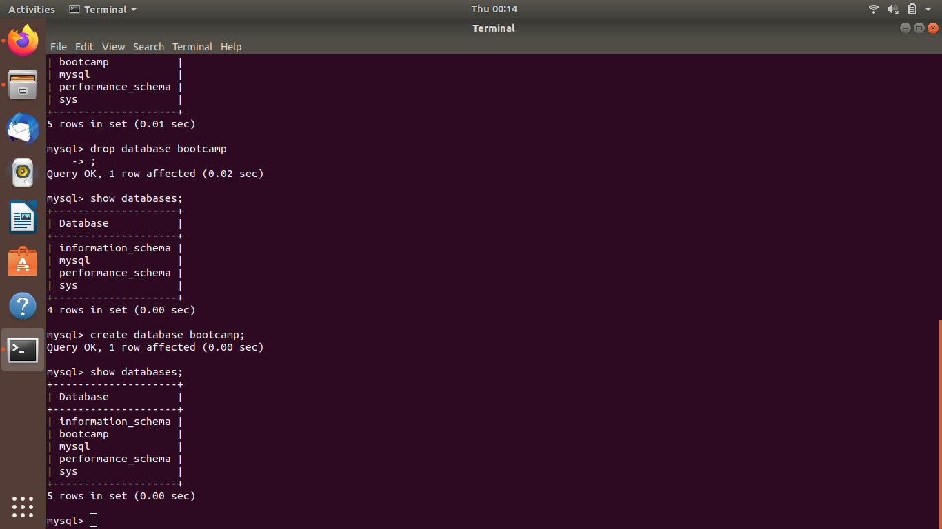

Ques2:Design Schema

Ans:

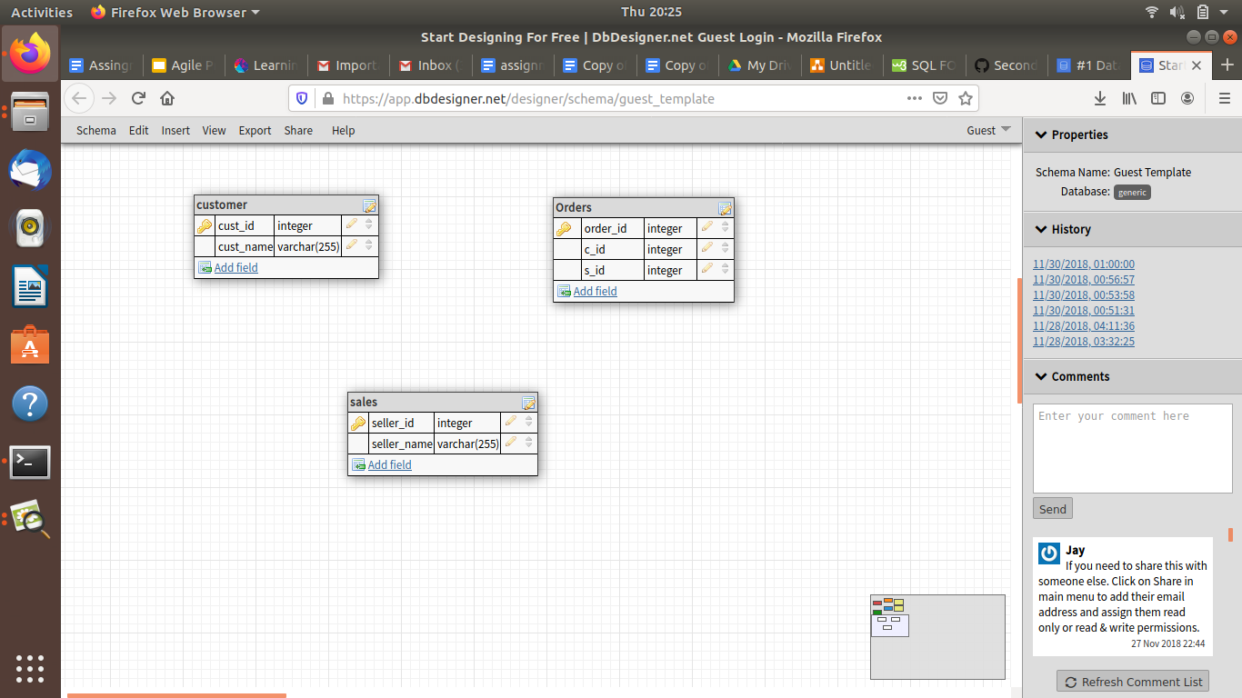

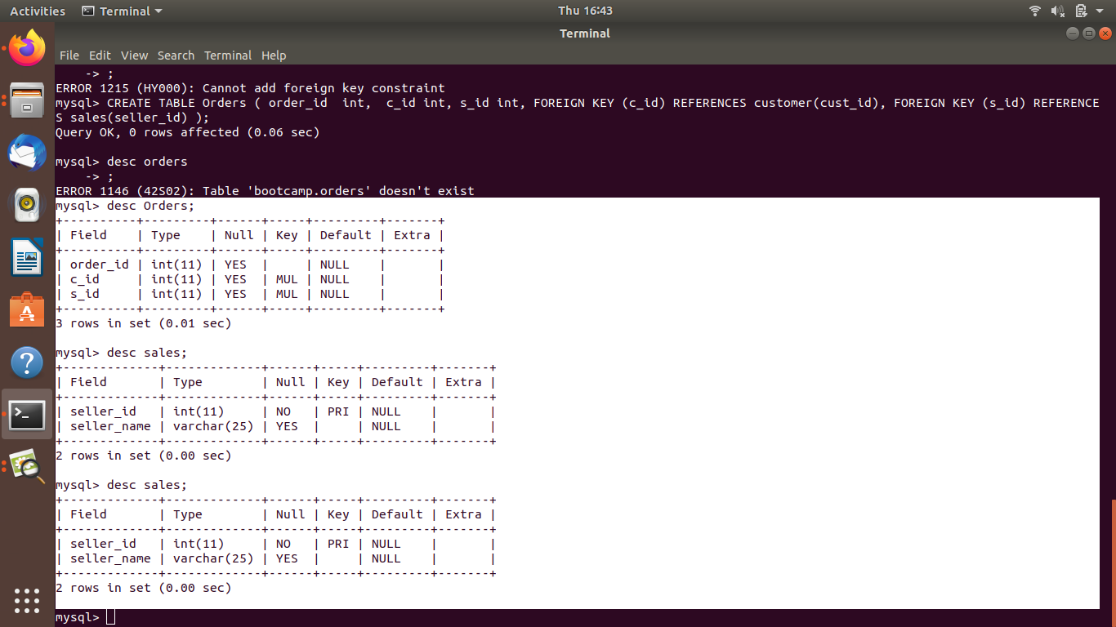

Ques 3:Create tables

Ans:

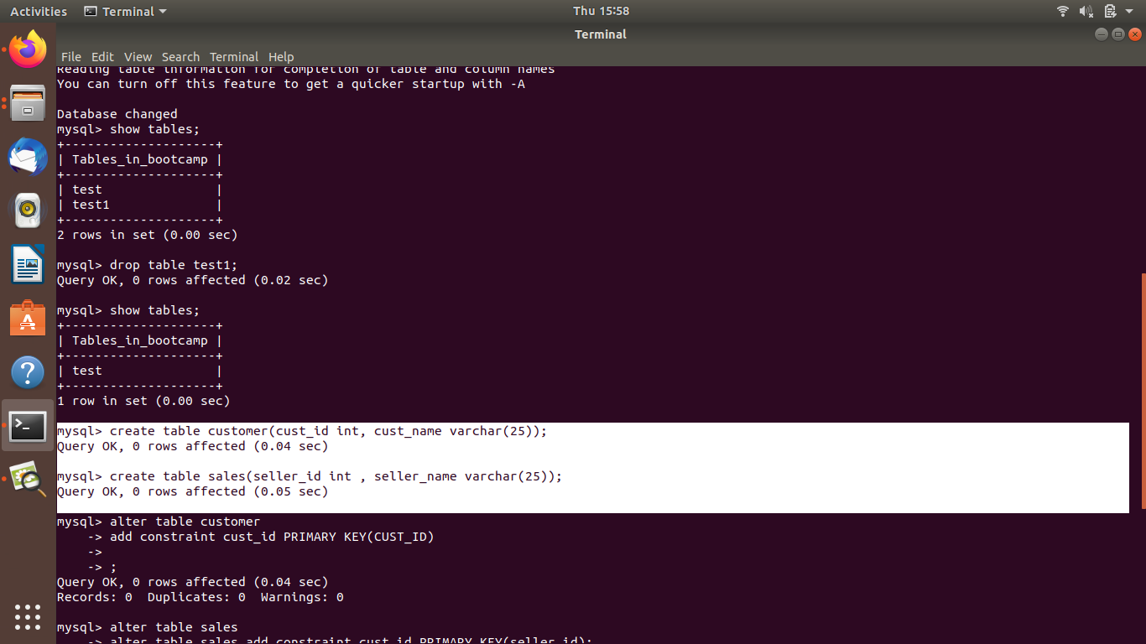

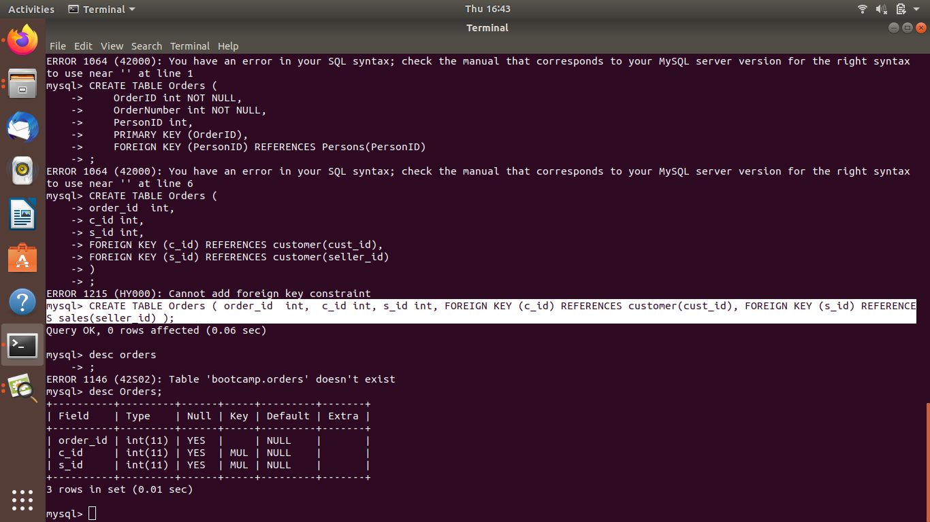

Ques 4:Insert sample data

Ans:

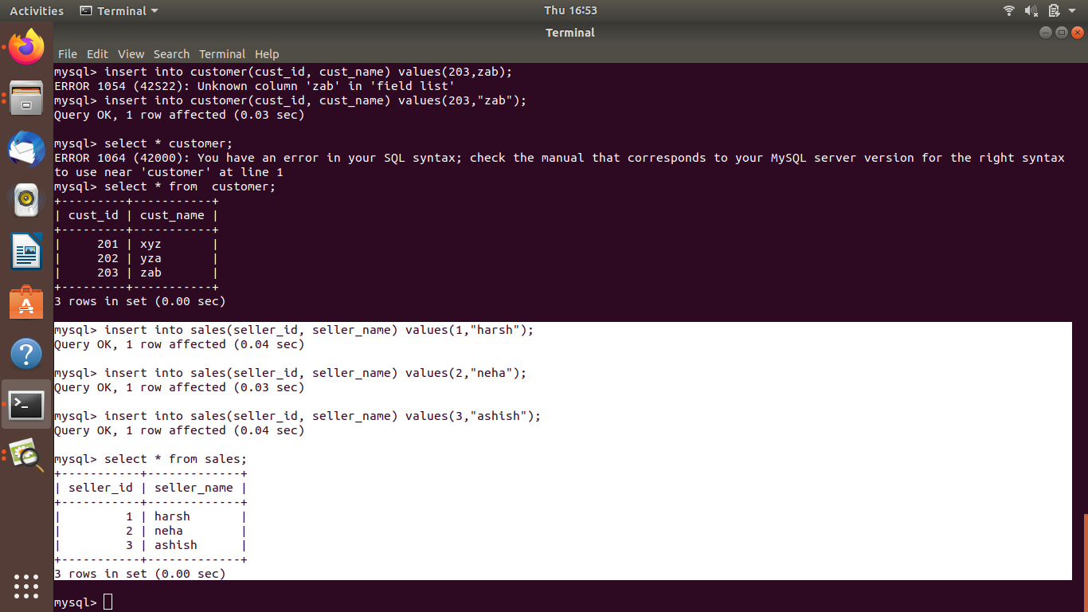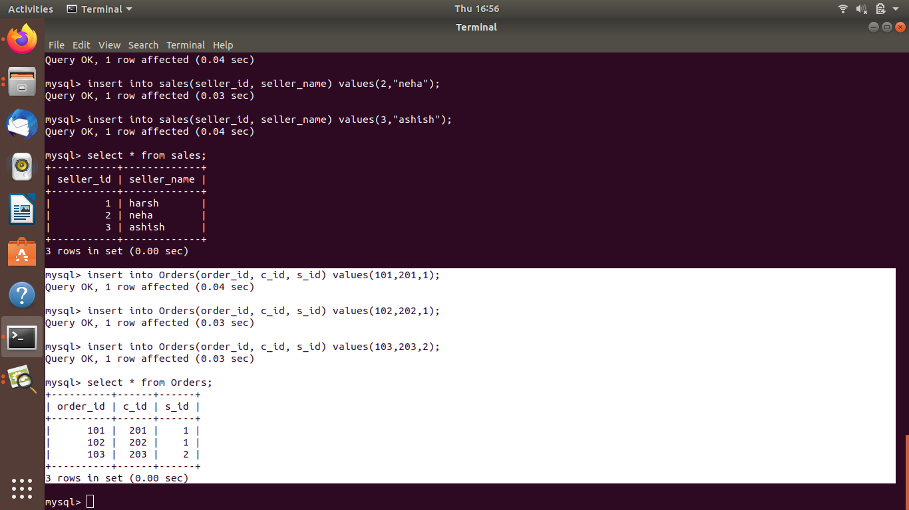

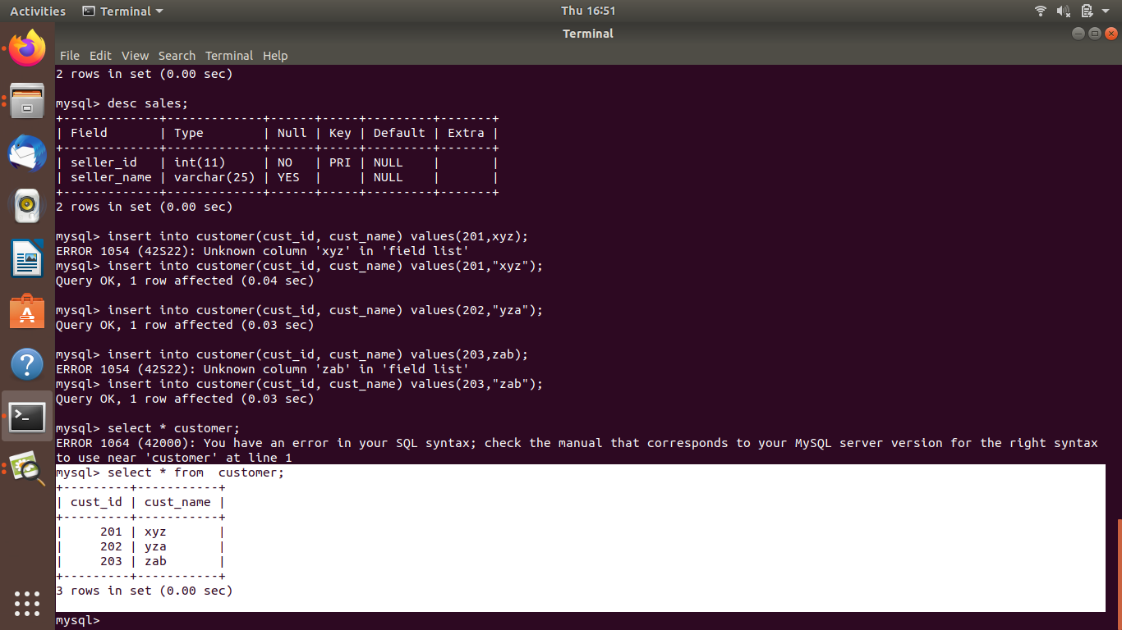



Ques 5:Find the sales person have multiple orders.

Ans:

Select sales.seller_name from sales where(select count(*) from Orders where Orders.s_id = sales.seller_id)1;

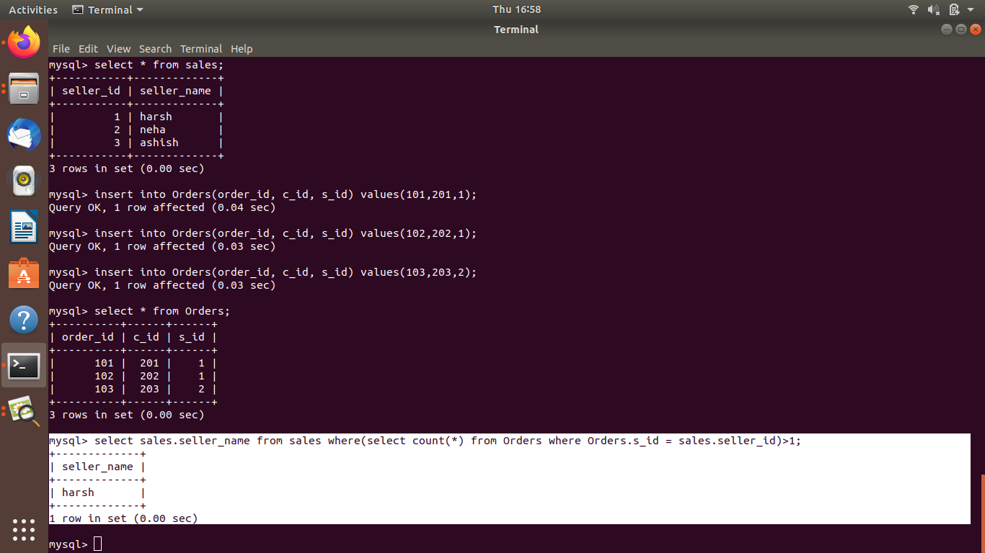

Ques 6: Find the all sales person details along with order details

Ans:

Select sales.seller_id sales.seller_name Orders.order_id from Orders inner join sales on Orders.s_id = sales.seller_id;

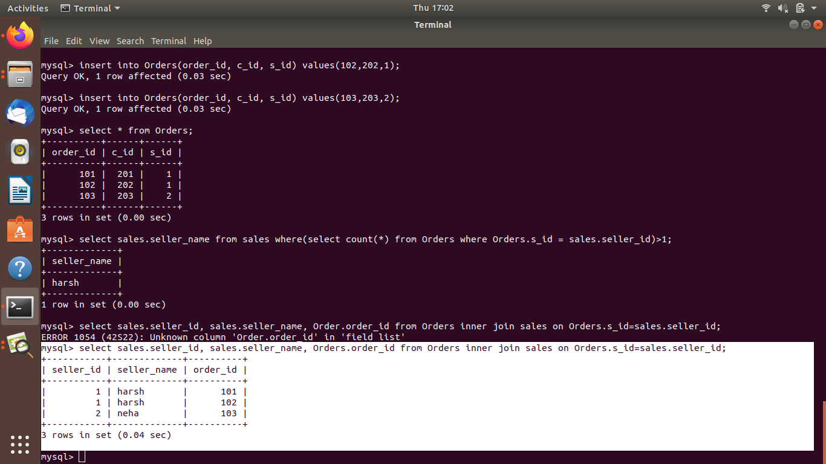

Ques 7:Create index

Ans:

Create index seller_index on sales(seller_id,seller_name);

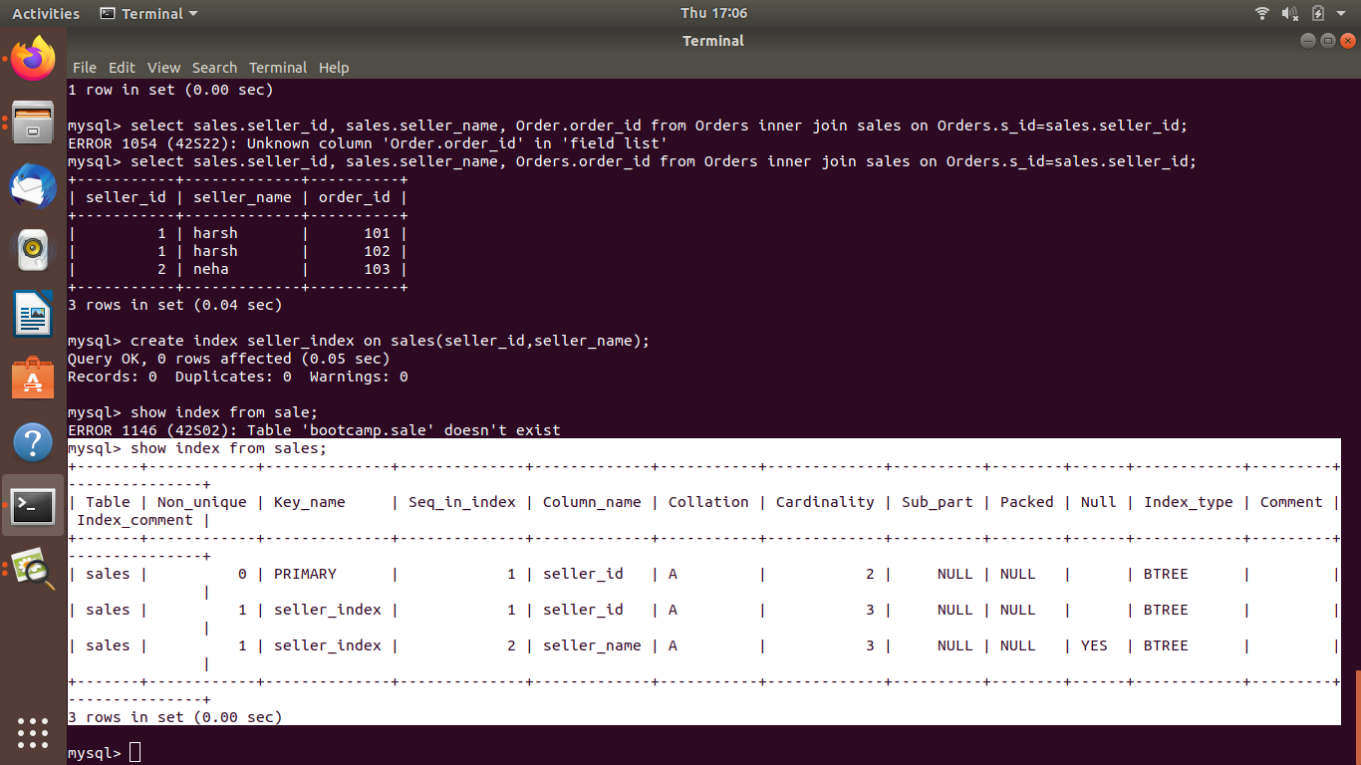

Ques 8:How to show index on a table

Ans:

Show index from sales;



Ques 9:Find the order number, sale person name, along with the customer to whom that order belongs to

Ans:

Select customer.cust_name, Orders.order_id, seller_name from ((Orders inner join customer ON Orders.c_id = customer.cust_id) inner join sales ON Orders.s_id=sales.seller_id);

