**JAVA-ASSINGMENT**

Ques 1:Write a program to replace a substring inside a string with other string ?

Ans:

Java-code:

public class HelloWorld{

public static void main(String []args){

String org ="this is original string";

String replaced=org.replace("original","savage");

System.out.print(replaced);

}

}

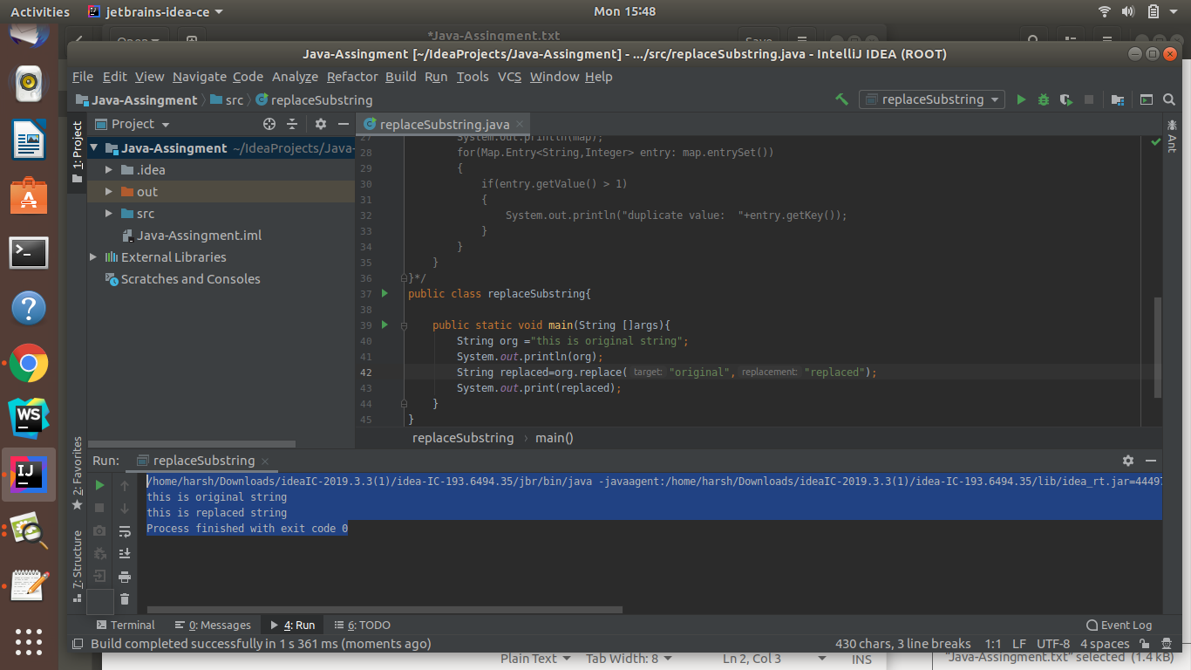

Ques 2:Write a program to find the number of occurrences of the duplicate words in a string and print them ?

Ans:

**Java-code-Using-HashMap**

import java.util.Map;

import java.util.HashMap;

public class HelloWorld{

public static void main(String []args){

Map<String,Integer> map = new HashMap<String,Integer>();

String org ="this is original string original";

String[] words = org.split(" ");

//map.put(words[0],1);

//System.out.println(map.get("this"));

for(int i=0; i<words.length; i++)

{

if(map.containsKey(words[i]))

{

//System.out.println("true");

int temp=0;

temp=map.get(words[i]);

temp++;

map.put(words[i],temp);

}

else

{

map.put(words[i],1);

}

}

System.out.println(map);

for(Map.Entry<String,Integer> entry: map.entrySet())

{

if(entry.getValue() > 1)

{

System.out.println("duplicate words:"+entry.getValue()+"duplicate value:"+entry.getKey());

}

}

}

}

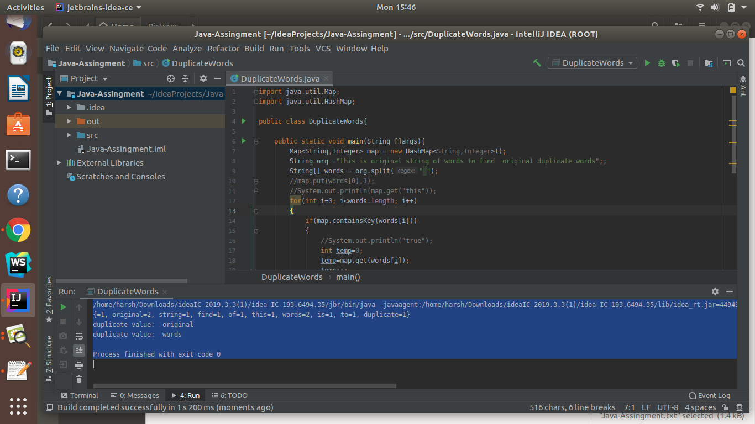

Ques 3:Write a program to find the number of occurrences of a character in a string without using loop?

Ans: **Java-code**

public class occurenceOfCharacter{

public static void main(String[] args)

{

String str ="this is original string of words to find original duplicate words";

System.out.println("We are finding number occurence of character a in string");

System.out.println();

int count = str.length() - str.replace("a","").length();

System.out.println("Occurence of a are: "+count);

}

}

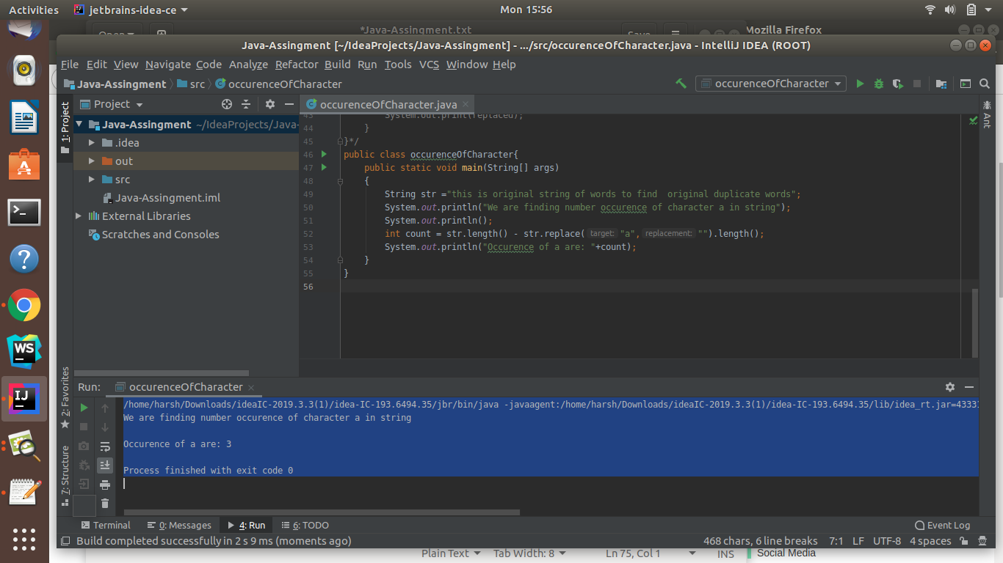

Ques 4:Calculate the number & Percentage Of Lowercase Letters,Uppercase Letters, Digits And Other Special Characters In A String

Ans:**JAVA-CODE**

import java.util.*;

public class occurenceOfCharacter{

public static void main(String[] args)

{

String str ="This is OrigInal @@@stRin6g of Words98 to 78find original duplicate words";

String specialcharacter="[!@#$%&*()_+=|<>?{}\\\\[\\\\]~-]";

Set<Character> set = new HashSet<Character>();

for(int i=0; i<specialcharacter.length();i++){

set.add(specialcharacter.charAt(i));

}

//System.out.println(set);

int lower=0,upper=0,digit=0,specialch=0,white=0;

int length=str.length();

for(int i=0; i<length; i++)

{

char ch =str.charAt(i);

if(Character.isUpperCase(ch)){

upper++;

}

else if(Character.isLowerCase(ch))

{

lower++;

}

else if(Character.isDigit(ch)){

digit++;

}

else if(set.contains(ch))

{

specialch++;

}

else if(Character.isWhitespace(ch))

{

white++;

}

}

length=length-white; // to remove number of whitespaces

double upper1=(upper*100.0)/length;

double lower1=(lower*100.0)/length;

double digit1=(digit*100.0)/length;

double specialch1=(specialch*100.0)/length;

System.out.println("Number of Lowercase "+lower+" lowercase percentage "+lower1);

System.out.println("Number of Uppercase "+upper+" Uppercase percentage "+upper1);

System.out.println("Number of Digit "+digit+" Digit percentage "+digit1);

System.out.println("Number of special character "+specialch+" special character percentage "+specialch1);

}

}

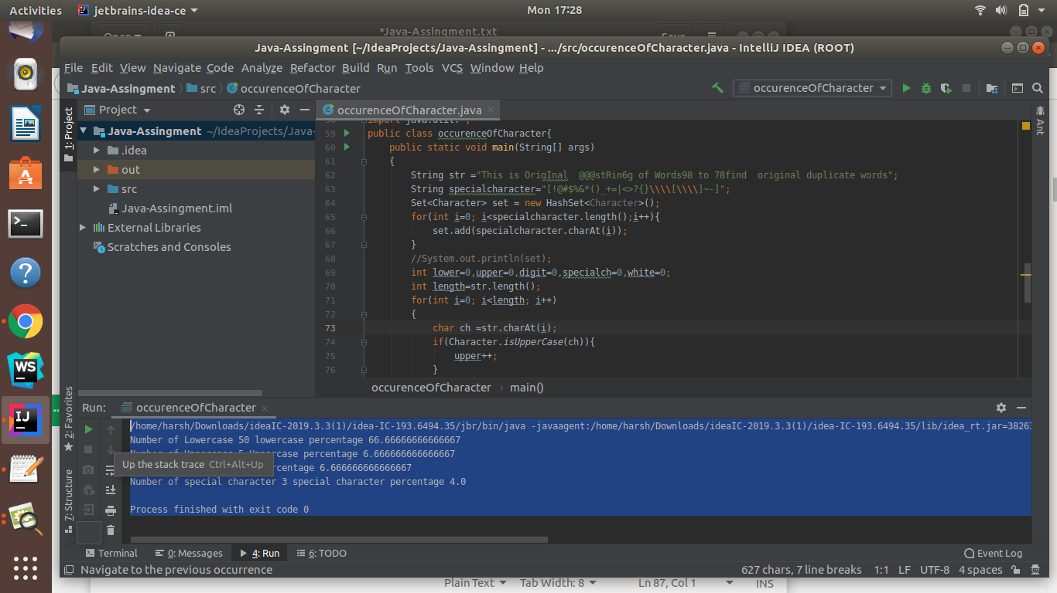

Ques 5:Find common elements between two arrays.

Ans: **Java-Code-Using-Set**

public class commonelements {

public static void main(String[] args) {

int[] arr1 = new int[]{25, 35, 45, 55, 25, 23};

int[] arr2 = new int[]{22, 35, 25, 56, 46, 67};

Set<Integer> set = new HashSet<Integer>();

for(int i=0; i<arr1.length;i++){

for(int j=0; j<arr2.length;j++){

if(arr1[i] == arr2[j]){

set.add(arr1[i]);

}

}

}

System.out.println("Common elements are:");

System.out.println(set);

}

}

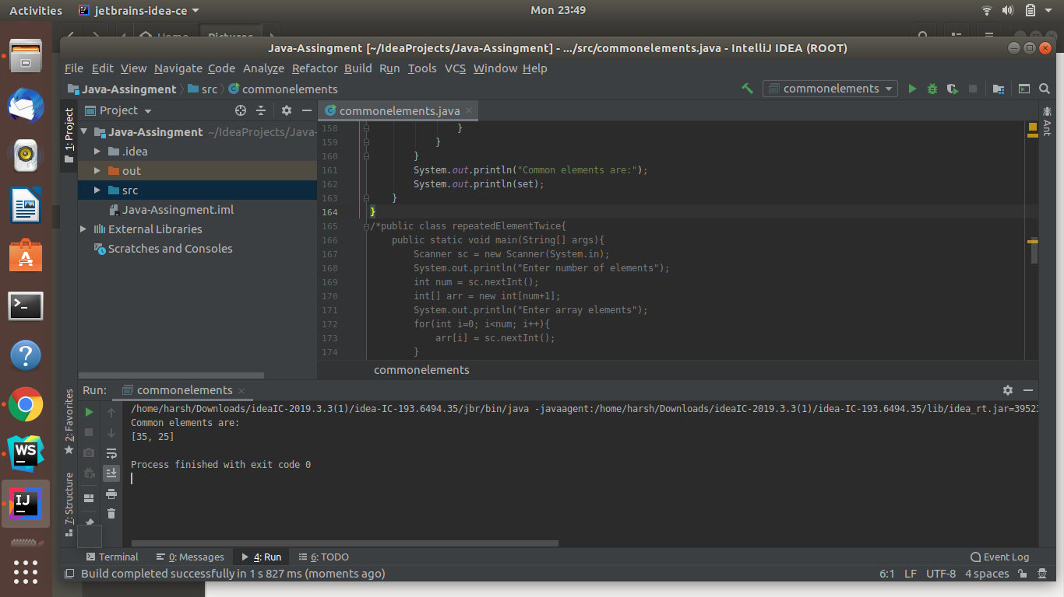

Ques 6:There is an array with every element repeated twice except one. Find that element

Ans: **JAVA-CODE**

public class repeatedElementTwice{

public static void main(String[] args){

Scanner sc = new Scanner(System.in);

System.out.println("Enter number of elements");

int num = sc.nextInt();

int[] arr = new int[num+1];

System.out.println("Enter array elements");

for(int i=0; i<num; i++){

arr[i] = sc.nextInt();

}

int result=arr[0];

for(int i=1; i<num; i++){

result=result^arr[i];

}

System.out.println("Single element is");

System.out.println(result);

}

}

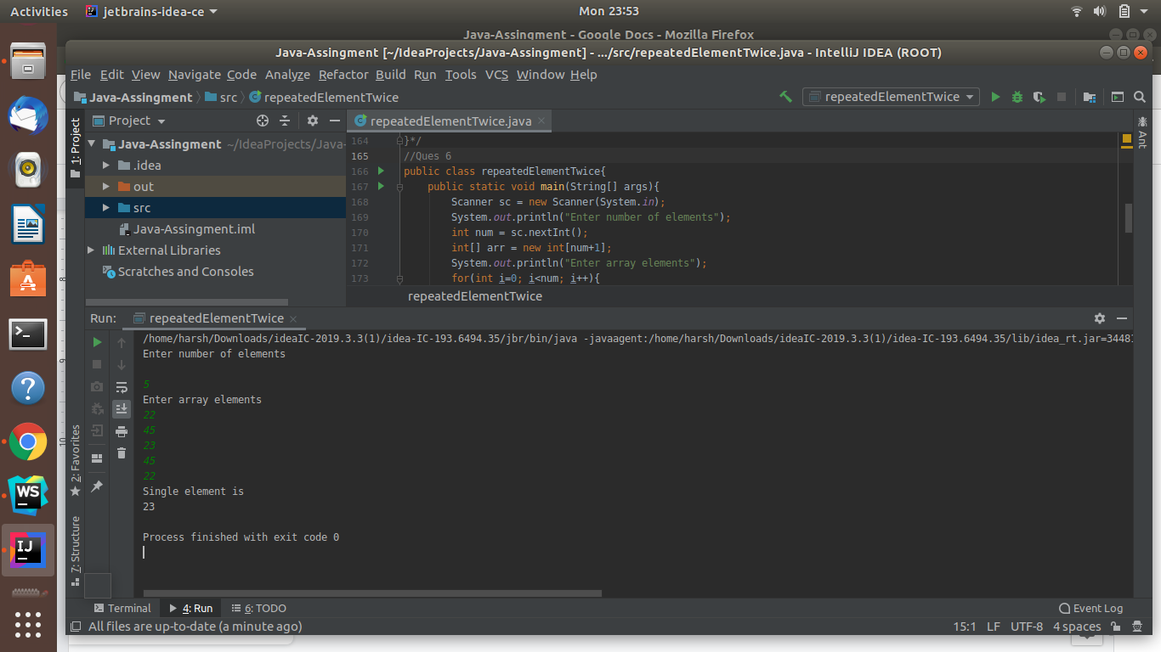

Ques 7:Write a program to print your Firstname,LastName & age using static block,static method & static variable respectively

Ans: **JAVA-CODE**

public class useOfStatic{

public static void main(String[] args){

Scanner sc = new Scanner(System.in);

System.out.println("enter your first name");

String first=sc.nextLine();

System.out.println("enter your last name");

String last =sc.nextLine();

staticDemo sd = new staticDemo();

sd.showname(first,last);

}

}

class staticDemo{

static int age;

static String firstname="";

static String lastname="";

static{

age =22;

}

static void showname(String first,String last){

firstname=first;

lastname=last;

System.out.println("Your first name is "+firstname);

System.out.println("Your Last name"+lastname);

System.out.println("Your age is "+age);

}

}

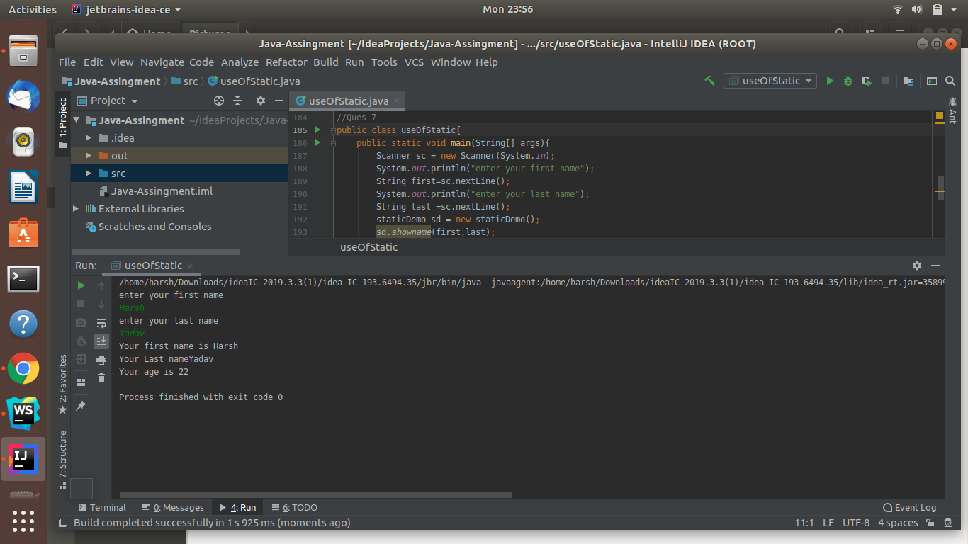

Ques 8:Write a program to reverse a string and remove character from index 4 to index 9 from the reversed string using String Buffer

Ans :**JAVA-CODE**

public class useOfStringBuffer{

public static void main(String[] args){

String value="this is string";

StringBuffer str = new StringBuffer(value);

System.out.println("original string: "+str);

StringBuffer reverse=str.reverse();

System.out.println("reversed string is: "+reverse);

System.out.println("character removed from index 4 to index 9: "+reverse.delete(4,9));

}

}

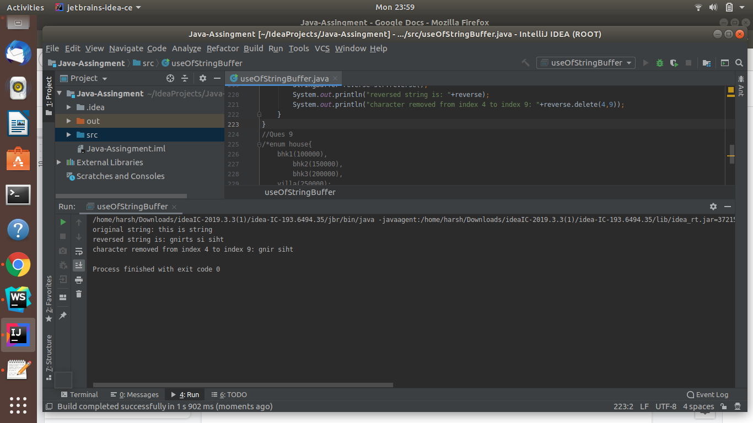

Ques 9:Write a program to display values of enums using a constructor & getPrice() method (Example display house & their prices)

Ans: **Java-Code**

enum house{

bhk1(100000),

bhk2(150000),

bhk3(200000),

villa(250000);

int price;

house(int p){

price = p;

}

int getPrice(){

return price;

}

}

public class useOfEnum{

public static void main(String[] args){

System.out.println("all house prices");

for(house h: house.values()){

System.out.println(h.getPrice());

}

}

}

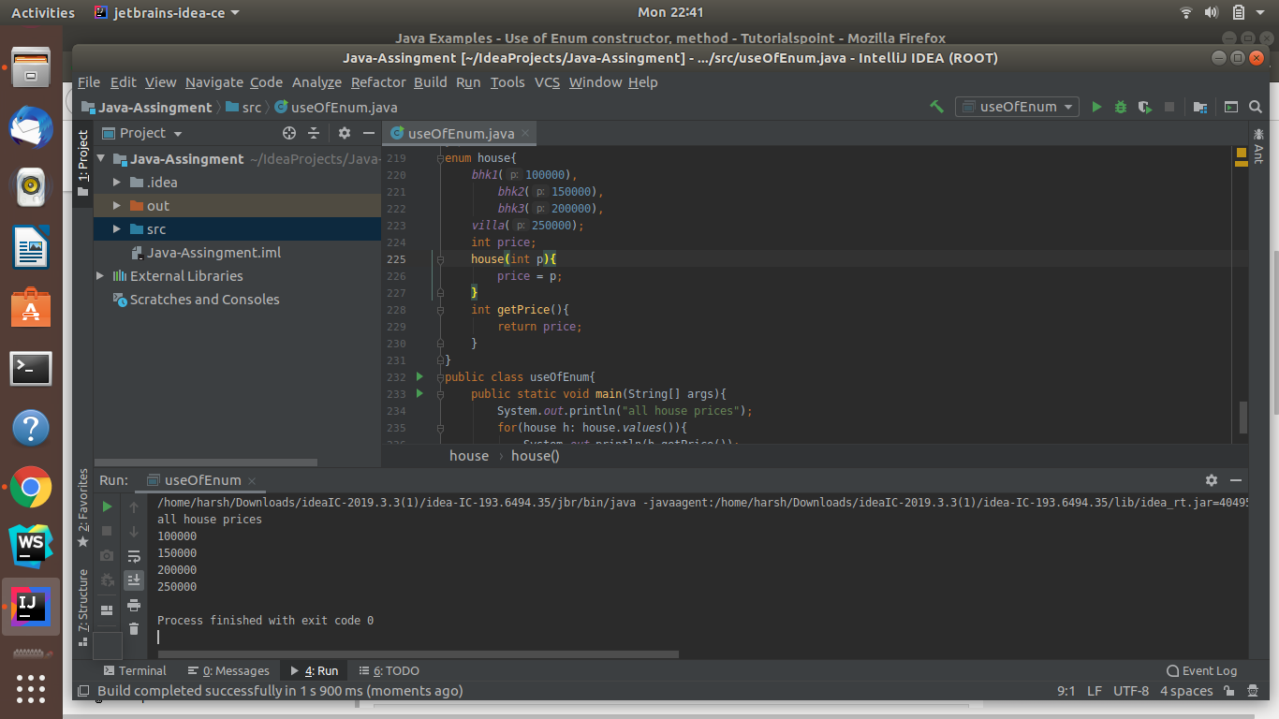

Ques 10:Write a single program for following operation using overloading

A) Adding 2 integer number

B) Adding 2 double

C) multiplying 2 float

D) multiplying 2 int

E) concate 2 string

F) Concate 3 String

Ans: **JAVA-CODE**

class operation{

int add(int a, int b){

return a+b;

}

double add(double a, double b){

return a+b;

}

float multiply(float a, float b){

return a*b;

}

int multiply(int a, int b){

return a*b;

}

String concate(String a, String b){

return a+b;

}

String concate(String a, String b,String c){

return a+b+c;

}

}

public class useOfOverloading{

public static void main(String[] args){

operation op = new operation();

System.out.println("Integer sum: "+op.add(23,22));

System.out.println("Double sum: "+op.add(23.3434343434,22.68686868686));

System.out.println("Integer multiply: "+op.multiply(23,22));

System.out.println("float multiply"+op.multiply(23.34f,22.68f));

System.out.println("Two String concatenation: "+op.concate("To","The"));

System.out.println("Three String concatenation: "+op.concate("To","The","New"));

}

}

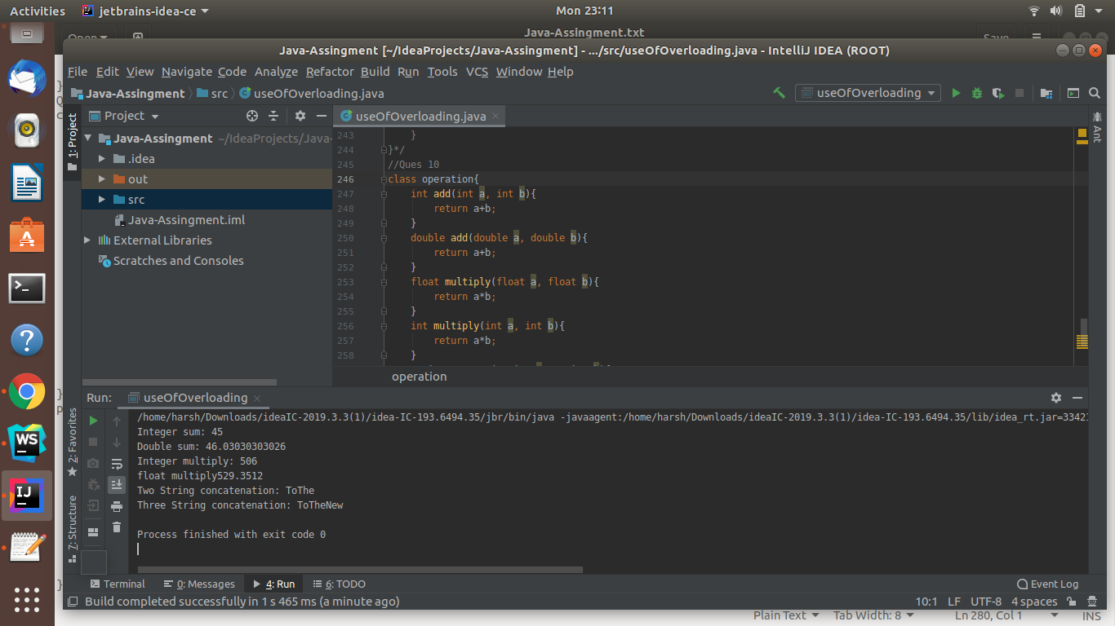

Ques 11:Create 3 sub class of bank SBI,BOI,ICICI all 4 should have method called getDetails which provide there specific details like rateofinterest etc,print details of every banks

Ans: **JAVA-CODE**

class SBI{

void getdetails(){

System.out.println("SBI Branch name 23, Himalaya House, Kasturba Gandhi Marg, New Delhi 110001");

System.out.println("IFSC code SBIN0005943");

System.out.println("Rate of Intrest 6.25%");

System.out.println();

}

}

class BOI extends SBI{

void getdetails(){

System.out.println("BOI Branch name NEW DELHI ZONAL OFFICE");

System.out.println("IFSC code BKID000ZO64");

System.out.println("Rate of Intrest 6.50%");

System.out.println();

}

}

class ICICI extends BOI{

void getdetails(){

System.out.println("ICICI Branch name Sahibabad Branch");

System.out.println("IFSC code ICIC0000255");

System.out.println("Rate of Intrest 6.60%");

System.out.println();

}

}

public class bank extends ICICI{

public static void main(String[] args){

//bank b = new bank();

ICICI i = new ICICI();

BOI b = new BOI();

SBI s = new SBI();

s.getdetails();

b.getdetails();

i.getdetails();

}

}

