**ABSTRACT**

The Online Auction System is a comprehensive, digital platform designed to facilitate the buying and selling of items through competitive bidding. This system transforms traditional auction processes into an efficient, user-friendly online experience. It incorporates features such as user registration and login, item listing, bidding, and real-time auction updates. Sellers can easily list items for auction, providing detailed descriptions, images, and starting prices. Buyers can browse available items, place bids, and receive notifications about their bid status.

The system includes an admin panel that allows administrators to manage users, monitor auctions, and generate various reports, such as user activity reports, auction statistics, and financial summaries. Key functionalities include the ability to search for items, view bid history, and utilize 'Buy Now' options for immediate purchases.

The primary objective of this system is to streamline the auction process, making it more efficient and accessible, while minimizing human intervention and errors. By leveraging modern web technologies, this system ensures a seamless and engaging experience for all users involved in online auctions.

**Table of Contents**

List of Figures I

List of Tables II

1. Introduction 1
   1. Product perspective 1
   2. Product features 1
      1. There are three different users who will be using this product: 1
      2. The features that are required for the Administrator are: 1
      3. The features that are required for the Vendor are: 1
      4. The features that are required for the Customer are 1
   3. Functional Requirement 2
      1. Administrator 2
      2. Vendor 2
      3. Buyer 3
      4. Guest 3
   4. Non-Functional Requirement 3
      1. Performance 3
      2. Usability 3
      3. Security 4
      4. Monitoring and Reporting 4
2. Design and Implementation Constraints 5
   1. Use case diagram 5
   2. Activity diagram and Swimlane diagram 7
   3. Sequence diagram 9
   4. State diagram 10
   5. Class diagram 11
   6. Data flow diagram 12
      1. Context diagram (level-0) 12
      2. DFD Level-1 12
3. External interface requirement (Screens) 13
   1. Screen-1: Home screen 13
   2. Screen-2: Auction Item List 14
   3. Screen-3: Item details 15
   4. Screen-4: Store List 16
   5. Screen-5: Categories Grid 17
4. Database design 18
   1. List of Tables 18
5. Stories and Scenario 20
   1. Story-1: Create New Auction Listing 20
      1. Scenario# S1.1 20
      2. Scenario# S1.2 20
      3. Scenario# S1.3 20
   2. Story-2: Search for Auctions 21
   3. Story-3: Place a Bid 21
   4. Story-4: Manage Auction End Date 21
   5. Story-5: Generate a Report on Auction Activity 21
6. Test cases 22
7. References 27

List of Figures

Figure 2.1-1 Use case diagram for Online Auction System 5

Figure 2.1-2 Use case diagram for Online Auction System 7

Figure 2.2-1 Activity diagram for Register 7

Figure 2.2-2 Swimlane diagram for Auction Start 8

Figure 2.3-1 Sequence diagram for Create Item 9

Figure 2.4-1 State diagram Auction Start 10

Figure 2.4-2 State diagram for Auction Bidding 10

Figure 2.5-1 Class diagram for Online Auction System 11

Figure 2.6-1 Context diagram for Online Auction System 12

Figure 2.6-2 DFD level-1 for Online Aution System 12

Figure 3.1-1 Screen-1: Home Screen 13

Figure 3.2-1 Screen-2: Auction item list 14

Figure 3.3-1 Screen-3: Item details 15

Figure 3.4-1 Screen-4:Store List 16

Figure 3.4-1 Screen-5:Categories grid

# Introduction

## Product perspective

Welcome to the "Online Auction System." This innovative platform revolutionizes the auction process by enabling seamless online bidding and product sales. Vendors can easily list their products for auction, and customers can place competitive bids to purchase them. The main objective of the e-Auction process is to obtain the best value and the highest price for products. Achieving optimal outcomes requires focusing on overall value rather than just price alone. The "Online Auction System" caters to two main user categories: customers and vendors. Vendors can sell their products on the website, and customers can participate in the auctions by placing bids. The product will be sold to the customer who places the highest bid. Users can place multiple bids on various products, ensuring a dynamic and competitive bidding environment.

## Product features

### There are three different users who will be using this product:

* + - * Addministrator who will manage the overall platform.
      * Vendor who will be listing products for auction.
      * Customer who will be placing bids on products.

### The features that are required for the Administrator are:

* + - * Control and manage vendor and customer accounts.
      * Oversee the listing and movement of products and ensure proper documentation.
      * Monitor ongoing auctions to ensure fair play and compliance with platform rules.
      * Search for specific products or users based on various criteria such as name, category, or user details.
      * Generate reports on auction activities, sales, and user engagement.
      * Address and resolve any disputes between vendors and customers.
      * Perform regular maintenance tasks to keep the platform running smoothly.
      * Send notifications and updates to users about their activities and auction statuses.

### The features that are required for the Vendor are:

* + - * Add and manage products for auction with detailed descriptions and images.
      * Set auction parameters such as start time, end time, and minimum bid increments.
      * View and manage bids placed on their products.
      * Access reports on sales and bidding history for their products.
      * Communicate with customers through the platform regarding their products and auctions.
      * Manage their account details, payment information, and transaction history.

### The features that are required for the Customer are:

* + - * View and browse different categories of products available for auction.
      * Place bids on products they are interested in purchasing.
      * Create and manage their account details and personal information.
      * Track their bids and receive notifications about the status of their bids.
      * View their purchase history and transaction details.
      * Search for specific products based on keywords, categories, or vendors.
      * Provide feedback and reviews on products they have purchased.

## Functional Requirement

* Users of this System:
  1. **Administrator**: Manages and oversees the platform or system, handling tasks like user management, content moderation, and system maintenance.
  2. **Vendor (Seller)**: A person or business that offers goods or services for sale on a platform or marketplace.
  3. **Customer (Buyer)**: An individual or entity purchasing goods or services from a vendor or business.
  4. **Guest**: A visitor with limited access, often browsing without full user privileges or registration.

### Administrator

* + - * User Management: The system shall allow the Administrator to create, update, and delete user accounts.
      * Role Assignment: The system shall allow the Administrator to assign roles (buyer, seller, admin) to users.
      * Auction Monitoring: The system shall provide the Administrator with the ability to monitor active, upcoming, and completed auctions.
      * Dispute Resolution**:** The system shall enable the Administrator to intervene and resolve disputes between buyers and sellers.
      * Content Moderation**:** The system shall allow the Administrator to review and approve or reject auction listings before they go live.
      * Policy Enforcement: The system shall enable the Administrator to enforce site policies and rules by banning or suspending users who violate terms of service.
      * Reporting and Analytics: The system shall provide the Administrator with detailed reports and analytics on system usage, auction activities, and financial transactions.
      * System Configuration: The system shall allow the Administrator to configure system settings such as auction duration, bid increments, and notification preferences.
      * Security Management: The system shall enable the Administrator to manage security settings, including setting password policies and enabling/disabling two-factor authentication.
      * Payment Management: The system shall allow the Administrator to oversee and manage payment gateways, transaction fees, and financial reconciliations.
      * Data Backup and Recovery: The system shall allow the Administrator to perform data backups and manage data recovery processes.
      * Communication Management: The system shall enable the Administrator to send messages or notifications to all users or specific user groups.

### Vendor

* + - * Item Listing Creation: The system shall allow sellers to create new auction listings by providing item details, descriptions, images, starting price, and auction duration.
      * Item Listing Management: The system shall allow sellers to edit or delete their auction listings before any bids are placed.
      * Reserve Price Setting: The system shall allow sellers to set a reserve price for their auction listings to ensure the item is not sold below a certain amount.
      * Bid Management: The system shall notify sellers when new bids are placed on their auction listings.
      * Communication with Buyers: The system shall allow sellers to communicate with potential buyers via a messaging system.
      * Payment Processing: The system shall facilitate the processing of payments from buyers to sellers once an auction is completed.
      * Feedback Management: The system shall allow sellers to leave feedback for buyers based on their transaction experience.
      * Upload Images: The seller must be able to upload multiple images for each auction listing to provide visual representation of the item.
      * View Active Auctions: The seller must be able to view a list of their active auctions along with current bids and auction status.
      * Cancel Auction Listings: The seller must have the ability to cancel an active auction listing, provided no bids have been placed.
      * View Sales History: The seller must be able to view a history of their completed sales, including item details, sale price, and buyer information.
      * Pending Orders : shows pending order in system

### Buyer

Registration Form: Buyers must be able to create an account by providing necessary details and then log in using their credentials.

* + - * Item Search and Browsing: Buyers must be able to search for items using various filters such as category, price range, auction end time, and keywords.
      * Item Viewing: Buyers should be able to view detailed information about an item, including descriptions, images, seller information, and current highest bid.
      * Automatic Bidding: Buyers should have the option to set a maximum bid amount, allowing the system to automatically place incremental bids on their behalf up to that limit.
      * Auction Monitoring: Buyers should be able to add items to a watchlist to monitor auctions they are interested in.
      * Transaction History: Buyers should be able to view a history of their transactions, including won auctions, payments made, and items received.
      * Communication: Communicate with sellers through messaging or inquiry features to ask questions about items.
      * Account Security**:** Ensure account security through password management and optional two-factor authentication.
      * Viewing Auction History: Access and view past auction activities, including items bid on and won.
      * Costumer Payment Details : shows detail about Costumer Payment Details
      * Rate Supplier Perfomance : User can Rate supplier

### Guest

* + - * View Auction Listings**:** The guest user shall be able to view all available auction listings.
      * Search Auctions: The guest user shall be able to search for auctions using keywords.
      * Sort Auctions: The guest user shall be able to sort auction listings by various parameters such as price, popularity, and end date.
      * View Item Details: The guest user shall be able to view detailed information about a listed item, including descriptions, images, and current bid status.
      * View Seller Information**:** The guest user shall be able to view limited information about the seller, such as their rating and number of auctions conducted.
      * View Auction Rules**:** The guest user shall be able to view the rules and guidelines for participating in auctions.
      * Viewing Auction Calendar: Ability to see upcoming auctions or events without needing to log in.
      * Language and Currency Selection: Options to select preferred language and currency for viewing auction listings.
      * Edit Profile : system user can edit profile

## Non-Functional Requirement

### Performance:

* + - * Response Time: The system should respond to user interactions (like placing bids or updating listings) within a certain timeframe (e.g., under 1 second).
      * Scalability**:** It should handle increasing numbers of users and transactions without significant degradation in performance.

### Usability**:**

* + - * The user interface should be intuitive and user-friendly, catering to both experienced and novice users.

### Security:

* + - * Data Encryption: All sensitive information (like user credentials, payment details) should be encrypted to prevent unauthorized access.
      * Protection Against Attacks**:** Measures should be implemented to defend against common cyber threats such as DDoS attacks, SQL injection, and cross-site scripting (XSS).

### Monitoring and Reporting:

* + - * Performance Monitoring**:** Monitor system performance metrics such as CPU usage, memory usage, and response times.
      * Reporting**:** Generate reports on auction activities, sales trends, and user behavior for business

## Use case diagram

**Online Auction System**

User and

registration login

profile

management

List viewing

Auction Monitoring

Transaction History

Buyer seller

Payment Processing

Reserve Price Setting

Communication

With Buyer

Item Listing

Management

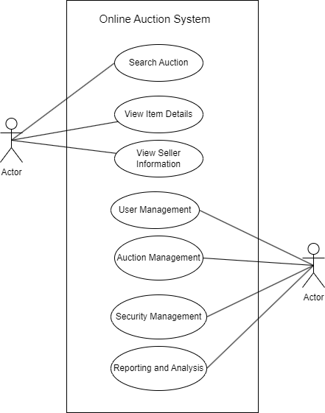

Seller

2.2 Activity diagram

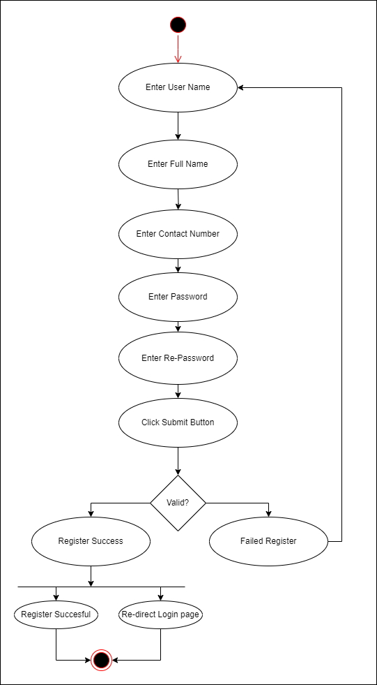

*Figure 2.2-1 Activity diagram for Register*

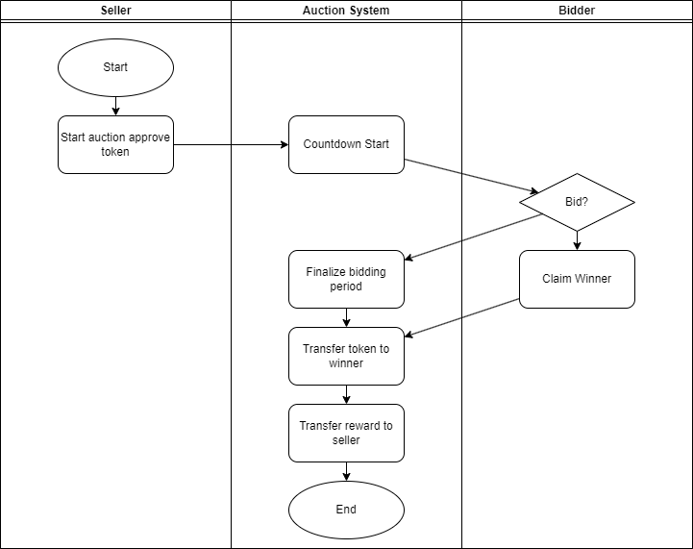

*Figure 2.2-2 Swimlane diagram for Auction Start*

## Sequence diagram

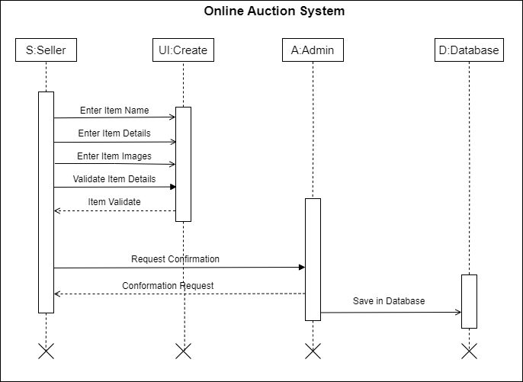

*Figure 2.3-1 Sequence diagram for Create Item*

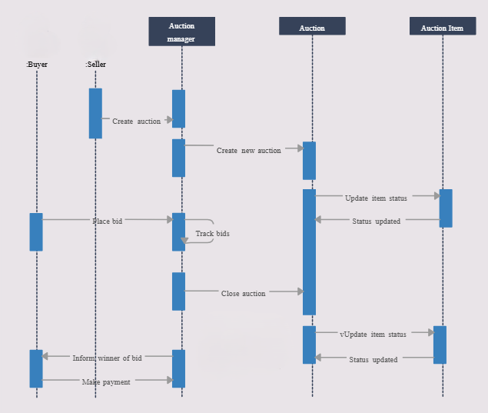

## State diagram

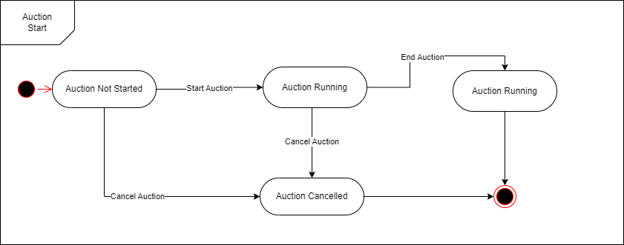

*Figure 2.4-1 State diagram for Auction Start*

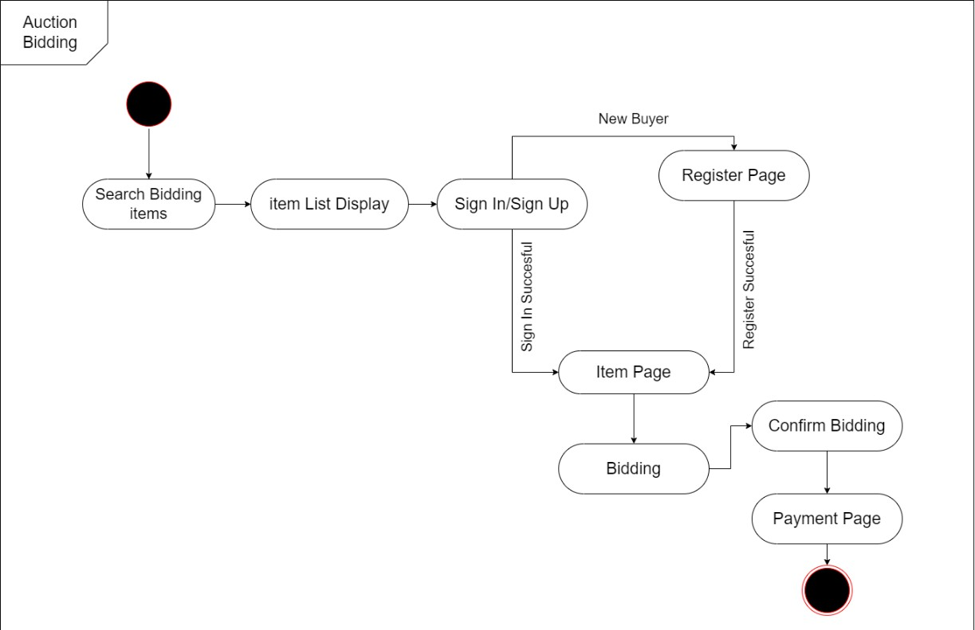

*Figure 2.4-2 State diagram for Auction Bidding*

## Class diagram

*Figure 2.5-1 Class diagram for Online Auction System*

## Data flow diagram

### Context diagram (level-0)

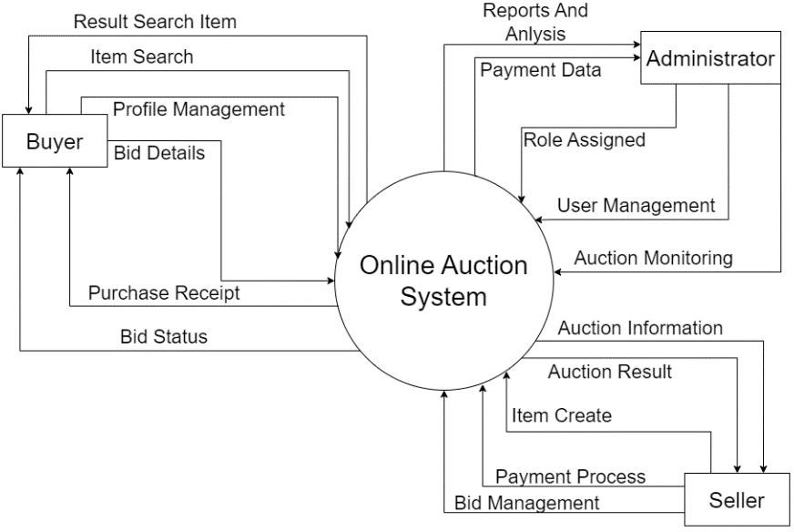

*Figure 2.6-1 Context diagram for Online Auction System*

### DFD Level-1

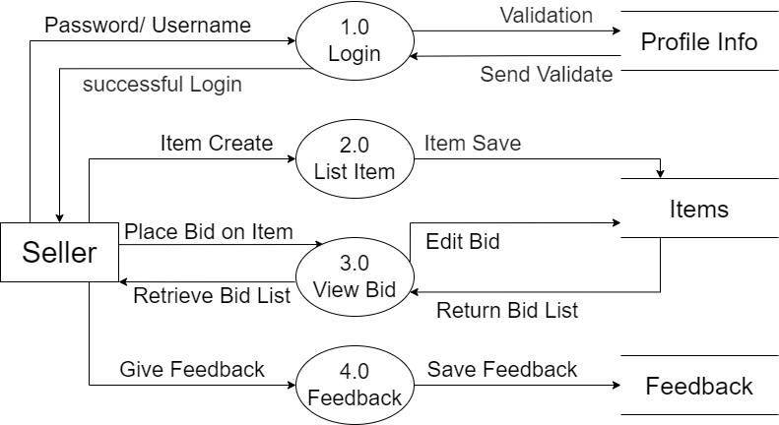

*Figure 2.6-2 DFD level-1 for Online*

## 3.1 Screen-1: Home screen

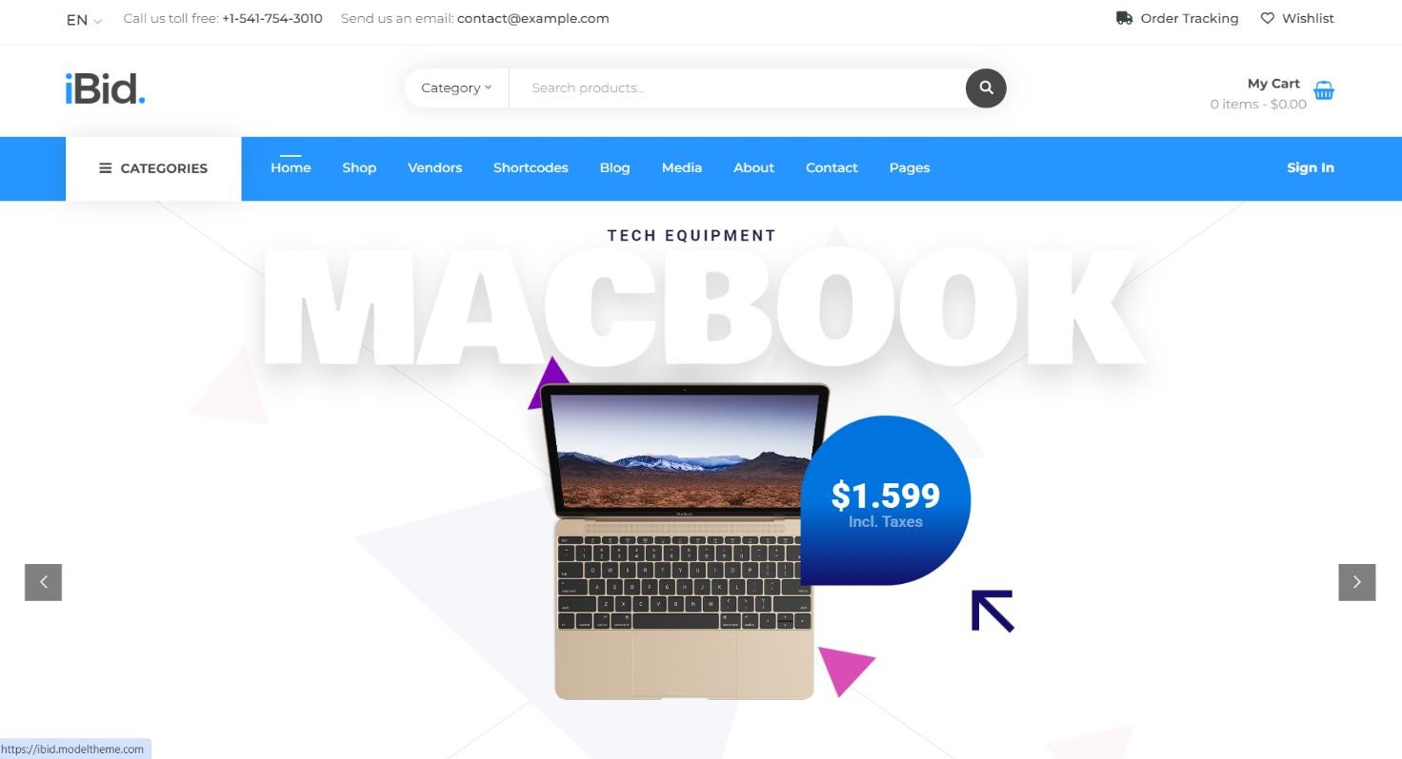

*Figure 3.1-1 Screen-1: Home Screen*

**Purpose:** The Home Screen aims to provide a seamless and engaging user experience, guiding users through the auction process with ease and efficiency.

*Table 3.1-1 Screen element of Home Screen*

|  |  |  |  |  |  |
| --- | --- | --- | --- | --- | --- |
| **Sr.** | **Screen Element** | **Input Type** | **O/M** | **1/N** | **Description** |
| **1** | Title | Text | M | 1 | Shows the site title "iBid." |
| **2** | Category | Text | M | 1 | Shows a dropdown menu to select categories of  products. |
| **3** | Search Item | Text | M | 1 | Allows users to search for items by entering item  names. |
| **4** | My Cart | Text | M | 1 | Displays items that the user wants to purchase. |
| **5** | Nav-bar | Link | M | 1 | Displays links to various pages like Home, Shop, Vendors, Shortcodes, Blog, Media, About,  Contact, and Pages. |
| **6** | Slider of Latest Ausction Item | Image | M | N | Shows a slider of the latest added auction items, currently displaying a MacBook with the price of  $1,599 including taxes. |

## Screen-2: Auction Item List

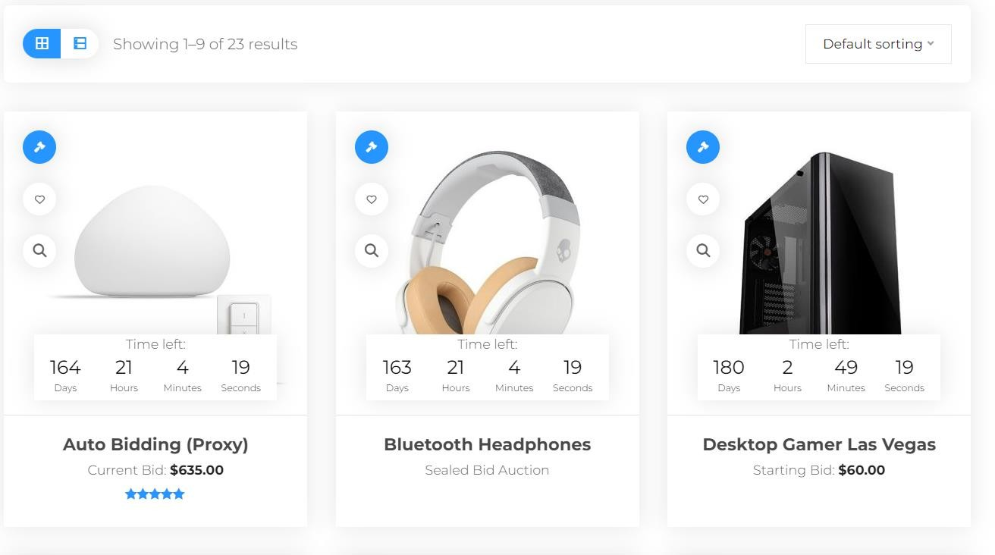

*Figure 3.2-1 Screen-2: Auction Item List*

**Purpose:** To display auction items in a user-friendly way, allowing users to browse, sort, and view item details easily. The page provides essential information such as item images, auction time, current bid prices, and quick view options to aid in efficient browsing and decision-making.

*Table 3.2-1 Screen element of Item List*

|  |  |  |  |  |  |
| --- | --- | --- | --- | --- | --- |
| **Sr.** | **Screen Element** | **Input Type** | **O/M** | **1/N** | **Description** |
| **1** | Grid -> List (List -  > Grid) | Buttons | M | 1 | Toggle between grid and list views for displaying items. |
| **2** | Default sorting | Button | M | 1 | Sort the list based on various criteria such as  alphabet, bid amount, and new/old items. |
| **3** | Item image | Image | M | N | Displays an image of the auction item. |
| **4** | Auction time left | Datetime | M | 1 | Shows the remaining time for the auction in a  countdown format. |
| **5** | Item current/starting  bid | Text | O | 1 | Displays the current bid price or the starting bid price in dollars. |
| **6** | Quick view | Button | M | 1 | Provides a quick view of the item details. |

## Screen-3: Item details

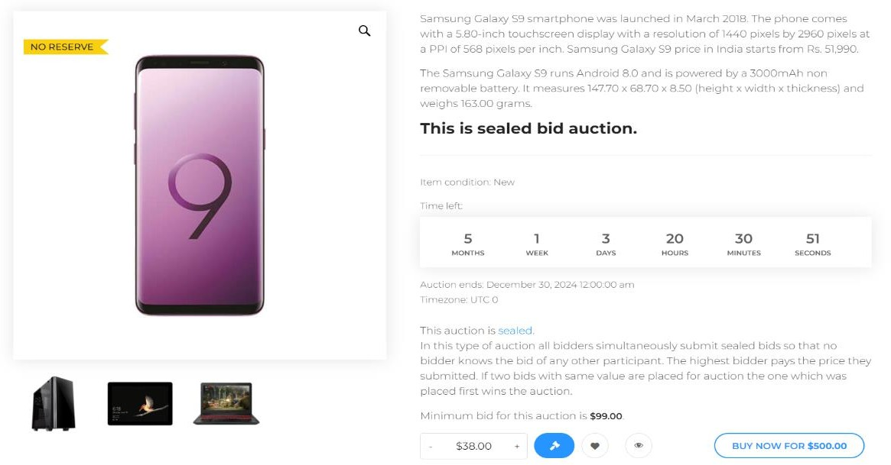

*Figure 3.3-1 Screen-3: Item Details*

**Purpose:** To display detailed information about a specific auction item, allowing users to view item specifications, auction details, and place bids. This page provides comprehensive information such as item images, descriptions, auction type, time left, minimum bid, and bidding options to facilitate informed decision-making for potential bidders.

*Table 3.3-1 Screen element of Item Details*

|  |  |  |  |  |  |  |
| --- | --- | --- | --- | --- | --- | --- |
| **Sr.** | **8** | Buy Now | Button | O | 1 | Allows users to buy the item immediately at a  specified price. |
| **1** | Item Image | Image | M | 1 | Displays the main image of the auction item. |
| **2** | Item Description | Text | M | 1 | Provides detailed information about the auction  item, including specifications and condition. |
| **3** | Auction Type | Text | M | 1 | Indicates the type of auction (e.g., sealed bid  auction). |
| **4** | Time Left | Datetime | M | 1 | Shows the remaining time for the auction in a  countdown format. |
| **5** | Auction End  Date | Datetime | M | 1 | Displays the date and time when the auction will  end. |
| **6** | Bid Amount | Textbox | M | 1 | Allows users to enter their bid amount. |
| **7** | Share | Button | O | 1 | Option to share the auction item. |

## Screen-4: Store List

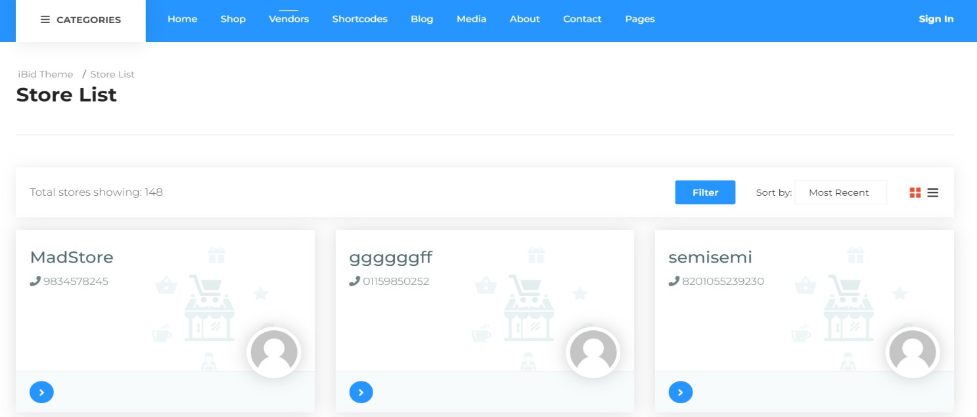

*Figure 3.4-1 Screen-4:Store List*

**Purpose:** The purpose of this screen is to display a list of stores available in the system. It allows users to view store details, filter the list, and sort the stores based on different criteria.

*Table 3.4-1 Screen element of Store List*

|  |  |  |  |  |  |
| --- | --- | --- | --- | --- | --- |
| **Sr.** | **Screen Element** | **Input Type** | **O/M** | **1/N** | **Description** |
| **1** | Store Name | Text | M | 1 | Displays the name of the store. |
| **2** | Store Contact | Text | M | 1 | Shows the contact number of the store. |
| **3** | Store Image | Image | O | 1 | Displays an image representing the store. |
| **4** | Filter Button | Button | - | - | Allows users to filter the list of stores based on  specific criteria.q |
| **5** | Sort Dropdown | Dropdown | - | - | Provides options to sort the store list (e.g., Most  Recent). |
| **6** | Navigation  Arrows | Button | - | - | Allows users to navigate through the store cards. |

## Screen-5: Categories Grid

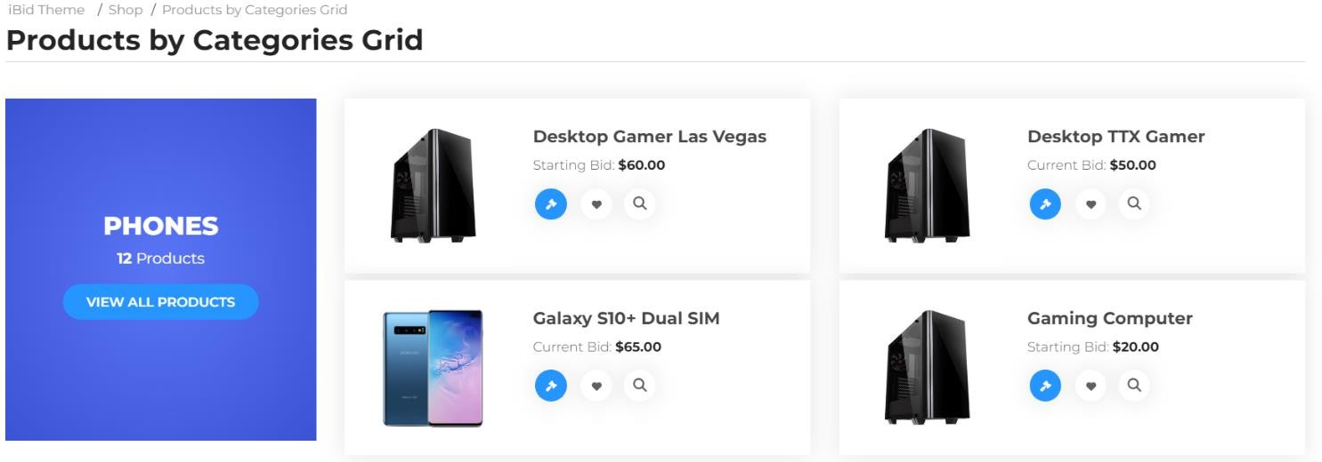

*Figure 3.4-1 Screen-5:Categories grid*

**Purpose:** This screen is Purpose to show Categories Wise Item.

*Table 3.4-1 Screen element of Categories grid*

|  |  |  |  |  |  |
| --- | --- | --- | --- | --- | --- |
| **Sr.** | **Screen Element** | **Input Type** | **O/M** | **1/N** | **Description** |
| **1** | Categories  Name | Text | M | 1 | Displays the name of the category (e.g.,  PHONES). |
| **2** | Category  Product Count | Text | M | 1 | Shows the number of products in the category. |
| **3** | View All  Products Button | Button | - | - | Displays the main image of the product. |
| **4** | Product Title | Text | M | N | Shows the title of the product. |
| **5** | View Details  Button | Button | O | N | Allows users to view detailed information about  the product. |

#### Screen-6: Registration Form

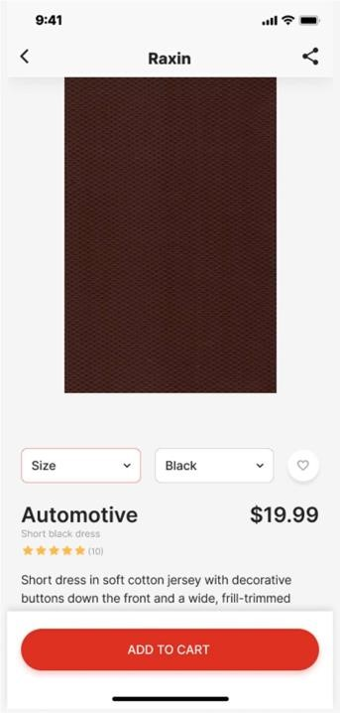

**Purpose:** The purpose of a product card is to provide concise, visually appealing information about a specific product.

*Table 3.5-1 Screen element of Registration form*

|  |  |  |  |  |  |
| --- | --- | --- | --- | --- | --- |
| **Sr.** | **Screen Element** | **Input Type** | **O/M** | **1/N** | **Description** |
| **1** | Size | Dropdown | M | 1 | Product Size can be Selected from Given List |
| **2** | Colour | Dropdown | M | 1 | Product Colour can be Selected from Given List |
| **3** | Like | Button | O | 1 | User Can Add Product to Favourite Section |
| **4** | Add to Cart | Button | M | 1 | User Can Add Item to Cart |
| **5** | Share | Button | O | 1 | User can Share the product |

#### Screen-7: Sales Histroy

|  |  |  |  |  |  |
| --- | --- | --- | --- | --- | --- |
| **Sr.** | **Screen Element** | **Input Type** | **O/M** | **1/N** | **Description** |
| **1** | ItemName | Dropdown | M | 1 | Product Size can be Selected from Given List |
| **2** | Saleprice | Dropdown | M | 1 | Product Colour can be Selected from Given List |
| **3** | Buyer | Button | O | 1 | User Can Add Product to Favourite Section |
| **4** | Sale date | Button | M | 1 | User Can Add Item to Cart |

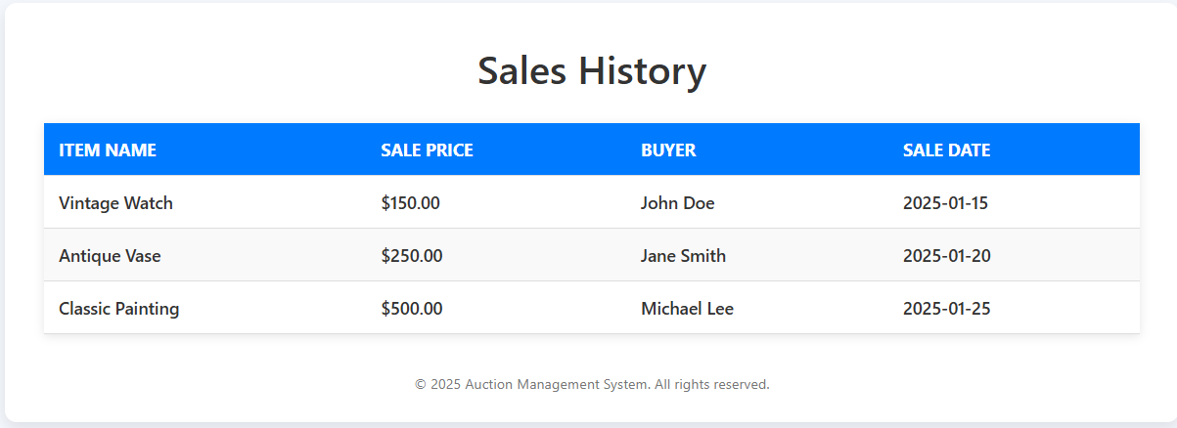

#### Screen-7: Pending Orders

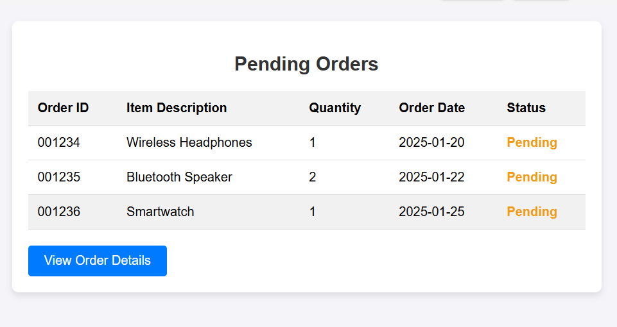

|  |  |  |  |  |  |
| --- | --- | --- | --- | --- | --- |
| Sr. | Screen Element | Input Type | O/M | 1/N | Description |
| 1 | Order id | number | M | 1 | Username field should be not editable . |
| 2 | Item description | Textbox | M | 1 | Email field should be editable and accept the description. |
| 3 | quantity | number | M | 1 | number field should be editable and accept the number . |
| 4 | Order date | date | M | 1 | Order date field should be not editable . |
| 5 | status | Text | M | 1 | status for accepting pending or accept. |

#### Screen-8: Costumer Payment Deatils

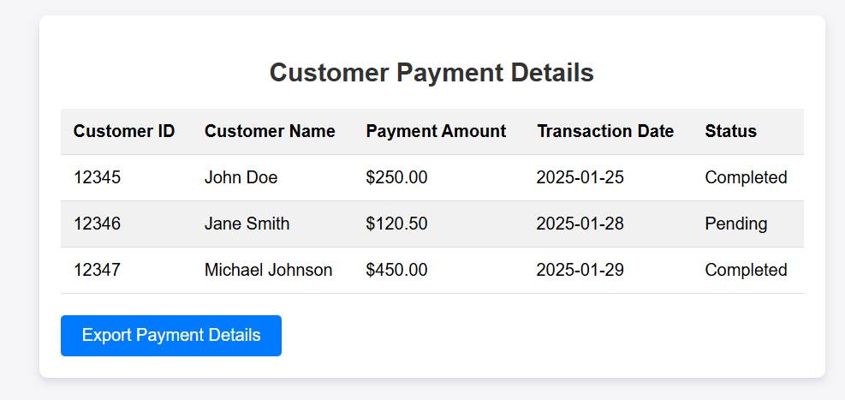

|  |  |  |  |  |  |
| --- | --- | --- | --- | --- | --- |
| Sr. | Screen Element | Input Type | O/M | 1/N | Description |
| 1 | Order id | number | M | 1 | Username field should be not editable . |
| 2 | Item description | Textbox | M | 1 | Email field should be editable and accept the description. |
| 3 | quantity | number | M | 1 | number field should be editable and accept the number . |
| 4 | Order date | date | M | 1 | Order date field should be not editable . |
| 5 | status | text | M | 1 | status for accepting pending or accept. |

#### Screen-9: Edit Profile

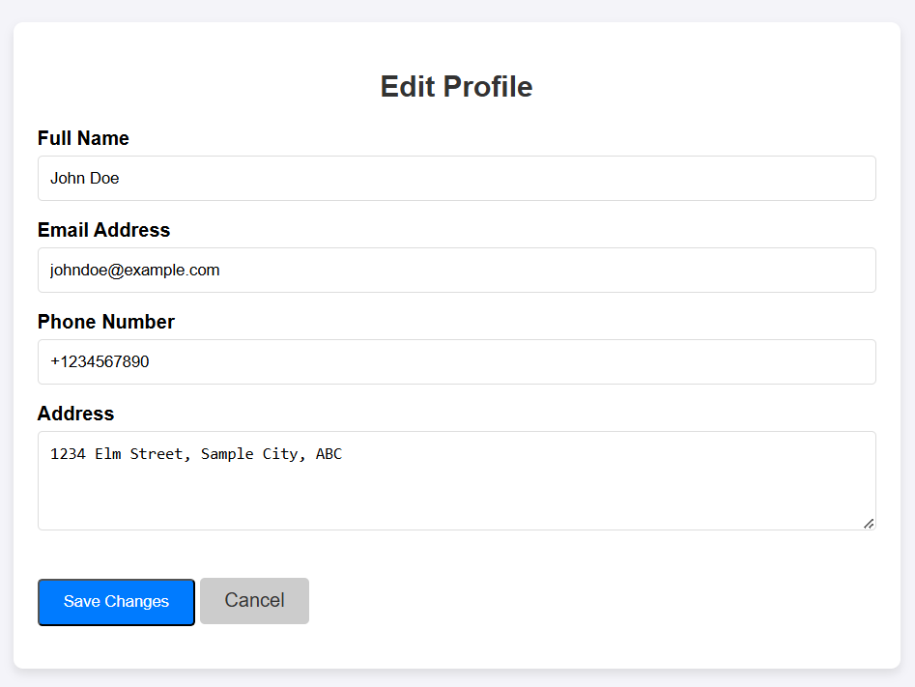

|  |  |  |  |  |  |
| --- | --- | --- | --- | --- | --- |
| Sr. | Screen Element | Input Type | O/M | 1/N | Description |
| 1 | fullname | Textbox | M | 1 | Username field should be editable and accept the Username. |
| 2 | Email | Textbox | M | 1 | Email field should be editable and accept the email with proper format. |
| 3 | Phone no. | number | M | 1 | Password field should be editable and accept the password and display as star or dot. |
| 4 | address | textbox | ------ | ------ | address is a textbox for store the entered data into database. |

#### Screen-10: Rate Supplier Perfomance

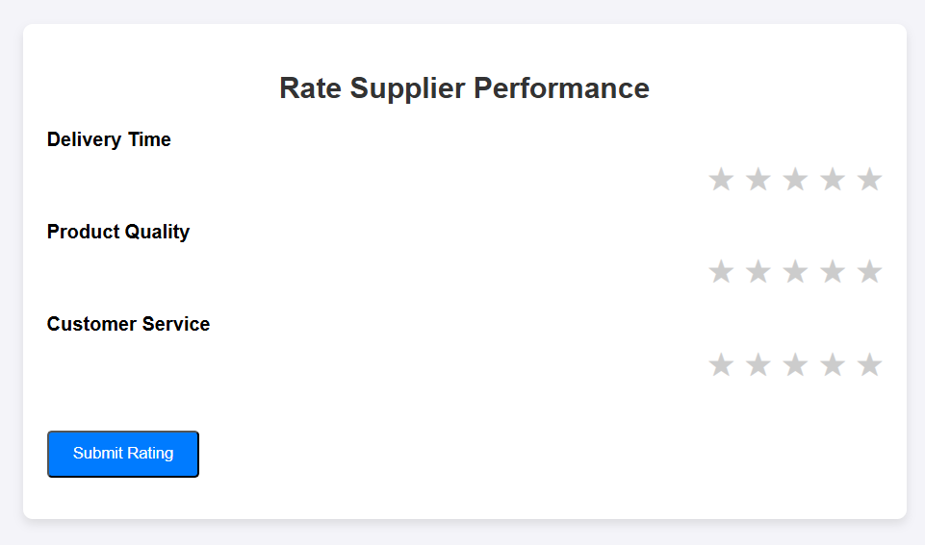

|  |  |  |  |  |  |
| --- | --- | --- | --- | --- | --- |
| Sr. | Screen Element | Input Type | O/M | 1/N | Description |
| 1 | Delivery time | Button | --- | --- | Delivery time field should be editable and accept the ratings. |
| 2 | Product quality | Button | --- | --- | product quality field should be editable and accept the ratings.. |
| 3 | Customer service | Button | --- | --- | cutomer service field should be editable and accept the ratings.. |
| 4 | Submit rating | Button | ------ | ------ | submite rating button navigates to another page even if valid rating credentials. |

# Database design

## List of Tables

* Users
* Item
* Bids
* Categories
* Payments

*Table 4.1-1 Table: Users*

|  |  |  |  |  |
| --- | --- | --- | --- | --- |
| **Column** | **Data Type** | **Null** | **Keys & Constrains** | **Default Value & Description** |
| **UserID** | int | NN | PK (Auto Increment) |  |
| **UserName** | varchar(100) | NN |  |  |
| **Password** | varchar(50) | NN |  |  |
| **Email** | Varchar(50) | NN |  |  |
| **ContactNumber** | Int | NN |  |  |
| **Address** | Varchar(100) | AN |  |  |

*Table 4.1-2 Table: Item*

|  |  |  |  |  |
| --- | --- | --- | --- | --- |
| **Column** | **Data Type** | **Null** | **Keys & Constrains** | **Default Value & Description** |
| **ItemID** | int | NN | PK (Auto Increment) |  |
| **ItemName** | varchar(100) | NN |  |  |
| **Title** | varchar(50) | AN |  |  |
| **Description** | varchar(100) | NN |  |  |
| **StartingPrice** | int | NN |  |  |
| **StartDate** | DateTime | NN |  |  |
| **EndDate** | DateTime | AN |  |  |
| **CategoryID** | int | AN | FK | Referencing of Category  Table |

*Table 4.1-3 Table: Bids*

|  |  |  |  |  |
| --- | --- | --- | --- | --- |
| **Column** | **Data Type** | **Null** | **Keys & Constrains** | **Default Value & Description** |
| **BidID** | int | NN | PK (Auto Increment) |  |
| **ItemID** | int | NN | FK | Referencing of Item Table |
| **UserID** | int | NN | FK | Referencing of Users Table |
| **BidAmount** | int | NN |  |  |
| **BidStart** | DateTime | AN |  |  |

*Table 4.1-4 Table: Categories*

|  |  |  |  |  |
| --- | --- | --- | --- | --- |
| **Column** | **Data Type** | **Null** | **Keys & Constrains** | **Default Value & Description** |
| **CategoryID** | int | NN | PK (Auto Increment) |  |
| **CategoryName** | varchar(100) | NN |  |  |
| **Description** | varchar(100) | AN |  |  |

*Table 4.1-5 Table: Payments*

|  |  |  |  |  |
| --- | --- | --- | --- | --- |
| **Column** | **Data Type** | **Null** | **Keys & Constrains** | **Default Value & Description** |
| **PaymentID** | int | NN | PK (Auto Increment) |  |
| **UserID** | int | NN | FK | Referencing of Users Table |
| **ItemID** | int | NN | FK | Referencing of Item Table |
| **PaymentAmount** | int | NN |  |  |
| **PaymentDate** | DateTime | NN |  |  |
| **PaymentMethod** | varchra(50) | AN |  |  |

# Stories and Scenario

## Story-1: Create New Auction Listing

|  |  |  |
| --- | --- | --- |
| *Story #* ***S1*** | **:** | **As a** Seller**,**  **I want** to create a new auction listing  **So that** I can sell my items to the highest bidder. |
| **Priority** | **:** | High |
| **Estimate** | **:** | XL |
| **Reason** | **:** | Creating auction listings is fundamental to the operation of the auction system,  enabling sellers to offer their items to potential buyers. |

### Scenario# S1.1

|  |  |  |
| --- | --- | --- |
| *Scenario#* ***S1.1*** | **:** | Creating an Auction Listing with Valid Information |
| **Prerequisite** | **:** | The seller is logged into the auction system. |
| **Acceptance Criteria** | **:** | **Given:** The seller is navigated to the auction creation page. Valid item details, including title, description, starting bid, reserve price, and auction duration, are provided.  **When:**  The seller selects the "Create New Auction" option, And the seller enters valid item details,  The seller clicks the "Save" button to list the item for auction.  **Then:** The system successfully creates the auction listing, and the seller receives a confirmation message with the auction ID. |

### Scenario# S1.2

|  |  |  |
| --- | --- | --- |
| *Scenario#* ***S1.2*** | **:** | Creating an Auction Listing with Invalid Information |
| **Prerequisite** | **:** | The seller is logged into the auction system. |
| **Acceptance Criteria** | **:** | **Given:** The seller is on the auction creation page.  **When:** The seller selects the "Create New Auction" option, And the seller enters incomplete or incorrect item details, The seller clicks the "Save" button to list the item for auction.  **Then:** The system displays error messages for the incorrect or missing information, and the auction listing is not created. |

### Scenario# S1.3

|  |  |  |
| --- | --- | --- |
| *Scenario#* ***S1.3*** | **:** | Attempting to Create a Duplicate Auction Listing |
| **Prerequisite** | **:** | The seller is logged into the auction system, and the seller is on the  auction creation page. |
| **Acceptance Criteria** | **:** | **Given**: The item information, including title, description, and starting bid, is available, and the item with the same details is already listed for auction.  **When**: The seller clicks the “Create Auction” button and attempts to create  a listing with the same item details.  **Then**: The system prevents the creation of a duplicate listing and prompts  the seller to update or manage the existing auction. |

## Story-2: Search for Auctions

|  |  |  |
| --- | --- | --- |
| *Story #* ***S2*** | : | **As a** Buyer or Seller**,**  **I want** to search for auctions by item title, category, or keyword  **So that** I can quickly find or manage auctions of interest. |
| **Priority** | **:** | High |
| **Estimate** | **:** | M |
| **Reason** | **:** | Implementing search functionality is essential for enhancing the user experience, enabling buyers and sellers to efficiently discover or manage auction listings. |

### Scenario# S2.2

|  |  |  |
| --- | --- | --- |
| *Scenario#* ***S2.1*** | **:** | Searching Auctions by Item Title |
| **Prerequisite** | **:** | The buyer or seller is logged into the auction system. |
| **Acceptance Criteria** | **:** | **Given:** The buyer or seller is on the auction search page.  **When** The buyer or seller enters a valid item title in the search field and clicks the "Search" button.  **Then** The system displays a list of auctions that match the entered item title, allowing the user to view relevant listings.. |

### Scenario# 2.2

|  |  |  |
| --- | --- | --- |
| *Scenario#* ***S2.2*** | **:** | 2.2: Searching Auctions by Category or Keyword |
| **Prerequisite** | **:** | The buyer or seller is logged into the auction system. |
| **Acceptance Criteria** | **:** | **Given:** The buyer or seller is on the auction search page..  **When:** The buyer or seller selects a category or enters a keyword related to the auction items they are looking for and clicks the "Search" button.  **Then:** The system displays a list of auction listings that match the selected category or keyword, providing relevant results for the user. |

## Story-3: Place a Bid

|  |  |  |
| --- | --- | --- |
| *Story #* ***S3*** | **:** | **As a** Buyer**,**  **I want** to place a bid on an auction item  **So that** I can compete to purchase the item. |
| **Priority** | **:** | High |
| **Estimate** | **:** | M |
| **Reason** | **:** | Bidding functionality is core to the auction system, allowing buyers to participate in auctions and compete for items. |

## Story-4: Manage Auction End Date

|  |  |  |
| --- | --- | --- |
| *Story #* ***S3*** | **:** | **As a** Seller**,**  **I want** to manage the end date of my auction  **So that I** can extend or shorten the auction period based on demand. |
| **Priority** | **:** | Medium |
| **Estimate** | **:** | M |
| **Reason** | **:** | Managing the auction end date is crucial for sellers who wish to optimize the  timing of their auctions based on market conditions. |

## Story-5: Generate a Report on Auction Activity

|  |  |  |
| --- | --- | --- |
| *Story #* ***S3*** | **:** | **As an** Administrator**,**  **I want** to generate reports on auction activity  **So that** I can analyze trends and make informed decisions about the platform**.** |
| **Priority** | **:** | Medium |
| **Estimate** | **:** | L |
| **Reason** | **:** | Reporting functionality is important for tracking the performance of the auction platform and making data-driven improvements. |