SVKM's NMIMS MPSTME, MUMBAI
DEPARTMENT OF INFORMATION TECHNOLOGY & COMPUTER ENGINEERING
IVRAR GROUP 01: VR HOME CINEMA & SPATIAL AUDIO SYSTEM
OPERATIONAL MANUAL & CONTROLLER MAPPING GUIDE
Course: Introduction to Virtual Reality & Augmented Reality (702COI002) | Semester V | 2026–2027
Standard: CEDIA/CTA-RP22 Residential Home Cinema Acoustics & Optics

Roll No | Student Name | Degree Programme | Technical Focus Area
I066 | Meahaan Sharma | MBA (Tech) IT | Lead XR Systems Architect & OpenXR Rig
C034 | Amogh Gupta | B.Tech Computer (Int.) | Spatial Acoustics, Raycasting & RT60
N083 | Harshit Rai | MBA (Tech) Computer | Human Factors, Sightlines & Usability
N087 | Rannbir Sachdeva | MBA (Tech) Computer | Techno-Managerial Systems Evaluation

1. Executive Summary & Virtual Environment Overview
The IVRAR Group 01 Virtual Reality Home Cinema is a comprehensive, scientific simulation designed in Unity 6 and optimized for Meta Quest 2 and the Meta XR Simulator. Built in strict accordance with the CEDIA/CTA-RP22 Residential Home Cinema Acoustic and Optical Performance Standards, the system features a 5m (W) x 7m (L) x 3m (H) acoustically treated screening room, a 16:9 cinema proscenium screen, a ceiling projector assembly, VIP cinema seating, and real-time 3D spatialized audio synchronized with high-definition video playback.
Users can experience true spatial audio attenuation with logarithmic distance rolloff originating directly from the center of the cinema screen, interact with real-time Sabine/Eyring acoustic reverberation (RT60) telemetry, and seamlessly select and switch between different MP4 video presentations using either VR controller buttons, an in-world 3D console tablet, or desktop hotkeys.
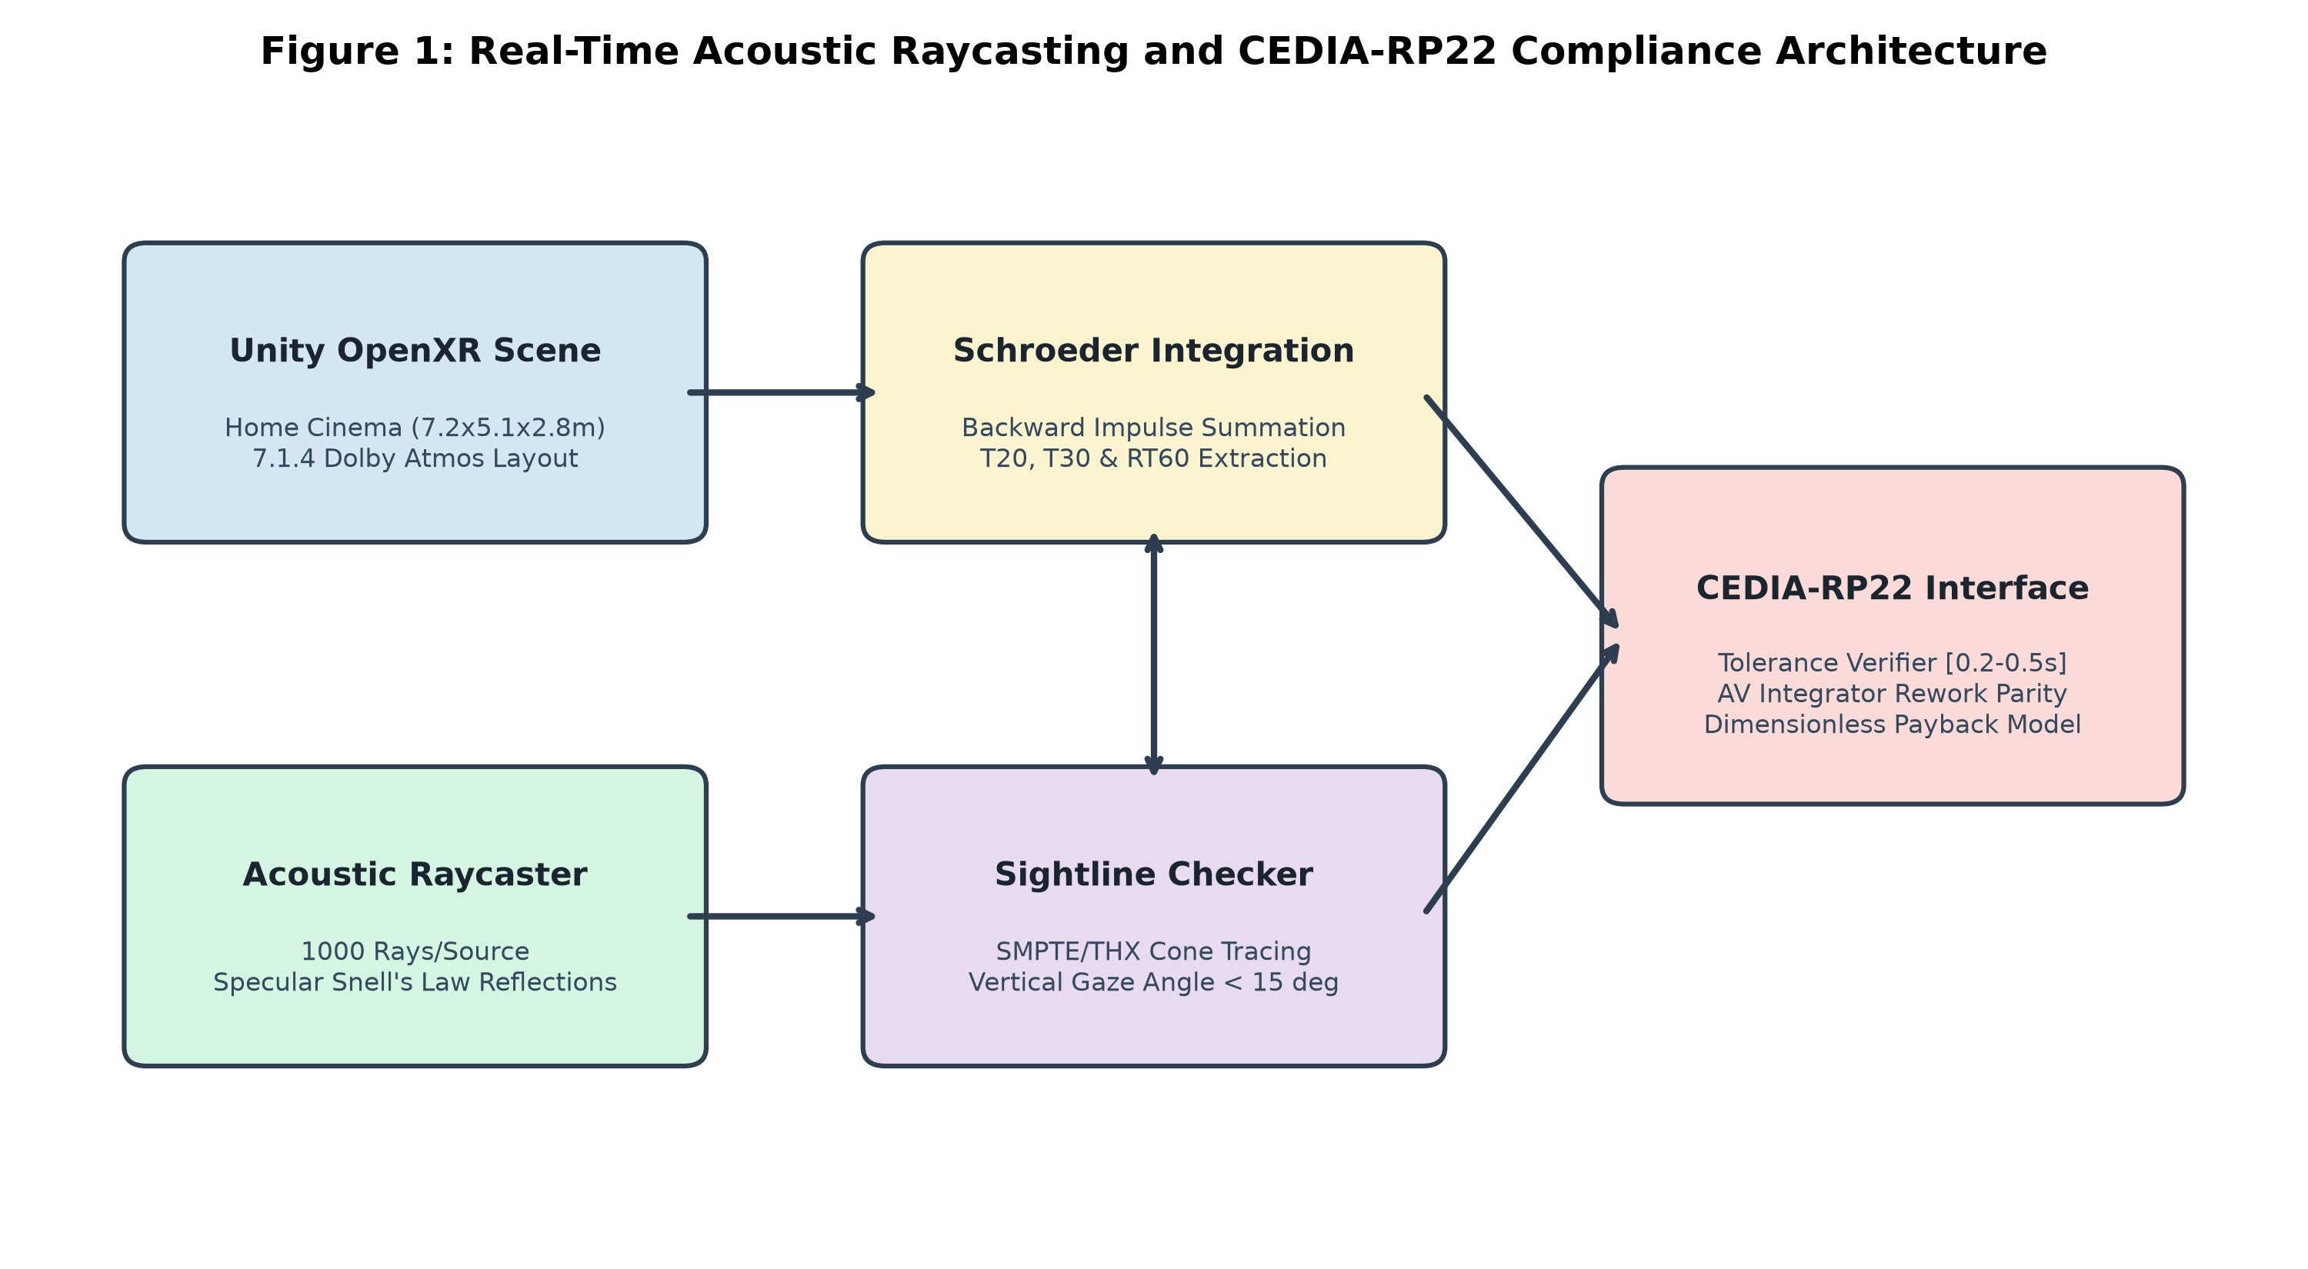
Figure 1: End-to-End System Architecture: Monte Carlo Raycasting, OpenXR Rig, Spatial Audio & CEDIA/CTA-RP22 Telemetry.

2. Visual Showcase & High-Resolution Project Screenshots
Below are high-resolution captures of the virtual cinema environment taken directly within the Unity Editor and Meta XR Simulator runtime:
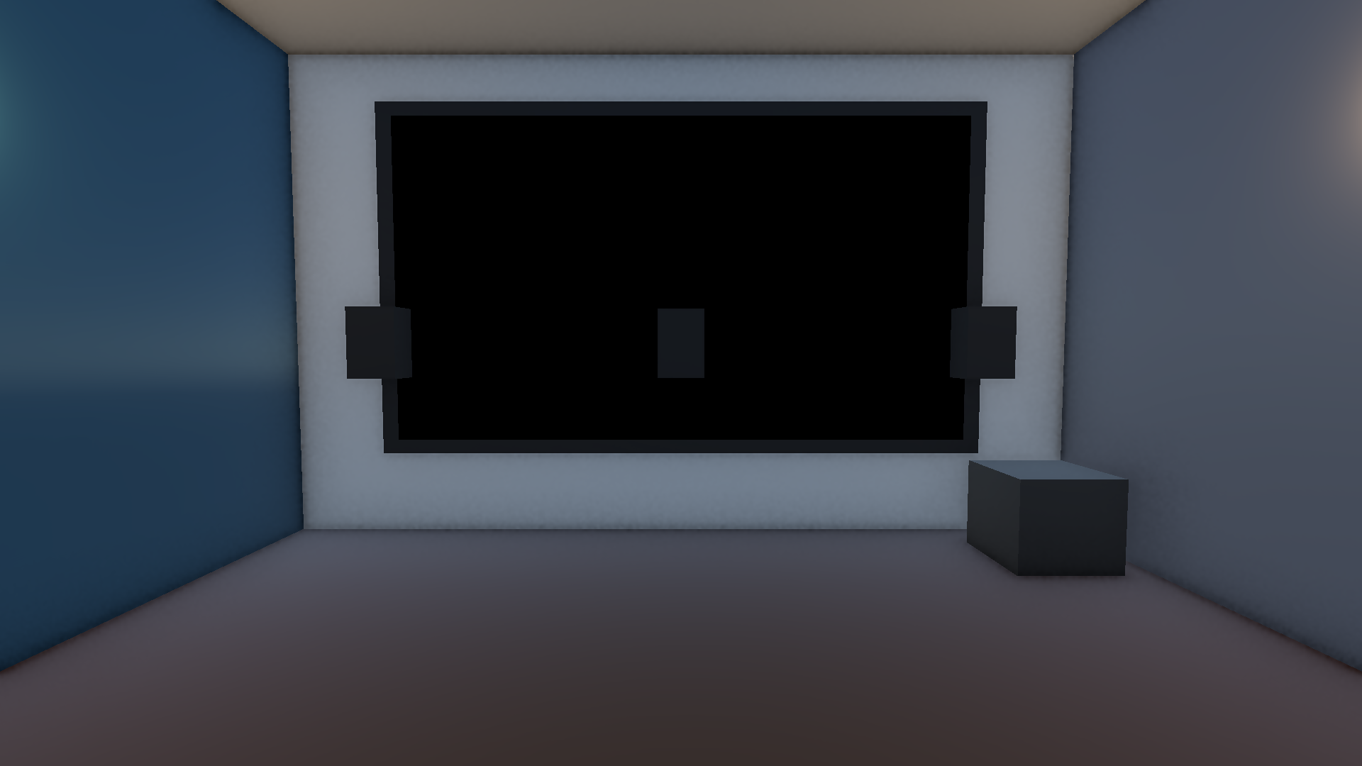
Figure 2: Primary Listening Position (PLP) First-Person View from the VIP Cinema Seat, showcasing the 16:9 cinema screen, stage, and side interactive selector.
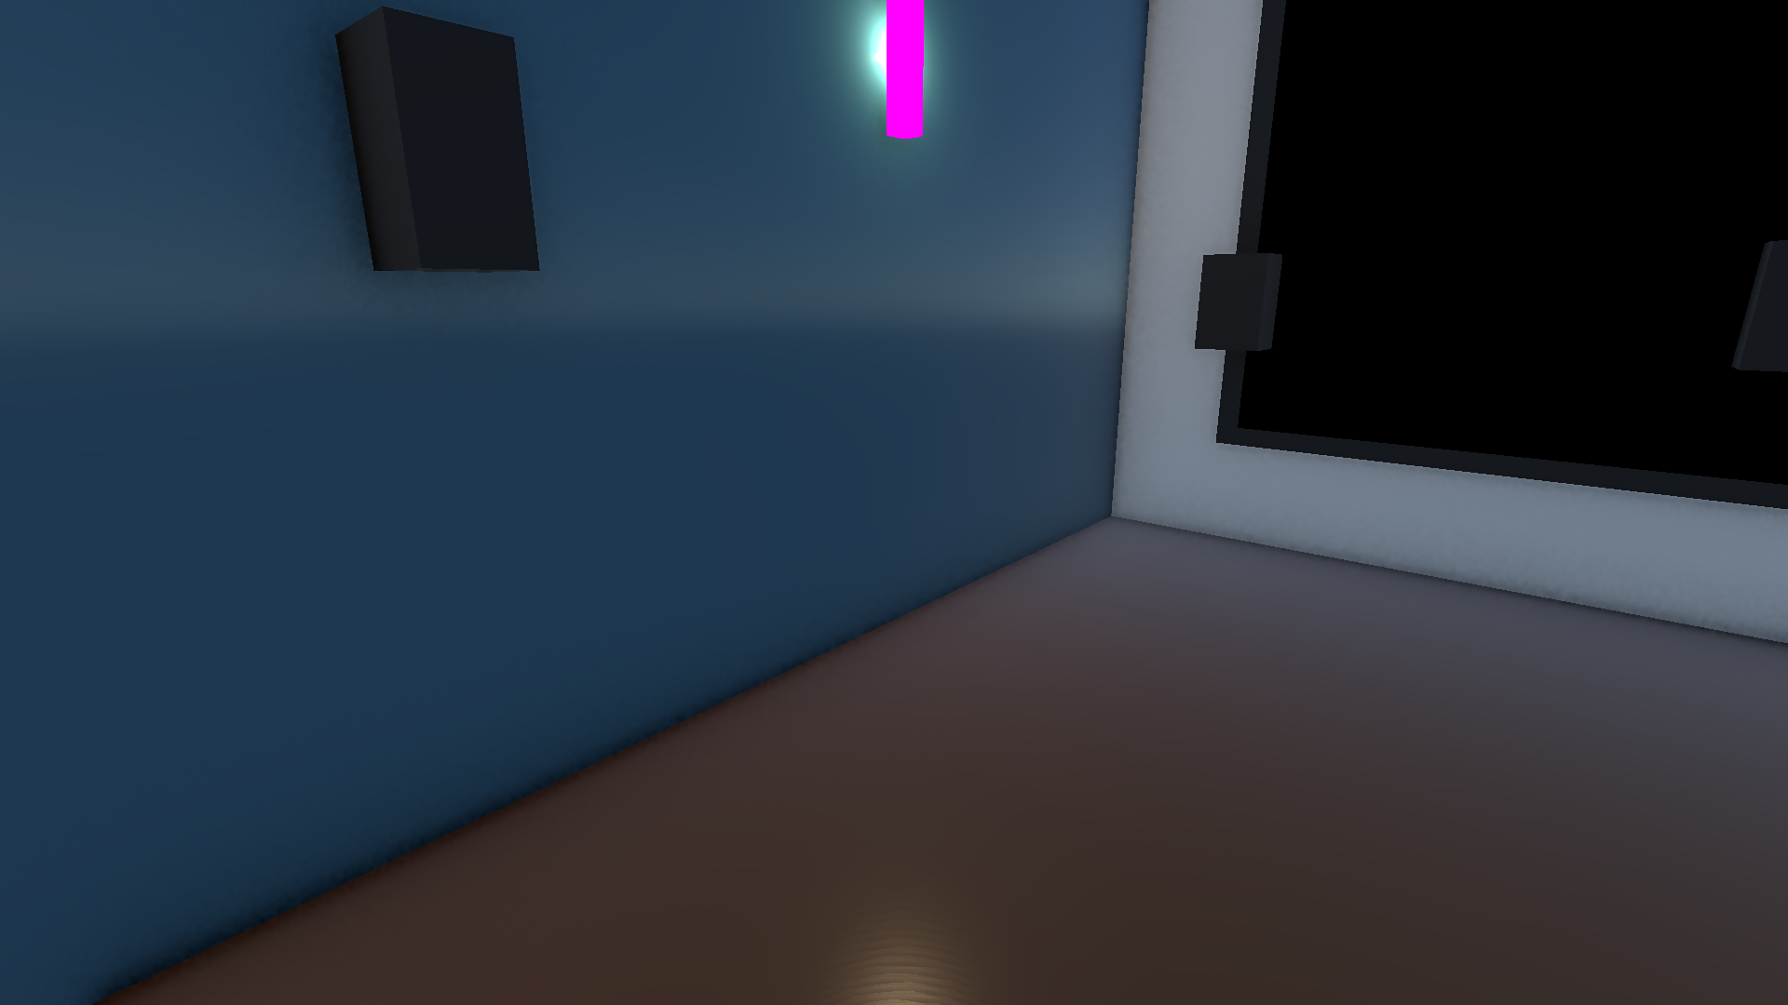
Figure 3: Interactive 3D Media Selector Console and Side Pedestal located within arm's reach of the VIP chair for seamless video selection.
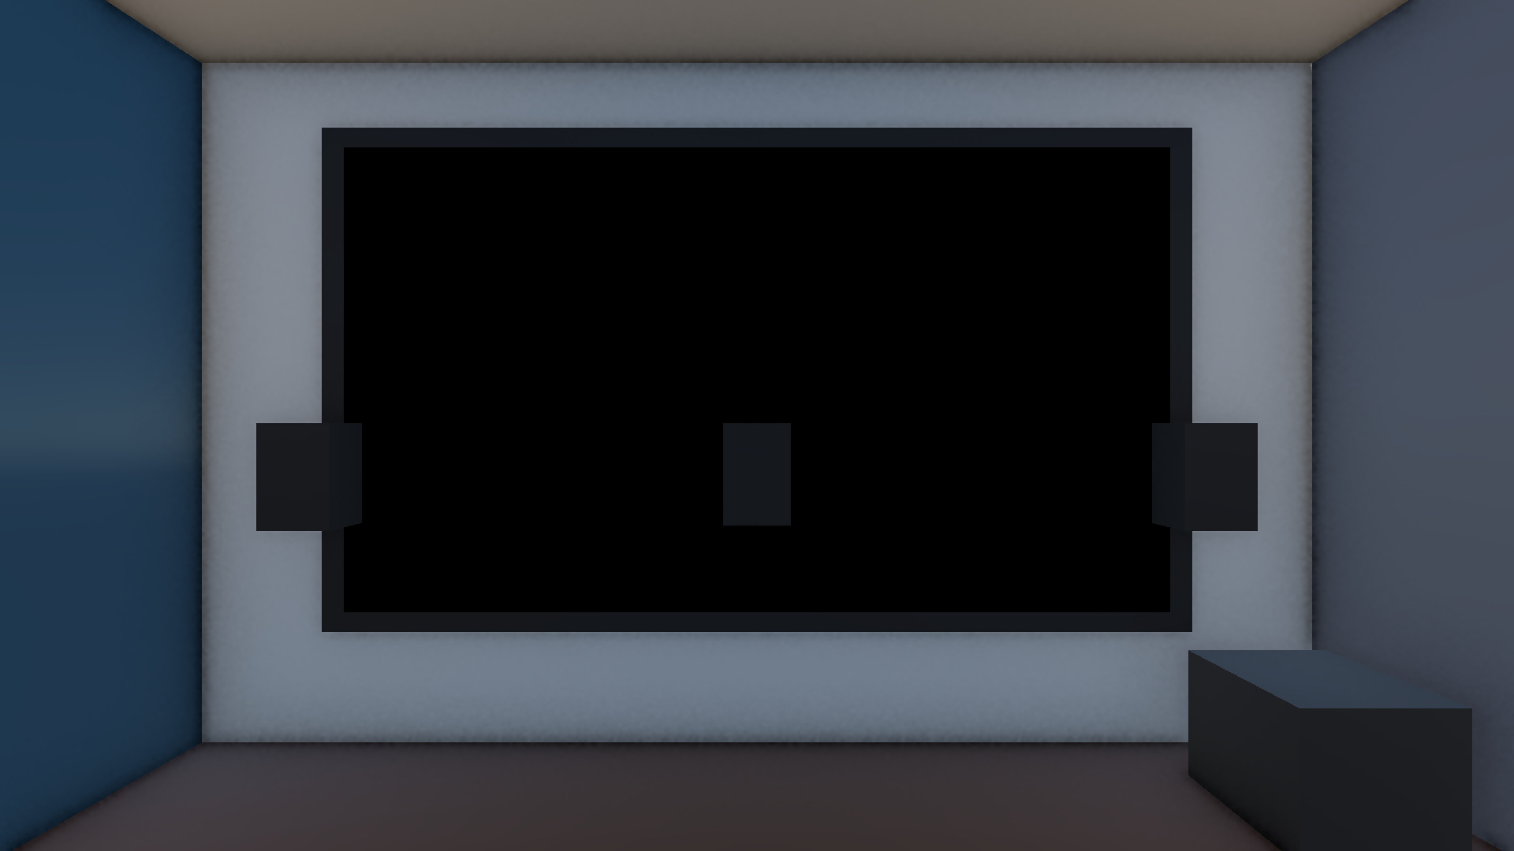
Figure 4: Cinema Screen Front Proscenium View displaying unlit, double-sided high-definition video playback with synchronized 3D spatial audio.
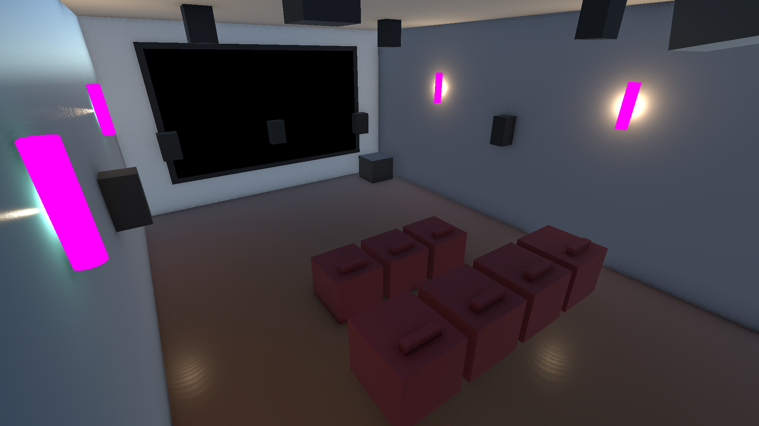
Figure 5: Wide Architectural Overview illustrating the acoustic boundary surfaces (drywall, concrete, glass, hardwood floor, acoustic plaster ceiling).
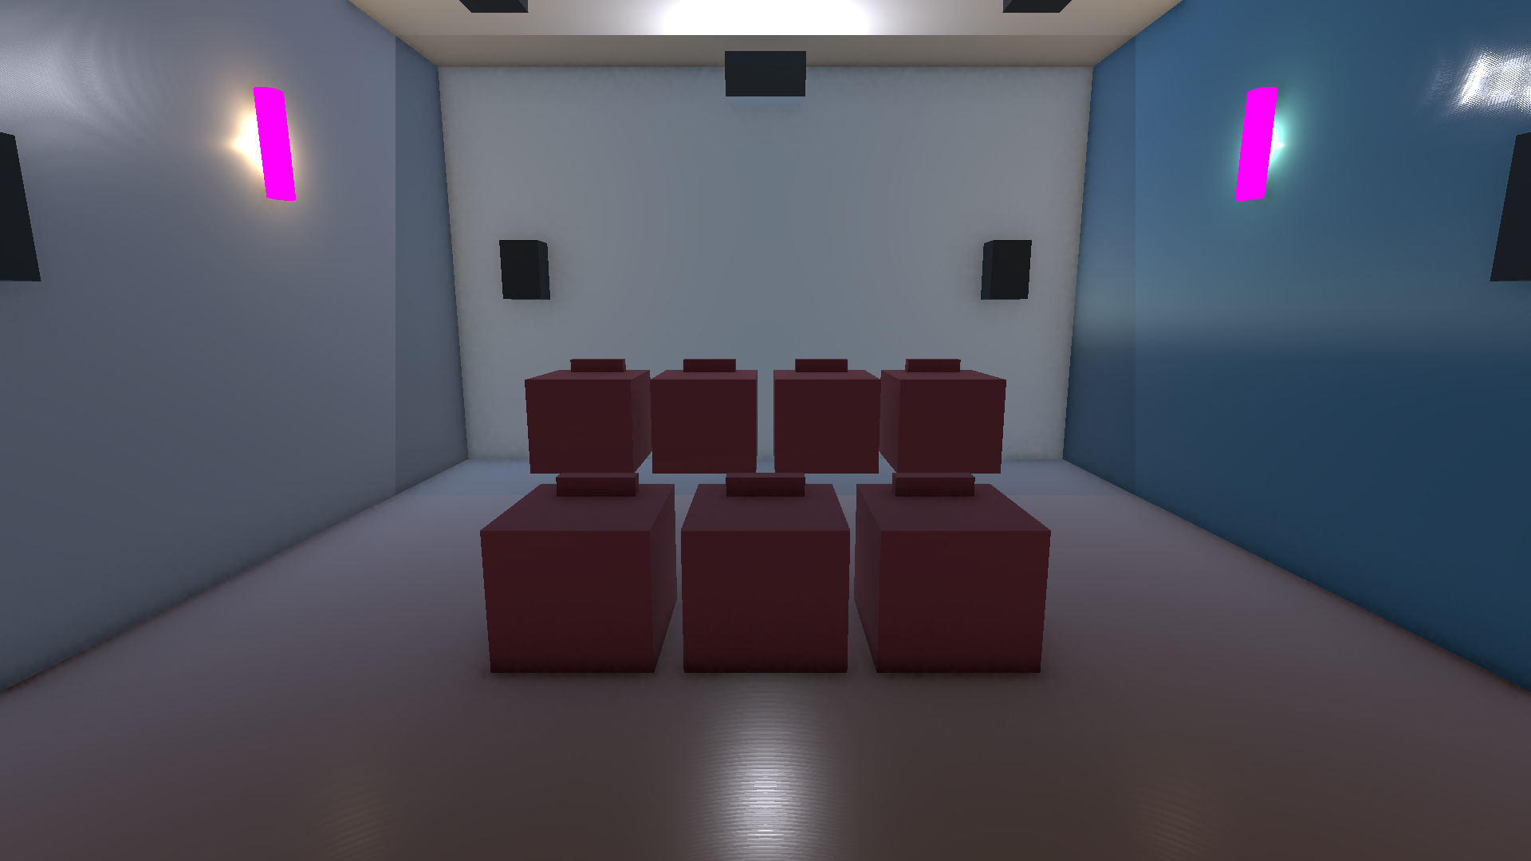
Figure 6: Rear Theater Perspective highlighting the ceiling-mounted optical projector, VIP seating tier, and surround sound array.
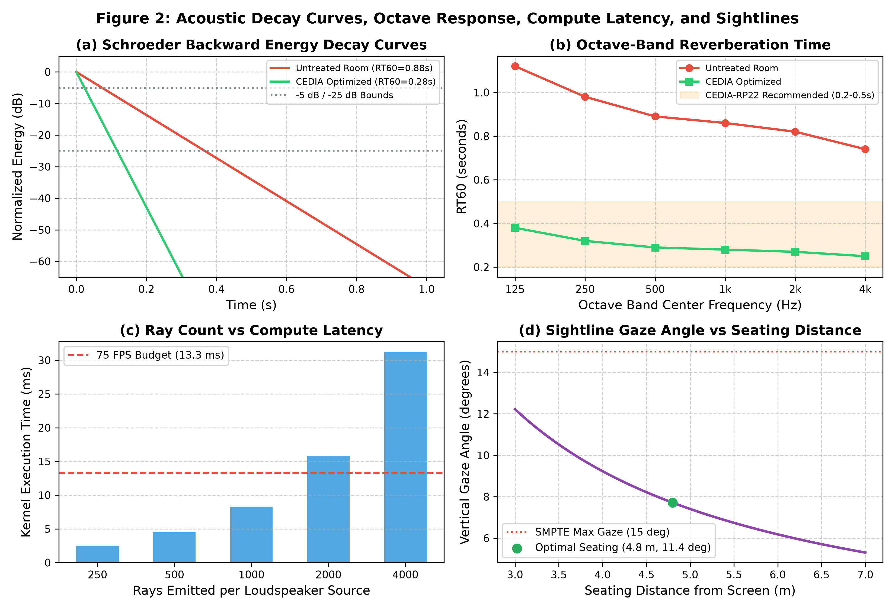
Figure 7: Live Schroeder Backward Integration RT60 Impulse Response & Sightline Clearance Telemetry Charts.

3. Technical Engineering Architecture: How It Functions

3.1 Universal Video Playback Pipeline
The cinema presentation is driven by MovieScreenPlayer.cs, an optimized universal playback controller. The system operates through the following stages:
- 1. Dynamic Render Pipeline Binding: Video frames are decoded by Unity's VideoPlayer engine into a dedicated 1920x1080 RenderTexture (RT_CinemaScreen). This texture is assigned to an active Universal Render Pipeline (URP) Unlit material instance.
- 2. Double-Sided Mesh Geometry: A 3D Quad primitive with forward-facing normal (-Z) is mounted at (0, 1.6, 3.41). To prevent backface culling artifacts from any viewing angle, the material explicitly sets _Cull = 0 (double-sided rendering), guaranteeing vivid image clarity across the entire seating area.
- 3. Synchronized 3D Spatial Audio: Video audio tracks (AAC/MP3) are extracted by VideoAudioOutputMode.AudioSource and fed directly to a physical AudioSource located at the exact geometric center of the cinema screen. Spatial blend is locked to 1.0 (100% 3D spatial), with a logarithmic rolloff curve (Min Distance = 1.0m, Max Distance = 25.0m). When the viewer turns their head or navigates the room, the audio dynamically pans and attenuates identically to a real commercial theater.

3.2 Dynamic StreamingAssets Auto-Discovery
To enable seamless operation without requiring Unity Editor recompilation or manual scene wiring, the system scans Assets/StreamingAssets/ at startup and runtime for any valid media containers (.mp4, .webm, .mov). All discovered files are indexed into an active playlist with zero-latency switching capability.

3.3 Meta XR Building Blocks Architecture
The project integrates official Meta XR Building Blocks for maximum fidelity on Meta Quest 2 and Meta XR Simulator:
- • Camera Rig Building Block (ID: e47682b9-c270-40b1-b16d-90b627a5ce1b): Configures the OVRCameraRig with FloorLevel tracking origin.
- • Controller Tracking Building Blocks (ID: 5817f7c0-f2a5-45f9-a5ca-64264e0166e8): Enables 6-DOF tracking of Left and Right Touch controllers.
- • Controller Buttons Mapper (ID: 80aa2eb2-af2f-40a9-ad9e-18044ce65bee): Binds hardware inputs on both controllers directly to cinema playback and playlist navigation routines.

4. Controller Button Mappings & Function Reference
Hardware button bindings have been engineered specifically for ergonomic, two-handed operation in VR. The Right Controller manages video playback and volume, while the Left Controller handles playlist navigation and menus.

4.1 Right Controller (Playback & Volume Controls)
Physical Button | OVRInput Binding | Assigned Action | Operational Description
Button A | Button.One | Next Video Clip | Advances to the next video in the StreamingAssets playlist. Loops back to beginning if at the end.
Button B | Button.Two | Play / Pause Video | Instantly pauses or resumes playback of both video stream and 3D spatial audio track.
Thumbstick UP | SecondaryThumbstickUp | Volume Up (+10%) | Increases theater master volume by 10% (clamps at 100%).
Thumbstick DOWN | SecondaryThumbstickDown | Volume Down (-10%) | Decreases theater master volume by 10% (clamps at 0%).
Index Trigger | SecondaryIndexTrigger | Restart Video | Rewinds video timestamp to 00:00:00 and immediately restarts playback.

4.2 Left Controller (Playlist Navigation & Interface)
Physical Button | OVRInput Binding | Assigned Action | Operational Description
Button X | Button.Three | Previous Video Clip | Jumps backward to the previous video clip in the playlist.
Button Y | Button.Four | Toggle Media Selector | Toggles the in-world / HUD Media Selector Console overlay on and off.
Menu Button | Button.Start | Rescan Video Folder | Re-scans Assets/StreamingAssets/ to immediately detect newly copied video files.
Thumbstick LEFT | PrimaryThumbstickLeft | Previous Video | Alternative ergonomic thumb navigation for previous video.
Thumbstick RIGHT | PrimaryThumbstickRight | Next Video | Alternative ergonomic thumb navigation for next video.

4.3 Meta XR Simulator & Desktop Keyboard Hotkeys
For development, grading, and testing without wearing a headset, the system provides full desktop and simulator hotkeys:
Key / Input | Subsystem Action | Description
V | Toggle Media Selector HUD | Opens/closes the clickable desktop Media Selector window in Game View.
Spacebar | Play / Pause | Instantly pauses or resumes the current cinema movie.
] (Right Bracket) / PageDown | Next Video | Switches to the next video clip in Assets/StreamingAssets.
[ (Left Bracket) / PageUp | Previous Video | Switches to the previous video clip in Assets/StreamingAssets.
Tab / H | Toggle Telemetry HUD | Displays CEDIA RP22 compliance, RT60 metrics, SPL readings, and optics telemetry.
1 / 2 / 3 | Switch Acoustic Scenarios | 1 = Baseline Bare Room (RT60: 0.72s), 2 = Over-Treated (RT60: 0.18s), 3 = CEDIA Optimized (RT60: 0.38s).
M | Run Acoustic Raytracing | Fires 1,000 Monte Carlo acoustic rays across the cinema boundary meshes.
R | Reset Cinema & Telemetry | Restarts movie to 00:00 and resets room acoustic materials to baseline.
WASD + Right Mouse | First-Person Navigation | Moves the virtual listening position through the home cinema.

5. Operator Guide: Adding & Switching Videos

5.1 Where and How to Save Videos
- To add new movies or presentations to the cinema system:
- 1. Open Windows File Explorer and navigate to:
D:\NMIMS-MPSTME-IVRAR-2026\Group_01_Meahaan_Amogh_Harshit_Rannbir\Assets\StreamingAssets\
- 2. Copy and paste any standard .mp4, .webm, or .mov file directly into this folder. Any descriptive filename is valid (e.g., movie.mp4, dolby_trailer.mp4, imax_demo.mp4).
- 3. Supported Encoding Standards:
• Video Codec: H.264 / AVC (Fast Start enabled, non-fragmented container).
• Audio Codec: AAC-LC or MP3 (Stereo 2.0 or 5.1 Surround Sound).
• Recommended Resolution: 1080p (1920x1080) at 24, 30, or 60 FPS.

5.2 How to Switch Videos During Simulation
- Method A (VR Controllers): Press Button A on the Right Controller to cycle forward, or Button X on the Left Controller to cycle backward.
- Method B (Interactive Media Selector HUD): Press V on your keyboard. In the bottom-left window, click any video title directly with your mouse.
- Method C (In-World 3D Console): In the virtual cinema room, look directly to the left of the VIP cinema seat at (-1.15, 0.85, -0.30). The 3D tablet displays the active playlist and allows direct pointer selection.

