**NCC**

**COMMUNICATION**

**IMAGES**

**ASSIGNMENT 6**

**1.THIS IMAGE SHOWS THREE COLORS WHICH SIGNAL PEOPLE TO STOP,SLOW OR GO THROUGH THE INTERSECTION.**

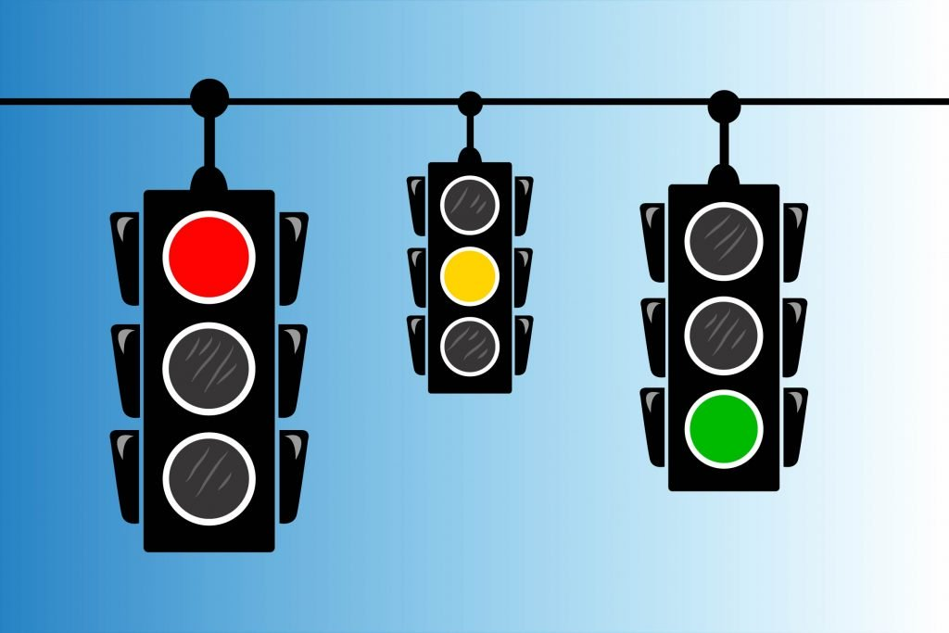

**2.THIS IMAGE HAS TWO SIGN BOARDS IN WHICH YELLOW COLOR DEFINES WARNING SIGNAL AND RED COLOR DEFINES STOP SIGNAL.**

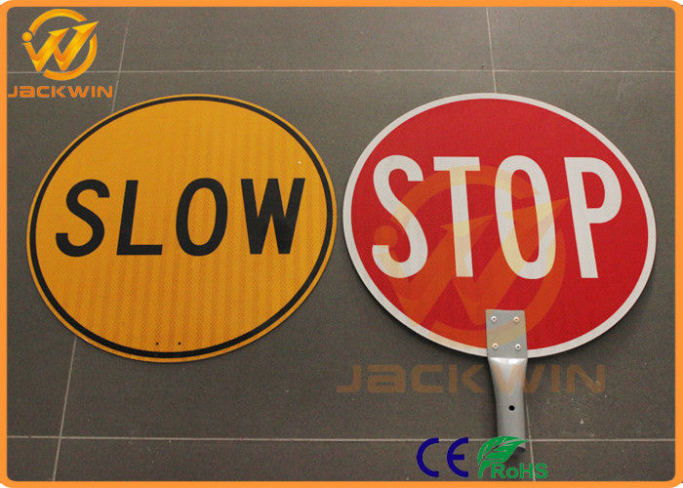

**3.IN THIS IMAGE THE COLORS OF EMERGENCY VEHICLES LET US KNOW ABOUT THE PARTICULAR TYPE OF VEHICLE.**

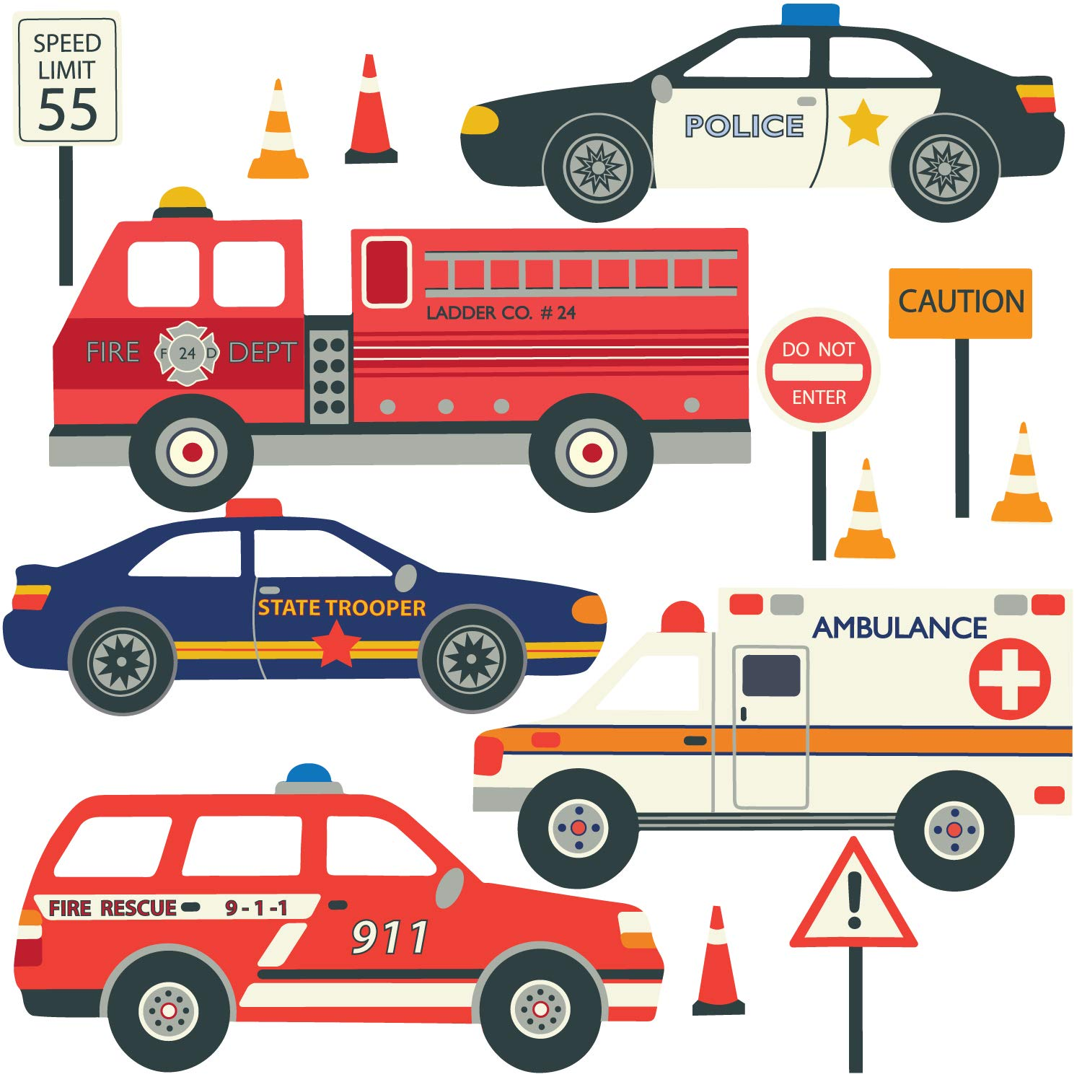

**4.THE WHITE COLOR SIGN ON RAINBOW FLAG NOTIFIES THE COLOR OF PEACE.**

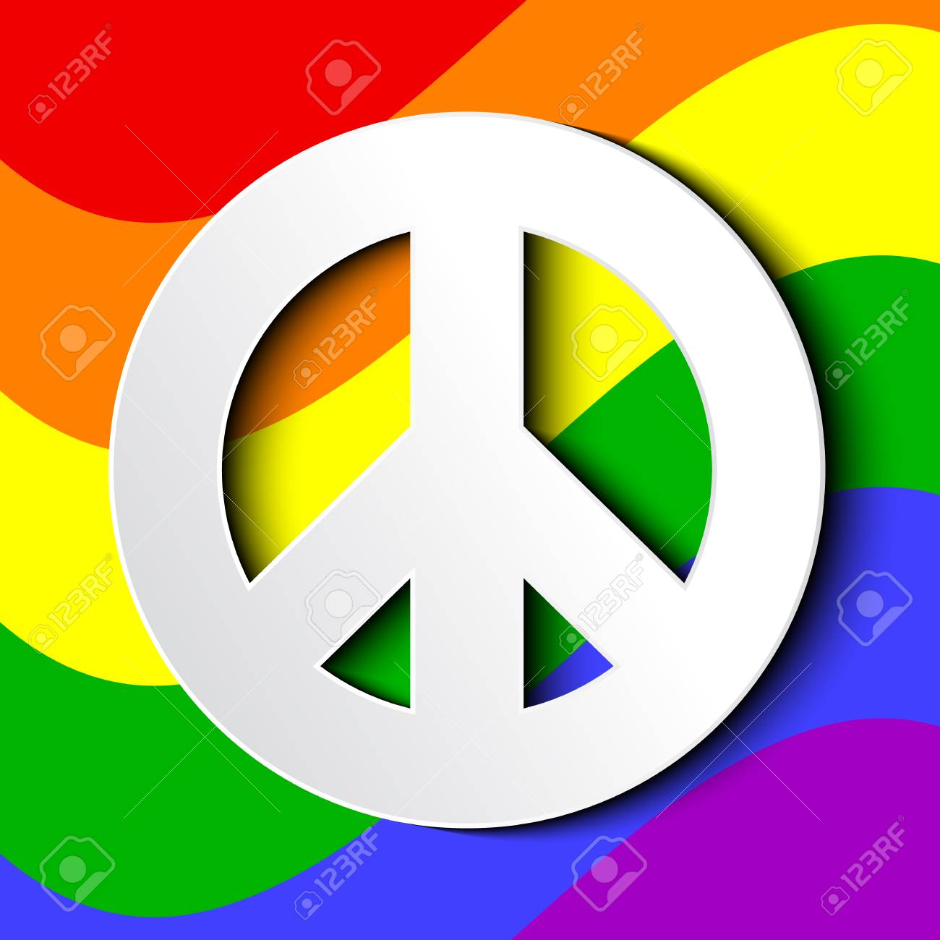

**5.THE COLORS IN IMAGE APPRISES THE BASIC EMOTIONS IN HUMANS AND PURPOSE OF EACH COLOR.**

