Project Two
Advance Embedded System Design

Embedded Vehicle System

Harsimran Singh Bindra
Yasir Aslam Shah

SOFTWARE ARCHITECTURE:

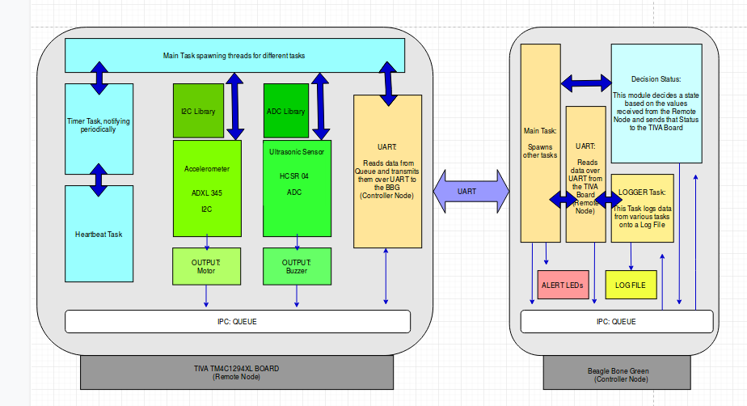

Introduction:

In this project, we are planning to demonstrate a wireless vehicle dash board using Accelerometer, and Ultrasonic Sensor. The accelerometer senses the movement of the system as forward, backward, left and right based on the tilt and the project represents the motion of the system using two motors as output. The system alerts a user using a Buzzer, in case the vehicle senses any obstacle based on the reading from the ultrasonic sensor. In this project we are representing output based on the sensor values received from the sensors using Motors and a Buzzer.

The system is divided into the following two nodes as below:

- Controller Node
- Remote Node

The Controller Node:

This node acts as a main task and is based on Linux-based Beagle Bone Green. This task
also contains an alert mechanism using on board LEDs for various tasks operational on the remote node based on freeRTOS Tiva Board. This task also sends different status values to the Tiva board to generate output on real Output devices like motors and a Buzzer.

This node also contains an Alert Task and a Heart Beat Task. The Heart Beat task sends sensor value periodically to the Queue which is then sent to the controller node and logged in the logger file.

The Alert Task alerts a user using On board LEDs in case of any voilation like, sensor disconnect, or sensor values crossing a threshold value.

The Remote Node:

The Remote Node is based on freeRTOS on TIVA Board and is responsible for interfacing various sensors. The Remote node communicates with the controller node and generates output on real output devices. This remote task in our project consists of two sensors ; Accelerometer and an Ultrasonic Sensor.

The remote node contains the following sensor task:

- Accelerometer Task

The accelerometer (ADXL 345) is a I2C based sensor that senses the tilt of the system as Forward/Backward or Left/Right. The Tiva board sends the sensor values to the Beagle Bone which compares the sensor values with a user defined threshold values and generates a status based on the sensor state. The controller node sends this sensor status value back to the Tiva Board which generate a desired Output on output devices.

- Ultrasonic Task

In this task, we are also planning to use Ultrasonic Sensor HCSR 04 based on ADC. We are planning to use this sensor to detect any obstacle based on its distance reading. The sensor generates an alert whenever the distance crosses a certain threshold value defined by the user. We are implementing a Buzzer as a real Output device to represent if the sensor values cross a certain threshold value.

- Logger Task

This task is responsible for accepting various logs from various on-board sources. A synchronization mechanism is implemented for protection from multiple log sources. The logger entry contains the following information in various data types as:
- Time stamp
- Log Level
- Logger ID
- Log Message

- Alert Task

This task is used to alert a user if the sensor values cross a threshold value. The threshold values are set by the user and any sensor values crossing the threshold values are represented using on board LEDs on the Beagle Bone Green board.

- Unit Testing and Startup Tests:

This task will be performing individual unit testing of components like testing individual sensors for read and write operation, testing communication protocols like ADC, I2C, and UART. This module is ran initially as a STARTUP test. Once this test is passed then only the project moves forward creating threads for different modules. Any startup failure results termination at start. Once the system starts communicating and in case of any failure, be it sensor failure , or anything the system demonstrates such a failure with LEDs so that the user gets to know about the level of the failure.

- Multiple system Failure demonstration:

In this project, three different levels of error/ failure representation is done using LEDs.
In case , the sensors fail at STARTUP test, the system alerts a user by turning on one LED.In case the system passes the STARTUP test but one of the sensor gets disconnected, the system informs user by alerting Level 2 failure by turning on two LEDs. In case the STARTUP module is working perfect;y and both the sensors are connected and working, but the UART communication is a failure then the sensor represents this failure by alerting user by Level 3 Failure by glowing three LEDs. Meanwhile, when sensors are disconnected in between it is also indicated using the leds.

Communication:

The two boards are connected using UART. IPC like queue is used to transmit data between threads spawned for various tasks. I2C and ADC communication protocol is used used to interface sensors for this project.
In this project we are implementing Queue (IPC) to transmit data between different tasks on both the nodes (controller as well as remote). The Queue transmits the data between the controller and the remote using UART. The decision based on sensor values made by the BBG is transmitted to the TIVA Board using Queues and UART also

UPDATE AS PER FEEDBACK

Project Requirements:

In this project based on the two sensors we have planned the following three requirements as below:

Requirement 1:

The Tiva Board (remote node) senses data from the ultrasonic sensor and sends the data over UART to the control node (BBG) for a decision that will drive the output peripheral (currently depicting Output with LED and if time permits will interface a motor)at the remote node end. The control node judges the decision to be made by comparing the value from the ultrasonic sensor with the threshold values set by the user initially. In case the sensor value is less or equal to the threshold values, the remote node sets the state of its output peripheral likewise.

Requirement 2:

In this project we are implementing another sensor as alcohol sensor based on ADC. The Tiva board reads the value from the alcohol sensor and returns the value to the BBG. The BBG decides if the sensor values cross a threshold or not. In case the values cross the threshold value, the remote node changes the state of the output peripheral. In this project we are implementing LEDs as basic output peripherals and will interface buzzers and motors in case time permits.

Requirement 3:

The third requirement is defined as a safety measure in our project. In case the remote node is disconnected from the control node, and the remote node does not have any control node to decide what to do with the output devices, the remote node in such a critical state takes care of the output devices itself as a safety measure.

*Note: In this project we are supposed to use accelerometer sensor however due to buring up our sensor we are fullfilling our project requirements using Alcohol sensor and in case of timely availabilty of other sensor, we will try our best to integrate that too in our project.

Reference:

- https://www.analog.com/en/products/adxl345.html
- https://www.sparkfun.com/products/13959

Project Members:

- Harsimran Singh Bindra (habi1225@colorado.edu)
- Yasir Aslam Shah (yash8307@colorado.edu)

