***Flow chart***

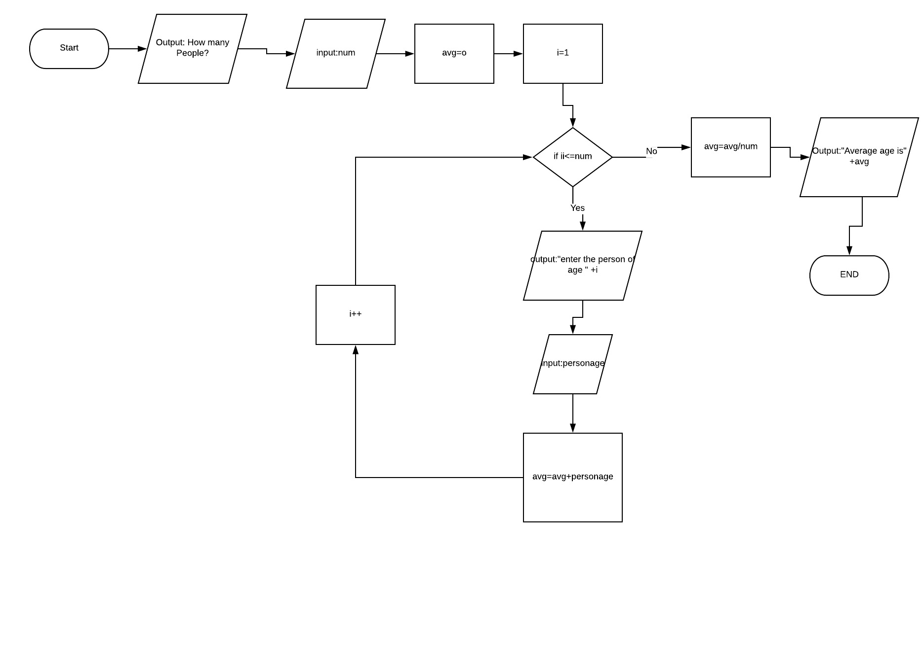

***Pseudocode***

1. Declare num
2. Declare i
3. Declare avg
4. Declare personage
5. Output : “ how many people ?”
6. Input num
7. Set i = 1
8. Set avg = 0
9. For (i = 1; i <=num ;i++) {
10. Output : “enter age of person “ + i
11. Input age
12. Avg = avg + age
13. Loop
14. avg = avg / num
15. Output : “average age is “ + avg
16. END

Trace

|  |  |  |  |  |  |  |
| --- | --- | --- | --- | --- | --- | --- |
| Line no. | Input buffer | num | i | Avg | personage | Output buffer |
| 1. | - | - | x | x | x | - |
| 2. | - | - | - | x | x | - |
| 3. | - | - | - | - | x | - |
| 4. | - | - | - | - | - | - |
| 5. | - | - | - | - | - | “How many people” |
| 6. | 4 | 4 | - | - | - | - |
| 7. | - | 4 | 1 | - | - | - |
| 8. | - | 4 | 1 | 0 | - | - |
| 9. | - | 4 | 1 | 0 | - | - |
| 10. | - | 4 | 1 | 0 | - | “Enter age of person 1 “ |
| 11. | 22 | 4 | 1 | 0 | 22 | - |
| 12. | - | 4 | 1 | 22 | 22 | - |
| 13 | - | 4 | 2 | 22 | 22 | - |
| 9. | - | 4 | 2 | 22 | - | - |
| 10. | - | 4 | 2 | 22 | - | “Enter age of person 2“ |
| 11. | - | 4 | 2 | 22 | 28 | - |
| 12. | - | 4 | 2 | 50 | 28 | - |
| 13 | - | 4 | 3 | 50 | 28 | - |
| 9. | - | 4 | 3 | 50 | - | - |
| 10. | - | 4 | 3 | 50 | - | “Enter age of person 3“ |
| 11. | - | 4 | 3 | 50 | 35 | - |
| 12. | - | 4 | 3 | 85 | 35 | - |
| 13 | - | 4 | 3 | 85 | 35 | - |
| 9. | - | 4 | 4 | 85 | - | - |
| 10. | - | 4 | 4 | 85 | - | “Enter age of person 4“ |
| 11. | - | 4 | 4 | 110 | 35 | - |
| 12. | - | 4 | 4 | 110 | 35 | - |
| 13. | - | 4 | 4 | 110 | 35 | - |
| 14. | - | 4 | 4 | 27.5 | 35 | - |
| 15. | - | 4 | 4 | 27.5 | 35 | “Average age is 27.5” |
| 16. | - | 4 | 4 | 27.5 | 35 | - |