**CERTIFICATE**

This is to certify that the project work entitled “**ONLINE SCHEDULER**” submitted to School of Computer Science and Applications, **REVA University** in partial fulfillment of the requirements for the award of the Degree of Master of Computer Applications in the academic year **2017-2018** is a record of the original work done by **SANDARYA PAUL(R16CA627)** under my supervision and guidance and that this project work has not formed the basis for the award of any Degree/Diploma/Associate Ship/Fellowship or similar title to any candidate of any University.

Place: Bangalore

Date: 5/21/2018

Signature of the guide Signature of the Program Co-Ordinator

Signature of the Director

Submitted for the University Examination held on __________________

Internal Examiner External Examiner

**DECLARATION**

I hereby declare that this project work entitled “**ONLINE SCHEDULER**” under the guidance of Prof. K. Vijayalakshmi and that this project work has not formed the basis for the award of any Degree/Diploma/Associate Ship/Fellowship orsimilar title to any candidate of any University.

|  |  |  |
| --- | --- | --- |
| Signature of the Candidate | Countersigned by | Signature of the Co-Ordinate |
|  |  |  |
| Name: |  |  |
| SRN No: |  |  |

**ACKNOWLEDGEMENT**

I would like to acknowledge all who has given the guidance and encouragement that has made us to do what is done so far.

I express my sincere thanks and gratitude to Dr. P. Shyama Raju, Honorable Chancellor, REVA University for providing us the excellent infrastructure to carry out this project work.

I am thankful to Dr. S.Y. Kulkarni, Vice Chancellor, Dr.M. Dhanamjaya, Registrar, Dr. Sunil Kumar S Manvi, Dean, Faculty of Engineering and Technology, Dr. N. Ramesh, Dean, Faculty of Science and Technology, REVA University, Bengaluru for their support and encouragement for this work.

I take this opportunity to express my heart full thanks to Dr. S. Senthil, Director, School of CSA, Prof. Rajiv Ranjan Deputy Director, School of CSA, REVA University for their encouragement to complete this project successfully.

I also thank my guide Prof. K. Vijayalakshmi, Assoc. Prof & Asst. Director, School of CSA, REVA University who helped me for the successful completion of this project.

I also thank our friends for their valuable suggestions. I am thankful to them for their co-operation for the successful completion of this project.

Last but not the least I also thank our parents for being supportive in all our activities and without whom it wouldn’t be possible to complete this project.

**ABSTRACT**

In Today’s era, people wants to keep on obtaining the knowledge and degrees within their respect fields. But the only problem lies where they need to give their physical presence for the examination because some people want to get certification during their job career as well. Hence, when they think of doing certification, they feel difficult to cope up with their office work. Therefore, we proposed such system which provide online certification courses over their desktop or laptop systems. This project is designed in order to provide certification in various programming languages so that people can log into and give the exams online without any hesitation and at anytime and anywhere. This project provides master in Php, Java, Oracle SQL, IOT, Python as well as machine learning. In order to this project is designed to automates the examination process.

Moreover, our major motive is to provide excellence in particular programming language and also to maintain their records and generate them the results. Since, we have to maintain large amounts of records of the students as well as updating the results, even the exam papers evaluation process which increases the complexity of the project. Therefore, it might be possible that project can cause issues like inconsistency of records or misplace of records. But in this case, we will keep on resolving the issues and making it robust in nature. The nature of this project is to provide the opportunity to users to give the exam on their figure tips within their preferred language and to eradicate the need of giving the physical presence for the same. As the proposed system is a centralized one, redundancy can be avoided. Above all the system provides high security for all its data. Following report will elaborate the project in detail regarding all its advantages as well as limitations. This final report also comprises the data flow diagram along with the ERP system.

Contents

CHAPTER 1 7

1.1 INTRODUCTION 7

About “ONLINE SCHEDULER” 7

STATEMENT OF THE PROBLEM: 7

BRIEF DESCRIPTION OF ONLINE SCHEDULER: 7

CHAPTER 2 8

2.1 LITERATURE SURVEY 8

CHAPTER 3 8

3.1 SYSTEM ANALYSIS 9

3.1.1 EXISTING SYSTEM 9

3.1.2 LIMITATIONS OF EXISTING SYSTEM 9

3.1.3 PROPOSED SYSTEM 9

3.1.4 ADVANTAGES OF PROPOSED SYSTEM 9

3.1.5 FEASIBILITY STUDY 10

CHAPTER 4 11

4.1 SYSTEM DEVELOPMENT STRATEGY 11

4.1.1 SYSTEM ENGINEERING 11

4.1.2 SYSTEM DEVELOPMENT ENVIRONMENT 11

CHAPTER 5 12

5.1 SYSTEM DESIGN 12

5.1.1 HIGH LEVEL DESIGN (ARCHITECTURAL) 12

5.1.2 LOW LEVEL DESIGN 12

5.1.3 FLOWCHARTS 13

5.1.4 DATAFLOW DIAGRAM 14

5.5 FIRST FLOW DIAGRAM 15

5.6 ENTITY-RELATIONSHIP DIAGRAM 16

5.7 TABLE DESIGN 16

5.8 INPUT/OUTPUT INTERFACE DESIGN 18

CHAPTER 6 19

6.1 CODING 19

6.1.1 PSEUDO CODE 19

CHAPTER 7 19

7.1 TESTING 19

SNAPSHOTS 21

CONCLUSION 21

BIBLOGRAPHY 22

# CHAPTER 1

## 1.1 INTRODUCTION

### About “ONLINE SCHEDULER”

Online scheduler is a system which is designed to provide online examination facility. In order to give exam, user has to log into the system if already created account or has to sign up first in order to pursue the further process. This project allows user to give examination anytime and anywhere. This scheduler will guide the user properly that how he/she should give the exam along with appropriate instructions.

### STATEMENT OF THE PROBLEM:

To develop a perfect and robust system that will provide best certification courses to the users.

### BRIEF DESCRIPTION OF ONLINE SCHEDULER:

The major aim of Online Scheduler is to provide a service to users by eliminated the physical presence while appearing for the exam physically at some place for the exam. Our web portal facilitates to provide online certification courses. This can be achieved by signing up into our web portal by creating valid account along with proper and accurate details which are required as per the instructions during creating an account and appearing for the exam online. Admin will play major role in this project as admin will be responsible for uploading the date and other details of exam as well as providing the results on time and uploading the exam paper.

The modules that has been implemented are as follows:

* **Login/Signup:** The first module is the login/signup page. Here a user can login or signup in order to get access.
* **Exam details:** The details of the upcoming tests and the previous appeared tests will be available over here.
* **History:** This section states the history about the entire process and the team related to the project.
* **Feedback:** This section deals with the client notes that are taken as feedbacks.

# CHAPTER 2

## 2.1 LITERATURE SURVEY

Literature survey may also be known as a literature review. Literature Survey was conducted by collecting information from surveys online. Existing online exam from present examination department & some companies were thoroughly analyzed, shortlisted and modified. This report will give the user a choice to select an Online Exam for related course according to their interests. The data was obtained by providing a questionnaire with open and closed ended questions including personal details. This questionnaire helped in knowing the exact factual information about the present online exam details. This is helpful to analyzing and developing our knowledge. Q & A forums gave details on the present working system and the problems faced in the system.

# CHAPTER 3

## 3.1 SYSTEM ANALYSIS

### 3.1.1 EXISTING SYSTEM

The Existing system for Online examination, taking existing system in to consideration, we cannot find that experts and guide are contracted with users who want to give the exam. No e - book facilities are there in an exciting system. It’s an online exam system but it works like a manual exam.

### 3.1.2 LIMITATIONS OF EXISTING SYSTEM

* We have to keep in mind that your students will take the exam on their own device in their own time with nobody to check up on them so we have to alert our question to provide for this situation. We have to ask questions which are not easily to retrieve from books or the internet or you can add a timer to each question so there is no time to search for the answer.
* Open text questions are possible, but they do not auto grade, so you have to check them yourself

### 3.1.3 PROPOSED SYSTEM

The proposed system Online exam is fully an automated system designed with a perspective to provide online certification to users over their hands. In the proposed system, the customer can view the subject details, exam details, etc and can select for which he/she wants to appear. Online registration is also possible with this proposed system. As the proposed system is a centralized one, redundancy can be avoided. Moreover, the coordination of different departments becomes much easier. The proposed system bridges this gap between the end-users and the contrivance planning managers by providing a centralized control over the entire system.

### 3.1.4 ADVANTAGES OF PROPOSED SYSTEM

* Improve skills and knowledge.
* Reduce the time.
* easily useable.
* easy to handle and maintained.

### 3.1.5 FEASIBILITY STUDY

#### TECHNICAL FEASIBILITY

**Front End:** HTML, CSS, bootstrap

**Back End:** Php, MySQL

**Coding purpose:** Notepad++

**Browser:** Mozilla Firefox

**Application:** Xampp Control Panel

#### ECONOMICAL FEASIBILITY

The procedure is to determine the benefits and savings that are expected from a person. If a benefit outweighs costs, then the decision is made to design and implement the system. Otherwise further alterations are made in the proposed system.

**Manpower cost:**

1. Hardware cost

2. Software cost

3. Maintenance cost

4. Legal cost

#### OPERATIONAL FEASIBILITY

* The structure of the system will not be changed.
* This system will look like the current structure of organization.
* All the overheads will be removed.
* Less time consuming,
* Response time is very quick.

# CHAPTER 4

## 4.1 SYSTEM DEVELOPMENT STRATEGY

### 4.1.1 SYSTEM ENGINEERING

|  |  |
| --- | --- |
| Content Type | Content Used |
| Web Server |  |
| Front End | HTML, Dreamweaver |
| Scripts | JavaScript |
| JDK |  |
| Back End |  |
| Operating System | Windows XP/Windows 7,8,10 |
| Browser | Firefox |

### 4.1.2 SYSTEM DEVELOPMENT ENVIRONMENT

**HTML:**

Hypertext Markup Language (HTML) is the standard markup language for creating web pages and web applications. With Cascading Style Sheets (CSS) and JavaScript, it forms a triad of cornerstone technologies for the World Wide Web.

# CHAPTER 5

## 5.1 SYSTEM DESIGN

### 5.1.1 HIGH LEVEL DESIGN (ARCHITECTURAL)



**FIG: 5.1.1 (HIGH LEVEL DESIGN)**

### 5.1.2 LOW LEVEL DESIGN

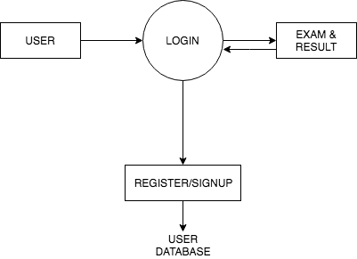

**FIG: 5.1.2 (LOW LEVEL DESIGN)**

### 5.1.3 FLOWCHARTS

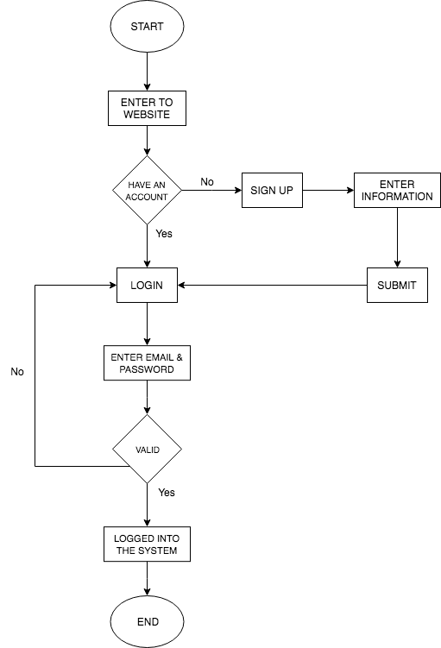

**FIG: 5.1.3 (FLOW CHART DIAGRAM)**

### 5.1.4 DATAFLOW DIAGRAM

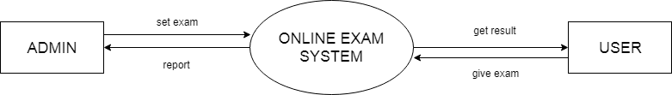

### 5.5 FIRST FLOW DIAGRAM

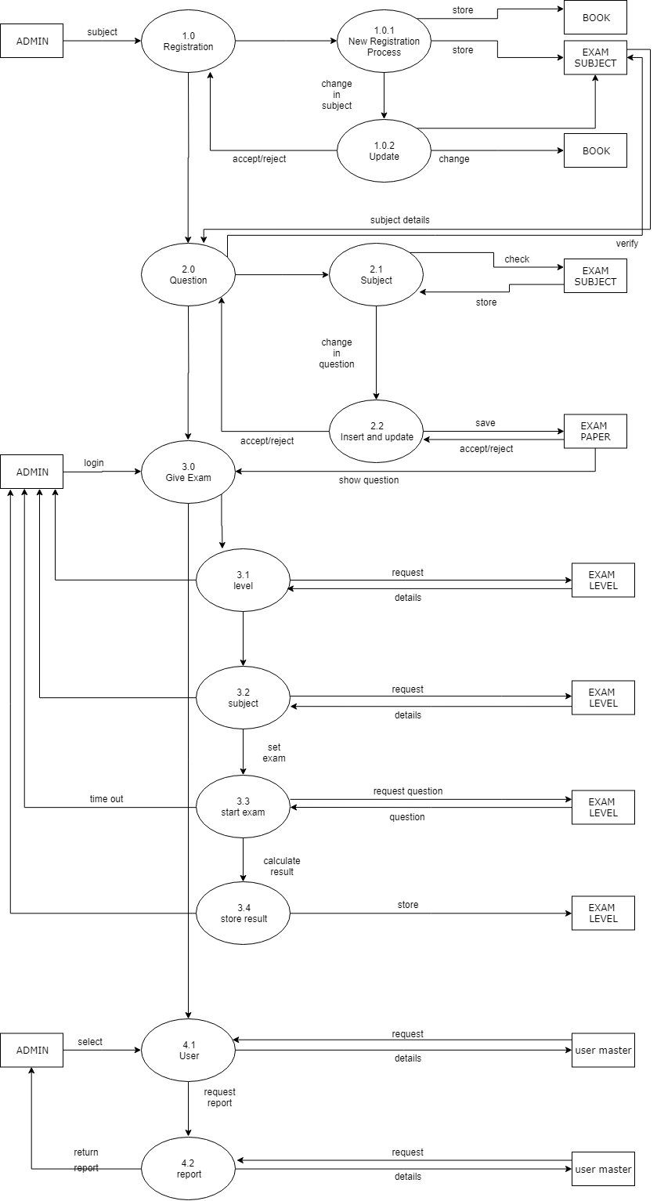

**FIG: 5.1.4 (FIRST FLOW DIAGRAM)**

### 5.6 ENTITY-RELATIONSHIP DIAGRAM

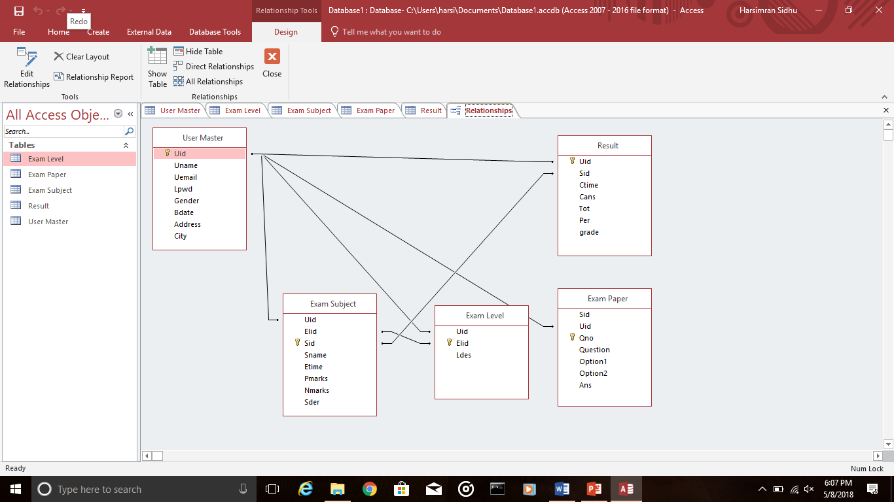

**FIG: 5.6.1 (ER DIAGRAM)**

### 5.7 TABLE DESIGN

#### TABLE - 5.7.1 USER MASTER TABLE

|  |  |  |  |  |
| --- | --- | --- | --- | --- |
| FIELD NAME | DATA TYPE | SIZE | CONSTRAINS | DESCRIPTION |
| Uid | Varchar2 | 8 | Primary key | user id |
| Uname | Varchar2 | 15 |  | User name |
| Uemail | Varchar2 | 30 |  | User email id |
| Lpwd | Varchar2 | 12 |  | Login password |
| Gender | Varchar2 | 6 | “Male”,”Female” |  |
| Bdate | Date |  |  | Date of birth |
| Address | Varchar2 | 50 |  |  |
| City | Varchar2 | 15 |  |  |
| State | Varchar2 | 15 |  |  |
| Country | Varchar2 | 15 |  |  |

#### TABLE 5.7.2-EXAM LEVEL

|  |  |  |  |  |
| --- | --- | --- | --- | --- |
| FIELD NAME | DATA TYPE | SIZE | CONSTRAINS | DESCRIPTION |
| Uid | Number | 8 | Foreign Key | User id |
| Elid | Varchar2 | 12 | Primary key | Exam level id |
| Ldes | Varchar2 | 100 |  | Level description |

#### TABLE 5.7.3-EXAM SUBJECT

|  |  |  |  |  |
| --- | --- | --- | --- | --- |
| FIELD NAME | DATA TYPE | SIZE | CONSTRAINS | DESCRIPTION |
| Uid | Number | 8 | Foreign Key | Student id |
| Elid | Number | 8 | Ref to Exam level | Exam level id |
| Sid | Number | 8 | Primary key | Subject id |
| Sname | Varchar2 | 15 |  | Subject name |
| Etime | Number | 4 | Time in minutes | Exam paper time |
| Pmarks | Number | 1 |  | Positive mark |
| Nmarks | Number | 1 |  | Negative marks |
| Sder | Varchar2 | 100 |  | Subject descriptions |

#### TABLE 5.7.4-EXAM PAPER

|  |  |  |  |  |
| --- | --- | --- | --- | --- |
| FIELD NAME | DATA TYPE | SIZE | CONSTRAINS | DESCRIPTION |
| Sid | Number | 8 | Ref to Exam subject | Student id |
| Uid | Number | 8 | Foreign Key | User id |
| Qno | Number | 2 | Primary key | Question number |
| Question | Varchar2 | 50 | Unique key |  |
| Option1 | Varchar2 | 25 |  |  |
| Option2 | Varchar2 | 25 |  |  |
| Option3 | Varchar2 | 25 |  |  |
| Ans | Number | 1 |  | Correct answer |

#### TABLE 5.7.5-RESULT

|  |  |  |  |  |
| --- | --- | --- | --- | --- |
| FIELD NAME | DATA TYPE | SIZE | CONSTRAINS | DESCRIPTION |
| Uid | Varchar2 | 20 | Ref to user master | User login id |
| Sid | Number | 8 | Ref to exam subject | Subject id |
| Ctime | Number | 3 | Time in mins | Exam complete time |
| Cans | Number | 3 |  | Correct answers |
| Wans | Number | 3 |  | Wrong answer |
| Tot | Number | 5 |  | Total |
| Per | Number | 5 |  | Percentage |
| Grade | Varchar2 | 10 |  | Grade |

### 5.8 INPUT/OUTPUT INTERFACE DESIGN

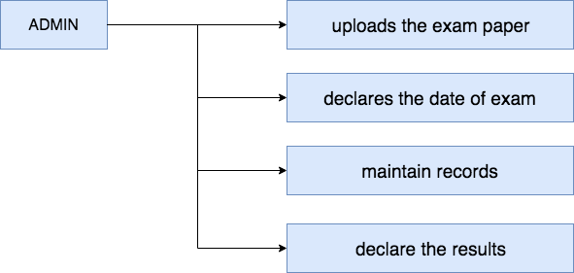

**FIG:5.7.1 (ADMIN INTERFACE DESIGN)**

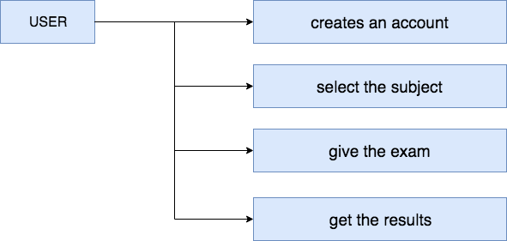

**FIG:5.7.2 (USER INTERFACE DESIGN)**

# CHAPTER 6

## 6.1 CODING

### 6.1.1 PSEUDO CODE

**HOME PAGE**

<?php

**include**("db.php");

**if**(**isset**($_POST["signup_1"])) {

$o1 = $_POST["up1"];

$o2 = $_POST["up2"];

$o3 = $_POST["up3"];

$o4 = $_POST["up4"];

$o5 = $_POST["up5"];

$o6 = $_POST["up6"];

$signup = "INSERT INTO users (Uid,Uname,Uemail,Lpwd,Gender,Address) VALUES ('**$o1**','**$o2**','**$o3**','**$o4**','**$o5**','**$o6**')";

**if**(**mysql_query**($signup)) {

$a=1;

} **else** {

$b=1;

}

}

**if**(**isset**($_POST["login_1"])){

**if**(!**empty**($_POST['in1']) && !**empty**($_POST['in2'])) {

$user=$_POST['in1'];

$pass=$_POST['in2'];

$signin=**mysql_query**("SELECT * FROM users WHERE Uemail='".$user."' AND Lpwd='".$pass."'");

$numrows=**mysql_num_rows**($signin);

**if**($numrows!=0)

{

**while**($row=**mysql_fetch_assoc**($signin))

{

$dbusername=$row['Uemail'];

$dbpassword=$row['Lpwd'];

}

**if**($user == $dbusername && $pass == $dbpassword)

{

// SESSION START

**session_start**();

$_SESSION['email_tmp']=$user;

**header**('location: home.php');

} **else** {

$c=1;

**echo** "Invalid username or password!"; } }

**else** {

$c=1;

**echo** "All fields are required!";

}

} }

?>

<!DOCTYPE html>

<html lang=**"en"**>

<head>

<meta charset=**"utf-8"**>

<meta name=**"viewport"** content=**"width=device-width, initial-scale=1, shrink-to-fit=no"**>

<meta http-equiv=**"x-ua-compatible"** content=**"ie=edge"**>

<title>**Online Examination System**</title>

<!-- Font Awesome -->

<link rel=**"stylesheet"** href=**"https://maxcdn.bootstrapcdn.com/font-awesome/4.7.0/css/font-awesome.min.css"**>

<!-- Bootstrap core CSS -->

<link href=**"css/bootstrap.min.css"** rel=**"stylesheet"**>

<!-- Material Design Bootstrap -->

<link href=**"css/mdb.min.css"** rel=**"stylesheet"**>

<!-- Your custom styles (optional) -->

<link href=**"css/style.css"** rel=**"stylesheet"**>

<style type=**"text/css"**>

**.dropdown:hover>.dropdown-menu {**

**display: block;**

**}**

</style>

<style type=**"text/css"**>

**html,**

**body,**

**header,**

**.carousel {**

**height: 70vh;**

**}**

**@media (max-width: 740px) {**

**html,**

**body,**

**header,**

**.carousel {**

**height: 100vh;**

**}**

**}**

**@media (min-width: 800px) and (max-width: 850px) {**

**html,**

**body,**

**header,**

**.carousel {**

**height: 100vh;**

**}**

**}**

**@media (min-width: 800px) and (max-width: 850px) {**

**.navbar:not(.top-nav-collapse) {**

**background: #929FBA!important;**

**}**

**}**

</style>

</head>

</head>

<body style=**"padding-right:0px !important;"**>

<!-- Navigation -->

<nav class=**"navbar navbar-expand-lg h6 text-white fixed-top scrolling-navbar"** id=**"mainNav"** style=**"font-family:Gill Sans MT"**>

<div class=**"container"**>

<a class=**"navbar-brand js-scroll-trigger"** href=**"#page-top"**><img class=**"img"** src=**"img/1.png"** width=**"150px"** height=**"50px"**></a>

<button class=**"navbar-toggler navbar-toggler-right text-uppercase bg-primary text-white rounded"** type=**"button"** data-toggle=**"collapse"** data-target=**"#navbarResponsive"** aria-controls=**"navbarResponsive"** aria-expanded=**"false"** aria-label=**"Toggle navigation"**>

**Menu**

<i class=**"fa fa-bars"**></i>

</button>

<div class=**"collapse navbar-collapse"** id=**"navbarResponsive"**>

<ul class=**"navbar-nav ml-auto"**>

<li class=**"nav-item dropdown"** style=**"margin: 0 0 0 30px;"**>

<a class=**"nav-link"** id=**"navbarDropdownMenuLink"** data-toggle=**"dropdown"** aria-haspopup=**"true"** aria-expanded=**"false"**><b>**Login**</b></a>

<div class=**"dropdown-menu dropdown-primary animated bounceIn"** aria-labelledby=**"navbarDropdownMenuLink"**>

<a class=**"dropdown-item"** data-toggle=**"modal"** data-target=**"#mss2"** >**Admin Login**</a>

<a class=**"dropdown-item"** data-toggle=**"modal"** data-target=**"#mss3"**>**Student Login**</a>

</div>

</li>

<li class=**"nav-item dropdown"** style=**"margin: 0 0 0 30px;"**>

<a class=**"nav-link"** id=**"navbarDropdownMenuLink"** data-toggle=**"dropdown"** aria-haspopup=**"true"** aria-expanded=**"false"**>**Exam Details**</a>

<div class=**"dropdown-menu dropdown-primary animated bounceIn"** aria-labelledby=**"navbarDropdownMenuLink"**>

<a class=**"dropdown-item"** href=**"subjects.html"**>**Subjects**</a>

<a class=**"dropdown-item"** href=**"instruction.html"**>**Instruction Page**</a>

<a class=**"dropdown-item"** href=**"books.html"**>**Book Details**</a>

</div>

</li>

<li class=**"nav-item dropdown"** style=**"margin: 0 0 0 30px;"**>

<a class=**"nav-link"** id=**"navbarDropdownMenuLink"** data-toggle=**"dropdown"** aria-haspopup=**"true"** aria-expanded=**"false"**>**History**</a>

<div class=**"dropdown-menu dropdown-primary animated bounceIn"** aria-labelledby=**"navbarDropdownMenuLink"**>

<a class=**"dropdown-item"** href=**"ourTeam.html"**>**Our Team**</a>

<a class=**"dropdown-item"** href=**"testimonials.html"**>**Testimonials**</a>

</div>

</li>

<li class=**"nav-item dropdown"** style=**"margin: 0 0 0 30px;"**>

<a class=**"nav-link"** id=**"navbarDropdownMenuLink"** data-toggle=**"dropdown"** aria-haspopup=**"true"** aria-expanded=**"false"**>**Feedback**</a>

<div class=**"dropdown-menu dropdown-primary animated bounceIn"** aria-labelledby=**"navbarDropdownMenuLink"**>

<a class=**"dropdown-item"** href=**"feedback.php"**>**Student Feedback**</a>

</div>

</li>

</ul>

</div>

</div>

</nav>

<!--/.Navbar-->

<!--Carousel Wrapper-->

<div id=**"carousel-example-1z"** class=**"carousel slide carousel-fade"** data-ride=**"carousel"**>

<!--Indicators-->

<ol class=**"carousel-indicators"**>

<li data-target=**"#carousel-example-1z"** data-slide-to=**"0"** class=**"active"**></li>

<li data-target=**"#carousel-example-1z"** data-slide-to=**"1"**></li>

<li data-target=**"#carousel-example-1z"** data-slide-to=**"2"**></li>

</ol>

<!--/.Indicators-->

<!--Slides-->

<div class=**"carousel-inner"** role=**"listbox"**>

<!--First slide-->

<div class=**"carousel-item active"**>

<div class=**"view"** style=**"background-image: url('https://mdbootstrap.com/img/Photos/Others/nature7.jpg'); background-repeat: no-repeat; background-size: cover;"**>

<!-- Mask & flexbox options-->

<div class=**"mask rgba-black-light d-flex justify-content-center align-items-center"**>

<!-- Content -->

<div class=**"text-center white-text mx-5 wow fadeIn"**>

<h1 class=**"mb-4"**>

<strong>**Welcome to Exam Scheduler**</strong>

</h1>

<p>

<strong>**Provides various certification courses online to level up the knowledge in the field of Computer Science**</strong>

</p>

<a target=**"_blank"** href=**"subjects.html"** class=**"btn btn-outline-white btn-lg"**>**Get Started!**

<i class=**"fa fa-graduation-cap ml-2"**></i>

</a>

</div>

<!-- Content -->

</div>

<!-- Mask & flexbox options-->

</div>

</div>

<!--/First slide-->

<!--Second slide-->

<div class=**"carousel-item"**>

<div class=**"view"** style=**"background-image: url('https://mdbootstrap.com/img/Photos/Others/images/77.jpg'); background-repeat: no-repeat; background-size: cover;"**>

<!-- Mask & flexbox options-->

<div class=**"mask rgba-black-light d-flex justify-content-center align-items-center"**>

<!-- Content -->

<div class=**"text-center white-text mx-5 wow fadeIn"**>

<h1 class=**"mb-4"**>

<strong>**Welcome to Exam Scheduler**</strong>

</h1>

<p>

<strong>**Provides various certification courses online to level up the knowledge in the field of Computer Science**</strong>

</p>

<a target=**"_blank"** href=**"https://mdbootstrap.com/bootstrap-tutorial/"** class=**"btn btn-outline-white btn-lg"**>**Get Started!**

<i class=**"fa fa-graduation-cap ml-2"**></i>

</a>

</div>

<!-- Content -->

</div>

<!-- Mask & flexbox options-->

</div>

</div>

<!--/Second slide-->

<!--Third slide-->

<div class=**"carousel-item"**>

<div class=**"view"** style=**"background-image: url('https://mdbootstrap.com/img/Photos/Others/images/47.jpg'); background-repeat: no-repeat; background-size: cover;"**>

<!-- Mask & flexbox options-->

<div class=**"mask rgba-black-light d-flex justify-content-center align-items-center"**>

<!-- Content -->

<div class=**"text-center white-text mx-5 wow fadeIn"**>

<h1 class=**"mb-4"**>

<strong>**Welcome to Exam Scheduler**</strong>

</h1>

<p>

<strong>**Provides various certification courses online to level up the knowledge in the field of Computer Science**</strong>

</p>

<a target=**"_blank"** href=**"https://mdbootstrap.com/bootstrap-tutorial/"** class=**"btn btn-outline-white btn-lg"**>**Get Started!**

<i class=**"fa fa-graduation-cap ml-2"**></i>

</a>

</div>

<!-- Content -->

</div>

<!-- Mask & flexbox options-->

</div>

</div>

<!--/Third slide-->

</div>

<!--/.Slides-->

<!--Controls-->

<a class=**"carousel-control-prev"** href=**"#carousel-example-1z"** role=**"button"** data-slide=**"prev"**>

<span class=**"carousel-control-prev-icon"** aria-hidden=**"true"**></span>

<span class=**"sr-only"**>**Previous**</span>

</a>

<a class=**"carousel-control-next"** href=**"#carousel-example-1z"** role=**"button"** data-slide=**"next"**>

<span class=**"carousel-control-next-icon"** aria-hidden=**"true"**></span>

<span class=**"sr-only"**>**Next**</span>

</a>

<!--/.Controls-->

</div>

<!--/.Carousel Wrapper-->

<hr>

<!--Card-->

<div class=**"row"**>

<div class=**"col-1"**>*&nbsp;*</div>

<div class=**"col-3"**>

<!--Card content-->

<div class=**"card-body blue-grey darken-1 white-text"**>

<!--Text-->

<div class=**"card-header"**><h3>**NewsFeed**</h3></div>

<p class=**"card-text white-text"**><marquee direction=**"down"** scrollamount=**"5"**>

<ul>

<li>**Next batch will start in june.**</li>

<li>**Results for PHP exam is out!login to see..**</li>

<li>**Java Exam date is rescheduled, further deatils will be mailed to the students personally on their accounts.**</li></marquee></p>

</div>

</div>

<!--panel-->

<div class=**"card-group container col-6"** >

<!--Panel-->

<div class=**"card"**>

<div class=**"card-body"**>

<h5 class=**"card-title h4"**>**Getting Started**</h5>

<p class=**"card-text"**>**Sign Up! if new this scheduler**</p>

</div>

<div class=**"card-footer"**><button type=**"button"** data-toggle=**"modal"** data-target=**"#mss"** class=**"btn btn-outline-dark waves-effect"**>**Register**</button></div>

</div>

<!--/.Panel-->

<!--Panel-->

<div class=**"card"**>

<div class=**"card-body"** style=**"padding-left:20px"**>

<h5 class=**"card-title h4"**>**Choose your subject**</h5>

<p class=**"card-text"**>**1. Java**<br>**2. PHP**<br>**3. Oracle**<br>**4. Python**<br>**5. IOT**<br>**6. Machine learning**</p>

</div>

<div class=**"card-footer d-flex justify-content-center"**><a type=**"button"** class=**"btn btn-outline-primary waves-effect"** href=**"subjects.html"**>**Proceed**</a></div>

</div>

<!--/.Panel-->

<!--Panel-->

<div class=**"card"**>

<div class=**"card-body"**>

<h5 class=**"card-title h4"**>**Feedback**</h5>

<p class=**"card-text"**>**Give us your feedback here**</p>

</div>

<div class=**"card-footer d-flex justify-content-center"**><a type=**"button"** class=**"btn btn-outline-secondary waves-effect"** href=**"feedback.php"**>**Feedback**</a></div>

</div>

</div></div>

<br>

<div class=**"card container"** style=**"position:relative;top:40px"**>

<div class=**"row"**>

<div class=**"comments col-md-9"** id=**"comments"**>

<h3 class=**"mb-2"**>**Comments**</h3>

<!-- comment -->

<div class=**"comment mb-2 row"**>

<div class=**"comment-avatar col-md-1 col-sm-2 text-center pr-1"**>

<a href=**""**><img class=**"mx-auto rounded-circle img-fluid"** src=**"http://demos.themes.guide/bodeo/assets/images/users/m103.jpg"** alt=**"avatar"**></a>

</div>

<div class=**"comment-content col-md-11 col-sm-10"**>

<h6 class=**"small comment-meta"**><a href=**"#"**>**admin**</a> **Today, 2:38**</h6>

<div class=**"comment-body"**>

<p>

**Lorem ipsum dolor sit amet, consectetur adipisicing elit, sed do eiusmod** <a href>**http://wwwwww.com**</a> **tempor incididunt ut labore et dolore magna aliqua. Ut enim ad minim veniam, quis nostrud exercitation ullamco laboris nisi ut aliquip ex ea commodo.**

<br>

<a href=**""** class=**"text-right small"**><i class=**"ion-reply"**></i> **Reply**</a>

</p>

</div>

</div>

<!-- reply is indented -->

<div class=**"comment-reply col-md-11 offset-md-1 col-sm-10 offset-sm-2"**>

<div class=**"row"**>

<div class=**"comment-avatar col-md-1 col-sm-2 text-center pr-1"**>

<a href=**""**><img class=**"mx-auto rounded-circle img-fluid"** src=**"http://demos.themes.guide/bodeo/assets/images/users/m101.jpg"** alt=**"avatar"**></a>

</div>

<div class=**"comment-content col-md-11 col-sm-10 col-12"**>

<h6 class=**"small comment-meta"**><a href=**"#"**>**phildownney**</a> **Today, 12:31**</h6>

<div class=**"comment-body"**>

<p>**Really?? Consectetur adipisicing elit, sed do eiusmod tempor incididunt ut labore et dolore magna aliqua. Ut enim ad minim veniam, quis nostrud exercitat.**

<br>

<a href=**""** class=**"text-right small"**><i class=**"ion-reply"**></i> **Reply**</a>

</p>

</div>

</div>

</div>

</div>

<!-- /reply is indented -->

</div>

<!-- /comment -->

<!-- comment -->

<div class=**"comment mb-2 row"**>

<div class=**"comment-avatar col-md-1 col-sm-2 text-center pr-1"**>

<a href=**""**><img class=**"mx-auto rounded-circle img-fluid"** src=**"http://demos.themes.guide/bodeo/assets/images/users/w102.jpg"** alt=**"avatar"**></a>

</div>

<div class=**"comment-content col-md-11 col-sm-10"**>

<h6 class=**"small comment-meta"**><a href=**"#"**>**maslarino**</a> **Yesterday, 5:03 PM**</h6>

<div class=**"comment-body"**>

<p>**Sit amet, consectetur adipisicing elit, sed do eiusmod tempor incididunt ut labore et dolore magna aliqua. Ut enim ad minim veniam, quis nostrud exercitation ullamco laboris nisi ut aliquip ex ea commodo.**

<br>

<a href=**""** class=**"text-right small"**><i class=**"ion-reply"**></i> **Reply**</a>

</p>

</div>

</div>

</div>

<!-- /comment -->

<div class=**"row pt-2"**>

<div class=**"col-12"**>

<a href=**""** class=**"btn btn-sm btn-primary"**>**Comment**</a>

</div>

</div>

</div>

</div>

</div>

<!--Modal: Login / Register Form-->

<div class=**"modal fade"** id=**"mss"** tabindex=**"-1"** role=**"dialog"** aria-labelledby=**"mss"** aria-hidden=**"true"**>

<div class=**"modal-dialog cascading-modal "** role=**"document"**>

<!--Content-->

<div class=**"modal-content"**>

<!--Modal cascading tabs-->

<div class=**"modal-c-tabs"**>

<!-- Nav tabs -->

<ul class=**"nav nav-tabs blue-gradient"** role=**"tablist"**>

<li class=**"nav-item active"**>

<a class=**"nav-link"** data-toggle=**"tab"** href=**"#panel8"** role=**"tab"**><i class=**"fa fa-user-plus mr-1"**></i> **Register**</a>

</li>

</ul>

<!-- Tab panels -->

<div class=**"tab-content"**>

<!--Panel 8-->

<div class=**"tab-pane fade show active"** id=**"panel8"** role=**"tabpanel"**>

<form method=**"post"**>

<!--Body-->

<div class=**"modal-body"**>

<div class=**"md-form form-sm mb-5"**>

<i class=**"fa fa-user prefix"** ></i>

<input type=**"text"** name=**"up1"** class=**"form-control form-control-sm validate"** required>

<label data-error=**"wrong"** data-success=**"right"** > **First Name**</label>

</div>

<div class=**"md-form form-sm mb-5"**>

<i class=**"fa fa-user prefix"** ></i>

<input type=**"text"** name=**"up2"** class=**"form-control form-control-sm validate"** required>

<label data-error=**"wrong"** data-success=**"right"** >**Last Name**</label>

</div>

<div class=**"md-form form-sm mb-5"**>

<i class=**"fa fa-envelope prefix"**></i>

<input type=**"email"** name=**"up3"** id=**"modalLRInput12"** class=**"form-control form-control-sm validate"** required>

<label data-error=**"wrong"** data-success=**"right"** for=**"modalLRInput12"**>**Your email**</label>

</div>

<div class=**"md-form form-sm mb-5"**>

<i class=**"fa fa-lock prefix"**></i>

<input type=**"password"** name=**"up4"** id=**"modalLRInput13"** class=**"form-control form-control-sm validate"** required>

<label data-error=**"wrong"** data-success=**"right"** for=**"modalLRInput13"**>**Your password**</label>

</div>

<div class=**"md-form form-sm mb-5"**>

<i class=**"fa fa-user prefix"** ></i>

<input type=**"text"** name=**"up5"** id=**"modalLRInput14"** class=**"form-control form-control-sm validate"** required>

<label data-error=**"wrong"** data-success=**"right"** for=**"modalLRInput14"**>**Gender**</label>

</div>

<div class=**"md-form form-sm mb-5"**>

<i class=**"fa fa-address-book prefix"** ></i>

<input type=**"text"** name=**"up6"** id=**"modalLRInput14"** class=**"form-control form-control-sm validate"** required>

<label data-error=**"wrong"** data-success=**"right"** for=**"modalLRInput14"**>**Address**</label>

</div>

<div class=**"text-center form-sm mt-2"**>

<button class=**"btn btn-info"** name=**"signup_1"**>**Sign up** <i class=**"fa fa-sign-in ml-1"**></i></button>

</div>

</div>

<!--Footer-->

<div class=**"modal-footer"**>

<div class=**"options text-right"**>

<p class=**"pt-1"**>**Already have an account?** <a data-toggle=**"tab"** href=**"#panel"** role=**"tab"** class=**"blue-text"**>**Log In**</a></p>

</div>

<button type=**"button"** class=**"btn btn-outline-info waves-effect ml-auto"** data-dismiss=**"modal"**>**Close**</button>

</div></form>

</div>

<!--/.Panel 8-->

</div>

</div>

</div>

<!--/.Content-->

</div>

</div>

<!--Modal: Login / Register Form-->

<!--Modal: Login / Register Form-->

<div class=**"modal fade"** id=**"mss2"** tabindex=**"-1"** role=**"dialog"** aria-labelledby=**"mss2"** aria-hidden=**"true"**>

<div class=**"modal-dialog cascading-modal"** role=**"document"**>

<!--Content-->

<div class=**"modal-content"**>

<!--Modal cascading tabs-->

<div class=**"modal-c-tabs"**>

<!-- Nav tabs -->

<ul class=**"nav nav-tabs tabs-2 light-blue darken-3"** role=**"tablist"**>

<li class=**"nav-item"**>

<a class=**"nav-link active"** data-toggle=**"tab"** href=**"#panel7"** role=**"tab"**><i class=**"fa fa-user mr-1"**></i>**Admin Login**</a>

</li>

</ul>

<!-- Tab panels -->

<div class=**"tab-content"**>

<!--Panel 7-->

<div class=**"tab-pane fade in show active"** id=**"panel7"** role=**"tabpanel"**>

<!--Body-->

<div class=**"modal-body mb-1"**>

<div class=**"md-form form-sm mb-5"**>

<i class=**"fa fa-envelope prefix"**></i>

<input type=**"email"** id=**"modalLRInput10"** class=**"form-control form-control-sm validate"**>

<label data-error=**"wrong"** data-success=**"right"** for=**"modalLRInput10"**>**Your email**</label>

</div>

<div class=**"md-form form-sm mb-4"**>

<i class=**"fa fa-lock prefix"**></i>

<input type=**"password"** id=**"modalLRInput11"** class=**"form-control form-control-sm validate"**>

<label data-error=**"wrong"** data-success=**"right"** for=**"modalLRInput11"**>**Your password**</label>

</div>

<div class=**"text-center mt-2"**>

<button class=**"btn btn-info"**>**Log in** <i class=**"fa fa-sign-in ml-1"**></i></button>

</div>

</div>

<!--Footer-->

<div class=**"modal-footer"**>

<div class=**"options text-center text-md-right mt-1"**>

<p>**Not a member?** <a href=**"#"** class=**"blue-text"**>**Sign Up**</a></p>

<p>**Forgot** <a href=**"#"** class=**"blue-text"**>**Password?**</a></p>

</div>

<button type=**"button"** class=**"btn btn-outline-info waves-effect ml-auto"** data-dismiss=**"modal"**>**Close**</button>

</div>

</div>

<!--/.Panel 7-->

<!--Panel 8-->

<div class=**"tab-pane fade"** id=**"panel8"** role=**"tabpanel"**>

<!--Body-->

<div class=**"modal-body"**>

<div class=**"md-form form-sm mb-5"**>

<i class=**"fa fa-envelope prefix"**></i>

<input type=**"email"** id=**"modalLRInput12"** class=**"form-control form-control-sm validate"**>

<label data-error=**"wrong"** data-success=**"right"** for=**"modalLRInput12"**>**Your email**</label>

</div>

<div class=**"md-form form-sm mb-5"**>

<i class=**"fa fa-lock prefix"**></i>

<input type=**"password"** id=**"modalLRInput13"** class=**"form-control form-control-sm validate"**>

<label data-error=**"wrong"** data-success=**"right"** for=**"modalLRInput13"**>**Your password**</label>

</div>

<div class=**"md-form form-sm mb-4"**>

<i class=**"fa fa-lock prefix"**></i>

<input type=**"password"** id=**"modalLRInput14"** class=**"form-control form-control-sm validate"**>

<label data-error=**"wrong"** data-success=**"right"** for=**"modalLRInput14"**>**Repeat password**</label>

</div>

<div class=**"text-center form-sm mt-2"**>

<button class=**"btn btn-info"**>**Sign up** <i class=**"fa fa-sign-in ml-1"**></i></button>

</div>

</div>

<!--Footer-->

<div class=**"modal-footer"**>

<div class=**"options text-right"**>

<p class=**"pt-1"**>**Already have an account?** <a href=**"#"** class=**"blue-text"**>**Log In**</a></p>

</div>

<button type=**"button"** class=**"btn btn-outline-info waves-effect ml-auto"** data-dismiss=**"modal"**>**Close**</button>

</div>

</div>

<!--/.Panel 8-->

</div>

</div>

</div>

<!--/.Content-->

</div>

</div>

<!--Modal: Login / Register Form-->

<div class=**"modal fade"** id=**"mss3"** tabindex=**"-1"** role=**"dialog"** aria-labelledby=**"mss3"** aria-hidden=**"true"**>

<div class=**"modal-dialog cascading-modal "** role=**"document"**>

<!--Content-->

<div class=**"modal-content"**>

<!--Modal cascading tabs-->

<div class=**"modal-c-tabs"**>

<!-- Nav tabs -->

<ul class=**"nav nav-tabs tabs-2 blue-gradient"** role=**"tablist"**>

<li class=**"nav-item"**>

<a class=**"nav-link active"** data-toggle=**"tab"** href=**"#panel9"** role=**"tab"**><i class=**"fa fa-user mr-1"**></i> **Login**</a>

</li>

<li class=**"nav-item"**>

<a class=**"nav-link"** data-toggle=**"tab"** href=**"#panel10"** role=**"tab"**><i class=**"fa fa-user-plus mr-1"**></i> **Register**</a>

</li>

</ul>

<!-- Tab panels -->

<div class=**"tab-content"**>

<!--Panel 9-->

<div class=**"tab-pane fade in show active"** id=**"panel9"** role=**"tabpanel"**>

<form method=**"post"** data-ajax=**"false"**>

<!--Body-->

<div class=**"modal-body mb-1"**>

<div class=**"md-form form-sm mb-5"**>

<i class=**"fa fa-envelope prefix"**></i>

<input type=**"email"** class=**"form-control form-control-sm"** name=**"in1"** required>

<label data-error=**"wrong"** data-success=**"right"**>**Your email / Username**</label>

</div>

<div class=**"md-form form-sm mb-4"**>

<i class=**"fa fa-lock prefix"**></i>

<input type=**"password"** id=**"modalLRInput11"** class=**"form-control form-control-sm validate"** name=**"in2"** required>

<label data-error=**"wrong"** data-success=**"right"** for=**"modalLRInput11"**>**Your password**</label>

</div>

<div class=**"text-center mt-2"**>

<button class=**"btn btn-info"** name=**"login_1"**>**Log in** <i class=**"fa fa-sign-in ml-1"**></i></button>

</div>

</div>

<!--Footer-->

<div class=**"modal-footer"**>

<div class=**"options text-center text-md-right mt-1"**>

<p>**Not a member?** <a data-toggle=**"tab"** href=**"#panel10"** role=**"tab"** class=**"blue-text"**>**Sign Up**</a></p>

</div>

<button type=**"button"** class=**"btn btn-outline-info waves-effect ml-auto"** data-dismiss=**"modal"**>**Close**</button>

</div>

</div></form>

<!--/.Panel 9-->

<!--Panel 10-->

<div class=**"tab-pane fade"** id=**"panel10"** role=**"tabpanel"**>

<form method=**"post"**>

<!--Body-->

<div class=**"modal-body"**>

<div class=**"md-form form-sm mb-5"**>

<i class=**"fa fa-user prefix"** ></i>

<input type=**"text"** name=**"up1"** class=**"form-control form-control-sm validate"** required>

<label data-error=**"wrong"** data-success=**"right"** > **First Name**</label>

</div>

<div class=**"md-form form-sm mb-5"**>

<i class=**"fa fa-user prefix"** ></i>

<input type=**"text"** name=**"up2"** class=**"form-control form-control-sm validate"** required>

<label data-error=**"wrong"** data-success=**"right"** >**Last Name**</label>

</div>

<div class=**"md-form form-sm mb-5"**>

<i class=**"fa fa-envelope prefix"**></i>

<input type=**"email"** name=**"up3"** id=**"modalLRInput12"** class=**"form-control form-control-sm validate"** required>

<label data-error=**"wrong"** data-success=**"right"** for=**"modalLRInput12"**>**Your email**</label>

</div>

<div class=**"md-form form-sm mb-5"**>

<i class=**"fa fa-lock prefix"**></i>

<input type=**"password"** name=**"up4"** id=**"modalLRInput13"** class=**"form-control form-control-sm validate"** required>

<label data-error=**"wrong"** data-success=**"right"** for=**"modalLRInput13"**>**Your password**</label>

</div>

<div class=**"md-form form-sm mb-5"**>

<i class=**"fa fa-user prefix"** ></i>

<input type=**"text"** name=**"up5"** id=**"modalLRInput14"** class=**"form-control form-control-sm validate"** required>

<label data-error=**"wrong"** data-success=**"right"** for=**"modalLRInput14"**>**Gender**</label>

</div>

<div class=**"md-form form-sm mb-5"**>

<i class=**"fa fa-address-book prefix"** ></i>

<input type=**"text"** name=**"up6"** id=**"modalLRInput14"** class=**"form-control form-control-sm validate"** required>

<label data-error=**"wrong"** data-success=**"right"** for=**"modalLRInput14"**>**Address**</label>

</div>

<div class=**"text-center form-sm mt-2"**>

<button class=**"btn btn-info"** name=**"signup_1"**>**Sign up** <i class=**"fa fa-sign-in ml-1"**></i></button>

</div>

</div>

<!--Footer-->

<div class=**"modal-footer"**>

<div class=**"options text-right"**>

<p class=**"pt-1"**>**Already have an account?** <a data-toggle=**"tab"** href=**"#panel"** role=**"tab"** class=**"blue-text"**>**Log In**</a></p>

</div>

<button type=**"button"** class=**"btn btn-outline-info waves-effect ml-auto"** data-dismiss=**"modal"**>**Close**</button>

</div></form>

</div>

<!--/.Panel 10-->

</div>

</div>

</div>

<!--/.Content-->

</div>

</div>

<!--Modal: Login / Register Form-->

</div>

</div><br><br><br>

<!--Footer-->

<footer class=**"page-footer font-small stylish-color-dark pt-4 mt-4"**>

<!--Footer Links-->

<div class=**"container text-center text-md-left"**>

<div class=**"row"**>

<!--First column-->

<div class=**"col-md-4"**>

<img class=**"img"** src=**"img/1.png"** width=**"180px"** height=**"60px"**><br><hr>

<h5 class=**"text-uppercase mb-4 mt-3 font-weight-bold"**>**Online examination Portal**</h5>

<p>**This portal provides expertised certficiation courses for various programming languages in order to increase knowledge level.**</p>

</div>

<!--/.First column-->

<hr class=**"clearfix w-100 d-md-none"**>

<hr class=**"clearfix w-100 d-md-none"**>

<!--Fourth column-->

<div class=**"col-md-2 mx-auto"**>

<h5 class=**"text-uppercase mb-4 mt-3 font-weight-bold"**>**Links**</h5>

<ul class=**"list-unstyled"**>

<li>

<a href=**"subjects.html"**>**Subjects**</a><br><br>

</li>

<li>

<a href=**"testimonials.html"**>**Testimonials**</a><br><br>

</li>

<li>

<a href=**"instruction.html"**>**Instructions**</a><br><br>

</li>

<li>

<a href=**"ourteam.html"**>**Our Team**</a><br><br>

</li>

<li>

<a href=**"books.html"**>**Book Details**</a><br><br>

</li>

</ul>

</div>

<!--/.Fourth column-->

</div>

</div>

<!--/.Footer Links-->

<hr>

<!--Call to action-->

<div class=**"text-center py-3"**>

<ul class=**"list-unstyled list-inline mb-0"**>

<li class=**"list-inline-item"**>

<a href=**"#!"** class=**"btn btn-danger btn-rounded"** data-toggle=**"modal"** data-target=**"#mss"**>**Sign up!**</a>

</li>

</ul>

</div>

<!--/.Call to action-->

<hr>

<!--Social buttons-->

<div class=**"text-center footer-copyright py-3"**>

<ul class=**"list-unstyled list-inline"**>

<li class=**"list-inline-item"**>

<a class=**"btn-floating btn-sm btn-fb mx-1"**>

<i class=**"fa fa-facebook"**></i>

</a>

</li>

<li class=**"list-inline-item"**>

<a class=**"btn-floating btn-sm btn-tw mx-1"**>

<i class=**"fa fa-twitter"**></i>

</a>

</li>

<li class=**"list-inline-item"**>

<a class=**"btn-floating btn-sm btn-gplus mx-1"**>

<i class=**"fa fa-google-plus"**></i>

</a>

</li>

<li class=**"list-inline-item"**>

<a class=**"btn-floating btn-sm btn-li mx-1"**>

<i class=**"fa fa-linkedin"**></i>

</a>

</li>

<li class=**"list-inline-item"**>

<a class=**"btn-floating btn-sm btn-dribbble mx-1"**>

<i class=**"fa fa-dribbble"**></i>

</a>

</li>

</ul>

</div>

<!--/.Social buttons-->

</footer>

<!--/.Footer-->

<!-- /Start your project here-->

<!-- SCRIPTS -->

<!-- JQuery -->

<script type=**"text/javascript"** src=**"js/jquery-3.2.1.min.js"**></script>

<script src=**"js/slider.js"**></script>

<!-- Bootstrap tooltips -->

<script type=**"text/javascript"** src=**"js/popper.min.js"**></script>

<!-- Bootstrap core JavaScript -->

<script type=**"text/javascript"** src=**"js/bootstrap.min.js"**></script>

<!-- MDB core JavaScript -->

<script type=**"text/javascript"** src=**"js/mdb.min.js"**></script>

<script type=**"text/javascript"**>

$**(*function*()** **{**

$**(**'marquee'**).**mouseover**(*function*()** **{**

$**(*this*).**attr**(**'scrollamount'**,**0**);**

**}).**mouseout**(*function*()** **{**

$**(*this*).**attr**(**'scrollamount'**,**5**);**

**});**

**});**

</script>

<?php

**if**(**isset**($a)) { ?>

<script type=**"text/javascript"**> toastr.success**(**'Succussfully Signed Up!'**);** </script><?php }

**if**(**isset**($b)) {?>

<script type=**"text/javascript"**> toastr.error**(**'Sorry! Failed to Sign Up'**);** </script><?php }

**if**(**isset**($c)) {?>

<script type=**"text/javascript"**> toastr.error**(**'Invalid Username/Password'**);** <?php } ?>

</script>

</body>

</html>

**USER WELCOME PAGE**

<?php

**include**("db.php");

**session_start**();

$Uemail = $_SESSION['email_tmp'];

$sdata = "SELECT * FROM users WHERE Uemail='**$Uemail**'";

$gdata = **mysql_query**($sdata);

$row = **mysql_fetch_assoc**($gdata);

$fname = $row["Uid"];

$lname = $row["Uname"];

$email = $row["Uemail"];

?>

<!DOCTYPE html>

<html lang=**"en"**>

<head>

<meta charset=**"utf-8"**>

<meta name=**"viewport"** content=**"width=device-width, initial-scale=1, shrink-to-fit=no"**>

<meta http-equiv=**"x-ua-compatible"** content=**"ie=edge"**>

<title>**Online Examination System**</title>

<!-- Font Awesome -->

<link rel=**"stylesheet"** href=**"https://maxcdn.bootstrapcdn.com/font-awesome/4.7.0/css/font-awesome.min.css"**>

<!-- Bootstrap core CSS -->

<link href=**"css/bootstrap.min.css"** rel=**"stylesheet"**>

<!-- Material Design Bootstrap -->

<link href=**"css/mdb.min.css"** rel=**"stylesheet"**>

<!-- Your custom styles (optional) -->

<link href=**"css/style.css"** rel=**"stylesheet"**>

<style type=**"text/css"**>

**.dropdown:hover>.dropdown-menu {**

**display: block;**

**}**

</style>

<style type=**"text/css"**>

**html,**

**body,**

**header,**

**.carousel {**

**height: 70vh;**

**}**

**@media (max-width: 740px) {**

**html,**

**body,**

**header,**

**.carousel {**

**height: 100vh;**

**}**

**}**

**@media (min-width: 800px) and (max-width: 850px) {**

**html,**

**body,**

**header,**

**.carousel {**

**height: 100vh;**

**}**

**}**

**@media (min-width: 800px) and (max-width: 850px) {**

**.navbar:not(.top-nav-collapse) {**

**background: #929FBA!important;**

**}**

**}**

</style>

</head>

<!-- Social Share Kit CSS -->

<link rel=**"stylesheet"** href=**"css/social-share-kit.css"** type=**"text/css"**>

</head>

<body style=**"padding-right:0px !important;background-image: url(https://barbarashdwallpapers.com/wp-content/uploads/2015/07/Light-pink-wallpaper-with-flowers.jpg);"**>

<!-- Navigation -->

<nav class=**"navbar navbar-expand-lg h6 text-white sticky-top scrolling-navbar"** id=**"mainNav"** style=**"font-family:Gill Sans MT"**>

<div class=**"container"**>

<a class=**"navbar-brand js-scroll-trigger"** href=**"#page-top"**><img class=**"img"** src=**"img/1.png"** width=**"150px"** height=**"50px"**></a>

<button class=**"navbar-toggler navbar-toggler-right text-uppercase bg-primary text-white rounded"** type=**"button"** data-toggle=**"collapse"** data-target=**"#navbarResponsive"** aria-controls=**"navbarResponsive"** aria-expanded=**"false"** aria-label=**"Toggle navigation"**>

**Menu**

<i class=**"fa fa-bars"**></i>

</button>

<div class=**"collapse navbar-collapse"** id=**"navbarResponsive"**>

<ul class=**"navbar-nav ml-auto"**>

<li class=**"nav-item dropdown"** style=**"margin: 0 0 0 30px;"**>

<a class=**"nav-link"** id=**"navbarDropdownMenuLink"** data-toggle=**"dropdown"** aria-haspopup=**"true"** aria-expanded=**"false"**><b>**Login**</b></a>

<div class=**"dropdown-menu dropdown-primary animated bounceIn"** aria-labelledby=**"navbarDropdownMenuLink"**>

<a class=**"dropdown-item"** data-toggle=**"modal"** data-target=**"#mss2"** >**Admin Login**</a>

<a class=**"dropdown-item"** data-toggle=**"modal"** data-target=**"#mss3"**>**Student Login**</a>

</div>

</li>

<li class=**"nav-item dropdown"** style=**"margin: 0 0 0 30px;"**>

<a class=**"nav-link"** id=**"navbarDropdownMenuLink"** data-toggle=**"dropdown"** aria-haspopup=**"true"** aria-expanded=**"false"**>**Exam Details**</a>

<div class=**"dropdown-menu dropdown-primary animated bounceIn"** aria-labelledby=**"navbarDropdownMenuLink"**>

<a class=**"dropdown-item"** href=**"subjects.html"**>**Subjects**</a>

<a class=**"dropdown-item"** href=**"instruction.html"**>**Instruction Page**</a>

<a class=**"dropdown-item"** href=**"books.html"**>**Book Details**</a>

</div>

</li>

<li class=**"nav-item dropdown"** style=**"margin: 0 0 0 30px;"**>

<a class=**"nav-link"** id=**"navbarDropdownMenuLink"** data-toggle=**"dropdown"** aria-haspopup=**"true"** aria-expanded=**"false"**>**History**</a>

<div class=**"dropdown-menu dropdown-primary animated bounceIn"** aria-labelledby=**"navbarDropdownMenuLink"**>

<a class=**"dropdown-item"** href=**"ourTeam.html"**>**Our Team**</a>

<a class=**"dropdown-item"** href=**"testimonials.html"**>**Testimonials**</a>

</div>

</li>

<li class=**"nav-item dropdown"** style=**"margin: 0 0 0 30px;"**>

<a class=**"nav-link"** id=**"navbarDropdownMenuLink"** data-toggle=**"dropdown"** aria-haspopup=**"true"** aria-expanded=**"false"**>**Feedback**</a>

<div class=**"dropdown-menu dropdown-primary animated bounceIn"** aria-labelledby=**"navbarDropdownMenuLink"**>

<a class=**"dropdown-item"** href=**"feedback.php"**>**Student Feedback**</a>

</div>

</li>

</ul>

</div>

</div>

</nav>

<!--/.Navbar-->

<!-- Content -->

<!--Jumbotron-->

<div class=**"text-center "**>

<!--Title-->

<h1 class=**"card-title h1-responsive font-bold mt-3"**><strong>**Welcome,** <?php **echo** $fname;?><?php **echo** $lname; ?> **To Online Scheduler**</strong></h1>

<!--Subtitle-->

<p class=**"pt-2 font-bold indigo-text"**><strong><?php **echo** $email; ?></strong></p>

<!--Text-->

<div class=**"d-flex justify-content-center"**>

<p class=**"card-text my-3"** style=**"max-width: 43rem;"**><b> **This Online Scheduler heartly welcome's you! hope you find our service convinent...Begin your test!**

</b></p>

</div>

<hr class=**"my-4 pb-2"**>

**;**

<a href=**"test.php"** class=**"btn peach-gradient btn-rounded"**><strong>**Start Test**<i class=**"fa fa-diamond ml-1"**></i><strong></a>

<a href=**"results.php"** class=**"btn purple-gradient btn-rounded"**><strong>**Test Results**<i class=**"fa fa-download ml-1"**></i><strong></a>

</div>

<!--Jumbotron-->

<!--./Content -->

<!--Footer-->

<footer class=**"page-footer font-small stylish-color-dark pt-4 mt-4"**>

<!--Footer Links-->

<div class=**"container text-center text-md-left"**>

<div class=**"row"**>

<!--First column-->

<div class=**"col-md-4"**>

<img class=**"img"** src=**"img/1.png"** width=**"180px"** height=**"60px"**><br><hr>

<h5 class=**"text-uppercase mb-4 mt-3 font-weight-bold"**>**Online examination Portal**</h5>

<p>**This portal provides expertised certficiation courses for various programming languages in order to increase knowledge level.**</p>

</div>

<!--/.First column-->

<hr class=**"clearfix w-100 d-md-none"**>

<hr class=**"clearfix w-100 d-md-none"**>

<!--Fourth column-->

<div class=**"col-md-2 mx-auto"**>

<h5 class=**"text-uppercase mb-4 mt-3 font-weight-bold"**>**Links**</h5>

<ul class=**"list-unstyled"**>

<li>

<a href=**"subjects.html"**>**Subjects**</a><br><br>

</li>

<li>

<a href=**"testimonials.html"**>**Testimonials**</a><br><br>

</li>

<li>

<a href=**"instruction.html"**>**Instructions**</a><br><br>

</li>

<li>

<a href=**"ourteam.html"**>**Our Team**</a><br><br>

</li>

<li>

<a href=**"books.html"**>**Book Details**</a><br><br>

</li>

</ul>

</div>

<!--/.Fourth column-->

</div>

</div>

<!--/.Footer Links-->

<hr>

<!--Social buttons-->

<div class=**"text-center footer-copyright py-3"**>

<ul class=**"list-unstyled list-inline"**>

<li class=**"list-inline-item"**>

<a class=**"btn-floating btn-sm btn-fb mx-1"**>

<i class=**"fa fa-facebook"**></i>

</a>

</li>

<li class=**"list-inline-item"**>

<a class=**"btn-floating btn-sm btn-tw mx-1"**>

<i class=**"fa fa-twitter"**></i>

</a>

</li>

<li class=**"list-inline-item"**>

<a class=**"btn-floating btn-sm btn-gplus mx-1"**>

<i class=**"fa fa-google-plus"**></i>

</a>

</li>

<li class=**"list-inline-item"**>

<a class=**"btn-floating btn-sm btn-li mx-1"**>

<i class=**"fa fa-linkedin"**></i>

</a>

</li>

<li class=**"list-inline-item"**>

<a class=**"btn-floating btn-sm btn-dribbble mx-1"**>

<i class=**"fa fa-dribbble"**></i>

</a>

</li>

</ul>

</div>

<!--/.Social buttons-->

</footer>

<!--/.Footer-->

<!-- /Start your project here-->

<!-- SCRIPTS -->

<!-- JQuery -->

<script type=**"text/javascript"** src=**"js/jquery-3.2.1.min.js"**></script>

<script src=**"js/slider.js"**></script>

<!-- Bootstrap tooltips -->

<script type=**"text/javascript"** src=**"js/popper.min.js"**></script>

<!-- Bootstrap core JavaScript -->

<script type=**"text/javascript"** src=**"js/bootstrap.min.js"**></script>

<!-- MDB core JavaScript -->

<script type=**"text/javascript"** src=**"js/mdb.min.js"**></script>

<script type=**"text/javascript"**>

$**(*function*()** **{**

$**(**'marquee'**).**mouseover**(*function*()** **{**

$**(*this*).**attr**(**'scrollamount'**,**0**);**

**}).**mouseout**(*function*()** **{**

$**(*this*).**attr**(**'scrollamount'**,**5**);**

**});**

**});**

</script>

</body>

</html>

**DATABASE CODING**

<?php

$conn = **mysql_connect**('localhost','root',''); //server name, user_name, password

$database = **mysql_select_db**('os');

**if** (!$conn) {

**die**("Connection failed: " . mysql_connect_error());

}

?>

**FEEDBACK PAGE:**

<?php

**include**("db.php");

**if**(**isset**($_POST["send"])) {

$aa = $_POST["a1"];

$bb = $_POST["a2"];

$cc = $_POST["a3"];

$send = "INSERT INTO feedback (uname,uemail,msg) VALUES ('**$aa**','**$bb**','**$cc**')";

$result = **mysql_query**($send);

**if**(!$result) {

**echo**"Failed!";

}

}

?>

<!DOCTYPE html>

<html lang=**"en"**>

<head>

<meta charset=**"utf-8"**>

<meta name=**"viewport"** content=**"width=device-width, initial-scale=1, shrink-to-fit=no"**>

<meta http-equiv=**"x-ua-compatible"** content=**"ie=edge"**>

<title>**Material Design Bootstrap**</title>

<!-- Font Awesome -->

<link rel=**"stylesheet"** href=**"https://maxcdn.bootstrapcdn.com/font-awesome/4.6.0/css/font-awesome.min.css"**>

<!-- Bootstrap core CSS -->

<link href=**"css/bootstrap.min.css"** rel=**"stylesheet"**>

<!-- Material Design Bootstrap -->

<link href=**"css/mdb.min.css"** rel=**"stylesheet"**>

<!-- Your custom styles (optional) -->

<link href=**"css/style.css"** rel=**"stylesheet"**>

<link href=**"css/feedback.css"** rel=**"stylesheet"**>

<style type=**"text/css"**>

**.dropdown:hover>.dropdown-menu {**

**display: block;**

**}**

</style>

</head>

<body>

<header data-spy=**"scroll"**>

<nav class=**"navbar fixed-top navber"** id=**"mainNav"** style=**"font-family:Gill Sans MT"**>

<div class=**""**>

<!--<a class="navbar-brand js-scroll-trigger" href="#page-top"><img class="img" src="img/1.png" width="180px" height="60px"></a>-->

<a href=**"#"** data-activates=**"slide-out"** class=**"button-collapse text-white"**><i class=**"fa fa-bars fa-2x"**></i></a>

<div class=**"collapse navbar-collapse"** id=**"navbarResponsive"**>

</div>

</div>

</nav>

<!-- Full Page Intro -->

<div class=**"view"** style=**"background-image: url('https://mdbootstrap.com/img/Photos/Others/images/89.jpg'); background-repeat: no-repeat; background-size: cover; background-position: center center;"**>

<!-- Mask & flexbox options-->

<div class=**"mask rgba-indigo-strong d-flex justify-content-center align-items-center"**>

<!-- Content -->

<div class=**"container"**>

<br><br><br>

<!--Grid row-->

<div class=**"row pt-lg-5 mt-lg-5"**>

<!--Grid column-->

<div class=**"col-md-6 mb-5 mt-md-0 mt-5 white-text text-center text-md-left animated wow fadeInLeft"** data-wow-delay=**"0.3s"**>

<h4 class=**"display-3 font-weight-bold"**>**STUDENT FEEDBACK**</h4>

<hr class=**"hr-light"**>

<h6 class=**"mb-3"**>**If you find any drawback of this website or any difficulty regarding any subject or details of the same, do write us we will look forward to it and resolve it.** </h6>

</div>

<!--Grid column-->

<!--Grid column-->

<div class=**"col-md-6 col-xl-5 mb-4"**>

<!--Form-->

<div class=**"card animated wow fadeInRight"** data-wow-delay=**"0.3s"**>

<div class=**"card-body z-depth-2"**>

<!--Header-->

<div class=**"text-center"**>

<h3 class=**"dark-grey-text"**>

<strong>**Write to us:**</strong>

</h3>

<hr>

</div>

<!--Body--><form method=**"post"**>

<div class=**"md-form"**>

<i class=**"fa fa-user prefix grey-text"**></i>

<input type=**"text"** id=**"form3"** class=**"form-control"** name=**"a1"** required>

<label for=**"form3"**>**Your name**</label>

</div>

<div class=**"md-form"**>

<i class=**"fa fa-envelope prefix grey-text"**></i>

<input type=**"text"** id=**"form2"** class=**"form-control"** name=**"a2"** required>

<label for=**"form2"**>**Your email**</label>

</div>

<!--Textarea with icon prefix-->

<div class=**"md-form"**>

<i class=**"fa fa-pencil prefix grey-text"**></i>

<textarea type=**"text"** id=**"form8"** class=**"md-textarea form-control"** rows=**"3"** name=**"a3"**></textarea>

<label for=**"form8"** >**Your message**</label>

</div>

<div class=**"text-center mt-3"**>

<button class=**"btn btn-indigo"** name=**"send"**>**Send**</button></form>

</div>

</div>

</div>

<!--/.Form-->

</div>

<!--Grid column-->

</div>

<!--Grid row-->

</div>

<!-- Content -->

</div>

<!-- Mask & flexbox options-->

</div>

<!-- Full Page Intro -->

<!-- Sidebar navigation -->

<div id=**"slide-out"** class=**"side-nav side-nav-dark fixed"**>

<ul class=**"custom-scrollbar"**>

<!-- Logo -->

<li>

<div class=**"logo-wrapper waves-light"**>

<a href=**"#"**><img src=**"img/1.png"** class=**"img-fluid flex-center"**></a>

</div>

</li>

<!--/. Logo -->

<!--Social-->

<li>

<ul class=**"social"**>

<li><a href=**"#"** class=**"icons-sm fb-ic"**><i class=**"fa fa-facebook"**></i></a></li>

<li><a href=**"#"** class=**"icons-sm pin-ic"**><i class=**"fa fa-pinterest"**></i></a></li>

<li><a href=**"#"** class=**"icons-sm gplus-ic"**><i class=**"fa fa-google-plus"**></i></a></li>

<li><a href=**"#"** class=**"icons-sm tw-ic"**><i class=**"fa fa-twitter"**></i></a></li>

</ul>

</li>

<!--/Social-->

<!--Search Form-->

<li>

<form class=**"search-form"** role=**"search"**>

<div class=**"form-group md-form mt-0 pt-1 waves-light"**>

<input type=**"text"** class=**"form-control"** placeholder=**"Search"**>

</div>

</form>

</li>

<!--/.Search Form-->

<!-- Side navigation links -->

<li>

<ul class=**"collapsible collapsible-accordion"**>

<li><a class=**"collapsible-header waves-effect arrow-r"** href=**"index.php"**><i class=**"fa fa-home"** aria-hidden=**"true"**></i>**Home**</a>

<li><a class=**"collapsible-header waves-effect arrow-r"**><i class=**"fa fa-chevron-right"**></i>**Login**<i class=**"fa fa-angle-down rotate-icon"**></i></a>

<div class=**"collapsible-body"**>

<ul>

<li><a class=**"waves-effect"** data-toggle=**"modal"** data-target=**"#mss2"**>**Admin Login**</a>

</li>

<li><a class=**"waves-effect"** data-toggle=**"modal"** data-target=**"#mss3"**>**Student Login**</a>

</li>

</ul>

</div>

</li>

<li><a class=**"collapsible-header waves-effect arrow-r"**><i class=**"fa fa-hand-pointer-o"**></i>**Exam Details**<i class=**"fa fa-angle-down rotate-icon"**></i></a>

<div class=**"collapsible-body"**>

<ul>

<li><a href=**"subjects.html"** class=**"waves-effect"**>**Subjects**</a>

</li>

<li><a href=**"instruction.html"** class=**"waves-effect"**>**Instruction Page**</a>

</li>

<li><a href=**"books.html"** class=**"waves-effect"**>**Book Details**</a>

</li>

</ul>

</div>

</li>

<li><a class=**"collapsible-header waves-effect arrow-r"**><i class=**"fa fa-eye"**></i> **History**<i class=**"fa fa-angle-down rotate-icon"**></i></a>

<div class=**"collapsible-body"**>

<ul>

<li><a href=**"ourTeam.html"** class=**"waves-effect"**>**Our Team**</a>

</li>

<li><a href=**"testiimonials.html"** class=**"waves-effect"**>**Testimonials**</a>

</li>

</ul>

</div>

</li>

<li><a class=**"collapsible-header waves-effect arrow-r"**><i class=**"fa fa-envelope-o"**></i> **Feedback**<i class=**"fa fa-angle-down rotate-icon"**></i></a>

<div class=**"collapsible-body"**>

<ul>

<li><a href=**"feedback.php"** class=**"waves-effect"**>**Student Feedback**</a>

</li>

</ul>

</div>

</li>

</ul>

</li>

<!--/. Side navigation links -->

</ul>

</div>

<!--/. Sidebar navigation -->

<!-- /Start your project here-->

<!-- SCRIPTS -->

<!-- JQuery -->

<script type=**"text/javascript"** src=**"js/jquery-3.2.1.min.js"**></script>

<script src=**"js/slider.js"**></script>

<!-- Bootstrap tooltips -->

<script type=**"text/javascript"** src=**"js/popper.min.js"**></script>

<!-- Bootstrap core JavaScript -->

<script type=**"text/javascript"** src=**"js/bootstrap.min.js"**></script>

<!-- MDB core JavaScript -->

<script type=**"text/javascript"** src=**"js/mdb.min.js"**></script>

<script type=**"text/javascript"**>

// SideNav Button Initialization

$**(**".button-collapse"**).**sideNav**();**

// SideNav Scrollbar Initialization

***var*** sideNavScrollbar **=** document.querySelector**(**'.custom-scrollbar'**);**

Ps.initialize**(**sideNavScrollbar**);**

</script>

</header>

</body>

</html>

**SIGNUP CODE**

<html>

<?php

**include**("db.php");

**session_start**();

$Uemail = $_SESSION['email_tmp'];

**echo** $Uemail;

**if**(**isset**($_POST["submit"])) {

$o1 = $_POST["i1"];

$o3 = $_POST["i3"];

$o4 = $_POST["i4"];

$o5 = $_POST["i5"];

$o6 = $_POST["i6"];

$o7 = $_POST["i7"];

$signup = **mysql_query**("INSERT INTO users (Uname,Uemail,Lpwd,Gender,Bdate) VALUES ('**$o1**','**$o3**','**$o4**','**$o5**','**$o6**','**$o7**')");

}

?>

<head>

</head>

<body>

<form name=**"f1"** method=**"post"**>

**Username :**

<input type=**"text"** name=**"i1"** />

<br>

**email :**

<input type=**"text"** name=**"i3"** />

<br> **Password :**

<input type=**"text"** name=**"i4"** />

<br> **Gender :**

<input type=**"text"** name=**"i5"** />

<br> **Birth Date :**

<input type=**"text"** name=**"i6"** />

<br> **Address :**

<input type=**"text"** name=**"i7"** />

<input type=**"submit"** name=**"submit"** value=**"Sign Up"** />

</form>

</body>

</html>

**RESULT PAGE:**

<?php

**include**("db.php");

**session_start**();

$Uemail = $_SESSION['email_tmp'];

$sdata = "SELECT * FROM users WHERE Uemail='**$Uemail**'";

$gdata = **mysql_query**($sdata);

$row = **mysql_fetch_assoc**($gdata);

$fname = $row["Uid"];

$lname = $row["Uname"];

$email = $row["Uemail"];

?>

<!DOCTYPE html>

<html lang=**"en"**>

<head>

<meta charset=**"utf-8"**>

<meta name=**"viewport"** content=**"width=device-width, initial-scale=1, shrink-to-fit=no"**>

<meta http-equiv=**"x-ua-compatible"** content=**"ie=edge"**>

<title>**Online Examination System**</title>

<!-- Font Awesome -->

<link rel=**"stylesheet"** href=**"https://maxcdn.bootstrapcdn.com/font-awesome/4.7.0/css/font-awesome.min.css"**>

<!-- Bootstrap core CSS -->

<link href=**"css/bootstrap.min.css"** rel=**"stylesheet"**>

<!-- Material Design Bootstrap -->

<link href=**"css/mdb.min.css"** rel=**"stylesheet"**>

<!-- Your custom styles (optional) -->

<link href=**"css/style.css"** rel=**"stylesheet"**>

<style type=**"text/css"**>

**.dropdown:hover>.dropdown-menu {**

**display: block;**

**}**

**.table-wrapper {**

**display: block;**

**max-height: 300px;**

**overflow-y: auto;**

**-ms-overflow-style: -ms-autohiding-scrollbar;**

**}**

</style>

<style type=**"text/css"**>

**html,**

**body,**

**header,**

**.carousel {**

**height: 70vh;**

**}**

**@media (max-width: 740px) {**

**html,**

**body,**

**header,**

**.carousel {**

**height: 100vh;**

**}**

**}**

**@media (min-width: 800px) and (max-width: 850px) {**

**html,**

**body,**

**header,**

**.carousel {**

**height: 100vh;**

**}**

**}**

**@media (min-width: 800px) and (max-width: 850px) {**

**.navbar:not(.top-nav-collapse) {**

**background: #929FBA!important;**

**}**

**}**

</style>

</head>

<!-- Social Share Kit CSS -->

<link rel=**"stylesheet"** href=**"css/social-share-kit.css"** type=**"text/css"**>

</head>

<body style=**"padding-right:0px !important;"**>

<!-- Navigation -->

<nav class=**"navbar navbar-expand-lg h6 text-white sticky-top scrolling-navbar"** id=**"mainNav"** style=**"font-family:Gill Sans MT"**>

<div class=**"container"**>

<a class=**"navbar-brand js-scroll-trigger"** href=**"#page-top"**><img class=**"img"** src=**"img/1.png"** width=**"150px"** height=**"50px"**></a>

<button class=**"navbar-toggler navbar-toggler-right text-uppercase bg-primary text-white rounded"** type=**"button"** data-toggle=**"collapse"** data-target=**"#navbarResponsive"** aria-controls=**"navbarResponsive"** aria-expanded=**"false"** aria-label=**"Toggle navigation"**>

**Menu**

<i class=**"fa fa-bars"**></i>

</button>

<div class=**"collapse navbar-collapse"** id=**"navbarResponsive"**>

<ul class=**"navbar-nav ml-auto"**>

<li class=**"nav-item dropdown"** style=**"margin: 0 0 0 30px;"**>

<a class=**"nav-link"** id=**"navbarDropdownMenuLink"** data-toggle=**"dropdown"** aria-haspopup=**"true"** aria-expanded=**"false"**><b>**Login**</b></a>

<div class=**"dropdown-menu dropdown-primary animated bounceIn"** aria-labelledby=**"navbarDropdownMenuLink"**>

<a class=**"dropdown-item"** data-toggle=**"modal"** data-target=**"#mss2"** >**Admin Login**</a>

<a class=**"dropdown-item"** data-toggle=**"modal"** data-target=**"#mss3"**>**Student Login**</a>

</div>

</li>

<li class=**"nav-item dropdown"** style=**"margin: 0 0 0 30px;"**>

<a class=**"nav-link"** id=**"navbarDropdownMenuLink"** data-toggle=**"dropdown"** aria-haspopup=**"true"** aria-expanded=**"false"**>**Exam Details**</a>

<div class=**"dropdown-menu dropdown-primary animated bounceIn"** aria-labelledby=**"navbarDropdownMenuLink"**>

<a class=**"dropdown-item"** href=**"subjects.html"**>**Subjects**</a>

<a class=**"dropdown-item"** href=**"instruction.html"**>**Instruction Page**</a>

<a class=**"dropdown-item"** href=**"books.html"**>**Book Details**</a>

</div>

</li>

<li class=**"nav-item dropdown"** style=**"margin: 0 0 0 30px;"**>

<a class=**"nav-link"** id=**"navbarDropdownMenuLink"** data-toggle=**"dropdown"** aria-haspopup=**"true"** aria-expanded=**"false"**>**History**</a>

<div class=**"dropdown-menu dropdown-primary animated bounceIn"** aria-labelledby=**"navbarDropdownMenuLink"**>

<a class=**"dropdown-item"** href=**"ourTeam.html"**>**Our Team**</a>

<a class=**"dropdown-item"** href=**"testimonials.html"**>**Testimonials**</a>

</div>

</li>

<li class=**"nav-item dropdown"** style=**"margin: 0 0 0 30px;"**>

<a class=**"nav-link"** id=**"navbarDropdownMenuLink"** data-toggle=**"dropdown"** aria-haspopup=**"true"** aria-expanded=**"false"**>**Feedback**</a>

<div class=**"dropdown-menu dropdown-primary animated bounceIn"** aria-labelledby=**"navbarDropdownMenuLink"**>

<a class=**"dropdown-item"** href=**"feedback.php"**>**Student Feedback**</a>

</div>

</li>

</ul>

</div>

</div>

</nav>

<!--/.Navbar-->

<!-- Content -->

<br>

<div class=**"card card-cascade narrower"**>

<!--Card image-->

<div class=**"view gradient-card-header blue-gradient narrower py-2 mx-4 mb-3 d-flex justify-content-center align-items-center"**>

<a href=**""** class=**"white-text mx-3 h3"**>**Test Results**</a>

</div>

<!--/Card image-->

<div class=**"px-4"**>

<div class=**"table-wrapper"**>

<!--Table-->

<table class=**"table table-hover mb-0"**>

<!--Table head-->

<thead>

<tr>

<th class=**"th-lg"**><a>**Serial No.** <i class=**"fa fa-sort ml-1"**></i></a></th>

<th class=**"th-lg"**><a href=**""**>**Name**<i class=**"fa fa-sort ml-1"**></i></a></th>

<th class=**"th-lg"**><a href=**""**>**Correct Questions**<i class=**"fa fa-sort ml-1"**></i></a></th>

<th class=**"th-lg"**><a href=**""**>**Incorrect Questions**<i class=**"fa fa-sort ml-1"**></i></a></th>

<th class=**"th-lg"**><a href=**""**>**Total Questions**<i class=**"fa fa-sort ml-1"**></i></a></th>

</tr>

</thead>

<!--Table head-->

<!--Table body-->

<tbody>

<?php

$getd = **mysql_query**("SELECT * FROM results");

**if**(**mysql_num_rows**($getd) > 0) {

**while**($row = **mysql_fetch_assoc**($getd)) {

?>

<tr>

<td><?php **echo** $row["id"]; ?></td>

<td><?php **echo** $row["name"]; ?></td>

<td><?php **echo** $row["correct_ques"]; ?></td>

<td><?php **echo** $row["wrong_ques"]; ?></td>

<td><?php **echo** $row["total_ques"]; ?></td>

</tr>

<?php } } ?>

</tbody>

<!--Table body-->

</table>

<!--Table-->

</div>

<hr class=**"my-0"**>

</div>

</div>

<!--./Content -->

<!--Footer-->

<footer class=**"page-footer font-small stylish-color-dark pt-4 mt-4"**>

<!--Footer Links-->

<div class=**"container text-center text-md-left"**>

<div class=**"row"**>

<!--First column-->

<div class=**"col-md-4"**>

<img class=**"img"** src=**"img/1.png"** width=**"180px"** height=**"60px"**><br><hr>

<h5 class=**"text-uppercase mb-4 mt-3 font-weight-bold"**>**Online examination Portal**</h5>

<p>**This portal provides expertised certficiation courses for various programming languages in order to increase knowledge level.**</p>

</div>

<!--/.First column-->

<hr class=**"clearfix w-100 d-md-none"**>

<hr class=**"clearfix w-100 d-md-none"**>

<!--Fourth column-->

<div class=**"col-md-2 mx-auto"**>

<h5 class=**"text-uppercase mb-4 mt-3 font-weight-bold"**>**Links**</h5>

<ul class=**"list-unstyled"**>

<li>

<a href=**"subjects.html"**>**Subjects**</a><br><br>

</li>

<li>

<a href=**"testimonials.html"**>**Testimonials**</a><br><br>

</li>

<li>

<a href=**"instruction.html"**>**Instructions**</a><br><br>

</li>

<li>

<a href=**"ourteam.html"**>**Our Team**</a><br><br>

</li>

<li>

<a href=**"books.html"**>**Book Details**</a><br><br>

</li>

</ul>

</div>

<!--/.Fourth column-->

</div>

</div>

<!--/.Footer Links-->

<hr>

<!--Social buttons-->

<div class=**"text-center footer-copyright py-3"**>

<ul class=**"list-unstyled list-inline"**>

<li class=**"list-inline-item"**>

<a class=**"btn-floating btn-sm btn-fb mx-1"**>

<i class=**"fa fa-facebook"**></i>

</a>

</li>

<li class=**"list-inline-item"**>

<a class=**"btn-floating btn-sm btn-tw mx-1"**>

<i class=**"fa fa-twitter"**></i>

</a>

</li>

<li class=**"list-inline-item"**>

<a class=**"btn-floating btn-sm btn-gplus mx-1"**>

<i class=**"fa fa-google-plus"**></i>

</a>

</li>

<li class=**"list-inline-item"**>

<a class=**"btn-floating btn-sm btn-li mx-1"**>

<i class=**"fa fa-linkedin"**></i>

</a>

</li>

<li class=**"list-inline-item"**>

<a class=**"btn-floating btn-sm btn-dribbble mx-1"**>

<i class=**"fa fa-dribbble"**></i>

</a>

</li>

</ul>

</div>

<!--/.Social buttons-->

</footer>

<!--/.Footer-->

<!-- /Start your project here-->

<!-- SCRIPTS -->

<!-- JQuery -->

<script type=**"text/javascript"** src=**"js/jquery-3.2.1.min.js"**></script>

<script src=**"js/slider.js"**></script>

<!-- Bootstrap tooltips -->

<script type=**"text/javascript"** src=**"js/popper.min.js"**></script>

<!-- Bootstrap core JavaScript -->

<script type=**"text/javascript"** src=**"js/bootstrap.min.js"**></script>

<!-- MDB core JavaScript -->

<script type=**"text/javascript"** src=**"js/mdb.min.js"**></script>

<script type=**"text/javascript"**>

$**(*function*()** **{**

$**(**'marquee'**).**mouseover**(*function*()** **{**

$**(*this*).**attr**(**'scrollamount'**,**0**);**

**}).**mouseout**(*function*()** **{**

$**(*this*).**attr**(**'scrollamount'**,**5**);**

**});**

**});**

// Material Select Initialization

$**(**document**).**ready**(*function*()** **{**

$**(**'.mdb-select'**).**material_select**();**

**});**

</script>

</body>

</html>

# CHAPTER 7

## 7.1 TESTING

### 7.1.1 LOGIN FORM

|  |  |
| --- | --- |
| Test id | A1 |
| Name of module | Customer Login |
| Test Designed by | Harsimran Kaur Sidhu |
| Test steps | 1. Sign up with correct email and with the validations. (SIGN UP FORM) 2. Sign in and Start Test (SIGN IN FORM) 3. Complete and Submit the test. |
| Test data | First Name: Harsimran Kaur Sidhu |
| Expected result | Correct Test Result of the exam in the website as well as in database |
| Actual result | Correct Test Result of the exam in the website as well as in database |
| Status | PASS |

### 7.1.2 REGISTRATION FORM VALIDATION:

|  |  |
| --- | --- |
| Test id | Manjot |
| Name of module | Student registration |
| Test Designed by | Harsimran Kaur Sidhu |
| Test steps | 1. Register with only characters as name and with the validations. (REGISTRATION FORM) 2. Continue and fill all the fields respective to the data type. 3. After filling registration form select sign up or if you want to cancel it press close. |
| Test data | First Name: Manjot  Gender: Male |
| Expected result | Correct Test Result of the exam in the website as well as in database |
| Actual result | Correct Test Result of the exam in the website as well as in database |
| Status | PASS |

# SNAPSHOTS

**LOGO:**



**REGISTRATION FORM:**

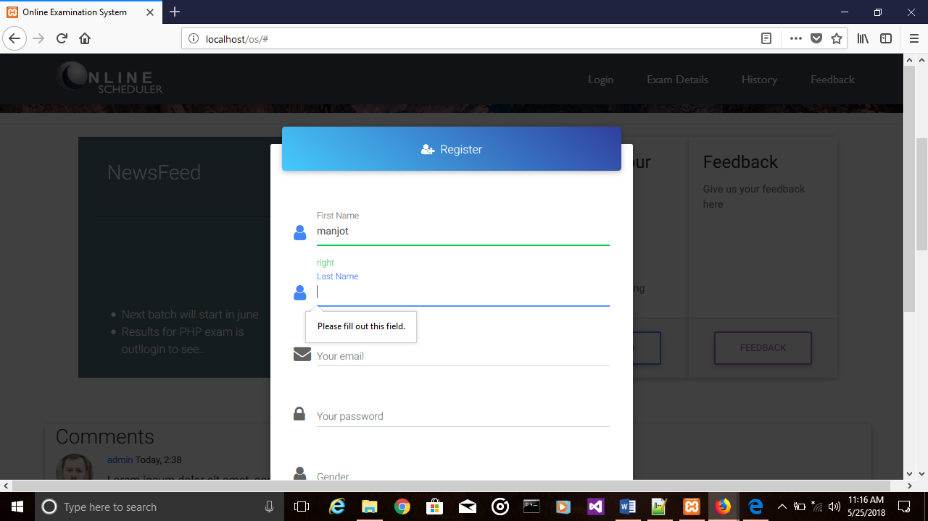

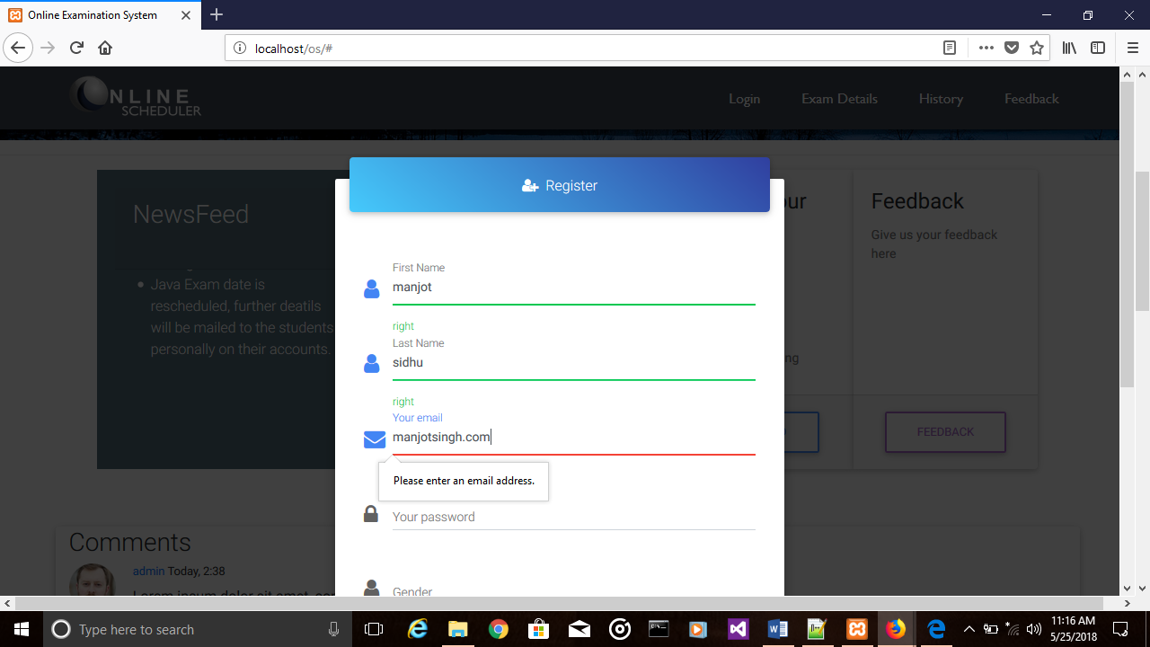

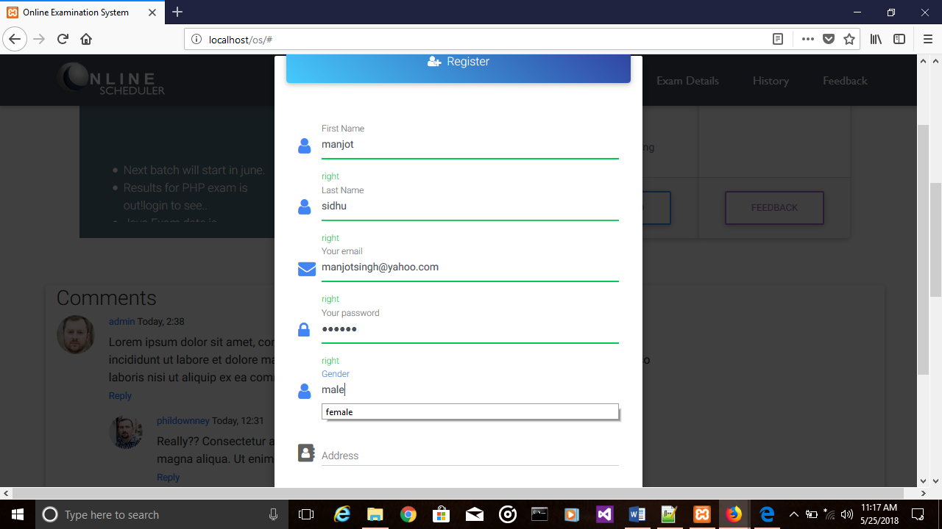

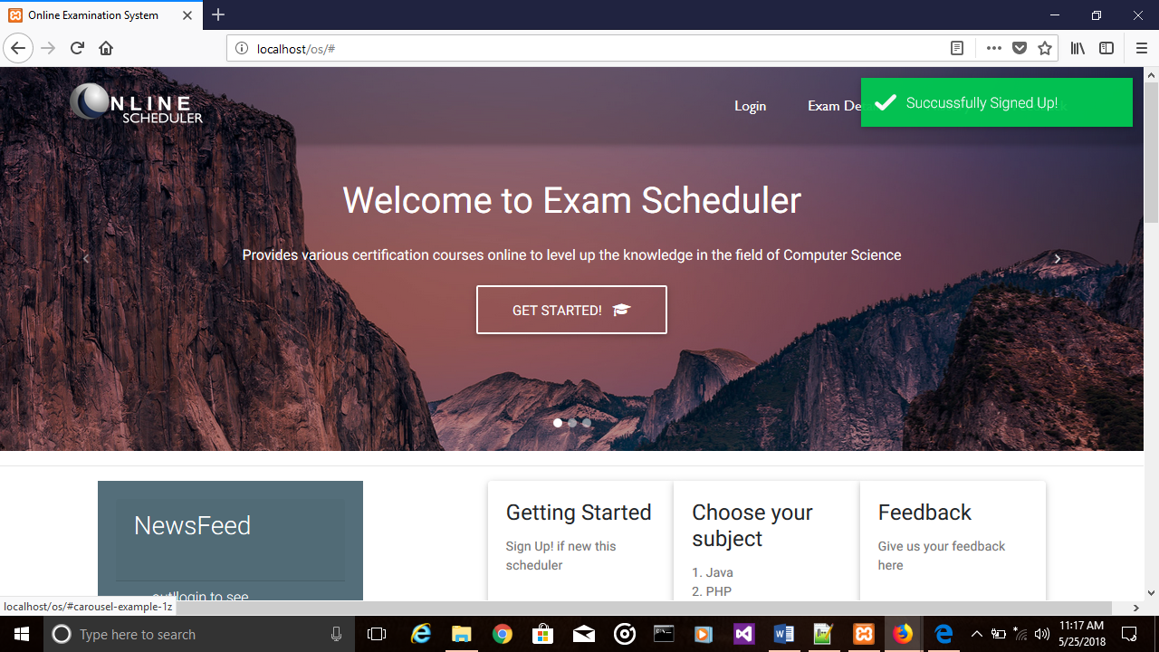

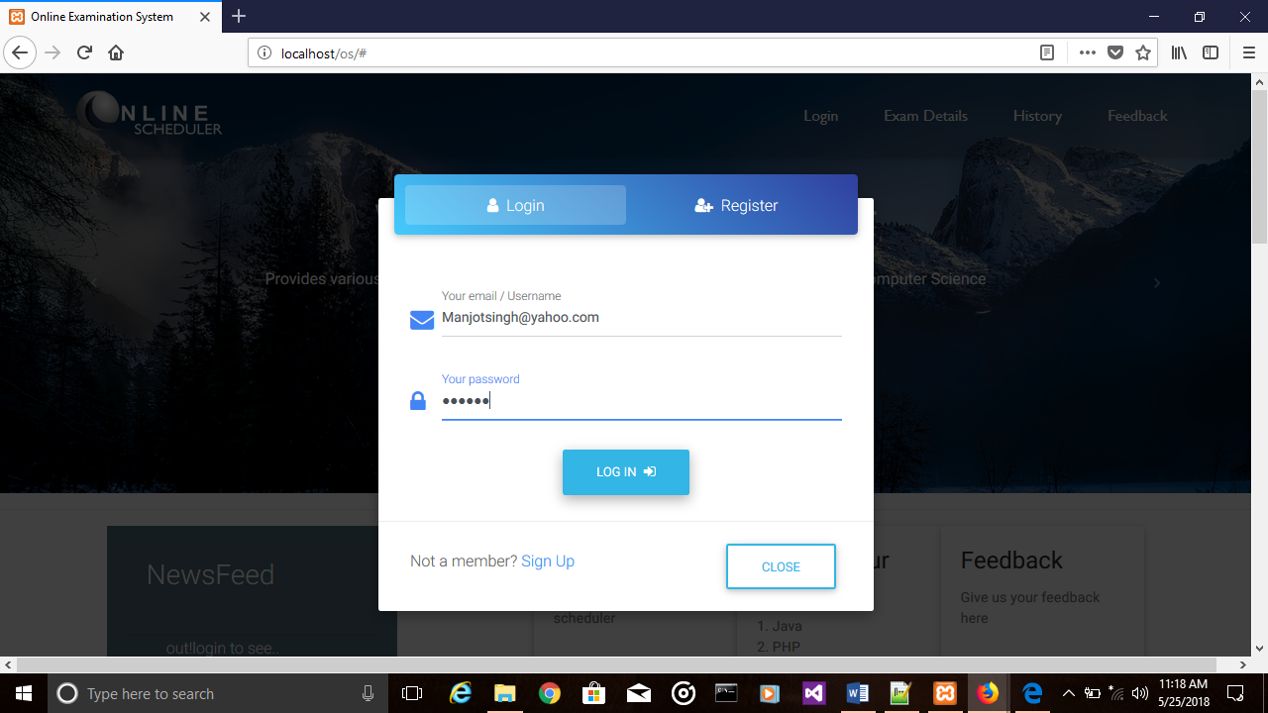

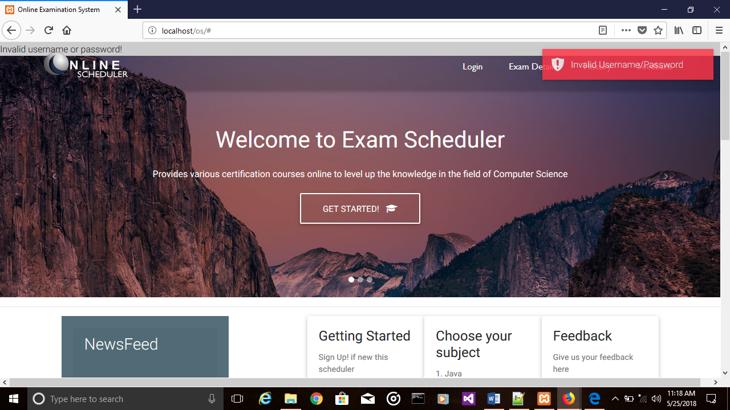

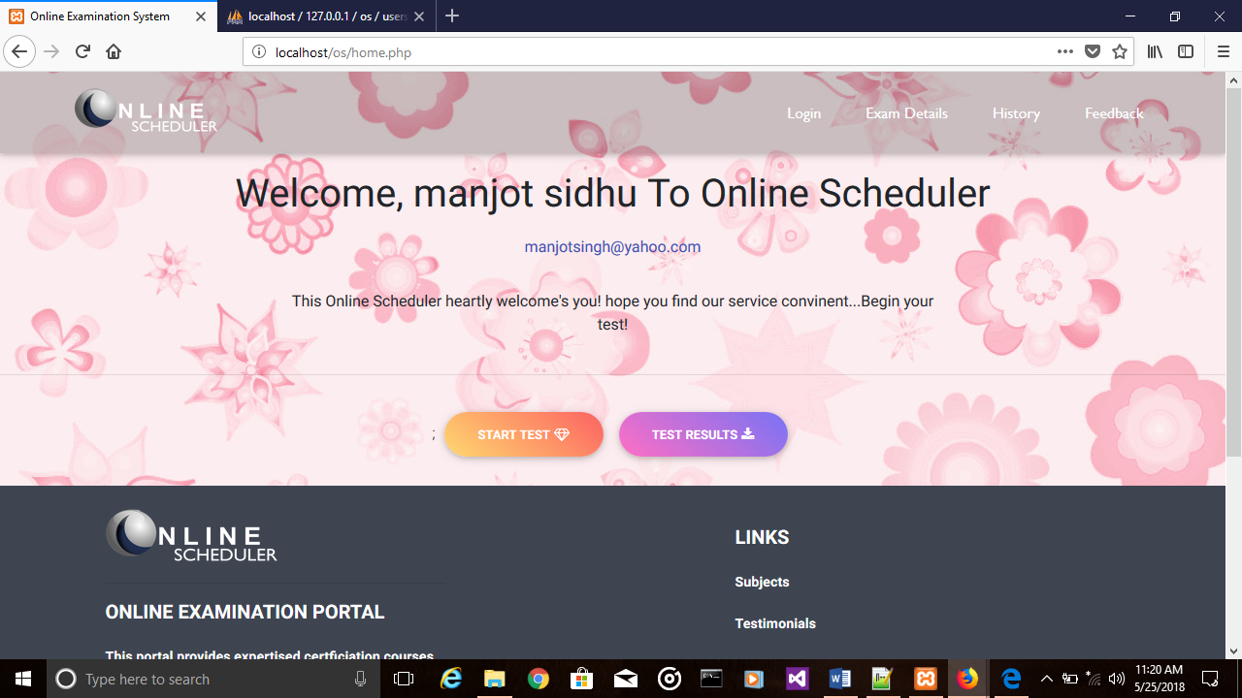

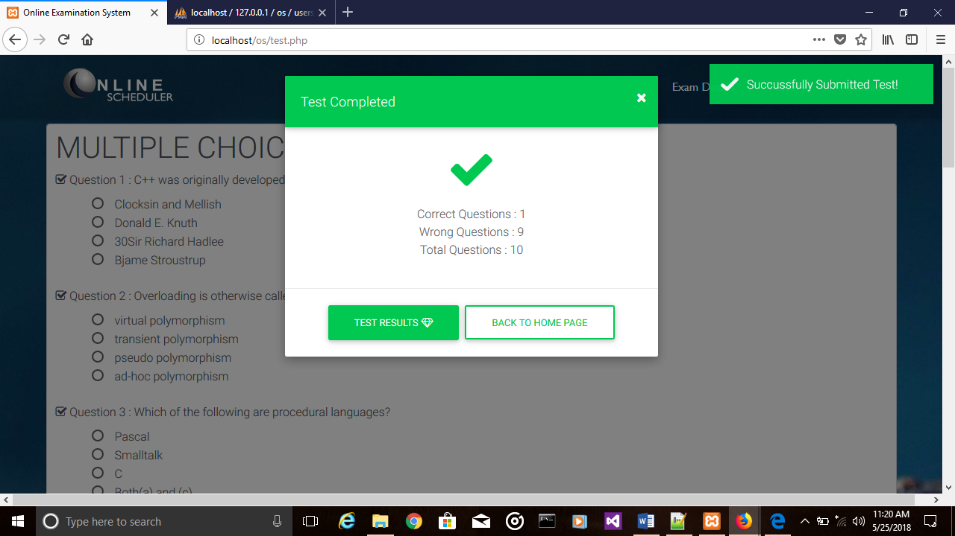

# CONCLUSION

This project is designed in such a way that new features and modification can easily be made in order to build it more secure and robust in nature. In order to increase the scope of the project, further modules will be designed in order to send the mail directly to the student so that they can directly get the result over their mail. This project will also provide the certification of many other programming languages such as c#, JavaScript, R programming etc. We will further extend this project by developing the mobile application of it so that students can access our project over their cell phones also. It will make the project more interactive.

# BIBLOGRAPHY

Material Design for Bootstrap. (2018). *Bootstrap Navbar Guideline - examples & tutorial. Basic & advanced usage*. [online] Available at: https://mdbootstrap.com/components/navbar/ [Accessed 22 May 2018].

Draw.io. (2018). *Flowchart Maker & Online Diagram Software*. [online] Available at: https://www.draw.io/ [Accessed 22 May 2018].

Mark Otto, a. (2018). *Bootstrap*. [online] V4-alpha.getbootstrap.com. Available at: https://v4-alpha.getbootstrap.com/ [Accessed 22 May 2018].

Exforsys.com. (2018). *System Testing: Why? What? & How? | IT Training and Consulting – Exforsys*. [online] Available at: http://www.exforsys.com/tutorials/testing/system-testing-whywhathow.html [Accessed 22 May 2018].

W3schools.com. (2018). *CSS Tutorial*. [online] Available at: https://www.w3schools.com/css/default.asp [Accessed 22 May 2018].

.