# EXPERIMENT 5

**Aim:**

To demonstrate the difference between the HTTP GET and POST methods using a Java Servlet, where a form will be created and requests will be handled accordingly by the GET and POST methods.

**CODE:**

**HTML :**

<!DOCTYPE html>

<html lang="en">

<head>

<meta charset="UTF-8">

<meta name="viewport" content="width=device-width, initial-scale=1.0">

<title>GET vs POST Example</title>

<style>

body {

font-family: Arial, sans-serif; background-color: #f4f4f9; color: #333;

margin: 0;

padding: 0;

}

h2 {

color: #4CAF50; text-align: center; margin-top: 50px;

}

.container { width: 50%;

margin: 0 auto; background-color: #fff; padding: 30px;

border-radius: 8px;

box-shadow: 0 4px 8px rgba(0, 0, 0, 0.1);

}

.form-group {

margin-bottom: 20px;

}

label {

font-size: 16px; color: #555;

}

input[type="text"] { width: 100%;

padding: 10px; margin-top: 5px; border-radius: 4px;

border: 1px solid #ccc; box-sizing: border-box;

}

button {

background-color: #4CAF50; color: white;

padding: 10px 20px; border: none;

border-radius: 4px; cursor: pointer; font-size: 16px;

}

button:hover {

background-color: #45a049;

}

.form-container { margin-bottom: 30px;

}

hr {

border: 1px solid #ddd;

}

.result {

background-color: #f9f9f9; border-left: 4px solid #4CAF50; padding: 20px;

margin-top: 20px; font-size: 16px; border-radius: 4px;

}

</style>

</head>

<body>

<div class="container">

<h2>GET vs POST Request Demonstration</h2>

<!-- Form to demonstrate GET method -->

<div class="form-container">

<h3>GET Method</h3>

<form action="DemoServlet" method="GET">

<div class="form-group">

<label for="data">Enter Data (GET):</label>

<input type="text" name="data" required>

</div>

<button type="submit">Submit (GET)</button>

</form>

</div>

<hr>

<!-- Form to demonstrate POST method -->

<div class="form-container">

<h3>POST Method</h3>

<form action="DemoServlet" method="POST">

<div class="form-group">

<label for="data">Enter Data (POST):</label>

<input type="text" name="data" required>

</div>

<button type="submit">Submit (POST)</button>

</form>

</div>

<!-- Result section will be dynamically updated -->

<div class="result" id="result">

<!-- Display GET or POST request result here -->

</div>

</div>

</body>

</html>

# Servlet.java:

import java.io.*; import javax.servlet.*;

import javax.servlet.http.*;

public class DemoServlet extends HttpServlet {

// Handle GET request @Override

protected void doGet(HttpServletRequest request, HttpServletResponse response) throws ServletException, IOException {

// Set response content type response.setContentType("text/html"); PrintWriter out = response.getWriter(); String data = request.getParameter("data");

out.println("<html><body>");

out.println("<h2>GET Request Received</h2>");

if (data != null && !data.isEmpty()) {

out.println("<p>Data received via GET method: " + data + "</p>");

} else {

out.println("<p>No data received in GET request.</p>");

}

out.println("</body></html>");

}

// Handle POST request @Override

protected void doPost(HttpServletRequest request, HttpServletResponse response) throws ServletException, IOException {

// Set response content type response.setContentType("text/html"); PrintWriter out = response.getWriter(); String data = request.getParameter("data"); out.println("<html><body>");

out.println("<h2>POST Request Received</h2>");

if (data != null && !data.isEmpty()) {

out.println("<p>Data received via POST method: " + data + "</p>");

} else {

out.println("<p>No data received in POST request.</p>");

}

out.println("</body></html>");

}

}

# web.xml :

<web-app xmlns="<http://java.sun.com/xml/ns/javaee>" xmlns:xsi="<http://www.w3.org/2001/XMLSchema-instance>" xsi:schemaLocation="<http://java.sun.com/xml/ns/javaee>

[http://java.sun.com/xml/ns/javaee/web-app_3_1.xsd"](http://java.sun.com/xml/ns/javaee/web-app_3_1.xsd) version="3.1">

<servlet>

<servlet-name>DemoServlet</servlet-name>

<servlet-class>DemoServlet</servlet-class>

</servlet>

<servlet-mapping>

<servlet-name>DemoServlet</servlet-name>

<url-pattern>/DemoServlet</url-pattern>

</servlet-mapping>

</web-app>

**OUTPUT :**

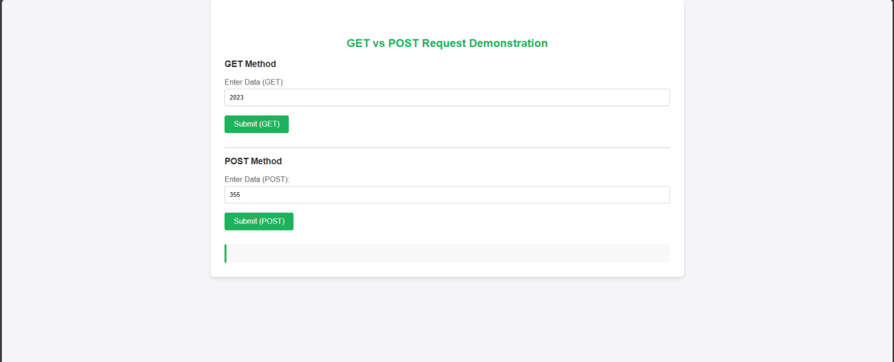

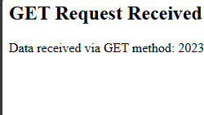



**RESULT :**

Thus the give program is executed successfully.