**AIM :**  
To create a web page that embeds a map with hotspots, frames, and links, and demonstrates the use of embedded, external, and inline CSS.

**CODE :**

<!DOCTYPE html>

<html lang="en">

<head>

    <meta charset="UTF-8">

    <meta name="viewport" content="width=device-width, initial-scale=1.0">

    <title>Web Page with Map, Hotspots, Frames & CSS</title>

    <style>

        /* Internal CSS: styling for text and page layout */

        body {

            font-family: Arial, sans-serif;

            background-color: #f0f0f0;

            text-align: center;

            margin: 0;

            padding: 0;

        }

        h1 {

            color: #333;

            margin-top: 20px;

        }

        /* Internal CSS for the map container */

        #map-container {

            width: 100%;

            height: 500px;

            margin: 0;

        }

        /* Hotspot styling */

        .hotspot {

            position: absolute;

            background-color: rgba(255, 0, 0, 0.5);

            border-radius: 50%;

            cursor: pointer;

        }

        /* Internal CSS for a frame */

        iframe {

            width: 100%;

            height: 400px;

            border: none;

        }

    </style>

    <!-- External CSS link (simulated as an external file) -->

    <link rel="stylesheet" href="styles.css">

</head>

<body>

    <h1>Interactive Map with Hotspots and Links</h1>

    <!-- Embedding Google Map -->

    <iframe id="map-container" src="https://www.google.com/maps/embed?pb=!1m18!1m12!1m3!1d387190.2799151065!2d-74.25986551872254!3d40.6976701!2m3!1f0!2f0!3f0!3m2!1i1024!2i768!4f13.1!3m3!1m2!1s0x89c25a1f8f2b6a99%3A0xa01d7e2f5b37a2a4!2sNew+York!5e0!3m2!1sen!2sus!4v1614326045003!5m2!1sen!2sus"

        frameborder="0" allowfullscreen="" aria-hidden="false" tabindex="0"></iframe>

    <!-- Hotspot placed over the map -->

    <div class="hotspot" style="top: 40%; left: 60%; width: 50px; height: 50px;" onclick="window.location.href='https://en.wikipedia.org/wiki/New_York_City'"></div>

    <p>Click the hotspot on the map to learn more about New York City.</p>

    <!-- Another Frame to display New York Wikipedia page -->

    <iframe src="https://en.wikipedia.org/wiki/New_York_City" id="info-frame"></iframe>

</body>

</html>

**OUTPUT :**

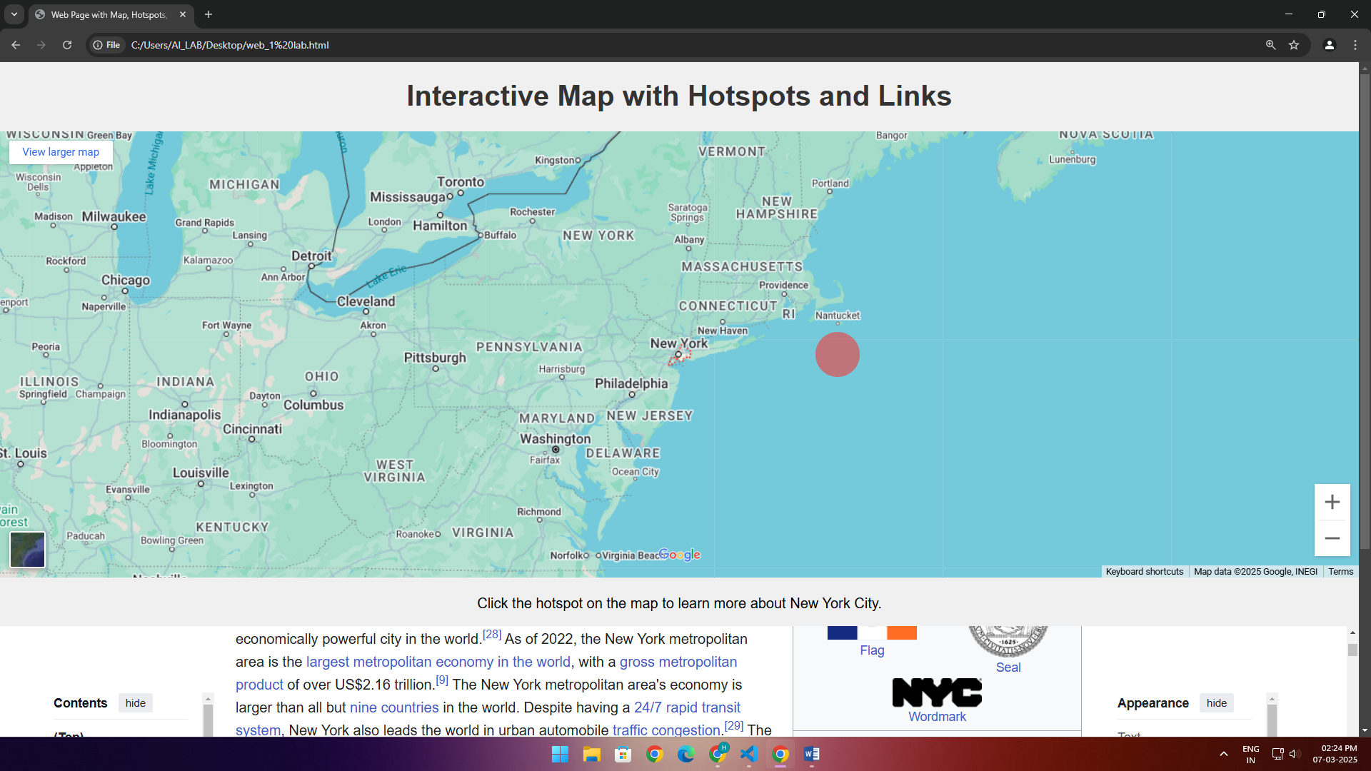

**RESULT:**

The web page successfully embeds a map with interactive hotspots, frames, and links. Additionally, it demonstrates the use of embedded CSS, external CSS, and inline CSS for styling the elements on the page.