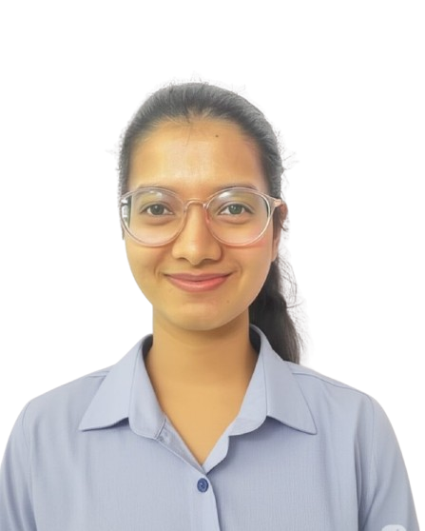

Name: Pankhuri
Email: saxenapankhuri992@gmail.com
Address: 722, Rikabganj, Ayodhya, Uttar Pradesh
Contact: 7017135511
Date of Birth: 21-12-2002
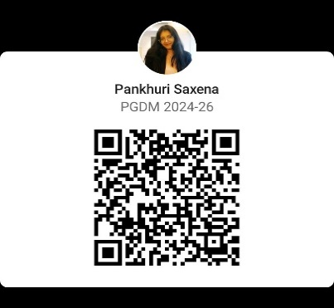
Linked in:
EDUCATION
Year | Course | School / College, City | Percentage/  CGPA
2026 – 2024 | PGDM (HR, Business Analytics) | New Delhi Institute of Management, New Delhi | 8.65
2024 – 2021 | Graduation - BBA | Amity University , Lucknow Campus | 9.15
2020 | XII Standard – Science , ISC | Modern Academy, Lucknow | 9.09
2018 | X Standard (CBSE) | Tiny Tots Sr. Sec. School | 9.95
INTERNSHIPS
Om Logistics Pvt. Ltd., Punjabi Bagh, Delhi  PANI Sansthaan  (People’s Action For National Integration | Duration – 01st May 2025 – 30st June 2025  Worked across key HR verticals at Om Logistics as a HR Intern, work in various departments were:  Recruitment & Selection  - Sourced candidates via Naukari.com for roles like CCTV Operator, Production Manager, and Fleet Operator  - Conducted telephonic and face-to-face interviews  - Drafted offer letters, calculated CTC, and assisted in referral hiring  - Understood job analysis and recruitment planning  Documentation & Onboarding  - Completed employee registration for over 100 candidates  - Handled apprentice registrations on NAPS and NATS government portals for 80+ employees  - Created employee codes, maintained digital records, and prepared experience letters  Payroll Support  - Understood salary components, CTC breakup, and statutory deductions  - Helped in generating employee codes using Oracle for payroll activation  Compliance (ESI & PF)  - Registered employees under ESI via the government portal  - Gained hands-on experience in ensuring statutory compliance through accurate employee data management  Training & Development  - Collected employee-manager feedback for Q1 to support Training Need Analysis (TNA)  - Developed an engaging induction video script using ChatGPT and Text-to-Speech tools which Contributed to making the onboarding process automated and efficient  Duration – 26th December 2024 – 04th January 2025  - Worked as a HR Operations intern for a week and learned various Human Resources Management System processes.  - Was part of recruitment process including sourcing and screening of Candidates.  - Was part of induction process team for new employees and managed their joining formalities to ensure seamless onboarding.
CERTIFICATE COURSES
- Microsoft Excel Beginner to Advanced w/ Data analysis by UDEMY (Completed: 31st May, 2024)
- HR Analytics using MS Excel for Human Resource Management by UDEMY (Completed: May, 2024)
- The Project Management Course: Beginner to Project Manager by UDEMY (Completed: June, 2024)

TECHNICAL SKILLS
- Data Analysis & Visualization: Excel (Intermediate), Power BI (Beginner), KNIME (Beginner), Tableau (Beginner)
- Software & Tools: Microsoft Office- PowerPoint (Intermediate), Word (Intermediate), Canva (beginner)
- Programming & Database: Python (Beginner), SQL (Beginner)
- RPA & Automation Tools: UiPath (Beginner)
POSITIONS OF RESPONSIBILITY
- Event Coordinator, SPANDAN College Fest
- Fest Committee Member, Amiphoria College Fest
Organized a successful event for the ABS department as a volunteer.
- International Buddy Program Volunteer
Facilitated the smooth transition and visit of Japanese students for one week by assisting with logistics, cultural guidance, and communication

ACHIEVEMENTS
- Secured 100% marks and topped the NPTEL course ‘Stress Management and Well-being’ (2025), awarded by IIT Madras & Ministry of Education.
- Awarded a 25% scholarship in recognition of securing a position among the top 3 students in the graduation batch.
- Received faculty appreciation for creating a comprehensive HR dashboard that provided data-driven insights into employee attrition.

EXTRACURRICULAR ACTIVITIES
Performing Arts:
- Holder of a Junior Diploma in Kathak.
- Won a dance competition during the 'Amiphoria' college fest.

