1. Analysing Model
   1. Model

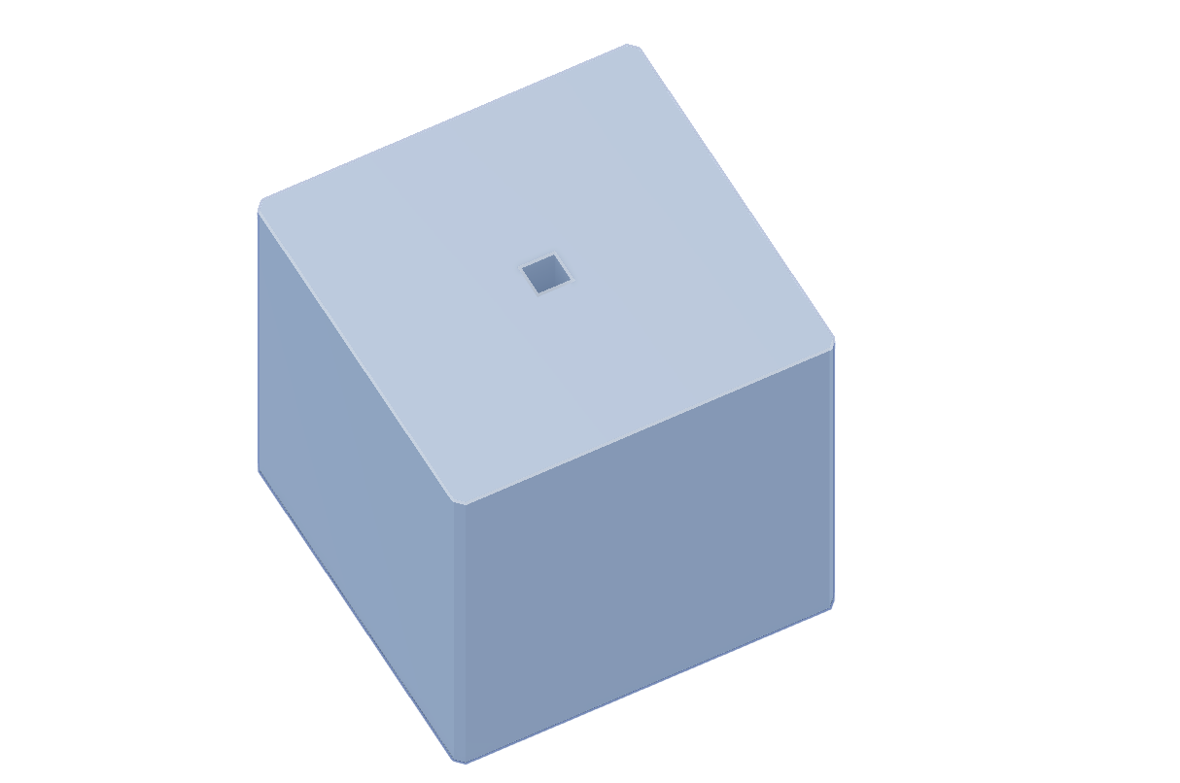

1. Raw Material stock selection
   1. Setup 1

* 1. Setup 2

1. Identify Machining Processes
   1. Setup 1 machining process
      1. Face milling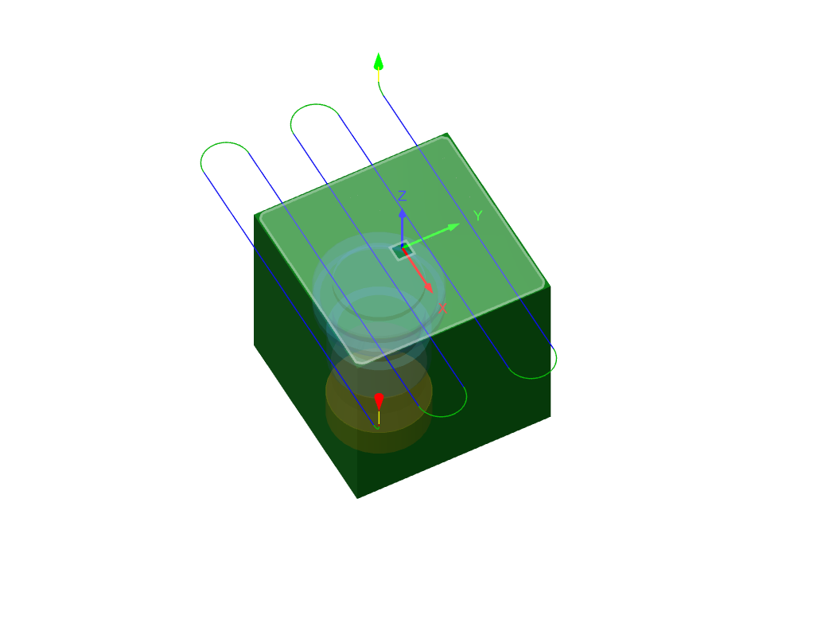
      2. Contour millingA green cube with blue lines and a clear cup

         Description automatically generated
   2. Setup 2 machining process
      1. Face milling

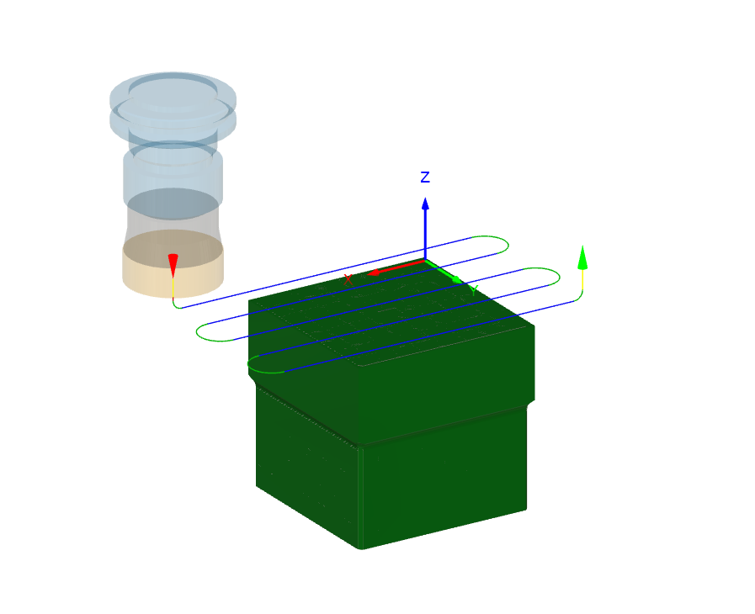

* + 1. Contour milling

1. Calculating Toolpath

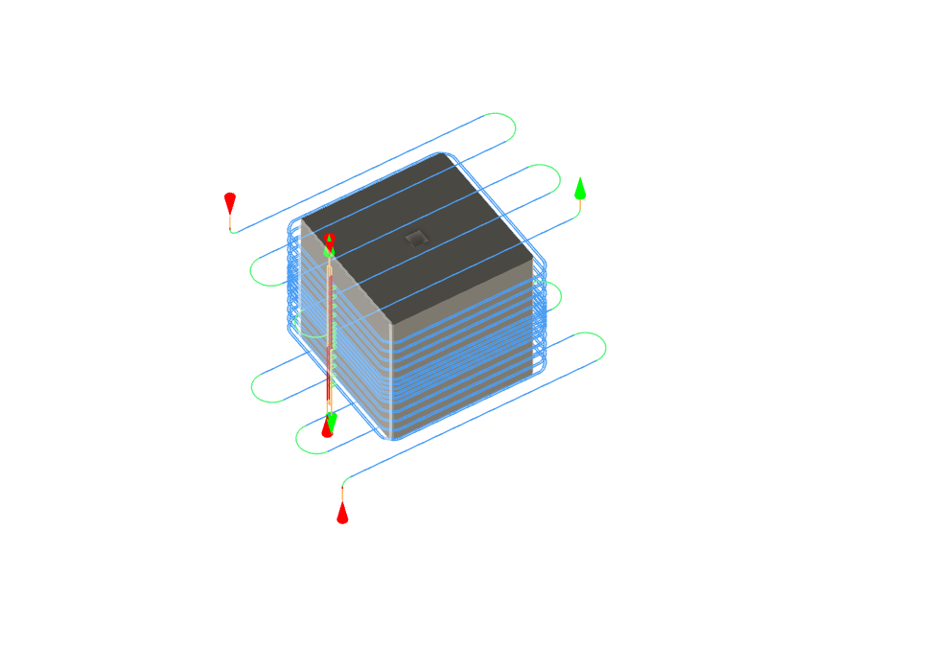

1. Calculating Machining Time
   1. Need to select template to show for this stage
2. Generating report (from 90% to 100% )
   1. Need to select template to show for this stage