1. Analyzing Model
   1. Model

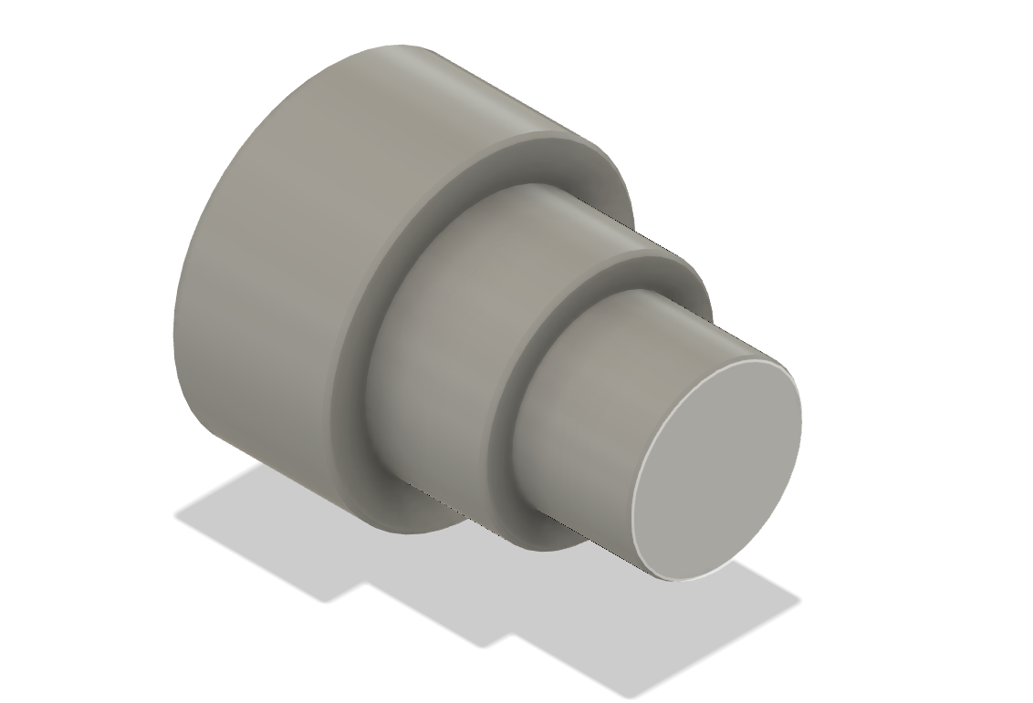

1. Raw Material stock selection
   1. Setup 1

* 1. Setup 2

1. Identify Machining Processes
   1. Setup 1 machining process
      1. Rough and Finish Turning

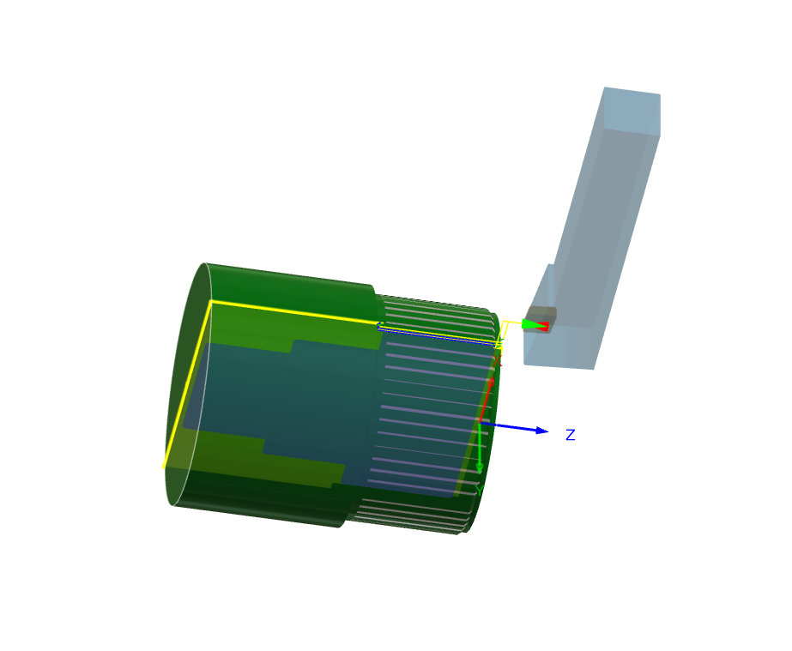

* + 1. Face Turning

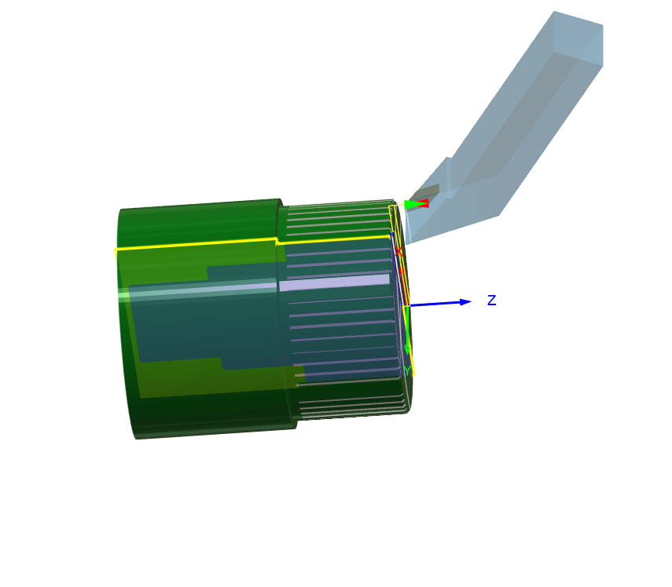

* 1. Setup 2 machining process
     1. Rough and finish Turning

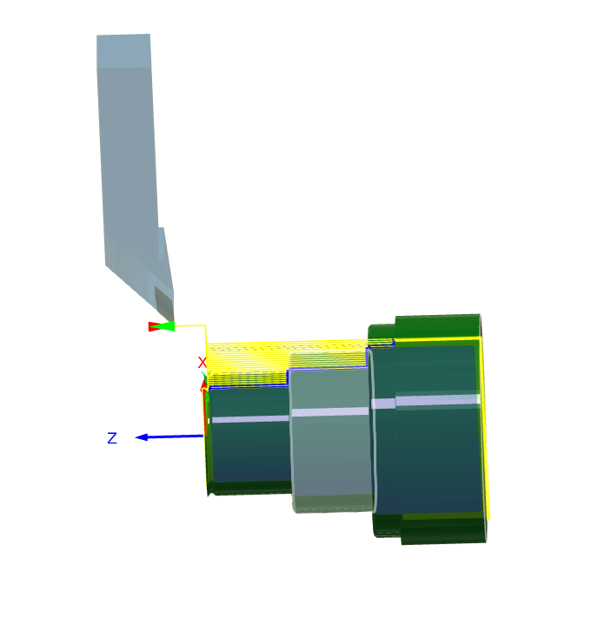

* + 1. Face Turning

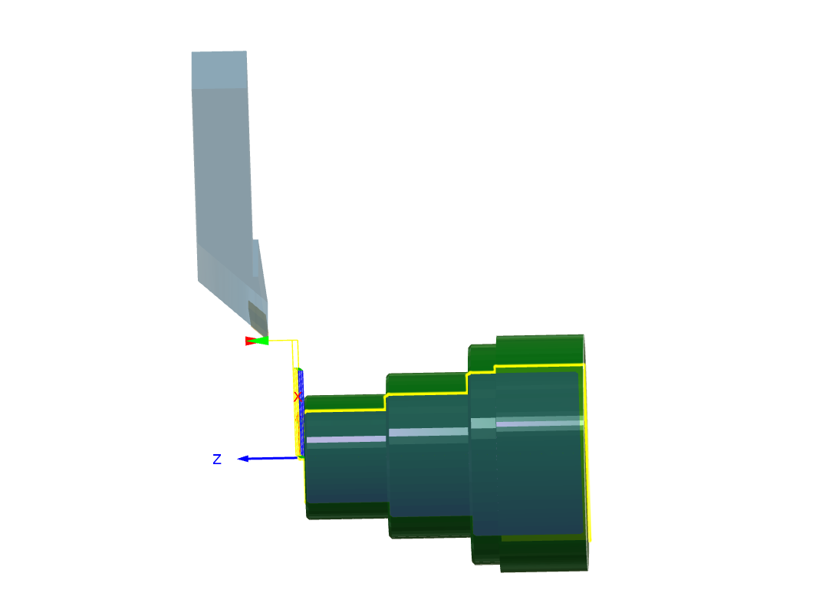

1. Calculating Toolpath

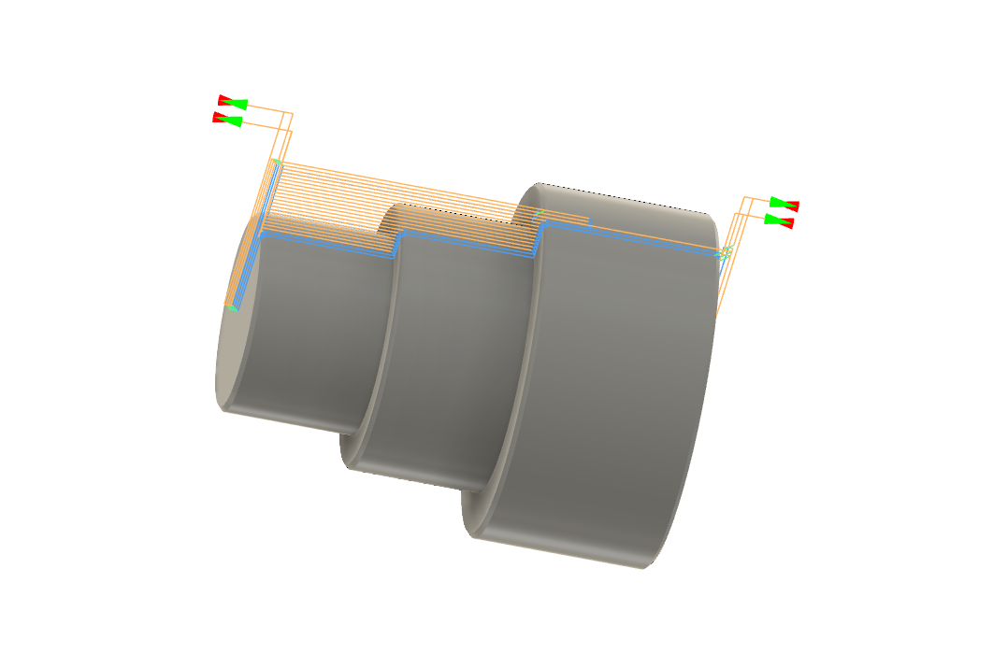

1. Calculating Machining Time
   1. Need to select template to show for this stage
2. Generating report (from 90% to 100% )
   1. Need to select template to show for this stage