Solution Design:

Building step of the project should be fairly simple as explained in README file. I am using ubuntu Linux systems but should not be an issue running this on any platform as we are not performing any OS depended operations.

Flow chart:

Flow chart of the project has not been changed but the number of inputs have been reduced in order to make it run on my laptop.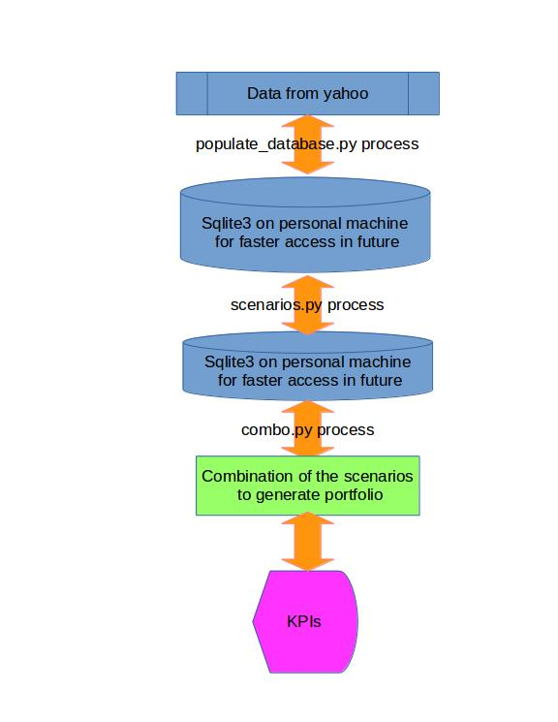

As explained in above digram, main purpose of this project was to use various skills which can help us productionize a live trading strategy.

We often need to create a lot of scenarios and test them out before we actually start trading on it. This project will help to modularize different aspects and work on those modules individually.

Scope of improvements:

* Needs to get data for thousands of symbols to make sure that signals we are testing do work on diverse universe and are not isolated to few tickers. Also we have this data in database, user can give parameters to decide what universe we should be running our project on.
* Need to increase the scenarios / chart patterns so that combo module will have various options to pick based on the market condition. For machine learning, more parameters will mean more opportunities to optimize.
* Needs to incorporate trading costs , slippage and hedging before we go live.
* Need to out put graphs of PNL and other KPI so that we get insights when testing a scenario.
* Needs to improve on error handling part before we start trading on this as we dont want to invest money on a code which can crash frequently.